Supporting Information

Realizing neuromorphic networks at self-organized criticality on a 2D hexagonal BN platform
Ankit Rao¹, Sooraj Sanjay¹, Majid Ahmadi², Anirudh Venugopalrao¹, Navakanta Bhat,¹ Bart Kooi^{2,3}, Srinivasan Raghavan¹, Pavan Nukala¹*

Affiliations
¹Centre for Nano Science and Engineering, Indian Institute of Science, Bengaluru 560012, ²Zernike Institute for Advanced Materials, University of Groningen, Groningen, the Netherlands, ³CogniGron center, University of Groningen, Groningen, 9747 AG, The Netherlands. Corresponding Author. * E-mail: pnukala@iisc.ac.in

This file includes:

Figures S1 to S7
Table S1

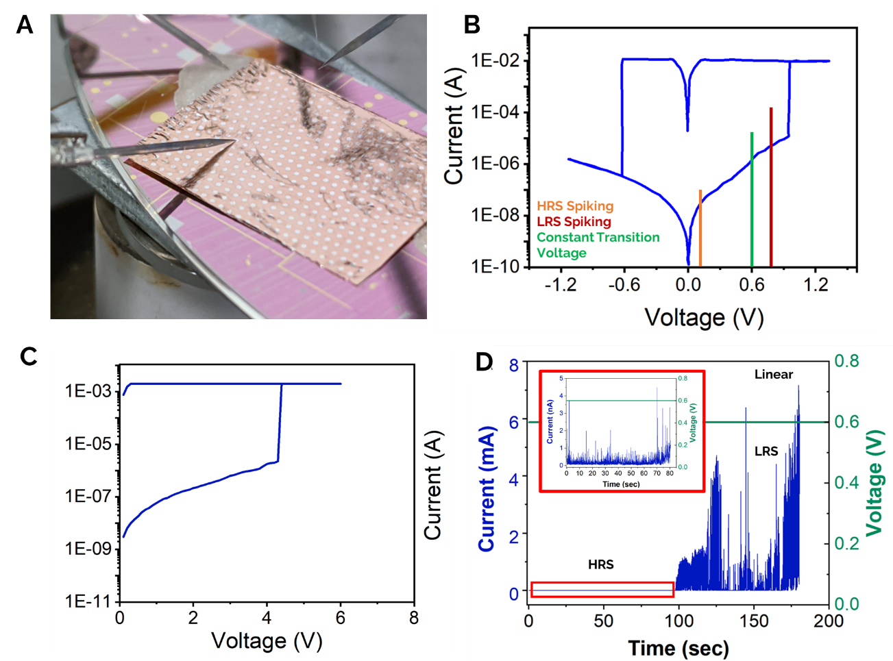

Figure S1. A) Large Area Ag-hBN-Cu device. B) Resistive switching behavior observed in the device at SET voltage (0.9V) and RESET voltage (0.6V). C) Electroforming process for the Ag-hBN device with forming voltage (V_{f}) of ~4V. D) Current-time plot in linear scale at a constant voltage of 0.6V. The temporal behavior of device exhibiting transition from HRS to LRS due to transport of ions under constant electric field. (Inset) The HRS pattern observed scaled to the current levels of the device in nA.

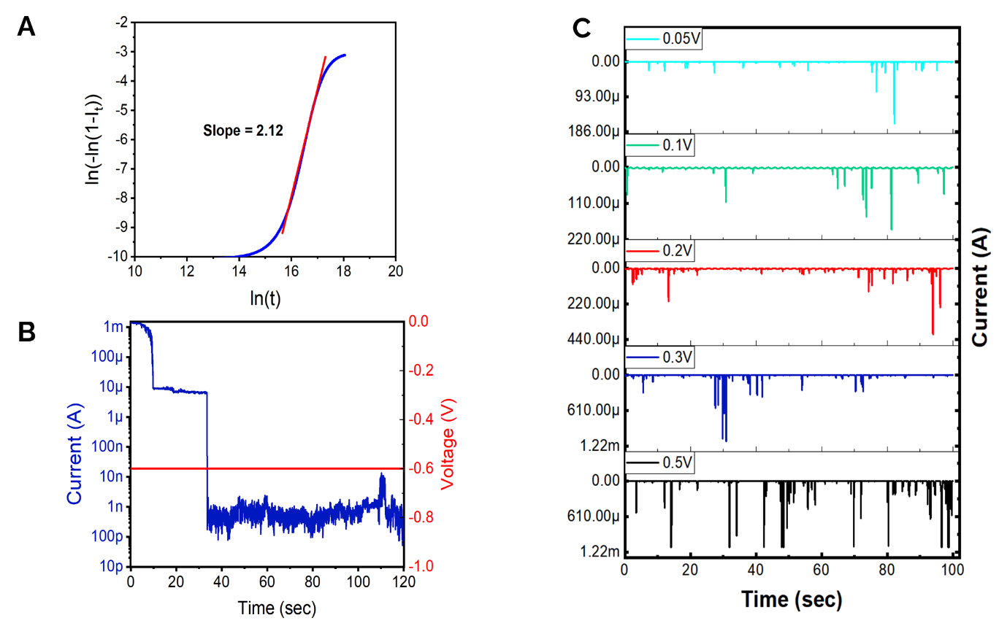
Figure S2. A) Avrami exponent determination from the ln(-ln(1-x) vs ln(t) curve. B) Time series plot of current under constant negative bias (-0.6V) resulting in filamentary breakage and reversal phenomenon. C) Rate coding. Controlling spiking rate as a function of input voltage. Spiking rate can be used to encode information for a specific input voltage.

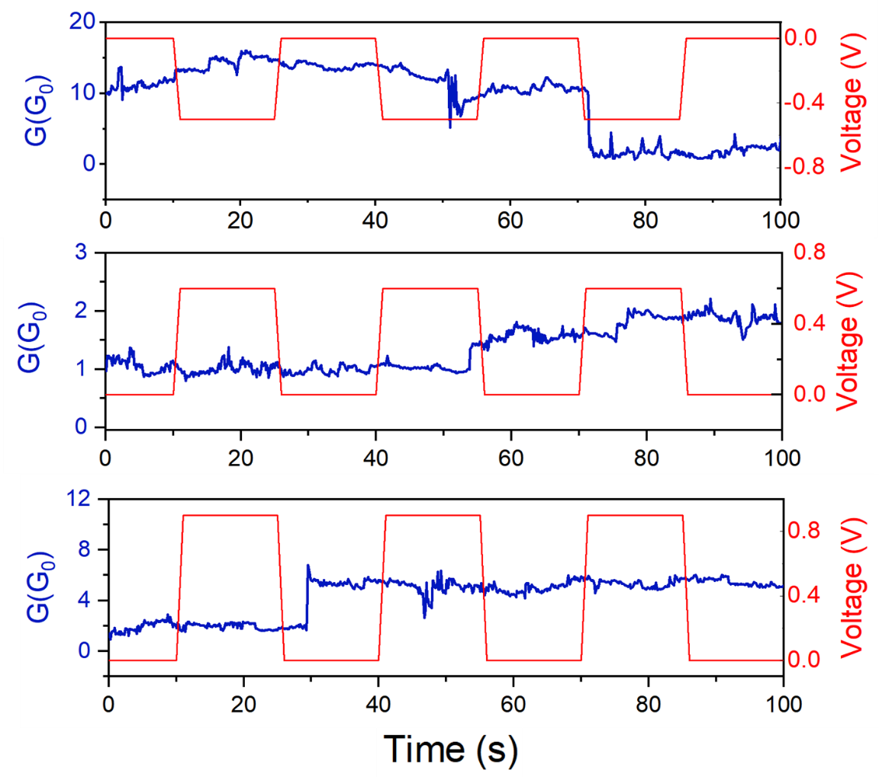
Figure S3. Diffusion based self-stabilizing behavior under application of long-range pulsed stimulus. (Top Panel) Under negative voltage stimulus (-0.6V), when the system is at higher conductance levels, the filaments tend to break and the return to lower conductance levels. (Middle Panel) Pulsing at a voltage (0.6V) lower than the SET voltage allows the system to stay in a stable configuration with small temporal change in conductance. (Bottom Panel) Under pulsing at voltage (0.8V) closer to SET point, the system conductance increases due to diffusion under application of higher fields.
Long Range Pulsed Stimulus
When negative voltage pulses in LRS state are applied (-0.6V), the system tends to switch from a high conductance level and the return to low conductance level as the filaments tend to break. When the device is in HRS state, the pulsing is applied at a voltage (0.6V) lower than the SET voltage which allows the system to stay in a stable configuration as small temporal changes in conductance are observed. Under pulsing at voltage (0.8V) closer to SET point, the system conductance increases due to diffusion under application of higher fields.
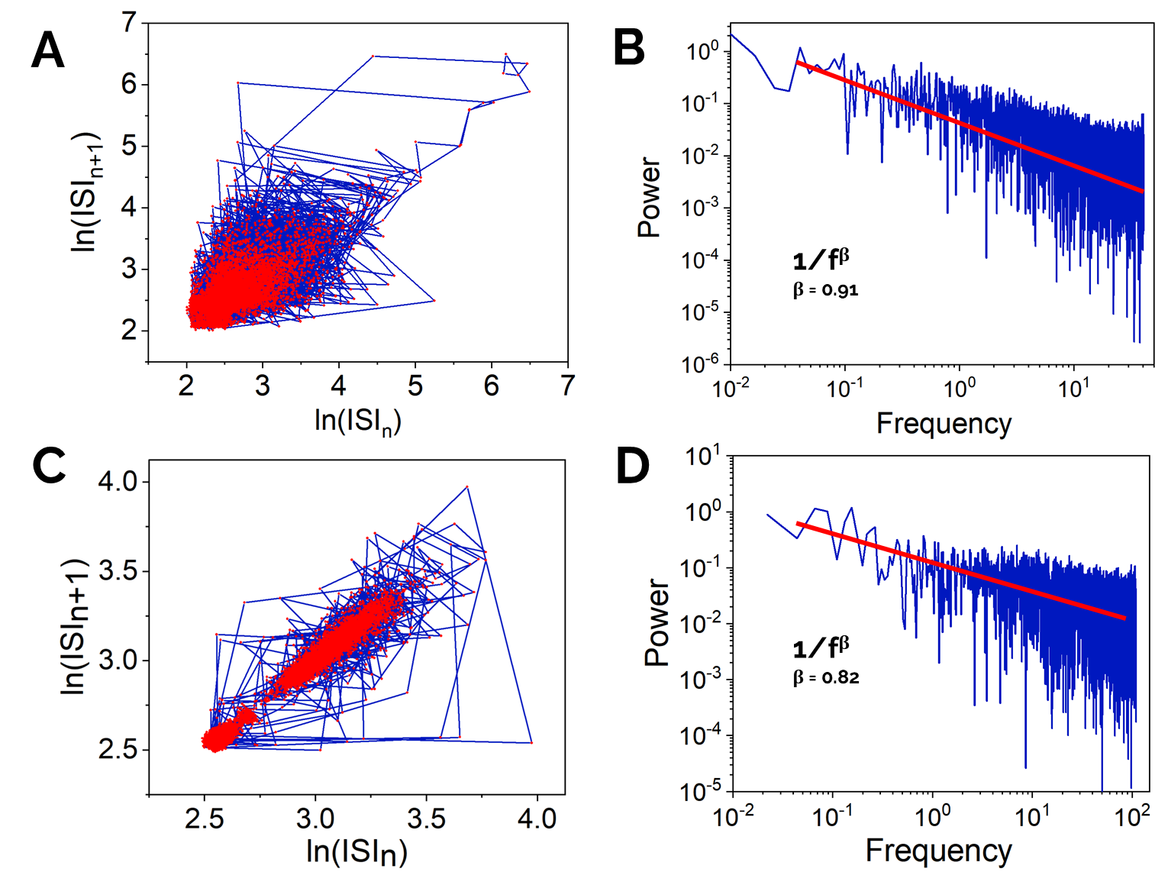
Figure S4. (A and C) Correlation between successive inter-spike intervals (ISI_{n}) for HRS and LRS cases. (B and D) Power Distribution (A²/Hz) as a function of frequency (Hz) plot for determination of 1/f noise and β exponent value for HRS and LRS.

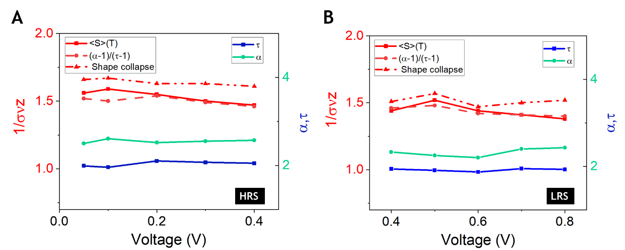
Figure S5. Variation of estimations of 1/συz as a function of voltage from <S>(T) vs T, (α-1)/(τ-1) and shape collapse analysis. Trend of critical exponents (α, τ) as a function of voltage for HRS (A) and LRS (B).

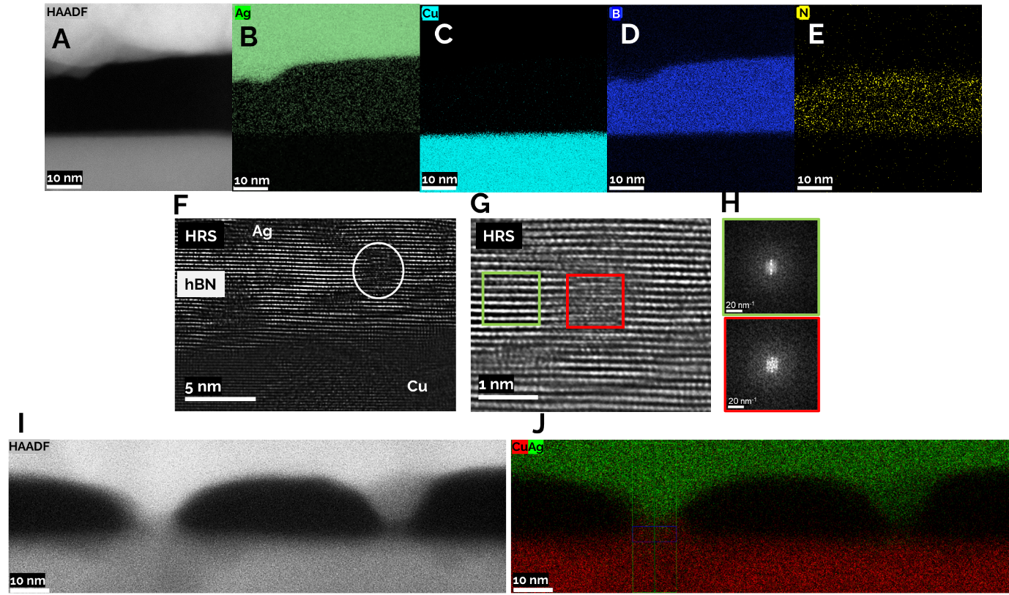

Figure S6. (A to E) HAADF-STEM EDS mapping of Ag-hBN-Cu stack in the HRS state. F) HRTEM image of the cross section from same sample after 10 switching cycles and rested in HRS state. G) Magnified area from F) (white region) which suggests the presence of an intercalated planar cluster of Ag between two hBN layers. H) The Fast Fourier Transform (FFT) of the regions pristine (green) and defective (red) from G) confirms change in the crystallinity of the structure due to Ag intercalation. I, J) HAADF-STEM (I) EDS (J) mapping of the Ag-hBN-Cu in the LRS state showing formation of Ag filaments.

Table S1. Critical Exponents

 | ∆G | IEI | τ | α | 1/συz
HRS | 2.59±0.05 | 1.54±0.05 | 1.98±0.1 | 2.61±0.1 | 1.59±0.03
LRS | 2.87±0.05 | 1.72±0.05 | 1.93±0.1 | 2.43±0.1 | 1.38±0.03
Nanoparticle Network | 2.59 | 1.93 | 2.05±0.1 | 2.66±0.1 | 1.55±0.03
Nanowire Network | - | - | 2±0.1 | 2.3±0.1 | 1.3±0.03
Rat cortices | - | - | 1.74 | 1.96 | 1.22
Neuronal cortices | - | - | 1.69 | 1.92 | 1.56

(*Error Analysis - This standard deviation is used as a measure of the error of the exponent of the original fit, and is estimated from the routines presented in Ref 36)

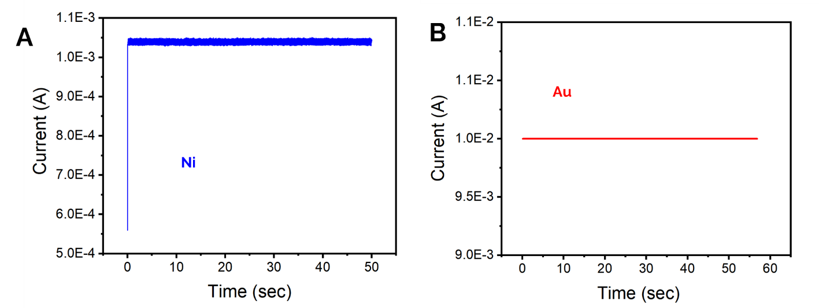
Figure S7. A) Ni and B) Au as the top electrode. No spiking behavior is observed with Ni and Au as the top electrode.

