Supplement materials
Table S1. The quality assessments of observational studies using Newcastle-Ottawa Scale score.
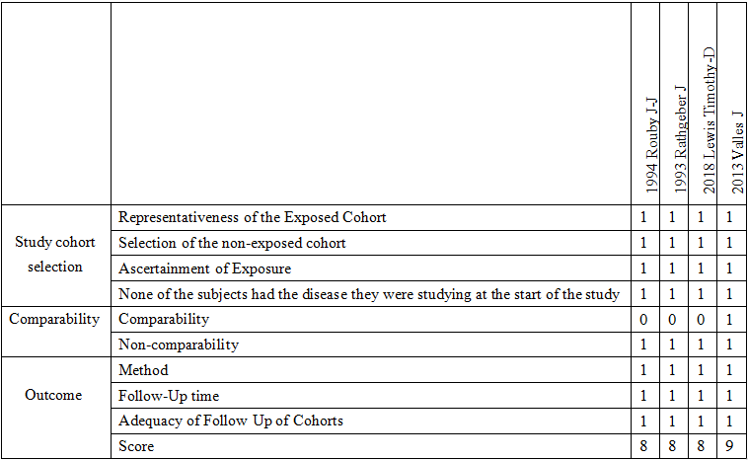

Figure S1. The quality assessments of observational studies using risk of bias tool recommended by the Cochrane Collaboration.
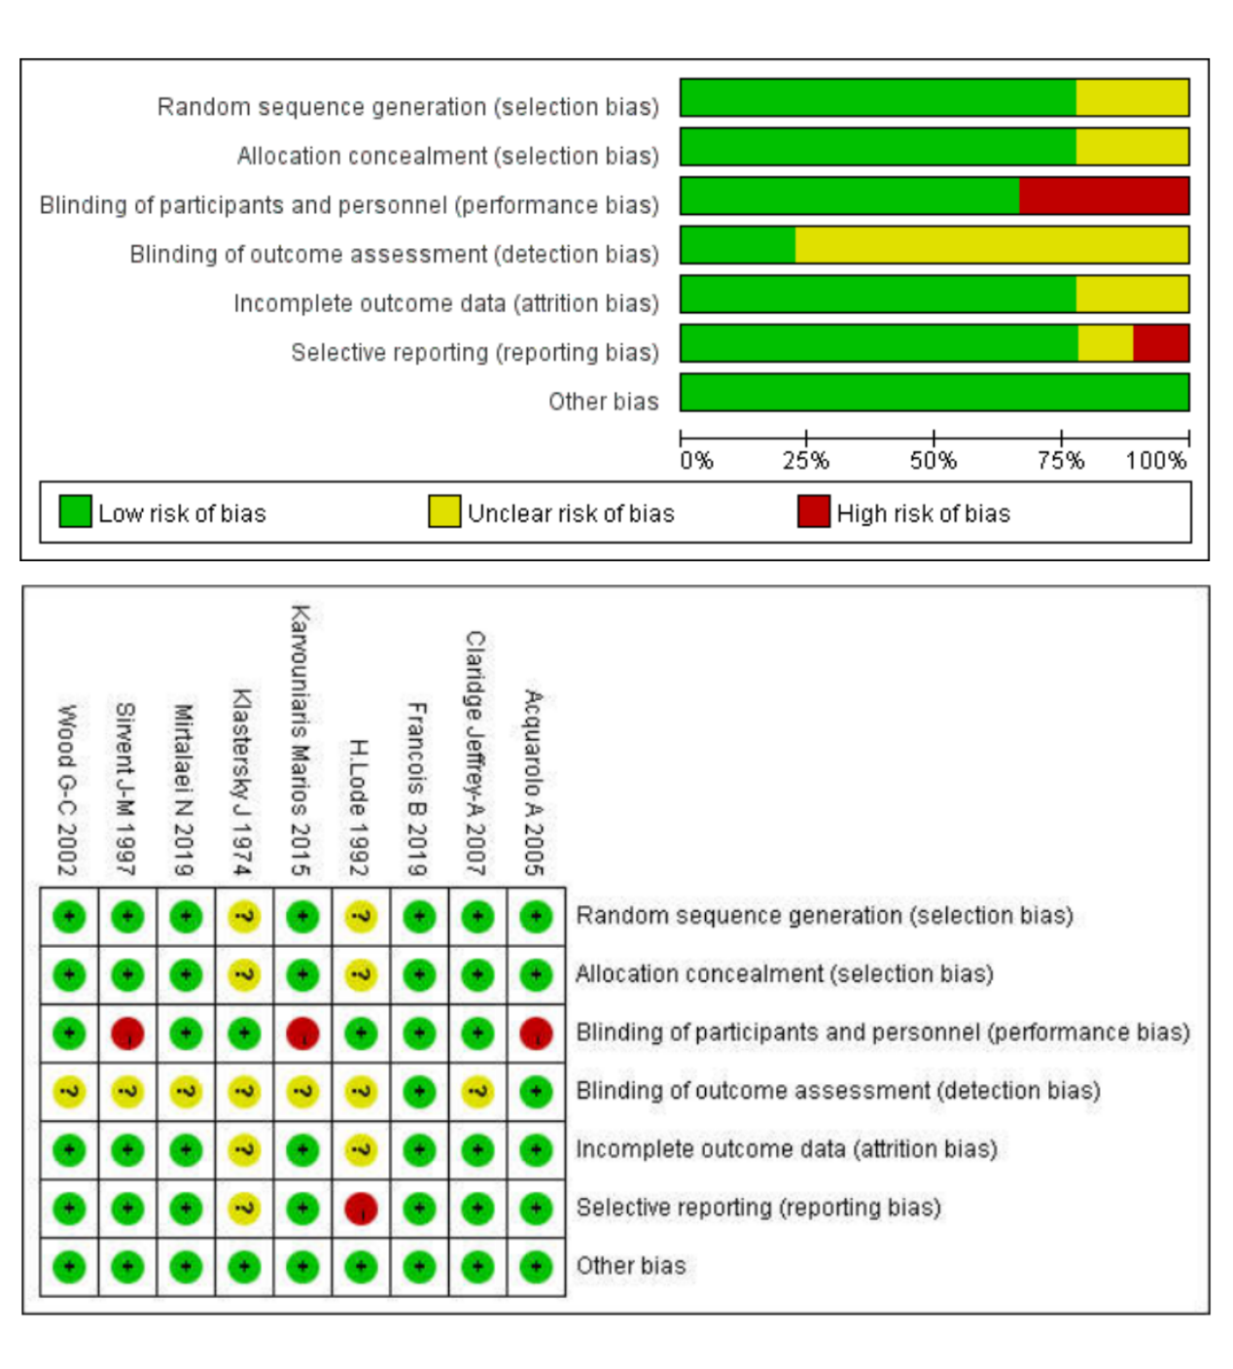

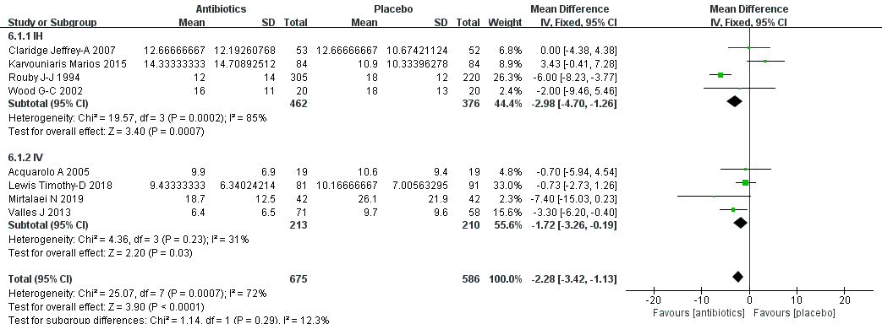
Figure S2. Forest plots of effect of prophylactic antibiotics compared to placebo on duration of invasive ventilation. Studies are grouped by routes of administration.

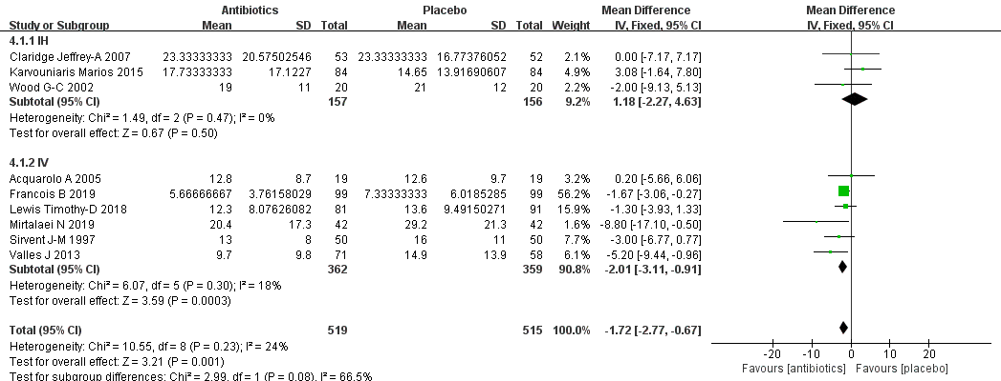
Figure S3. Forest plots of effect of prophylactic antibiotics compared to placebo on duration of ICU. Studies are grouped by routes of administration.

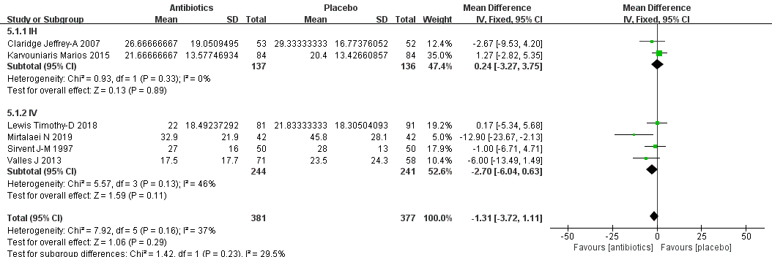
Figure S4. Forest plots of effect of prophylactic antibiotics compared to placebo on duration of hospitalization. Studies are grouped by routes of administration.

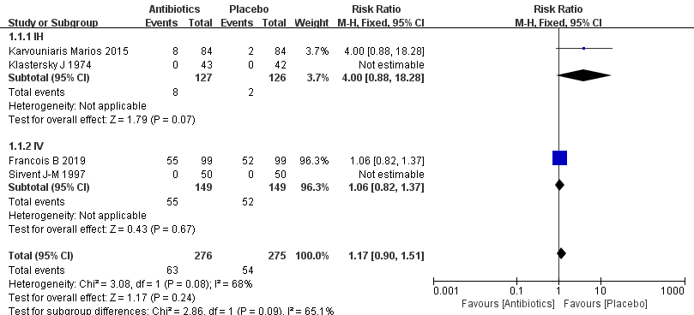
Figure S5. Forest plots of effect of prophylactic antibiotics compared to placebo on adverse events. Studies are grouped by routes of administration.

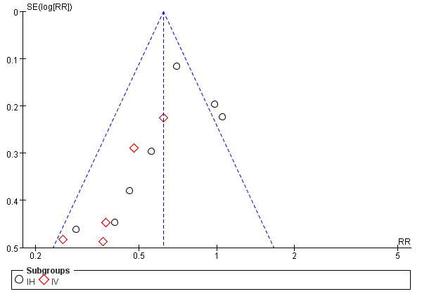
Figure S6. Funnel plot of the included studies for incidence of VPA.

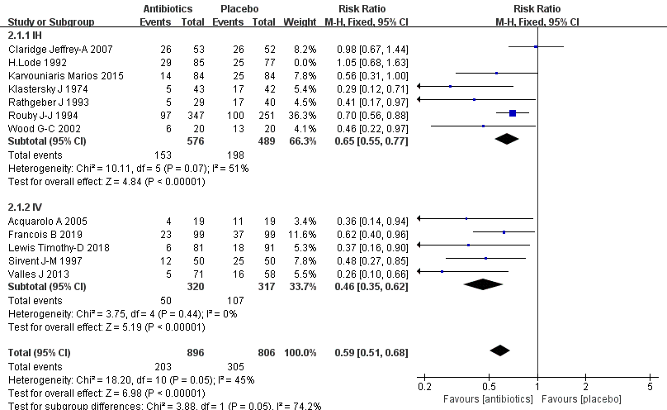
Figure S7. Sensitivity analyses on the incidence of VAP.

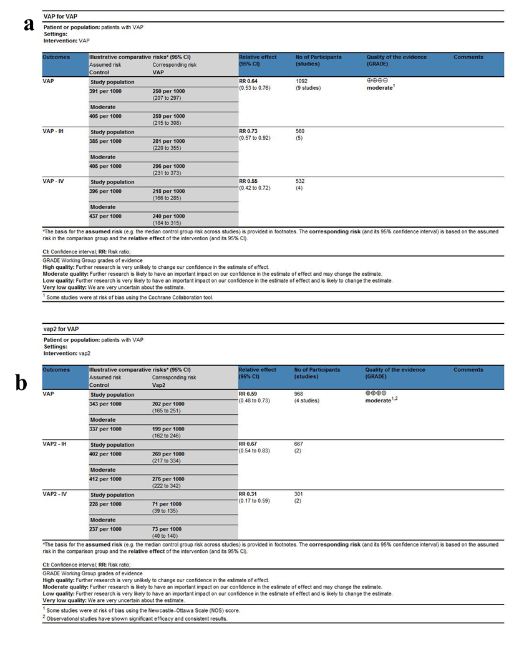
Figure S8. GRADE assessment of a) randomized controlled studies and b) observational studies.

