Supplementary Table 1 Detailed information of the seventy cases with clinical characteristics

No. | name | sex | age | smoking | drinking | symptom | site（1super-articular cavity2subarticular cavity） | size | local invasion（1Skullbase bone2Dura mater3Brain lobe4No） | condyle repair method | skull base repair method | condyle integrity | recurrence | post-operative complication | follow-up(m)
1 | LDA | Male | 48 | Yes | Yes | H | 1 | 4.5*4.5 | 1 | no | AF | Yes | Yes | No | 11.6
2 | YJB | Male | 59 | Yes | Yes | H，LMO | 1 | 2*2 | 1 | no | TMF | No | No | No | 125.4
3 | SXZ | Female | 57 | No | No | FN | 1 | 3.5*3.7 | 1 | no | No | Yes | No | No | 120.5
4 | LX | Female | 23 | No | No | H | 2 | 2*3 | 4 | no | AF | No | No | No | 120.1
5 | XXF | Female | 39 | No | No | HL | 2 | 3.6*3 | 4 | no | AF | No | No | No | 115
6 | TYF | Male | 32 | Yes | No | H，LMO | 1 | 3*6.1 | 1 | costal cartilage | IB+TMF | No | No | No | 107.2
7 | SXA | Female | 50 | No | No | H | 2 | 3.6*2.5 | 4 | no | AF | No | No | No | 106.1
8 | QY | Male | 41 | No | No | H，LMO | 2 | 2.6*1.7*1.8 | 4 | no | AF | No | Yes | No | 39.7
9 | LZF | Female | 39 | No | No | H | 2 | 1.2*1.4 | 4 | no | AF | Yes | No | H | 85.3
10 | DYX | Female | 37 | No | No | H | 1 | 6.1*4.8*3.5 | 1 | no | No | Yes | Yes | No | 15.6
11 | SZQ | Male | 39 | No | No | HL | 1 | 4.8*3.6 | 2 | no | No | Yes | No | No | 86.7
12 | JHX | Female | 38 | No | No | HL、FN | 1 | 3.7*4*3.5 | 1 | no | TB | Yes | Yes | No | 24.1
13 | XHG | Male | 39 | No | No | M | 2 | 3*4 | 4 | costal cartilage | TB | No | No | No | 73.1
14 | FCJ | Male | 58 | No | Yes | H | 1 | 2.0*1.5 | 1 | no | TM | Yes | No | No | 59.2
15 | XXY | Male | 52 | Yes | No | HL | 1 | 4.8*3.7*4.2 | 2 | no | TM+TMF | No | No | FP | 58.9
16 | HWJ | Male | 49 | Yes | No | HL | 1 | 5.6*4 | 2 | no | TM+TMF | Yes | No | LMO、M | 58.2
17 | ZS | Female | 33 | No | No | H | 1 | 2.4*2.4*2.5 | 1 | no | TM | No | No | No | 56.6
18 | GHX | Male | 26 | Yes | No | H | 2 | 3.5*3.2 | 4 | costal cartilage | TM | No | No | No | 56.1
19 | YAY | Female | 57 | No | No | HL | 1 | 4.5*4.2*4.3 | 1 | no | IB+SCMF | No | No | No | 54.9
20 | GFL | Female | 58 | No | No | H | 2 | 3.1*1.9*1.5 | 4 | no | No | Yes | No | No | 53.8
21 | WWD | Male | 47 | No | Yes | PAM | 2 | 2.5*2.3 | 4 | costal cartilage | No | No | No | No | 53.1
22 | LJJ | Male | 44 | No | No | LMO | 2 | 3.5*3.8 | 4 | costal cartilage | No | No | No | No | 51.3
23 | DYJ | Female | 72 | No | No | PAM | 2 | 3.9*2.8 | 4 | no | No | No | No | No | 51
24 | ZJZ | Male | 46 | No | No | M，HL | 1 | 5.6*4.6 | 1 | no | No | Yes | No | No | 50.8
25 | DL | Male | 32 | No | No | HL | 1 | 4*3 | 1 | no | BF | No | No | No | 47
26 | ZYH | Female | 26 | No | No | PAM | 2 | 1.1*0.4 | 4 | no | AF | Yes | No | No | 46.1
27 | YYZ | Female | 55 | No | No | PAM | 1 | 2.9*1.6 | 1 | no | AF | Yes | No | No | 43.1
28 | JHR | Male | 27 | No | No | H | 1 | 4*5*4.5 | 1 | no | Medpor+AF | Yes | No | No | 41.9
29 | XCC | Female | 23 | No | No | LMO | 2 | 3.9*2.5 | 4 | no | TMF | No | No | No | 41.2
30 | XJJ | Female | 50 | No | No | LMO | 1 | 3.5*3.5*2.8 | 1 | no | TB | Yes | No | FP | 35.8
31 | XJJ | Female | 48 | No | No | PAM | 2 | 1.5*1.4 | 4 | no | No | Yes | No | No | 34.2
32 | YQH | Male | 61 | No | No | LMO | 1 | 4*3 | 1 | artificial joint | AF | No | No | No | 31.8
33 | JXJ | Male | 63 | Yes | Yes | PAM | 2 | 1.9*1.4 | 4 | no | No | Yes | No | No | 30.9
34 | MHM | Female | 45 | No | No | H | 2 | 2.5*1.9*2 | 4 | artificial joint | AF | No | No | FP | 30.2
35 | ZSL | Female | 24 | No | No | PAM | 1 | 3.7*2.6 | 1 | artificial joint | No | No | Yes | No | 16
36 | CYS | Male | 56 | No | No | H | 1 | 3*5.6*2.7 | 2 | no | TB+TMF | Yes | No | M,FP,brain contusion | 27.6
37 | YTT | Female | 26 | No | No | H，PAM | 2 | 3.3*2.2 | 4 | artificial joint | AF | No | No | 5 | 27.4
38 | YHF | Male | 27 | No | No | PAM | 1 | 5.7*3.4 | 1 | no | No | Yes | No | No | 26.4
39 | MLF | Female | 53 | No | No | LMO | 2 | 2.9*1.9 | 4 | artificial joint | No | Yes | No | 5 | 25.5
40 | WQW | Male | 48 | No | No | PAM | 2 | 2.7*1.9 | 4 | artificial joint | No | No | No | No | 21.4
41 | TXH | Male | 47 | No | No | H，HL | 1 | 2.1*1.2 | 1 | no | No | Yes | No | No | 38.5
42 | WWX | Female | 49 | No | No | H | 1 | 4.1*3.2 | 1 | no | No | Yes | No | No | 18.8
43 | LXG | Male | 34 | No | No | PAM | 1 | 2*2.5 | 1 | no | BF | Yes | No | No | 37.2
44 | HHJ | Male | 46 | No | No | HL | 1 | 6.2*4.1*6.5 | 1 | artificial joint | No | No | No | S | 30.8
45 | TJH | Male | 48 | No | No | PAM | 2 | 2.1*1.5 | 4 | no | No | Yes | No | No | 27.2
46 | ZXQ | Female | 59 | No | No | H，HL | 1 | 2.8*4*3.1 | 1 | no | TM+BF | No | No | S | 26.7
47 | ZL | Male | 39 | Yes | No | PAM | 1 | 4.7*3.6*5.1 | 2 | no | TM+TMF | Yes | No | LMO | 23.6
48 | WGY | Male | 26 | No | No | H | 1 | 3.9*4.3*2.5 | 2 | no | TM+TMF | Yes | Yes | LMO | 27.6
49 | FQ | Male | 32 | No | No | PAM | 1 | 4.9*3.7 | 2 | no | TM+TMF | Yes | Yes | No | 33.3
50 | WSC | Male | 50 | No | No | HL | 1 | 5*3*4 | 3 | no | TM+TMF | No | No | FP | 48.7
51 | LJJ | Male | 43 | No | No | H | 1 | 2.1*3.3*4 | 3 | no | TM+ALTF | No | Yes | M | 48.9
52 | HHL | Male | 32 | No | No | H | 1 | 4.5*3 | 2 | no | TB+TMF | No | No | H | 58.7
53 | MXP | Male | 46 | No | No | H | 1 | 3*4.8 | 2 | no | TB+TMF | Yes | Yes | No | 88.1
54 | XJ | Male | 26 | No | No | H | 1 | 4*5*4.5 | 2 | no | TM | Yes | No | No | 100.7
55 | YJS | Male | 54 | No | No | HL | 1 | 1.7*1.2 | 2 | no | TB+TMF | Yes | No | HL、FP | 100.9
56 | MRJ | Female | 52 | No | No | H、HL | 1 | 2.9*2.4 | 1 | no | TB | Yes | No | No | 110
57 | MCX | Female | 48 | No | No | H | 1 | 3.8*3.3 | 2 | no | TM | Yes | No | No | 105.8
58 | ZZL | Female | 50 | No | No | H、LMO | 1 | 0.6*0.4*0.2 | 2 | no | TM+TMF | No | No | LMO | 138.7
59 | WLC | Male | 42 | No | No | HL | 1 | 3*4*1 | 1 | no | TM | Yes | No | No | 141.4
60 | ZJY | Male | 47 | Yes | Yes | HL | 1 | 3.8*2.5*2.1 | 2 | no | TB+TMF | Yes | No | HL | 77.1
61 | XJ | Female | 32 | No | No | H | 1 | 4.7*3.8 | 2 | no | TM+TMF | Yes | No | HL | 55.7
62 | MHZ | Female | 46 | No | No | H | 1 | 2.6*2.8*2.4 | 2 | no | TM | Yes | Yes | FP | 75.3
63 | LXJ | Female | 65 | No | No | H | 1 | 5.9*3.7*3.6 | 1 | no | TM+ALTF | No | No | FP | 20.8
64 | LBH | Male | 52 | No | No | H | 1 | 1.2*2 | 1 | no | TM+TMF | Yes | No | S | 85.1
65 | ZFY | Female | 30 | No | No | LMO | 1 | 4*3 | 1 | costal cartilage | TM+BF | No | No | No | 17.4
66 | CZQ | Male | 36 | No | No | HL | 1 | 2.8*2.7 | 2 | no | TM+ALTF | No | Yes | FP | 19.2
67 | ZCF | Female | 62 | No | No | LMO | 1 | 5.3*3 | 1 | no | TM+TMF | Yes | No | FP | 28.3
68 | ZBB | Male | 28 | No | No | H.LMO | 2 | 3*3 | 4 | artificial joint | No | Yes | No | No | 34
69 | CZH | Male | 26 | No | No | PAM | 2 | 4*4 | 4 | artificial joint | No | Yes | No | No | 30.8
70 | LJM | Female | 53 | No | No | PAM | 1 | 4*4.5 | 1 | no | TMF | No | No | No | 18.3
Note: Note: FN=facial numbness, M=Malocclusion, S=swelling, FP=facial paralysis, H=Headache, HL=hearing loss, LMO=limited mouth opening, P=pain, PAM=pre-auricular mass, SCMF=sternocleidomastoid flap, TMF=temporalis muscle flap, BF=belly fat, ALTF=anterolateral thigh flap, AF=adjacent flap, TB=temporal bone, IB=iliac bone, TM=titanium mesh

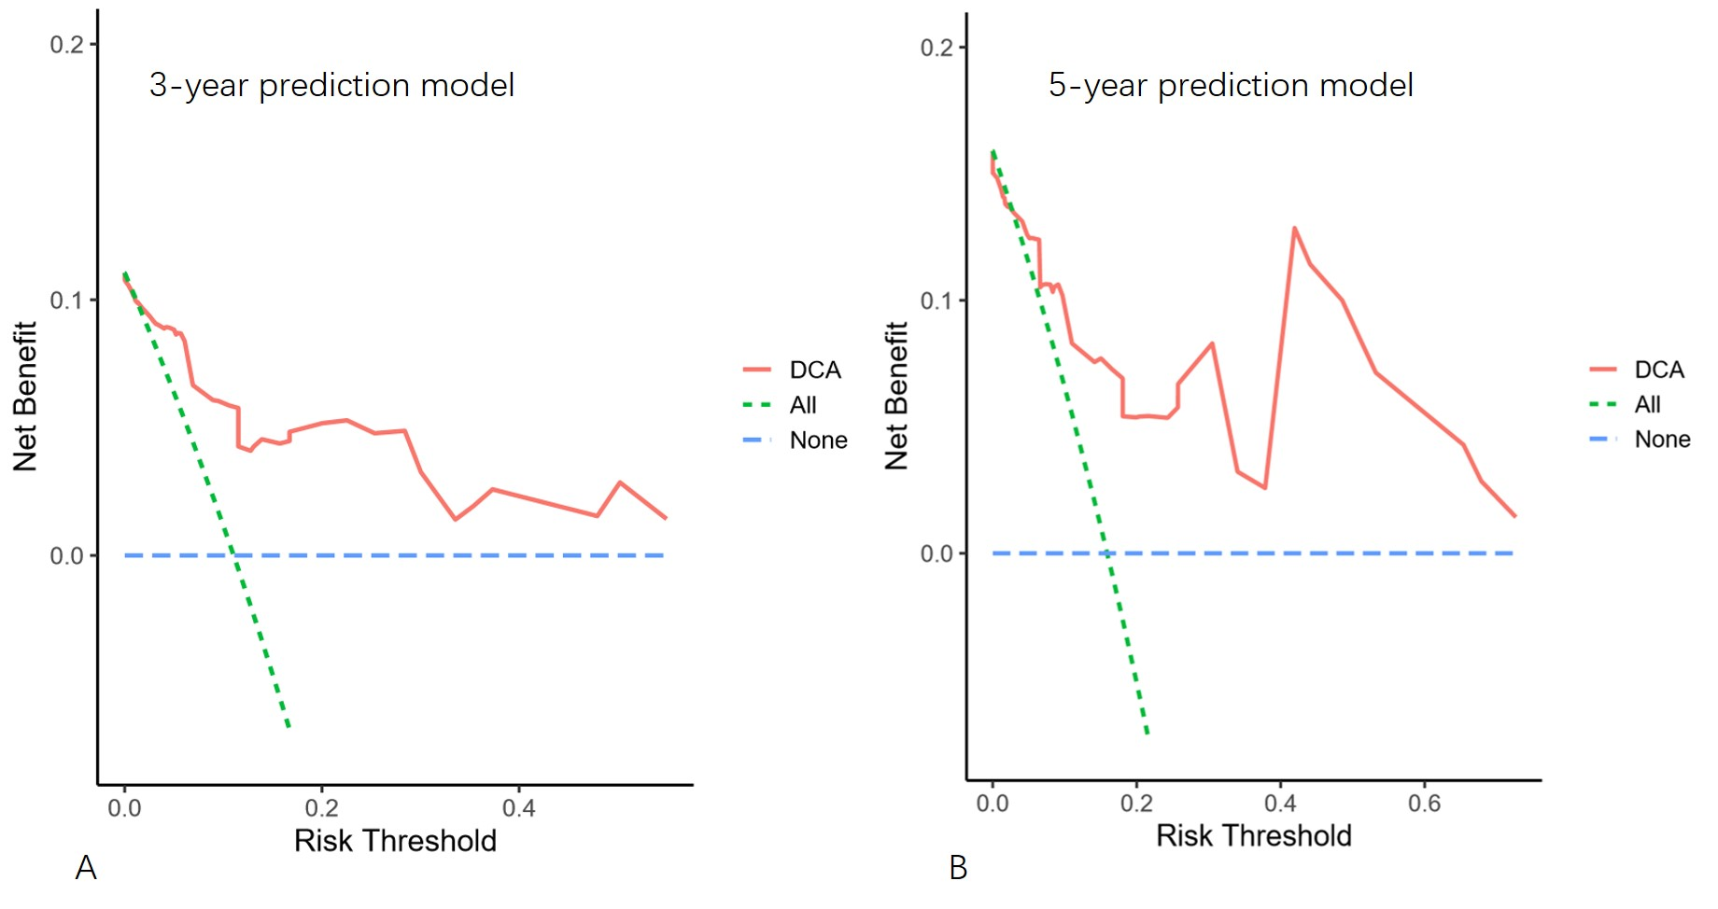
Supplementary Fig 1 Decision curve analysis for the nomogram model in the training cohort. (A) 3-year LRFS; (B) 5-year LRFS.

