Supplementary Information - Protocol for the production of micro- and nanoplastic test materials

Luke A. Parker¹, Elena M. Höppener¹, Edward F. van Amelrooij¹, Sieger Henke¹, Ingeborg Kooter¹, Kalouda Grigoriadi², Merel Nooijens², Andrea M. Brunner¹ and Arjen Boersma ^{2,}*

¹ TNO, Princetonlaan 6-8, 3584 CB Utrecht; luke.parker@tno.nl; elena.hoppener@tno.nl; Edward.vanamelrooij@tno.nl; sieger.henke@tno.nl; ingeborg.kooter@tno.nl; andrea brunner@tno.nl;
² TNO, HTC 25, 5656 AE Eindhoven; louda.grigoriadi@tno.nl; merel.nooijens@tno.nl;
* Correspondence: arjen.boersma@tno.nl;

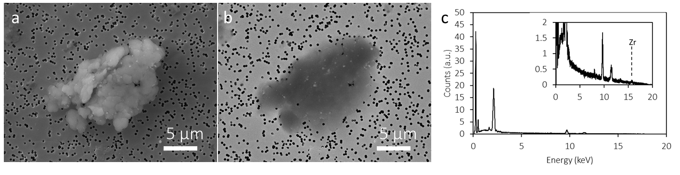
Figure S1. Secondary electron (SE) (a) and back scattered electron (BSE) (b) images of PVC 1-5 µm particle with Zr contamination present as white spots in the BSE image. EDX of the particles (c) shows the Zr Kα peak at 15.744 keV. The larger Zr Lα peak at 2.042 keV is obscured by the Au M peak at 2.120 keV present due to filter material.

