Mixed chimaerism is associated with poorer long-term failure-free survival among aplastic anaemia patients receiving HLA-matched donor transplantation
Authors: Zheng-Li Xu^{1,2#}, Lan-Ping Xu^{1,2#}, Yuan-Yuan Zhang^{1,2}, Yi-Fei Cheng^{1,2}, Xiao-Dong Mo^{1,2}, Ting-Ting Han^{1,2}, Feng-Rong Wang^{1,2}, Chen-Hua Yan^{1,2}, Yu-Qian Sun^{1,2}, Yu-Hong Chen^{1,2}, Fei-Fei Tang^{1,2}, Wei Han^{1,2}, Yu Wang^{1,2}, Xiao-Hui Zhang^{1,2}, Kai-Yan Liu^{1,2}, Xiao-Jun Huang^{1-4 *}

Figure 1. The overall survival outcomes between mixed chimerism and donor chimerism (80.0±8.9% vs. 88.9±3.5%, P = 0.327).

Figure 2. The incidence of grade II-IV aGvHD between mixed chimerism and donor chimerism (0% vs. 9.6±0.1%, P = 0.151).
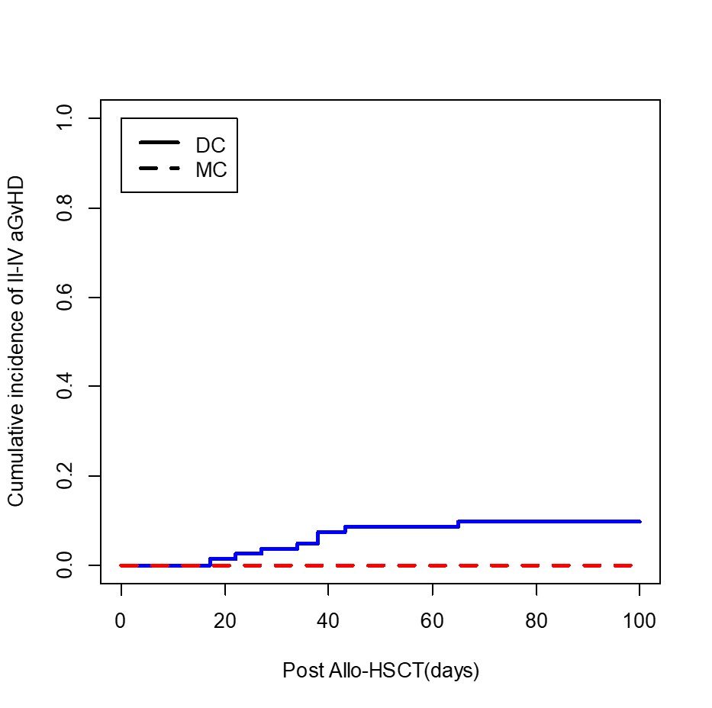
Figure 3. The incidence of chronic GvHD between mixed chimerism and donor chimerism (0% vs. 6.3±0.1%, P = 0.251).
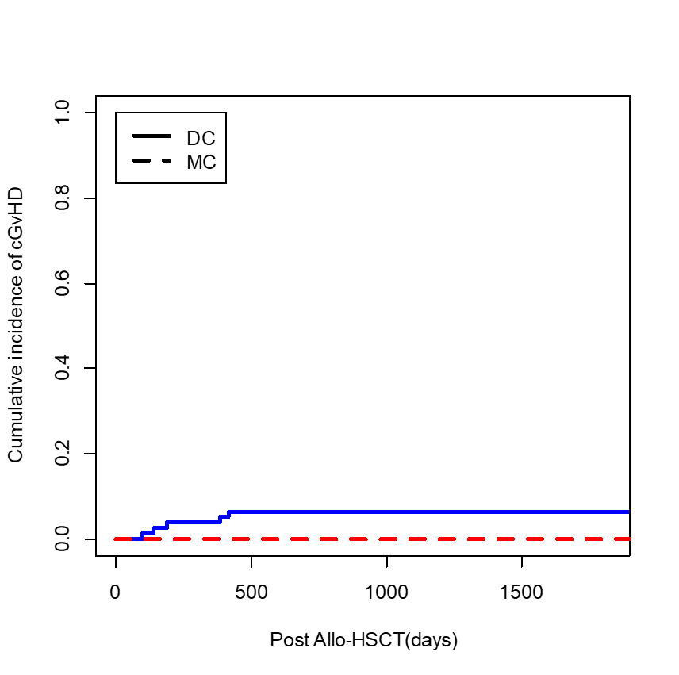

Figure 4. The incidence of mixed chimerism between MRD and MUD transplantation (17.8 ± 0.2% and 25.0 ± 0.8%, P = 0.432).
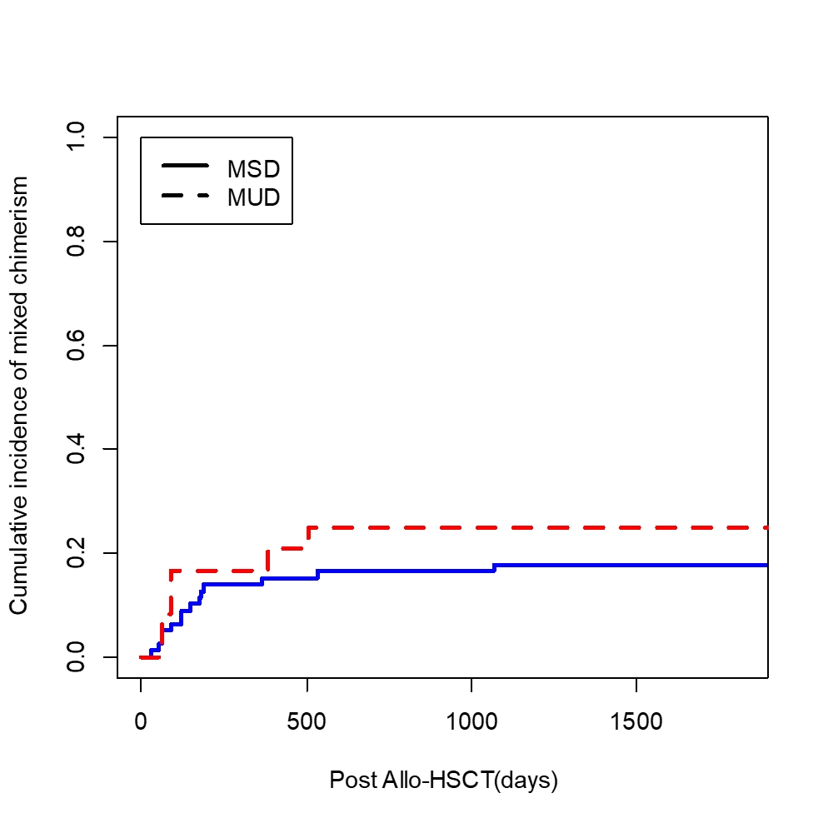

Figure 5. The overall survival outcomes based on predictive model (85.4±4.8%, 89.7±4.9% and 87.5±11.7% in low, int, high risk groups, P = 0.837).

