The synergistic response of primary production in grasslands to combined nitrogen and phosphorus addition is caused by increased nutrient uptake and retention
Eduardo Vázquez^{1,2}, Elizabeth T. Borer³, Miguel N. Bugalho⁴, Maria C. Caldeira⁵, Rebecca L. McCulley⁶, Anita C. Risch⁷, Eric W. Seabloom³, George R. Wheeler⁸, Marie Spohn^{1,2}
¹Department of Soil and Environment, Swedish University of Agricultural Sciences (SLU), Lennart Hjelms väg 9, 75007 Uppsala, Sweden
²Department of Soil Ecology, Bayreuth Center of Ecology and Environmental Research (BayCEER), University of Bayreuth, Dr.-Hans-Frisch-Straße 1-3, 95448, Bayreuth, Germany
³University of Minnesota, Dept of Ecology, Evolution, and Behavior, 140 Gortner Laboratory, 1479 Gortner Ave, Saint Paul, MN 55108, USA
⁴Centre for Applied Ecology “Prof. Baeta Neves” (CEABN-InBIO), School of Agriculture, University of Lisbon, Tapada da Ajuda 1349-017, Lisbon, Portugal
⁵Forest Research Centre, School of Agriculture, University of Lisbon, 1349-017, Lisbon, Portugal
⁶Dept of Plant & Soil Sciences, University of Kentucky, Lexington, KY 40546-0312, USA
⁷Swiss Federal Institute for Forest, Snow and Landscape Research WSL, Community Ecology, Zuercherstrasse 111, 8903 Birmensdorf, Switzerland
⁸School of Biological Sciences, University of Nebraska, Lincoln, NE, 68588-0118, USA
Corresponding author:
Eduardo Vázquez.
Department of Soil and Environment, Swedish University of Agricultural Sciences (SLU), Lennart Hjelms väg 9, 75007 Uppsala, Sweden
Email: eduardo.vazquez.garcia@slu.se
ORCID: 0000-0003-4662-1921

GRAPHICAL ABSTRACT
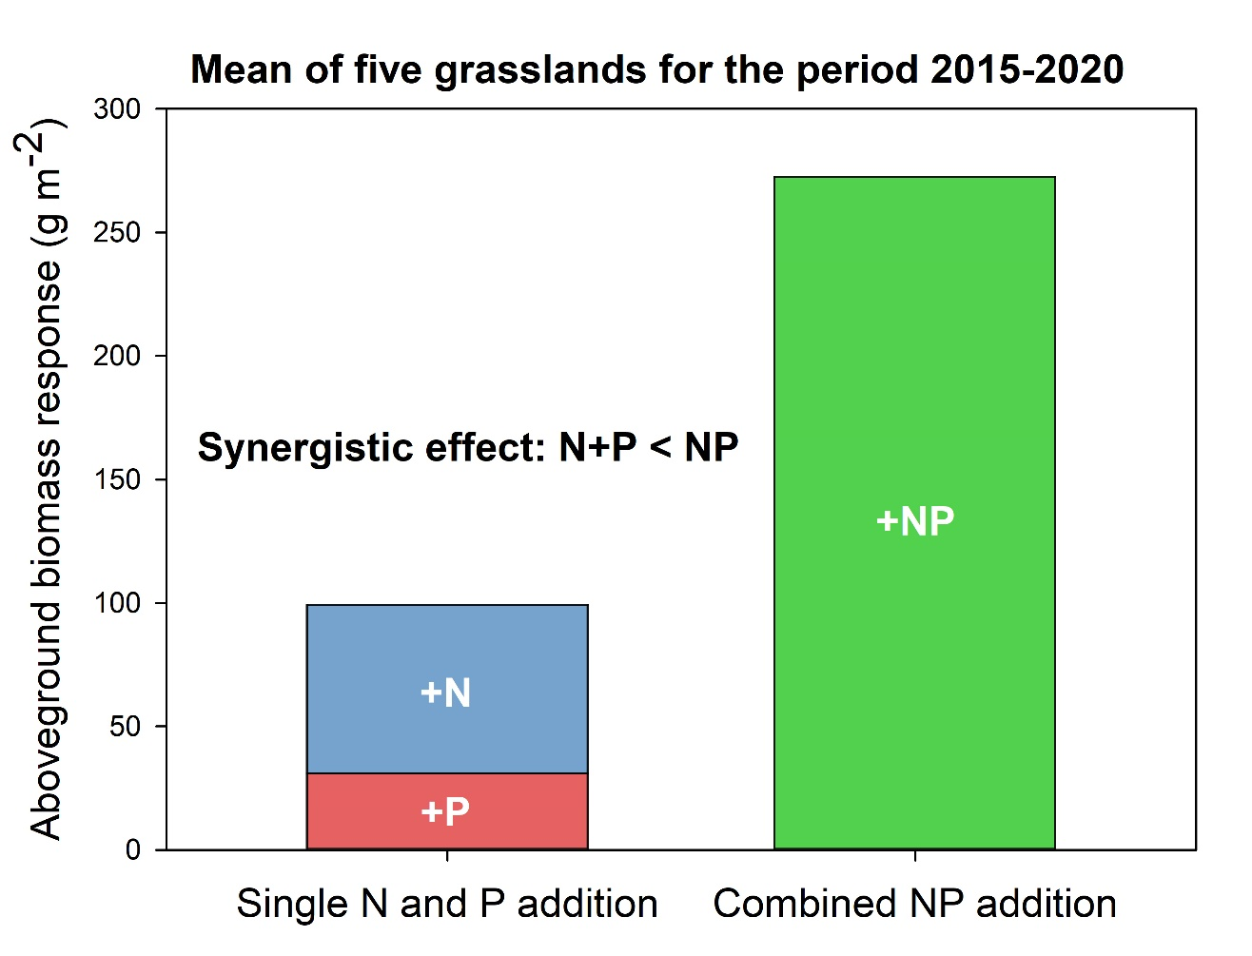

Supplement
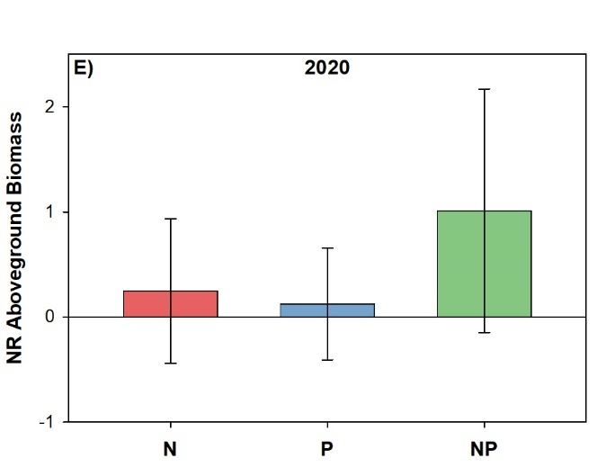
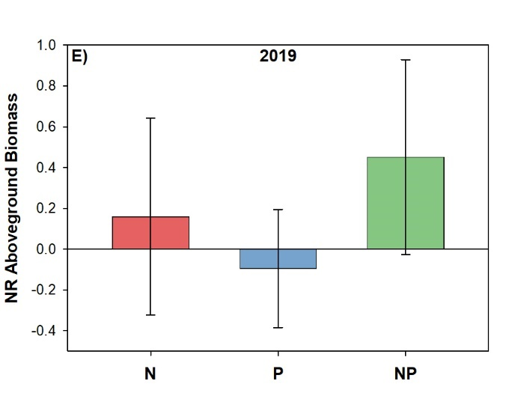
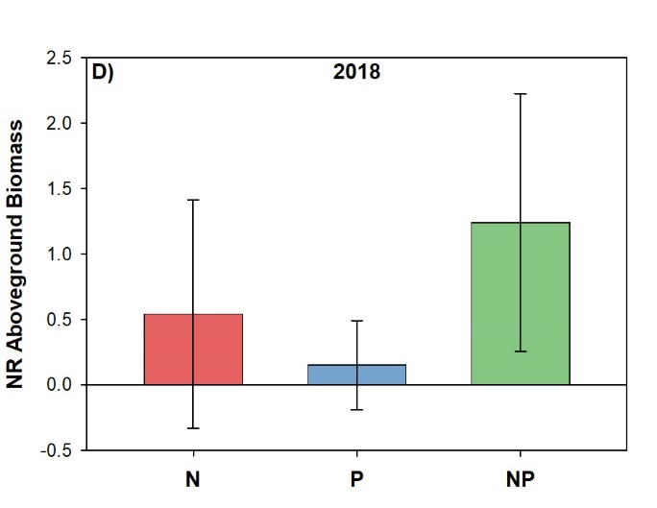
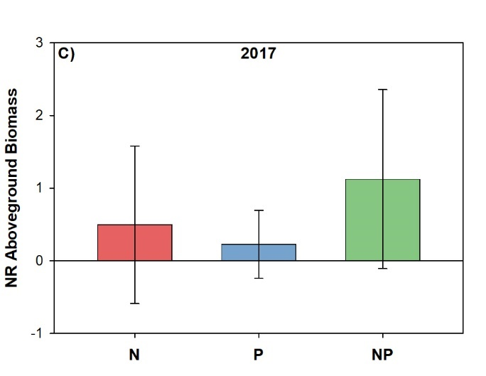
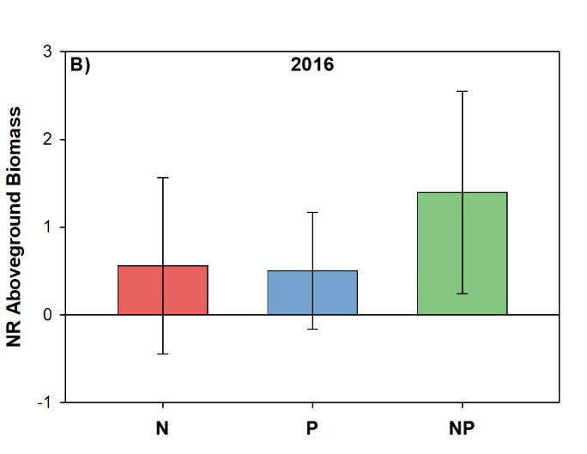
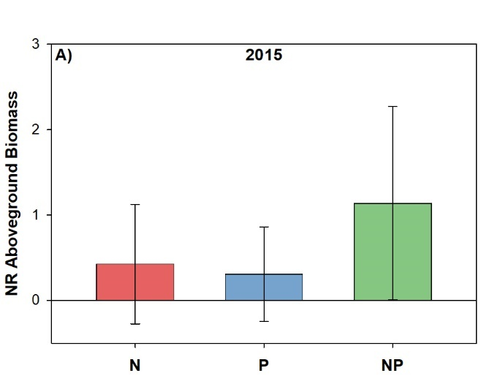
Figure S1: Normalized response (NR) of aboveground biomass to nitrogen (N), phosphorus (P) and their combined addition (NP) for each season in the period between 2015 and 2020 across all five sites (n = 15). The normalized response was calculated dividing values of the treatments (N, P or NP) by the value of the control and subtracting 1. Columns show means, and error bars indicate standard deviations.

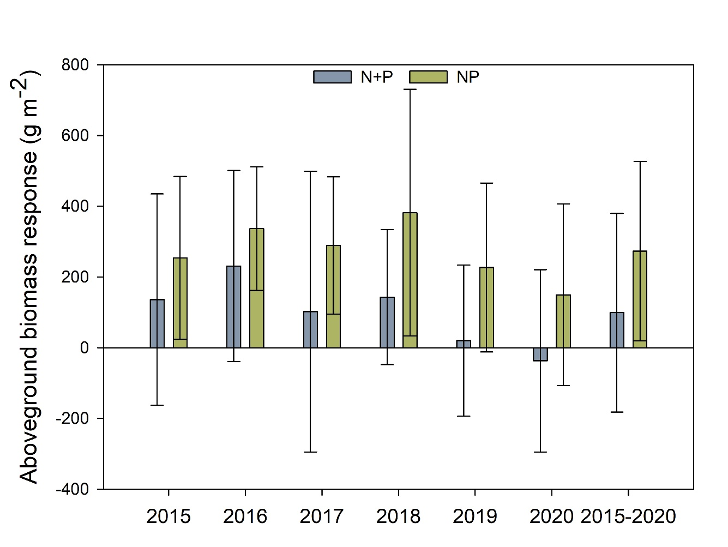
Figure S2: Response of aboveground biomass to separate nitrogen (N) and phosphorus (P) addition (N+P) and to combined NP addition (NP) for each season in the period between 2015 and 2020 and the mean value of the 2015-2020 period across all five sites. N+P was calculated as the sum of aboveground biomass response to single N and to single P addition, and NP was calculated as the aboveground biomass response to combined NP addition. Bars show means (n = 15) with standard deviations, 2015-2020 (n = 90).

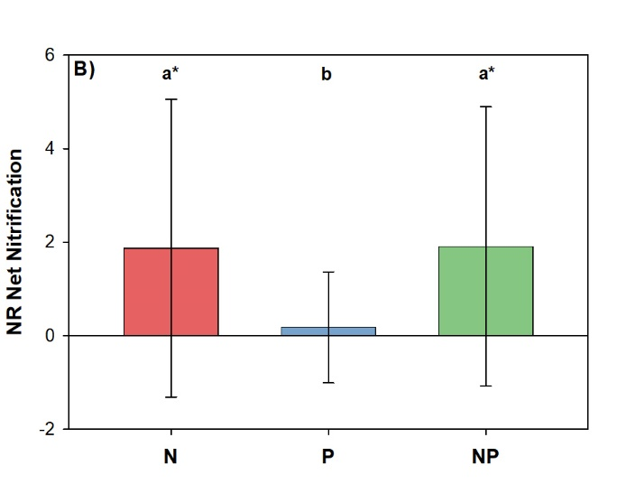
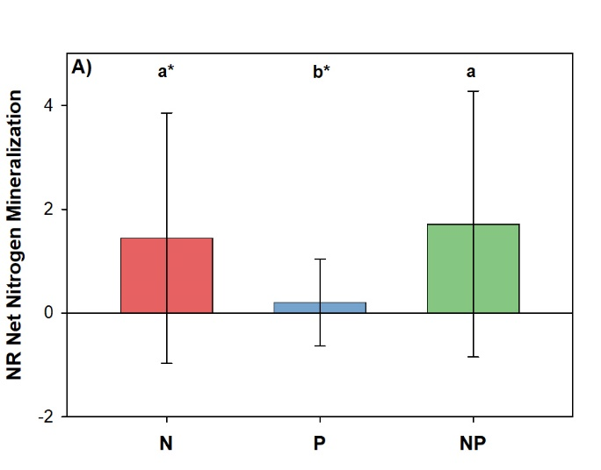
Figure S3: Normalized response (NR) of net nitrogen mineralization (A) and net nitrification (C) of soil samples (0 - 15 cm) to nitrogen (N), phosphorus (P) and their combined addition (NP) across all five sites (n = 15). The normalized response was calculated dividing values of the treatments (N, P or NP) by the value of the control and subtracting 1. Columns show means, and error bars indicate standard deviations.. Significant differences (p < 0.05) among element addition treatments (N, P and NP) are indicated by different letters, and among element addition treatments and control (Ctrl = 0) by an asterisk (*). Prior to analysis, all variables were log transformed

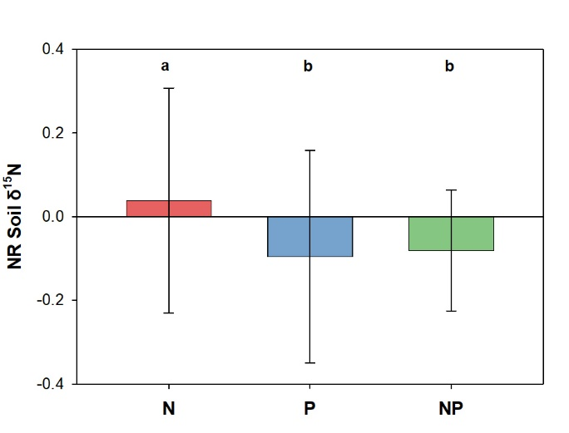
Figure S4: Normalized response (NR) of soil δ¹⁵N of the six NutNet sites including Schleuss et al. (2021) (n = 18) to nitrogen (N), phosphorus (P) and their combined addition (NP). The response ratio were calculated dividing the treatment (N, P or NP) by the control. The normalized response was calculated dividing values of the treatments (N, P or NP) by the value of the control and subtracting 1. Columns show means, and error bars indicate standard deviations. Significant differences (p < 0.05) among element addition treatments (N, P and NP) are indicated by different letters, and among element addition treatments and control (Ctrl = 0) by an asterisk (*). Prior to analysis, all variables were log transformed.

Table S1: Aboveground biomass, belowground biomass and total biomass (the sum of above- and belowground biomass) and the proportion of biomass belowground (the proportion of the total biomass allocated belowground) at each site (n = 3) and the mean across the five sites (n=15) for the sampling in 2020. In addition, the mean aboveground biomass for the period 2015 – 2020 at each site and across the five sites is presented. Mean ± standard deviation.
Site |  | Aboveground biomass | Belowground  biomass | Total  biomass | Proportion biomass belowground | Aboveground biomass 2015-2020
 |  | g m⁻² |  |  |  | g m⁻²
Konza.us | Ctrl | 440 ± 31 | 766 ± 277 | 1206 ± 296 | 0.62 ± 0.07 | 612 ± 256
 | N | 386 ± 57 | 136 ± 62 | 521 ± 109 | 0.25 ± 0.07 | 653 ± 187
 | P | 461 ± 76 | 625 ± 253 | 1086 ± 206 | 0.56 ± 0.13 | 670 ± 302
 | NP | 692 ± 225 | 418 ± 72 | 1110 ± 159 | 0.39 ± 0.11 | 889 ± 257
Spin.us | Ctrl | 762 ± 174 | 237 ± 118 | 999 ± 113 | 0.24 ± 0.12 | 539 ± 183
 | N | 663 ± 210 | 78 ± 22 | 741 ± 201 | 0.11 ± 0.05 | 641 ± 99
 | P | 487 ± 226 | 114 ± 48 | 600 ± 251 | 0.20 ± 0.08 | 555 ± 122
 | NP | 667 ± 116 | 108 ± 16 | 775 ± 120 | 0.14 ± 0.03 | 832 ± 151
Cdpt.us | Ctrl | 151 ± 137 | 996 ± 410 | 1147 ± 307 | 0.85 ± 0.15 | 179 ± 40
 | N | 159 ± 42 | 789 ± 501 | 949 ± 543 | 0.81 ± 0.05 | 294 ± 70
 | P | 187 ± 110 | 455 ± 75 | 643 ± 144 | 0.72 ± 0.11 | 211 ± 50
 | NP | 175 ± 101 | 828 ± 412 | 1003 ± 421 | 0.82 ± 0.10 | 340 ± 96
Comp.pt | Ctrl | 332 ± 67 | 317 ± 140 | 650 ± 136 | 0.48 ± 0.14 | 312 ± 137
 | N | 448 ± 176 | 193 ± 79 | 641 ± 255 | 0.30 ± 0.01 | 390 ± 141
 | P | 347 ± 102 | 178 ± 15 | 525 ± 108 | 0.35 ± 0.06 | 317 ± 118
 | NP | 803 ± 123 | 208 ± 109 | 1011 ± 144 | 0.20 ± 0.09 | 796 ± 348
Valm.ch | Ctrl | 79 ± 48 | 3210 ± 1456 | 3289 ± 1501 | 0.98 ± 0.01 | 215 ± 99
 | N | 109 ± 83 | 3627 ± 1662 | 3736 ± 1745 | 0.97 ± 0.01 | 219 ± 86
 | P | 93 ± 51 | 3565 ± 1818 | 3658 ± 1769 | 0.96 ± 0.04 | 238 ± 108
 | NP | 206 ± 108 | 5084 ± 2241 | 5290 ± 2347 | 0.96 ± 0.01 | 329 ± 139
Mean | Ctrl | 353 ± 265 | 1105 ± 1270 | 1458 ± 1136 | 0.63 ± 0.29 | 377 ± 233
 | N | 353± 236 | 965 ± 1549 | 1318 ± 1443 | 0.49 ± 0.35 | 447 ± 214
 | P | 315 ± 192 | 987 ± 1516 | 1302 ± 1412 | 0.56 ± 0.29 | 404 ± 241
 | NP | 509 ± 298 | 1329 ± 2141 | 1838 ± 2007 | 0.50 ± 0.35 | 648 ± 313

Ctrl, control; N, Nitrogen addition; P, Phosphorus addition; NP, combined N and P addition.

Continent | Country | Site | Aboveground biomass 2015-2020 |  | TOC | TN | TOC:TN ratio | pH | Bray-phosphorus.
 |  |  | g m⁻² |  | g kg⁻¹ |  |  |  | mg kg⁻¹
North America | USA | Konza.us | 612 ± 256 |  | 42.3 ± 2.3 | 2.9 ± 0.1 | 14.8 ± 0.6 | 6.3 ± 0.0 | 7.7 ± 4.3
North America | USA | Spin.us | 539 ± 183 |  | 23.2 ± 0.2 | 2.5 ± 0.0 | 9.2 ± 0.0 | 6.2 ± 0.1 | 234 ± 17
North America | USA | CdPt.us | 179 ± 40 |  | 12.1 ± 1.1 | 1.0 ± 0.1 | 12.9 ± 0.4 | 6.6 ± 0.2 | 9.5 ± 1.1
Europe | Portugal | Comp.pt | 312 ± 137 |  | 11.5 ± 0.3 | 0.9 ± 0.0 | 13.2 ± 0.3 | 5.9 ± 0.1 | 8.3 ± 1.6
Europe | Switzerland | Valm.ch | 215 ± 99 |  | 71.9 ± 10 | 5.7 ± 0.4 | 12.6 ± 0.9 | 6.2 ± 0.1 | 6.6 ± 1.1
Table S2: Aboveground biomass for the period 2015-2020 in the control treatment and soil chemical properties (0-15 cm) in the control treatment.
TOC, total organic carbon, TN, total nitrogen, TOC:TN ratio, carbon to nitrogen ratio (g g⁻¹), Bray-phosphorus, extractable-Bray phosphorus. The methods used for soil analysis are described in Seabloom et al., (2021).
Seabloom, E. W., Adler, P. B., Alberti, J., Biederman, L., Buckley, Y. M., Cadotte, M. W., Collins, S. L., Dee, L., Fay, P. A., Firn, J., Hagenah, N., Harpole, W. S., Hautier, Y., Hector, A., Hobbie, S. E., Isbell, F., Knops, J. M. H., Komatsu, K. J., Laungani, R., … Borer, E. T. (2021). Increasing effects of chronic nutrient enrichment on plant diversity loss and ecosystem productivity over time. Ecology, 102(2), 1–11. https://doi.org/10.1002/ecy.3218

Table S3: Effect on plant biomass and nitrogen (N) and phosphorus (P) stocks of plant biomass for the sum of separate N and P addition (N+P) and for combined nitrogen and phosphorus addition (NP) across all five sites (n = 15). Mean ± standard deviation. The values are calculated based on the data shown in Table S1.
 | Sum of N and P treatment effect | NP treatment effect
Aboveground biomass (g m⁻²) | -38 ± 258 | 156 ± 248
Belowground biomass (g m⁻²) | -258 ± 1921 | 224 ± 1258
Total biomass (g m⁻²) | -296 ± 1959 | 380 ± 1286
Aboveground Nitrogen Stock (g N m⁻²) | 0.78 ± 6.72 | 3.67 ± 4.75
Aboveground Phosphorus Stock (g P m⁻²) | 0.12 ± 0.97 | 0.92 ± 0.96
Belowground Nitrogen Stock (g N m⁻²) | -1.06 ± 31.74 | 8.53 ± 24.66
Belowground Phosphorus Stock (g P m⁻²) | 0.87 ± 3.31 | 2.15 ± 4.42
Total Nitrogen Stock (g N m⁻²) | -0.28 ± 33.34 | 12.20 ± 26.42
Total Phosphorus Stock (g P m⁻²) | 0.99 ± 3.51 | 3.07 ± 4.61

Table S4: The effect of element addition treatments on the normalize response (NR) of the studied variables. Linear mixed models (LMM) were used considering the different element addition treatments (Ctrl, N, P, NP) as fixed factor, while site and block (nested within site) were considered as random factors. The NR of the control treatment was equal to 0. When a significant treatment effect (p < 0.05) was found, LSD post hoc test (p < 0.05) was used for comparison of means of the element addition treatments. Because NR data were not normally distributed (Shapiro-Wilk-test, p>0.05) all variables were log transformed (log₁₀ (NR+1)) prior to run the LMM analysis.
Variable | F | p | Variable | F | p
Aboveground biomass | 4.966 | 0.005 | Soil carbon concentration | 2.915 | 0.043
Belowground biomass | 3.298 | 0.029 | Soil nitrogen concentration | 3.271 | 0.030
Total biomass | 3.441 | 0.025 | Soil carbon nitrogen ratio | 0.923 | 0.438
Proportion biomass belowground | 5.476 | 0.003 | Soil pH | 19.137 | 0.000
Aboveground nitrogen concentration | 9.336 | 0.000 | Soil Bray-phosphorus | 53.306 | 0.000
Aboveground phosphorus concentration | 21.790 | 0.000 | Total organic phosphorus | 0.251 | 0.860
Belowground nitrogen concentration | 21.007 | 0.000 | Net nitrogen mineralization | 8.733 | 0.000
Belowground phosphorus concentration | 21.199 | 0.000 | Net nitrification | 5.499 | 0.003
Aboveground nitrogen stock | 11.305 | 0.000 | Soil δ¹⁵N | 2.908 | 0.046
Aboveground phosphorus stock | 13.173 | 0.000
Belowground nitrogen stock | 4.176 | 0.011
Belowground phosphorus stock | 11.810 | 0.000
Total nitrogen stock | 5.968 | 0.002
Total phosphorus stock | 16.570 | 0.000

Table S5: Normalized response (NR) of nitrogen and phosphorus concentrations of aboveground and belowground plant biomass to nitrogen (N), phosphorus (P) and their combined addition (NP) across all five sites (n = 15). The normalized response was calculated dividing values of the treatment (N, P or NP) by the values of the control and subtracting 1. Mean with standard deviations. Significant differences (p < 0.05) among element addition treatments (N, P and NP) are indicated by different letters, and among element addition treatments and control (Ctrl = 0) by an asterisk (*). Prior to analysis, all variables were log transformed.
 | Normalized response
 | N | P | NP
Aboveground nitrogen concentration | 0.60^{a*} ± 0.52 | 0.15^{b} ± 0.54 | 0.54^{a*} ± 0.55
Aboveground phosphorus concentration | -0.04^{b} ± 0.30 | 1.21^{a*} ± 1.39 | 1.27^{a*} ± 1.21
Belowground nitrogen concentration | 0.34^{a*} ± 0.83 | -0.06^{b} ± 0.57 | 0.49^{a*} ± 0.84
Belowground phosphorus concentration | -0.08^{b} ± 0.05 | 0.01^{a*} ± 0.10 | 0.25^{a*} ± 0.28

Table S6: Nitrogen and phosphorus concentration of above- and belowground plant biomass and nitrogen and phosphorus stocks of aboveground, belowground and total biomass (the sum of above- and belowground biomass) at each site (n = 3) and the mean across the five sites (n=15). Mean ± standard deviation.
 |  | Aboveground  nitrogen  concentration | Aboveground  phosphorus  concentration | Belowground  nitrogen  concentration | Belowground  phosphorus  concentration |  | Aboveground  Nitrogen  Stock | Aboveground  Phosphorus  stock | Belowground  Nitrogen  stock |  | Belowground  Phosphorus  stock |  | Total  Nitrogen stock |  | Total Phosphorus stock
 |  | g kg⁻¹ |  |  |  |  | g m⁻²
Konza.us | Ctrl | 5.1 ± 1.0 | 0.53 ± 0.13 | 6.7 ± 1.5 | 0.70 ± 0.12 |  | 2.24 ± 0.47 | 0.23 ± 0.05 | 5.06 ± 1.68 | 0.51 ± 0.10 |  | 7.30 ± 2.03 |  | 0.74 ± 0.13
 | N | 10 8 ± 1.9 | 0.61 ± 0.12 | 11.6 ± 1.3 | 0.49 ± 0.03 |  | 4.12 ± 0.54 | 0.24 ± 0.07 | 1.60 ± 0.87 | 0.07 ± 0.03 |  | 5.72 ± 0.65 |  | 0.30 ± 0.07
 | P | 6.2 ± 0.7 | 1.77 ± 0.65 | 6.6 ± 1.2 | 1.03 ± 0.07 |  | 2.83 ± 0.32 | 0.80 ± 0.25 | 4.28 ± 2.30 | 0.63 ± 0.21 |  | 7.12 ± 1.98 |  | 1.43 ± 0.19
 | NP | 12.0 ± 5.0 | 1.92 ± 0.33 | 15.1 ± 0.8 | 1.58 ± 0.33 |  | 8.90 ± 5.94 | 1.37 ± 0.64 | 6.31 ± 0.96 | 0.65 ± 0.03 |  | 15.20 ± 5.00 |  | 2.01 ± 0.66
Spin.us | Ctrl | 20.1 ± 2.4 | 4.22 ± 0.21 | 10.2 ± 0.7 | 1.87 ± 0.20 |  | 15.57 ± 5.54 | 3.24 ± 0.87 | 2.36 ± 1.05 | 0.43 ± 0.18 |  | 17.94 ± 4.74 |  | 3.66 ± 0.75
 | N | 25.1 ± 5.6 | 4.44 ± 0.32 | 13.3 ± 1.0 | 2.31 ± 0.29 |  | 15.88 ± 1.16 | 2.93 ± 0.87 | 1.05 ± 0.35 | 0.18 ± 0.06 |  | 16.93 ± 0.86 |  | 3.11 ± 0.84
 | P | 17.0 ± 1.0 | 4.56 ± 0.61 | 9.8 ± 1.2 | 1.86 ± 0.34 |  | 8.29 ± 3.97 | 2.20 ± 1.02 | 1.08 ± 0.35 | 0.20 ± 0.04 |  | 9.37 ± 4.15 |  | 2.40 ± 1.06
 | NP | 21.5 ± 1.7 | 4.86 ± 0.55 | 15.0 ± 1.8 | 2.49 ± 0.64 |  | 14.25 ± 1.53 | 3.29 ± 0.90 | 1.60 ± 0.10 | 0.26 ± 0.05 |  | 15.85 ± 1.48 |  | 3.55 ± 0.95
Cdpt.us | Ctrl | 12.2 ± 1.2 | 1.86 ± 0.14 | 10.0 ± 2.4 | 0.73 ± 0.25 |  | 1.89 ± 1.75 | 0.28 ± 0.24 | 9.98 ± 4.41 | 0.69 ± 0.23 |  | 11.87 ± 2.68 |  | 0.97 ± 0.11
 | N | 20 4 ± 11.0 | 1.68 ± 0.92 | 11.7 ± 1.0 | 0.57 ± 0.18 |  | 3.25 ± 1.68 | 0.27 ± 0.15 | 8.91 ± 4.84 | 0.40 ± 0.15 |  | 12.15 ± 5.81 |  | 0.67 ± 0.29
 | P | 12.0 ± 5.0 | 2.31 ± 0.46 | 9.8 ± 0.4 | 0.94 ± 0.07 |  | 2.20 ± 1.35 | 0.46 ± 0.35 | 4.45 ± 0.76 | 0.42 ± 0.04 |  | 6.65 ± 1.17 |  | 0.88 ± 0.37
 | NP | 14.3 ± 1.5 | 1.78 ± 0.16 | 10.0 ± 1.3 | 1.33 ± 1.01 |  | 2.51 ± 1.56 | 0.32 ± 0.20 | 8.39 ± 4.86 | 0.91 ± 0.40 |  | 10.90 ± 4.59 |  | 1.23 ± 0.20
Comp.pt | Ctrl | 9.2 ± 1.7 | 1.82 ± 0.30 | 12.1 ± 2.0 | 0.98 ± 0.24 |  | 3.01 ± 0.53 | 0.60 ± 0.08 | 3.65 ± 1.05 | 0.29 ± 0.09 |  | 6.66 ± 1.44 |  | 0.89 ± 0.12
 | N | 12.1 ± 4.3 | 1.20 ± 0.20 | 15.5 ± 0.9 | 0.79 ± 0.04 |  | 5.43 ± 2.43 | 0.54 ± 0.23 | 3.00 ± 1.29 | 0.15 ± 0.07 |  | 8.43 ± 3.35 |  | 0.70 ± 0.30
 | P | 16.1 ± 3.7 | 4.56 ± 0.43 | 10.2 ± 2.2 | 1.96 ± 0.37 |  | 5.81 ± 3.00 | 1.56 ± 0.29 | 1.83 ± 0.47 | 0.35 ± 0.05 |  | 7.64 ± 3.25 |  | 1.90 ± 0.25
 | NP | 12.8 ± 3.2 | 3.71 ± 0.74 | 15.6 ± 0.4 | 1.94 ± 0.31 |  | 10.24 ±2.59 | 2.94 ± 0.51 | 3.22 ± 1.61 | 0.39 ± 0.15 |  | 13.46 ± 4.06 |  | 3.33 ± 0.64
Valm.ch | Ctrl | 19.4 ± 4.4 | 1.72 ± 0.18 | 14.9 ± 1.5 | 0.94 ± 0.18 |  | 1.61 ± 1.27 | 0.14 ± 0.09 | 48.75 ± 25.92 | 2.84 ± 0.65 |  | 50.35 ± 27.16 |  | 2.97 ± 0.73
 | N | 30.6 ± 5.8 | 1.75 ± 0.82 | 16.6 ± 2.0 | 0.91 ± 0.21 |  | 3.27 ± 2.67 | 0.15 ± 0.08 | 58.67 ± 24.80 | 3.29 ± 1.86 |  | 61.94 ± 27.44 |  | 3.45 ± 1.95
 | P | 15.4 ± 1.7 | 4.21 ± 0.87 | 13.4 ± 2.7 | 2.34 ± 0.25 |  | 1.46 ± 0.90 | 0.39 ± 0.25 | 49.43 ± 32.35 | 8.16 ± 4.02 |  | 50.89 ± 31.48 |  | 8.55 ± 3.78
 | NP | 32.9 ± 2.5 | 5.99 ± 0.92 | 18.4 ± 0.7 | 2.85 ± 0.80 |  | 6.77 ± 3.39 | 1.17 ± 0.46 | 92.96 ± 39.33 | 13.29 ± 2.85 |  | 99.73 ± 42.70 |  | 14.46 ± 3.30
Mean | Ctrl | 13.2 ± 6.4 | 2.03 ± 1.26 | 10.8 ± 3.1 | 1.04 ± 0.48 |  | 4.86 ± 6.01 | 0.89 ± 1.27 | 13.96 ± 20.75 | 0.95 ± 1.02 |  | 18.82 ± 19.85 |  | 1.85 ± 1.33
 | N | 19.8 ± 9.5 | 1.94 ± 1.45 | 13.7 ± 2.3 | 1.01 ± 0.71 |  | 6.39 ± 5.23 | 0.83 ± 1.15 | 14.65 ± 24.88 | 0.82 ± 1.47 |  | 21.04 ± 24.03 |  | 1.65 ± 1.61
 | P | 13.3 ± 4.8 | 3.48 ± 1.35 | 10.0 ± 2.7 | 1.63 ± 0.61 |  | 4.12 ± 3.30 | 1.08 ± 0.85 | 12.21 ± 22.88 | 1.95 ± 3.56 |  | 16.33 ± 21.61 |  | 3.03 ± 3.26
 | NP | 18.7 ± 8.5 | 3.65 ± 1.77 | 14.8 ± 3.0 | 2.04 ± 0.82 |  | 8.53 ± 4.94 | 1.82 ± 1.26 | 22.50 ± 39.51 | 3.10 ± 5.39 |  | 31.03 ± 39.21 |  | 4.92 ± 5.20

Ctrl, control; N, Nitrogen addition; P, Phosphorus addition; NP, combined N and P addition.
Table S7: Normalized response of carbon to nitrogen ratio, pH, extractable-Bray phosphorus and total organic phosphorus in the soil (0 - 15 cm) to nitrogen (N), phosphorus (P) and their combined addition (NP) across all five sites (n = 15). The normalized response was calculated dividing values of the treatment (N, P or NP) by the values of the control and subtracting 1. Mean with standard deviations. Significant differences (p < 0.05) among element addition treatments (N, P and NP) are indicated by different letters, and among element addition treatments and control (Ctrl = 0) by an asterisk (*). Prior to analysis, all variables were log transformed.
 | Normalized response
 | N | P | NP
Carbon:nitrogen ratio | -0.02ª ± 0.07 | 0.00ª ± 0.09 | -0.01ª ± 0.06
pH | -0.66^{b*} ± 0.06 | 0.02^{a*} ± 0.04 | -0.46^{b*} ± 0.05
Bray-phosphorus | -0.07^{b} ± 0.51 | 15.33^{a*} ± 16.51 | 14.63^{a*} ± 15.96
Total organic phosphorus | -0.08ª ± 0.05 | 0.01ª ± 0.10 | 0.25ª ± 0.28

Table S8: Total organic carbon (TOC), total nitrogen (TN), carbon to nitrogen ratio (g g⁻¹) (TOC : TN ratio), pH, soil δ¹⁵N, Bray-extractable phosphorus (Bray-phosphorus) and total organic phosphorus (TOP) in 0-15 cm soil depth at each site (n = 3) and the mean across the five sites (n=15). Mean ± standard deviation.
Site |  | TOC | TN | TOC : TN | pH | δ¹⁵N | Bray-phosphorus | TOP
 |  | g kg⁻¹ |  | ratio |  | ‰ | mg kg⁻¹ | g kg⁻¹
Konza.us | Ctrl | 42.2 ± 3.9 | 2.9 ± 0.2 | 14.8 ± 1.1 | 6.3 ± 0.1 | 4.53 ± 0.18 | 7.6 ± 7.4 | 3.13 ± 0.45
 | N | 37.2 ± 4.1 | 2.8 ± 0.3 | 13.4 ± 0.2 | 5.8 ± 0.2 | 4.86 ± 0.49 | 3.2 ± 1.2 | 2.63 ± 0.40
 | P | 39.5 ± 6.4 | 2.9 ± 0.7 | 14.0 ± 1.3 | 6.4 ± 0.1 | 4.53 ± 0.43 | 113.4 ± 12.5 | 3.34 ± 1.16
 | NP | 38.5 ± 2.4 | 2.9 ± 0.2 | 13.7 ± 0.1 | 6.2 ± 0.1 | 4.54 ± 0.28 | 107.1 ± 38.6 | 2.90 ± 0.27
Spin.us | Ctrl | 23.2 ± 0.3 | 2.5 ± 0.0 | 9.2 ± 0.1 | 6.2 ± 0.1 | 3.84 ± 0.15 | 234.3 ± 29 | 2.51 ± 1.46
 | N | 23.2 ± 0.6 | 2.6 ± 0.0 | 9.0 ± 0.1 | 6.0 ± 0.1 | 4.49 ± 0.17 | 219.8 ± 8 | 2.06 ± 0.50
 | P | 22.7 ± 1.4 | 2.5 ± 0.1 | 9.0 ± 0.3 | 6.2 ± 0.0 | 4.09 ± 0.13 | 364.5 ± 20 | 3.67 ± 2.06
 | NP | 25.3 ± 1.0 | 2.7 ± 0.1 | 9.2 ± 0.1 | 5.9 ± 0.1 | 4.00 ± 0.26 | 344.5 ± 32 | 3.36 ± 1.72
Cdpt.us | Ctrl | 12.1 ± 1.8 | 1.0 ± 0.2 | 12.9 ± 0.8 | 6.5 ± 0.4 | 2.66 ± 0.48 | 9.5 ± 2.0 | 1.33 ± 0.19
 | N | 14.9 ± 2.6 | 1.1 ± 0.2 | 13.5 ± 0.6 | 5.4 ± 0.5 | 3.80 ± 0.31 | 16.1 ± 8.2 | 1.20 ± 0.19
 | P | 14.1 ± 1.6 | 1.0 ± 0.1 | 13.7 ± 0.1 | 6.2 ± 0.1 | 4.22 ± 0.97 | 76.5 ± 1.6 | 1.40 ± 0.03
 | NP | 15.3 ± 1.5 | 1.1 ± 0.2 | 13.7 ± 0.7 | 5.8 ± 0.0 | 4.36 ± 0.25 | 76.0 ± 4.2 | 2.79 ± 2.58
Comp.pt | Ctrl | 11.5 ± 0.5 | 0.9 ± 0.1 | 13.2 ± 0.5 | 5.9 ± 0.2 | 2.03 ± 0.82 | 8.3 ± 2.8 | 0.70 ± 0.10
 | N | 11.6 ± 2.9 | 0.9 ± 0.2 | 13.0 ± 0.2 | 5.5 ± 0.3 | 2.65 ± 0.40 | 4.0 ± 1.5 | 0.61 ± 0.06
 | P | 10.7 ± 2.0 | 0.8 ± 0.2 | 13.7 ± 0.5 | 5.6 ± 0.2 | 2.56 ± 0.63 | 57.9 ± 12.7 | 0.63 ± 0.10
 | NP | 12.8 ± 0.5 | 1.0 ± 0.1 | 12.9 ± 0.7 | 5.4 ± 0.1 | 2.00 ± 0.26 | 69.2 ± 10.8 | 0.55 ± 0.09
Valm.ch | Ctrl | 71.9 ± 18.1 | 5.7 ± 0.7 | 12.5 ± 1.5 | 6.2 ± 0.2 | 1.26 ± 0.54 | 6.6 ± 1.9 | 5.07 ± 1.02
 | N | 89.3 ± 32.8 | 7.2 ± 2.3 | 12.2 ± 0.7 | 5.4 ± 0.2 | 1.95 ± 0.83 | 6.0 ± 0.7 | 5.23 ± 1.61
 | P | 63.6 ± 22.5 | 5.2 ± 1.8 | 12.3 ± 0.2 | 5.9 ± 0.2 | 1.75 ± 1.35 | 256.3 ± 59.3 | 2.69 ± 1.22
 | NP | 112 ± 57.0 | 9.0 ± 4.2 | 12.4 ± 0.4 | 5.7 ± 0.2 | 0.79 ± 0.54 | 261.4 ± 138.2 | 3.24 ± 1.26
Mean | Ctrl | 32.2 ± 24.6 | 2.6 ± 1.8 | 12.5 ± 2.0 | 6.2 ± 0.3 | 2.86 ± 1.30 | 53.3 ± 94.4 | 2.55 ± 1.72
 | N | 35.2 ± 32.0 | 2.9 ± 2.5 | 12.2 ± 1.8 | 5.6 ± 0.3 | 3.55 ± 1.21 | 49.8 ± 88.2 | 2.35 ± 1.78
 | P | 30.1 ± 22.0 | 2.5 ± 1.8 | 12.5 ± 2.0 | 6.0 ± 0.3 | 3.43 ± 1.32 | 173.7 ± 124.7 | 2.35 ± 1.57
 | NP | 40.9 ± 43.9 | 3.3 ± 3.4 | 12.4 ± 1.8 | 5.7 ± 0.3 | 3.14 ± 1.56 | 171.7 ± 127.8 | 2.57 ± 1.66
Ctrl, control; N, Nitrogen addition; P, Phosphorus addition; NP, combined N and P addition.

 |  | Net
Site |  | N mineralization | Nitrification
 |  | mg N kg⁻¹ day⁻¹
Konza.us | Ctrl | 0.09 ± 0.03 | 0.07 ± 0.01
 | N | 0.59 ± 0.13 | 0.62 ± 0.11
 | P | 0.19 ± 0.17 | 0.17 ± 0.19
 | NP | 0.55 ± 0.18 | 0.55 ± 0.17
Spin.us | Ctrl | 0.57 ± 0.02 | 0.54 ± 0.02
 | N | 0.57 ± 0.09 | 0.59 ± 0.07
 | P | 0.62 ± 0.06 | 0.62 ± 0.06
 | NP | 0.68 ± 0.14 | 0.67 ± 0.14
Cdpt.us | Ctrl | 0.52 ± 0.13 | 0.52 ± 0.13
 | N | 0.51 ± 0.10 | 0.49 ± 0.06
 | P | 0.51 ± 0.05 | 0.49 ± 0.05
 | NP | 0.67 ± 0.01 | 0.52 ± 0.24
Comp.pt | Ctrl | 0.35 ± 0.02 | 0.66 ± 0.52
 | N | 0.38 ± 0.04 | 0.48 ± 0.08
 | P | 0.35 ± 0.03 | 0.33 ± 0.07
 | NP | 0.43 ± 0.13 | 0.48 ± 0 04
Valm.ch | Ctrl | 1.85 ± 1.09 | 1.90 ± 0.93
 | N | 3.60 ± 0.80 | 4.12 ± 0.99
 | P | 1.36 ± 0.54 | 1.35 ± 0.55
 | NP | 4.85 ± 1.49 | 5.72 ± 2.85
Mean | Ctrl | 0.68 ± 0.75 | 0.74 ± 0.76
 | N | 1.13 ± 1.32 | 1.26 ± 1.53
 | P | 0.61 ± 0.47 | 0.59 ± 0.48
 | NP | 1.44 ± 1.86 | 1.59 ± 2.40
Table S9: Net N mineralization and nitrification in 0-15 cm soil depth at each site (n = 3) and the mean across the five sites (n=15). Mean ± standard deviation.

Ctrl, control; N, Nitrogen addition; P, Phosphorus addition; NP, combined N and P addition.

Soil net N mineralization and nitrification rates were determined after 28-days incubation of soil samples at 60% WHC. Two sub-samples of each soil sample (20 g dry-weight equivalent) were weighed into 250-mL PET bottles and incubated in the dark at 20°C. The first and second subsamples were extracted after 7 and 35 days of incubation, respectively, in 100 mL KCl (1 M) during 1 h of overhead shaking. The extracts were filtered (0.45 µm) and the NH₄⁺ and NO₃⁻ concentrations were measured by a flow injection analyzer (FIA-LAB, MLE Dresden, Germany). The soil net N mineralization rates were calculated according to Hart et al. (1994) based of the accumulation of inorganic N (NH₄⁺-N and NO₃⁻ -N) between day 7 and day 35 as follows:
$$Net N mineralization \left(mg N kg\text{-1} d\text{-1}\right)= \frac{\left[\left(NH\text{4}\text{+}-N\text{day35} \left(mg kg\text{-1}\right)- NH\text{4}\text{+}-N\text{day7} \left(mg kg\text{-1}\right)\right)+ \left(NO\text{3}\text{-}-N\text{day35} \left(mg kg\text{-1}\right) – NO\text{3}\text{-}-N\text{day7} \left(mg kg\text{-1}\right)\right)\right]}{28 days of incubation}$$

$$Net nitrification \left(mg N kg\text{-1} d\text{-1}\right)= \frac{\left[ \left(NO\text{3}\text{-}-N\text{day35} \left(mg kg\text{-1}\right) – NO\text{3}\text{-}-N\text{day7} \left(mg kg\text{-1}\right)\right)\right]}{28 days of incubation}$$

Table S10: Soil δ¹⁵N in 0-15 cm soil depth at each site (n = 3) and the mean of the six sites studied in Schleuss et al. (2021) (n = 18). Mean ± standard deviation.
 |  | δ¹⁵N
Site |  | (‰)
Ukul.za | Ctrl | 5.78 ± 0.21
 | N | 5.59 ± 1.30
 | P | 4.87 ± 0.67
 | NP | 5.33 ± 0.46
Summ.za | Ctrl | 6.98 ± 0.13
 | N | 6.64 ± 0.38
 | P | 6.28 ± 0.48
 | NP | 6.10 ± 0.33
Cdcr.us | Ctrl | 2.01 ± 0.46
 | N | 2.27 ± 1.28
 | P | 1.23 ± 0.77
 | NP | 1.60 ± 0.28
Cbgb.us | Ctrl | 3.33 ± 1.32
 | N | 3.59 ± 0.71
 | P | 3.69 ± 0.70
 | NP | 2.86 ± 1.01
Rook.uk | Ctrl | 4.27 ± 0.11
 | N | 4.21 ± 0.24
 | P | 3.74 ± 0.26
 | NP | 3.96 ± 0.64
Hero.uk | Ctrl | 3.86 ± 0.19
 | N | 3.94 ± 0.33
 | P | 3.72 ± 0.53
 | NP | 4.13 ± 0.19
Mean | Ctrl | 4.37 ± 1.74
 | N | 4.37 ± 1.61
 | P | 3.92 ± 1.64
 | NP | 4.00 ± 1.60

Ctrl, control; N, Nitrogen addition; P, Phosphorus addition; NP, combined N and P addition.

Table S11: Author Contributions
 | Developed and framed research questions | Data collection | Contribute to data analysis | Wrote the paper | Contributed to paper writing | Site coordinator | NutNet coordinator
Eduardo Vázquez | X | X | X | X
Elizabeth T. Borer |  |  |  |  | X |  | X
Miguel N. Bugalho |  | X |  |  | X | X
Maria C. Caldeira |  | X |  |  | X | X
Rebecca L. McCulley |  | X |  |  | X | X
Anita C. Risch |  | X |  |  | X | X
Eric W. Seabloom |  |  |  |  | X |  | X
George R. Wheeler |  | X |  |  | X | X
Marie Spohn | X |  | X | X

