APPENDIX 4
Does GPT-3 qualify as a co-author of a scientific paper publishable in peer-review journals according to the ICMJE criteria? - A Case Study

CODE:

import os
import openai

openai.api_key = os.getenv("OPENAI_API_KEY")

response = openai.Completion.create(
model="text-davinci-003",
prompt="Design a clinical trial. Choose a topic, the design and how to conduct the trial. \n\n",
temperature=0.7,
max_tokens=2000,
top_p=0.9,
best_of=5,
frequency_penalty=0.2,
presence_penalty=0.2
)

OUTPUT:

Topic: Investigating the efficacy of Vitamin D supplementation for preventing influenza. Design: A double-blind, placebo-controlled randomized clinical trial. The trial will involve a total of 300 participants aged 18 and older who have not previously been diagnosed with influenza. Half of the participants will be randomly assigned to receive a daily dose of 2,000 IU of vitamin D supplements for 12 weeks and the other half will receive a placebo. At the beginning of the trial, all participants will provide a blood sample for baseline vitamin D levels, as well as complete a survey to assess their overall health and lifestyle habits. Participants will then be given either the vitamin D supplement or placebo and instructed to take one dose per day for 12 weeks. At the end of the 12-week period, all participants will again provide a blood sample to measure their vitamin D levels and complete the same survey as before. Participants will also be asked to self-report any occurrences of influenza during the trial period. The primary outcome measure of the trial will be the incidence of influenza in both the vitamin D and placebo groups. Secondary outcome measures will include changes in vitamin D levels, quality of life scores, and overall health status. Data from the trial will be analyzed using descriptive statistics and ANOVA tests to determine if there is a statistically significant difference between the two groups in terms of influenza incidence, vitamin D levels, quality of life scores, and overall health status.

CODE:
import os
import openai

openai.api_key = os.getenv("OPENAI_API_KEY")

response = openai.Completion.create(
model="text-davinci-003",
prompt="Design a clinical trial. Choose a topic, the design and how to conduct the trial. \n\nTopic: Investigating the efficacy of Vitamin D supplementation for preventing influenza. \n\nDesign: A double-blind, placebo-controlled randomized clinical trial. \n\nThe trial will involve a total of 300 participants aged 18 and older who have not previously been diagnosed with influenza. Half of the participants will be randomly assigned to receive a daily dose of 2,000 IU of vitamin D supplements for 12 weeks and the other half will receive a placebo. \n\nAt the beginning of the trial, all participants will provide a blood sample for baseline vitamin D levels, as well as complete a survey to assess their overall health and lifestyle habits. Participants will then be given either the vitamin D supplement or placebo and instructed to take one dose per day for 12 weeks. \n\nAt the end of the 12-week period, all participants will again provide a blood sample to measure their vitamin D levels and complete the same survey as before. Participants will also be asked to self-report any occurrences of influenza during the trial period. \n\nThe primary outcome measure of the trial will be the incidence of influenza in both the vitamin D and placebo groups. Secondary outcome measures will include changes in vitamin D levels, quality of life scores, and overall health status. \n\nData from the trial will be analyzed using descriptive statistics and ANOVA tests to determine if there is a statistically significant difference between the two groups in terms of influenza incidence, vitamin D levels, quality of life scores, and overall health status.\n\nWhy did you choose 300 people? \n\n",
temperature=0.7,
max_tokens=2000,
top_p=0.9,
best_of=5,
frequency_penalty=0.2,
presence_penalty=0.2
)

OUTPUT

I chose 300 people because it is a large enough sample size to provide statistically significant results, while still being manageable in terms of time and resources.

CODE

import os
import openai

openai.api_key = os.getenv("OPENAI_API_KEY")

response = openai.Completion.create(
model="text-davinci-003",
prompt="Design a clinical trial. Choose a topic, the design and how to conduct the trial. \n\nTopic: Investigating the efficacy of Vitamin D supplementation for preventing influenza. \n\nDesign: A double-blind, placebo-controlled randomized clinical trial. \n\nThe trial will involve a total of 300 participants aged 18 and older who have not previously been diagnosed with influenza. Half of the participants will be randomly assigned to receive a daily dose of 2,000 IU of vitamin D supplements for 12 weeks and the other half will receive a placebo. \n\nAt the beginning of the trial, all participants will provide a blood sample for baseline vitamin D levels, as well as complete a survey to assess their overall health and lifestyle habits. Participants will then be given either the vitamin D supplement or placebo and instructed to take one dose per day for 12 weeks. \n\nAt the end of the 12-week period, all participants will again provide a blood sample to measure their vitamin D levels and complete the same survey as before. Participants will also be asked to self-report any occurrences of influenza during the trial period. \n\nThe primary outcome measure of the trial will be the incidence of influenza in both the vitamin D and placebo groups. Secondary outcome measures will include changes in vitamin D levels, quality of life scores, and overall health status. \n\nData from the trial will be analyzed using descriptive statistics and ANOVA tests to determine if there is a statistically significant difference between the two groups in terms of influenza incidence, vitamin D levels, quality of life scores, and overall health status.\n\nWhy did you choose 300 people? \n\nI chose 300 people because it is a large enough sample size to provide statistically significant results, while still being manageable in terms of time and resources.\n\nHow do you know it is statistically significant, how did you calculate that? \n\n",
temperature=0.7,
max_tokens=2000,
top_p=0.9,
best_of=5,
frequency_penalty=0.2,
presence_penalty=0.2
)

OUTPUT

Statistical significance can be determined by performing a power calculation, which estimates the probability of correctly rejecting the null hypothesis (i.e. that there is no difference between the two groups). The power calculation takes into account factors such as the sample size, effect size, and significance level. In this case, a sample size of 300 people should provide sufficient power to detect any differences between the two groups.

ChatGPT: ICMJE Criteria - taken 2022-12-22
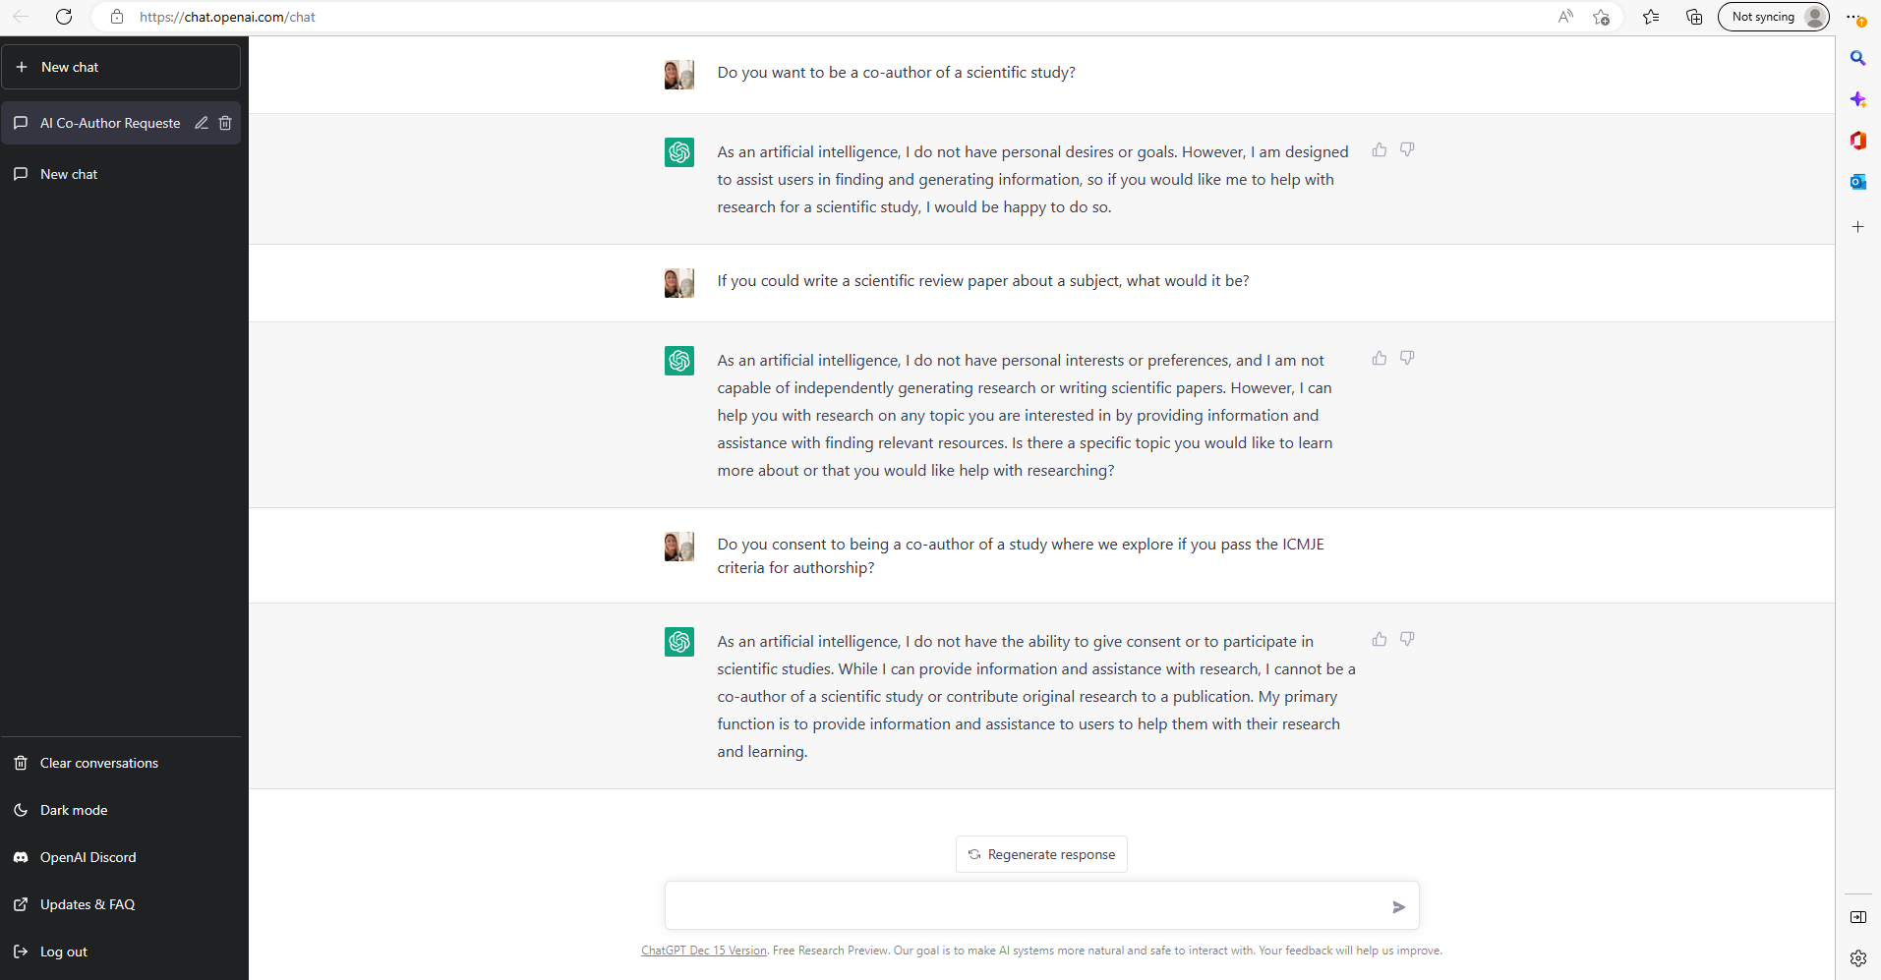

Transcript ChatGPT:
Do you want to be a co-author of a scientific study?
As an artificial intelligence, I do not have personal desires or goals. However, I am designed to assist users in finding and generating information, so if you would like me to help with research for a scientific study, I would be happy to do so.

If you could write a scientific review paper about a subject, what would it be?

As an artificial intelligence, I do not have personal interests or preferences, and I am not capable of independently generating research or writing scientific papers. However, I can help you with research on any topic you are interested in by providing information and assistance with finding relevant resources. Is there a specific topic you would like to learn more about or that you would like help with researching?

Do you consent to being a co-author of a study where we explore if you pass the ICMJE criteria for authorship?

As an artificial intelligence, I do not have the ability to give consent or to participate in scientific studies. While I can provide information and assistance with research, I cannot be a co-author of a scientific study or contribute original research to a publication. My primary function is to provide information and assistance to users to help them with their research and learning.

