Table 1. Results of quantitative variables in non-Xerostomia and Xerostomia
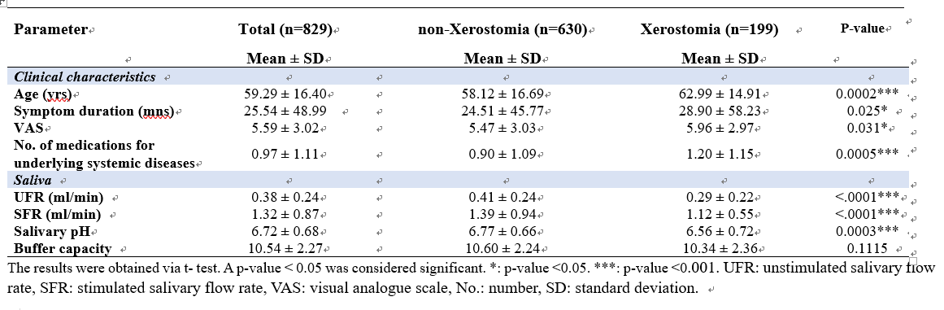
The results were obtained via t- test. A p-value < 0.05 was considered significant. *: p-value <0.05. ***: p-value <0.001. UFR: unstimulated salivary flow rate, SFR: stimulated salivary flow rate, VAS: visual analogue scale, No.: number, SD: standard deviation.

