Supplementary material
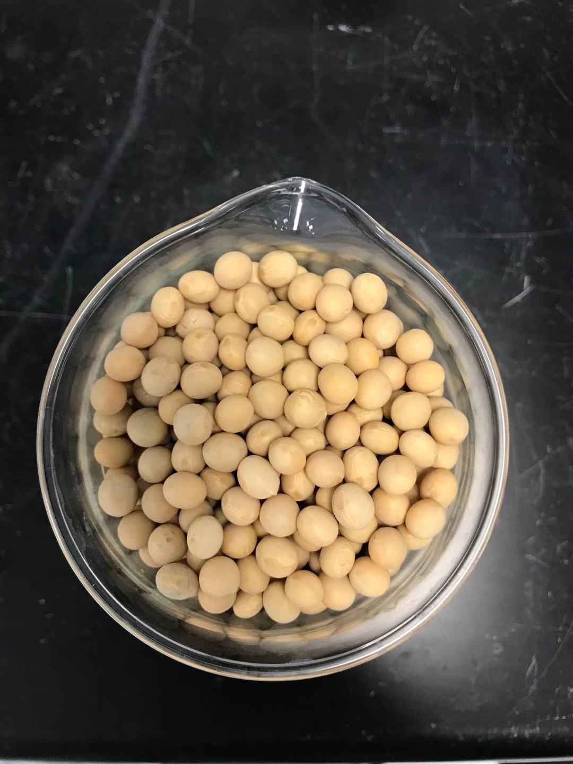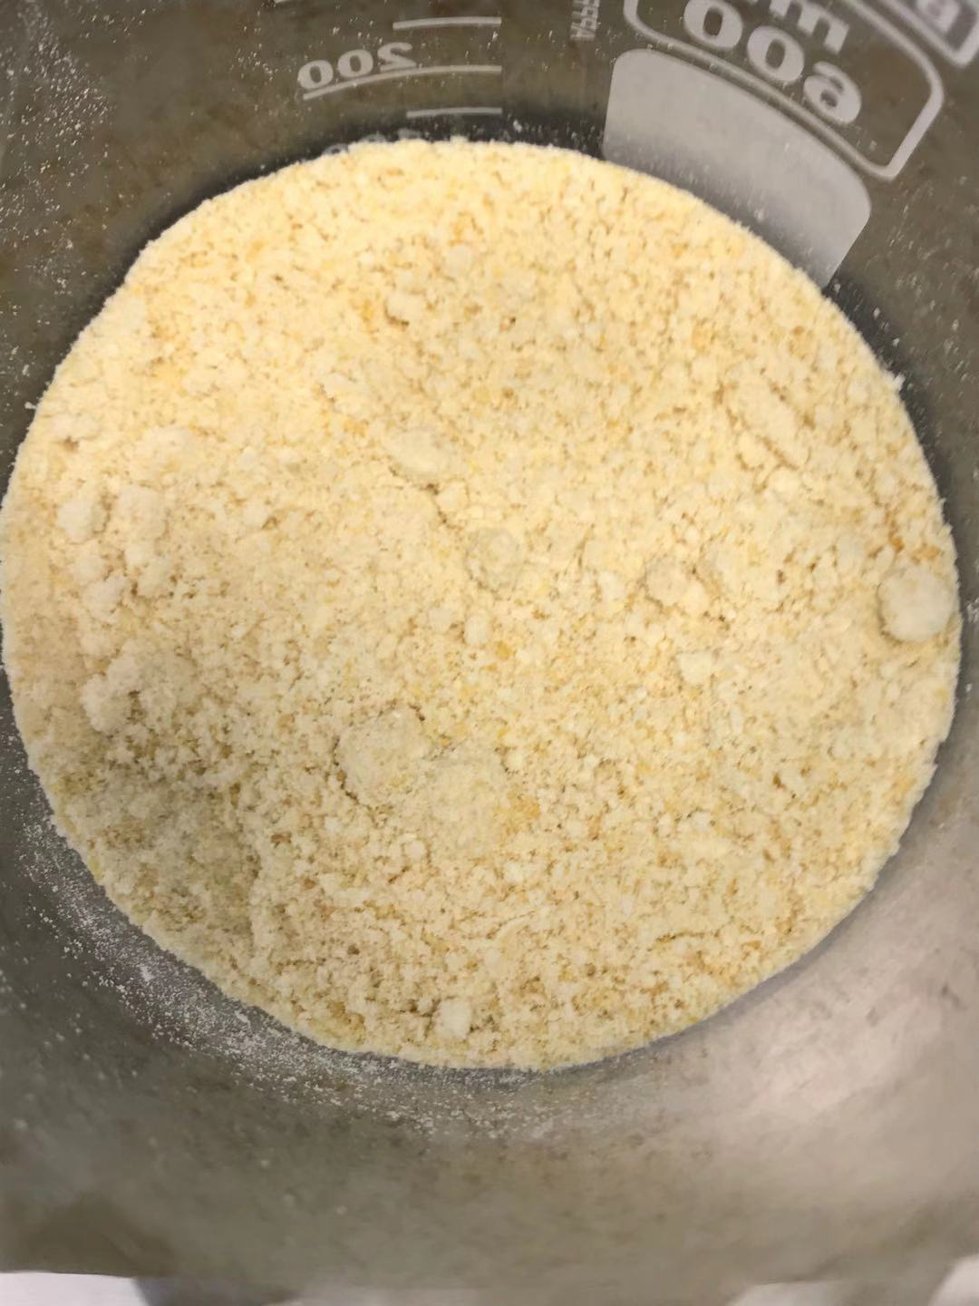
- (b)
Figure S1 Soybeans (a) and their powders (b).
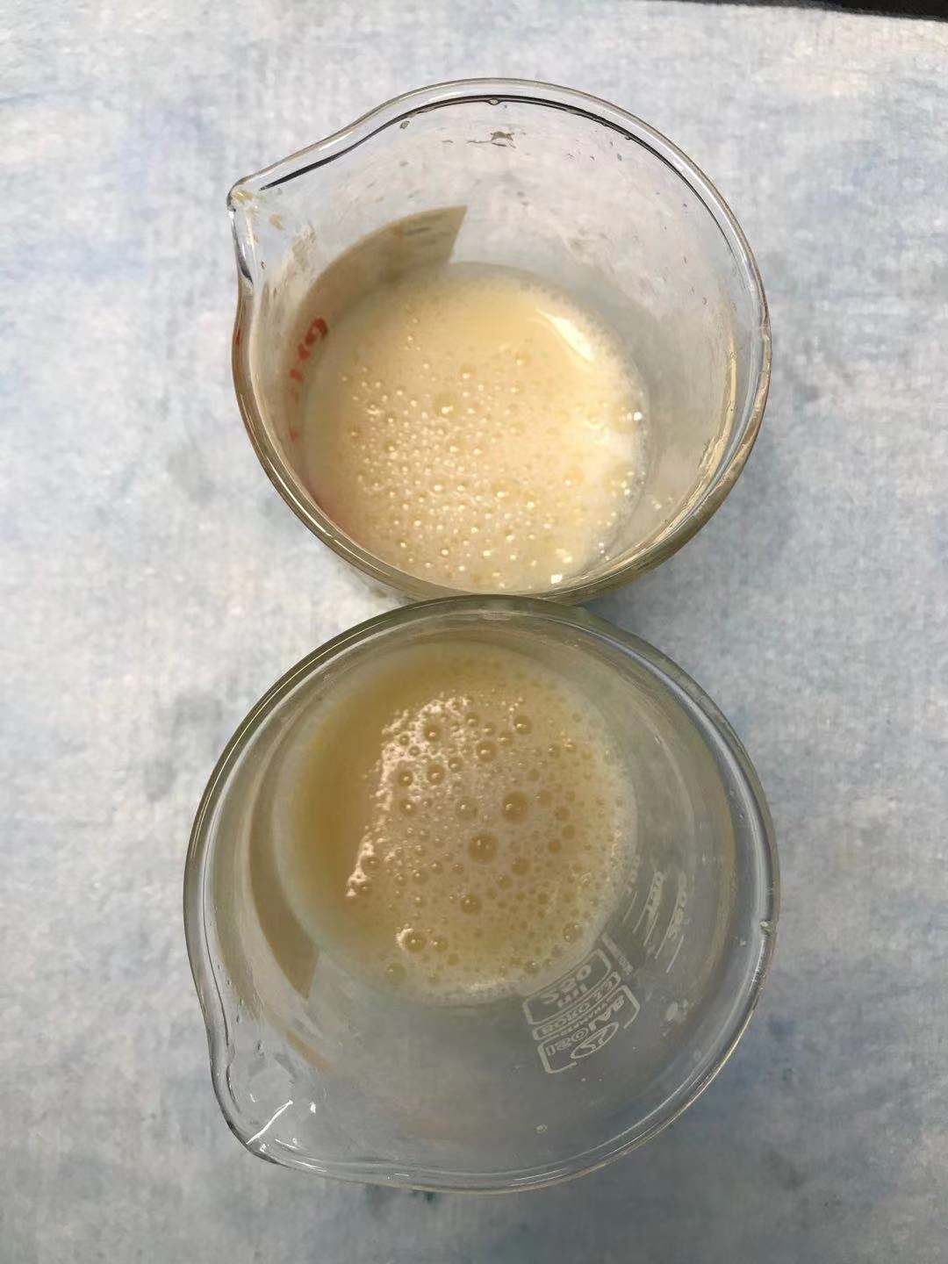
Figure S2 Soybean powder filtrate.

