Supporting information’s

Electrochemical, computational, chemical and surface investigation on novel synthesized imine surfactants as an eco-friendly inhibitor for carbon steel corrosion in 1 M HCl
Mohamed A. Abo-Riya^{1*}, Kamal A. Soliman^{1*}, Hany M. Abd El-Lateef ^{2,3}, Ahmed H. Tantawy¹, Salah Eid^{1,4*}
¹ Chemistry department, Faculty of science, Benha University, Benha-13518, Egypt
² Department of Chemistry, College of Science, King Faisal University, Al-Ahsa 31982, Saudi Arabia
³Chemistry Department, Faculty of Science, Sohag University, Sohag-82534, Egypt
⁴ Chemistry Department, College of Science and Arts, Alqurayat, Jouf University, KSA

* * Corresponding authors: mohamed.aborya@fsc.bu.edu.eg (Mohamed A. Abo-Riya); kamal.soliman@fsc.bu.edu.eg, kamalsoliman@gmail.com (Kamal.A.Soliman) ;eedsalah@yahoo.com (Salah Eid)

Contents
Title | Page
Materials | 3
Figure S1. IR, ¹H, and ¹³C NMR spectra of ((2-chlorobenzylidene)amino)-N,N-dimethyl-N-(2-oxo-2-(decyloxy)ethyl) propan-1- ammonium chloride [ICS-10]. | 4
Figure S2. IR, ¹H, and ¹³C NMR spectra of ((2-chlorobenzylidene)amino)-N,N-dimethyl-N-(2-oxo-2-(tetradecyloxy) ethyl) propan-1-ammonium chloride [ICS-14]. | 6
Figure S3. PDP curves for C-steel electrode in 1.0 M HCl solution containing different concentrations of (A) ICS-10 and (B) ICS-14 at a scan rate of 1.0 mV/sec. | 8
Table S1: The effects of the addition of various concentrations of ICS-10 and ICS-14 on the weight of carbon steel in 1.0 M HCl solution. | 9
Table S2: The inhibition capacity comparisons for some conventional Surfactants | 10
Materials
The metal used is carbon steel (C-Steel) which has the following structure (wt./wt.%): 0.05 Ni, 0.02 Cr, 0.0256 Si, 1.81 Mn, 0.09 P, 0.1 C, 0.001 V, 0.01 Mo, 0.03 Cu, and the remainder is iron. 3-(N, N Dimethylamino)-1-propylamine (99%), 2-Chlorobenzaldehyde (97%), and Decyl (98%) were purchased from Acros organics Company (Belgium). Hexadecyl (97%) alcohol was attained from M/s S.D. Fine chemicals Pvt. Ltd (India) and tetrahydrofuran (99%) were obtained from Alnasr-chemical Company. Solvents (ethyl acetate, ethyl alcohol absolute (99%), and diethyl ether (99%) were obtained from Algomhoria Chemical Co., Cairo, Egypt. All the utilized solvents and reagents were received without further purification.

Figure S1. IR, ¹H, and ¹³C NMR spectra of ((2-chlorobenzylidene)amino)-N,N-dimethyl-N-(2-oxo-2-(decyloxy)ethyl) propan-1- ammonium chloride [ICS-10].
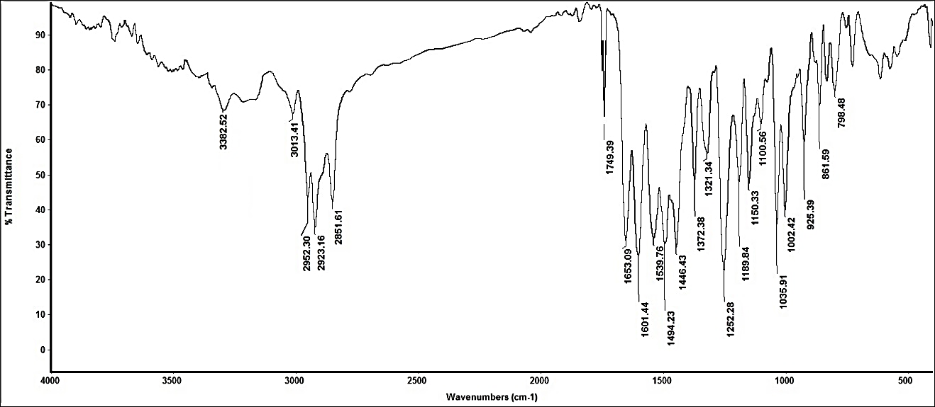
A
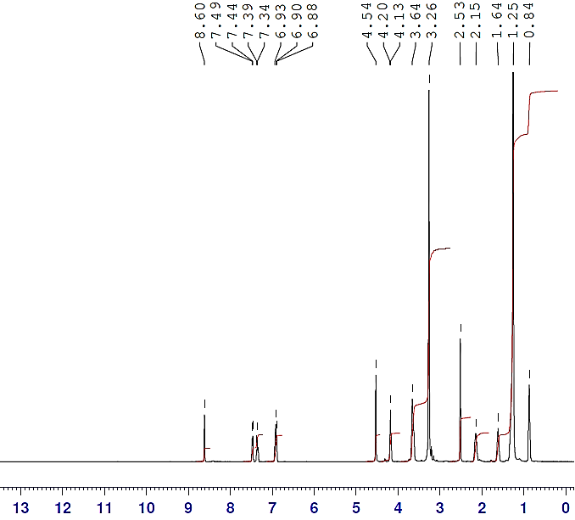
B
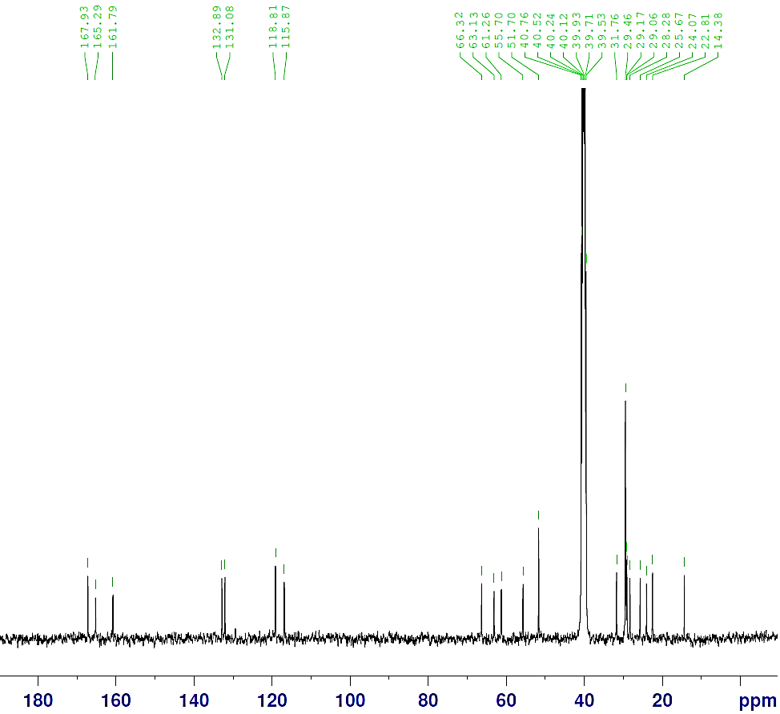
C

Figure S2. IR, ¹H, and ¹³C NMR spectra of ((2-chlorobenzylidene)amino)-N,N-dimethyl-N-(2-oxo-2-(tetradecyloxy) ethyl) propan-1-ammonium chloride [ICS-14].
A
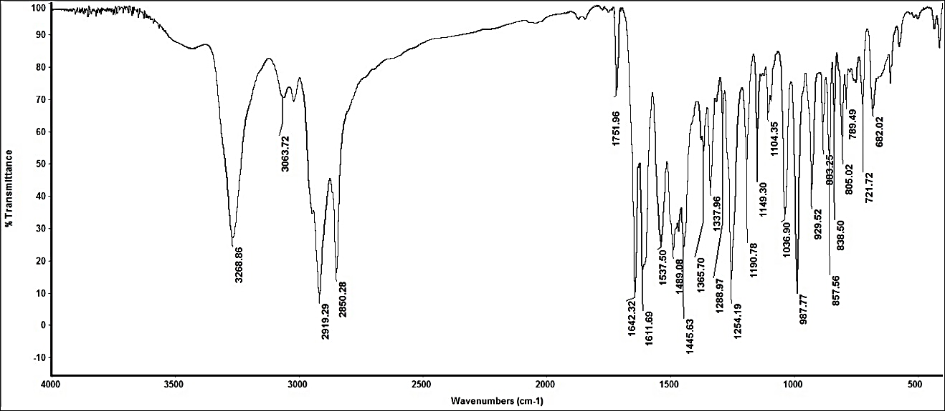
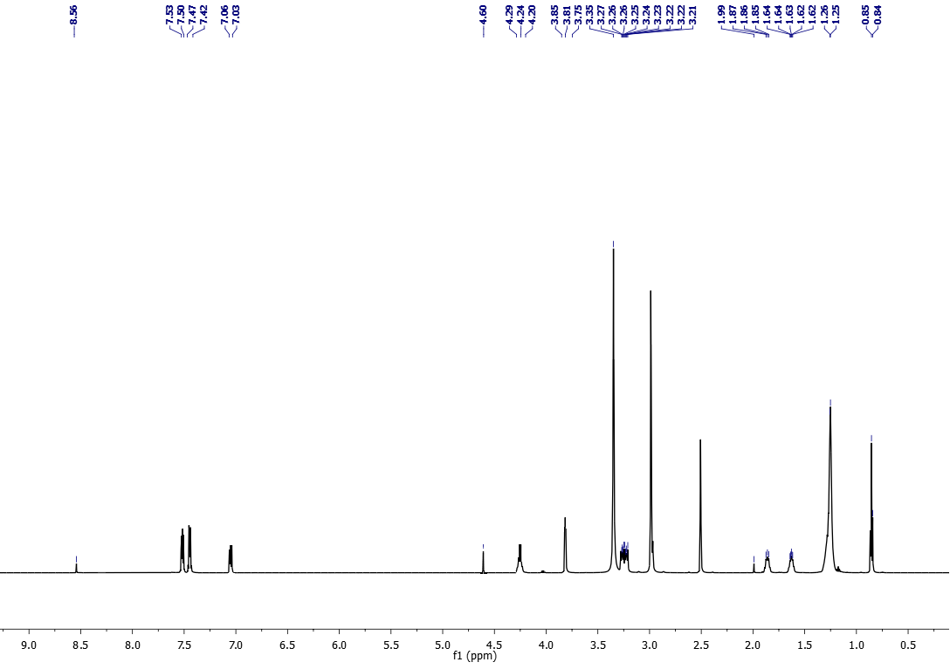
B
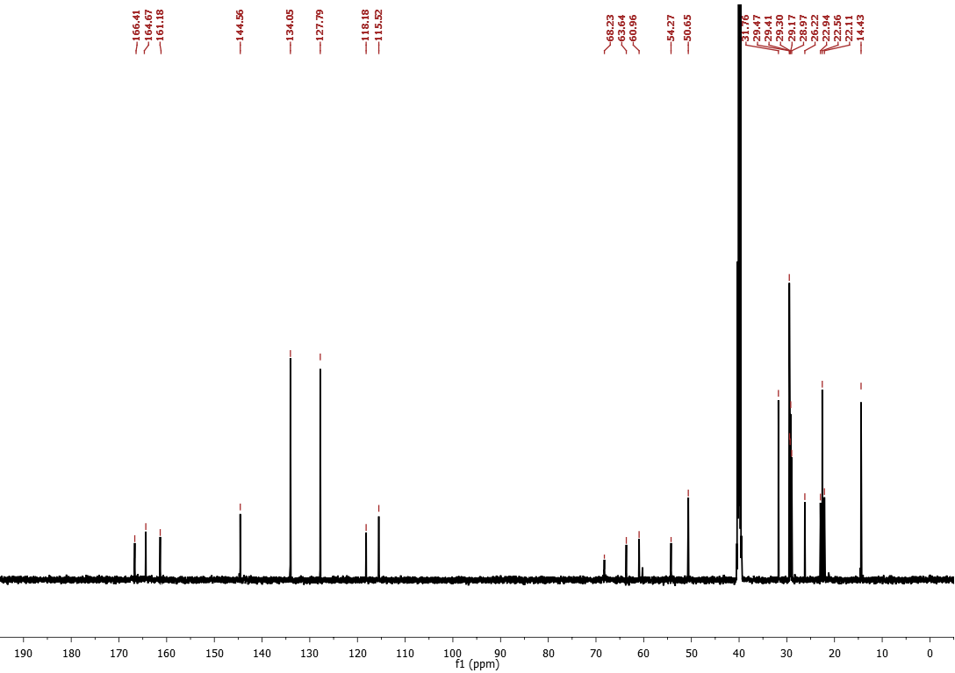
C

Figure S3. PDP curves for C-steel electrode in 1.0 M HCl solution containing different concentrations of (A) ICS-10 and (B) ICS-14 at a scan rate of 1.0 mV/sec.
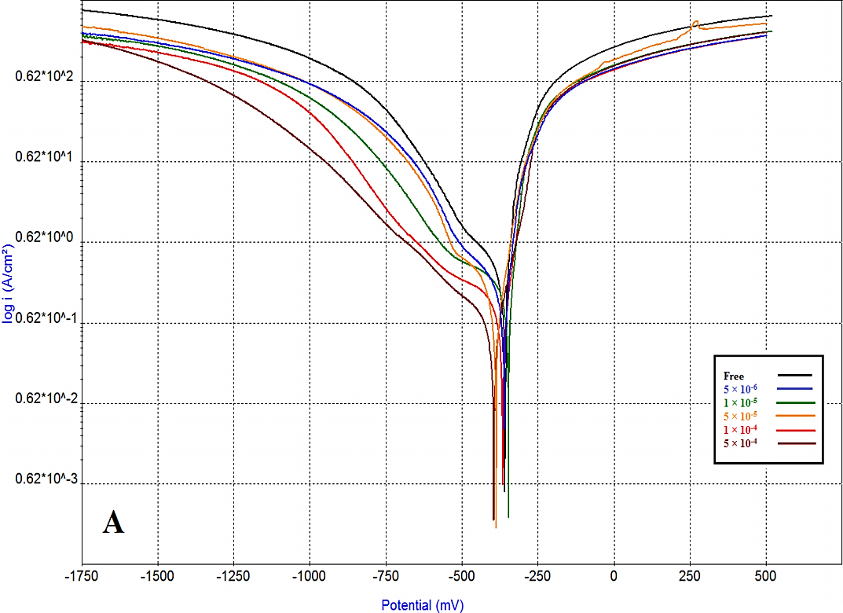
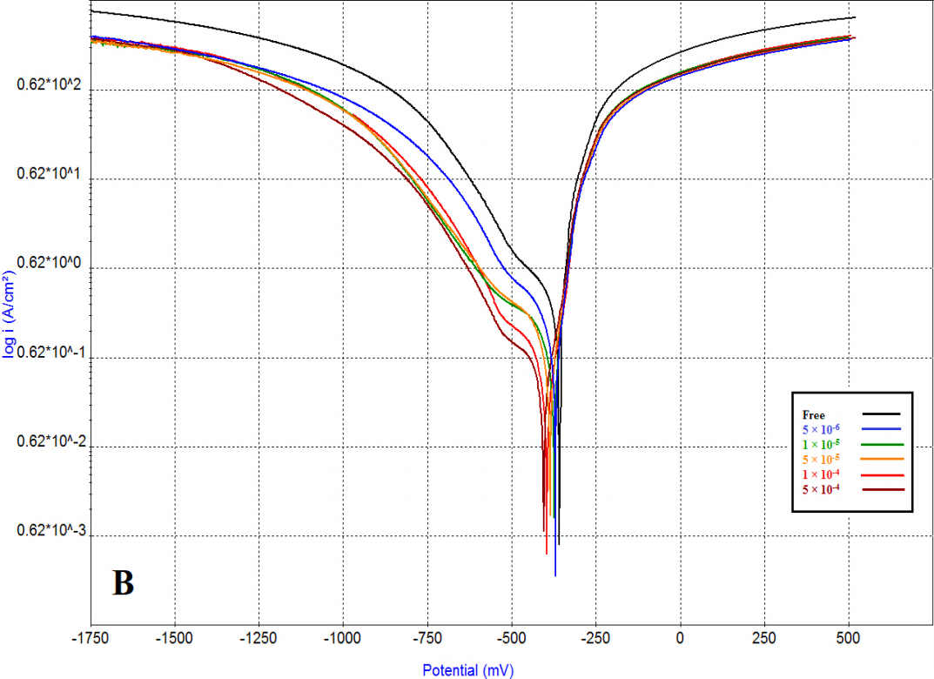

Table S1: The effects of the addition of various concentrations of ICS-10 and ICS-14 on the weight of carbon steel in 1.0 M HCl solution.

Inhibitor code | Inh. Conc.  (M) | Weight loss  (gm) | θ | I.E/.%
- | 0 | 0.137 | - | -
ICS-10 | 5 × 10⁻⁶ | 0.070 | 0.4891 | 48.91
ICS-10 | 1 × 10⁻⁵ | 0.049 | 0.6423 | 64.23
ICS-10 | 5 × 10⁻⁵ | 0.027 | 0.8029 | 80.29
ICS-10 | 1× 10⁻⁴ | 0.019 | 0.860 | 86.00
ICS-10 | 5 × 10⁻⁴ | 0.012 | 0.9113 | 91.13
ICS-14 | 5 × 10⁻⁶ | 0.053 | 0.6131 | 61.31
ICS-14 | 1 × 10⁻⁵ | 0.040 | 0.7080 | 70.80
ICS-14 | 5 × 10⁻⁵ | 0.018 | 0.8686 | 86.86
ICS-14 | 1× 10⁻⁴ | 0.014 | 0.8978 | 89.78
ICS-14 | 5 × 10⁻⁴ | 0.008 | 0.9416 | 94.16

Table S2: The inhibition capacity comparisons for some conventional Surfactants

Inhibitor type | Corrosive medium | Inhibitor concentration | Substrate type | Inhibition capacity / % | Reference
ICS-10 | 1 M HCl | 0.5 mM | C- steel | ~92 | Curent study
ICS-14 | 1 M HCl | 0.5 mM | C- steel | ~ 95 | Curent study
4-Diethyl Amino Benzaldehyde Schiff base cationic | 2N HCl | 200 ppm | C- steel | ~94 | [1]
Cetyl trimethyl ammonium bromide | 0.5 M HCl | 200 ppm | Mild-steel | ~ 86.5 | [2]
dodecyl trimethyl ammonium chloride | 0.5 M HCl | 200 ppm | Mild-steel | ~ 87.1 | [2]
3-((2-hydroxybenzylidene)amino)-N,N-dimethyl-N-(2-oxo-2-(decyloxy)ethyl) propan-1- ammonium chloride | 3.5%NaCl +0.5 M HCl | 150 ppm | Carbon Steel | ~ 88.88 | [3]
3-((2-hydroxybenzylidene)amino)-N,N-dimethyl-N-(2-oxo-2-(tetradecyloxy) ethyl) propan-1-ammonium chloride | 3.5%NaCl +0.5 M HCl | 150 ppm | Carbon Steel | ~ 93.80 | [3]
Quaternary ammonium surfactants | 1.0 M HCl | 720 ppm | C-steel | ~ 85.0 | [4]

References
- Negm NA, Zaki MF, Salem MAI. Synthesis and Evaluation of 4-Diethyl Amino Benzaldehyde Schiff Base Cationic Amphiphiles as Corrosion Inhibitors for Carbon Steel in Different Acidic Media. J. Surfact. Deterg. 2009;12:321. https://doi.org/10.1007/s11743-009-1156-0
- Fouda AS, Elewady YA, Abd El-Aziz HK, Ahmed AM. Corrosion Inhibition of Carbon Steel in 0.5 M HCl Solution Using Cationic Surfactants. Int. J. Electrochem. Sci.2012;7:10456-10475. http://www.electrochemsci.org/papers/vol7/71110456.pdf
- Abd El-Lateef HM, Tantawy AH. Synthesis and evaluation of novel series of Schiff base cationic surfactants as corrosion inhibitors for carbon steel in acidic/chloride media: experimental and theoretical investigations. RSC Adv. 2016;6;8681–8700. https://doi.org/10.1039/C5RA21626E
- Hamitouche H, Khelifa A, Kouache A, Moulay S. Petroleum quaternary ammonium surfactants mixture synthesized from light naphtha as corrosion inhibitors for carbon steel in 1 m HCl. Corros. Rev. 2013;31(2):61. https://doi.org/10.1515/corrrev-2012-0022

