Supplementary Material
Effect of precursor molecular structure on the facile synthesis of efficient red-emissive two-photon carbon dots: real-time cellular imaging and high-resolution deep-tissue imaging
Pooria Lesani ^{a,b*}, Aina Hazeera Mohamad Hadi ª, Mansi Khetarpaul ª, Zufu Lu ª, Hala Zreiqat ^{a, b*}
ª Tissue Engineering & Biomaterials Research Unit, School of Biomedical Engineering, the University of Sydney, Sydney, NSW, Australia, 2006
^{b} The University of Sydney Nano Institute (Sydney Nano), The University of Sydney, Sydney, NSW, Australia, 2006

E-mails:
Aina Hazeera Mohamad Hadi: amoh2151@uni.sydney.edu.au
Mansi Khetarpaul: mkhe2643@uni.sydney.edu.au
Zufu Lu: zufu.lu@sydney.edu.au
* Pooria Lesani: pooria.lesani@sydney.edu.au – Tel: +61 2 9351 7158
* Hala Zreiqat: hala.zreiqat@sydney.edu.au – Tel: +61 2 9351 2392
* Corresponding authors

Table S1. Percentage of different functional groups in XPS C 1s, N 1s, and O 1s spectra of 30-100 KDa-CD.
C 1s |  |  |  |  |  |  |  | N 1s
C-H | C-C/  C=C |  | C-N/  C-O |  | C=O |  | COOH | Pyridinic N | Amino N | Pyrrolic N | Graphitic N
n/a | 58.54 |  | 16.59 |  | 16.73 |  | 8.13 | 30.67 | 62.66 | 6.67 | n/a
O 1s
C=O |  | C-O |  | C-OH |  | COOH
37.40 |  | 62.60 |  | n/a |  | n/a
Table S2. Percentage of different functional groups in XPS C 1s, N 1s, O 1s, and S 2p spectra of D-CD.
C 1s |  |  |  |  |  |  |  | N 1s
C-H/  C-S | C-C/  C=C |  | C-N/  C-O |  | C=N/  C=O |  | COOH | Pyridinic N | Amino N | Pyrrolic N | Graphitic N
4.84 | 54.89 |  | 19.31 |  | 14.18 |  | 6.77 | 18.63 | 43.94 | 25.78 | 11.65
O 1s |  |  |  |  |  |  |  | S 2p
C=O |  | C-O |  | C-OH |  | COOH |  | S-H | S-C  (S_{2p3/2}) | S-C  (S_{2p1/2}) | S=O
40.02 |  | 37.85 |  | 19.9 |  | 2.22 |  | 4.37 | 10.32 | 8.79 | 76.52

Figure S1. Fluorescence emission spectra of (A) W-CD, (B) E-CD, and (C) D-CD at different excitation wavelengths.

Figure S2. Photograph of deionized water in daylight and under λ_{ex} = 680 nm, respectively.

Figure S3. Normalized absorption and fluorescence excitation spectra of D-CD. The overlap between these two spectra indicates the formation of the new aromatic structure within D-CD due to the integration of precursors with aromatic structure along with precursors with aliphatic structures into the synthesis process.

Figure S4. XPS S 2p spectra of D-CD.

Figure S5. Normalized two-photon fluorescence excitation (λ_{ex} = 945 nm) and emission (λ_{em} = 580 nm) spectra of D-CD. FL stands for fluorescence emission, and Ex for excitation.

Figure S6. Cell viability of Fibroblast incubated with D-CD at increasing concentration for 3 days (mean ± SD, n = 3). Cells incubated with only media served as the control.

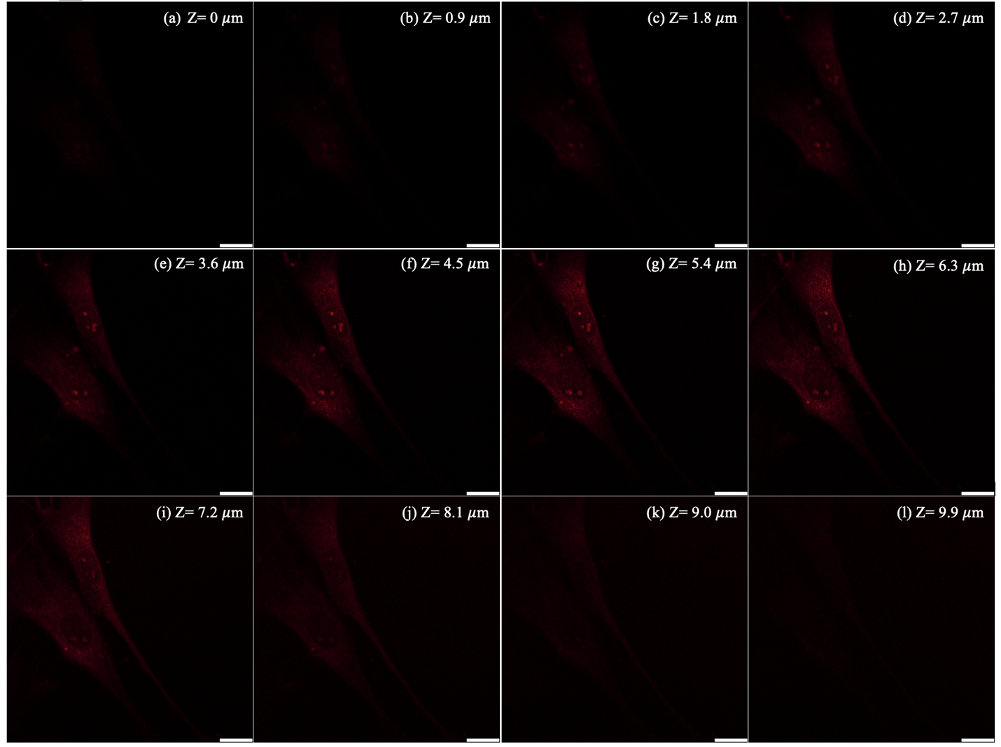
Figure S7. (a-l) Two-photon fluorescence excitation images of fibroblasts incubated with D-CD (200 µg/mL) at different Z positions (from the top 0 µm to the bottom 9.9 µm, ∆Z = 0.9 µm, scale = 15 µm). The cells were imaged under a two-photon pulsed laser at the excitation wavelength of 945 nm.

