Supplementary figures

Figure. S1.

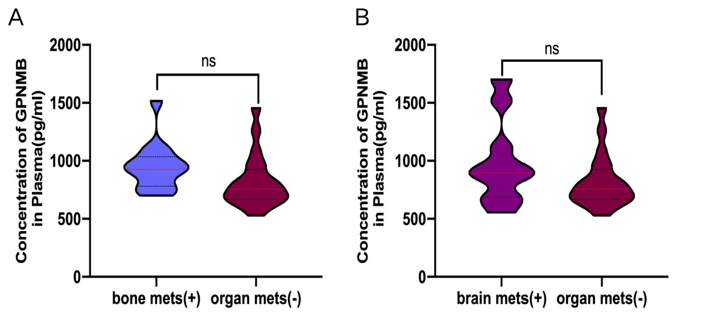
(A) Comparison of GPNMB concentrations between bone metastasis and non-distance metastasis. (B) Comparison of GPNMB concentrations between brain metastasis and non-distance metastasis.

