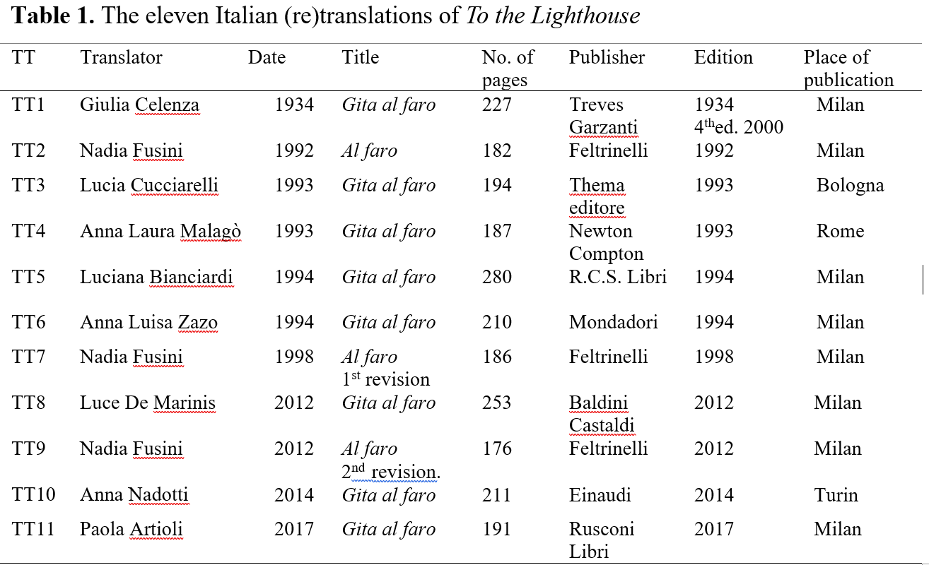

Table 2. Number of occurrences of literary and stylistic features
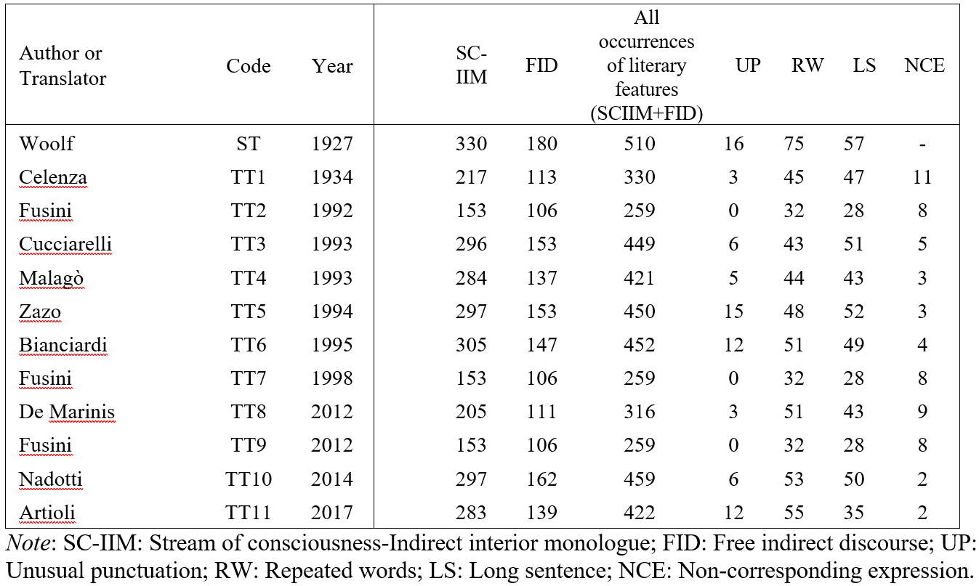

Table 3. Statistical test of the temporal trend of the ST’s modernist features in the TTs
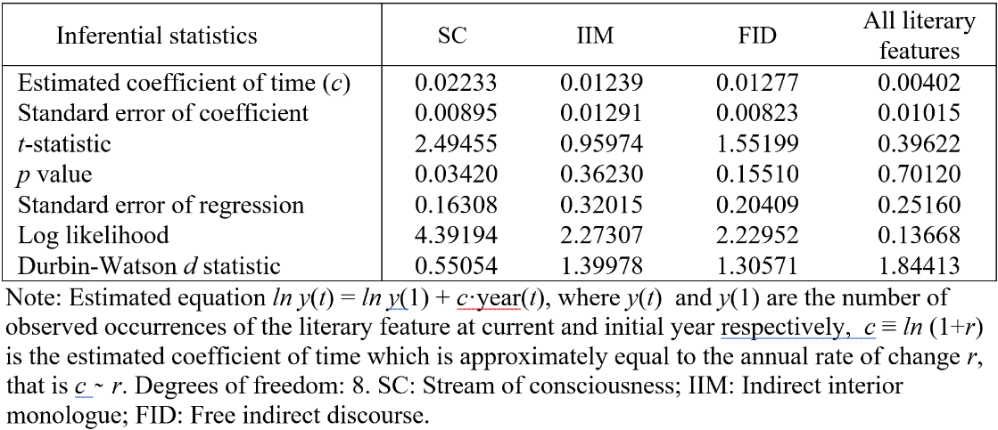

Table 4. The type-token ratio
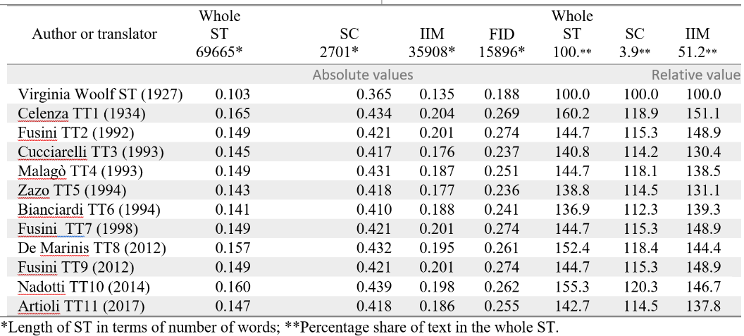

Table 5. Lexical frequency in the whole text of the novel

