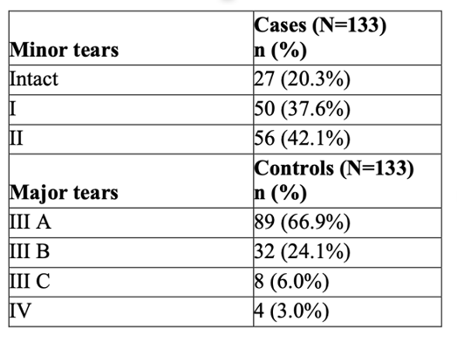
Table 1: type of tear in the case and in the control group
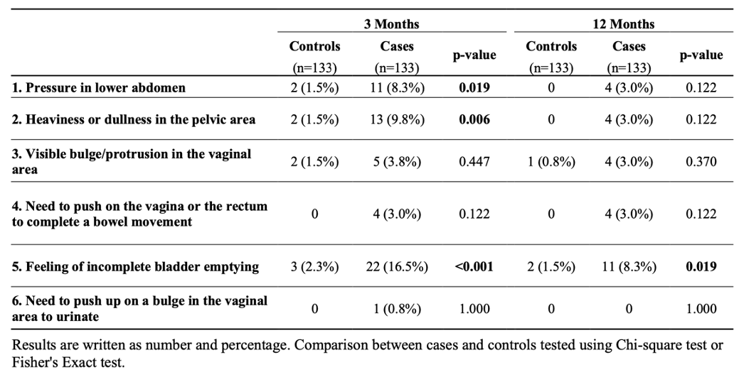
Table 2: Proportion of individuals who scored 3-4 for each item of the POPDI-6 survey

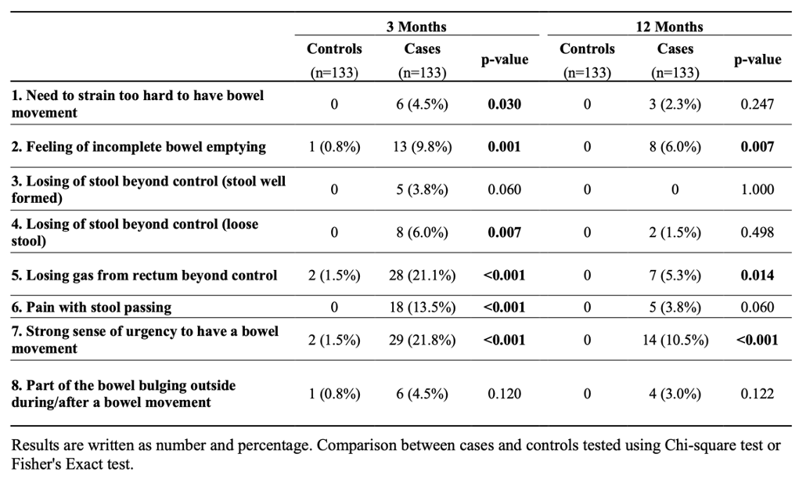
Table 3: Proportion of individuals who scored 3-4 for each item of the CRADI-8 survey

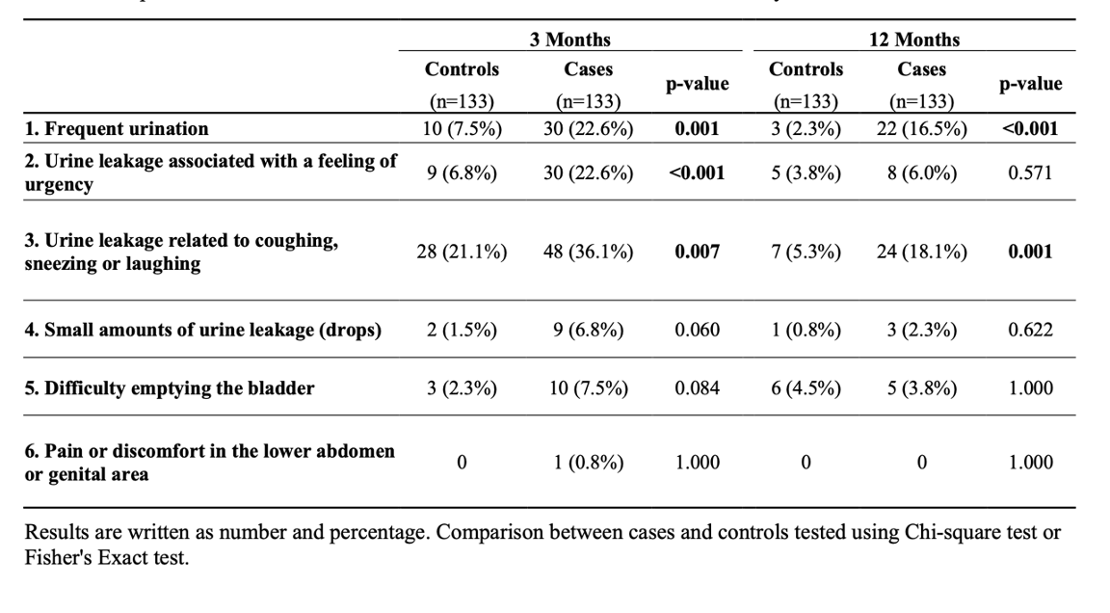
Table 4: Proportion of individuals who scored 3-4 for each item of the UDI-6 survey

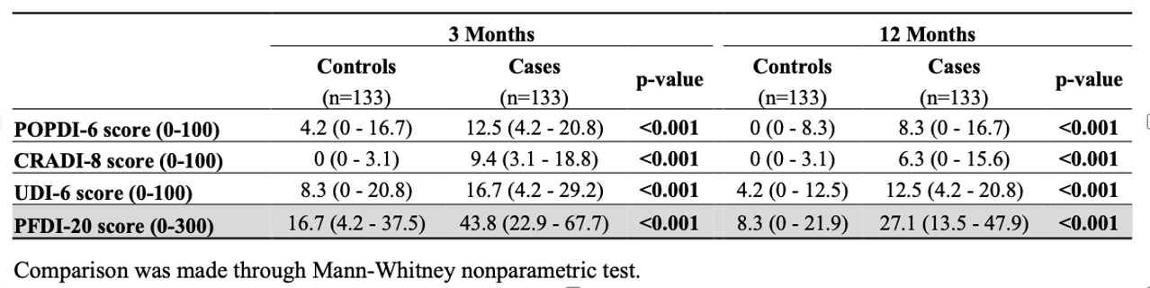
Table 5: Summary scores written ad median and interquartile range

