Rock Varnish: A Nature’s Shield

Amritpal Singh Chaddha^{1,2*}, Anupam Sharma^{1*}, Narendra Kumar Singh², Devendra Kumar Patel³, G.N.V. Satyanarayana³
¹Birbal Sahni Institute of Palaeosciences; 53 University Road, Lucknow, India.
²Department of Chemistry, Faculty of Science, University of Lucknow; Lucknow, India.
³Analytical Chemistry, Regulatory Toxicology Group, CSIR-Indian Institute of Toxicology
Research; Lucknow, India.
* Corresponding author Email: anupam110367@yahoo.com; amrit.chemsingh@gmail.com

Supplementary Information

This file includes:

Figs. S1 to S11
Tables S1

Other Supplementary Materials for this manuscript include the following:

Movies S1 (Visual displaying simple drop retention test for testing surface wettability on rock varnish and host rock surface.)

Data S1 (GC-MS/MS matched library data for varnish samples)

Study Area

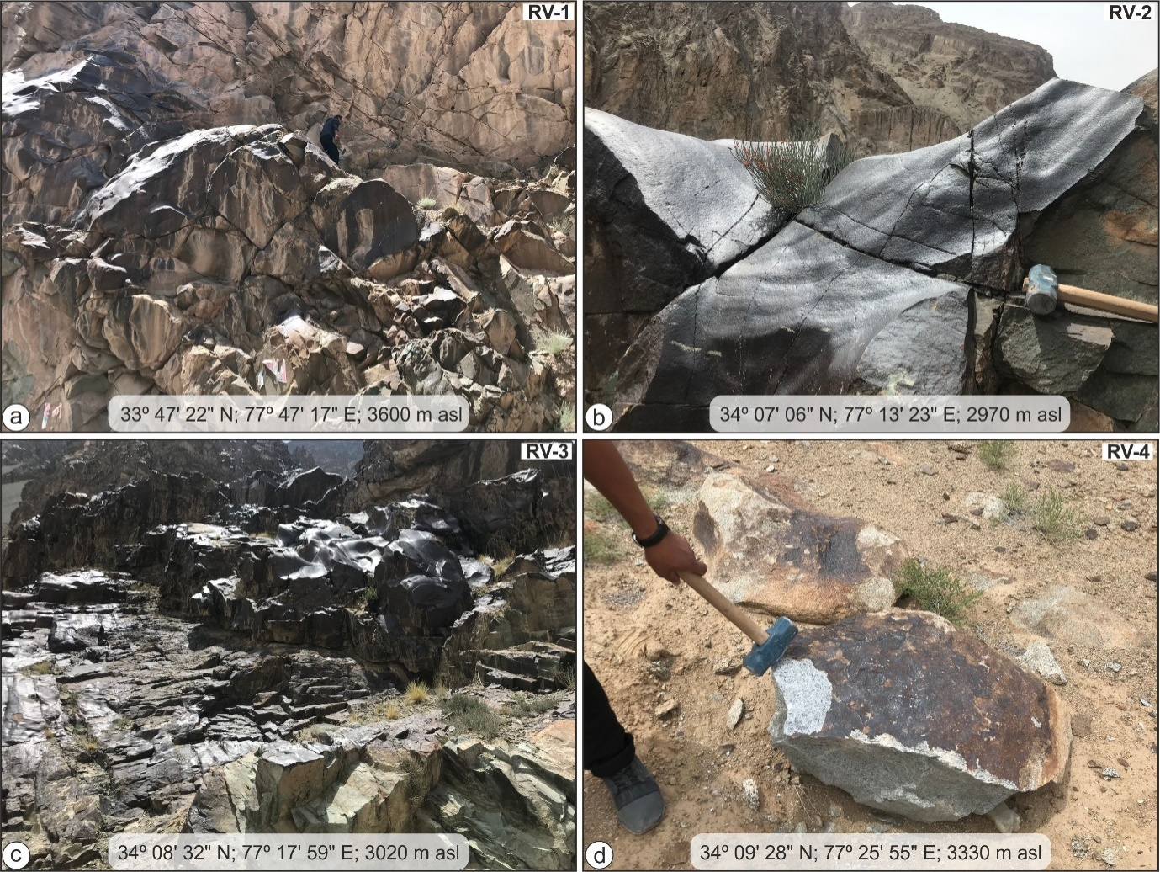 Field photographs of different sample locations (RV-1 to RV-4) having varnish coated rocks used in the current study.

Samples for the current study were collected from four distinct places in the Leh district (Ladakh), NW India that are situated between 32 and 36°north latitude and 75 and 80° east longitude. The district of Leh is bounded geologically by the Ladakh Range (Ladakh Batholith) in the north and the Zanskar Range (Indus Molasse and other rocks) in the south, with the contact between these two ranges roughly following the Indus River. Leh experiences an extreme climate with the temperature ranging between 34.8°C in summer to -27.9°C in winter(4). The RV-1, 2, and 3 samples represent varnish coatings on Indus Molasse rocks, while the sample RV-4 represents the Ladakh Batholith. Varnish layer scrapped from these samples are denoted as 1V, 2V, 3V, and 4V in the current study.
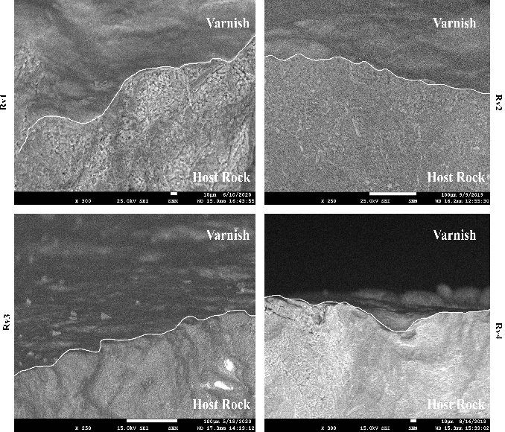

Fig. S1 A back scattered electron (BSE) image of the rock varnish sample taken with an FE-SEM clearly differentiates the boundary between the varnish layer and the host rock.

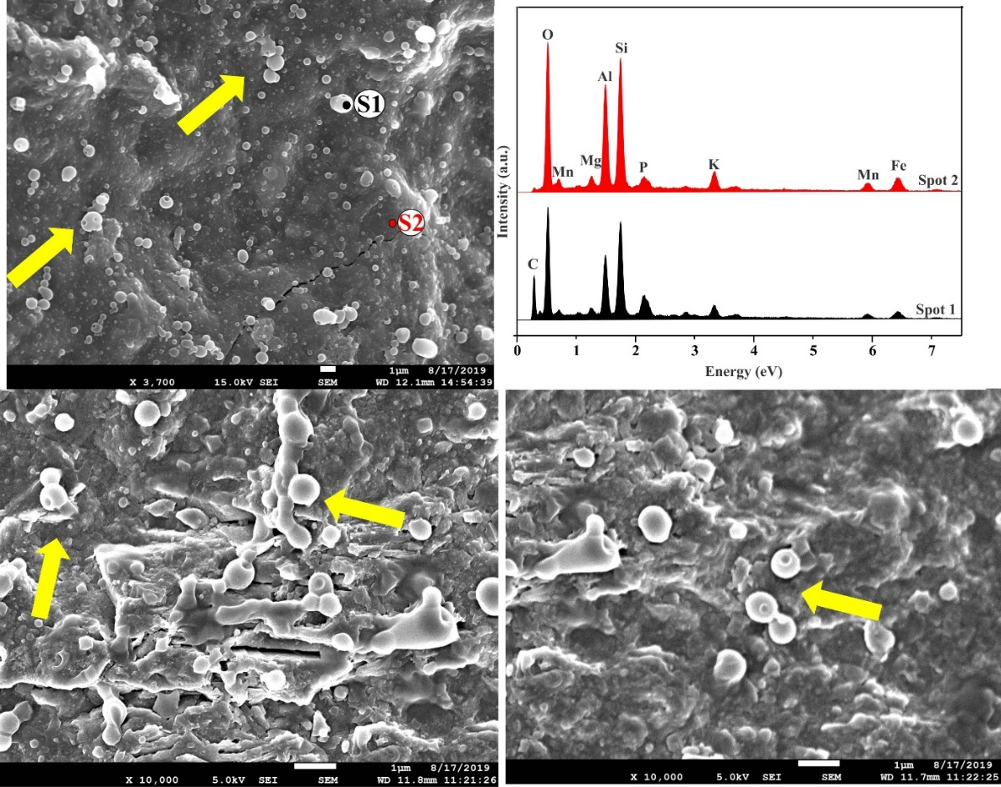

Fig.S2 Coccoid-shape cyanobacterial cells, as marked by the yellow arrows, are observed in the varnish layer. The elemental analysis reveals that the cells have a high carbon content (spot 1) as compared to the (spot 2) in the varnish layer.

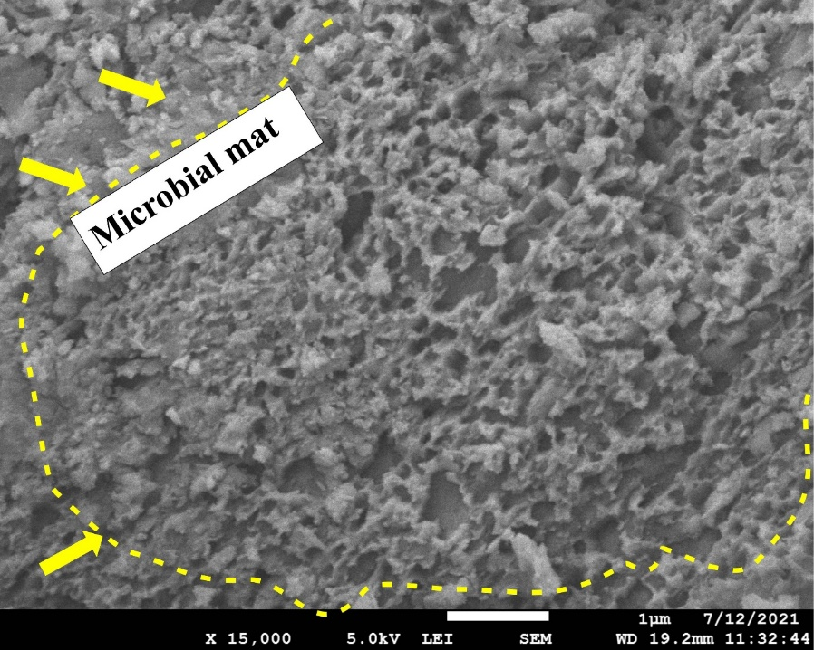

Fig.S3 A general view of the microbial mat spread on the varnish layer with a net like honeycomb structure.

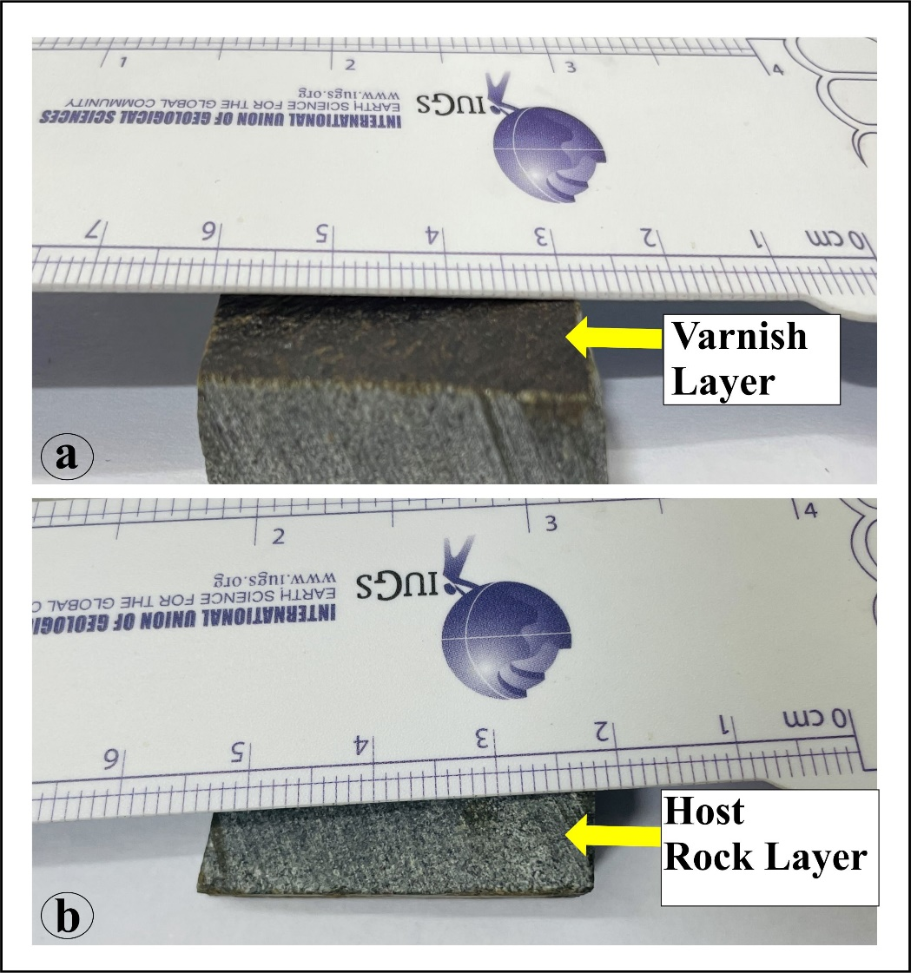

Fig. S4 (a and b) The contact angle study was performed on a typical, notably smooth (polished) varnish and host rock surface.

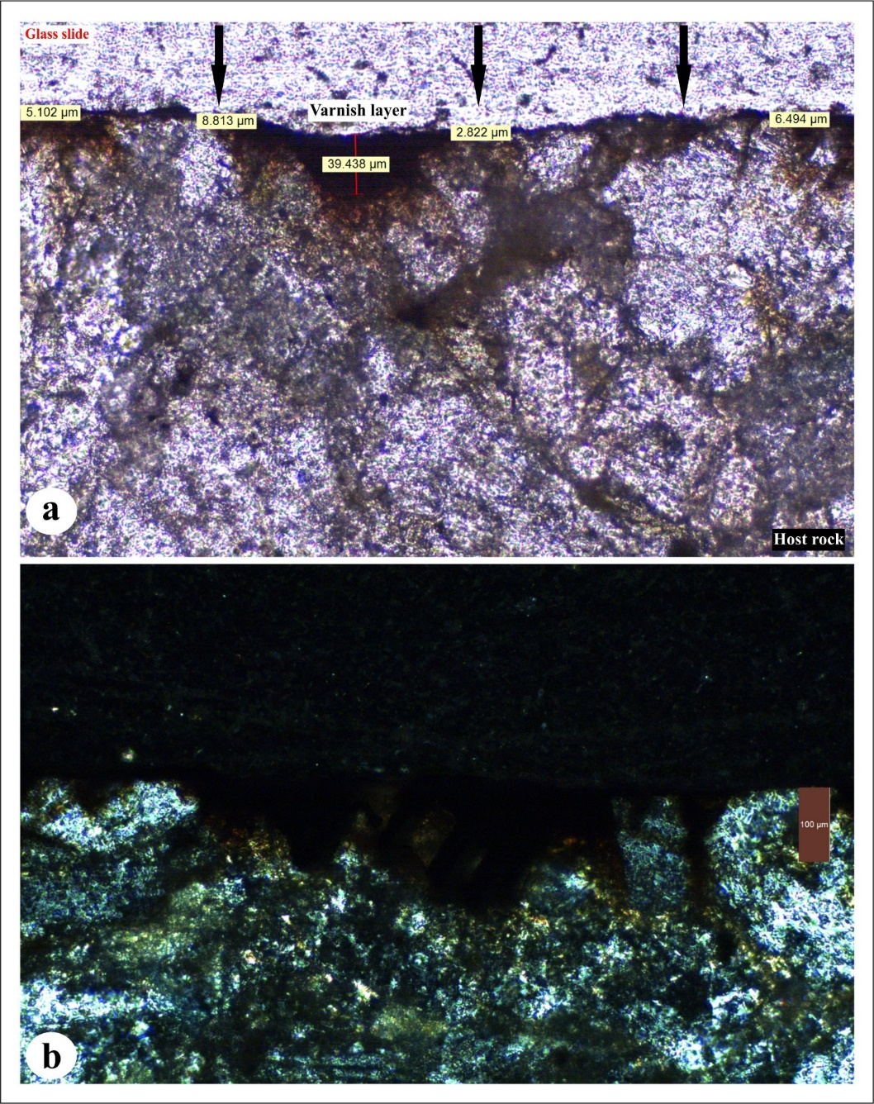
Fig. S5 (a, b) Thin section slide of a cross-section of a varnish sample (RV4) in plane and cross-polarized light with marked varnish layer thickness.

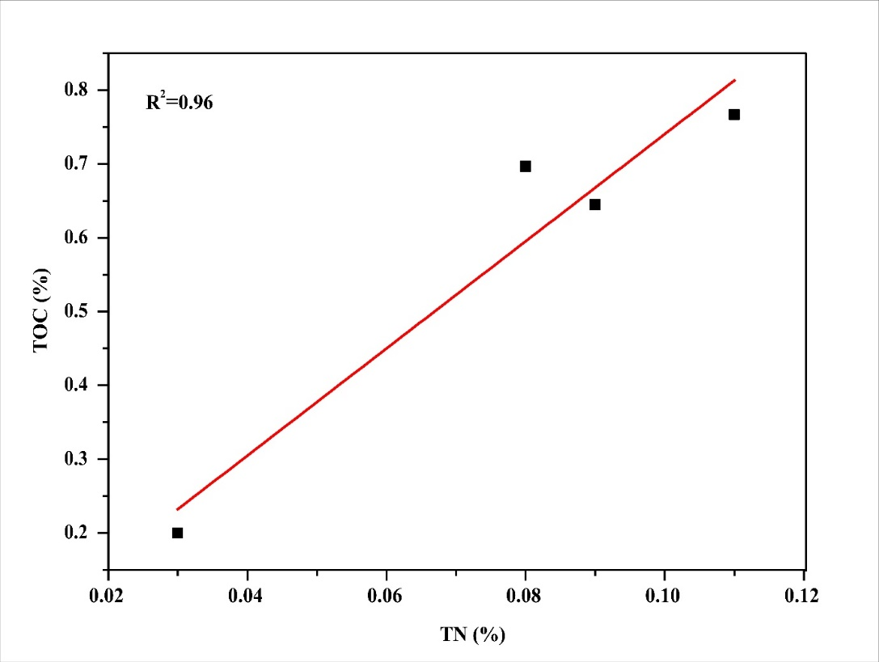
Fig.S6 The significant relationship between TOC and TN indicates that both are generated from comparable organic sources such as C3 plants processed by the bacteria.

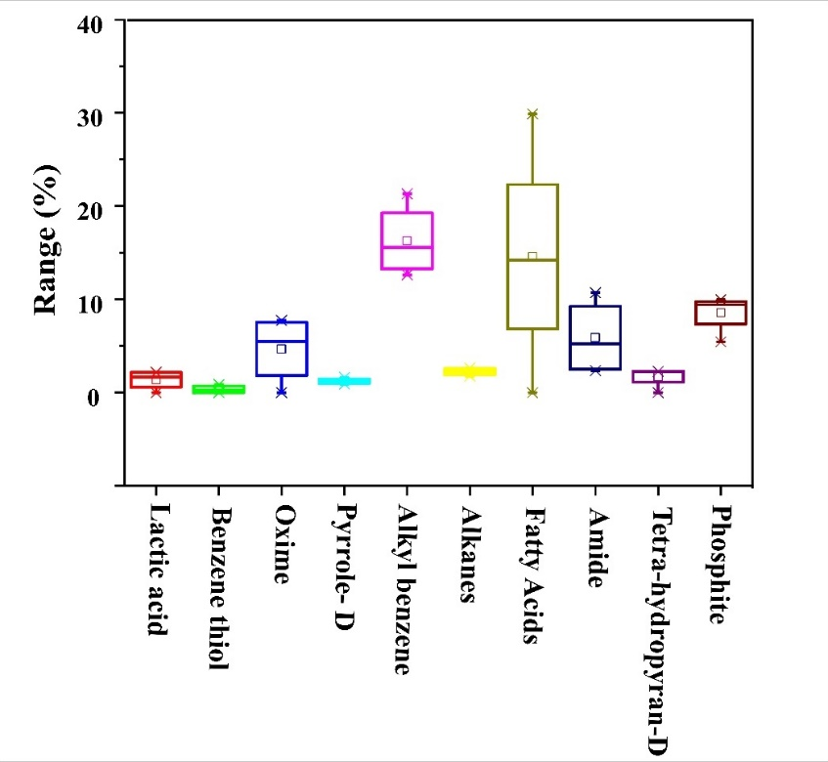
Fig. S7 A box and whisker plot showing variable range of the organic compounds present in the rock varnish layer.

In order to ascertain how homogeneous, the varnish layer is (as the thickness varies in different samples), the varnish layer is scraped from different locations from all samples and analysed. The results show that δ¹³C values vary in a narrow range for all individual samples, suggesting that the varnish layer is almost homogeneous (Table S1).

Table. S1 The δ¹³C measurements from several sites on each rock varnish sample, demonstrate a very homogeneous distribution of depletion relative to VPDB. The symbol (*) denotes several spots on the rock varnish sample from which it was scraped for analysis.

1v |  | 2v |  | 3v |  | 4v
Sample no. | δ¹³C values (‰; VPDB) | Sample no. | δ¹³C values (‰; VPDB) | Sample no. | δ¹³C values (‰; VPDB) | Sample no. | δ¹³C values (‰; VPDB)
1/1* | -22.4 | 2/1* | -27.0 | 3/1* | -20.4 | 4/1* | -23.6
1/2* | -22.8 | 2/2* | -25.6 | 3/1* | -20.6 | 4/2* | -18.6
1/3* | -22.5 | 2/3* | -24.7 | 3/2* | -19.5 | 4/3* | -22.1
1/4* | -22.1 | 2/4* | -25.6 | 3/3* | -22.2 | 4/4* | -21.6
 |  | 2/4* | -21.9 | 3/4* | -22.5
 |  |  |  | 3/4* | -23.7

Movie S1. (Separate file)
Visual displaying simple drop retention test for testing surface wettability on rock varnish and host rock surface.

Data S1. (Separate file)
GC-MS/MS matched library data for varnish samples

