Supplementary Figure SF1. Study Flow

Supplementary Figure SF2. Bifactor Model
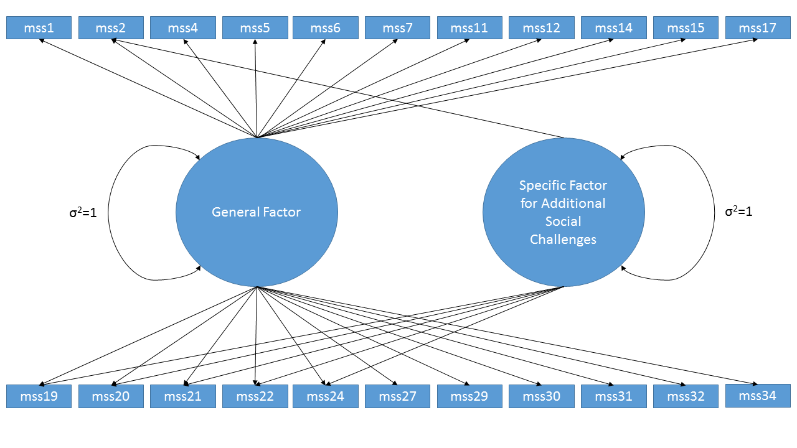

Supplementary Table ST1. Marginal IRT Parameters with Plots for Item Characteristic Curves and Item Information Curves

Item ID | Stem | General Factor Slope | Specific Factor Slope | Marginal Slope | Intercept / Marginal Threshold |  |  |  | Average Threshold (Difficulty) | Item Characteristic Curve
 |  |  |  |  | 1 | 2 | 3 | 4 | Average Threshold (Difficulty) | Item Characteristic Curve
MSSS30 | Not enough time to get things done | 1.24 |  | 1.24 | 5.54 | 2.71 | 0.57 | -1.51 | -1.476 | 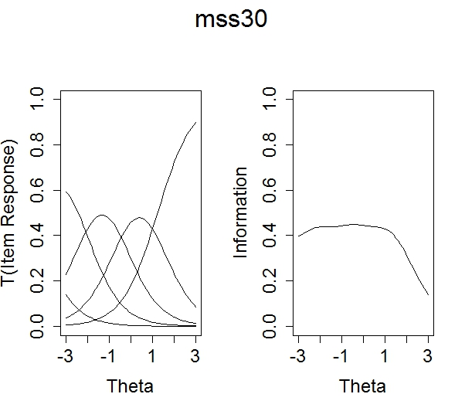
 |  |  |  |  | -4.50 | -2.19 | -0.50 | 1.22 | -1.476
MSSS27 | Overly self-critical | 1.54 |  | 1.54 | 5.36 | 2.50 | 0.03 | -1.78 | -0.991 | 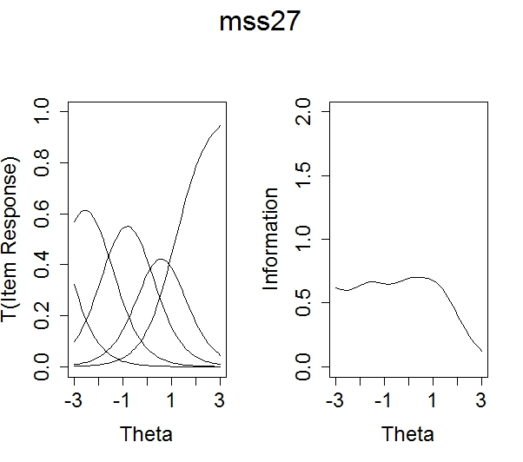
 |  |  |  |  | -3.5 | -1.62 | -0.00 | 1.15 | -0.991
MSSS31 | Overwhelmed by everything there is to do | 2.23 |  | 2.23 | 6.70 | 3.61 | 0.64 | -2.51 | -0.945 | 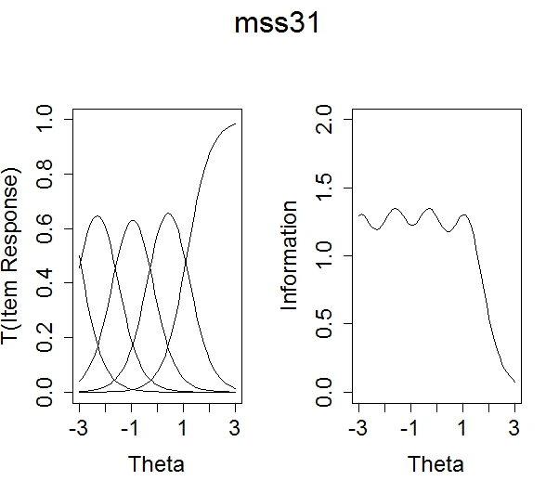
 |  |  |  |  | -3.0 | -1.62 | -0.3 | 1.12 | -0.945
MSSS6 | Feel anxious | 1.96 |  | 1.96 | 5.99 | 2.88 | -0.24 | -3.68 | -0.630 | 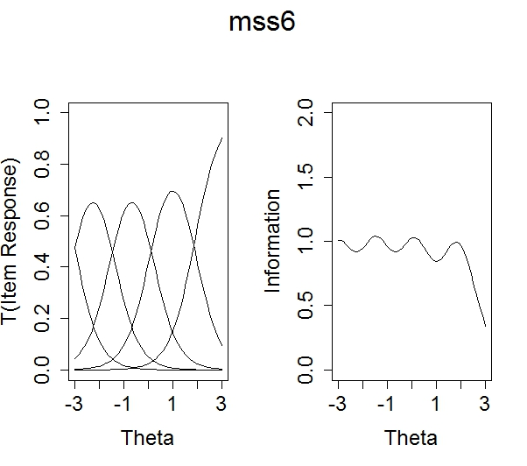
 |  |  |  |  | -3.0 | -1.46 | 0.12 | 1.87 | -0.630
MSSS32 | Struggle maintaining school-life balance | 1.72 |  | 1.72 | 5.03 | 2.19 | -0.44 | -2.88 | -0.565 | 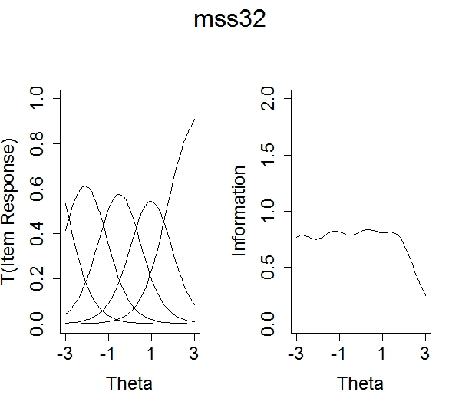
 |  |  |  |  | -2.9 | -1.27 | 0.26 | 1.67 | -0.565
MSSS29 | Unsure of abilities as student | 1.87 |  | 1.87 | 4.25 | 1.93 | -0.65 | -2.91 | -0.351 | 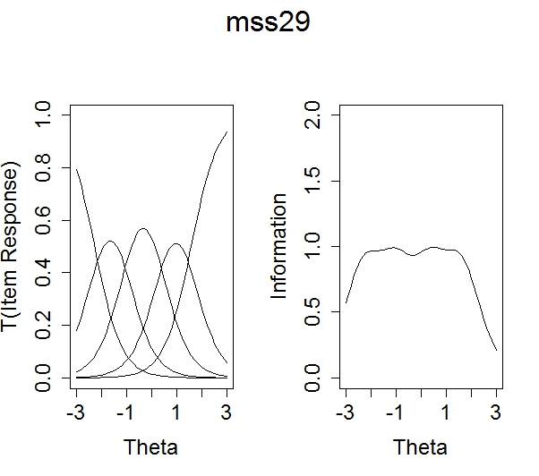
 |  |  |  |  | -2.3 | -1.04 | 0.35 | 1.56 | -0.351

MSSS15 | Emotionally exhausted | 1.91 |  | 1.91 | 4.13 | 1.75 | -0.89 | -3.57 | -0.185 | 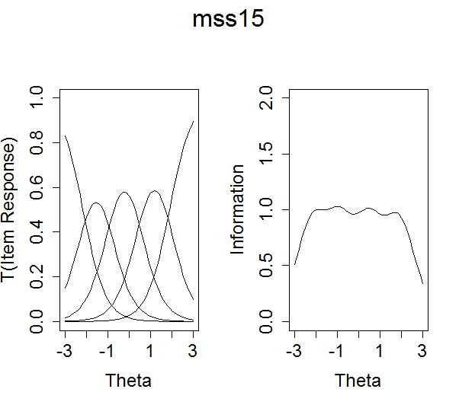
 |  |  |  |  | -2.20 | -0.92 | 0.47 | 1.87 | -0.185
MSSS14 | Hard time motivating self to study | 1.08 |  | 1.08 | 3.37 | 1.46 | -1.04 | -3.28 | -0.116 | 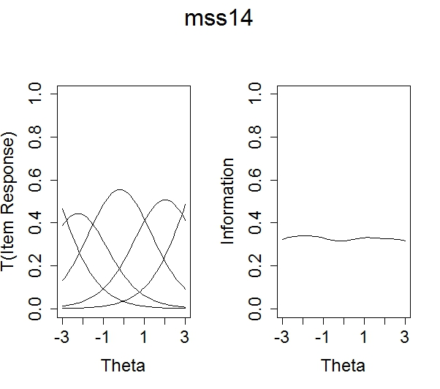
 |  |  |  |  | -3.10 | -1.35 | 0.97 | 3.05 | -0.116
MSSS5 | Unable to relax | 1.92 |  | 1.92 | 4.18 | 1.38 | -1.40 | -4.19 | 0.002 | 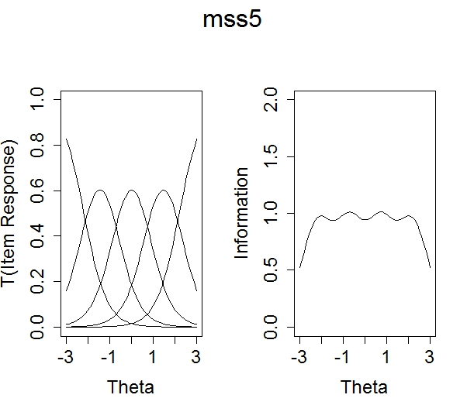
 |  |  |  |  | -2.20 | -0.72 | 0.73 | 2.18 | 0.002

MSSS17 | Fearful of failing | 1.96 |  | 1.96 | 3.09 | 1.02 | -1.28 | -3.78 | 0.121 | 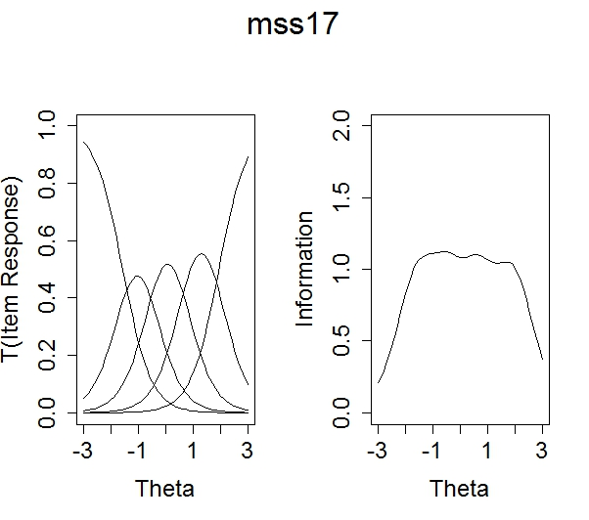
 |  |  |  |  | -1.60 | -0.52 | 0.65 | 1.92 | 0.121
MSSS20 | Competition from peers | 0.82 | 0.91 | 0.72 | 3.54 | 0.75 | -1.40 | -3.74 | 0.258 | 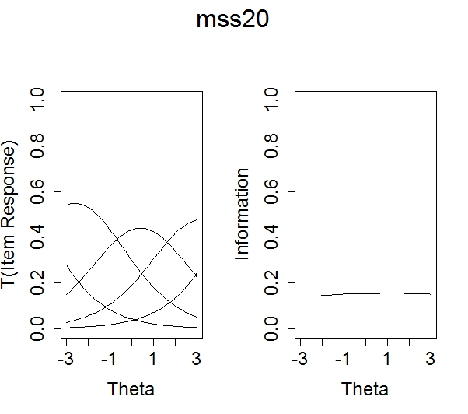
 |  |  |  |  | -4.30 | -0.91 | 1.70 | 4.57 | 0.258
MSSS1 | Fluctuations in appetite | 1.14 |  | 1.14 | 2.41 | 0.76 | -1.11 | -4.10 | 0.449 | 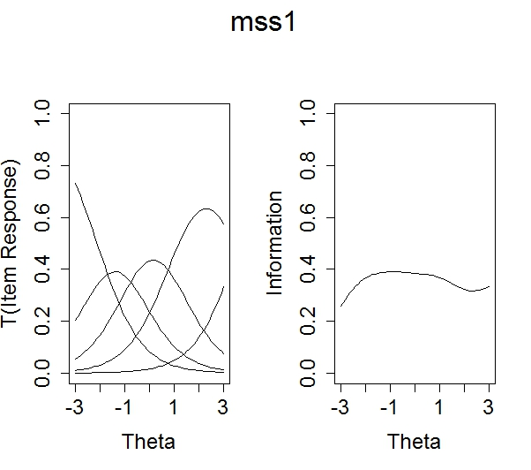
 |  |  |  |  | -2.10 | -0.67 | 0.97 | 3.61 | 0.449

MSSS4 | Less satisfaction from learning | 1.06 |  | 1.06 | 2.56 | 0.24 | -1.75 | -3.77 | 0.640 | 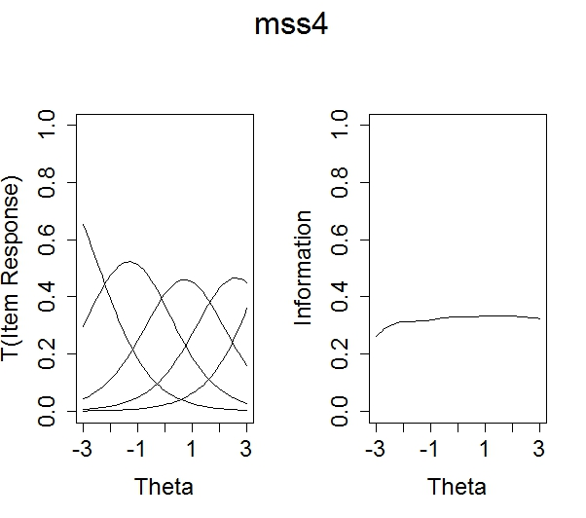
 |  |  |  |  | -2.40 | -0.22 | 1.65 | 3.54 | 0.640
MSSS24 | Pressure from others to get good grades | 0.89 | 0.54 | 0.85 | 1.82 | 0.13 | -1.28 | -2.95 | 0.644 | 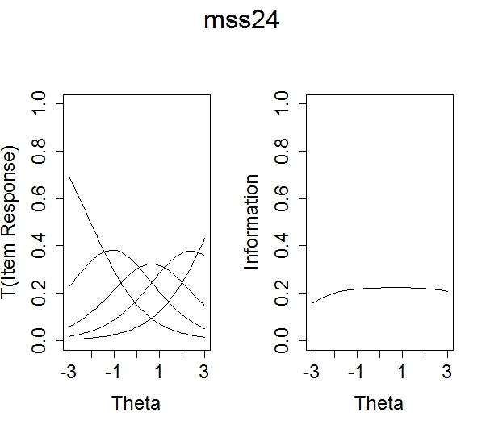
 |  |  |  |  | -2.00 | -0.14 | 1.44 | 3.32 | 0.644
MSSS2 | Difficulty asking for help | 1.37 | 0.78 | 1.24 | 3.10 | 0.30 | -2.60 | -5.19 | 0.801 | 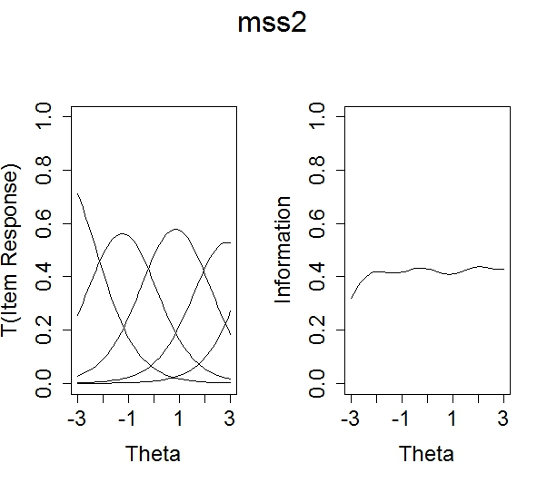
 |  |  |  |  | -2.30 | -0.22 | 1.90 | 3.79 | 0.801

MSSS12 | Feel depressed | 1.87 |  | 1.87 | 2.18 | -0.14 | -2.87 | -5.23 | 0.809 | 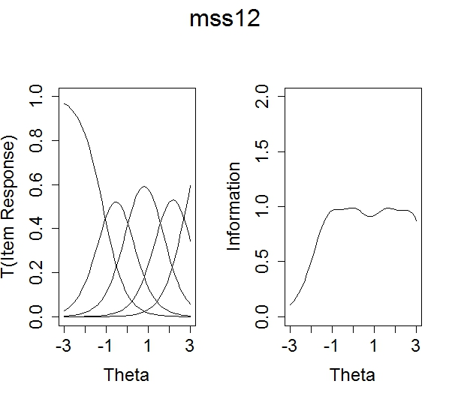
 |  |  |  |  | -1.20 | 0.07 | 1.53 | 2.79 | 0.809
MSSS7 | Unable to enjoy activities outside of classes | 1.45 |  | 1.45 | 2.10 | -0.40 | -2.14 | -4.88 | 0.922 | 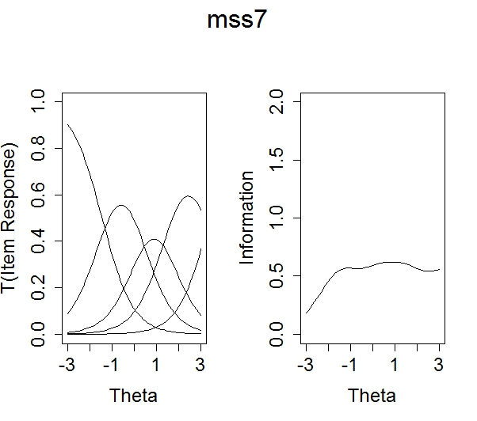
 |  |  |  |  | -1.50 | 0.28 | 1.48 | 3.38 | 0.922
MSSS21 | Unsupported by faculty | 1.47 | 2.02 | 0.94 | 3.09 | -0.54 | -3.39 | -7.24 | 1.38 | 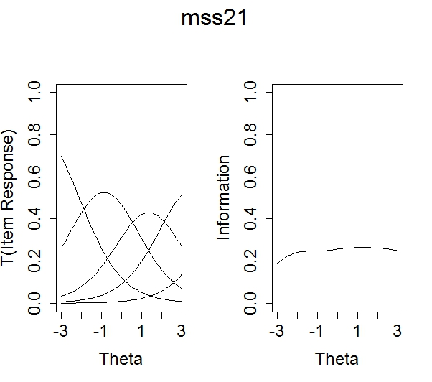
 |  |  |  |  | -2.10 | 0.37 | 2.32 | 4.94 | 1.38

MSSS19 | Unsupported by peers | 1.25 | 1.09 | 1.05 | 1.72 | -0.81 | -3.60 | -5.53 | 1.64 | 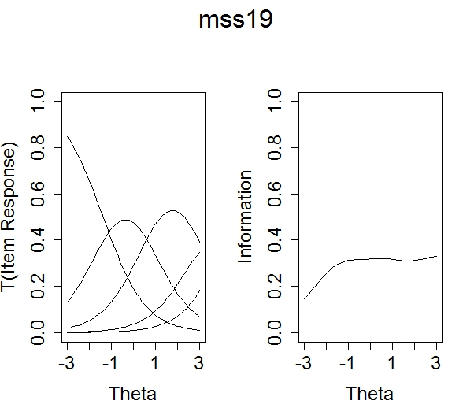
 |  |  |  |  | -1.40 | 0.651 | 2.88 | 4.42 | 1.64
MSSS11 | Hopeless ever get degree | 1.82 |  | 1.82 | -0.07 | -2.27 | -4.06 | -6.45 | 1.76 | 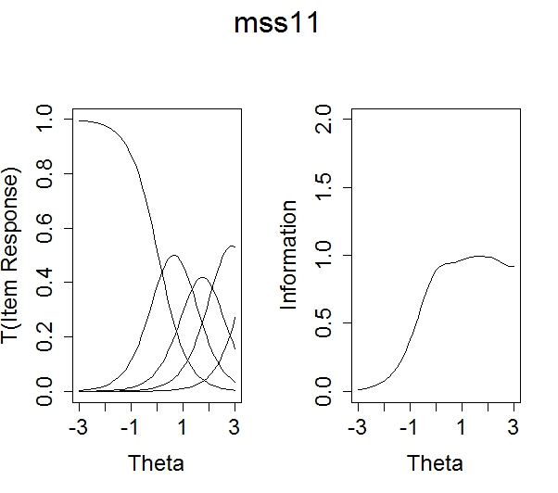
 |  |  |  |  | 0.04 | 1.24 | 2.23 | 3.54 | 1.76
MSSS34 | Think about dropping out | 1.38 |  | 1.38 | -0.08 | -1.65 | -3.09 | -5.40 | 1.85 | 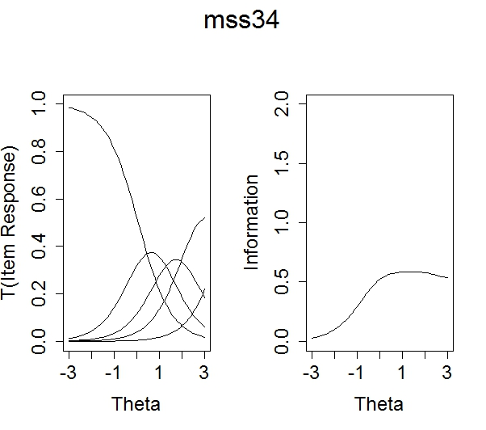
 |  |  |  |  | 0.06 | 1.20 | 2.24 | 3.92 | 1.85

MSSS22 | Feel taken advantage of by faculty | 0.68 | 1.34 | 0.54 | 0.21 | -1.92 | -3.80 | -5.27 | 3.94 | 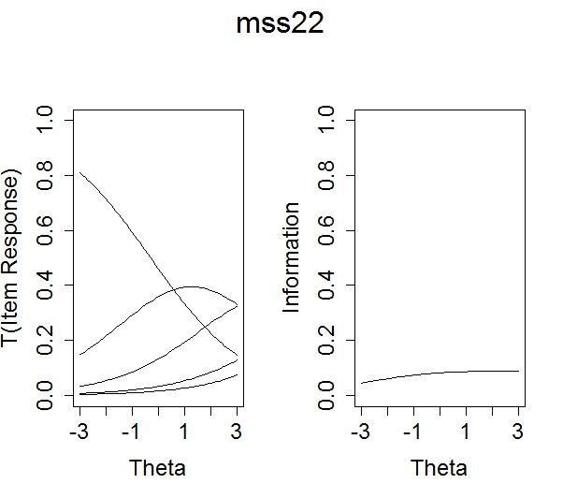
 |  |  |  |  | -0.30 | 2.81 | 5.55 | 7.71 | 3.94
Note: This presents both the bifactor parameters in slope-intercept format, with marginal slopes on the general factor and marginal thresholds, for the multidimensional elements.

Supplementary Table ST2.
Item Response Theory-Derived T-Score Conversion Table
MSSS Total  Raw Score | T-Score | Standard Deviation
0 | 10.37 | 4.72
1 | 12.66 | 4.41
2 | 14.69 | 4.19
3 | 16.53 | 4.03
4 | 18.20 | 3.90
5 | 19.74 | 3.80
6 | 21.17 | 3.71
7 | 22.50 | 3.65
8 | 23.76 | 3.59
9 | 24.94 | 3.54
10 | 26.07 | 3.50
11 | 27.15 | 3.46
12 | 28.19 | 3.43
13 | 29.19 | 3.41
14 | 30.15 | 3.38
15 | 31.10 | 3.37
16 | 32.01 | 3.35
17 | 32.91 | 3.34
18 | 33.79 | 3.32
19 | 34.65 | 3.32
20 | 35.49 | 3.31
21 | 36.32 | 3.30
22 | 37.14 | 3.30
23 | 37.95 | 3.29
24 | 38.74 | 3.29
25 | 39.53 | 3.29
26 | 40.30 | 3.28
27 | 41.07 | 3.28
28 | 41.83 | 3.28
29 | 42.58 | 3.28
30 | 43.32 | 3.28
31 | 44.06 | 3.28
32 | 44.79 | 3.28
33 | 45.51 | 3.28
34 | 46.23 | 3.28
35 | 46.95 | 3.28
36 | 47.66 | 3.28
37 | 48.37 | 3.28
38 | 49.08 | 3.28
39 | 49.78 | 3.28
40 | 50.48 | 3.28
41 | 51.18 | 3.28
42 | 51.87 | 3.28
43 | 52.57 | 3.29
44 | 53.26 | 3.29
45 | 53.95 | 3.29
46 | 54.64 | 3.30
47 | 55.33 | 3.30
48 | 56.01 | 3.30
49 | 56.70 | 3.31
50 | 57.39 | 3.32
51 | 58.08 | 3.32
52 | 58.78 | 3.33
53 | 59.47 | 3.34
54 | 60.17 | 3.35
55 | 60.86 | 3.36
56 | 61.57 | 3.38
57 | 62.27 | 3.39
58 | 62.99 | 3.41
59 | 63.70 | 3.42
60 | 64.42 | 3.44
61 | 65.15 | 3.47
62 | 65.89 | 3.49
63 | 66.63 | 3.52
64 | 67.38 | 3.55
65 | 68.14 | 3.58
66 | 68.90 | 3.62
67 | 69.68 | 3.65
68 | 70.47 | 3.69
69 | 71.26 | 3.74
70 | 72.07 | 3.78
71 | 72.89 | 3.83
72 | 73.72 | 3.88
73 | 74.56 | 3.94
74 | 75.42 | 4.00
75 | 76.30 | 4.06
76 | 77.19 | 4.12
77 | 78.11 | 4.18
78 | 79.04 | 4.25
79 | 80.01 | 4.31
80 | 81.02 | 4.37
81 | 82.06 | 4.44
82 | 83.16 | 4.49
83 | 84.32 | 4.55
84 | 85.57 | 4.60
85 | 86.92 | 4.65
86 | 88.42 | 4.70
87 | 90.11 | 4.77
88 | 92.13 | 4.90

