Supplementary Figure SF1. Study Flow

Supplementary Figure SF2. Bifactor Model
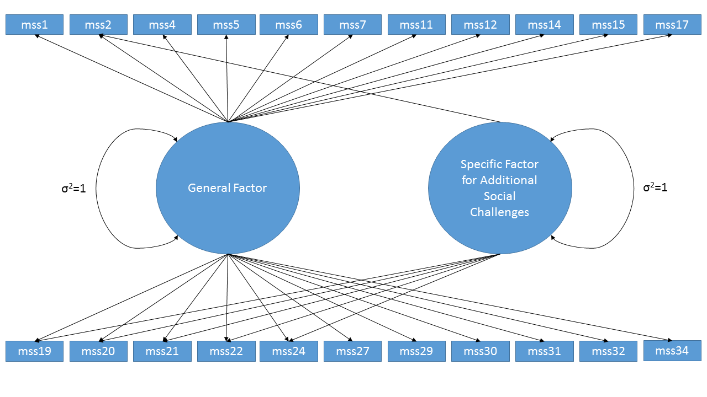

Supplementary Table ST1. Marginal IRT Parameters with Plots for Item Characteristic Curves and Item Information Curves

Item ID | Stem | Slope / Marginal Slope | CB1 | CB2 | CB3 | CB4 | Average Threshold (Difficulty) | Item Characteristic Curve
MSSS30 | Not enough time to get things done | 1.238 | -4.5 | -2.19 | -0.5 | 1.22 | -1.476 | 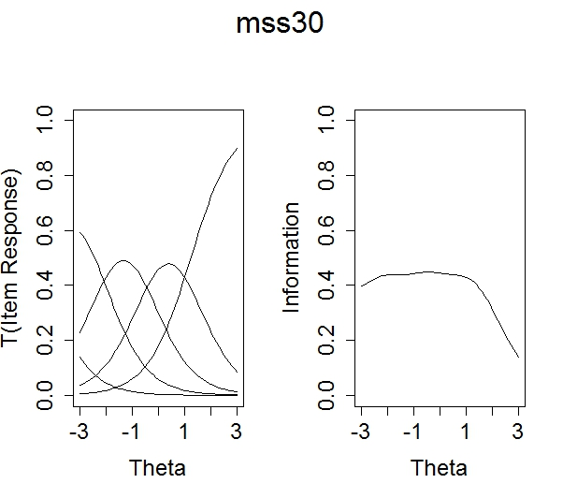
MSSS27 | Overly self-critical | 1.543 | -3.5 | -1.62 | -0 | 1.15 | -0.991 | 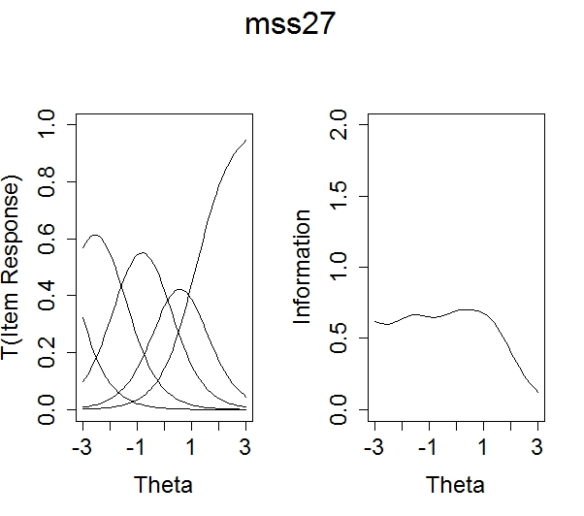
MSSS31 | Overwhelmed by everything there is to do | 2.23 | -3.0 | -1.62 | -0.3 | 1.12 | -0.945 | 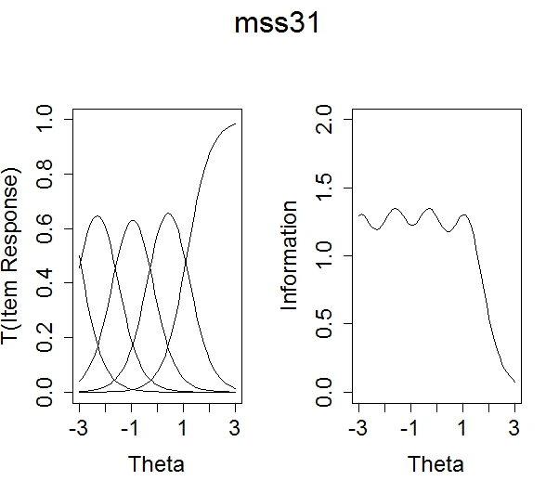
MSSS6 | Feel anxious | 1.96 | -3.0 | -1.46 | 0.12 | 1.87 | -0.630 | 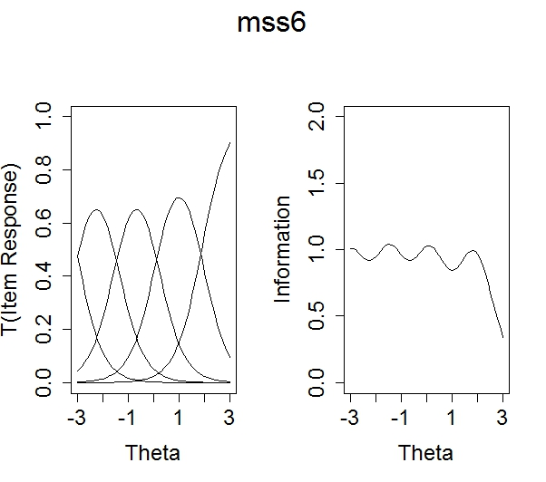
MSSS32 | Struggle maintaining school-life balance | 1.72 | -2.9 | -1.27 | 0.26 | 1.67 | -0.565 | 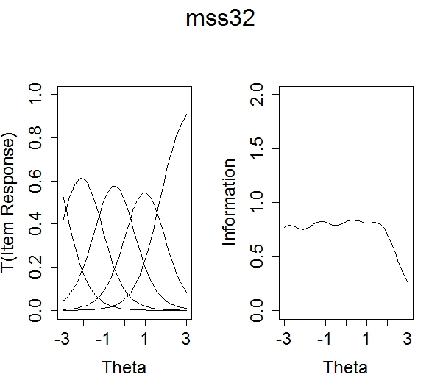
MSSS29 | Unsure of abilities as student | 1.87 | -2.3 | -1.04 | 0.35 | 1.56 | -0.351 | 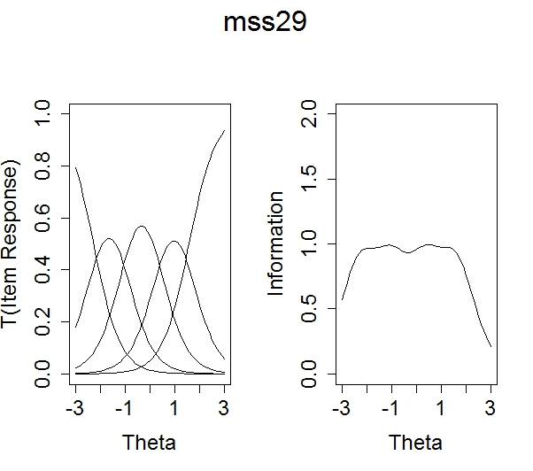
MSSS15 | Emotionally exhausted | 1.907 | -2.2 | -0.92 | 0.47 | 1.87 | -0.185 | 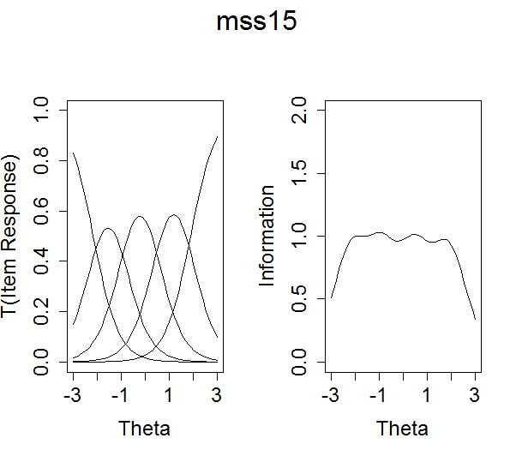
MSSS14 | Hard time motivating self to study | 1.077 | -3.1 | -1.35 | 0.97 | 3.05 | -0.116 | 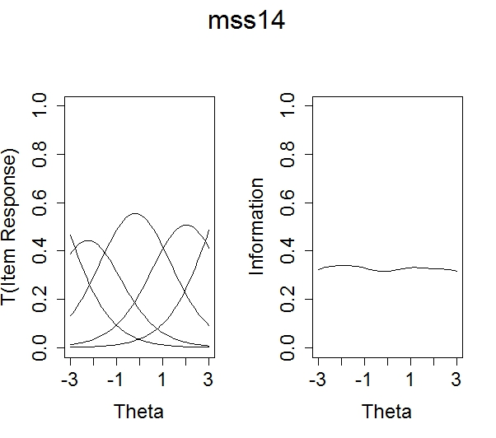
MSSS5 | Unable to relax | 1.917 | -2.2 | -0.72 | 0.73 | 2.18 | 0.002 | 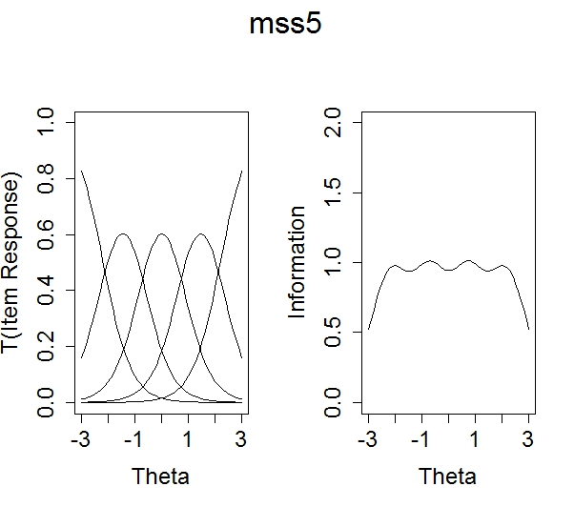
MSSS17 | Fearful of failing | 1.964 | -1.6 | -0.52 | 0.65 | 1.92 | 0.121 | 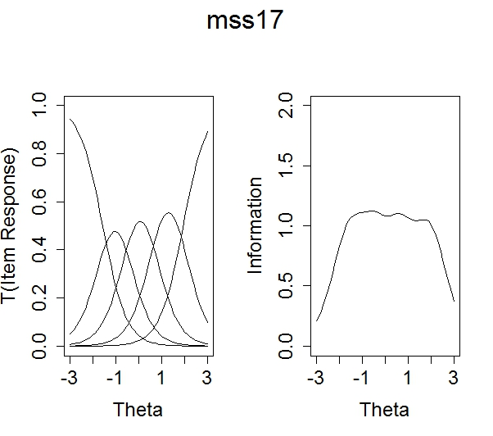
MSSS20 | Competition from peers | 0.723 | -4.3 | -0.91 | 1.7 | 4.57 | 0.258 | 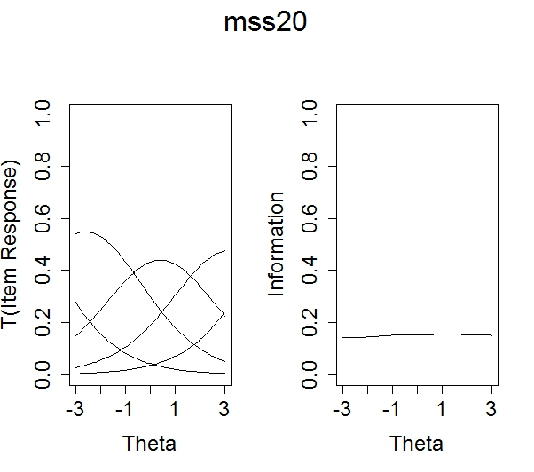
MSSS1 | Fluctuations in appetite | 1.137 | -2.1 | -0.67 | 0.97 | 3.61 | 0.449 | 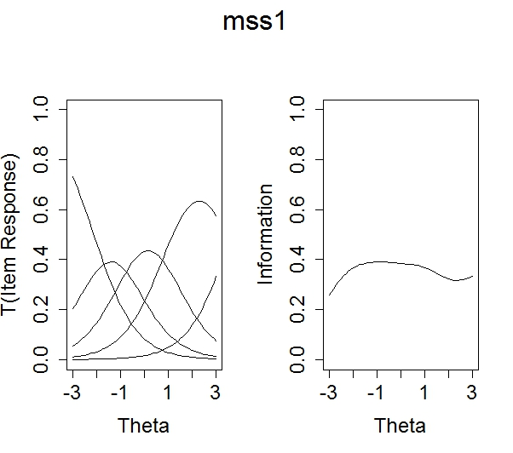
MSSS4 | Less satisfaction from learning | 1.064 | -2.4 | -0.22 | 1.65 | 3.54 | 0.640 | 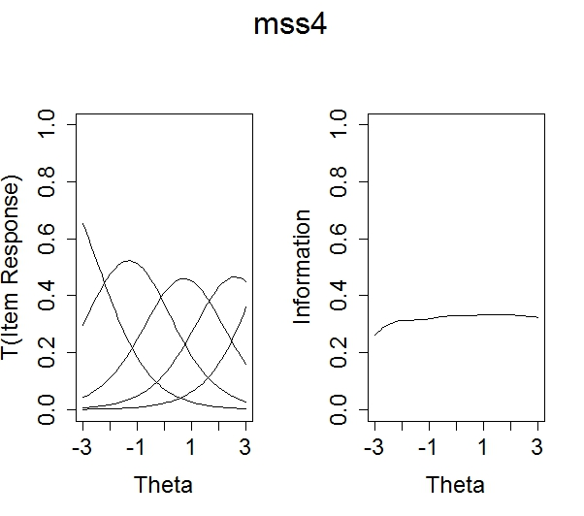
MSSS24 | Pressure from others to get good grades | 0.847 | -2.0 | -0.14 | 1.44 | 3.32 | 0.644 | 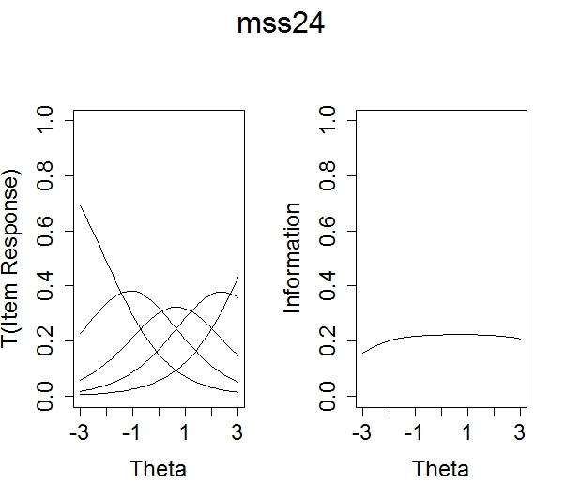
MSSS2 | Difficulty asking for help | 1.244 | -2.3 | -0.22 | 1.9 | 3.79 | 0.801 | 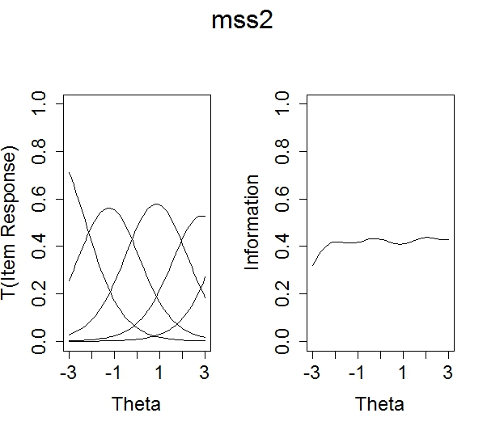
MSSS12 | Feel depressed | 1.871 | -1.2 | 0.073 | 1.53 | 2.79 | 0.809 | 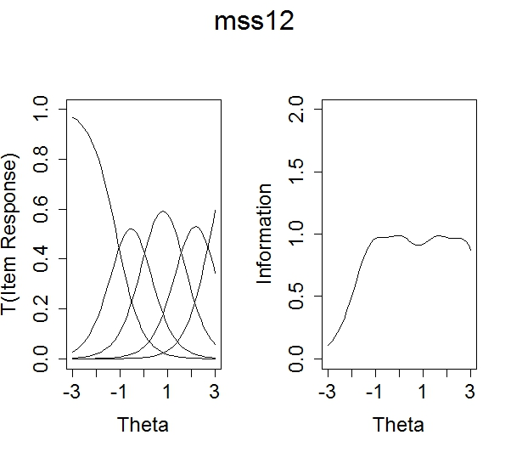
MSSS7 | Unable to enjoy activities outside of classes | 1.445 | -1.5 | 0.279 | 1.48 | 3.38 | 0.922 | 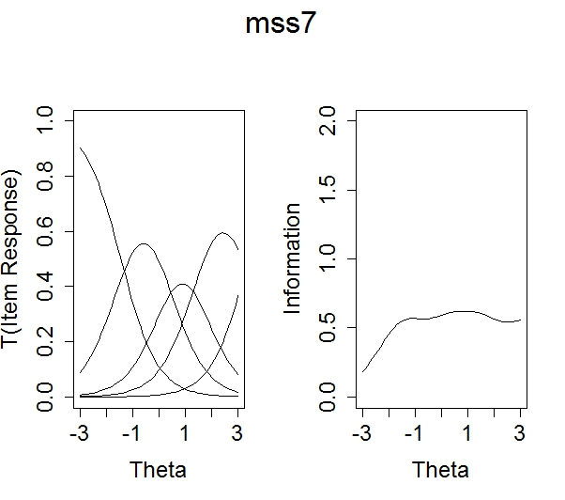
MSSS21 | Unsupported by faculty | 0.944 | -2.1 | 0.368 | 2.32 | 4.94 | 1.38 | 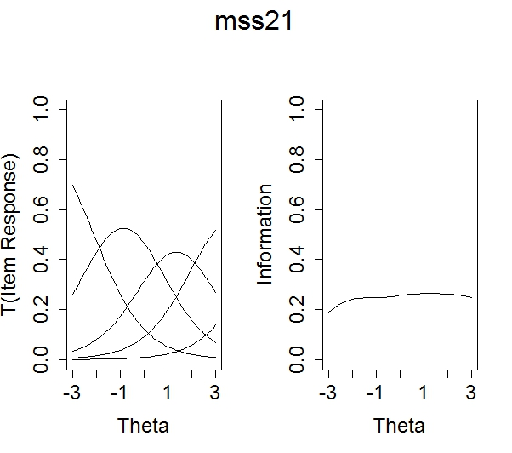
MSSS19 | Unsupported by peers | 1.053 | -1.4 | 0.651 | 2.88 | 4.42 | 1.64 | 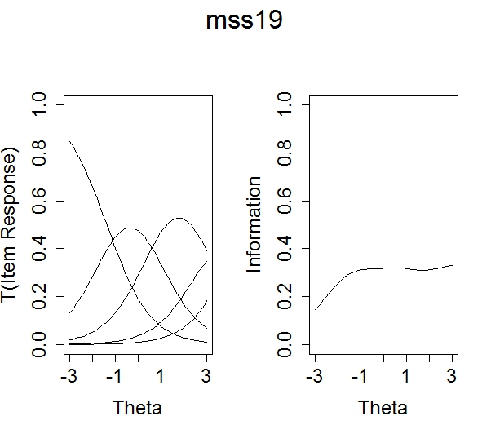
MSSS11 | Hopeless ever get degree | 1.824 | 0.04 | 1.244 | 2.23 | 3.54 | 1.76 | 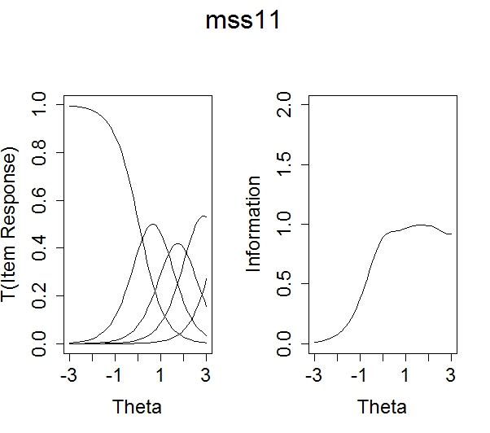
MSSS34 | Think about dropping out | 1.379 | 0.06 | 1.199 | 2.24 | 3.92 | 1.85 | 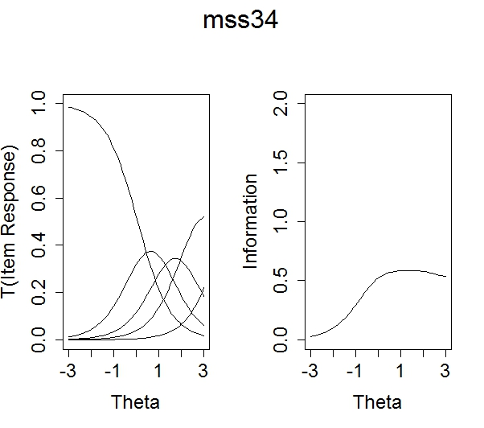
MSSS22 | Feel taken advantage of by faculty | 0.537 | -0.30 | 2.808 | 5.55 | 7.71 | 3.94 | 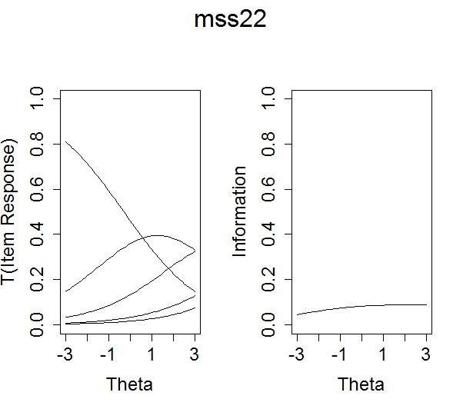
Note: The slopes are for the general factor in the bifactor model. For items that only represent the general factor, these are identical to the unidimensional case. For items that also load on the specific factor for social challenges, these are marginal slopes on the general factor, following Stucky et al. (2013).

Supplementary Table ST2.
Item Response Theory-Derived T-Score Conversion Table
MSSS Total  Raw Score | T-Score | Standard Deviation
0 | 10.37 | 4.72
1 | 12.66 | 4.41
2 | 14.69 | 4.19
3 | 16.53 | 4.03
4 | 18.20 | 3.90
5 | 19.74 | 3.80
6 | 21.17 | 3.71
7 | 22.50 | 3.65
8 | 23.76 | 3.59
9 | 24.94 | 3.54
10 | 26.07 | 3.50
11 | 27.15 | 3.46
12 | 28.19 | 3.43
13 | 29.19 | 3.41
14 | 30.15 | 3.38
15 | 31.10 | 3.37
16 | 32.01 | 3.35
17 | 32.91 | 3.34
18 | 33.79 | 3.32
19 | 34.65 | 3.32
20 | 35.49 | 3.31
21 | 36.32 | 3.30
22 | 37.14 | 3.30
23 | 37.95 | 3.29
24 | 38.74 | 3.29
25 | 39.53 | 3.29
26 | 40.30 | 3.28
27 | 41.07 | 3.28
28 | 41.83 | 3.28
29 | 42.58 | 3.28
30 | 43.32 | 3.28
31 | 44.06 | 3.28
32 | 44.79 | 3.28
33 | 45.51 | 3.28
34 | 46.23 | 3.28
35 | 46.95 | 3.28
36 | 47.66 | 3.28
37 | 48.37 | 3.28
38 | 49.08 | 3.28
39 | 49.78 | 3.28
40 | 50.48 | 3.28
41 | 51.18 | 3.28
42 | 51.87 | 3.28
43 | 52.57 | 3.29
44 | 53.26 | 3.29
45 | 53.95 | 3.29
46 | 54.64 | 3.30
47 | 55.33 | 3.30
48 | 56.01 | 3.30
49 | 56.70 | 3.31
50 | 57.39 | 3.32
51 | 58.08 | 3.32
52 | 58.78 | 3.33
53 | 59.47 | 3.34
54 | 60.17 | 3.35
55 | 60.86 | 3.36
56 | 61.57 | 3.38
57 | 62.27 | 3.39
58 | 62.99 | 3.41
59 | 63.70 | 3.42
60 | 64.42 | 3.44
61 | 65.15 | 3.47
62 | 65.89 | 3.49
63 | 66.63 | 3.52
64 | 67.38 | 3.55
65 | 68.14 | 3.58
66 | 68.90 | 3.62
67 | 69.68 | 3.65
68 | 70.47 | 3.69
69 | 71.26 | 3.74
70 | 72.07 | 3.78
71 | 72.89 | 3.83
72 | 73.72 | 3.88
73 | 74.56 | 3.94
74 | 75.42 | 4.00
75 | 76.30 | 4.06
76 | 77.19 | 4.12
77 | 78.11 | 4.18
78 | 79.04 | 4.25
79 | 80.01 | 4.31
80 | 81.02 | 4.37
81 | 82.06 | 4.44
82 | 83.16 | 4.49
83 | 84.32 | 4.55
84 | 85.57 | 4.60
85 | 86.92 | 4.65
86 | 88.42 | 4.70
87 | 90.11 | 4.77
88 | 92.13 | 4.90

