Supplementary information

Optically-boosted planar IBC Solar Cells with Electrically-harmless Photonic Nanocoatings
I. M. Santos^{1,}*, M. Alexandre¹, V. D. Mihailetchi², T. Mateus¹, A. Mouquinho¹, J. Boane¹, A. T. Vicente¹, D. Nunes¹, U. D. Menda¹, H. Águas¹, E. Fortunato¹, R. Martins¹, M. J. Mendes^{1,}*
¹CENIMAT/I3N, Departamento de Ciência dos Materiais, Faculdade de Ciências e Tecnologia (FCT),
Universidade Nova de Lisboa, and CEMOP/UNINOVA, 2829-516 Caparica, Portugal;
²International Solar Energy Research Center (ISC) Konstanz, Rudolf-Diesel-Str. 15, D-78467 Konstanz, Germany
* Corresponding authors: imi.santos@campus.fct.unl.pt, mj.mendes@fct.unl.pt

Section S1. Atomic Force Microscopy analysis
The top-view morphology measured via Atomic Force Microscopy (AFM) of the TiO₂ photonic coatings of the best-performing samples (in terms of average absorption, $〈Abs〉$, and photocurrent density, $J_{ph}$) is presented in Fig. S1. We correlated the structures’ average height (see bottom height profiles) with the equivalent TiO₂ film thickness deposited on the c-Si wafers.
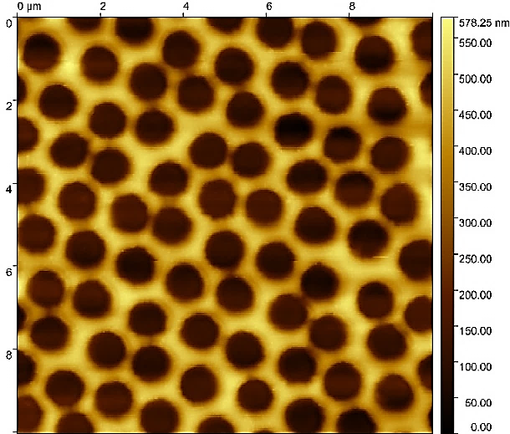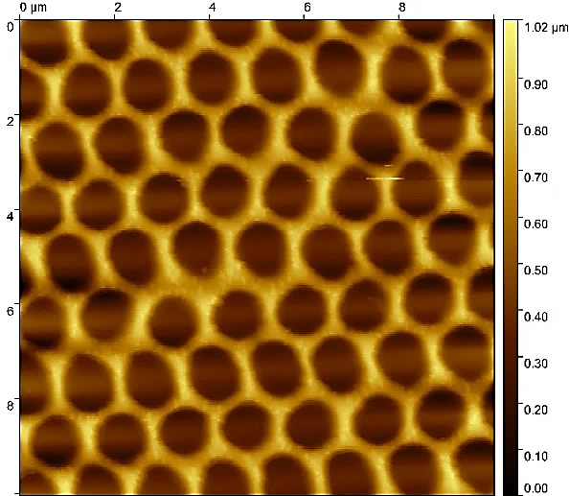
Fig. S1 | Atomic Force Microscopy (AFM) of the nanostructured designs on conventional (250 µm thick) c-Si wafers. a,b AFM top-views of the coatings with the highest average absorption (a1, a2) and photocurrent density (b1, b2). (a1) Nanostructure formed with 0.430 µm of TiO₂ equivalent film thickness, where it was obtained an average height of the TiO₂ features of $0.429±0.070$ nm, which was determined using the data from (a2) height profile corresponding to the dashed line in (a1); (b1) equivalent film thickness of 0.793 µm of TiO₂, with obtained average features’ height of $0.669±0.055$ nm, determined using the data from (b2) height profile corresponding to the dashed line in (b1). Both are resultant of 300 seconds of reactive ion etching (O₂) time applied in the second step of the colloidal lithography process.
a1
b1
a2
b2
As seen in the bottom profiles of Fig. S1, the AFM tip did not penetrate completely through the voids, so it did not follow their smooth curvature. Still, the determined average heights of the photonic features match what was expected for the respective TiO₂ deposition times.

Section S2. Optical assessment of c-Si wafers and IBC solar cells
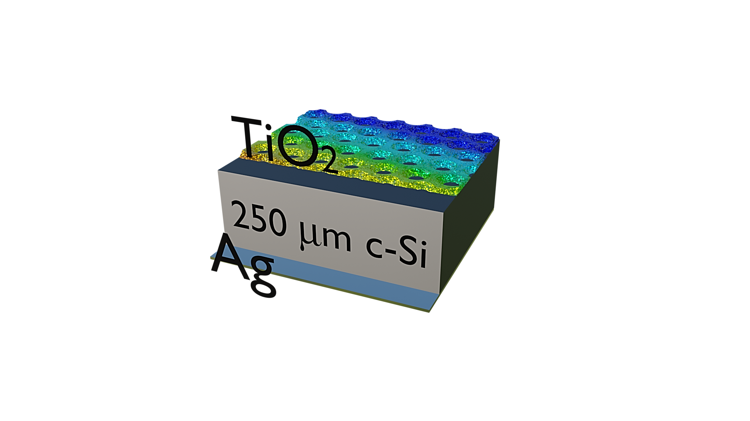
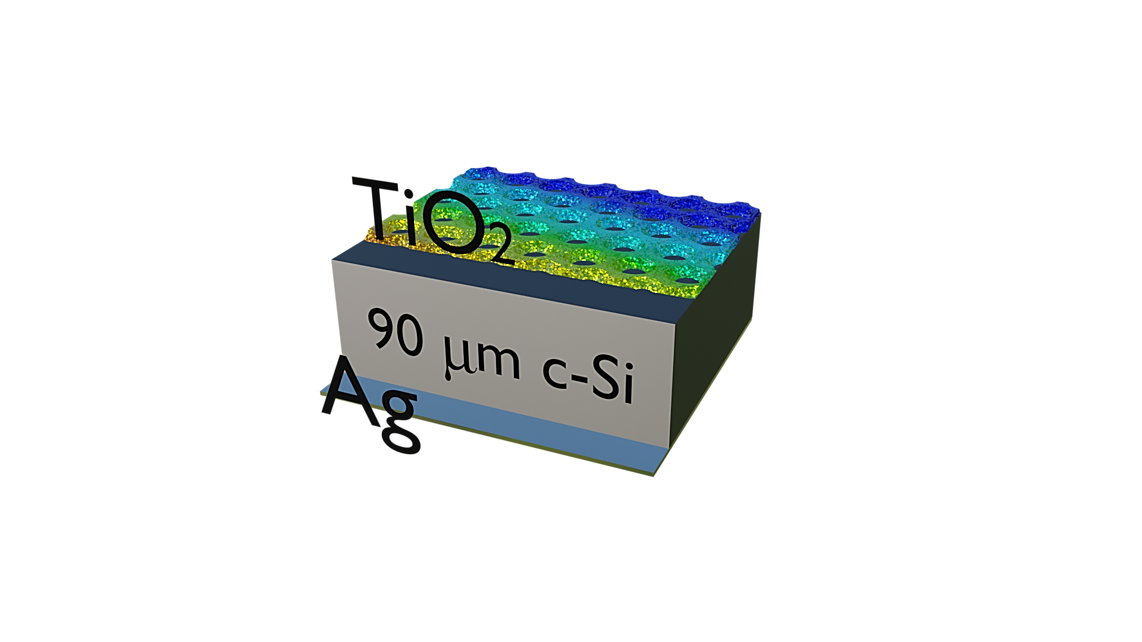
Figure S2 presents the optical spectra complementary to the main manuscript, specifically the transmittance and reflectance of conventional (250 µm, a and c) and thin (90 µm, b and d) c-Si wafers (with and without an Ag mirror layer at the rear side), as well as planar interdigitated back-contact solar cells (pIBCSCs, e and f), both with and without (reference) TiO₂ photonic coatings.
Fig. S2 | Supporting optical assessment of conventional (250 µm, a-c) and thin (90 µm, b-d) c-Si wafers and planar interdigitated back contact solar cells (pIBCSCs) with and without the nanostructured coatings (e-f). a,b Transmittance spectra of representative batches of (a) conventional and (b) thin c-Si wafers with TiO₂ thickness of 693 nm, for different O₂ reactive ion etching times ($t_{RIE}$). c,d Reflectance spectra correspondent to the samples of a,b but with ~300 nm of Ag rear mirror. e, f Reflectance and transmittance spectra of the IBCSCs with nanocoatings on top, for different TiO₂ thicknesses and $t_{RIE}$.
a
b
c
d
e
f

TiO₂
180 µm
n-type c-Si
n⁺ Si

n⁺
p⁺
Ag
SiO₂

