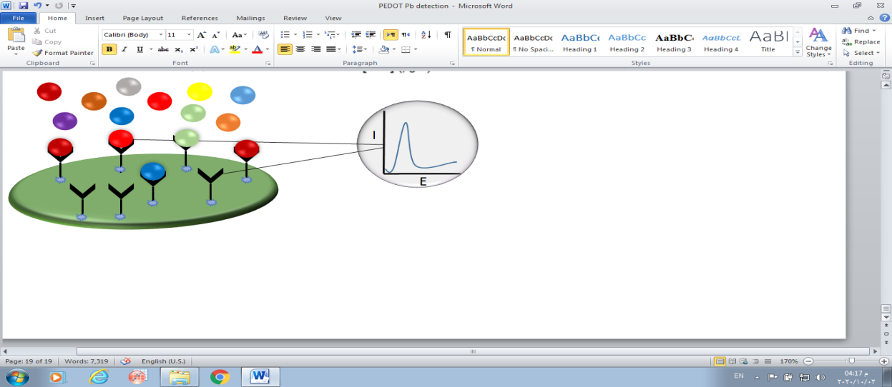
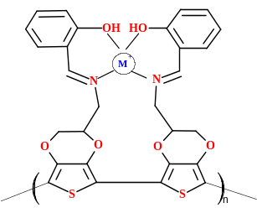
Metal ions
Reactive sites
Receptor/ ligand
Poly EDOT/ Schiff electrode
Square wave voltammetry
Computer processing

