Online supplement 3 – Figure: P/F ratio at different experimental conditions
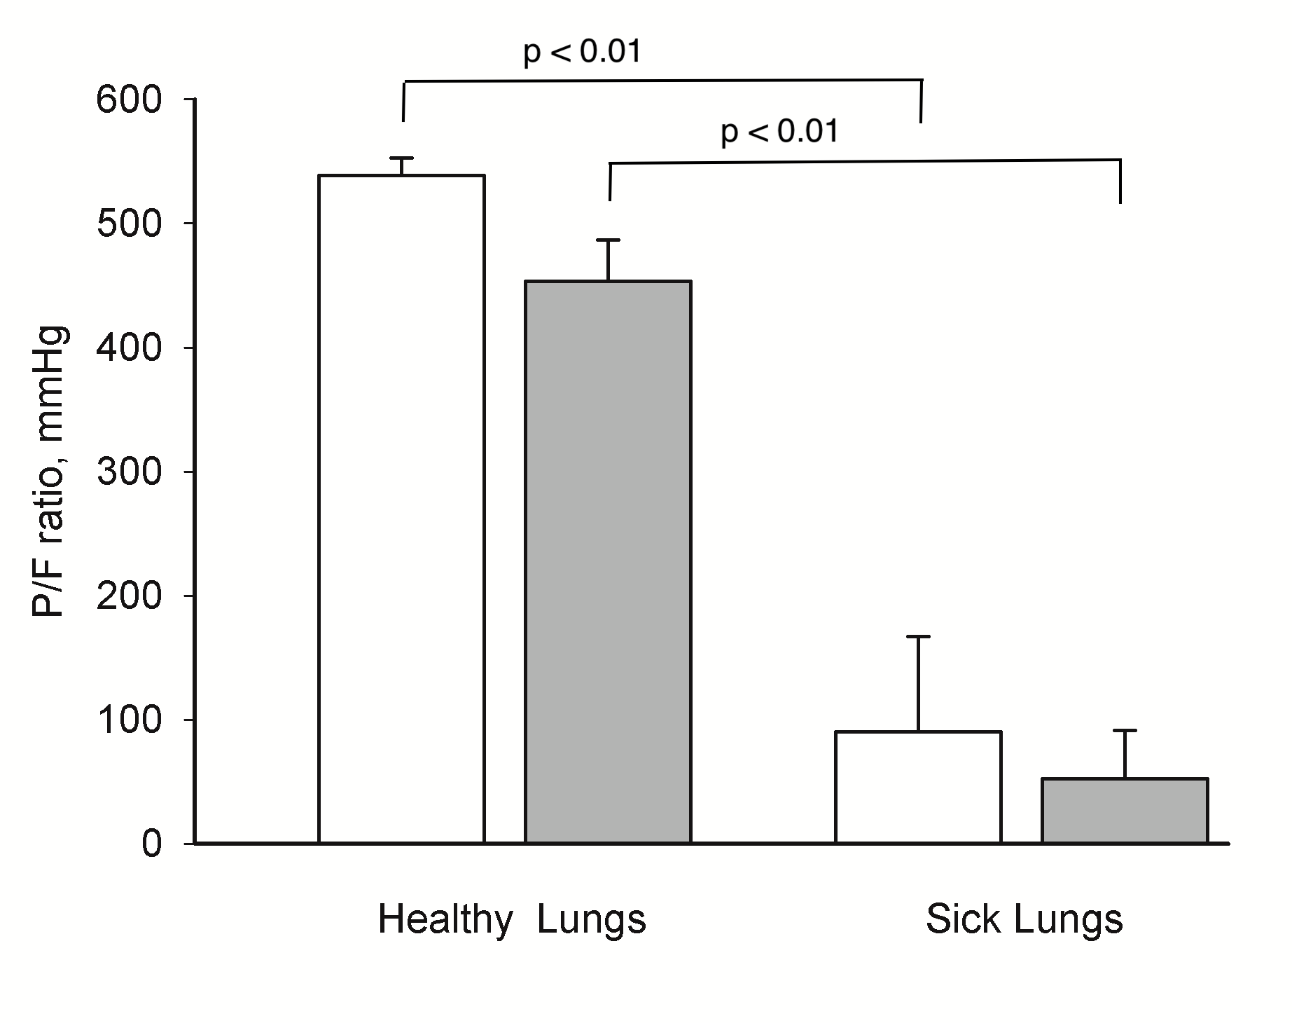
Arterial oxygen tension/fractional inspiratory concentration of oxygen (P/F ratio) in mmHg before (Healthy Lungs) and after oleic acid was given (lung injury). White and grey bars represent before (baseline) and after abdominal inflation (intra-abdominal hypertension) respectively. Mean and SE are shown. Mixed linear model was applied. Overall intra-abdominal hypertension (p=0.01) and oleic acid (p <0.01) decreased oxygenation. Only oleic acid decreased oxygenation (p<0.01) when comparing the different settings.

