Supplementary figure 1. The expression of ATAT1 after shRNA interference.

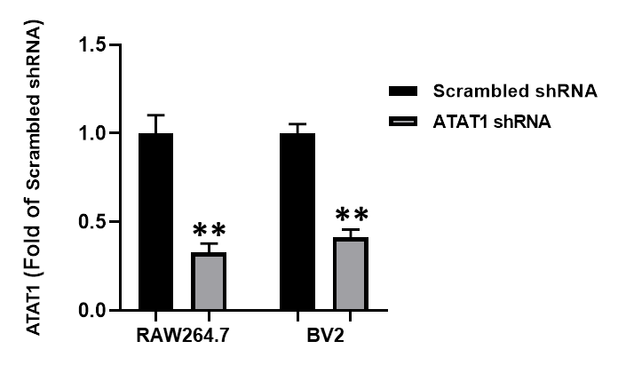

Figure legend. Quantification data of the ATAT1 expression after shRNA interference using qRT-QPCR. Data are shown as the mean ± SEM (n = 3 independent cell cultures). **P < 0.01 (two-tailed Student’s t-test).

