Supplementary Information

26.7% efficiency silicon heterojunction solar cells achieved by electrically optimized nanocrystalline-silicon hole contact layers
Hao Lin^{1,2,4}, Miao Yang ^{1,4}, Xiaoning Ru^{1,4}, Genshun Wang^{1,2}, Shi Yin¹, Fuguo Peng¹, Chengjian Hong¹, Minghao Qu¹, Junxiong Lu¹, Liang Fang¹, Can Han^{2,3}, Paul Procel Moya³, Olindo Isabella³, Pingqi Gao², Zhenguo Li¹, Xixiang Xu¹
¹LONGi Green Energy Technology Co., Ltd., Xi’an 710016, China, LONGi Central R&D Institute, Xi’an, 712000, China; ²School of Materials, Institute for Solar Energy Systems, Sun Yat-sen University, Guangzhou, 510275, China; ³Photovoltaic Materials and Devices Group, Delft University of Technology, Delft, the Netherlands. ⁴These authors contributed equally: Hao Lin, Miao Yang, Xiaoning Ru. e-mail: yinshi@longi.com, gaopq3@mail.sysu.edu.cn, xuxixiang@longi.com

Supplementary Tables
Table S1 | The PV performance of SHJ solar cells with p-nc-Si:H based HSCs.¹⁻⁵
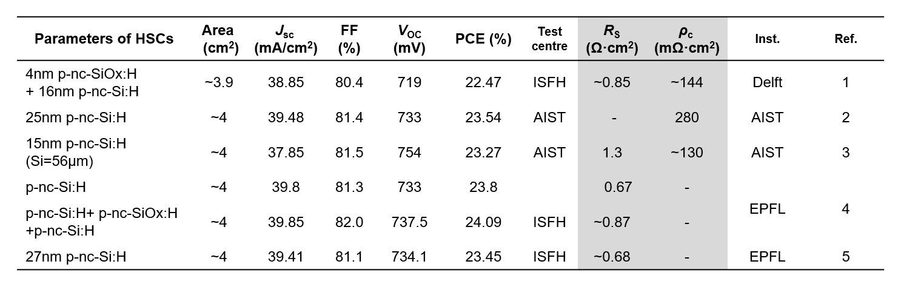

Table S2 | The PV performance of crystal silicon solar cells in Fig. 1.⁶⁻¹⁵
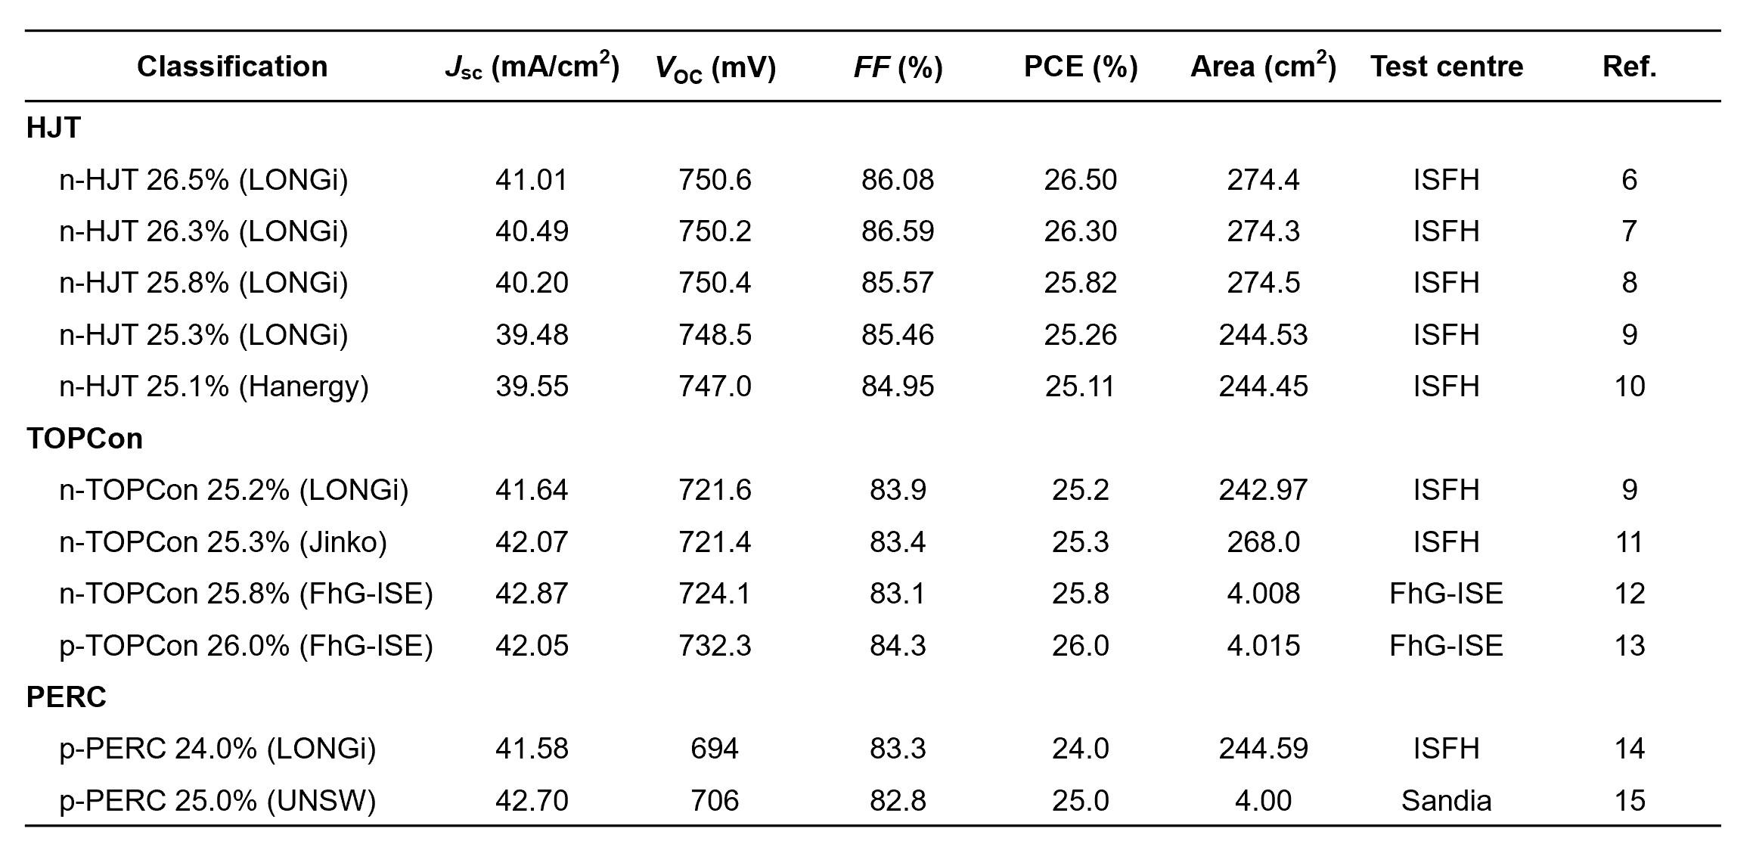

Table S3| Parameters of the functional layers used for fabrication of cell ① and cell ② in Fig. 2.
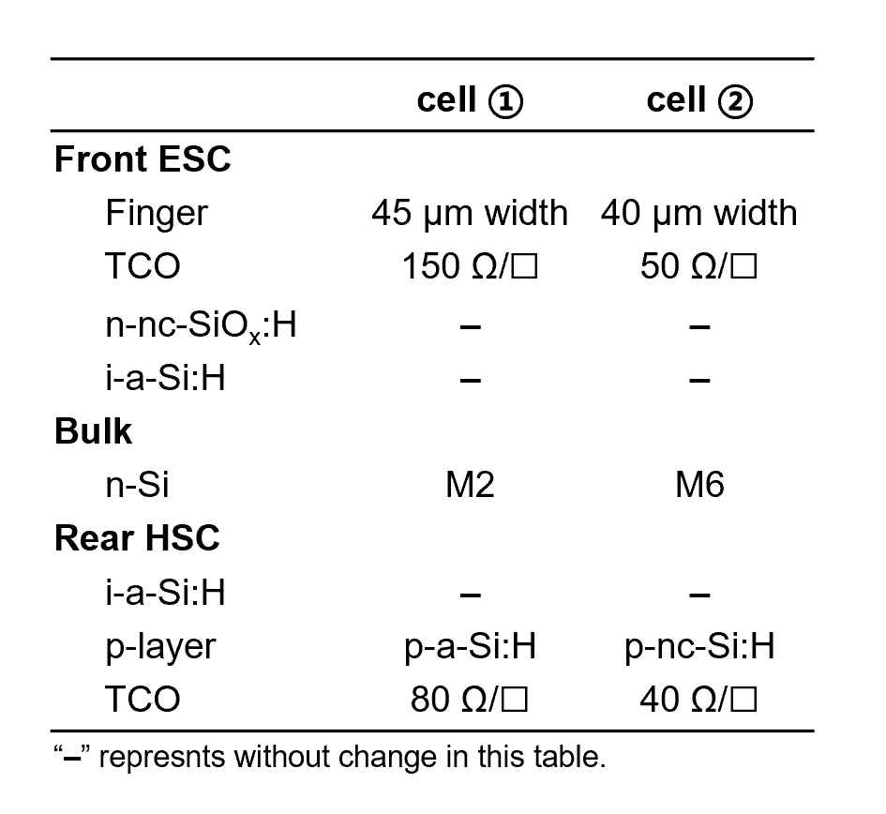

Table S4| Input parameters of Quokka2 simulation for cell ① and cell ②. ¹⁶
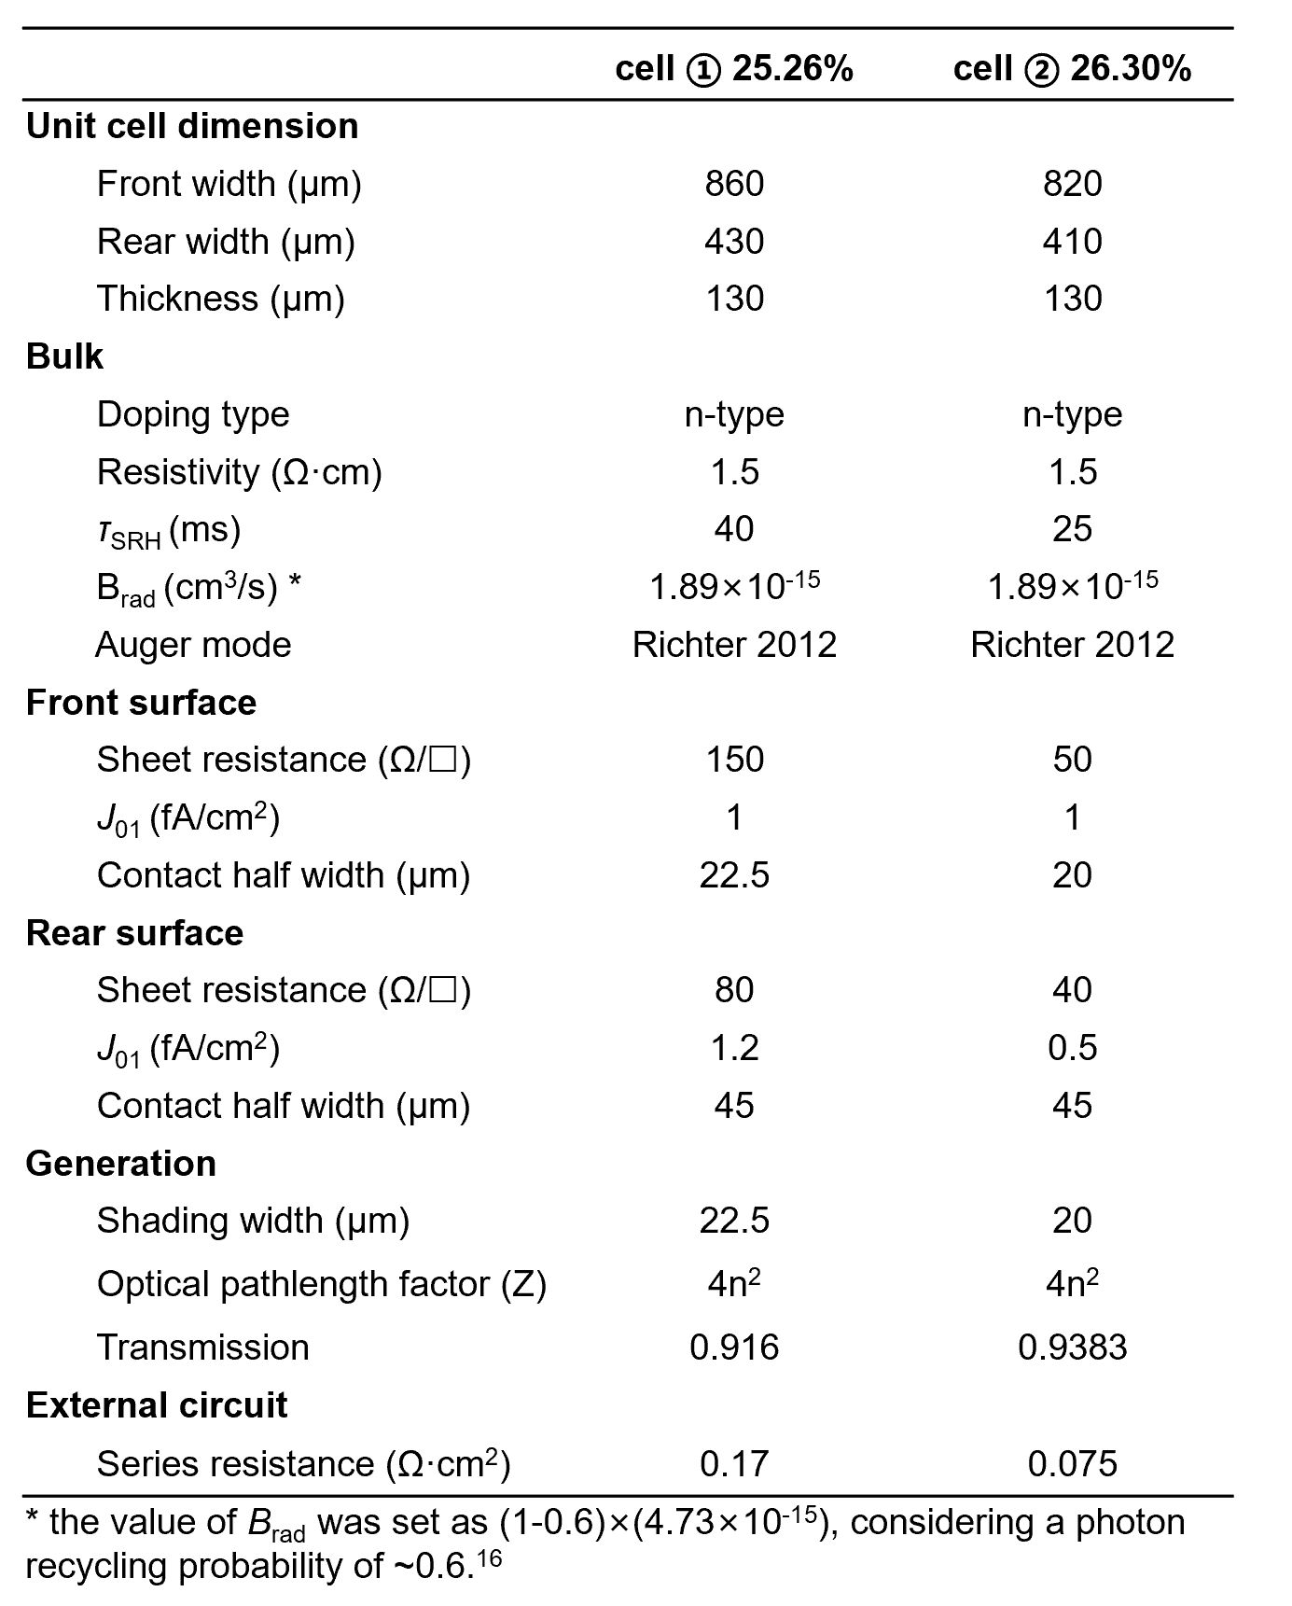

Table S5 | The growth recipes of the p1-p4 in Fig. S3.
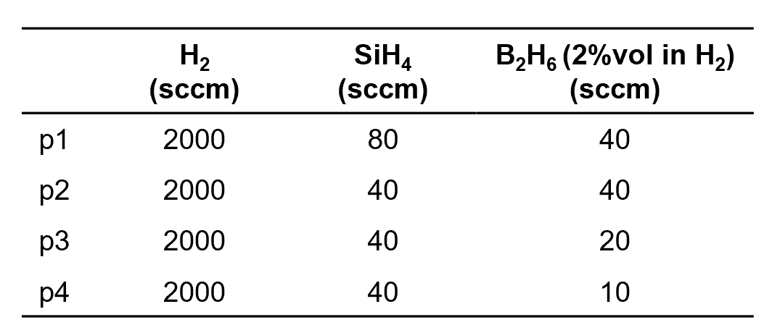

Table S6 | Input parameters of TCAD simulation used for calculating band diagrams (Fig. 3e and 3f) and dark I-V curves (Fig. S4) of HSCs based on p-nc-Si:H and p-a-Si:H.¹⁷⁻²⁰
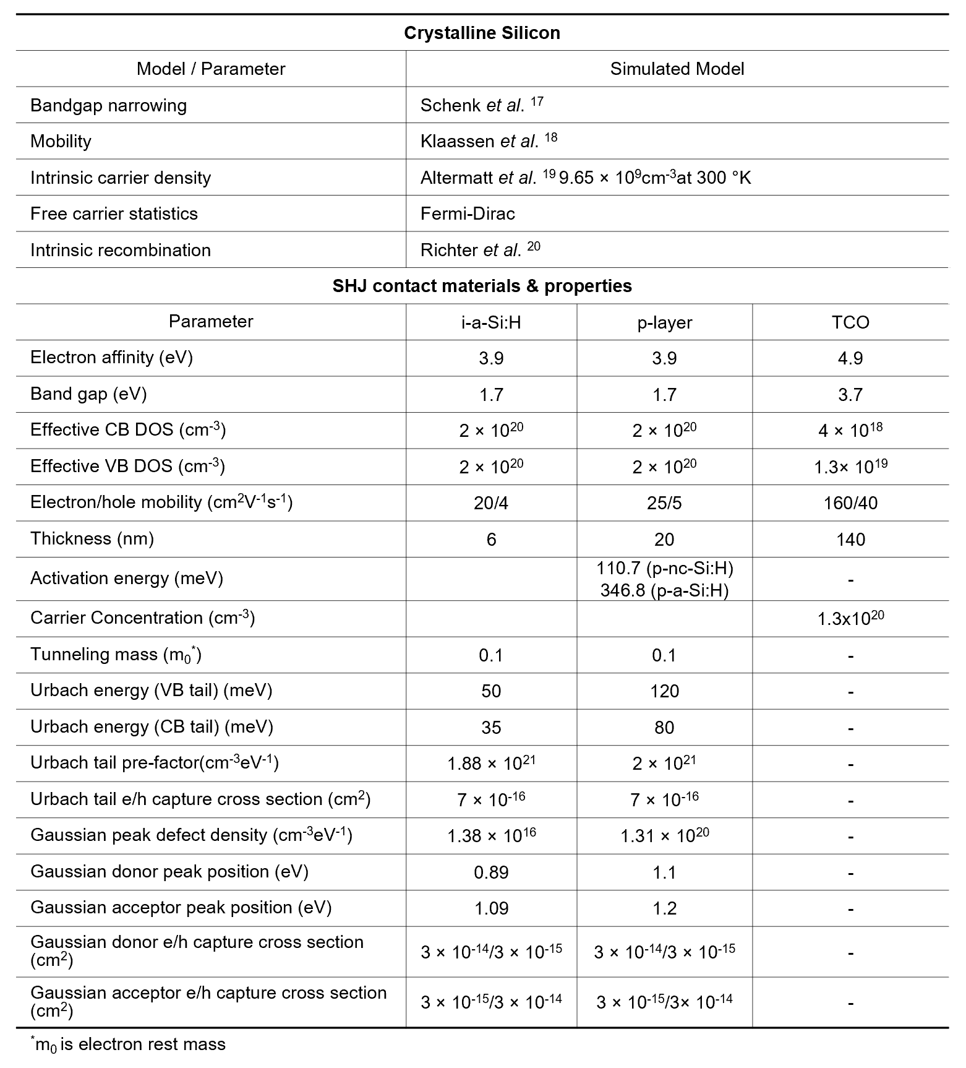

Supplementary Figures

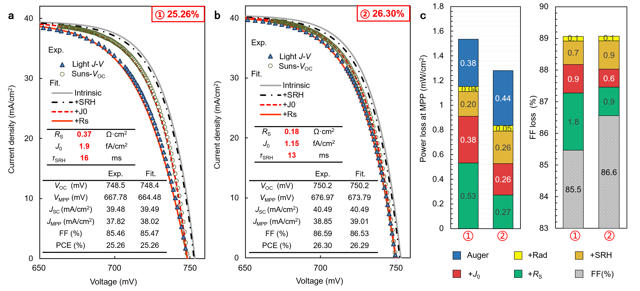 Fig. S1 | Electrical performance analysis by simple recombination model. a-b, The experimental (Exp.) and fitted (Fit.) J-V curves for 25.26%-PCE and 26.30%-PCE solar cells, respectively. Experimental curves include light J-V and Suns-V_{OC} curves. When fitting curves, the ‘Intrinsic’, ‘+SRH’, ‘+J₀’, and ‘+R_{S}’ mean that the influence of intrinsic recombination, SRH recombination, other recombination (J₀, mainly from surface recombination)²¹ and series resistance (R_{S}) are considered one by one in the simulation equations. The intrinsic recombination here contains the Auger recombination and the Radiative (Rad) recombination with a photon recycling of ~0.6.¹⁶ The inset tables from up to down show the fitting parameters and photovoltaic (PV) parameters, respectively. c, The power loss analysis (PLA) at MPP and FF loss analysis according to the fitting curves in a and b.
As shown in Figs. S1a and S1b, the experimental curves and the corresponding PV parameters are both highly consistent with the theoretical ones. The fitting parameters from experiments, such as R_{S} and J₀, are consistent with the results of Quokka simulation, proving high reliability and accuracy. Here, Auger recombination model by Black et al.²² , rather than Richter’ 2012 model²⁰ was used for simulation to avoid underestimation of SRH recombination of bulk silicon (overestimates the Auger recombination near the MPP for the doped Si substrate)²³. According to the experiments, the wafer thickness and the doping density are set to 130 µm and 3.23×10¹⁵ cm⁻³, respectively. It should mention that R_{S} is not a fixed value but a variable parameter changing with the applied voltage. Therefore, compensation was directly introduced according to the change of the silicon wafer conductivity that was caused by the variations in excess carrier concentration driven by applied voltages.
In contrast to the results demonstrated in Fig. 2, the information of intrinsic recombination is shown in Fig. S1c. The power loss of intrinsic recombination is close to ~0.4 mW for both cells, which is non-negligible. Due to a better evaluation of the Auger recombination by Black et al., the proportion of power loss analysis (PLA) from SRH recombination increases to ~0.2 and ~0.26 mw/cm² for cell ① and cell ②, respectively. The trend of other power losses is basically consistent with those in Fig. 2. To directly examine the influence of power loss on FF, the FF loss analysis is shown in the right of Fig. S1c. Obviously, the final FF is affected by recombination and R_{S}. The pseudo FF (pFF) contains the information from all recombination losses in absence of the effect of R_{S}. It is clearly seen that both cells have a nearly same pFF (at the interface of red and green squares) of about 87.3%. Of course, a slightly higher surface recombination in cell ① and a little bit higher SRH recombination in cell ② were found, solely indicating a small variation in surface passivation and wafer quality turn by turn. Therefore, the large difference in R_{S} is the main reason responsible for the large difference of the final FF. In combination with the huge reduction in the R_{S} after nano-crystallization (Fig.2d), it proves again that the key role of p-nc-Si:H in achieving high FF.

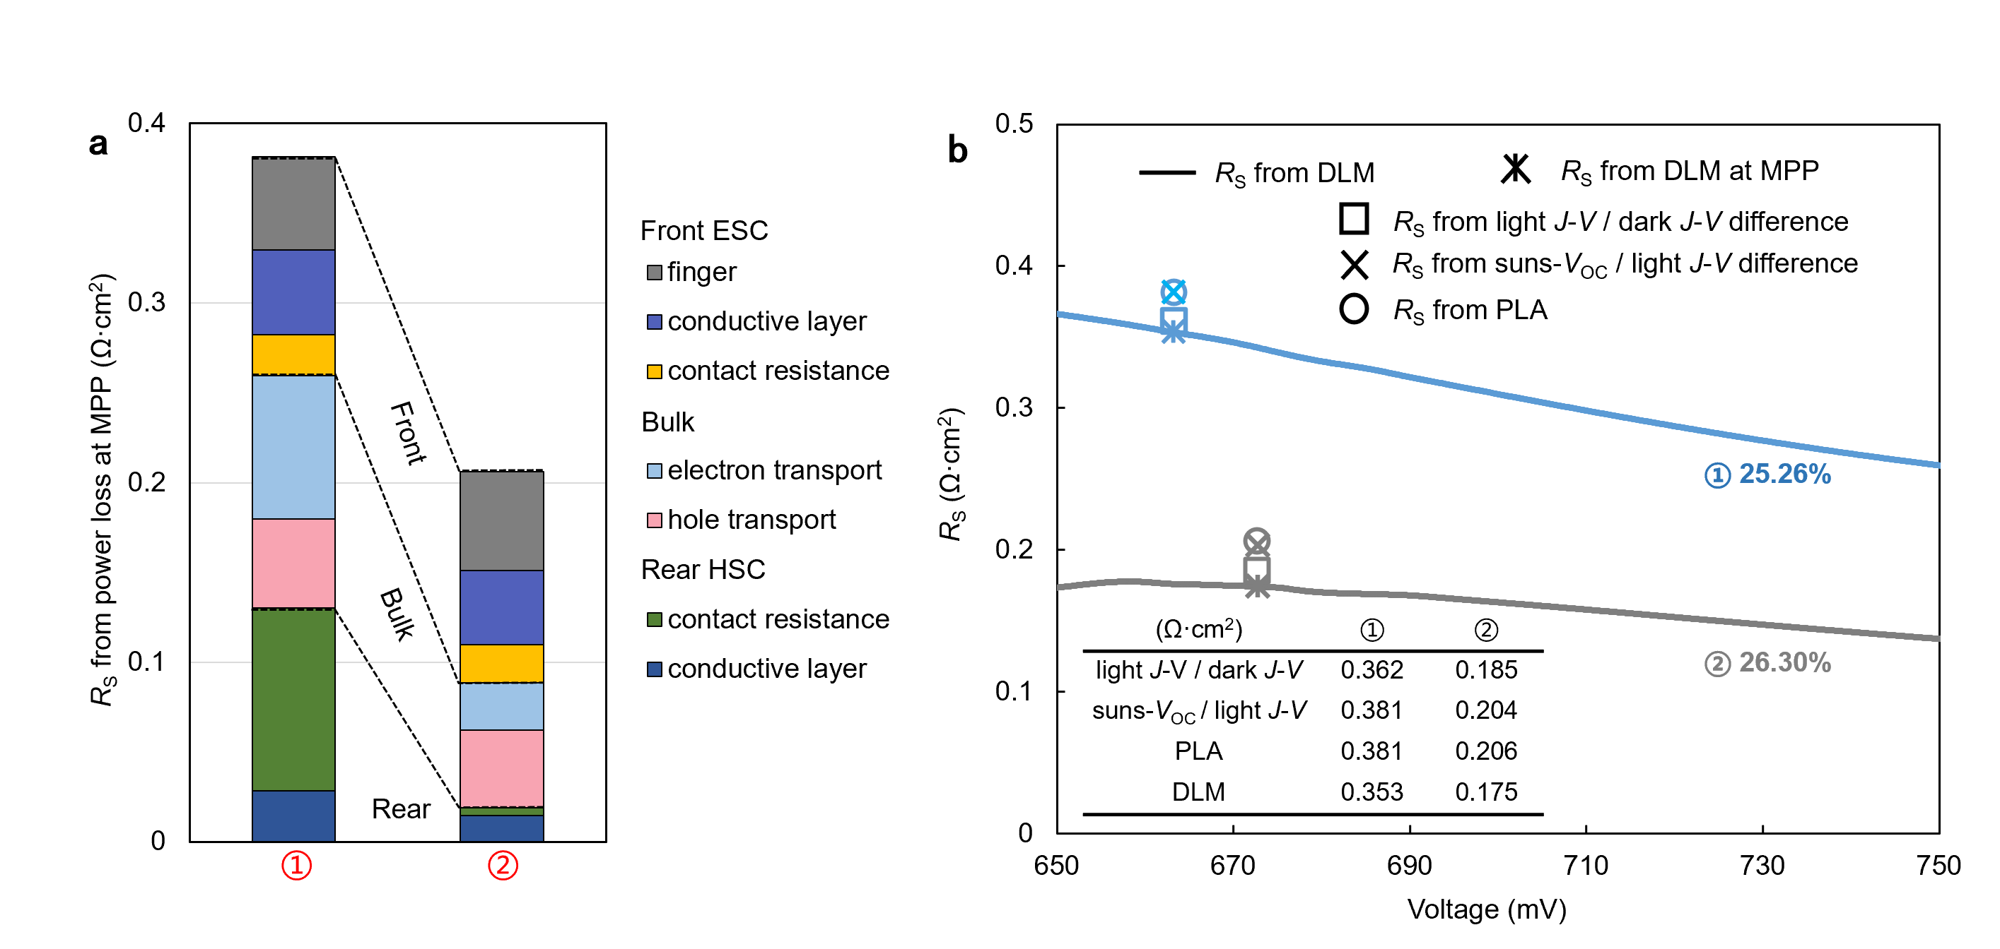
Fig. S2 | Analysis of R_{S} for 25.26% and 26.30% - PCE solar cells. a, The R_{S} loss analysis derived from the fitted J-V curves in Figs. 2b and 2c. b, The extracted R_{S} at MPP. Four well-known methods, 1) comparison of a one-sun with a dark J-V curve, 2) comparison of a Suns-V_{OC} with a one-sun J-V curve, 3) calculated from PLA, 4) comparison of two J-V curves measured at different illumination intensities (named double light method, DLM),²⁴ are utilized to extract R_{S}, as shown in the inset Table. All data are extracted from fitted J-V curves in Figs. 2b and 2c.

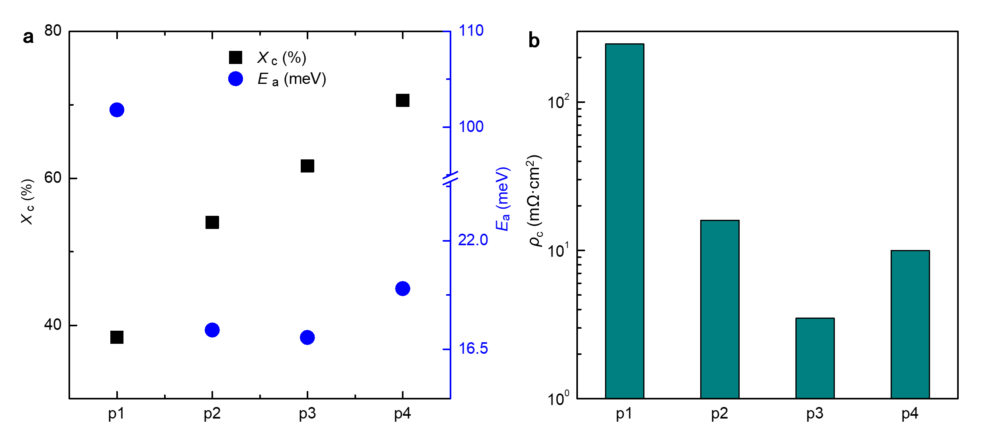
Fig. S3 | Optimization of HSCs based on p-nc-Si:H. a, The variation of crystalline volume fraction (X_{C}) and activation energy (E_{a}) with the different growth recipes. b, The contact resistance of HSCs based on p-nc-Si:H with the different growth recipe. Here, the samples for testing E_{a} utilize planar glass as substrate, while the measurement of contact resistance is Cox and Strack method (CSM). The details of growth recipes, labeled by p1~p4 in figure, is showed in Table S5.
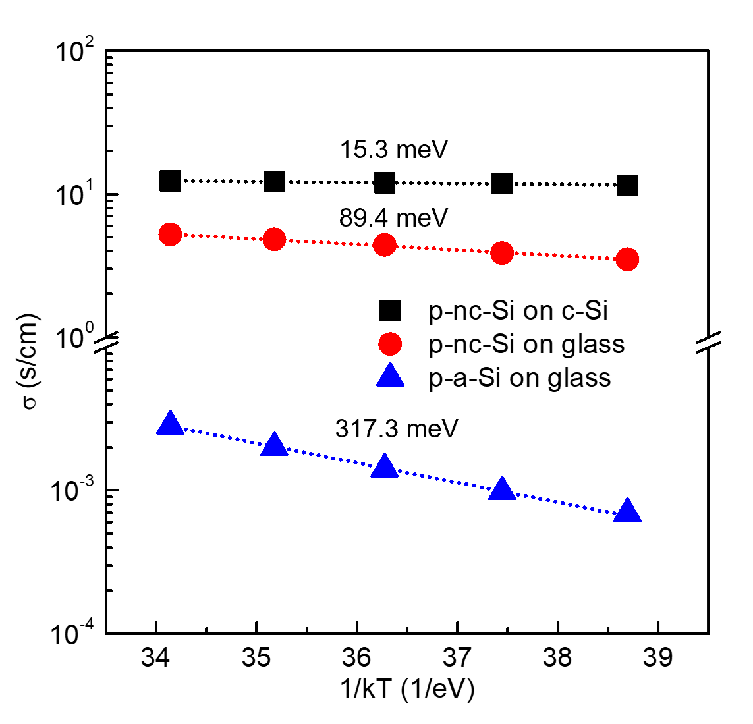
Fig.S4 | Extraction of activation energy (E_{a}) for p-nc-Si:H and p-a-Si:H films with light soaking. Here, the process of light soaking for testing samples was the same as that used in final solar cells.

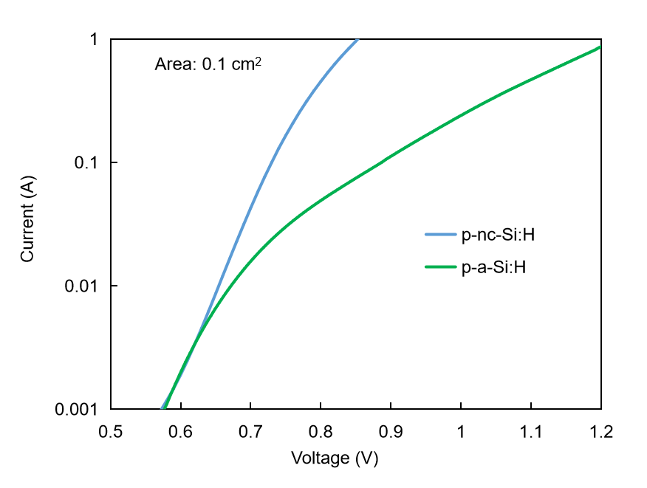
Fig. S5 | The comparison of experimental I-V curves for contact resistance testing devices with HSCs based on p-nc-Si:H and p-a-Si:H.

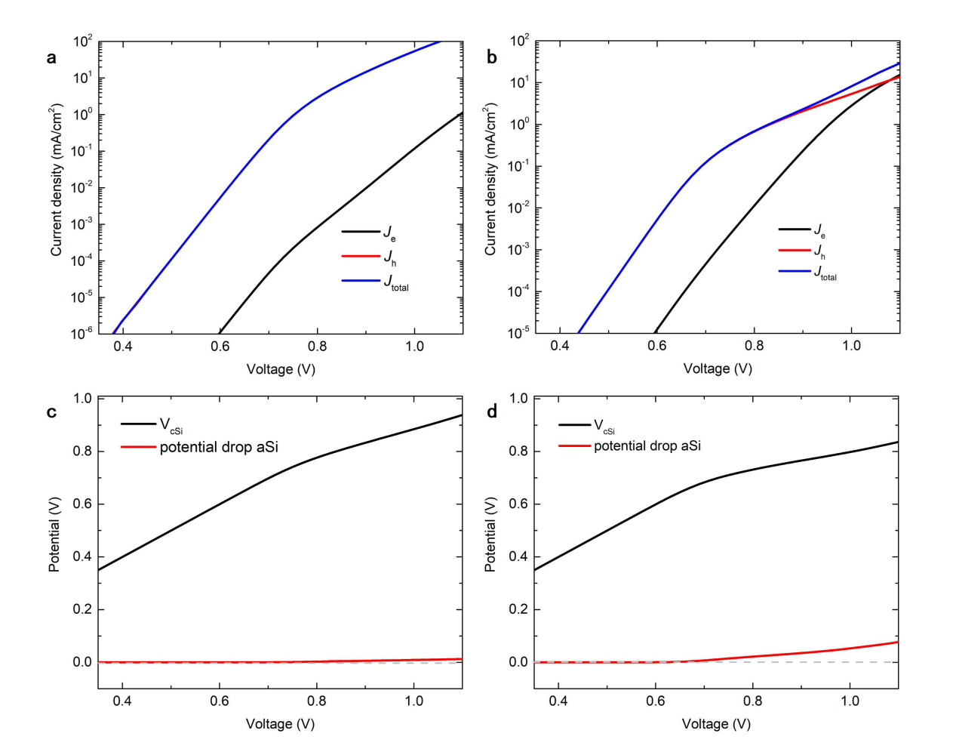
Fig. S6 | Simulated electrical results of HSCs based on p-a-Si:H and p-nc-Si:H from TCAD. a-b, The simulated separated J-V curves of contact resistance testing devices and c-d, the potential drop as a function of voltage. The dashed grey lines indicate the potential with 0.
From the comparison of Figure a and b, it can be seen that for p-nc-Si:H, the ratio of hole current/electron current at different voltages is much larger than that for p-a-Si:H. This indicates a large difference between holes and electrons density at the interface of i-a-Si:H/n-Si for HSC based on p-nc-Si:H. Therefore, due to the carrier population difference, the corresponding surface recombination decreases even if the defect state density remains unchanged. Of course, this can also be simply understood as the larger effective dopant density of p-nc-Si:H (lower E_{a}), which leads to a larger built-in potential and therefore an enhanced field passivation, thus leading to the improvement of the passivation quality. On the other hand, from the changes of hole and electron currents with voltages in TCO/p-nc-Si:H/i-a-Si:H/n-Si, the hole current is dominant in the whole voltage range. This means that the hole transport is relatively smooth with energy-less transitions. However, for the HSC based on p-a-Si:H, the electron current in the high voltage range can even exceed the hole current. It indicates, at this voltage range, the hole transport faces energy variation crossing the HSC, which can be well confirmed from the analysis of potential drop in Figure c and d. When the applied voltage was increased beyond 0.7 V, a portion of the voltage will fall on the amorphous silicon layer (p-a-Si:H/i-a-Si:H) to overcome the series resistance faced by the holes, while in p-nc-Si:H, there is almost no change. In summary, the passivation and carrier transport capability of p-a-Si:H are weaker than those of the p-nc-Si:H, which is consistent with the experimental results.

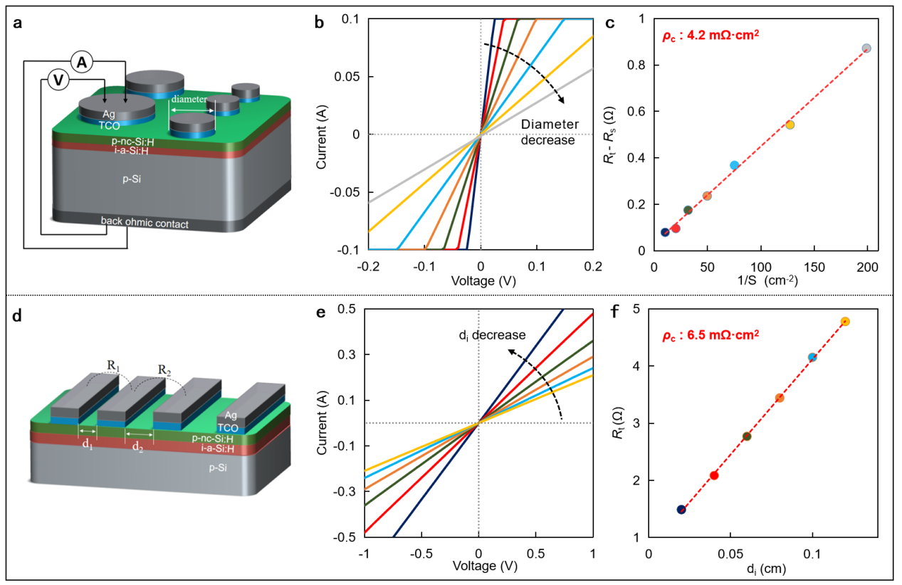
Fig. S7 | Contact resistance of HSC based on p-nc-Si:H. a-c, Cox and Strack method (CSM). d-f, transfer length method (TLM). The testing structures are shown in a and d.^{25,26} It should be noted that, when the ECSM testing structure was used, the substrate of p-Si had to be changed into n-Si ones in a.

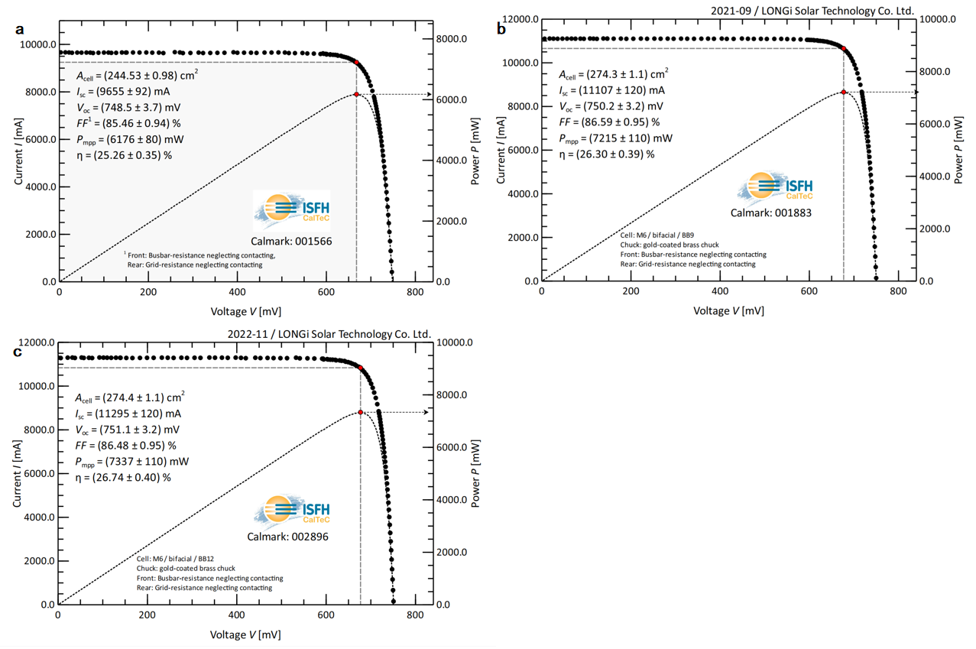
Fig. S8 | Certification results of the n-type Si solar cells with 25.26% (cell ①), 26.30% (cell ②) and record 26.74%-PCE.

Supplementary References

1. Zhao, Y. et al. Design and optimization of hole collectors based on nc-SiOx:H for high-efficiency silicon heterojunction solar cells Solar Energy Materials and Solar Cells 219, 110779 (2021).
2. Umishio, H., Sai, H., Koida, T. & Matsui, T. Nanocrystalline-silicon hole contact layers enabling efficiency improvement of silicon heterojunction solar cells: Impact of nanostructure evolution on solar cell performance. Prog. Photovolt: Res. Appl. 29, 344–356 (2021).
3. Sai, H., Umishio, H. & Matsui, T. Very thin (56μm) silicon heterojunction solar cells with an efficiency of 23.3% and an open-circuit voltage of 754mV. Solar RRL 5, (2021).
4. Boccard, M. et al. Hole-selective dront contact atack enabling 24.1%-efficient silicon heterojunction solar cells. IEEE Journal of Photovoltaics 11, 9-15 (2020).
5. Fioretti, A.N., Boccard, M., Monnard, R. & Ballif, C. Low-temperature p-type microcrystalline silicon as carrier selective contact for silicon heterojunction solar cells. IEEE Journal of Photovoltaics 9, 1158-1165 (2019).
6. LONGi once again sets new world record for HJT solar cell efficiency. https://www.longi.com/en/news/new-hjt-world-record/ (2021).
7. LONGi breaks world record for HJT solar cell efficiency twice in one week. https://www.longi.com/en/news/7469/ (2021).
8. LONGi sets new world record of 25.82% for HJT solar cell efficiency. https://www.longi.com/en/news/6751/ (2021).
9. LONGi breaks three more world records for solar cell efficiency https://www.longi.com/en/news/7474/ ( 2021).
10. Hanergy reports 25.11% efficiency for SHJ technology. . https://taiyangnews.info/technology/hanergy-reports-25-11-efficiency-for-shj-technology/ (2019).
11. JinkoSolar: ‘Record’ 25.25% efficiency for TOPCon cell. https://taiyangnews.info/technology/jinkosolar-record-25-25-efficiency-for-n-type-mono-cell/ (2021).
12. Richter, A. et al. N-Type Si solar cells with passivating electron contact: Identifying sources for efficiency limitations by wafer thickness and resistivity variation. Solar Energy Materials & Solar Cells 173, 96-105 (2017).
13. Richter, A. et al. Design rules for high-efficiency both-sides-contacted silicon solar cells with balanced charge carrier transport and recombination losses. Nature Energy 6, (2021).
14. Q., W. Status of crystalline silicon PERC solar cells. . in NIST/UL Workshop on Photovoltaic Materials Durability (Gaithersburg, MD USA, 2019).
15. MA., G. The passivated emitter and rear cell (PERC): From conception to mass production. . Sol Energy Mater Sol Cells 143 190-197 (2015).
16. Richter, A., Hermle, M. & Glunz, S.W. Reassessment of the Limiting Efficiency for Crystalline Silicon Solar Cells. IEEE Journal of Photovoltaics 3, 1184-1191 (2013).
17. Schenk & Andreas. Finite-temperature full random-phase approximation model of band gap narrowing for silicon device simulation. Journal of Applied Physics 84, 3684-3695 (1998).
18. Klaassen, D. A unified mobility model for device simulation—II. Temperature dependence of carrier mobility and lifetime. Solid-State Electronics 35, 961-967 (1992).
19. Altermatt, P.P., Schenk, A., Schmithu?Sen, B. & Heiser, G. A simulation model for the density of states and for incomplete ionization in crystalline silicon. I. Establishing the model in Si:P. Journal of Applied Physics 100, 113714 (2006).
20. Richter, A., Werner, F., Cuevas, A., Schmidt, J. & Glunz, S.W. Improved parameterization of Auger recombination in silicon. Energy Procedia 27, 88-94 (2012).
21. Cuevas, A. & Macdonald, D. Measuring and interpreting the lifetime of silicon wafers. Solar Energy 76, 255-262 (2004).
22. Black, L.E. & Macdonald, D.H. On the quantification of Auger recombination in crystalline silicon. Solar Energy Materials and Solar Cells 234, 111428 (2022).
23. Niewelt, T. et al. Reassessment of the intrinsic bulk recombination in crystalline silicon. Solar Energy Materials and Solar Cells 235, 111467 (2022).
24. Pysch, D., Mette, A. & Glunz, S.W. A review and comparison of different methods to determine the series resistance of solar cells. Solar Energy Materials & Solar Cells 91, 1698-1706 (2007).
25. Cox, R.H. & Strack, H.A. Ohmic contacts for GaAs devices. Solid-State Electronics 10, 1213-1218 (1966).
26. Reeves, G.K. & Harrison, H.B. Obtaining the specific contact resistance from transmission line model measurements. IEEE Electron Device Letters 3, 111-113 (2005).

