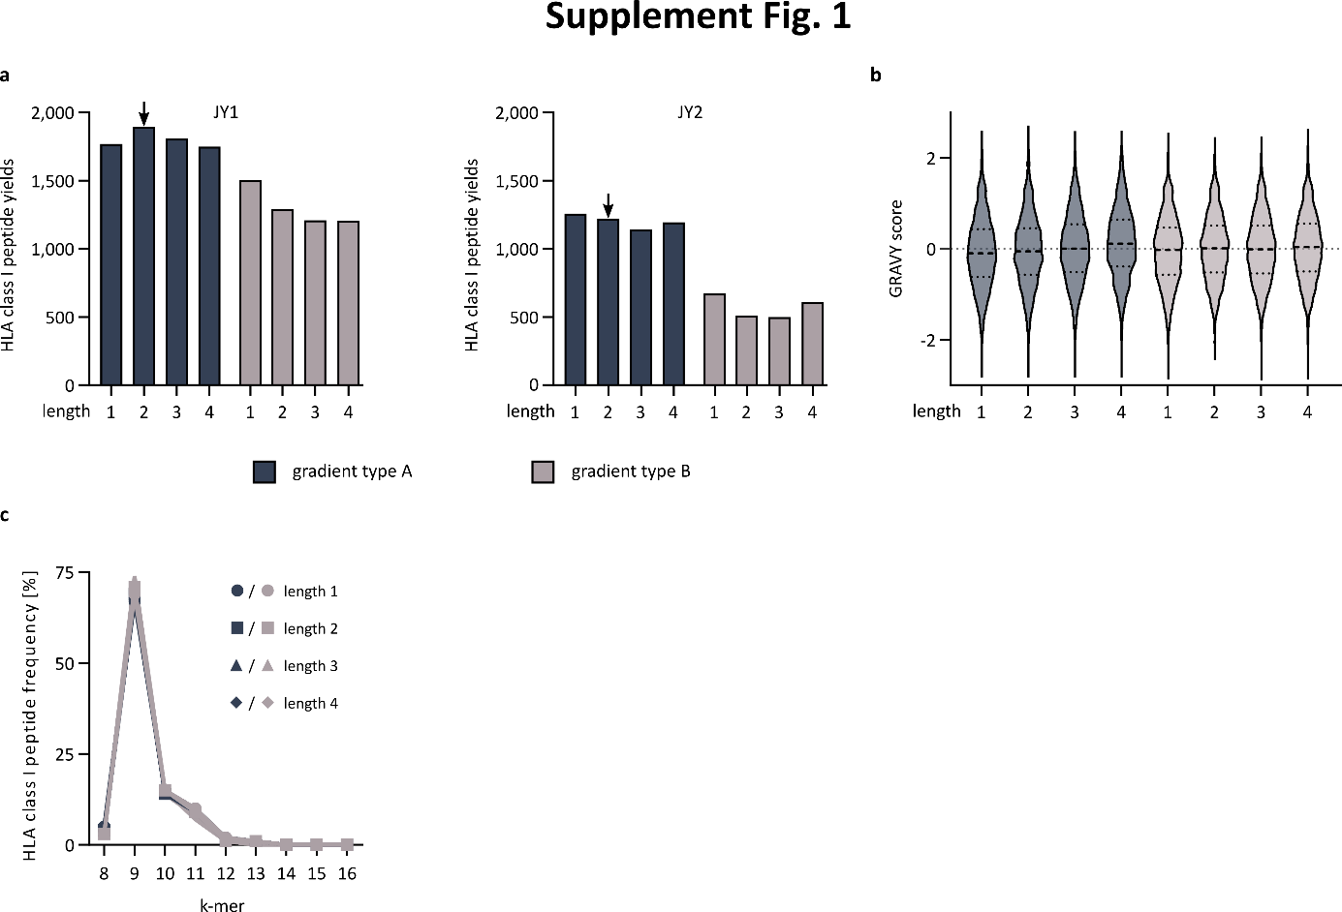
Supplementary Fig. 1 | Method development for immunopeptidomics using liquid chromatography coupled mass spectrometry with trapped ion mobility separation. a, HLA class I peptide yields according to different gradient lengths (1, 2, 3, and 4) and gradient types (A, B) for different JY cell line sample concentrations, JY1 (left) and JY2 (right). b, Violin plots of grand average of hydrophobicity (GRAVY) score of HLA class I-presented peptides identified using different gradient lengths (1, 2, 3, and 4) and gradient types (A, B) from JY 2 sample. Median and 25th to 75th percentiles are indicated by dashed and dotted lines, respectively. c, Length distribution of identified HLA class I-presented peptides using the different gradient lengths (1, 2, 3 and 4) and types (A and B). Abbreviations: HLA, Human leukocyte antigen; GRAVY, grand average of hydropathy.
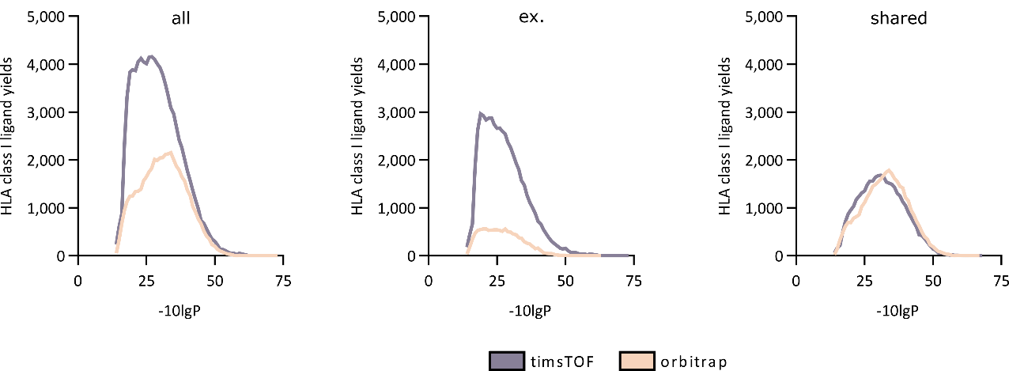
Supplementary Fig. 2 | -10lgP distribution of HLA class I ligands. Distribution of HLA class I ligands identified across all samples (n = 10) for total (all, left), exclusive (ex., middle) and shared (right) HLA class I ligands. Abbreviations: HLA, human leukocyte antigen; ex., exclusive; timsTOF, trapped ion mobility spectrometry time-of-flight.
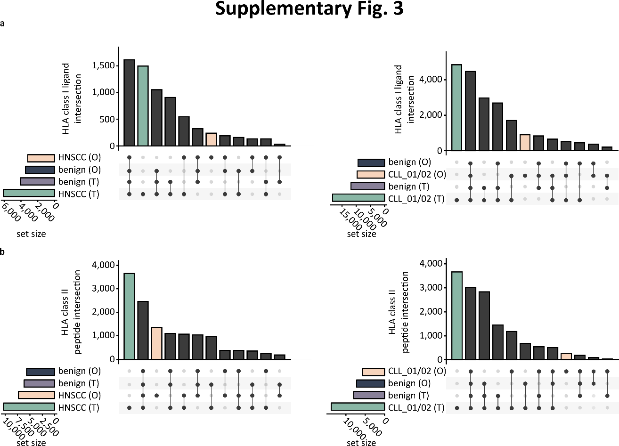
Supplementary Fig. 3 | timsTOF technology enables increased tumor-associated HLA class I and HLA class II-presented peptide identifications from primary tumor samples. a, b, UpSet plots showing HLA class I ligand (a) and HLA class II peptide (b) intersection size between peptides identified from one head and neck squamous cell carcinoma (HNSCC, left) and two chronic lymphocytic leukemia (CLL_01 and CLL_02, right) primary samples using timsTOF (T) and orbitrap (O) mass spectrometers and their overlap with benign timsTOF dataset (benign (T)) and published orbitrap benign dataset (benign (O)). Abbreviations: HLA, Human leukocyte antigen; HNSCC, head and neck squamous cell carcinoma; O, orbitrap; T, timsTOF; CLL, chronic lymphocytic leukemia.

