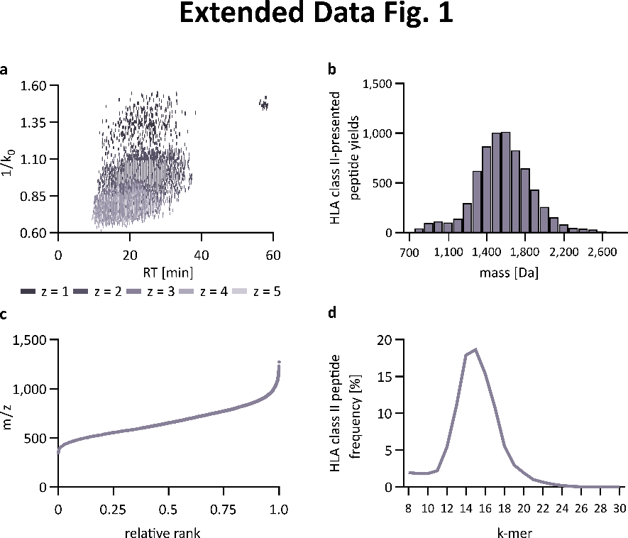
Extended Data Fig. 1 | timsTOF based immunopeptidomics for HLA class II-presented peptide identification. a, Distribution of the collisional cross section (1/k₀) of PSMs of HLA class II-presented peptides in a JY sample across the retention time (RT) and different charge states (z). b, Histogram of peptide mass distribution of HLA class II-presented peptides identified in a JY sample. c, Ranked mass to charge ratio (m/z) of HLA class II-presented peptides identified in a JY sample. d, Length distribution of identified HLA class II peptides. Abbreviations: HLA, human leukocyte antigen; min, minutes; Da, Dalton; PSM, peptide spectrum match, retention time, RT.
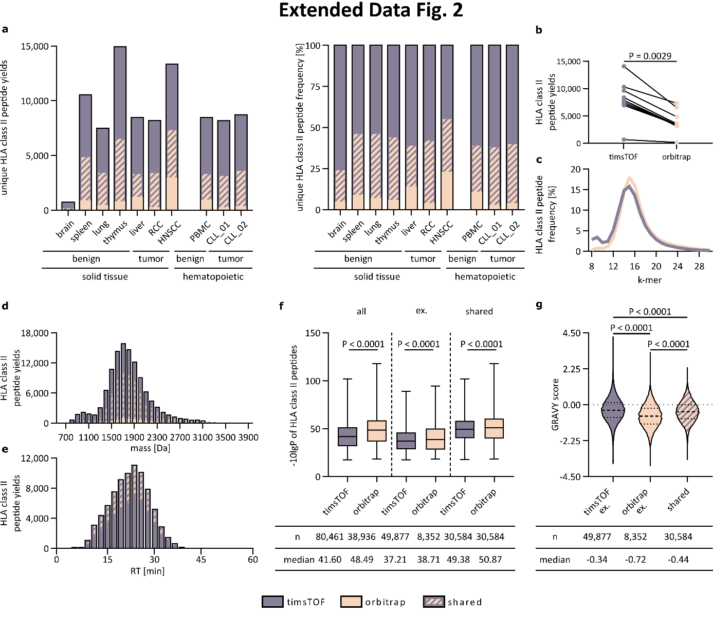 Extended Data Fig. 2 | Trapped ion mobility technology increases HLA class II-presented peptide yields identified by MS-based immunopeptidomics. a, Unique HLA class II-presented peptide yields (left) and percentage of peptides (right) from various benign and malignant primary samples of hematological and solid tissue origin identified by timsTOF (grey) and orbitrap (beige) mass spectrometers or found by both devices (stripped). b, HLA class II-presented peptide yields identified in all ten samples using timsTOF and orbitrap MS (paired Wilcoxon t-test). c, Length distribution of timsTOF- or orbitrap- identified HLA class II-presented peptides of all analyzed samples (n = 10). d, Mass distribution of timsTOF, orbitrap or shared HLA class II-presented peptides across all samples (n = 10). e, Number of unique HLA class II-presented peptide identifications by timsTOF in all samples (n = 10) across the chromatographic gradient. f, -10lgP of timsTOF and orbitrap HLA class II-presented peptides for total (all), timsTOF/orbitrap exclusive (ex.) and shared HLA class II-presented peptides, respectively across all ten samples. Boxes represent median and 25th to 75th percentiles, whiskers are minimum to maximum. g, GRAVY score of timsTOF, orbitrap and shared unique HLA class II-presented peptides across all samples (n = 10). Violin plots with median and 25th to 75th percentiles and unpaired Kruskal-Wallis t-test. Abbreviations: HLA, Human leukocyte antigen; RCC; renal cell carcinoma; HNSCC, head and neck squamous-cell carcinoma; PBMC, peripheral blood mononuclear cell; CLL, chronic lymphocytic leukemia; Da, Dalton; RT, retention time; grand average of hydropathy, GRAVY.

