Additional file: Figure S2.

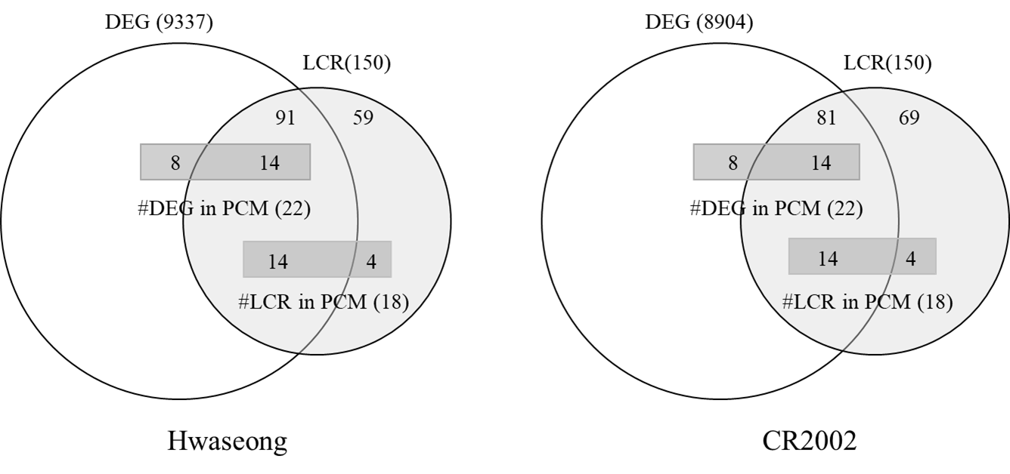

Additional file: Figure S2. Comparisons of LCR genes and DEGs identified in Hwaseong and CR2002(Shim et al., 2020).
The larger circles represent the number of DEGs identified by RNA-Seq for dark-treated rice plants. The smaller circles represent the number of LCR genes collected by literature mining. The number of DEGs in the PCM pathway and the number of LCR genes in the PCM pathway are indicated.

Reference:
Shim K-c, Kim SH, Jeon Y-A, Lee H-S, Adeva C, Kang J-W, Kim H-J, Tai TH, Ahn S-N, 2020. A RING-Type E3 Ubiquitin Ligase, OsGW2, Controls Chlorophyll Content and Dark-Induced Senescence in Rice. International Journal of Molecular Sciences 21 (5):1704.

