Future flow and water temperature scenarios in an impounded drainage basin: Implications for summer flow and temperature management downstream of the dam

Supplementary Material Part A
Table S1 Characteristics of Sockeye salmon fish species in this study
Scientific name | Oncorhynchus nerka
Maximum tolerable temperature | 19°C (20-30% mortality)  20°C (40% mortality)  21°C (100% mortality 72 hours following exhaustive exercise)  (Middleton et al., 2018; Robinson et al., 2015)
Current Summer Temperature Monitoring Program (STMP) limit | 20°C
Spawning period | August to September

Table S2 Parameters of the hydrologic module after calibration using the multisite calibration method
No. | Parameter | Unit | Value | Description
1 | CIN | dimensionless | 0.09 | Percolation coefficient from the upper zone to the lower zone
2 | CVMAR | dimensionless | 0.04 | Lakes and marshes drainage coefficient
3 | CVNB | dimensionless | 0.0002 | Lower-zone lower drainage coefficient
4 | CVNH | dimensionless | 0.0008 | Lower-zone upper drainage coefficient
5 | CVSB | dimensionless | 0.0002 | Upper-zone lower drainage coefficient
6 | CVSI | dimensionless | 0.056 | Upper-zone intermediate drainage coefficient
7 | XINFMA | mm/day | 2.30 | Daily maximum infiltration
8 | HINF | mm | 49.13 | Percolation threshold from the upper to the lower zone
9 | HINT | mm | 99.19 | Upper-zone intermediate drainage threshold
10 | HMAR | mm | 263.24 | Lakes and marshes drainage threshold
11 | HNAP | mm | 362.54 | Lower-zone upper threshold
12 | HPOT | mm | 133.40 | Threshold of evaporation at the potential rate
13 | HSOL | mm | 299.15 | Upper-zone runoff threshold
14 | HRIMP | mm | 4.69 | Upper-zone runoff threshold for impermeable surfaces
15 | EXXKT | dimensionless | 0.006 | Routing coefficient fitting parameter
16 | STRNE | °C | 2.94 | Rain-snow threshold
17 | TFC | mm/ᵒC/day | 1.07 | Melting rate in forested area
18 | TFD | mm/ᵒC/day | 2.57 | Melting rate in open area
19 | TSC | °C | 0.018 | Melting threshold in forested area
20 | TSD | °C | 0.43 | Melting threshold in open area
21 | TTD |  | 0.99 | Cold content coefficient for snowpack
22 | TTS | °C | -0.59 | Priming threshold of snowpack
23 | EVNAP | % | 0.38 | Percentage of daily evapotranspiration taken from Lower zone
24 | XAA | dimensionless | 1.42 | Exponent of Thornthwaite formula
25 | XIT | dimensionless | 25.88 | Thermal index of Thornthwaite formula
26 | ZN | days | 2.68 | Concentration time, i.e. time for water to travel from the highest upstream point to the outlet

Table S3 Parameters of the thermal module after calibration using the multisite calibration method
No. | Parameter | Unit | Value | Description
1 | CRAYSO | dimensionless | 1.28 | Coefficient for shortwave radiation (ratio)
2 | CRAYIN | dimensionless | 0.61 | Coefficient for longwave radiation (ratio)
3 | CEVAPO | dimensionless | 0.22 | Coefficient for evaporation (ratio)
4 | CCONVE | dimensionless | 2.00 | Coefficient for convection (ratio)
5 | CRIGEL | dimensionless | 422.66 | Threshold snow stock for controlling water temperature
6 | TNAP | °C | 6.99 | Temperature of groundwater
7 | BASSOL | dimensionless | 6.89 | Amount of precipitation that will identify days with low solar radiation
8 | CORSOL | dimensionless | 0.00 | Correction factor for bassol (ratio)

Table S4 Eight global climate models used in this study to produce future climate data
No. | GCM | Full Name | Modeling Center | Spatial Resolution
1 | BCC-CSM2-MR | Beijing Climate Center Climate System Model | Beijing Climate Center (BCC) | 110 × 110 km
2 | CMCC-CM2-SR5 | Euro-Mediterranean Centre on Climate Change coupled climate model | Euro-Mediterranean Centre on Climate Change | 0.9° lat × 1.25° lon  100 × 140 km
3 | CMCC-ESM2 | Second-generation CMCC Earth System Model | Euro-Mediterranean Centre on Climate Change | 0.9° lat × 1.25° lon  100 × 140 km
4 | EC-Earth3 | European Centre Earth3 Model | European Centre  for Medium-Range Weather Forecasts (ECMWF) | 40 × 40 km
5 | MIROC6 | Model for Interdisciplinary Research on Climate | Japanese modeling community | 1.4° lat × 1.4° lon  150 × 150 km
6 | MPI-ESM1-2-HR | Max Planck Institute for Meteorology Earth System Higher-resolution Model | Max Planck Institute | 100 × 100 km
7 | MPI-ESM1-2-LR | Max Planck Institute for Meteorology Earth System Lower-resolution Model | Max Planck Institute | 200 × 200 km
8 | MRI-ESM2-0 | Meteorological Research Institute Earth System Model version 2.0 | Meteorological Research Institute | 100 × 100 km

Table S5 Shared Socioeconomic Pathways (SSP) scenario descriptions
Scenario | Description
SSP2-4.5 | Emissions in SSP2-4.5 will peak around 2040 at ~4.5W/m², then decline and stabilize after the year 2100
SSP5- 8.5 | Emissions in SSP5-8.5 emissions continue to rise throughout the 21st century to ~8.5W/m² by the year 2100

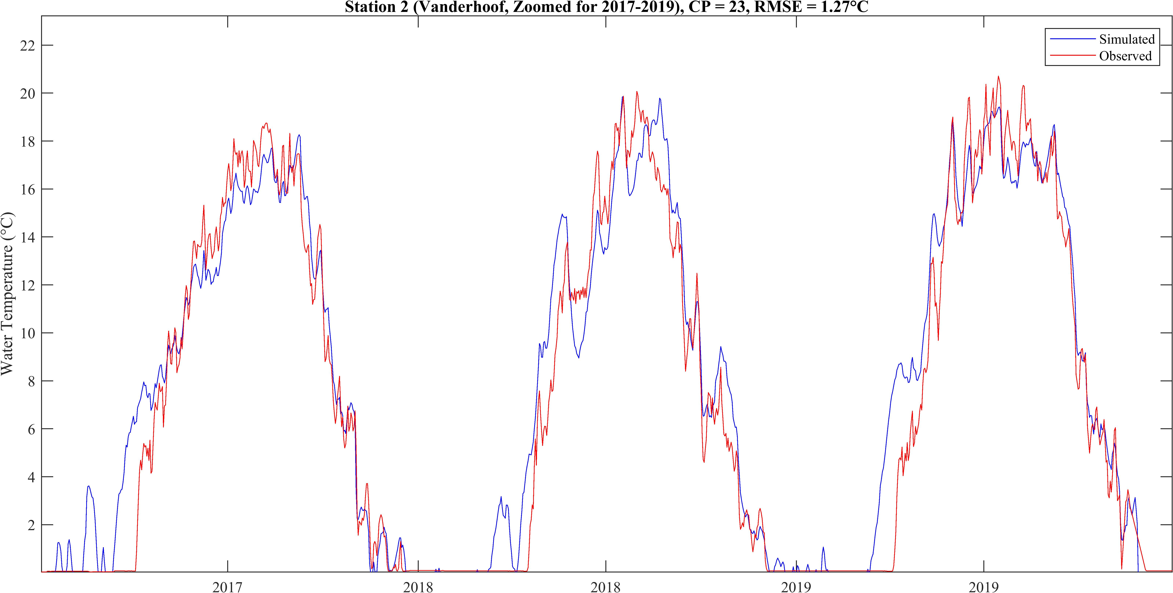
Fig. S1 The simulated (blue) and observed (red) water temperature time series for station 2 (Vanderhoof) with CP=23, using the multisite calibration approach for the June-September period.

Supplementary Material Part B
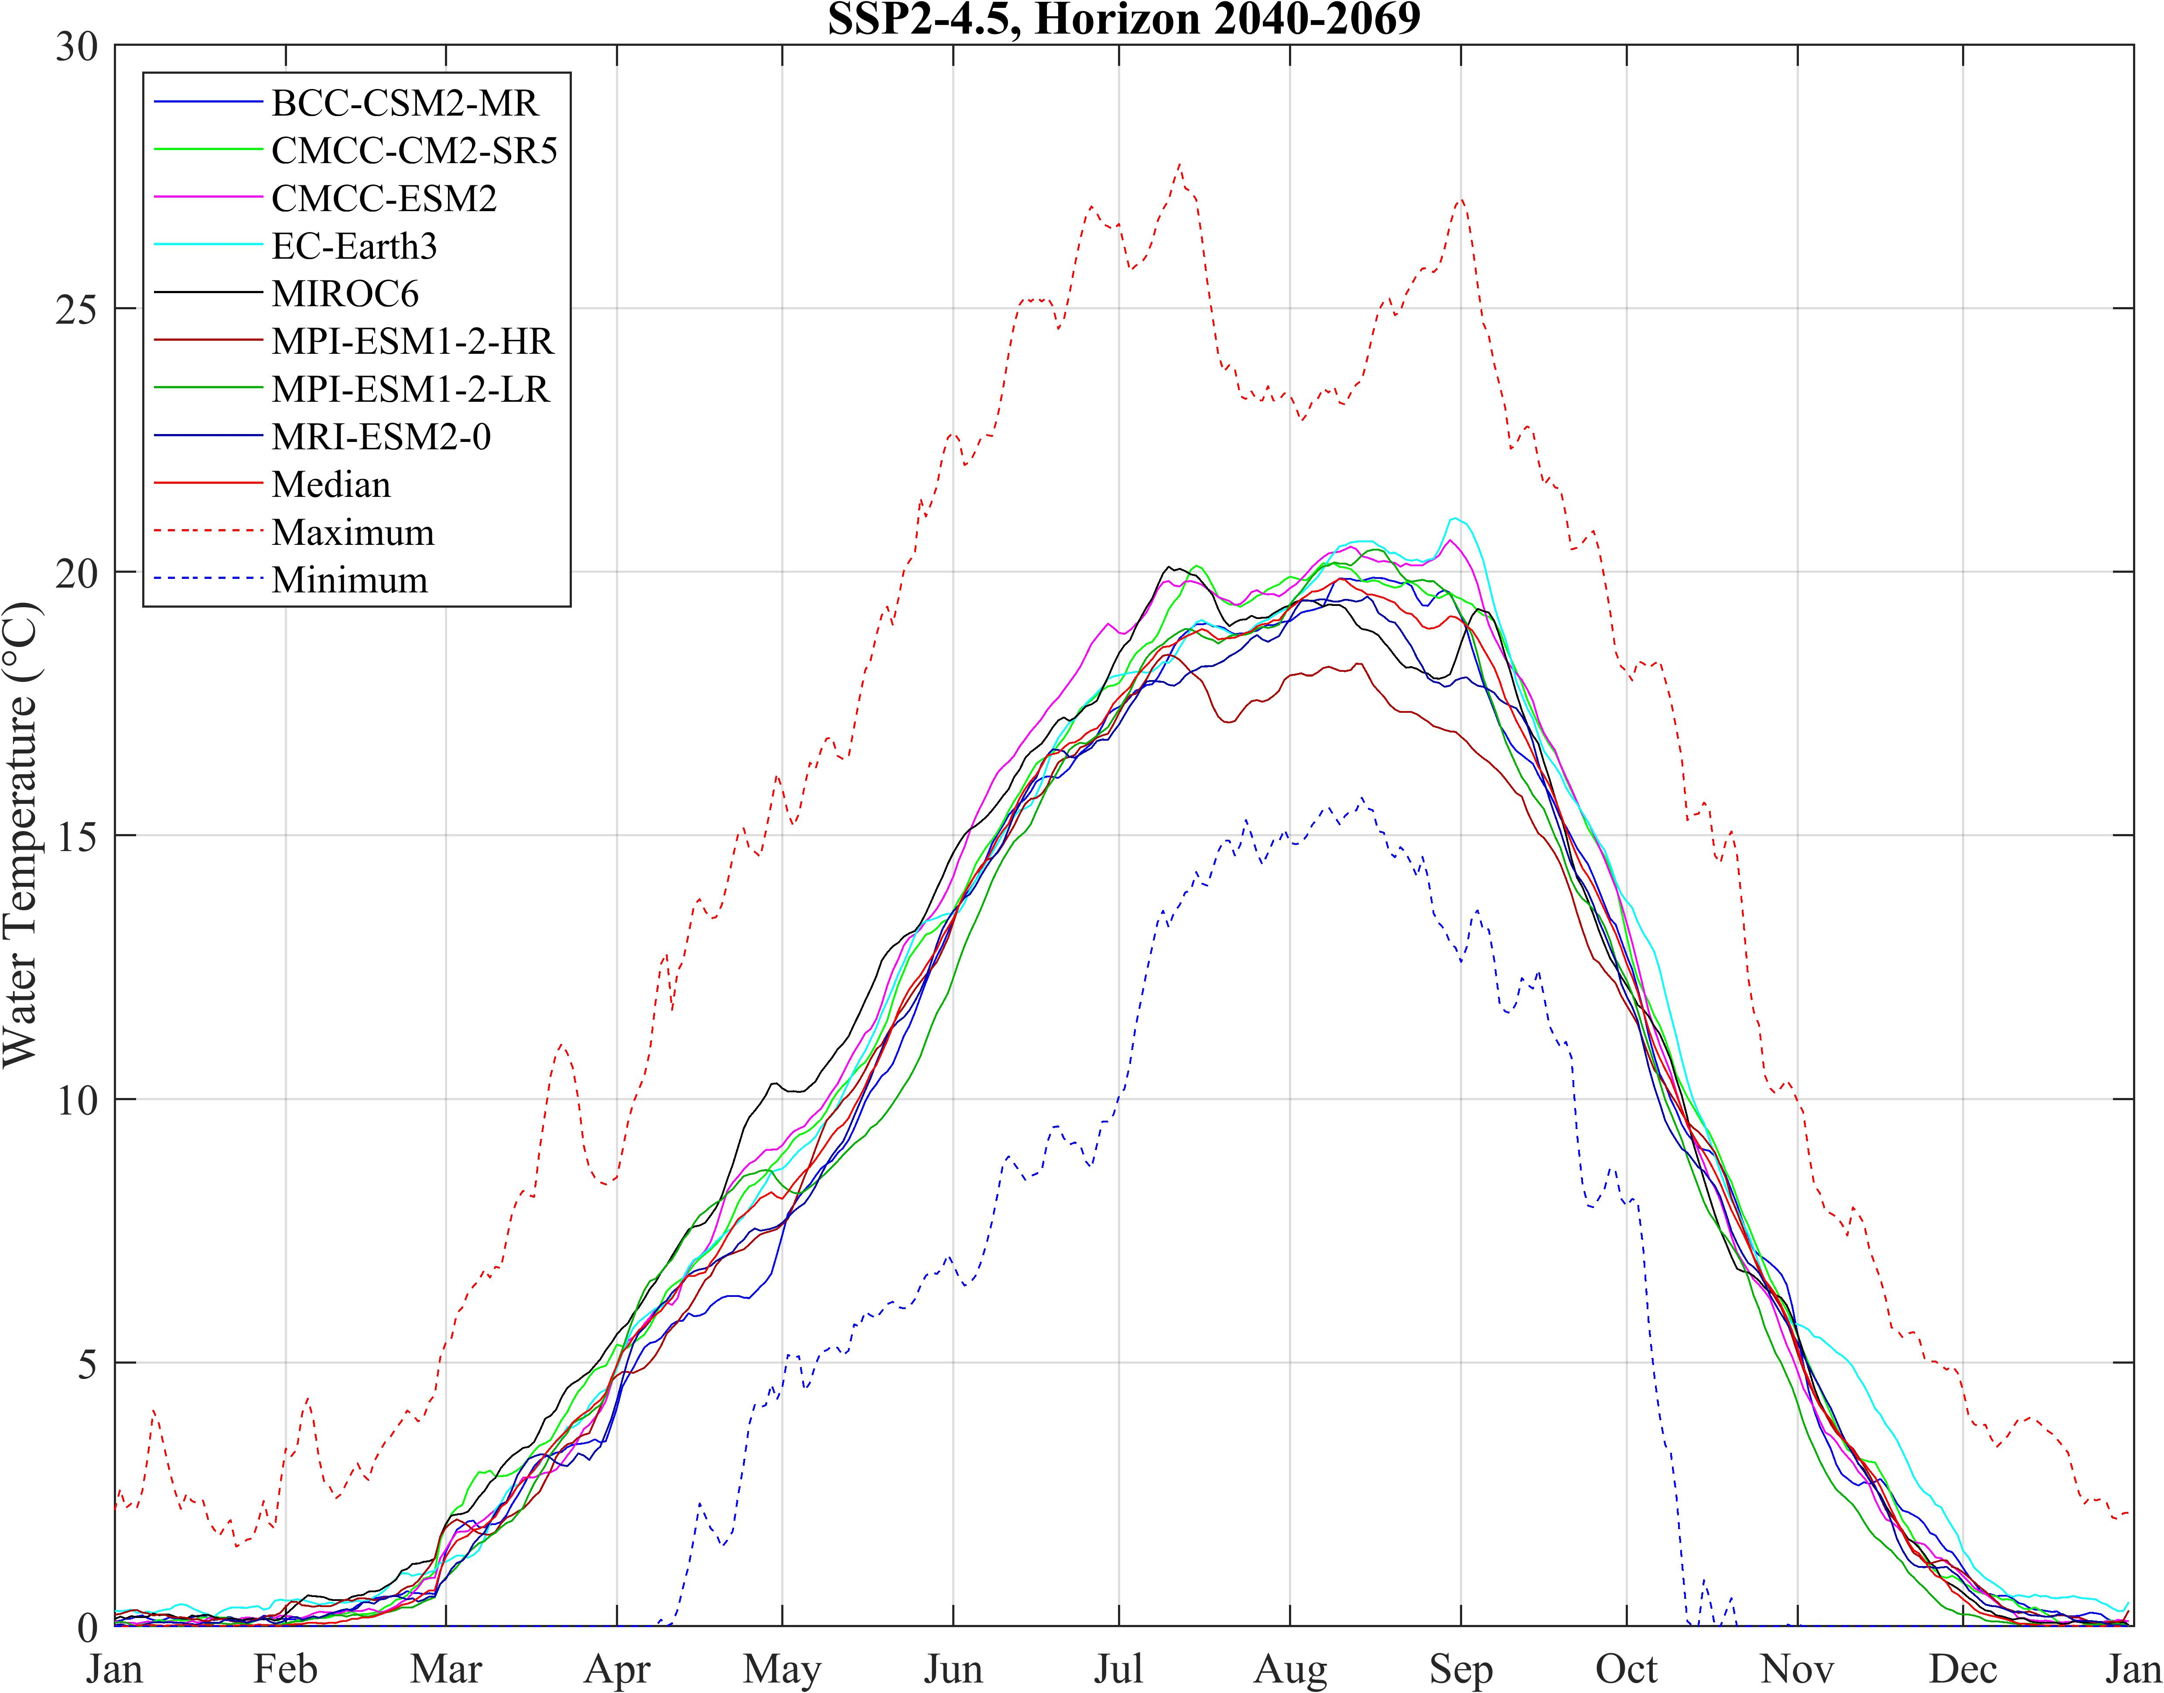
Fig. S2 Simulated water temperature for Vanderhoof station using eight climate models with SSP2-4.5 for the 2040-2069 future time horizon and the median of eight-time series (red line) together with the lower and upper boundary of simulated values (blue and red dotted lines)
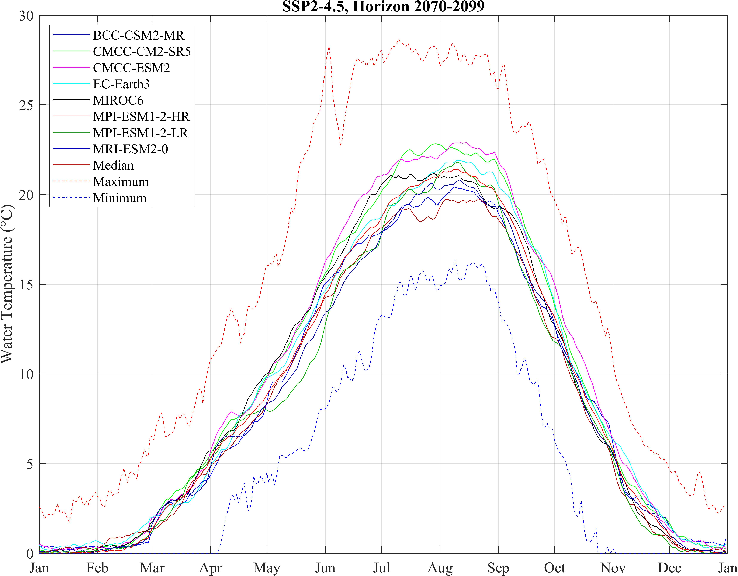
Fig. S3 Same as Fig. S1, but for the 2070–2099-time horizon
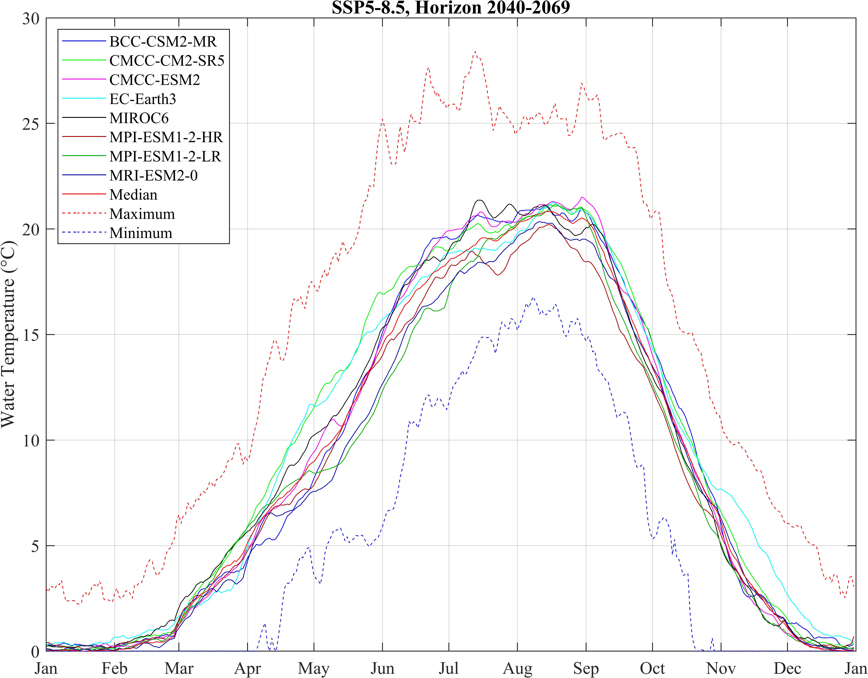
Fig. S4 Same as Fig. S1, but for the SSP5-8.5 scenario
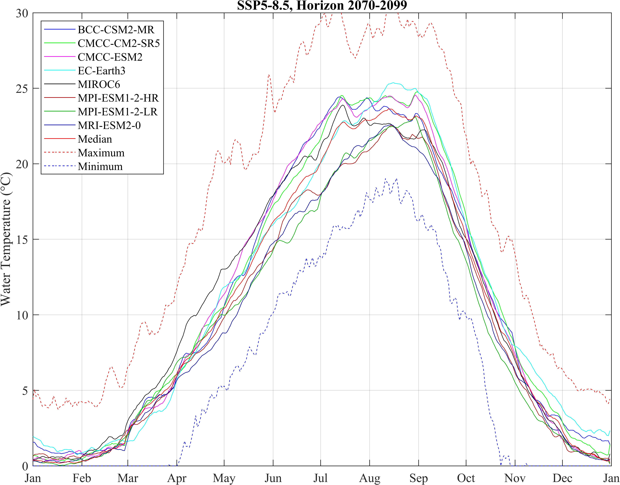
Fig. S5 Same as Fig. S1, but for the 2070–2099-time horizon and the SSP5-8.5 scenario

Supplementary Material Part C
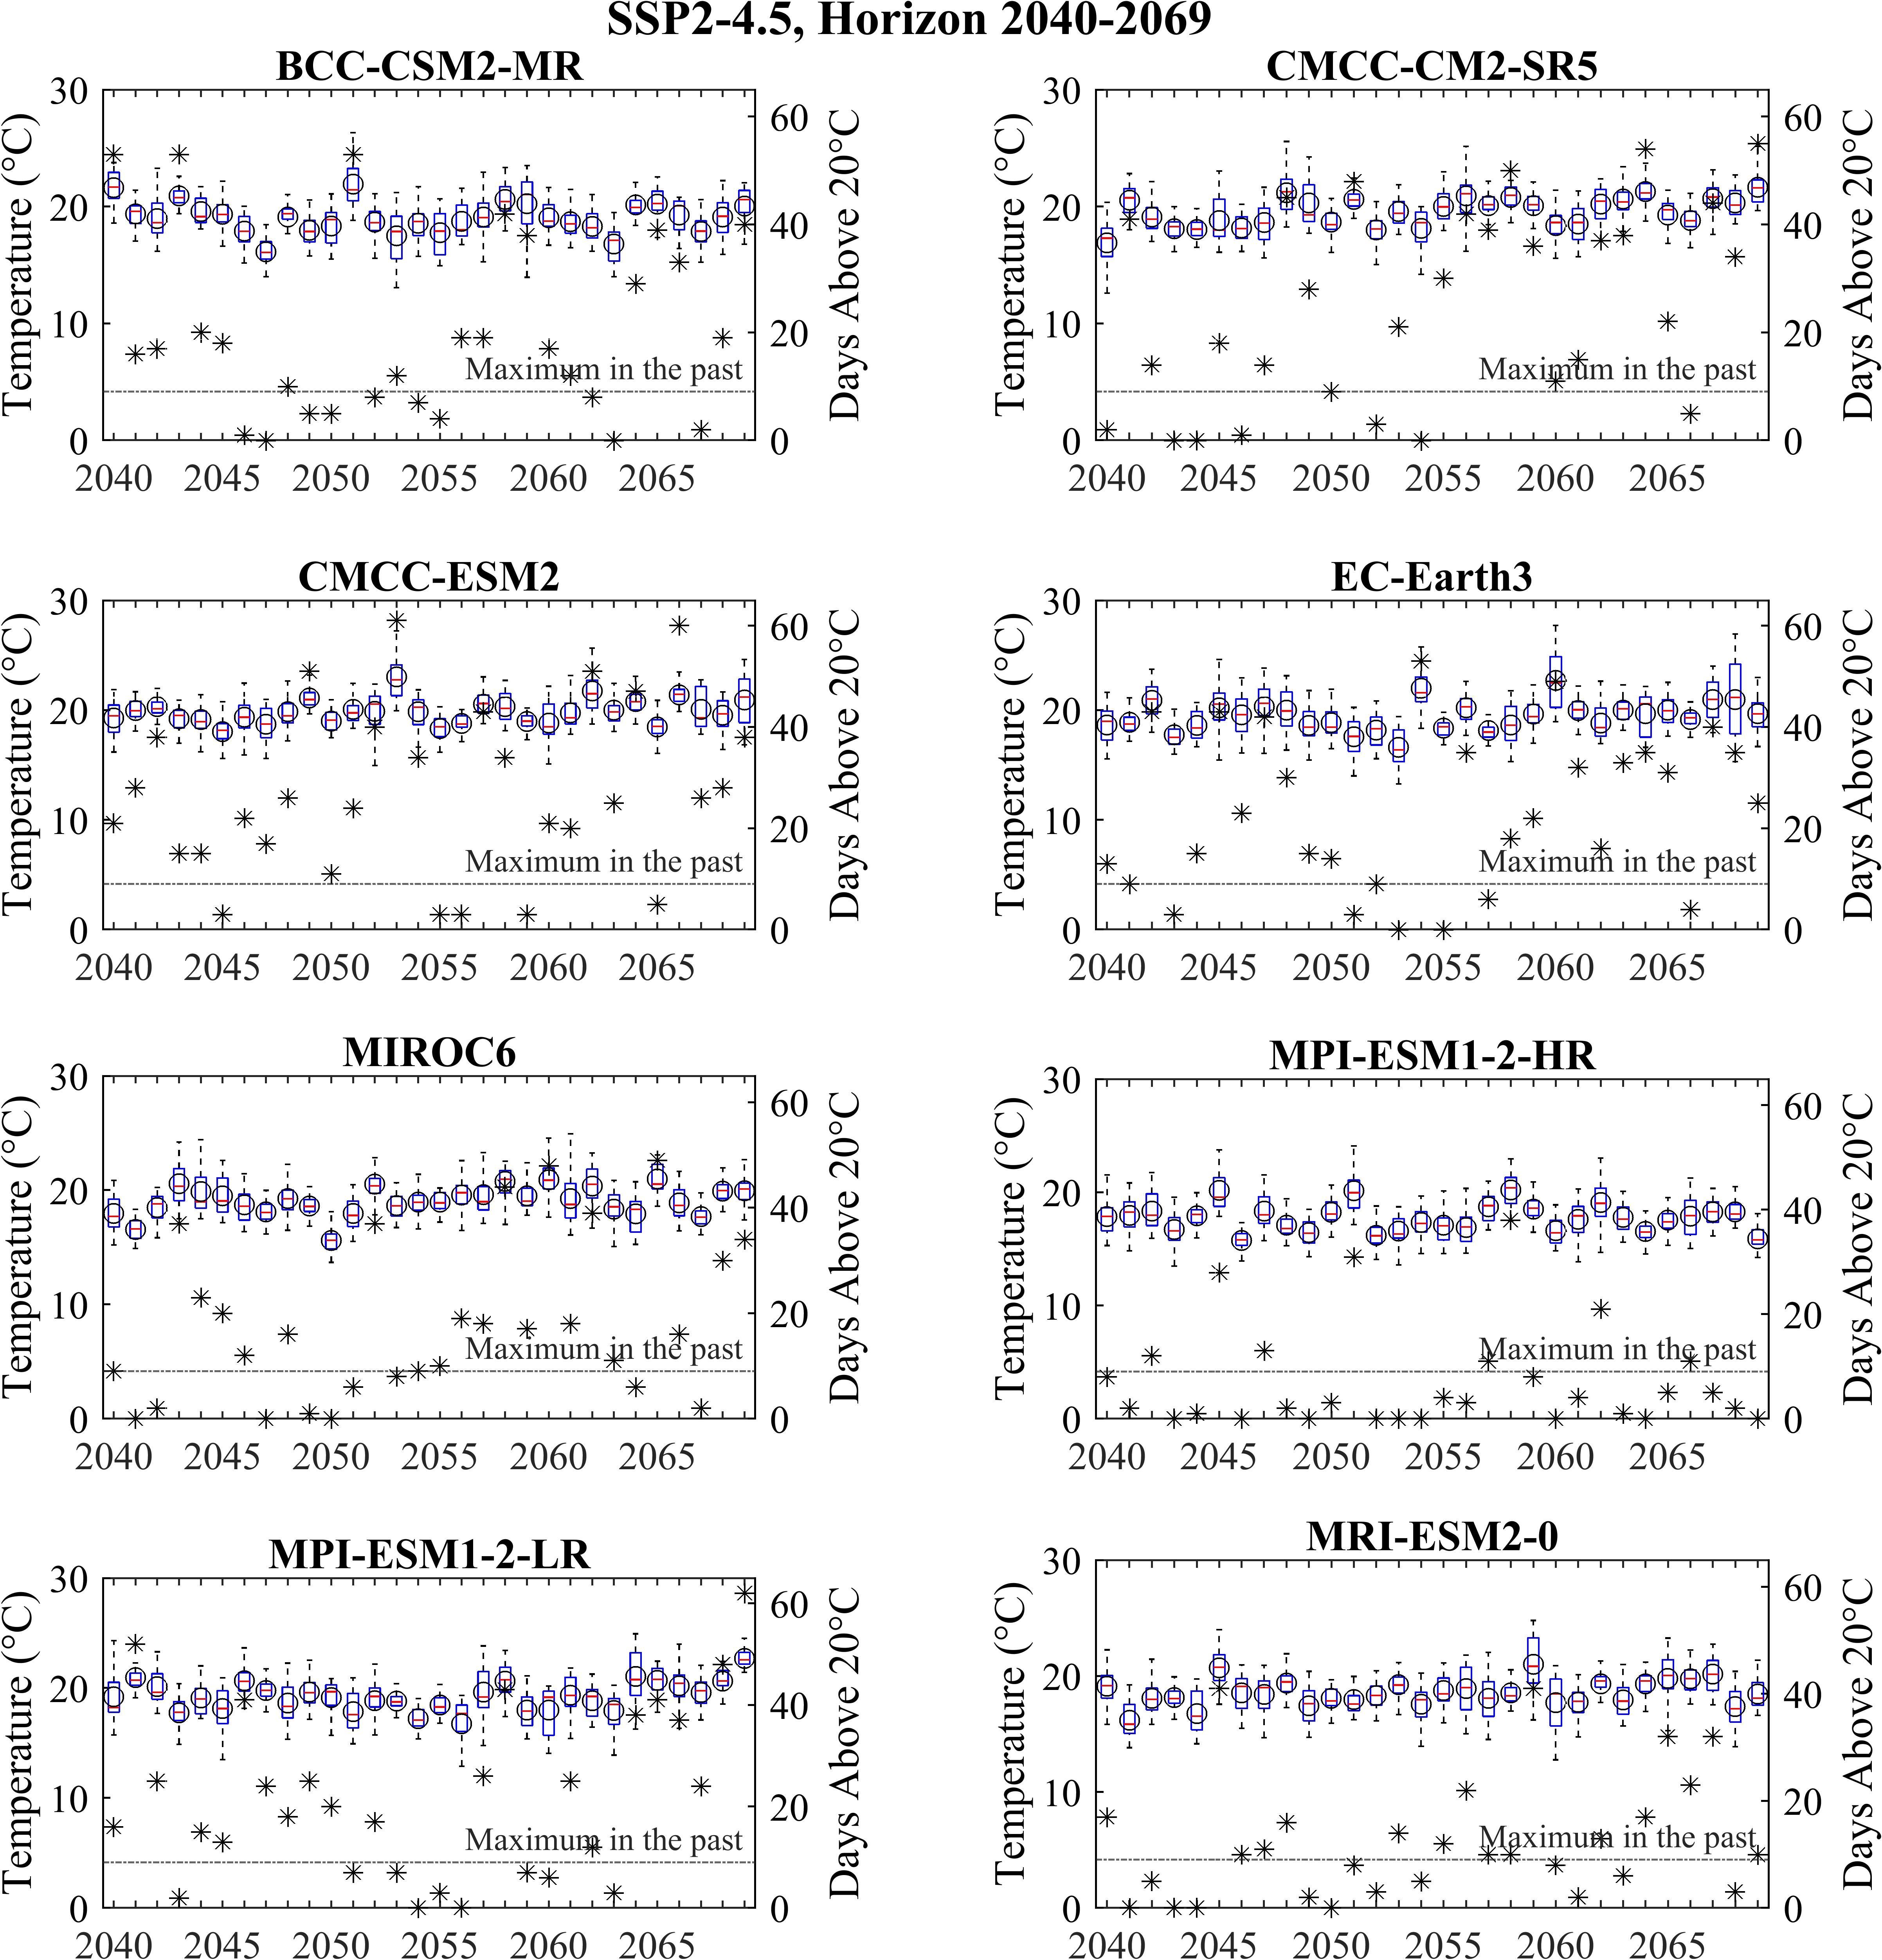
Fig. S6 Yearly range of water temperature variability using boxplot for baseline horizon 2040-2069 for eight climate models under SSP2-4.5 climate change scenario. The left Y-axis shows temperature (°C). For this axis, the median value is the red line, and the black circle presents the mean value. The right Y axis is the number of days. For this axis, asteriscs show the annual number of days on which temperature exceeds the critical limit of 20°C, also the “Maximum in the past” shows the maximum of days per year with temperature above 20 °C. The upper and lower limits of boxes show 25th and 75th percentiles. Whiskers show the most extreme data.
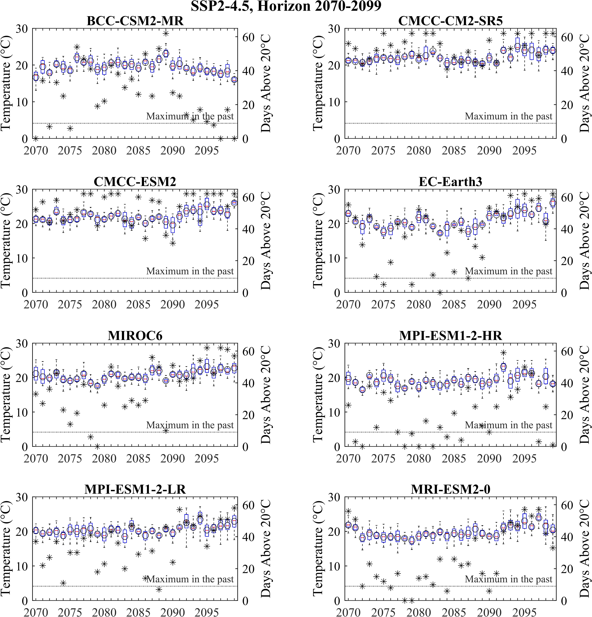
Fig. S7 Same as Fig. S6, but for the 2070-2099 time horizon
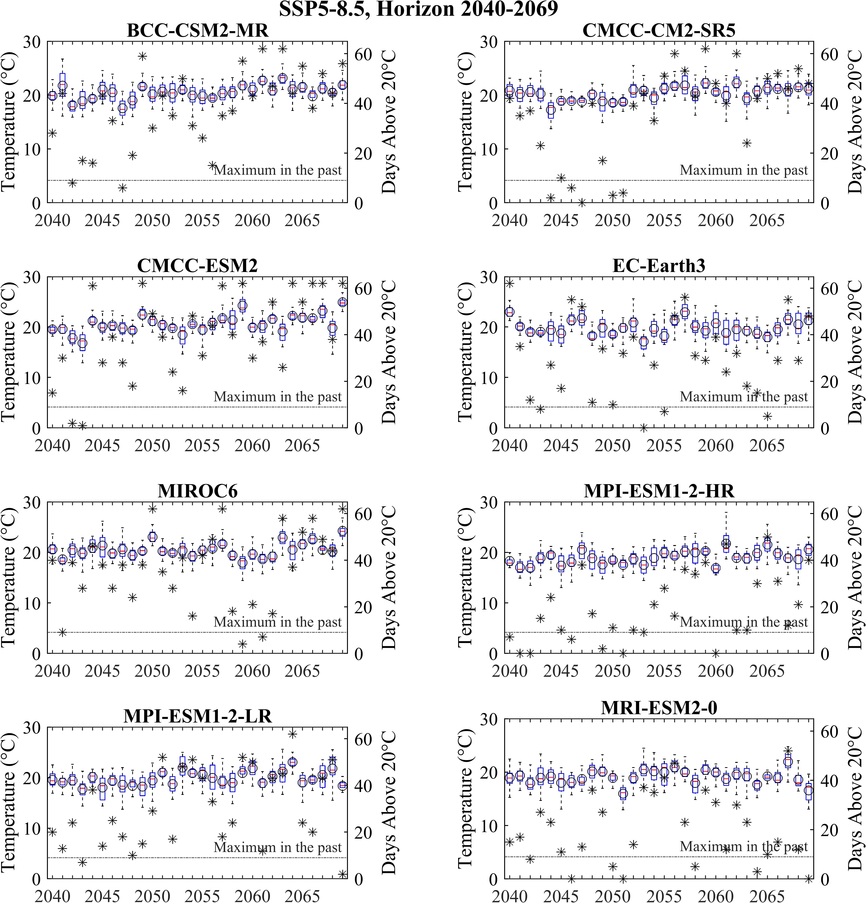
Fig. S8 Same as Fig. S6, but for the SSP5-8.5 scenario
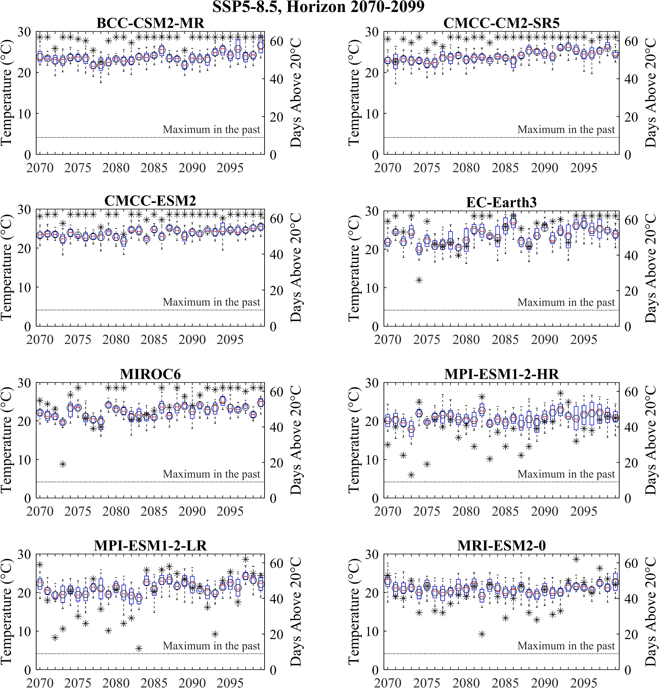
Fig. S9 Same as Fig. S6, but for the 2070-2099 time horizon and the SSP5-8.5 scenario
Table S6 Comparison of calibration metrics between this study and previous studies for different watersheds
Study (Authors, Date) | Variable | Meric | Metric Value
Islam et al. (2019) | Water temperature | NSE (Calibration) | 0.76 - 0.97
Islam et al. (2019) | Water temperature | Bias (Calibration) | -0.06 – 0.28°C
Islam et al. (2019) | Water temperature | RMSE (Calibration) | 0.32 – 1.14°C
Islam et al. (2019) | Water temperature | Bias (Validation) | ≤ 2.0°C
Islam et al. (2019) | Water temperature | RMSE (Validation) | 1.09 – 2.16°C
Kwak et al. (2017b) | Water flow | NSE (Calibration) | 0.82
Kwak et al. (2017b) | Water flow | NSE (Validation) | 0.93
Kwak et al. (2017b) | Water temperature | RMSE (Calibration) | 0.80°C
Kwak et al. (2017b) | Water temperature | RMSE (Validation) | 0.77°C
Kwak et al. (2017b) | Water temperature | Bias (Calibration) | -0.36°C
Kwak et al. (2017b) | Water temperature | Bias (Validation) | -1.14°C
Ouellet-Proulx et al. (2017b) | Water flow | NSE (Calibration) | 0.96
Ouellet-Proulx et al. (2017b) | Water flow | NSE (Validation) | 0.86
Ouellet-Proulx et al. (2017b) | Water temperature | RMSE (Calibration) | 1.38°C
Ouellet-Proulx et al. (2017b) | Water temperature | RMSE (Validation) | 1.54°C
Ouellet-Proulx et al. (2017b) | Water temperature | Bias (Calibration) | 0.24°C
Ouellet-Proulx et al. (2017b) | Water temperature | Bias (Validation) | 0.2°C

