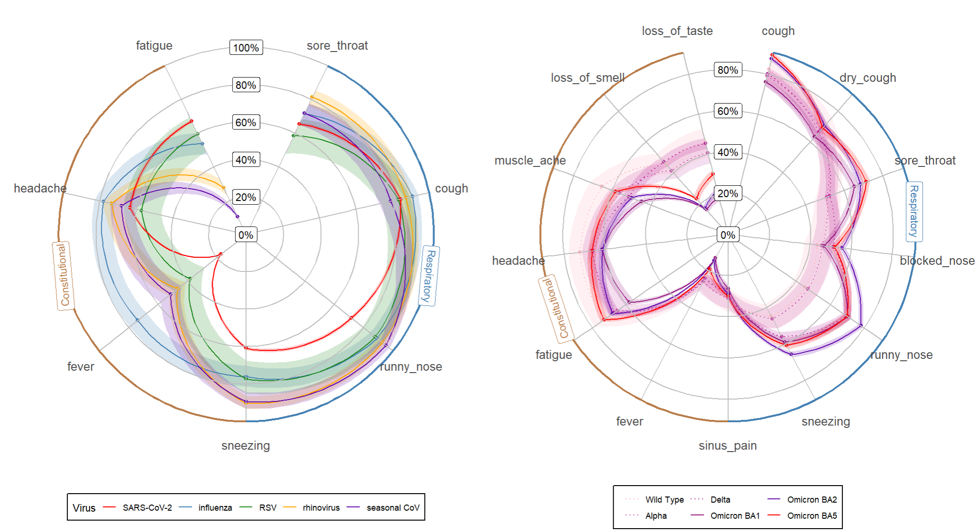
Appendix 1: Sensitivity analysis: Restricting SARS-CoV-2 illnesses meeting the ARI WHO case definition.

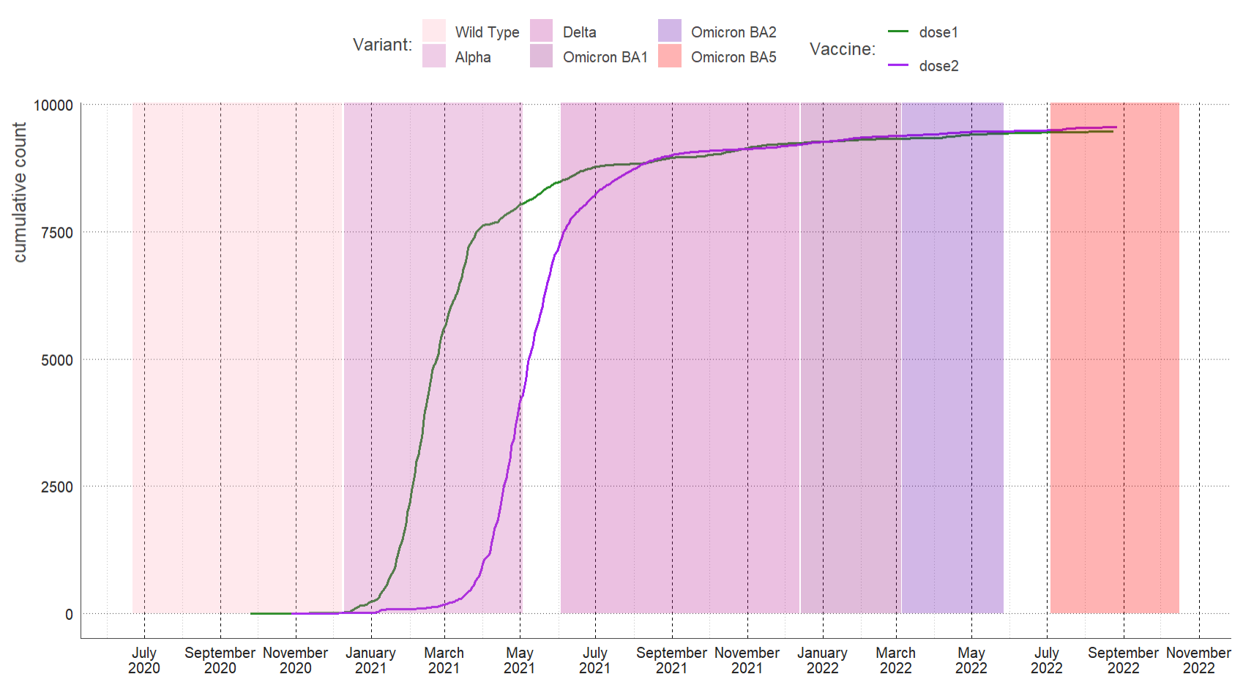
Appendix 2: Cumulative count of SARS-CoV-2 vaccination dose 1 and dose 2.
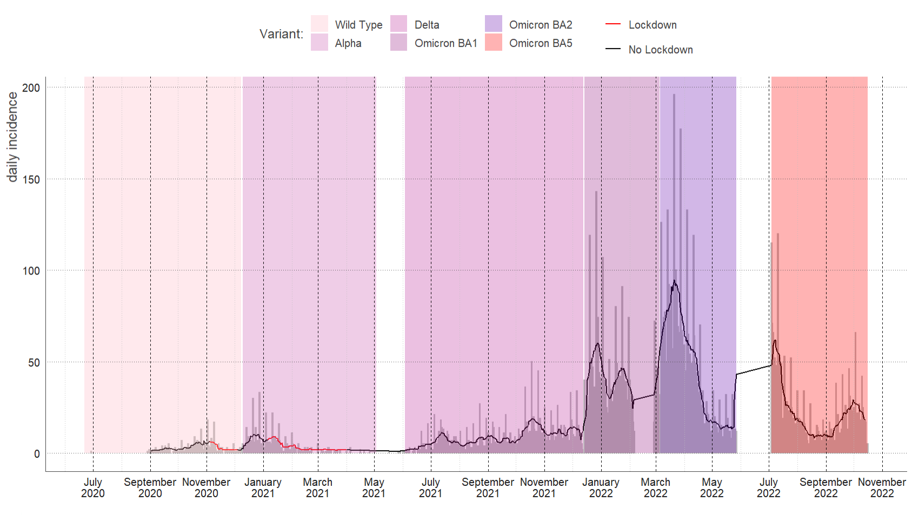
Appendix 3: proportion of SARS-CoV-2 positive illnesses (grey bars represent daily proportion, line represents 7 -day average).

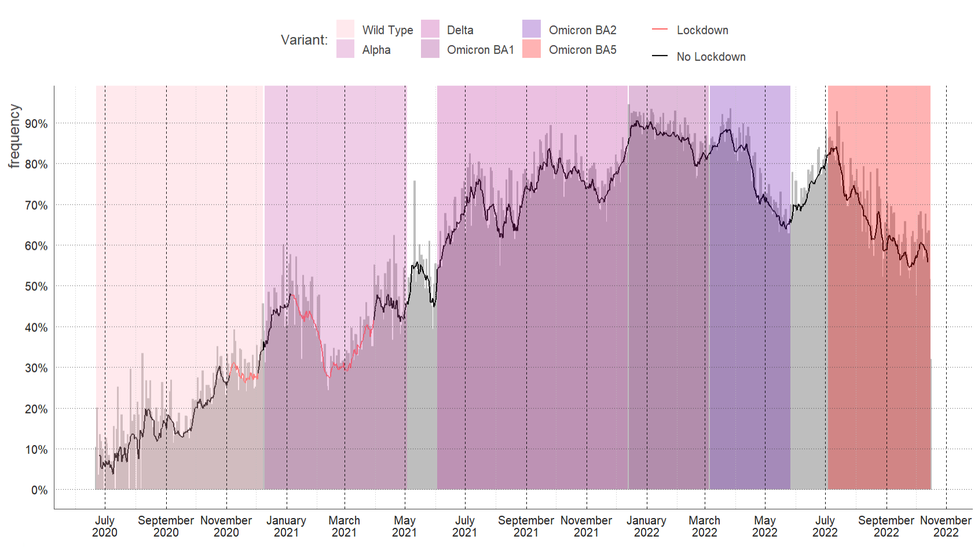
Appendix 4: proportion of illnesses tested for SARS-CoV-2 (grey bars represent daily proportion, line represents 7 -day average).

