From 1.5ºC to 2.0ºC: the global increase in cooling degree days

Nicole D. Miranda^{a,b} – nicole.miranda@eng.ox.ac.uk – ORCID: 0000-0002-3372-4414
Jesus Lizana^{a,b,}*– jesus.lizana@eng.ox.ac.uk – ORCID: 0000-0002-1802-5017
Sarah N. Sparrow^{c} - sarah.sparrow@oerc.ox.ac.uk - ORCID: 0000-0002-1802-6909
Miriam Zachau-Walker^{b} – miriam.zachauwalker@eng.ox.ac.uk - ORCID: 0000-0002-4757-3688
David C.H. Wallom^{c} – david.wallom@oerc.ox.ac.uk - ORCID: 0000-0001-7527-3407
Radhika Khosla^{a,d} – radhika.khosla@smithschool.ox.ac.uk – ORCID: 0000-0002-7730-8041
Malcolm McCulloch^{a,b} - malcolm.mcculloch@eng.ox.ac.uk – ORCID: 0000-0001-5378-1128

ª Future of Cooling Programme, Oxford Martin School, University of Oxford, Oxford OX1 3BD, United Kingdom
^{b} Energy and Power Group, Department of Engineering Science, University of Oxford, Parks Road, Oxford OX1 3PJ, United Kingdom
^{c} Oxford e-Research Centre, University of Oxford, Oxford OX13QG, UK
^{d} Smith School of Enterprise and the Environment, School of Geography and the Environment, University of Oxford, Oxford, UK

* Corresponding author. E-mail address: jesus.lizana@eng.ox.ac.uk
These authors contributed equally: Nicole D. Miranda, Jesus Lizana

Supplementary Information
In this Appendix, we provide additional results obtained from the analysis.
Supplementary Figure S1 maps the standard deviation of the absolute delta of CDD between 1.5ºC and 2ºC scenarios. It shows the uncertainty per longitude and latitude in the ensemble members.

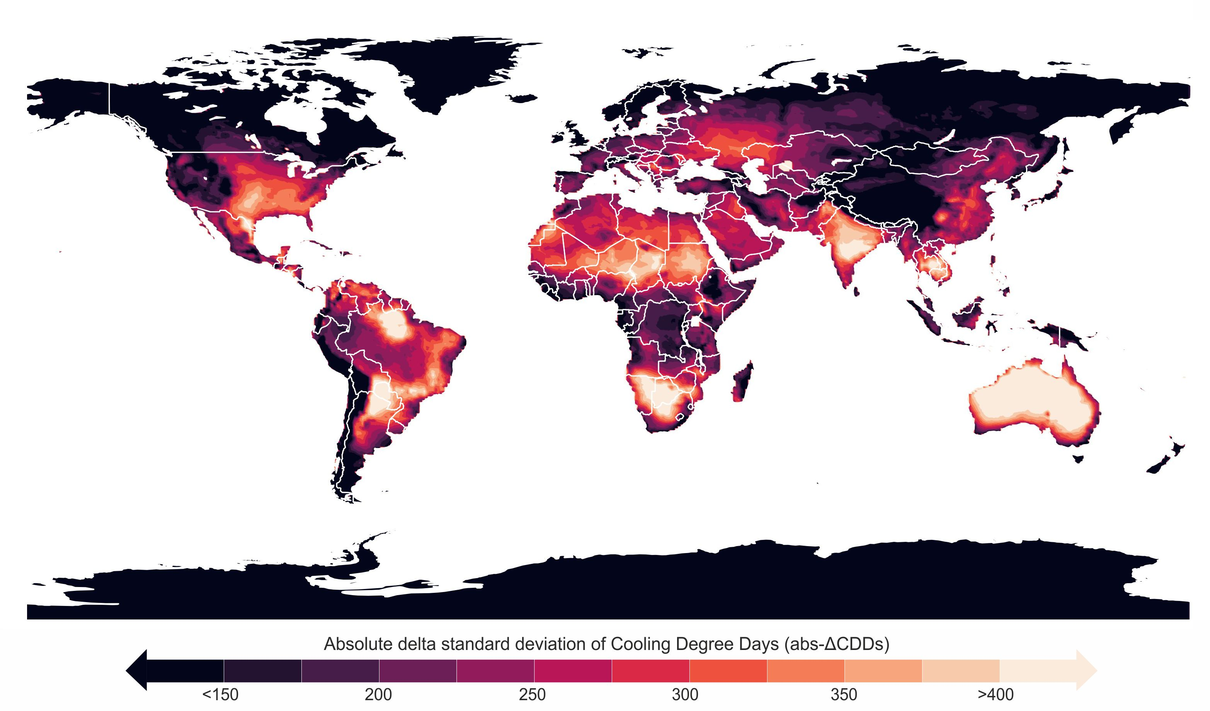

Supplementary Figure S1 | Standard deviation of CDD difference between 1.5ºC and 2ºC global warming scenarios.

Supplementary table 1 includes the top 100 countries with a population of more than 1 million that will experience the most significant changes in absolute and relative CDDs from 1.5ºC to 2.0ºC.

Supplementary table 1 | Ranking of countries with more than 1 million inhabitants that will suffer a higher increase (absolute and relative) in area-weighted mean CDDs from 1.5ºC to 2.0ºC.
 | a, Countries by absolute change | abs-ΔCDD₁₈ | Population (M)²⁵ |  |  | b, Countries by relative change | rel-ΔCDD₁₈ | Population (M)²⁵
1 | Bahrain | 321 | 1.5 |  | 1 | Ireland | 36% | 4.9
2 | Qatar | 313 | 2.8 |  | 2 | United Kingdom | 31% | 67.0
3 | Kuwait | 282 | 4.5 |  | 3 | Switzerland | 30% | 8.6
4 | Central African Republic | 266 | 5.3 |  | 4 | Norway | 30% | 5.4
5 | Hong Kong | 256 | 7.5 |  | 5 | Sweden | 28% | 10.3
6 | Burkina Faso | 254 | 21.2 |  | 6 | Finland | 28% | 5.5
7 | Mali | 253 | 20.9 |  | 7 | Denmark | 27% | 5.8
8 | South Sudan | 251 | 10.5 |  | 8 | Canada | 25% | 37.8
9 | Trinidad and Tobago | 251 | 1.5 |  | 9 | Austria | 24% | 8.9
10 | Nigeria | 245 | 205.8 |  | 10 | New Zealand | 24% | 5.0
11 | Congo | 241 | 5.6 |  | 11 | Estonia | 22% | 1.3
12 | Democratic Republic of The Congo | 240 | 91.3 |  | 12 | Lesotho | 21% | 2.2
13 | Chad | 236 | 16.4 |  | 13 | Netherlands | 21% | 17.4
14 | Uganda | 234 | 43.7 |  | 14 | Belgium | 21% | 11.5
15 | Cameroon | 228 | 26.1 |  | 15 | Germany | 21% | 83.3
16 | Brazil | 227 | 212.6 |  | 16 | Czechia | 20% | 10.5
17 | Djibouti | 227 | 1.1 |  | 17 | Slovenia | 20% | 2.1
18 | Mauritius | 226 | 1.3 |  | 18 | Russian Federation | 20% | 145.8
19 | Guatemala | 225 | 17.2 |  | 19 | Latvia | 19% | 1.9
20 | Singapore | 224 | 5.9 |  | 20 | Slovakia | 19% | 5.5
21 | United Arab Emirates | 220 | 9.2 |  | 21 | Kyrgyzstan | 19% | 6.4
22 | Saudi Arabia | 220 | 36.2 |  | 22 | Bosnia and Herzegovina | 18% | 3.3
23 | Benin | 220 | 12.5 |  | 23 | Poland | 18% | 38.5
24 | Sudan | 220 | 43.8 |  | 24 | Armenia | 18% | 2.8
25 | Côte d'Ivoire | 219 | 26.5 |  | 25 | Chile | 18% | 19.2
26 | Honduras | 216 | 10.0 |  | 26 | Lithuania | 17% | 2.8
27 | Venezuela | 215 | 28.6 |  | 27 | Belarus | 17% | 9.7
28 | Mauritania | 215 | 4.4 |  | 28 | Serbia | 17% | 7.4
29 | Guinea | 213 | 13.0 |  | 29 | North Macedonia | 17% | 2.1
30 | Togo | 213 | 8.3 |  | 30 | Georgia | 17% | 3.8
31 | Botswana | 212 | 2.5 |  | 31 | Croatia | 17% | 4.1
32 | Niger | 212 | 23.9 |  | 32 | Hungary | 16% | 9.8
33 | Angola | 211 | 32.9 |  | 33 | Romania | 16% | 19.5
34 | Paraguay | 210 | 6.6 |  | 34 | Mongolia | 16% | 3.3
35 | Eritrea | 209 | 3.5 |  | 35 | Albania | 16% | 2.9
36 | Oman | 208 | 4.6 |  | 36 | Rwanda | 14% | 13.0
37 | Timor-Leste | 208 | 1.3 |  | 37 | Bulgaria | 14% | 7.0
38 | Senegal | 207 | 16.2 |  | 38 | Burundi | 14% | 12.1
39 | United Republic of Tanzania | 206 | 60.8 |  | 39 | North Korea | 14% | 25.8
40 | Sierra Leone | 206 | 8.1 |  | 40 | Ukraine | 14% | 44.1
41 | Nicaragua | 205 | 6.7 |  | 41 | Italy | 13% | 59.6
42 | Liberia | 205 | 5.0 |  | 42 | Moldova | 13% | 3.1
43 | Zambia | 205 | 18.7 |  | 43 | Spain | 13% | 47.3
44 | Myanmar/Burma | 204 | 53.2 |  | 44 | United States | 13% | 335.4
45 | Colombia | 202 | 50.6 |  | 45 | France | 12% | 64.5
46 | Thailand | 199 | 71.4 |  | 46 | Greece | 12% | 10.5
47 | Guinea-Bissau | 197 | 2.0 |  | 47 | Portugal | 12% | 10.3
48 | Laos | 196 | 7.3 |  | 48 | Turkey | 12% | 83.8
49 | Gabon | 195 | 2.3 |  | 49 | South Korea | 12% | 51.9
50 | Puerto Rico | 195 | 3.3 |  | 50 | Kazakhstan | 11% | 18.9
51 | Ghana | 193 | 31.8 |  | 51 | Lebanon | 11% | 5.7
52 | El Salvador | 193 | 6.3 |  | 52 | Japan | 11% | 125.5
53 | Kenya | 192 | 51.5 |  | 53 | Zambia | 11% | 18.7
54 | Cambodia | 190 | 16.3 |  | 54 | China | 11% | 1424.0
55 | Yemen | 190 | 31.9 |  | 55 | Uganda | 11% | 43.7
56 | Algeria | 188 | 43.1 |  | 56 | Angola | 11% | 32.9
57 | Bangladesh | 188 | 166.4 |  | 57 | Eswatini | 10% | 1.2
58 | Ethiopia | 187 | 115.6 |  | 58 | Azerbaijan | 10% | 10.3
59 | Malawi | 187 | 19.1 |  | 59 | South Africa | 10% | 58.5
60 | Namibia | 187 | 2.5 |  | 60 | United Republic of Tanzania | 10% | 60.8
61 | Mozambique | 186 | 30.7 |  | 61 | Zimbabwe | 10% | 15.5
62 | Iraq | 185 | 42.0 |  | 62 | Hong Kong | 10% | 7.5
63 | Zimbabwe | 185 | 15.5 |  | 63 | Tajikistan | 10% | 9.4
64 | Somalia | 182 | 16.3 |  | 64 | Democratic Republic of The Congo | 10% | 91.3
65 | Jamaica | 181 | 2.8 |  | 65 | Uruguay | 10% | 3.4
66 | Egypt | 178 | 106.5 |  | 66 | Malawi | 9% | 19.1
67 | Malaysia | 177 | 33.0 |  | 67 | Botswana | 9% | 2.5
68 | Gambia | 177 | 2.5 |  | 68 | Namibia | 9% | 2.5
69 | Madagascar | 176 | 27.9 |  | 69 | Argentina | 9% | 44.9
70 | Indonesia | 175 | 270.8 |  | 70 | Peru | 9% | 33.1
71 | Panama | 172 | 4.3 |  | 71 | Honduras | 9% | 10.0
72 | Rwanda | 172 | 13.0 |  | 72 | Guatemala | 9% | 17.2
73 | Burundi | 171 | 12.1 |  | 73 | Uzbekistan | 9% | 33.2
74 | Philippines | 171 | 111.3 |  | 74 | Mexico | 9% | 125.6
75 | India | 171 | 1390.0 |  | 75 | Congo | 9% | 5.6
76 | Bolivia | 170 | 11.9 |  | 76 | Israel | 9% | 8.7
77 | Mexico | 167 | 125.6 |  | 77 | Bahrain | 9% | 1.5
78 | Libya | 166 | 6.6 |  | 78 | Mauritius | 9% | 1.3
79 | Vietnam | 164 | 96.2 |  | 79 | Jordan | 9% | 10.8
80 | Jordan | 163 | 10.8 |  | 80 | Bolivia | 8% | 11.9
81 | Israel | 160 | 8.7 |  | 81 | Central African Republic | 8% | 5.3
82 | Papua New Guinea | 155 | 9.6 |  | 82 | Madagascar | 8% | 27.9
83 | Lebanon | 154 | 5.7 |  | 83 | Nepal | 8% | 29.0
84 | Costa Rica | 153 | 5.1 |  | 84 | Cameroon | 8% | 26.1
85 | Syria | 152 | 20.5 |  | 85 | Ecuador | 8% | 17.5
86 | Ecuador | 151 | 17.5 |  | 86 | Myanmar/Burma | 8% | 53.2
87 | Cuba | 149 | 11.3 |  | 87 | Qatar | 8% | 2.8
88 | Sri Lanka | 147 | 21.7 |  | 88 | Laos | 8% | 7.3
89 | Peru | 146 | 33.1 |  | 89 | Ethiopia | 8% | 115.6
90 | Australia | 142 | 25.5 |  | 90 | Morocco | 8% | 36.5
91 | Equatorial Guinea | 138 | 1.6 |  | 91 | Brazil | 8% | 212.6
92 | Dominican Republic | 137 | 10.9 |  | 92 | Colombia | 8% | 50.6
93 | Pakistan | 134 | 225.1 |  | 93 | Mozambique | 8% | 30.7
94 | Tunisia | 133 | 12.1 |  | 94 | Syria | 8% | 20.5
95 | Uzbekistan | 131 | 33.2 |  | 95 | Gabon | 8% | 2.3
96 | Iran | 131 | 87.0 |  | 96 | Costa Rica | 8% | 5.1
97 | Turkmenistan | 128 | 6.2 |  | 97 | Paraguay | 8% | 6.6
98 | Greece | 128 | 10.5 |  | 98 | Afghanistan | 7% | 38.3
99 | Serbia | 128 | 7.4 |  | 99 | Trinidad and Tobago | 7% | 1.5
100 | Croatia | 126 | 4.1 |  | 100 | Liberia | 7% | 5.0

Countries with more than 1 million inhabitants in 2020²⁵ are listed. Annual CDDs were calculated using a temperature baseline of 18°C. The rankings use the area-weighted mean values per country rather than grid-specific relative values, as the latter can distort results with large percentage values for specific latitude-longitudes that go from no/negligible CDDs in a 1.5C to having any significant CDDs in a 2.0 ºC.

