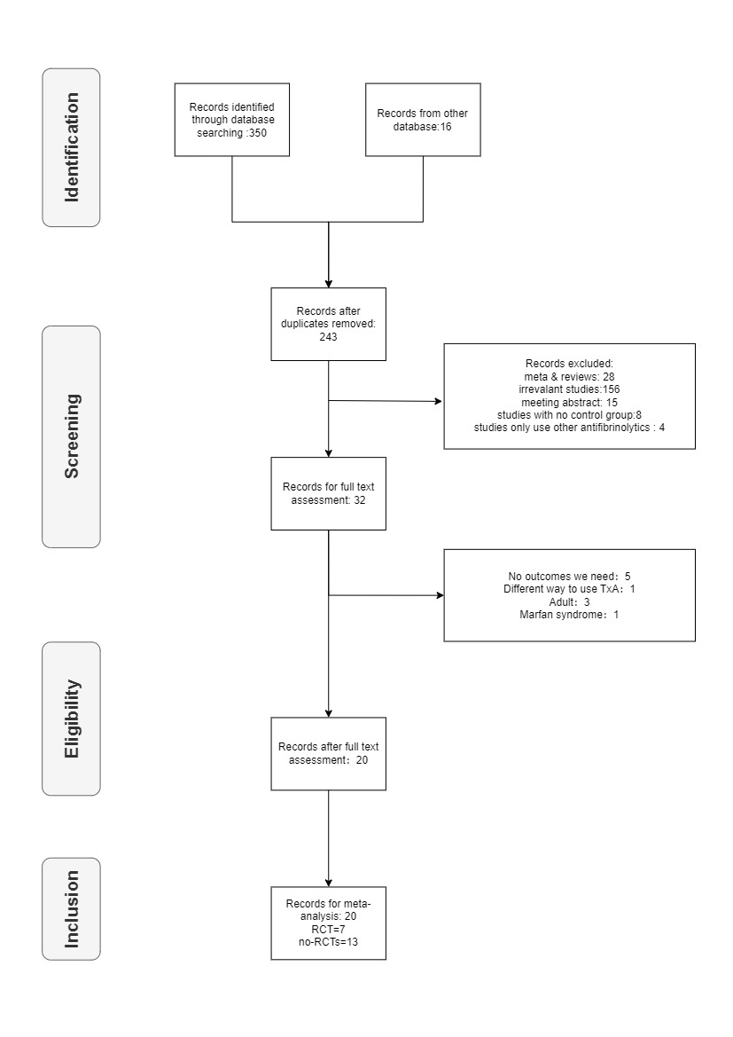
Supplementary File Legends
Supplementary Figure 1. Searching strategy for meta-analysis

