Supplementary information for

Culturally diverse facial expression signals diminish the precision of emotion communication across cultures

Chaona Chen, Daniel S. Messinger, Cheng Chen, Hongmei Yan, Yaocong Duan, Robin A. A. Ince, Oliver G. B. Garrod, Philippe G. Schyns, & Rachael E. Jack

The following pages include:

Supplementary information text
Supplementary Fig. 1 to 7
Legend for Supplementary Movie 1

Supplementary information text

Screening questionnaire

Each potential observer completed the following questionnaire. We selected only those answering “no” to all questions for participation in the experiment.

Western European observers
Have you ever:
i) lived in a non-Western* country before (e.g., on a gap year, summer work, move due to parental employment)?
ii) visited a non-Western country (e.g., vacation)?
iii) dated a non-Westerner?
iv) had a very close friendship with a non-Westerner?
v) been involved with any non-Western culture societies/groups?
*by Western groups/countries, we are referring to Europe (East and West), USA, Canada, United Kingdom, Australia and New Zealand.

East Asian observers
Have you ever:
i) lived in a non-East Asian* country before (e.g., on a gap year, summer work, move due to parental employment)?
ii) visited a non-East Asian country (e.g., vacation)?
iii) dated a non-East Asian person?
iv) had a very close friendship with a non-East Asian person?
v) been involved with any non-Eastern culture societies/groups?
*by East Asian groups/countries, we are referring to China, Japan, Korea, Thailand and Taiwan.

Modelling emotion classifier and intensifier facial movements
We modelled the facial movements (i.e., AUs) that observers in each culture used to classify the six classic emotions and judge their intensity using Mutual Information (MI) analysis (see Methods, Modelling emotion classifier and intensifier facial movements for full details). Supplementary Fig. 1 shows the results of the AUs with effects observed in the number of observers above the population prevalence threshold (i.e., N > 10 observers) as color-coded face maps for each emotion and culture. Color saturation shows the number of observers with a statistically significant effect for each AU (see color bars to right). The color-coded matrices below show the results of each individual AU (exact number shown in each cell).

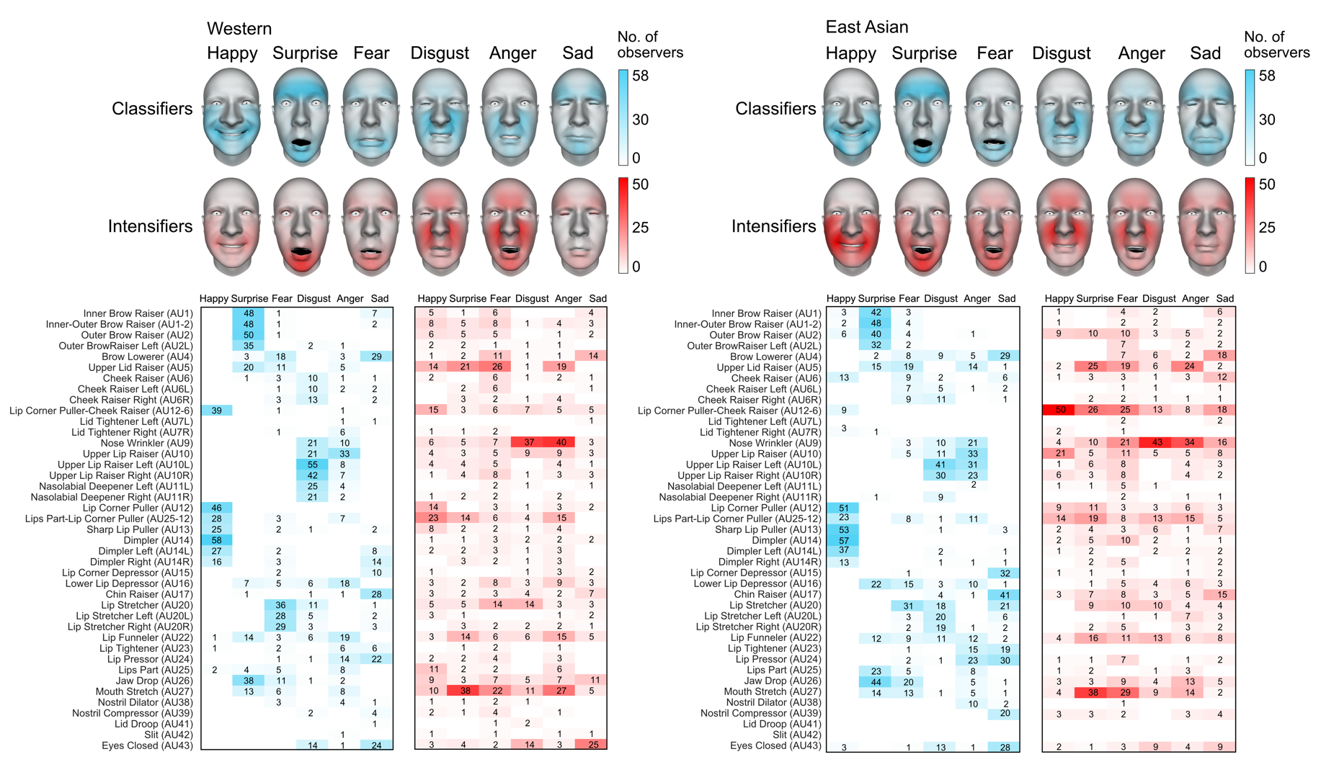

Supplementary Fig. 1. Emotion classifier and intensifier facial movements in two cultures. For each culture, Color-coded face maps show the classifier (cyan) and intensifier (red) facial movements for each emotion and culture. Color saturation indicates the number of observers showing a statistically significant effect (see color bars to right). Color-coded matrices show per AU results, with the exact value shown in each cell.

Validating emotion classifier and intensifier facial movements
We validated the emotion classifier and intensifier facial movements in each culture derived above using a machine learning approach (see Methods, Validating emotion classifier and intensifier facial movements). Supplementary Fig. 2 shows the result for emotion classifiers (panel a) and emotion intensifiers (panel b). In each plot, color-coded boxplots and distributions shows the posterior probabilities of accurately classification based on the three test sets—with the full set of AUs (in gray), the classifier AUs removed (in cyan) or the intensifier AUs removed (in red; see legend to upper right). Individual points represent the results of Bayesian classifier trained using the experimental trials of each individual observer. Asterisks indicate Ps < 0.05 with Bonferroni corrected over emotions.

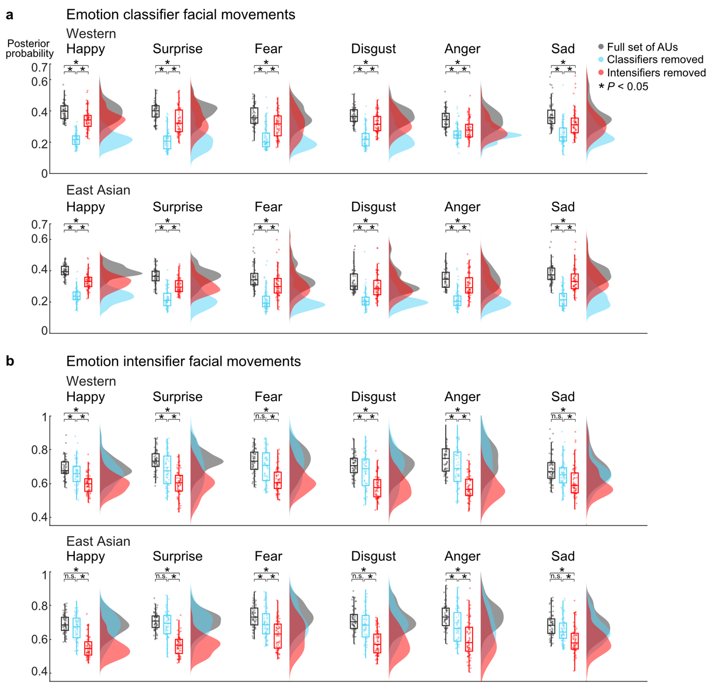
Supplementary Fig. 2. Validating emotion classifier and intensifier facial movements in each culture. In each panel, color-coded boxplots and distributions show for, each emotion and culture, the posterior probability of accurate classification according to three test sets (see legend to upper right). Individual points represent individual observers; asterisks indicate statistically significant differences between test sets (ANOVA, P < 0.05). a Emotion classifier facial movements. The posterior probability to accurately classify each emotion significantly decreased with emotion classifiers removed compared to removal of the full set of AUs or intensifiers. b Emotion intensifier facial movements. The posterior probability to accurately classify high intensity significantly decreased with intensifiers removed compared to removal of the full set of AUs or emotion classifiers. These results validate the relevance of the classifier AUs for emotion classification behavior and the intensifier AUs for perceiving high emotional intensity.

Signal distinctiveness of emotion classifier and intensifier facial movements
We examined the distinctiveness of the emotion classifier and intensifier facial movements across emotions by computing the average percentage of shared AUs between emotions (see Methods, Signal distinctiveness of emotion classifier and intensifier facial movements). Supplementary Fig. 3a shows the results for each culture. Boxplots show the average percentage of emotion classifier (shown in cyan) and intensifier facial movements (shown in red) that are shared across emotions. Results show that, in each culture, intensifiers are more similar across emotions than classifiers are (two-tailed two-sample t-tests; Western: t(17) = 2.56, P = 0.02, East Asian: t(23) = 3.41, P = 0.003). Color-coded matrices to the right show results per emotion pair—for example, in Western observers, ‘disgust’ and ‘anger’ share a low percentage of emotion classifier AUs but a high percentage of intensifier AUs. Supplementary Fig. 3b shows examples of AUs that intensify several emotions, for each culture—for example, in Western observers, the wide-open eyes (Upper Lid Raiser—AU5) and gaping mouth (Mouth Stretch—AU27) intensify several emotions including ‘surprise,’ ‘fear’ and ‘anger’. In Supplementary Fig. 3c, red-coded matrices below show the results of each individual intensifier AU (see label on left). Red squares indicate the emotions that each AU intensifies, with the total number of emotions shown on the right. For example, for Western observers, the wide opened eyes (Upper Lid Raiser—AU5) and gaping mouth (Mouth Stretch—AU27) intensify 4 out of 6 emotions. For East Asian observers, lip pulling with cheek raising (Lip Corner Puller-Cheek raiser—AU12-6), nose wrinkling (Nose Wrinkler—AU9) and lip pulling with open mouth (Lips Part-Lip Corner Puller—AU12-25) intensify 4–5 emotions.

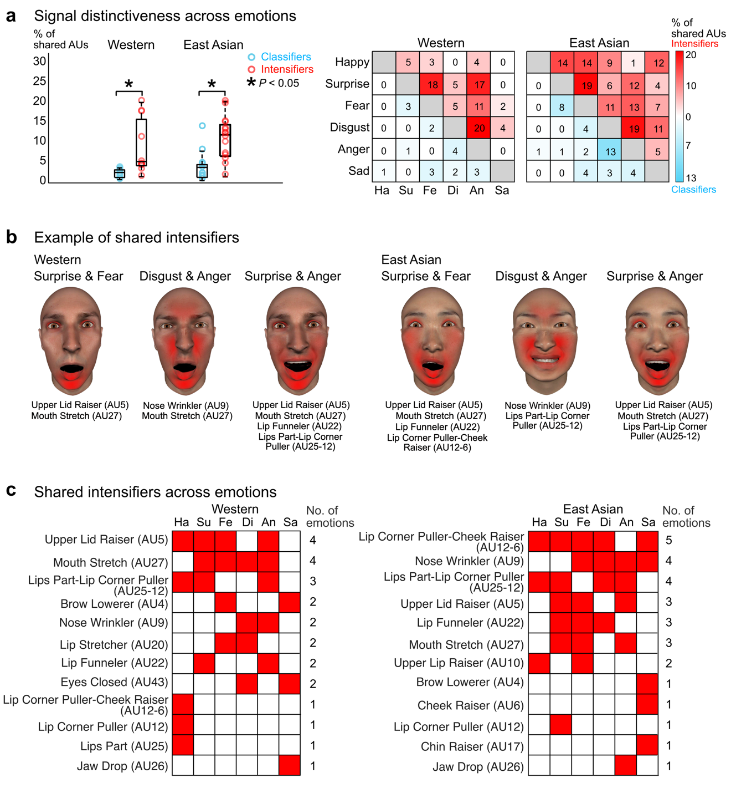Supplementary Fig. 3. Signal distinctiveness of emotion classifiers and intensifiers. a Signal distinctiveness across emotions. Boxplots show the average percentage of emotion classifiers (cyan) and intensifiers (red) that are shared across emotions, for each culture. Asterisks indicate a statistically significant difference (P < 0.05, two-sample t-tests). Circles represent specific emotion pairs, detailed in matrices to right. b Example of shared intensifiers. Red-coded faces show example shared AUs (see AU labels below) that intensify several emotions. c Shared intensifiers across emotions. Red-coded matrixes below show per AU results, with each red square indicates the emotion that the AU intensifies. Total number of emotions is shown to right. Intensifiers are ranked from highest to lowest number of emotions.

Temporal signatures of emotion classifier and intensifier facial movements
To examine the temporal distribution of the emotion classifiers and intensifiers, we compared their peak latencies using the shift function (see Methods, Temporal analysis of emotion classifier and intensifier facial movements). Supplementary Fig. 4 shows the results, for each culture separately. Color-coded areas show the temporal distribution of the classifier facial movements (cyan) and intensifier facial movements (red). Distribution height represents the kernel density estimation of the number of observers over time. Color-coded points below show the results of individual observers (see legend to right). Asterisks denote a statistically significant difference in temporal activation (on left—intensifiers are earlier than classifiers; on right—intensifiers are later than classifiers), further detailed in the line plots below. Specifically, the y-axis shows the quantile differences in the peak latencies of the emotion classifiers and intensifiers. For each decile difference, the vertical line indicates its 95% bootstrap confidence interval (CI, see legend to right). Those vertical lines with red circles in the middle indicate the statistically significant differences in the peak latencies (i.e., when the CI does not include zero). If the CIs > 0 (i.e., above the dashed line), this suggests that the intensifier AUs peaked before the classifier AUs; if the CIs < 0 (i.e., below the dashed line), this suggests that the intensifier AUs peaked after the classifier AUs. For example, for Westerners, ‘anger’ intensifiers are activated earlier than the emotion classifiers. In contrast, for East Asians, ‘anger’ intensifiers are activated later than classifiers. Together, these results show that, in each culture, emotion classifier and intensifiers follow a distinct temporal structure (except ‘sad’ for East Asian observers).

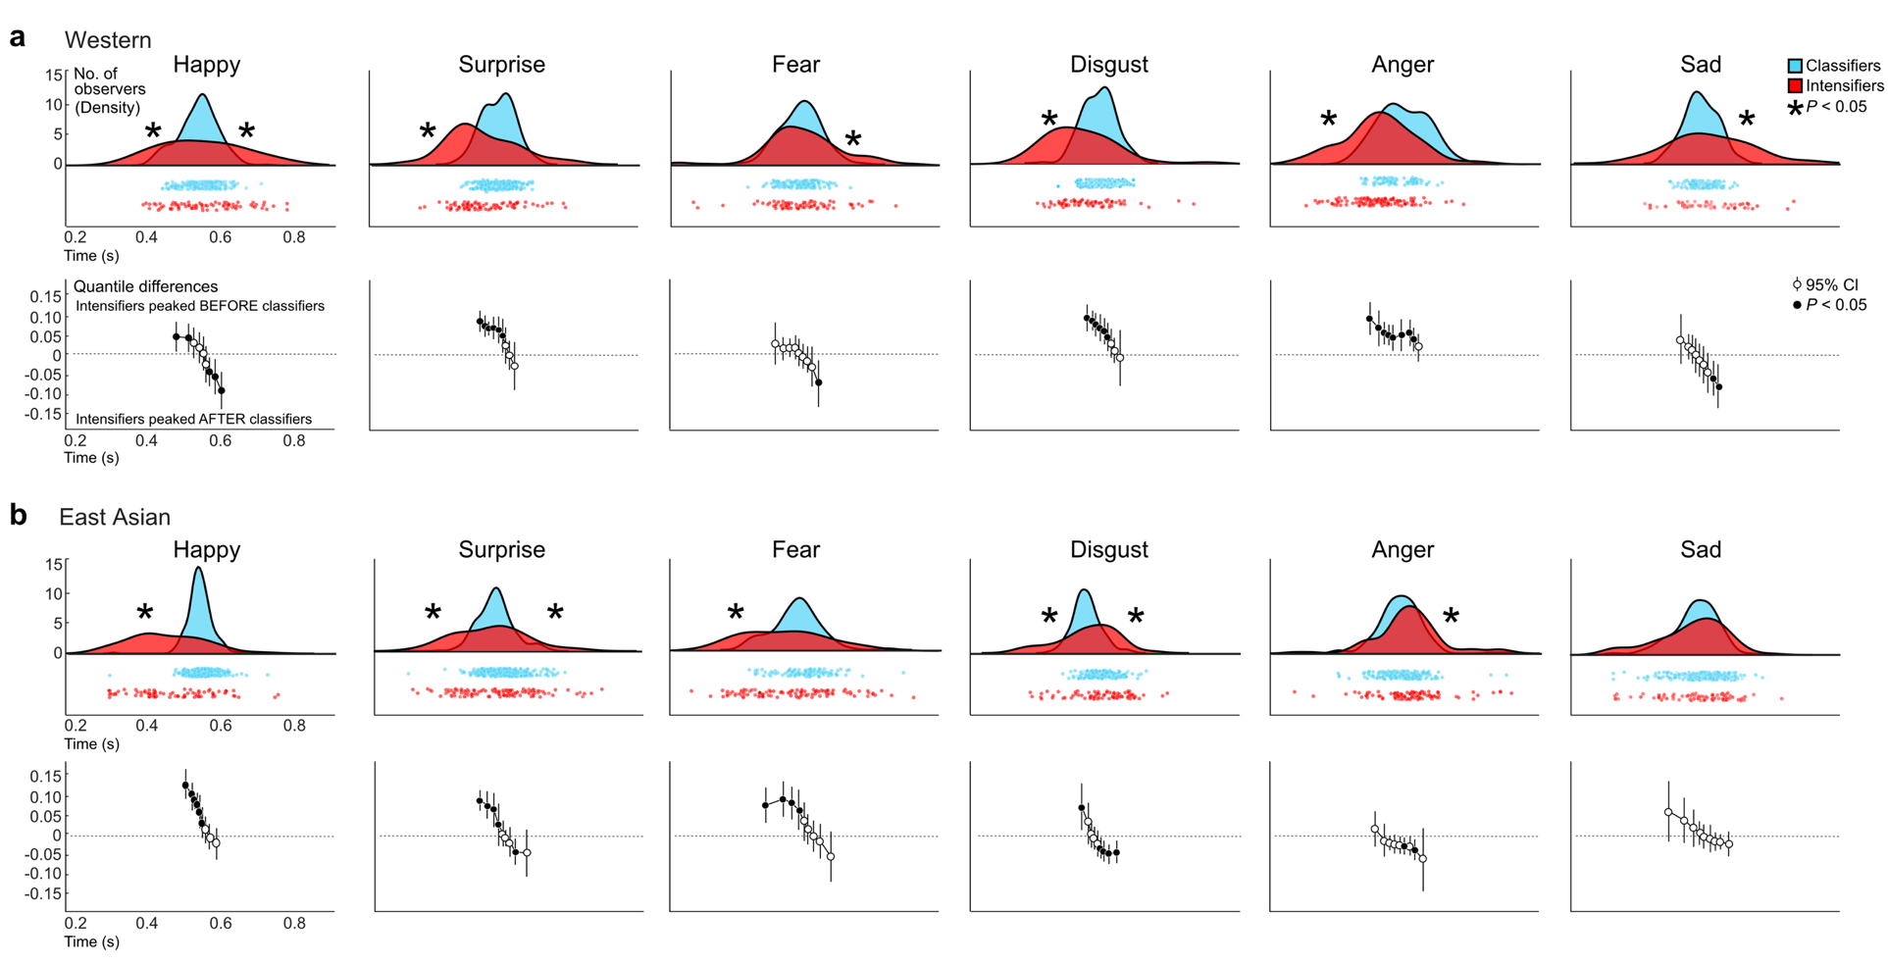
Supplementary Fig. 4. Temporal signatures of emotion classifier and intensifier facial movements in each culture. a For each emotion, color-coded plots show the distribution of emotion classifier (cyan) and intensifier facial movements (red) across time (see legend in upper right). Distribution height represents the kernel density estimation of the number of Western observers at each time point. Asterisks denote a statistically significant difference in temporal activation (on left—intensifiers are earlier than classifiers; on right—intensifiers are later than classifiers; see Methods, Temporal analysis of emotion classifier and intensifier facial movements). Below, color-coded circles represent individual observers and AUs. Line plots show the quantile differences in the peak latencies. For each decile difference, the vertical line indicates its 95% bootstrap confidence interval (CI, see legend to right). Those with solid circles in the middle indicate the statistically significant difference in the peak latencies. CIs above 0 show that the intensifier AUs peaked before the classifiers; CIs below 0 show that the intensifier AUs peaked after the classifiers (see legend). b Color-coded distribution and line plots below show the results for East Asian observers, using the same lay out. In both cultures, intensifier facial movements are temporally distinct from emotion classifiers (except sad, East Asian).
Cross-cultural classification of emotion categories and their intensity
Bayesian classifiers. To compare the dynamic signalling of emotion categories and intensity across cultures, we used a naïve Bayesian classifier approach (see Methods, Cross-cultural classification of emotion categories and their intensity). Supplementary Fig. 5a shows the results. For each emotion and each train-test set (i.e., Western train, East Asian test or vice versa), solid color-coded lines show the posterior probability to accurately classify the emotion (cyan) and high intensity (red), averaged across the test samples (i.e., individual observer facial expression models). Dashed lines show within-culture performance (see legend). Shaded area shows the standard error of means (SEM) across the test samples. We then identified the first time point at which the (1) within-culture classification accuracy is significantly higher than chance and the (2) cross-culture classification accuracy is significantly lower than the within-culture classification accuracy (two-tailed two-sampled t-tests, P < 0.05 with Bonferroni correction over emotions). Asterisks and vertical lines show the results.

Specific cross-cultural confusions. Next, we examined the cross-cultural misclassifications by analyzing the specific emotion confusions across time. Supplementary Fig. 5b shows the results. For each train-test set, the color-coded matrix shows at each time point (i.e., t1-10) the posterior probability to classify each emotion, averaged across the test samples. Brighter colors show higher posterior probability; darker colors show lower posterior probability (see color bar to right). Diagonal squares show the results of cross-culture classification accuracy of each emotion as shown in Supplementary Fig. 5a. Pink outlines show which emotions are accurately classified across cultures; green boxes show which emotions are inaccurately classified across cultures. Off-diagonal squares show the cross-cultural misclassifications between emotions. At each time point, we then identified when the cross-cultural misclassifications between emotions is significantly higher than the within-culture misclassifications between emotions and is also higher than the chance level (two-tailed two-sampled t-tests, P < 0.05 with Bonferroni correction over emotions). Asterisks indicate statistically significant cross-cultural confusions between emotions—for example, ‘disgust’ is often misclassified as ‘anger.’

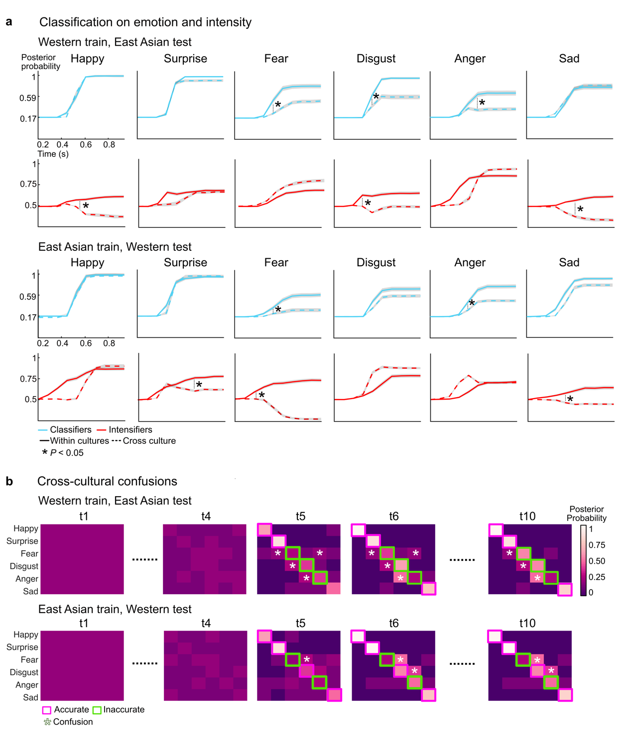
Supplementary Fig. 5: Cross-culture classification of emotion categories and intensity. a Classification on emotion and intensity. For each emotion train-test set (e.g., Western train, East Asian test), solid color-coded lines show the posterior probability of the Bayesian classifier to accurately classify the emotion (cyan) or intensity (red) within each culture. Shaded areas show the standard error of means across test samples. Dashed lines show cross-culture accuracy; asterisks indicate statistically lower cross-culture compared to within-culture accuracy (two-sample t-tests, P < 0.05, Bonferroni corrected over emotions). For example, ‘anger’ classifications are statistically significantly lower in accuracy across than within cultures. b Cross-cultural confusions. For each train-test set, color-coded matrices show the posterior probability of classifying each emotion at each time point (i.e., t1-10). Brighter colors show higher posterior probability; darker colors show lower posterior probability (see color bar to right). Pink boxes indicate accurate classifications (i.e., above chance level and no statistically significantly difference compared to within-culture classification accuracy); green boxes show inaccurate classifications (i.e., statistically significantly lower than within-culture classification accuracy); asterisks indicate significant confusions across cultures—for example, in ‘fear,’ ‘disgust’ and ‘anger’.
Facial movements driving cross-cultural classifications
We identified the AUs that drive cross-cultural performance using a leave-one-out approach (see Methods, Cross-cultural classification of emotion categories and their intensity). Supplementary Fig. 6 and Supplementary Fig. 7 show the results, for emotion classification and intensity classification separately. For each train and test set, the color-coded matrices show the change in cross-cultural classification accuracy when a given AUs is removed. If removing the AU resulted in decreased cross-cultural classification accuracy (pink-coded cells), we can infer that the AU is cross-cultural. In contrast, if removing the AU resulted in increased classification accuracy of the other-culture facial expression models (i.e., incorrect classifications are reduced; green-coded cells), thus reflecting the AU is culture specific. Color saturation shows the magnitude of chance (see color bar to right). AUs are ranked according to magnitude of change summed across time. Asterisks indicate the AUs that, when removed, cause a statistically significant increase or decrease in cross-cultural classification accuracy in at least one time point (P < 0.05, two-tailed two-sample t-tests; cross-validated across the two train-test sets). For culture-specific facial movements (green matrices), labels in the final time bin indicate the culture that the AU is specific to (‘W’—Western; ‘EA’—East Asian).
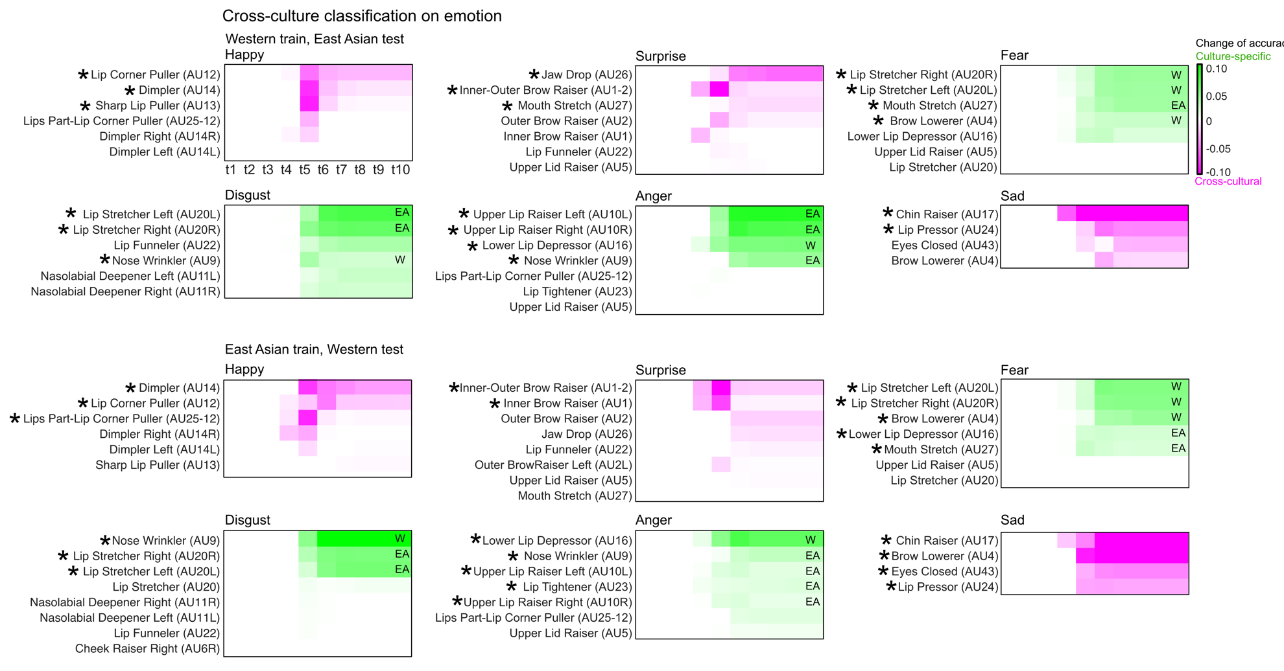

Supplementary Fig. 6. Facial movements driving cross-cultural emotion classification performance. For each train and test set (e.g., Western trained, East Asian tested), the color-coded matrices show the AUs that cause a change in emotion classification performance when removed. Pink denotes that accuracy decreased, thus reflecting the AU is cross-cultural; green denotes that accuracy increased (i.e., incorrect classifications are reduced), thus reflecting the AU is culture specific. Color saturation shows the magnitude of change (see color bar to right). AUs are ranked according to the magnitude of change summed across time. Asterisks indicate the AUs that cause a statistically significant change in performance when removed (P < 0.05, two-tailed two-sample t-tests). For culture-specific AUs (i.e., green matrices), labels in the final time bin indicate the culture that the AU is specific to (‘W’—Western; ‘EA’—East Asian).

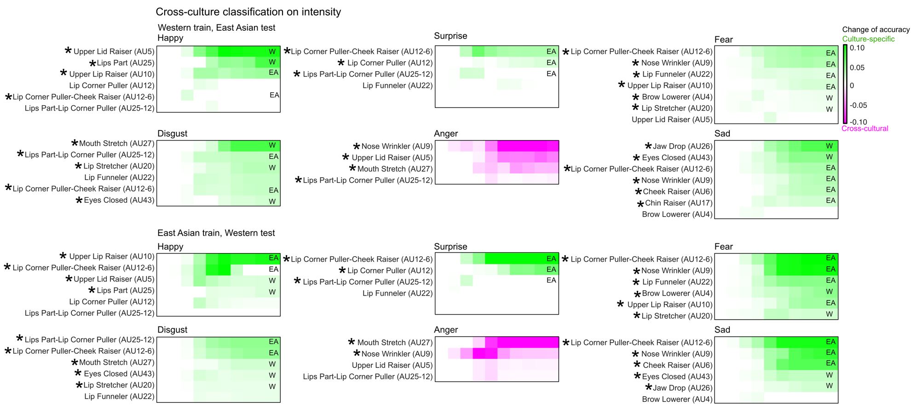

Supplementary Fig. 7. Facial movements driving cross-cultural intensity classification performance. For each train and test set, the color-coded matrices show the AUs that cause a change in intensity classification performance when removed, using the same color-coding as in Supplementary Fig. 6. Asterisks indicate the AUs that cause a statistically significant change in performance when removed (P < 0.05, two-tailed two-sample t-tests). For culture-specific AUs (i.e., green matrices), labels in the final time bin indicate the culture that the AU is specific to (‘W’—Western; ‘EA’—East Asian).

Supplementary Movie 1. The video illustrates the stimulus generation using an example trial. On each trial, a dynamic face movement generator randomly selected a combination of individual face movements called Action Units (AUs) from a core set of 41 AUs (minimum = 1, maximum = 4, median = 3 AUs selected on each trial). A random movement is assigned to each AU individually using six temporal parameters—onset latency, acceleration, peak amplitude, peak latency, deceleration, and offset latency—represented here using the color-coded curve below each face. In this example trial, four AUs are randomly selected—Nose Wrinkler (AU9) color-coded in orange, Mouth Stretch (AU27) color-coded in purple, Brow Lowerer (AU4) color-coded in blue, and Lip Corner Puller (AU12) color-coded in yellow. The randomly activated AUs are then combined to produce a random facial animation (here, ‘Stimulus trial’). The cultural observer viewed the random facial animation played once for a duration of 1.25 seconds and classified it as one of the six classic basic emotions—‘happy,’ ‘surprise,’ ‘fear,’ ‘disgust,’ ‘anger,’ or ‘sad’—and rated its intensity on a 5-point scale from ‘very weak’ to ‘very strong’—only if they perceived that the facial animation accurately represented the emotion and intensity.

