Supplementary Table 1. Details of 17 groundnut genotypes used in the study
S.No. | Genotype | Pedigree | Habit Group  SB/VB | Year of Release | Released Institute
1 | TPT 1 | E.C 106983 × 3 | SB | 1989 | RARS, ANGRAU, Tirupati
2 | TPT 2 | GAUG 1 × Nc.Ac.FLA.14 | SB | 1989 | RARS, ANGRAU, Tirupati
3 | TPT 3 | Selection from TMV 10, a Virginia bunch variety with variegated testa | VB | 1991 | RARS, ANGRAU, Tirupati
4 | TAG 24* | TGS 2 × TGE 1 | SB | 1991 | BARC, Mumbai
5 | TPT 4 | JL 24 × Ah316/S | SB | 1995 | RARS, ANGRAU, Tirupati
6 | Narayani | JL 24 × Ah316/S | SB | 2002 | RARS, ANGRAU, Tirupati
7 | Kalahasti | TCG1709 × TCG1518 | SB | 2002 | RARS, ANGRAU, Tirupati
8 | Prasuna | TCG1717 × TCG1518 | SB | 2006 | RARS, ANGRAU, Tirupati
9 | Abhaya | K 134 × TAG 24 | SB | 2006 | RARS, ANGRAU, Tirupati
10 | Greeshma | TIR 46 × JUG 37 | SB | 2009 | RARS, ANGRAU, Tirupati
11 | Rohini | Tirupati 4 × TIR 45 | SB | 2010 | RARS, ANGRAU, Tirupati
12 | Bheema | TAG 24 × TG 19 | SB | 2010 | RARS, ANGRAU, Tirupati
13 | ICGV 00350 | ICGV 87290 × ICGV 87846 | SB | 2011 | RARS, ANGRAU, Tirupati
14 | Dharani | VRI 2 × TCGP 6 | SB | 2012 | RARS, ANGRAU, Tirupati
15 | TCGS 1073 | Narayani × JAL 30 | SB | 2018 | RARS, ANGRAU, Tirupati
16 | TCGS 1157 | TAG 24 × Jyothi | SB | 2018 | RARS, ANGRAU, Tirupati
17 | TCGS 894 | TIR 46 × Kadiri 134 | SB | 2018 | RARS, ANGRAU, Tirupati

RARS, Regional Agricultural Research Station, Tirupati; BARC, Baba Atomic Research Center; SB, Spanish Bunch; VB, Virginia Bunch
*Hybridization between mutant TGS2 obtained by irradiation with gamma rays (200 Gy) and mutant TGE1 obtained by irradiation with X-rays (750 Gy).

Supplementary Table 2. List of Yield Gene targeted markers of rice used in the study

S. No. | Trait to be studied in Groundnut | Genes identified to be associated with corresponding trait in Rice | Chr | Marker | Gene Function | Reference
1 | Plant height | sd1/GA20ox2 (semi-dwarfing), LOC_Os01g66100 | 1 | sd1-h | GA20 oxidase-2 (GA20ox-2) | Monna et al., 2002
2 | Plant Architecture | MOC1 (MONOCULM 1), LOC_Os06g40780 | 6 | MOC1 | GRAS family nuclear protein, expresses mainly in axillary buds | Shao et al., 2019
 |  | OsSPL14/WFP/IPA1, LOC_Os08g39890 | 8 | OsSPL14 | squamosa promoter binding protein-like 14, (also known as wealthy farmer's panicle / ideal plant architecture 1 | Mohapatra et al, 2018
 |  | PLANT ARCHITECTURE AND YIELD 1, LOC_Os08g31470 | 8 | PAY1sp6 | peptidase, trypsin-like serine and cysteine proteases | Zhao et al., 2015
3 | Yield Contributing Genes | Gn1a/OsCKX2 (Grain number), LOC_Os01g10110 | 1 | ex Gn1a | Cytokinin oxidase/dehydrogenase regulation of grain production | Kim et al., 2016
 |  | GN2 (GRAINS NUMBER 2), LOC_Os02g56630 | 2 | RM3535 | OsWAK (Wall-associated kinase) receptor-like protein kinase | Chen et al., 2017
 |  | YLD |  | RM223 |  | Haritha et al., 2018
 |  |  |  | HY2-4
 |  | NAL1 / SPIKELET NUMBER (SPIKE), LOC_Os04g52479 | 8 | SPIKE- indel 3 | peptidase, trypsin-like serine and cysteine proteases | Kim et al., 2016
 |  | EP3 (ERECT PANICLE) LOC_Os02g15950 | 2 | S5 803 | putative F-box protein | Piao et al., 2009
 |  | Hybrid sterility, LOC_Os06g11010 | 6 | S5-1 | eukaryotic aspartyl protease domain containing protein, wide compatibility genes, pollination, fertilization, hybrid sterility | Li et al., 2017
 |  | APO1/OsAPO1/ SCM2, LOC_Os06g45460 | 6 | SCM2 indel1 | OsFBX202 - F-box domain containing protein | Kim et al., 2016
 |  | DEP1/DN1/qPE9-1/OsDEP1 (DENSE AND ERECT PANICLE), LOC_Os09g26999 | 9 | exDep1 | PEBP-domain protein | Huang et al., 2009
 |  |  |  | DEP1 indel1
 |  |  |  | DEP1-1 |  | Li et al., 2017
 |  |  |  | Dep1s7 |  | Kim et al., 2016
4 | Seed Quality Genes | GS2/OsGRF4/GL2/ GLW2/LGS1/PT2 (Grain size), LOC_Os02g47280 | 2 | RM3212 | growth-regulating factor 4 | Zhang et al., 2013
 |  | GS3 (Grain size), RAP ID -Os03g0407400) | 3 | RGS1 | transmembrane protein; negative regulator for grain size | Ngangkham et al., 2018
 |  |  |  | SR17 |  | Ngangkham et al., 2018
 |  | GS5/OsSCP26/ SCP26/OsGS5 (Grain size), LOC_Os05g06660 | 5 | C62 |  | Li et al., 2011
 |  |  |  | RM593 |  | Yan et al., 2014
 |  |  |  | GS5 indel 1 |  | Kim et al., 2016
 |  |  |  | RM574 | OsSCP26 - Putative Serine Carboxypeptidase homologue, expressed | Bidanchiet al., 2018
 |  | AP2/EREBP#073, AP2/EREBP73, AP2-3, SSH1, OsSSH1, OsSNB, DLN181, DLN181a, DLN181b, OsDLN181, OsDLN181a, OsDLN181b, SUI4, OsSUI4, SUI4/SNB, LOC_Os07g13170 | 7 | OsSNB2 | APETALA2/ethylene-responsive element binding protein 73, APETALA2-3, suppression of shattering1, DLN repressor 181, DLN motif protein 181 | Ma et al., 2019
 |  | GW2 (Grain weight), LOC_Os02g14720 | 2 | GW2SNP2 | Ring type E-3 ubiquitin ligase | Zhang et al., 2015
 |  |  |  | GW004 |  | Ngangkham et al., 2018
 |  | GW5 /SW5/ GSE5 (Grain width/Seedwidth),LOC_Os05g09520 | 5 | RM3328 |  | Wang et al., 2008
 |  |  |  | RMw513 | Calmodulin binding protein, protein IQ-DOMAIN 14 | Zhao et al., 2015
 |  |  |  | N1212 |  | Y.D. Zhang et al., 2015
 |  | GW7 /GL7/qGW7/ qGL7/ SLG7/Qpy7 (Grain weight), LOC_Os07g41200 | 7 | RM22015 | TONNEAU1-recruiting motif protein/ expressed protein | Bian et al., 2013
 |  | GRAIN LENGTH AND WEIGHT ON CHROMOSOME 7/OsSPL13, LOC_Os07g32170 | 7 | GLW7/OsSPL13/SPL13 | SQUAMOSA PROMOTER-BINDING-LIKE POTEIN 13 | Si et al., 2016
 |  |  |  | RM505 | (qgrl7.1 -Grain Filling/Grain Plumpiness), Grain length | Liu et al., 2017
 |  |  |  | RM21945 |  | Verma et al., 2015
 |  | GW8/ SPL16/ OsSPL16/ SLP1/ qGW8 (Grain weight), LOC_Os08g41940 | 8 | GW8 PRO2 | Squamosa promoter-binding-like protein 16 | Wang et al., 2012
5 | Seed Filling | GIF1/OsCIN2/OsGIF1/WB1 (Grain incomplete filling), LOC_Os04g33740 | 4 | exGIF1 | glycosyl hydrolases | Wang et al., 2008
 |  |  |  | RM16942 |  | Wang et al., 2008
6 | Flowering Time | Hd1 (heading date), LOC_Os06g16370 | 6 | Hd1 | CCT/B-box zinc finger protein | Yano et al., 2000
 |  |  |  | Hd1 AGC |  | Gaafar., 2010
 |  | Hd3a (heading date 3a), LOC_Os06g06320. | 6 | Hd3a | OsFTL2 FT-Like2 homologous to Flowering Locus T gene, Phosphatidyl ethanolamine-binding protein | Tsuji et al., 2015
 |  | Hd5/DTH8/Ghd8/ OsHAP3H/LHD1/ EF8/CAR8/OsNF-YB11, LOC_Os08g07740 | 8 | DTH8-INDEL | OsHAP3 SUBUNIT OF A CCAAT-BOX BINDING PROTEIN (a histone-like CCAAT-box binding transcription factor) | Dai et al., 2012
7 | Seed Micronutrient Content | YSL2 (Yellow stripe like),LOC-Os02g43370 | 2 | vf0226164188 | Transposan protein, putative, unclassified, expressed | Indel primers designed in current study using Primer 3 software
 |  |  |  | vf0226169288
 |  |  |  | vf0226164382
 |  | YSL15(Yellow stripe like), LOC-Os02g43410 | 2 | 02g43410 | Iron phytosidarophore transporter
 |  | YSL13 (Yellow stripe like), LOC-Os04g44300 | 4 | 04g44300 | Probable metal nicotianamine transporter
Supplementary Table 3. Rice yield and seed size gene Orthologs found in A. hypogaea genome, chromosome distribution and their location
Rice genes |  |  |  | Rice gene ortholog of A. hypogaea
Gene | Trait Governed | Chr | Gene Function | Arachis Gene | Chr | Gene Function | Chr Start (bp) | Chr End (bp)
Gn1a | Grain or seed number/plant | 1 | Cytokinin oxidase/dehydrogenase | arahy.6Z1DTG | 1 | cytokinin oxidase/dehydrogenase 1 | 94873927 | 94879978
 |  |  |  | arahy.K2AT2P | 1 | cytokinin oxidase/dehydrogenase 1 | 94938761 | 94944365
 |  |  |  | arahy.VUSB1V | 1 | cytokinin oxidase/dehydrogenase 1 | 94901563 | 94906152
 |  |  |  | arahy.ZP1VNA | 1 | cytokinin oxidase/dehydrogenase 1 | 94987985 | 94991588
 |  |  |  | arahy.IXQ7CK | 1 | cytokinin oxidase/dehydrogenase 6 | 95003690 | 95008859
 |  |  |  | arahy.QM99BA | 3 | cytokinin oxidase/dehydrogenase 1 | 41283378 | 41288376
 |  |  |  | arahy.46YZYG | 3 | cytokinin oxidase/dehydrogenase 6 | 9566772 | 9569838
 |  |  |  | arahy.KIE2XR | 4 | cytokinin oxidase/dehydrogenase 1 | 125871002 | 125874225
 |  |  |  | arahy.7YV5MC | 6 | cytokinin oxidase/dehydrogenase 1 | 111030885 | 111036561
 |  |  |  | arahy.E69B57 | 6 | cytokinin oxidase/dehydrogenase 1 | 11209566 | 11212624
 |  |  |  | arahy.T07MCP | 8 | cytokinin oxidase/dehydrogenase 1 | 1358925 | 1361175
 |  |  |  | arahy.MEWG3I | 8 | cytokinin oxidase/dehydrogenase 1 | 1357528 | 1358197
 |  |  |  | arahy.G4U6W9 | 9 | cytokinin oxidase/dehydrogenase 1 | 40418962 | 40420038
 |  |  |  | arahy.IUS8SN | 10 | cytokinin dehydrogenase 5-like | 55673394 | 55676630
 |  |  |  | arahy.HS4ETS | 10 | cytokinin oxidase/dehydrogenase 1 | 97966577 | 97970965
 |  |  |  | arahy.22S773 | 11 | cytokinin oxidase/dehydrogenase 1 | 148802938 | 148806971
 |  |  |  | arahy.G2KK8P | 11 | cytokinin oxidase/dehydrogenase 1 | 148817551 | 148822324
 |  |  |  | arahy.NB98VA | 11 | cytokinin oxidase/dehydrogenase 1 | 148851151 | 148856049
 |  |  |  | arahy.95G8P9 | 11 | cytokinin oxidase/dehydrogenase 1 | 148782971 | 148789346
 |  |  |  | arahy.V0WFIB | 11 | cytokinin oxidase/dehydrogenase 6 | 148856415 | 148857504
 |  |  |  | arahy.VN3YD3 | 11 | cytokinin oxidase/dehydrogenase 6 | 148829475 | 148834413
 |  |  |  | arahy.S7A2EF | 13 | cytokinin oxidase/dehydrogenase 1 | 43008953 | 43014087
 |  |  |  | arahy.0N24AQ | 13 | cytokinin oxidase/dehydrogenase 6 | 12837601 | 12840527
 |  |  |  | arahy.1E8W48 | 16 | cytokinin oxidase/dehydrogenase 1 | 149676810 | 149683529
 |  |  |  | arahy.W51I50 | 16 | cytokinin oxidase/dehydrogenase 1 | 8455010 | 8458111
 |  |  |  | arahy.3XUI20 | 17 | cytokinin oxidase/dehydrogenase 1 | 113055511 | 113057812
 |  |  |  | arahy.SFX2CC | 17 | cytokinin oxidase/dehydrogenase 1 | 113058560 | 113059234
 |  |  |  | arahy.76U9D5 | 20 | cytokinin oxidase/dehydrogenase 1 | 120269882 | 120274721
OsSPL14 | Panicle branching and grain number | 8 | Squamosa promoter binding protein-like 14 | arahy.W5ECAN | 10 | squamosa promoter binding protein-like 14 | 116514813 | 116521071
 |  |  |  | arahy.JYN5FU | 16 | squamosa promoter binding protein-like 14 | 133169240 | 133172520
 |  |  |  | arahy.NWS29J | 20 | squamosa promoter binding protein-like 14 | 143387157 | 143393308
sd1 | Plant height | 1 | Gibberelin 20 oxidase 2-like | arahy.M32WB3 | 2 | gibberellin 20 oxidase 2-like | 96604553 | 96607968
 |  |  |  | arahy.RF8D1A | 2 | gibberellin 20 oxidase 2-like | 97689814 | 97691760
 |  |  |  | arahy.BLJ7SD | 3 | gibberellin 20 oxidase 2-like | 119800329 | 119803558
 |  |  |  | arahy.QH4I6C | 3 | gibberellin 20 oxidase 2-like | 29463351 | 29465950
 |  |  |  | arahy.822FWS | 4 | gibberellin 20 oxidase 2-like | 112865361 | 112867715
 |  |  |  | arahy.2861FR | 5 | gibberellin 20 oxidase 2-like | 111807397 | 111809794
 |  |  |  | arahy.47A3W6 | 5 | gibberellin 20 oxidase 2-like | 579788 | 582139
 |  |  |  | arahy.TS21P9 | 8 | gibberellin 20 oxidase 2-like | 9746064 | 9750980
 |  |  |  | arahy.F7AUT2 | 9 | gibberellin 20 oxidase 2-like | 109934486 | 109936817
 |  |  |  | arahy.R01U6H | 9 | gibberellin 20 oxidase 2-like | 1535948 | 1539001
 |  |  |  | arahy.422KT0 | 10 | gibberellin 20 oxidase 2-like | 30584585 | 30585698
 |  |  |  | arahy.C5YR29 | 12 | gibberellin 20 oxidase 2-like | 113165828 | 113169352
 |  |  |  | arahy.22IVZ0 | 13 | gibberellin 20 oxidase 2-like | 122485223 | 122488173
 |  |  |  | arahy.IXQG45 | 13 | gibberellin 20 oxidase 2-like | 31198647 | 31203055
 |  |  |  | arahy.DP7WE9 | 13 | gibberellin 20 oxidase 2-like | 142327260 | 142328637
 |  |  |  | arahy.D8TDQV | 14 | gibberellin 20 oxidase 2-like | 124190184 | 124192537
 |  |  |  | arahy.JY6JSS | 15 | gibberellin 20 oxidase 2-like | 579788 | 582139
 |  |  |  | arahy.QV02Z8 | 15 | gibberellin 20 oxidase 2-like | 156853124 | 156855627
 |  |  |  | arahy.GH5A87 | 16 | gibberellin 20 oxidase 2-like | 143734566 | 143737125
 |  |  |  | arahy.VJ5WH4 | 16 | gibberellin 20 oxidase 2-like | 146243328 | 146245898
 |  |  |  | arahy.C5TJ0J | 17 | gibberellin 20 oxidase 2-like | 125676721 | 125681049
 |  |  |  | arahy.4TCZ1X | 19 | gibberellin 20 oxidase 2-like | 157818648 | 157820991
 |  |  |  | arahy.K8MVYG | 19 | gibberellin 20 oxidase 2-like | 2104635 | 2107190
GW2 | Grain or seed  width 2 | 2 | E3 ubiquitin-protein ligase | arahy.UI60BE | 1 | E3 ubiquitin ligase | 101931004 | 101933494
 |  |  |  | arahy.YREA25 | 1 | ubiquitin protein ligase 5 | 104264587 | 104269526
 |  |  |  | arahy.U26HEC | 4 | ubiquitin protein ligase 5 | 5984904 | 5992388
 |  |  |  | arahy.FX1Z4A | 4 | E3 ubiquitin protein ligase DRIP2-like | 126580389 | 126596198
 |  |  |  | arahy.T63L49 | 5 | E3 ubiquitin protein ligase RIE1-like isoform X2 | 13316610 | 13325464
 |  |  |  | arahy.W2FENU | 6 | E3 ubiquitin protein ligase DRIP2-like | 3770024 | 3773112
 |  |  |  | arahy.XI1KBX | 6 | E3 ubiquitin protein ligase DRIP2-like | 17376687 | 17383323
 |  |  |  | arahy.TDR434 | 8 | E3 ubiquitin protein ligase DRIP2-like | 48720243 | 48726068
 |  |  |  | arahy.8YHQ6Y | 9 | E3 ubiquitin protein ligase DRIP2-like | 63636794 | 63642334
 |  |  |  | arahy.4JD3YM | 10 | E3 ubiquitin protein ligase RIN2-like isoform X3 | 114640221 | 114649155
 |  |  |  | arahy.SBV9CP | 10 | Ubiquitin ligase SCF complex subunit cullin | 108223218 | 108225243
 |  |  |  | arahy.WNC7YQ | 11 | ubiquitin protein ligase 5 | 136639109 | 136644108
 |  |  |  | arahy.YUC3W2 | 11 | ubiquitin protein ligase 6 | 143758259 | 143768132
 |  |  |  | arahy.G4V0MI | 12 | E3 ubiquitin protein ligase RIN2-like isoform X3 | 99000125 | 99019021
 |  |  |  | arahy.407K2U | 13 | Ubiquitin-protein ligase, putative | 109720105 | 109723214
 |  |  |  | arahy.ULYV8E | 14 | E3 ubiquitin protein ligase DRIP2-like | 141015919 | 141031728
 |  |  |  | arahy.UE6XF8 | 16 | E3 ubiquitin protein ligase DRIP2-like | 19624970 | 19629518
 |  |  |  | arahy.V7CRUC | 19 | E3 ubiquitin protein ligase DRIP2-like | 81155833 | 81161567
 |  |  |  | arahy.V4XZ4Q | 20 | Ubiquitin ligase SCF complex subunit cullin | 133513218 | 133517271
 |  |  |  | arahy.WP6JS3 | 20 | E3 ubiquitin protein ligase RIN2-like isoform X3 | 141428001 | 141437099
GW5 | Grain or seed  width 5 | 5 | Calmodulin binding protein | arahy.SYM6HI | 1 | Calmodulin binding protein-like | 89103228 | 89108389
 |  |  |  | arahy.Z1AXDZ | 1 | Calmodulin-binding protein | 96374961 | 96381971
 |  |  |  | arahy.6IHK1L | 3 | pyruvate dehydrogenase E1 component, alpha subunit | 32586306 | 32589297
 |  |  |  | arahy.9X98AJ | 3 | Calmodulin-binding protein | 32030322 | 32035083
 |  |  |  | arahy.NSK5D4 | 3 | Calmodulin-binding protein | 126802308 | 126807726
 |  |  |  | arahy.PIMJ0B | 3 | Calmodulin binding protein-like | 37863635 | 37866370
 |  |  |  | arahy.1J3RWB | 4 | syntaxin , Calmodulin binding protein-like | 12902798 | 12906511
 |  |  |  | arahy.3F0XG2 | 5 | Calmodulin binding protein-like | 99998934 | 100003978
 |  |  |  | arahy.GM51F1 | 6 | Calmodulin-binding protein | 5720578 | 5724168
 |  |  |  | arahy.KXLH0Y | 6 | Calmodulin-binding protein | 5716176 | 5718770
 |  |  |  | arahy.RSK3K5 | 6 | Calmodulin-binding protein | 5640255 | 5644774
 |  |  |  | arahy.XSRH3V | 6 | Calmodulin-binding protein | 5667015 | 5670778
 |  |  |  | arahy.3T6VK1 | 10 | Calmodulin-binding protein | 3141879 | 3146552
 |  |  |  | arahy.13F19V | 11 | Calmodulin binding protein-like | 113362251 | 113367406
 |  |  |  | arahy.2T4A42 | 11 | Calmodulin-binding protein | 147781024 | 147788544
 |  |  |  | arahy.79N218 | 11 | uncharacterized protein LOC100797598 isoform X2 ; Calmodulin binding protein-like | 137337339 | 137338345
 |  |  |  | arahy.R2NPVK | 12 | Calmodulin-binding protein | 116775765 | 116781461
 |  |  |  | arahy.RV2MLL | 12 | Calmodulin-binding protein | 93486388 | 93487822
 |  |  |  | arahy.5CXD2A | 13 | Calmodulin binding protein-like | 39807302 | 39810048
 |  |  |  | arahy.T2UMYP | 13 | Calmodulin-binding protein | 33908587 | 33913324
 |  |  |  | arahy.GK1SJ0 | 15 | Calmodulin binding protein-like | 144955831 | 144961150
 |  |  |  | arahy.1Y8NUF | 16 | Calmodulin-binding protein; | 16087933 | 16092123
 |  |  |  | arahy.35SLR1 | 16 | Calmodulin-binding protein | 16103209 | 16106002
 |  |  |  | arahy.8I98WG | 16 | Calmodulin binding protein-like | 16112993 | 16116947
 |  |  |  | arahy.FSM3AC | 16 | Calmodulin-binding protein | 16180086 | 16182352
 |  |  |  | arahy.R41K8Z | 16 | Calmodulin-binding protein | 16055140 | 16059198
 |  |  |  | arahy.TZF7UT | 16 | probable protein S-acyltransferase 22-like ; (almodulin binding protein-like | 138639643 | 138642219
 |  |  |  | arahy.LG7ZS8 | 20 | Calmodulin-binding protein | 5451926 | 5456586
GW8 | Grain or seed  width 8 | 8 | Squamosa promoter-binding-like protein 16 | arahy.YYFQ06 | 13 | squamosa promoter-binding-like protein 16-like | 115933761 | 115937461
GS2 | Grain/seed size 2 | 2 | Growth-regulating factor 4 | arahy.KV1X6M | 6 | growth-regulating factor 4 | 66975933 | 66979061
 |  |  |  | arahy.G4PR1G | 16 | growth-regulating factor 4 | 94527987 | 9453117
HD3A | Heading date/flowering and Grain or seed yield/plant | 6 | Flowering Locus T gene, Phosphatidylethanolamine-binding protein | arahy.711CF1 | 2 | PEBP (phosphatidylethanolamine-binding protein) | 91056857 | 91058647
 |  |  |  | arahy.9X2P9A | 2 | flowering locus protein T; Phosphatidylethanolamine-binding protein | 556893 | 562588
 |  |  |  | arahy.DYRS20 | 2 | flowering locus protein T; (Phosphatidylethanolamine-binding protein PEBP) | 101515604 | 101518031
 |  |  |  | arahy.I7DBCX | 2 | flowering locus protein T; Phosphatidylethanolamine-binding protein | 563342 | 565188
 |  |  |  | arahy.M4T34S | 2 | PEBP (phosphatidylethanolamine-binding protein) | 91075304 | 91077677
 |  |  |  | arahy.TCE5WS | 3 | flowering locus protein T; Phosphatidylethanolamine-binding protein | 136432462 | 136435303
 |  |  |  | arahy.S8RL65 | 4 | flowering locus protein T; Phosphatidylethanolamine-binding protein | 128475989 | 128479574
 |  |  |  | arahy.V0UB6N | 4 | flowering locus protein T; Phosphatidylethanolamine-binding protein | 128454149 | 128456460
 |  |  |  | arahy.XGVA1E | 4 | flowering locus protein T; Phosphatidylethanolamine-binding protein | 128493080 | 128494201
 |  |  |  | arahy.FFIH3X | 5 | flowering locus protein T; Phosphatidylethanolamine-binding protein | 112576170 | 112577954
 |  |  |  | arahy.T6PK46 | 5 | flowering locus protein T; Phosphatidylethanolamine-binding protein | 100220562 | 100223017
 |  |  |  | arahy.02PX6U | 6 | flowering locus protein T; Phosphatidylethanolamine-binding protein | 71914130 | 71915947
 |  |  |  | arahy.LUT2QN | 6 | flowering locus protein T; Phosphatidylethanolamine-binding protein | 96587319 | 96589586
 |  |  |  | arahy.M2THPA | 6 | flowering locus protein T; Phosphatidylethanolamine-binding protein | 96067127 | 96070620
 |  |  |  | arahy.G6F3P2 | 8 | flowering locus protein T; Phosphatidylethanolamine-binding protein | 463134 | 466222
 |  |  |  | arahy.SB1I92 | 8 | flowering locus protein T; Phosphatidylethanolamine-binding protein | 30510005 | 30511446
 |  |  |  | arahy.IZ8FG5 | 10 | flowering locus protein T; Phosphatidylethanolamine-binding protein | 114868429 | 114870091
 |  |  |  | arahy.VGT3DW | 10 | flowering locus protein T; Phosphatidylethanolamine-binding protein | 3263221 | 3265309
 |  |  |  | arahy.1WC97K | 12 | PEBP (phosphatidylethanolamine-binding protein) | 105768710 | 105770108
 |  |  |  | arahy.BBG51B | 12 | flowering locus protein T; Phosphatidylethanolamine-binding protein | 119113529 | 119115956
 |  |  |  | arahy.SWS1EB | 12 | PEBP (phosphatidylethanolamine-binding protein) | 105751031 | 105752343
 |  |  |  | arahy.PBX2T9 | 13 | flowering locus protein T; Phosphatidylethanolamine-binding protein | 139222068 | 139224866
 |  |  |  | arahy.JQBA31 | 14 | flowering locus protein T; Phosphatidylethanolamine-binding protein | 142928610 | 142929731
 |  |  |  | arahy.L2SG6N | 14 | flowering locus protein T; Phosphatidylethanolamine-binding protein | 142889679 | 142891990
 |  |  |  | arahy.MKP2FL | 14 | flowering locus protein T; Phosphatidylethanolamine-binding protein | 142911519 | 142915104
 |  |  |  | arahy.FW8Z6T | 15 | flowering locus protein T; Phosphatidylethanolamine-binding protein | 144414793 | 144416287
 |  |  |  | arahy.NBC3HK | 15 | flowering locus protein T; Phosphatidylethanolamine-binding protein | 157748194 | 157750008
 |  |  |  | arahy.CIFX90 | 16 | flowering locus protein T; Phosphatidylethanolamine-binding protein | 96936470 | 96938403
 |  |  |  | arahy.EM6VH3 | 16 | flowering locus protein T; Phosphatidylethanolamine-binding protein | 127109490 | 127113119
 |  |  |  | arahy.VQ1Q3Q | 16 | flowering locus protein T; Phosphatidylethanolamine-binding protein | 127276002 | 127278695
 |  |  |  | arahy.4GAQ4U | 17 | flowering locus protein T; Phosphatidylethanolamine-binding protein | 115182498 | 115185383
 |  |  |  | arahy.9K247M | 18 | flowering locus protein T; Phosphatidylethanolamine-binding protein | 6315186 | 6316626
 |  |  |  | arahy.5H2LSK | 19 | flowering locus protein T; Phosphatidylethanolamine-binding protein | 12120552 | 12123149
 |  |  |  | arahy.2I11L4 | 20 | flowering locus protein T; Phosphatidylethanolamine-binding protein | 5682075 | 5684382
 |  |  |  | arahy.E8V3SA | 20 | flowering locus protein T; Phosphatidylethanolamine-binding protein | 141627892 | 141628952

Supplementary Table 4. Collinearity of cereal and legume genomes analysed with genomic sequences of molecular model crops

 | Poaceae
Molecular Model Genomes | Osindica Group | Os Japonica Group |  | Z. mays |  | T. aestivum |  | S. bicolor | Hv subsp. vulgare
Arabidopsis thaliana | Uncovered: 55% Matches: 29% | Uncovered: 48%  Matches: 34% |  | Uncovered: 46% Matches: 35% |  | Uncovered: 48% Matches: 33% |  | Uncovered: 49% Matches: 33% | Uncovered: 50%  Matches: 32%
Oryza sativa Japonica Group | Uncovered: 7% Covered: 93% |  |  | Uncovered: 13% Matches: 68% |  | Uncovered: 9% Matches: 70% |  | Uncovered: 12% Matches: 69% | Uncovered: 14% Matches: 67%
Oryza sativa Indica Group |  | Uncovered: 7%  Covered: 93%
 | Leguminaceae
Molecular Model Genomes | G. max |  | P. vulgaris |  | V. radiata var. radiata |  | Vigna angularis
Arabidopsis thaliana | Uncovered: 27%  Matches: 49% |  | Uncovered: 25% Matches: 50% |  | Uncovered: 26%  Matches: 49% |  | Uncovered: 27% Matches: 49%
Oryza sativa Japonica Group | Uncovered: 38%  Matches: 41% |  | Uncovered: 41% Matches: 38% |  | Uncovered: 36%  Matches: 42% |  | Uncovered: 45% Matches: 36%
Source: http://plants.ensembl.org/compara_analyses

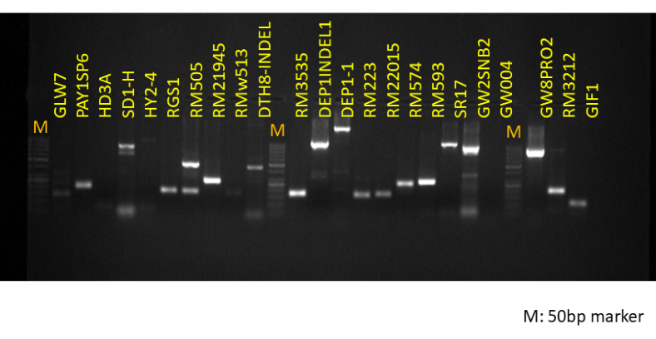
S. Fig.1.Representative gel image showing standardization of markers with rice genotype, a cultivated popular rice variety NLR 34449 (Nellore Mashuri) at 58°C annealing temperature
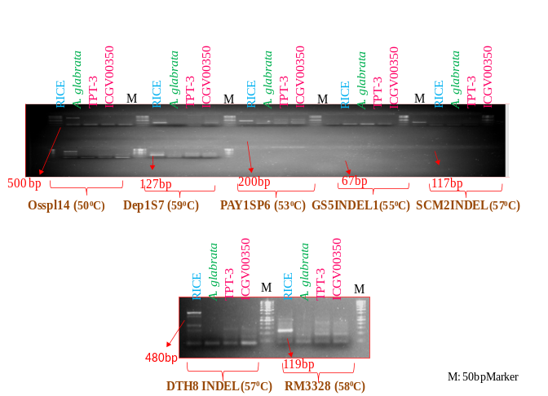
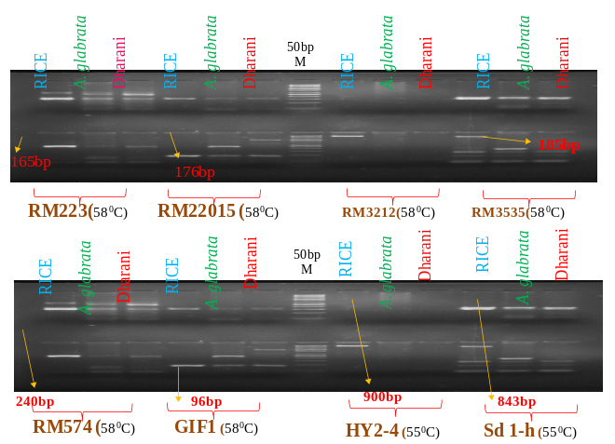

S. Fig. 2.Standardization of chosen set of markers with groundnut genotypes

Rice: cultivated popular rice variety NLR 34449 (Nellore Mashuri), Wild genotype of groundnut:

Arachisglabrata, Dharani: cultivated popular groundnut variety released from ANGRAU
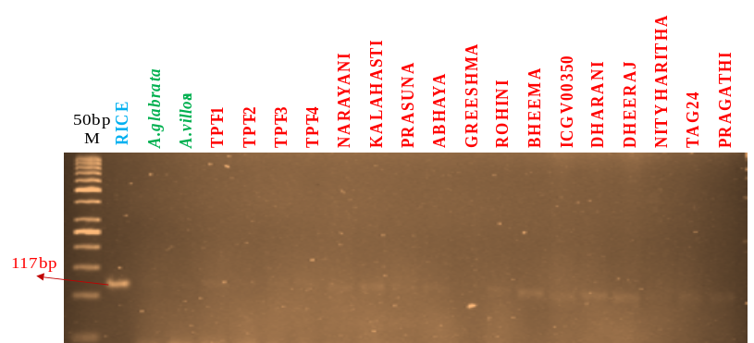

S. Fig 3.Gel image showing SCM2 Indel 1 marker amplified faintly
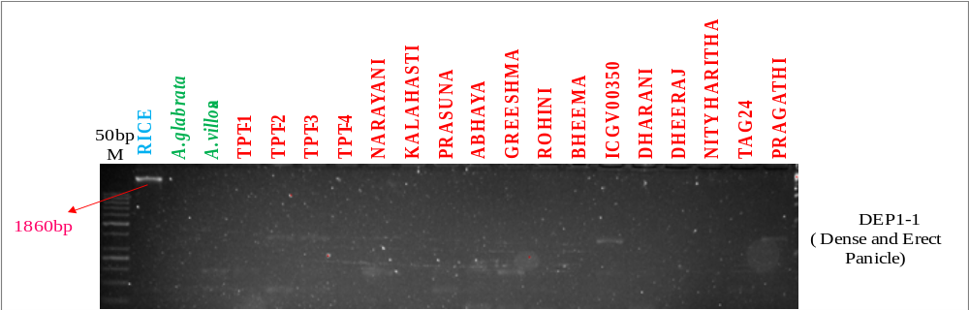
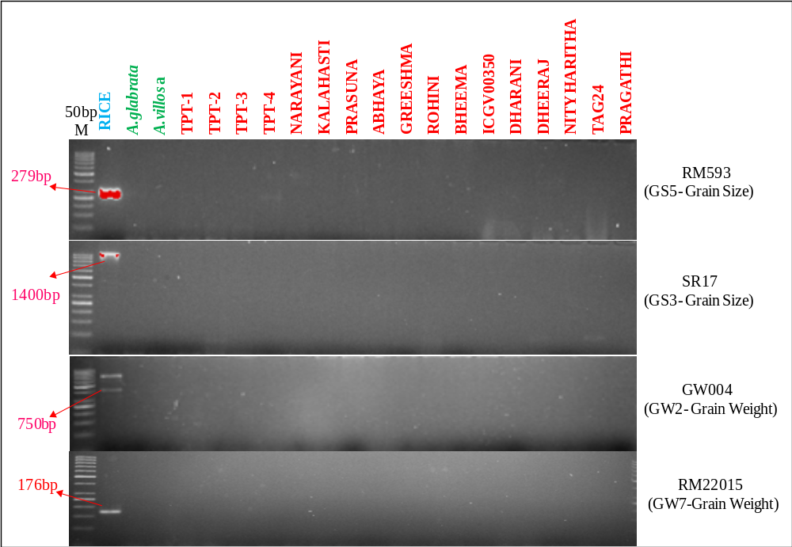
S. Fig 4. Gel images showing rice gene tagged markers amplified only in rice

