<Exercise description>

As the chest muscles can be shortened after breast cancer surgery, you may feel pain or discomfort during arm movements. Thus, you may feel difficulty during arm elevation, or during the weight lifting. To minimize this complaints, chest muscles stretching and scapular exercises are recommended.

- Chest muscles stretching (Target muscles: pectoralis major and minor)

As the chest muscles mobility improves, the arm movement and range of motion are increased.

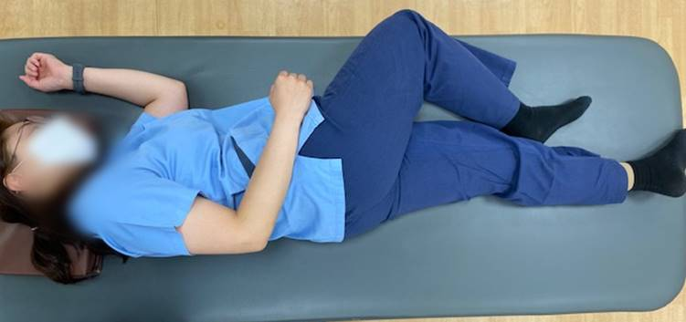 | 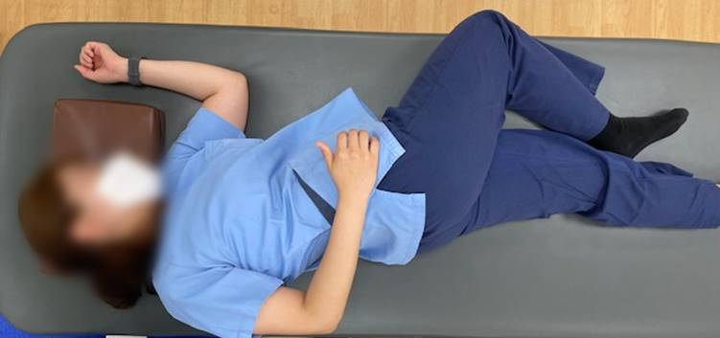
- Start position | - End position
<Chest muscles stretching>

Hold 10 seconds / repeat 10 times
Twice a day / three times a week

- Lie on your sound side as (a) above pictures
- Gently rotate your trunk to operated side as (b) above pictures.
- Hold the position for 10 seconds and back to start position
- Repeat 10 times

2. Scapular exercise

You should move the scapular to backward and inward.
As the strength stabilizing the scapular to the trunk improved, the arm movement is improved.

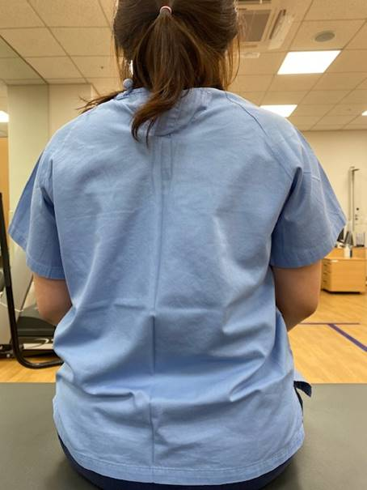 | 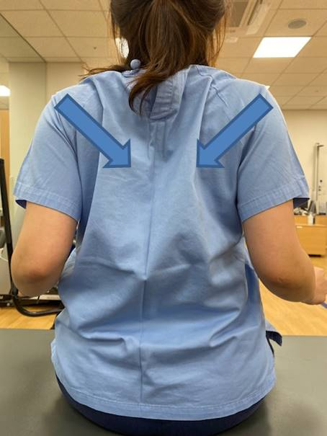
<Scapular exercise>

Hold 5 seconds / repeat 10 times / 3 sets
Twice a day / three times a week

- Sit on the chair with your feet on the ground.
- Slightly bend your both elbow then squeeze the both scapulars (blade bones) at back.
- During the squeezing, you should feel the closeness of the two scapulars not elbow.

Notice: Excessive exercise may increase or worsen the edematous arm, it also can induce shoulder muscles injury.

Exercise adherence survey

Questions | Strongly disagree  (1) | Disagree  (2) | Neither  (3) | Agree  (4) | Strongly agree  (5)
- I regularly performed the exercise as instructed.
- I performed both instructed exercises.
- I followed the instructed frequency and volume when I performed the exercise.

Normalization = [(Q1+Q2+Q3)/3-1]*25

