Table 4 Simulation results of CFD
Parameter | Direction of rotation  (s=5000rpm; h=0.4mm) |  | Rotation speed  (clockwise; h=0.4mm) |  |  | Polishing gap  (clockwise; s=5000rpm)
Cloud diagram of shear stress | Clockwise  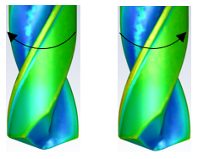 | Counter-clockwise | 4000rpm  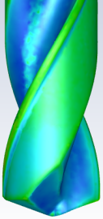 | 5000rpm  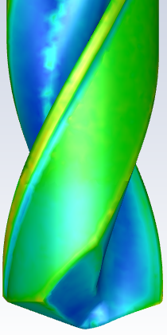 | 6000rpm  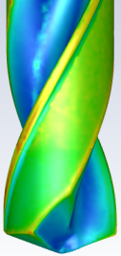 | 0.2mm  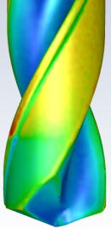 | 0.4mm | 0.6mm  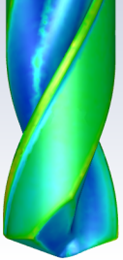
Shear stress of feature point | 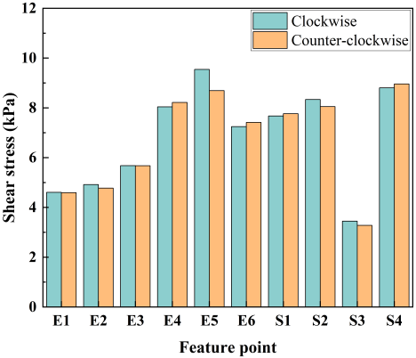 |  | 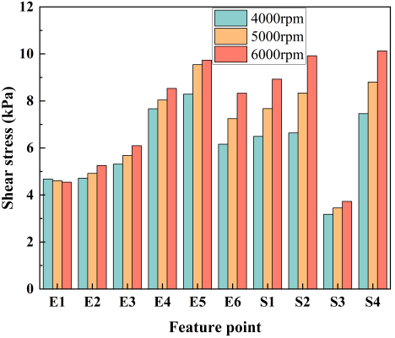 |  |  | 