Additional file 1
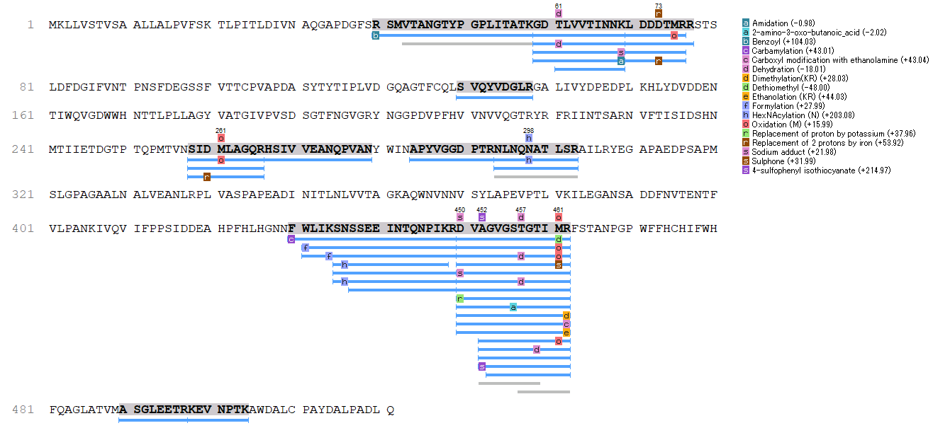

Figure 1. Coverage map of peptide fragments of LeLcc13. The SDS-PAGE band was subjected to trypsin digestion and LC-MS/MS analysis and compared with the protein database of Lentinula edodes (Accession, PRJDB4944) (Sakamoto et al. 2017). De novo peptide sequencing was performed using PEAKS Studio v10. Homology searches were performed with BLAST (NCBI). Blue lines indicate digestible fragments analyzed with a total sequence coverage of 26%.

