Supplementary Material

Supplement

Supplement 1. Consensus signature generation.

Pairwise correlations between signatures were calculated and the mean correlation with other signatures was calculated for each signature The similarities were scaled to sum to 1, then the z-score signature vectors were multiplied by their similarity weights. The weighted z-score signature vectors were summed up and used as the consensus signature for DrugBank small molecules (Himmelstein, Daniel, 2015).

Figures

Supplementary Figure 1. Performance of MultiGML variants for increasing negative samples for side-effect prediction. The performance metrics for AUROC, Average Precision (AUPR) and Precision at k with k=30 on side-effect prediction are shown for both Multi-GML variants, MultiGML-RGCN on the left, and MultiGML-RGAT on the right. For each number of negative samples per positive sample $k ϵ [1, 5, 10, 50, 100, 250, 500, 750, 1000]$ testing was performed 5 times. The standard deviation is shown in the plots.

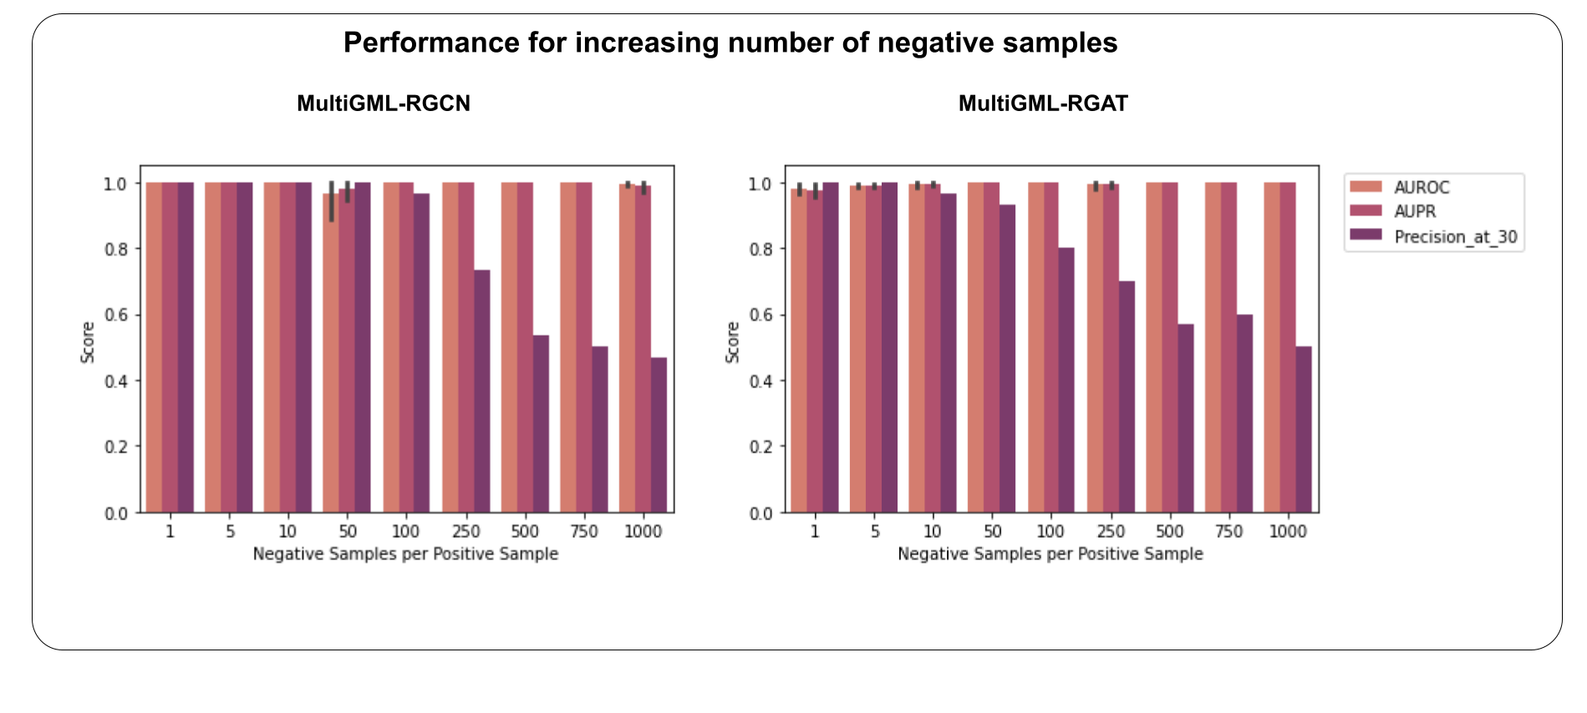

Supplementary Figure 2. Hyperparameter importances for parameter during hyperparameter optimization for A) MultiGML-RGCN and B) MultiGML-RGAT. Plots were made with optuna. 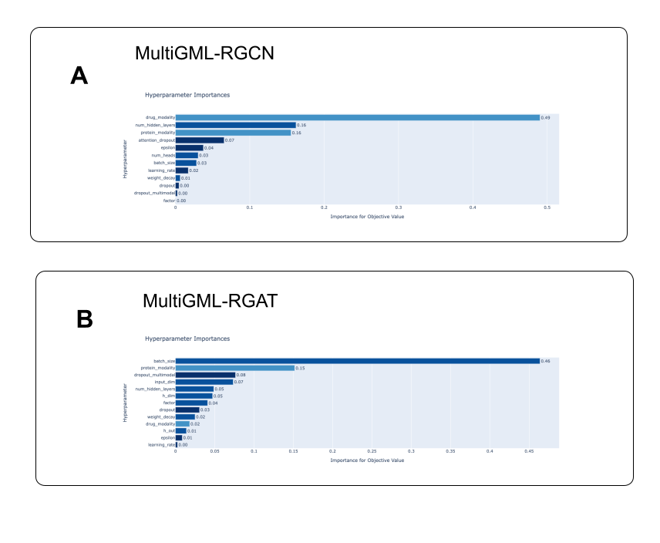

Tables

Supplementary Table 1. Count of edge types in biomedical KG.
Edge Type | Count
side-effect | 197
functional association | 1761
protein-condition | 5448
physical interaction | 6087
drug-protein | 12451
indication | 12848
genetic protein-condition association | 159202

Supplementary Table 2. Edge type count in biomedical KG according to source database.
Source Database | Count
PHEWAS | 159202
BIOGRID | 102447
KEGG | 63356
PATHWAYCOMMONS | 32928
INTACT | 23055
DRUGBANK | 10072
CLINICALTRIALS | 7626
REACTOME | 6379
DISGENET | 5448
OPENTARGETS | 5222
IUPHAR | 2379
NEUROMMSIG | 1761
SIDER | 135
OFFSIDES | 62

Supplementary Table 3. Hyperparameters selected by the optuna hyperparameter optimization for the MultiGML-variants (-RGCN and -RGAT) and the respective ranges for each hyperparameter.
Hyperparameter Name | Range | Best Value RGCN | Best Value RGAT
Input dimension | [10, 500; 10] | 390 | 8
Hidden dimension | [10, 300; 10] | 280 | 200
Output dimension | [10, 100; 10] | 60 | 24
Number of hidden layers | [1 : 7] | 3 | 2
Dropout embedding layer | [0.0, 0.4; 0.1] | 0.4 | 0.2
Dropout graph neural network | [0.0, 0.5; 0.1] | 0.0 | 0.1
Learning rate (optimizer) | [10e-5 : 10e-2] | 0.00028 | 0.00024
Weight decay (optimizer) | [1e-4, 1e-5, 1e-6] | 1e-06 | 1e-05
Epsilon | [1e-8 : 1e-6] | 5.85e-07 | 6.12e-07
Batch size | [100, 800; 100] | 100 | 300
Drug modalities | all possible combinations of [gene expression signature, cytological profiling signature, molecular fingerprint] | drug_fc, drug_fcfp | drug_fcfp
Protein modalities | all possible combinations of [gene ontology fingerprint, protein sequence embedding] | protein_go | protein_go
Number of attention heads | [1, 2, 3, 4] | - | 2
Dropout graph attention network | [0.0, 0.5; 0.1] | - | 0.0

Supplementary Table 4. GO enrichment analysis of biological processes for the prediction of alendronic acid and acute liver failure. Top 20 clusters with their representative enriched terms (one per cluster) created with Metascape. "Count" is the number of genes in the user-provided lists with membership in the given ontology term. "%" is the percentage of all of the user-provided genes that are found in the given ontology term (only input genes with at least one ontology term annotation are included in the calculation). "Log10(P)" is the p-value in log base 10. "Log10(q)" is the multi-test adjusted p-value in log base 10.
GO | Description | Count | % | Log10(P) | Log10(q)
GO:0051493 | regulation of cytoskeleton organization | 17 | 8.50 | -6.87 | -2.68
GO:0031647 | regulation of protein stability | 13 | 6.50 | -6.52 | -2.63
GO:0034470 | ncRNA processing | 14 | 7.00 | -6.13 | -2.42
GO:0018205 | peptidyl-lysine modification | 12 | 6.00 | -5.90 | -2.41
GO:0006351 | DNA-templated transcription | 16 | 8.00 | -5.59 | -2.30
GO:0009895 | negative regulation of catabolic process | 11 | 5.50 | -4.85 | -1.85
GO:0006325 | chromatin organization | 15 | 7.50 | -4.83 | -1.85
GO:0071229 | cellular response to acid chemical | 6 | 3.00 | -4.54 | -1.61
GO:0030097 | hemopoiesis | 15 | 7.50 | -4.50 | -1.59
GO:0030036 | actin cytoskeleton organization | 13 | 6.50 | -4.12 | -1.32
GO:0006388 | tRNA splicing, via endonucleolytic cleavage and ligation | 3 | 1.50 | -4.11 | -1.32
GO:0022613 | ribonucleoprotein complex biogenesis | 12 | 6.00 | -4.05 | -1.32
GO:0045785 | positive regulation of cell adhesion | 12 | 6.00 | -3.99 | -1.32
GO:0043542 | endothelial cell migration | 5 | 2.50 | -3.98 | -1.32
GO:0043414 | macromolecule methylation | 9 | 4.50 | -3.98 | -1.32
GO:0051603 | proteolysis involved in protein catabolic process | 14 | 7.00 | -3.97 | -1.32
GO:1904874 | positive regulation of telomerase RNA localization to Cajal body | 3 | 1.50 | -3.91 | -1.30
GO:0010810 | regulation of cell-substrate adhesion | 8 | 4.00 | -3.90 | -1.30
GO:0098655 | cation transmembrane transport | 14 | 7.00 | -3.77 | -1.20
GO:0006820 | anion transport | 11 | 5.50 | -3.72 | -1.18

​​Supplementary Table 5. Genes of gene expression signature from alendronic acid that were found to be highly positively or negatively attributed and their attribution score. The top 100 negatively and positively attributed genes are listed.

Entrez Gene ID  (positively attributed) | IG attribute score | Entrez Gene ID  (negatively attributed) | IG attribute score
GeneID:8270 | 0.0008995434594862807 | GeneID:79991 | -0.00022609830045582771
GeneID:10818 | 0.0006192149080605368 | GeneID:8767 | -0.00022696953517483613
GeneID:8266 | 0.0005135424521145966 | GeneID:8671 | -0.00022726055071385894
GeneID:2115 | 0.0005086604545451612 | GeneID:100133941 | -0.00022778707316336734
GeneID:5613 | 0.0004933134851079761 | GeneID:11062 | -0.00022831795333338567
GeneID:8607 | 0.0004888437663445203 | GeneID:9650 | -0.0002285026585543125
GeneID:323 | 0.000479714563022701 | GeneID:23223 | -0.000230089399928658
GeneID:10165 | 0.0004775488374604353 | GeneID:29100 | -0.00023059142980525314
GeneID:79643 | 0.0004667461276415183 | GeneID:55379 | -0.0002317155058196544
GeneID:3964 | 0.0004540885843581498 | GeneID:8994 | -0.0002322113961224113
GeneID:28972 | 0.0004499720020473656 | GeneID:5501 | -0.00023270193574622522
GeneID:10362 | 0.0004446570083222257 | GeneID:23370 | -0.0002329637862120419
GeneID:2131 | 0.0004392332159276795 | GeneID:1389 | -0.00023396015149374343
GeneID:23220 | 0.00042694559786747474 | GeneID:81605 | -0.00023475954324415508
GeneID:6881 | 0.0004148178621251951 | GeneID:28962 | -0.00023495287595794428
GeneID:63875 | 0.0004105340282162946 | GeneID:27340 | -0.000235966767954977
GeneID:54512 | 0.0004102499925159137 | GeneID:51582 | -0.0002364244446109688
GeneID:8569 | 0.0003951798959150862 | GeneID:5709 | -0.00023874839244842727
GeneID:9289 | 0.0003851491817799898 | GeneID:25901 | -0.0002395699583677032
GeneID:3182 | 0.00037852541869558406 | GeneID:10360 | -0.0002396031321191957
GeneID:6596 | 0.0003782558882481143 | GeneID:79763 | -0.00023983217670731533
GeneID:3930 | 0.00037757946556041635 | GeneID:65258 | -0.0002404346803024866
GeneID:7422 | 0.00037071445266386924 | GeneID:151011 | -0.0002417044032186267
GeneID:24149 | 0.0003646547605455143 | GeneID:10126 | -0.00024283211230190484
GeneID:2960 | 0.00036237481671281223 | GeneID:54440 | -0.00024337408990114009
GeneID:8192 | 0.00035673952356988137 | GeneID:8148 | -0.00024379506957160647
GeneID:23304 | 0.00035434660466432475 | GeneID:5636 | -0.00024541604181013075
GeneID:55173 | 0.00034364603821231 | GeneID:23325 | -0.0002457759459000078
GeneID:9788 | 0.00034052652177369664 | GeneID:26133 | -0.0002464948043059844
GeneID:55027 | 0.0003397633126819151 | GeneID:5412 | -0.0002473416633911184
GeneID:5870 | 0.00033439205063118114 | GeneID:8558 | -0.00024736601878430983
GeneID:29994 | 0.0003329920458052786 | GeneID:55740 | -0.0002481856756041328
GeneID:10565 | 0.00032835317326553135 | GeneID:8349 | -0.0002482960411639851
GeneID:624 | 0.00032366259164699605 | GeneID:949 | -0.0002490416919672065
GeneID:2316 | 0.00032326800679876157 | GeneID:71 | -0.0002514311204311707
GeneID:28974 | 0.00032310573761873906 | GeneID:3508 | -0.0002533838597956925
GeneID:63933 | 0.00032286788013682053 | GeneID:9829 | -0.00025465704150274063
GeneID:7439 | 0.0003186807804837892 | GeneID:7430 | -0.0002556078056872143
GeneID:10381 | 0.0003174085770658916 | GeneID:55793 | -0.0002558848103986634
GeneID:55737 | 0.00031620944375184725 | GeneID:29928 | -0.0002562121802701867
GeneID:10383 | 0.0003153799497778071 | GeneID:9929 | -0.00025666161799732144
GeneID:10552 | 0.0003122251689802513 | GeneID:23408 | -0.00025747222936345603
GeneID:10732 | 0.00031007641498102063 | GeneID:54504 | -0.00025965181798654087
GeneID:23077 | 0.0003078562519840672 | GeneID:6674 | -0.0002601844105004172
GeneID:25804 | 0.0003076865722904266 | GeneID:22911 | -0.0002632359652195597
GeneID:6261 | 0.00030679586317539624 | GeneID:6533 | -0.00026349799376778244
GeneID:404672 | 0.00030608988245862153 | GeneID:7862 | -0.00026625014118050836
GeneID:23594 | 0.0003021986541538205 | GeneID:642 | -0.00026662265190429904
GeneID:5971 | 0.00029964370273934154 | GeneID:79651 | -0.0002676439253825327
GeneID:81848 | 0.00029588257669001684 | GeneID:9862 | -0.0002680283508349592
GeneID:23348 | 0.0002945500638849357 | GeneID:26018 | -0.00027047788380515046
GeneID:55651 | 0.0002934386491512662 | GeneID:6904 | -0.0002736807253864681
GeneID:25940 | 0.0002907318435333681 | GeneID:112611 | -0.00027716501797302515
GeneID:10574 | 0.0002845476716444732 | GeneID:79867 | -0.00027791256273626157
GeneID:2201 | 0.00028438902519003345 | GeneID:4001 | -0.0002819600763266954
GeneID:63895 | 0.0002838128604232874 | GeneID:8417 | -0.0002833042577312835
GeneID:55666 | 0.0002819438923753184 | GeneID:4678 | -0.00028337110030636465
GeneID:80271 | 0.0002818991331659287 | GeneID:23075 | -0.0002847791220921523
GeneID:26499 | 0.0002797155758109364 | GeneID:27339 | -0.0002869081999755051
GeneID:7248 | 0.00027835654026509216 | GeneID:54554 | -0.00028707619802396576
GeneID:292 | 0.00027730360518614497 | GeneID:23011 | -0.0002873733538876851
GeneID:25949 | 0.000277094023921693 | GeneID:5037 | -0.00028875808411212326
GeneID:3185 | 0.0002766357754518144 | GeneID:5696 | -0.0002888639466219454
GeneID:3028 | 0.0002758245191811366 | GeneID:51026 | -0.0002903371476901049
GeneID:199 | 0.00027499707904491994 | GeneID:746 | -0.00029504257352229316
GeneID:7726 | 0.0002746186666142056 | GeneID:6693 | -0.00029679994013166554
GeneID:59343 | 0.0002724388964547083 | GeneID:529 | -0.00029723583942685227
GeneID:1124 | 0.0002723803070153473 | GeneID:29104 | -0.0002981346741123123
GeneID:81554 | 0.0002708230597962987 | GeneID:6993 | -0.00029819081847451027
GeneID:4724 | 0.0002666732930872493 | GeneID:54020 | -0.00029838412984473415
GeneID:55841 | 0.0002663926250959751 | GeneID:79053 | -0.00030115854376564513
GeneID:2769 | 0.0002658547944375328 | GeneID:5092 | -0.0003054734205912938
GeneID:10095 | 0.000264939410547679 | GeneID:5261 | -0.0003072767493442332
GeneID:22933 | 0.00026460352244546946 | GeneID:80746 | -0.0003091011241485384
GeneID:57214 | 0.00026348814658941696 | GeneID:8636 | -0.0003101706109962096
GeneID:2783 | 0.0002617748084926127 | GeneID:126321 | -0.0003144495989148965
GeneID:5698 | 0.00026107337450141665 | GeneID:23530 | -0.0003180070804040382
GeneID:6443 | 0.0002598119608832808 | GeneID:256364 | -0.00031891705054651554
GeneID:11180 | 0.00025957667675911974 | GeneID:10921 | -0.0003223289147302725
GeneID:51650 | 0.0002593204003898797 | GeneID:716 | -0.000322608178093432
GeneID:3265 | 0.0002592667936421793 | GeneID:51278 | -0.0003259721718142552
GeneID:79017 | 0.00025884852084566087 | GeneID:902 | -0.00033134746579535797
GeneID:648 | 0.000258685049081244 | GeneID:9778 | -0.0003313896104479341
GeneID:445 | 0.00025666535832682096 | GeneID:2356 | -0.00033508541320056154
GeneID:9404 | 0.00025395498832191934 | GeneID:10542 | -0.00033562939042893196
GeneID:7041 | 0.0002523205544312143 | GeneID:2524 | -0.00033760608355564
GeneID:116985 | 0.0002520070168574069 | GeneID:1021 | -0.0003378433632986821
GeneID:26063 | 0.0002515512748850723 | GeneID:29761 | -0.00034363297259283214
GeneID:6634 | 0.0002501185647212259 | GeneID:5469 | -0.0003474179997338746
GeneID:7070 | 0.0002498839591129629 | GeneID:54665 | -0.0003526452723477166
GeneID:25844 | 0.00024975960366947287 | GeneID:51703 | -0.0003645450562149516
GeneID:79001 | 0.00024974034757776375 | GeneID:10939 | -0.0003700582783608668
GeneID:2542 | 0.00024846847156446907 | GeneID:3915 | -0.0003750396714760705
GeneID:4193 | 0.00024769030301595045 | GeneID:8446 | -0.00037538815318446575
GeneID:1789 | 0.0002457226616798318 | GeneID:9044 | -0.0003767583503481191
GeneID:1556 | 0.0002437985367657615 | GeneID:81566 | -0.0003878085662785802
GeneID:51493 | 0.00024360876455965555 | GeneID:91369 | -0.0004094507881797229
GeneID:49855 | 0.0002434010027060879 | GeneID:1759 | -0.0004395845189518063
GeneID:8476 | 0.0002429233375216671 | GeneID:51646 | -0.00044154668812577795
GeneID:8140 | 0.00024224934641965242 | GeneID:155066 | -0.000448837306106213

Supplementary Table 6. GO enrichment analysis of biological processes for the prediction of kanamycin and paralysis. Top 20 clusters with their representative enriched terms (one per cluster) created with Metascape. "Count" is the number of genes in the user-provided lists with membership in the given ontology term. "%" is the percentage of all of the user-provided genes that are found in the given ontology term (only input genes with at least one ontology term annotation are included in the calculation). "Log10(P)" is the p-value in log base 10. "Log10(q)" is the multi-test adjusted p-value in log base 10.
GO | Description | Count | % | Log₁₀(p) | Log₁₀(q)
GO:0006974 | cellular response to DNA damage stimulus | 20 | 10.05 | -6.92 | -2.85
GO:0007420 | brain development | 20 | 10.05 | -6.74 | -2.85
GO:0097421 | liver regeneration | 5 | 2.51 | -5.91 | -2.20
GO:0070542 | response to fatty acid | 6 | 3.02 | -5.42 | -1.84
GO:0008283 | cell population proliferation | 16 | 8.04 | -4.75 | -1.47
GO:0051301 | cell division | 13 | 6.53 | -4.43 | -1.24
GO:1903047 | mitotic cell cycle process | 13 | 6.53 | -4.26 | -1.18
GO:1901654 | response to ketone | 8 | 4.02 | -4.17 | -1.18
GO:0030902 | hindbrain development | 7 | 3.52 | -4.17 | -1.18
GO:0006869 | lipid transport | 10 | 5.03 | -4.15 | -1.18
GO:0006739 | NADP metabolic process | 4 | 2.01 | -4.04 | -1.15
GO:0009410 | response to xenobiotic stimulus | 11 | 5.53 | -3.94 | -1.08
GO:0035272 | exocrine system development | 4 | 2.01 | -3.81 | -1.00
GO:0055086 | nucleobase-containing small molecule metabolic process | 13 | 6.53 | -3.81 | -1.00
GO:1901137 | carbohydrate derivative biosynthetic process | 13 | 6.53 | -3.79 | -1.00
GO:0006914 | autophagy | 9 | 4.52 | -3.74 | -1.00
GO:0009314 | response to radiation | 11 | 5.53 | -3.70 | -0.99
GO:1903432 | regulation of TORC1 signaling | 4 | 2.01 | -3.55 | -0.95
GO:0097305 | response to alcohol | 8 | 4.02 | -3.54 | -0.95
GO:0007098 | centrosome cycle | 5 | 2.51 | -3.53 | -0.95

Supplementary Table 7. Genes of gene expression signature from kanamycin that were found to be highly positively or negatively attributed and their attribution score. The top 100 negatively and positively attributed genes are listed.

Entrez Gene ID  (positively attributed) | IG attribute score | Entrez Gene ID  (negatively attributed) | IG attribute score
GeneID:1027 | 4,39E+07 | GeneID:6726 | -1,86E+10
GeneID:7503 | 3,35E+10 | GeneID:7763 | -1,86E+10
GeneID:29083 | 3,11E+10 | GeneID:1070 | -1,86E+10
GeneID:23352 | 3,11E+10 | GeneID:4605 | -1,86E+10
GeneID:10447 | 3,09E+10 | GeneID:3460 | -1,86E+10
GeneID:8733 | 3,07E+10 | GeneID:26119 | -1,86E+10
GeneID:1666 | 3,05E+10 | GeneID:137886 | -1,87E+09
GeneID:3382 | 3,00E+10 | GeneID:7515 | -1,87E+10
GeneID:7107 | 2,87E+10 | GeneID:6601 | -1,87E+10
GeneID:7319 | 2,83E+09 | GeneID:6560 | -1,88E+10
GeneID:11133 | 2,81E+10 | GeneID:55567 | -1,88E+10
GeneID:7257 | 2,78E+10 | GeneID:55003 | -1,89E+10
GeneID:112611 | 2,73E+09 | GeneID:5763 | -1,89E+10
GeneID:4924 | 2,67E+10 | GeneID:157680 | -1,89E+10
GeneID:633 | 2,65E+10 | GeneID:2235 | -1,90E+10
GeneID:25805 | 2,60E+09 | GeneID:54386 | -1,91E+10
GeneID:2958 | 2,58E+10 | GeneID:5891 | -1,91E+10
GeneID:51290 | 2,55E+10 | GeneID:4967 | -1,92E+10
GeneID:533 | 2,52E+09 | GeneID:2063 | -1,92E+10
GeneID:8672 | 2,51E+10 | GeneID:5361 | -1,93E+09
GeneID:8744 | 2,50E+09 | GeneID:6414 | -1,94E+10
GeneID:10797 | 2,47E+10 | GeneID:883 | -1,95E+09
GeneID:843 | 2,46E+10 | GeneID:5327 | -1,96E+10
GeneID:2548 | 2,44E+10 | GeneID:51335 | -1,97E+10
GeneID:5708 | 2,39E+09 | GeneID:1213 | -1,97E+10
GeneID:4329 | 2,37E+09 | GeneID:51131 | -1,97E+10
GeneID:201229 | 2,34E+10 | GeneID:10419 | -1,98E+10
GeneID:10966 | 2,34E+09 | GeneID:1870 | -1,98E+10
GeneID:63924 | 2,30E+10 | GeneID:51805 | -2,00E+09
GeneID:3712 | 2,29E+10 | GeneID:10309 | -2,00E+09
GeneID:11011 | 2,29E+10 | GeneID:54978 | -2,01E+09
GeneID:1537 | 2,29E+09 | GeneID:3489 | -2,02E+10
GeneID:5058 | 2,28E+09 | GeneID:63895 | -2,03E+10
GeneID:8382 | 2,24E+07 | GeneID:1983 | -2,03E+09
GeneID:8061 | 2,22E+09 | GeneID:8312 | -2,05E+10
GeneID:5347 | 2,20E+09 | GeneID:348995 | -2,05E+09
GeneID:55898 | 2,18E+10 | GeneID:29893 | -2,06E+08
GeneID:54872 | 2,14E+09 | GeneID:51366 | -2,06E+09
GeneID:7398 | 2,13E+09 | GeneID:10732 | -2,08E+10
GeneID:22985 | 2,11E+09 | GeneID:55013 | -2,08E+10
GeneID:28992 | 2,08E+10 | GeneID:25837 | -2,10E+09
GeneID:5423 | 2,07E+10 | GeneID:144404 | -2,10E+10
GeneID:978 | 2,04E+08 | GeneID:4666 | -2,10E+10
GeneID:11215 | 2,04E+10 | GeneID:26151 | -2,11E+10
GeneID:55329 | 2,04E+10 | GeneID:28978 | -2,12E+09
GeneID:221061 | 2,02E+10 | GeneID:9040 | -2,13E+10
GeneID:5649 | 2,02E+09 | GeneID:1374 | -2,14E+10
GeneID:2539 | 2,01E+10 | GeneID:58488 | -2,14E+09
GeneID:8925 | 1,98E+09 | GeneID:80254 | -2,14E+09
GeneID:5226 | 1,98E+09 | GeneID:124222 | -2,15E+10
GeneID:80758 | 1,98E+10 | GeneID:51195 | -2,19E+10
GeneID:79084 | 1,97E+10 | GeneID:5355 | -2,21E+09
GeneID:11060 | 1,96E+09 | GeneID:26001 | -2,21E+10
GeneID:5727 | 1,93E+10 | GeneID:2203 | -2,26E+10
GeneID:5111 | 1,91E+10 | GeneID:8428 | -2,26E+09
GeneID:51026 | 1,91E+10 | GeneID:375056 | -2,27E+09
GeneID:8624 | 1,91E+10 | GeneID:6284 | -2,33E+10
GeneID:23231 | 1,90E+10 | GeneID:4983 | -2,34E+09
GeneID:79006 | 1,90E+10 | GeneID:8506 | -2,34E+10
GeneID:2218 | 1,90E+09 | GeneID:64759 | -2,35E+10
GeneID:9181 | 1,90E+10 | GeneID:8514 | -2,35E+10
GeneID:6867 | 1,89E+10 | GeneID:7534 | -2,36E+10
GeneID:2564 | 1,89E+10 | GeneID:6286 | -2,37E+09
GeneID:473 | 1,86E+10 | GeneID:1051 | -2,39E+09
GeneID:10542 | 1,85E+10 | GeneID:55041 | -2,39E+09
GeneID:27109 | 1,85E+10 | GeneID:10036 | -2,42E+09
GeneID:51569 | 1,81E+10 | GeneID:653639 | -2,45E+10
GeneID:57016 | 1,80E+10 | GeneID:7045 | -2,46E+10
GeneID:10140 | 1,80E+10 | GeneID:1774 | -2,49E+10
GeneID:65265 | 1,80E+10 | GeneID:6693 | -2,54E+10
GeneID:5813 | 1,79E+10 | GeneID:4350 | -2,55E+10
GeneID:55748 | 1,79E+09 | GeneID:51123 | -2,57E+10
GeneID:57194 | 1,77E+10 | GeneID:7296 | -2,58E+10
GeneID:9639 | 1,76E+09 | GeneID:10247 | -2,62E+10
GeneID:2975 | 1,76E+08 | GeneID:9088 | -2,62E+10
GeneID:4828 | 1,76E+10 | GeneID:5743 | -2,66E+10
GeneID:4293 | 1,75E+10 | GeneID:28957 | -2,68E+08
GeneID:64208 | 1,75E+10 | GeneID:400949 | -2,70E+10
GeneID:6832 | 1,74E+09 | GeneID:6118 | -2,83E+10
GeneID:9887 | 1,73E+10 | GeneID:57513 | -2,86E+10
GeneID:29978 | 1,73E+10 | GeneID:10476 | -2,87E+10
GeneID:10174 | 1,72E+09 | GeneID:54982 | -2,88E+09
GeneID:83440 | 1,71E+10 | GeneID:7358 | -2,89E+10
GeneID:4781 | 1,71E+10 | GeneID:4487 | -2,98E+10
GeneID:1019 | 1,71E+10 | GeneID:51389 | -2,98E+10
GeneID:51227 | 1,69E+10 | GeneID:2176 | -2,99E+10
GeneID:10651 | 1,68E+10 | GeneID:5127 | -3,03E+10
GeneID:79177 | 1,68E+10 | GeneID:10388 | -3,04E+09
GeneID:9187 | 1,67E+10 | GeneID:5898 | -3,19E+09
GeneID:6602 | 1,67E+10 | GeneID:9854 | -3,19E+10
GeneID:5638 | 1,66E+10 | GeneID:80212 | -3,23E+09
GeneID:64419 | 1,66E+10 | GeneID:8208 | -3,23E+10
GeneID:9486 | 1,66E+10 | GeneID:8031 | -3,52E+10
GeneID:6566 | 1,65E+10 | GeneID:10099 | -3,55E+10
GeneID:9540 | 1,65E+10 | GeneID:79947 | -3,62E+10
GeneID:26155 | 1,64E+10 | GeneID:3773 | -3,63E+10
GeneID:55207 | 1,63E+10 | GeneID:1869 | -4,88E+09
GeneID:4815 | 1,62E+10 | GeneID:5547 | -4,93E+09
GeneID:84747 | 1,61E+10 | GeneID:6839 | -5,30E+09
GeneID:80742 | 1,61E+10 | GeneID:2131 | -5,74E+09

