Supplementary Information
Intramolecular Interactions (O-H∙∙∙O, C-H∙∙∙N, N-H∙∙∙π) in Isomers of Neutral, Cation, and Anion Dopamine Molecules - A DFT Study on the Influence of Solvents (Water and Ethanol)
Thekkayil Sangeetha , Senthilkumar Lakshmipathi*
Department of Physics, Bharathiar University, Coimbatore 641016, Tamil Nadu, INDIA
Figure S1 Optimised geometries of Dopamine in the gas phase

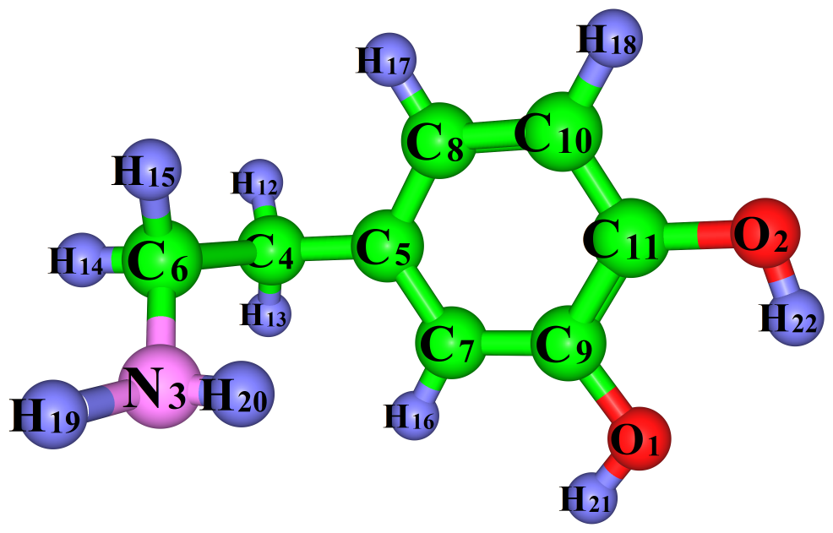
DA⁰
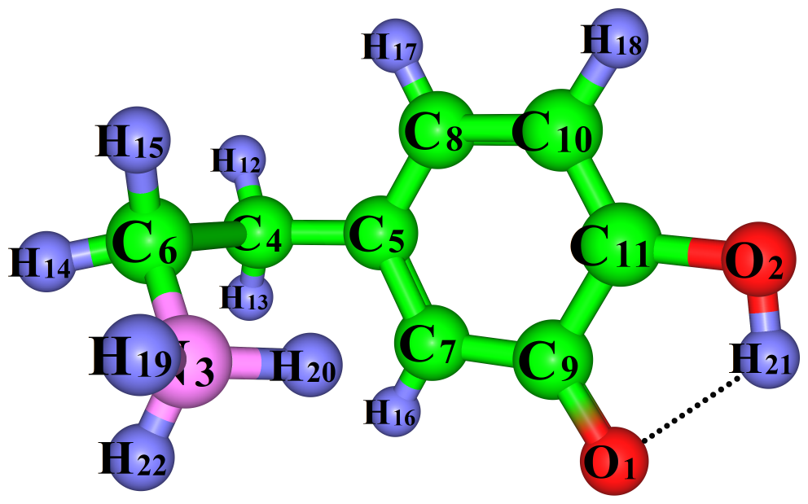
KI-1
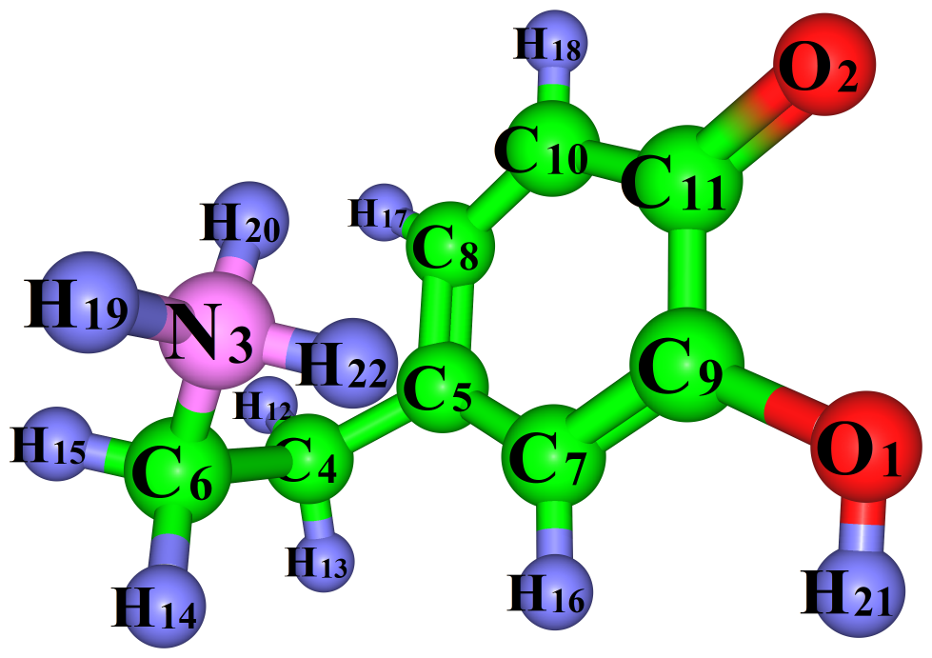
KI-2
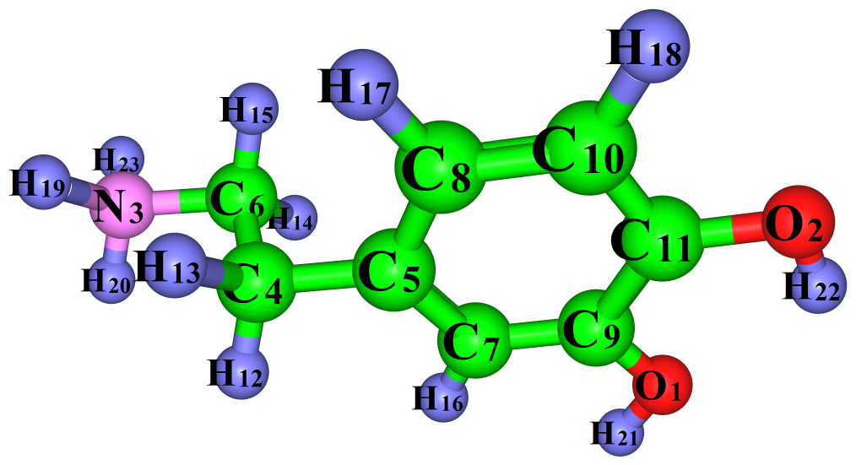

DA⁺
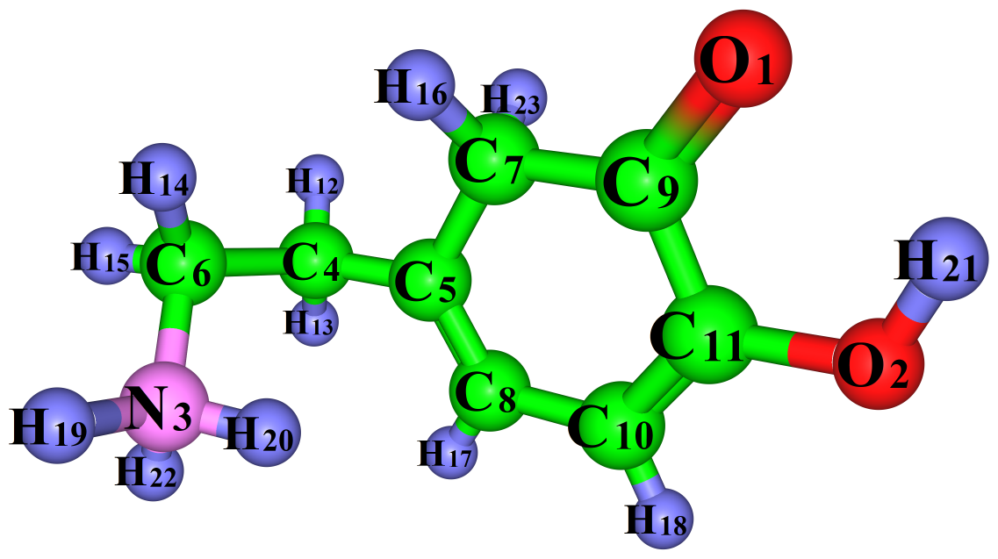
Iso-1
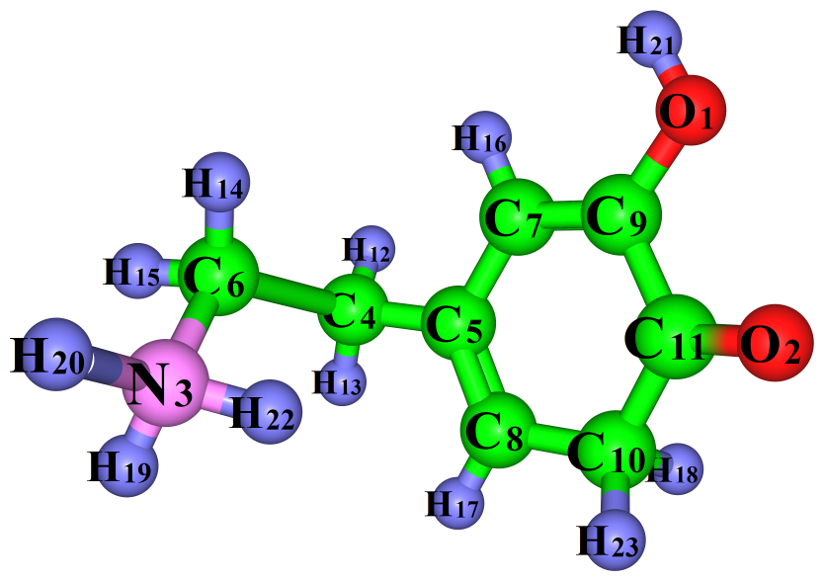

Iso-2 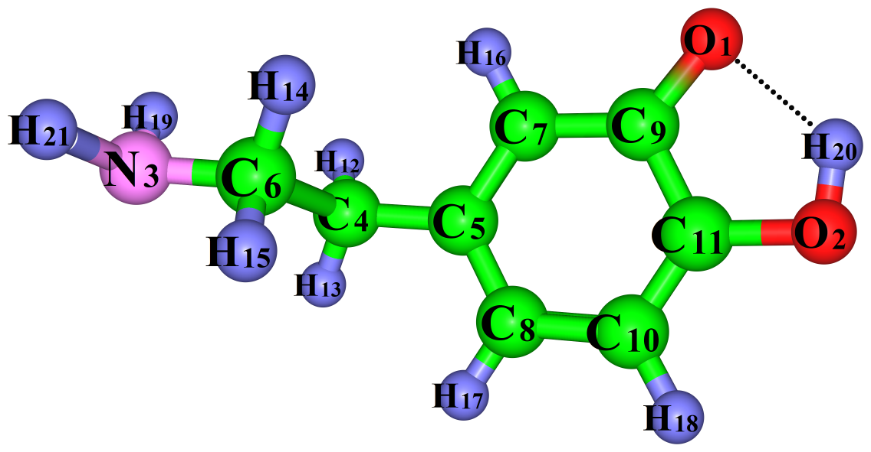
DA⁻

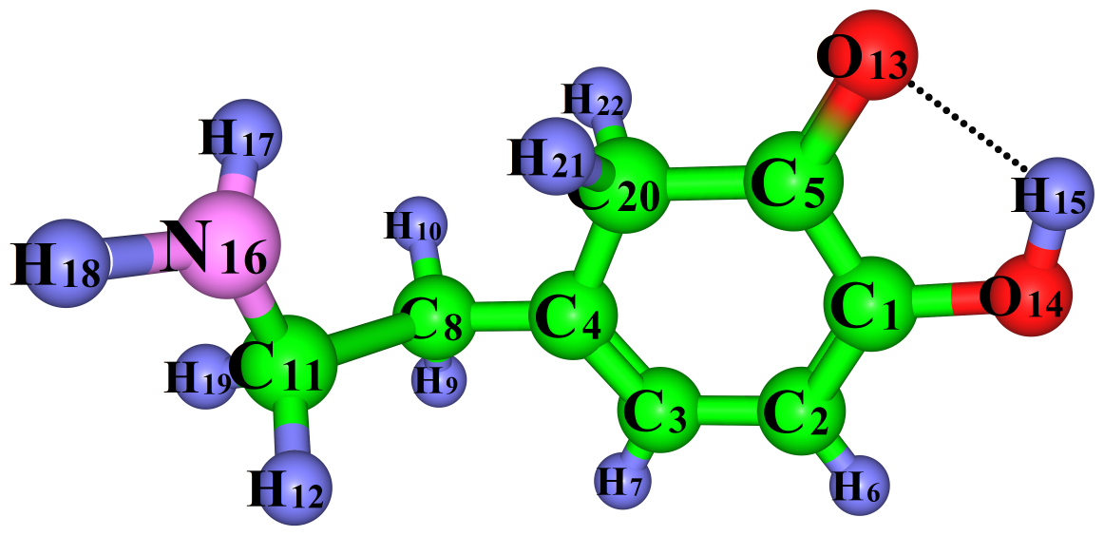
Iso-3

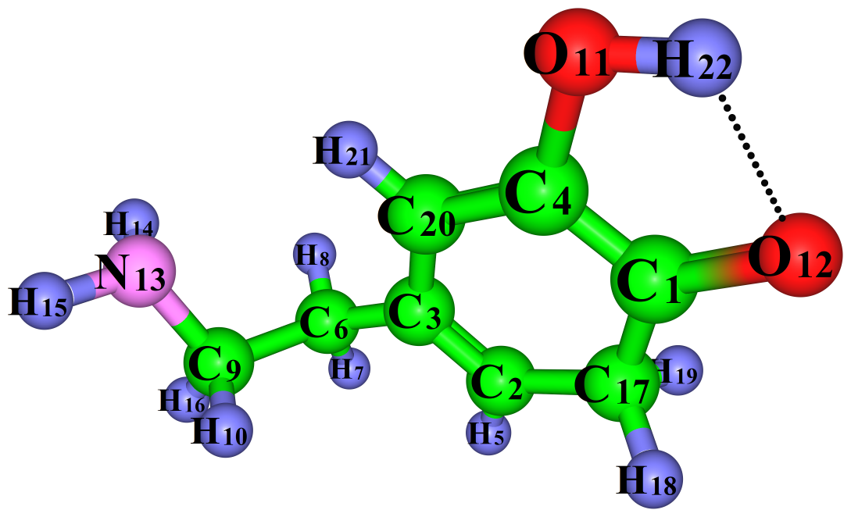
Iso-4

Figure S2 Optimised geometries of Dopamine in water
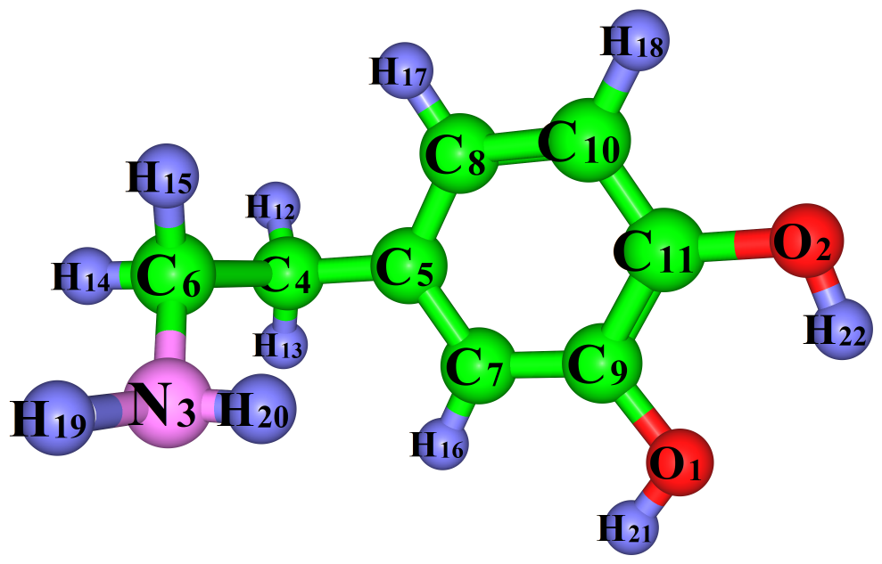
DA⁰
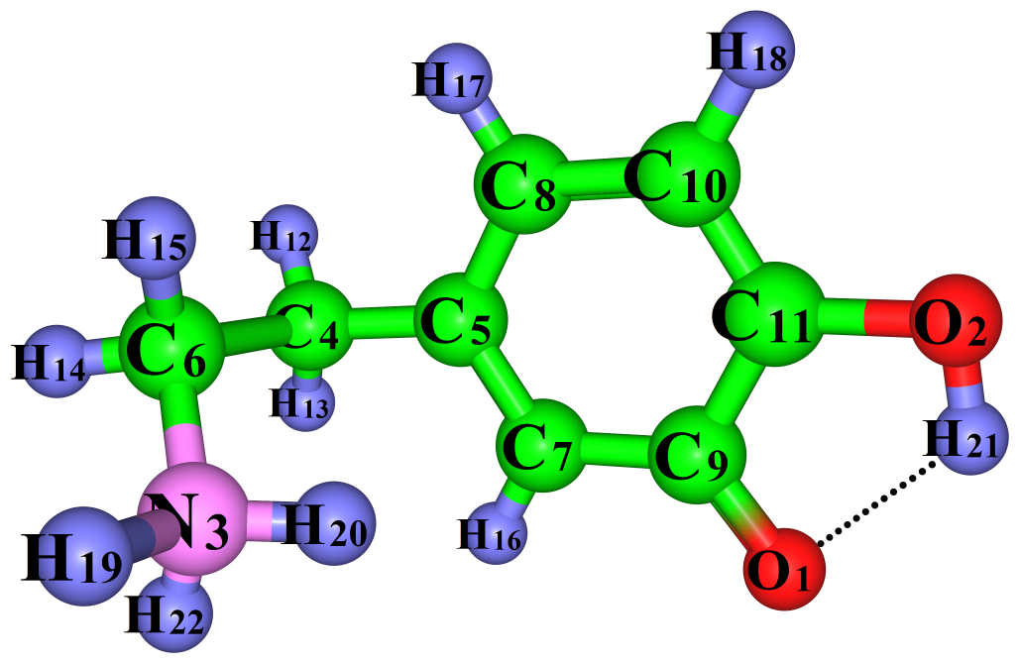
KI-1
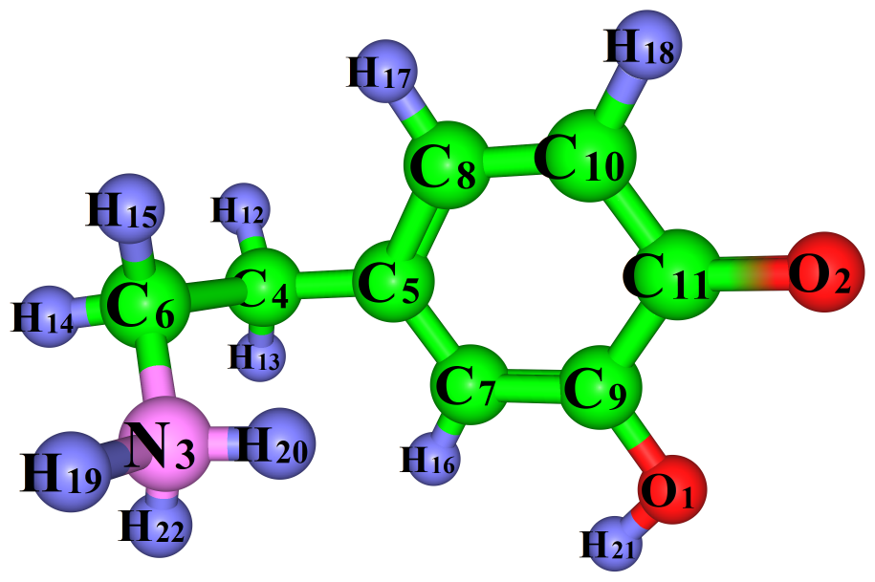
KI-2

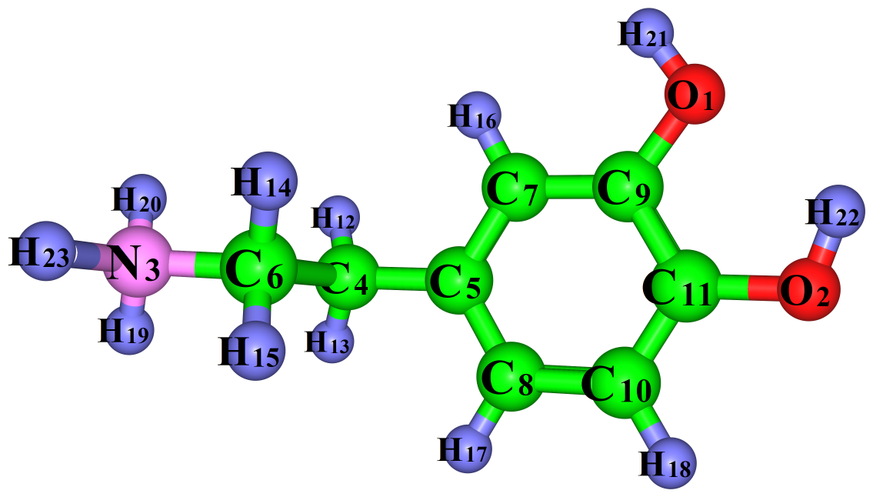
DA⁺

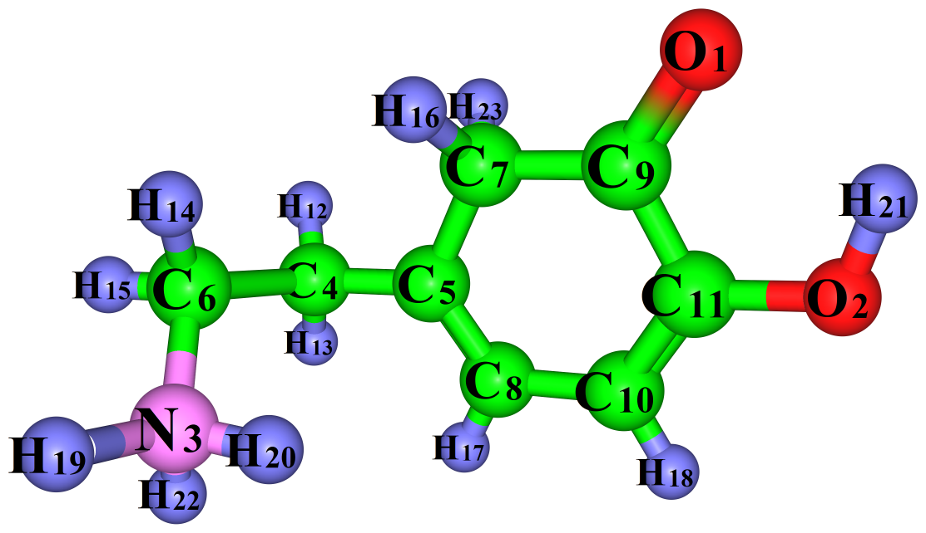
Iso-1

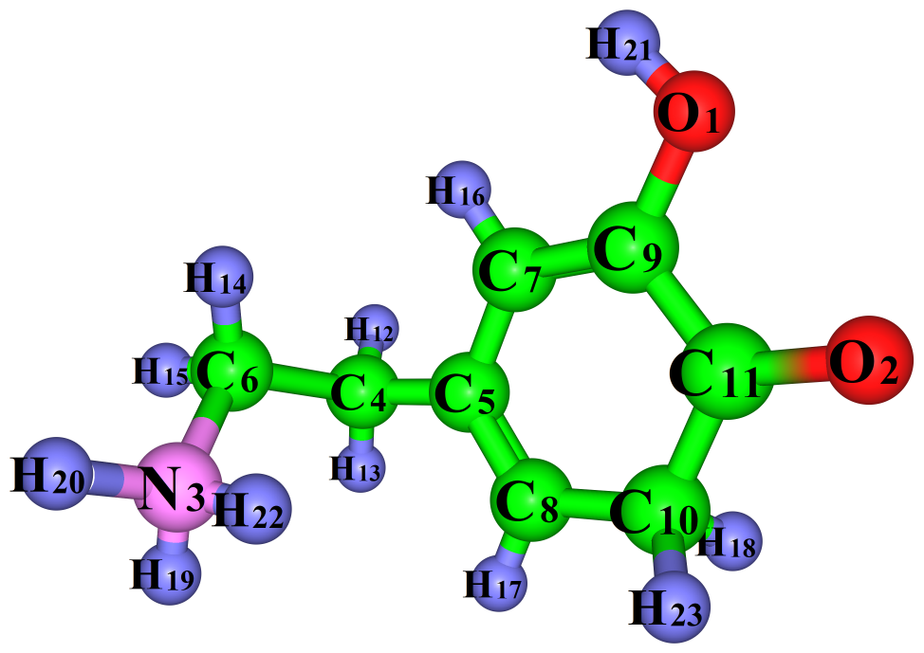

Iso-2
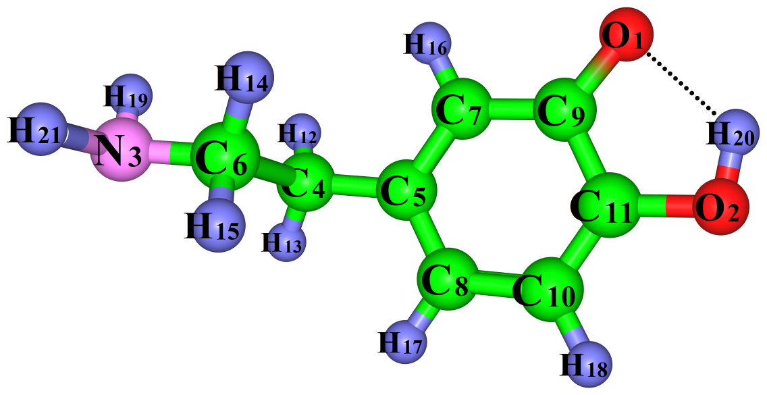

DA⁻
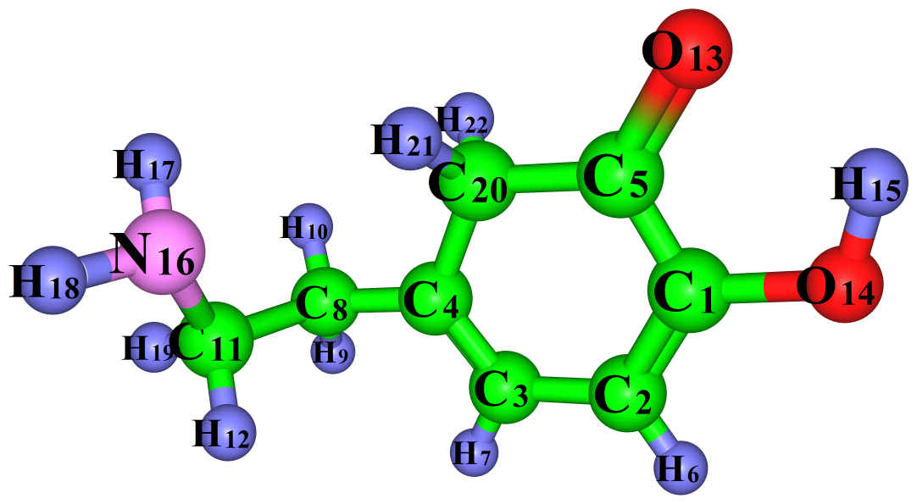
Iso-3

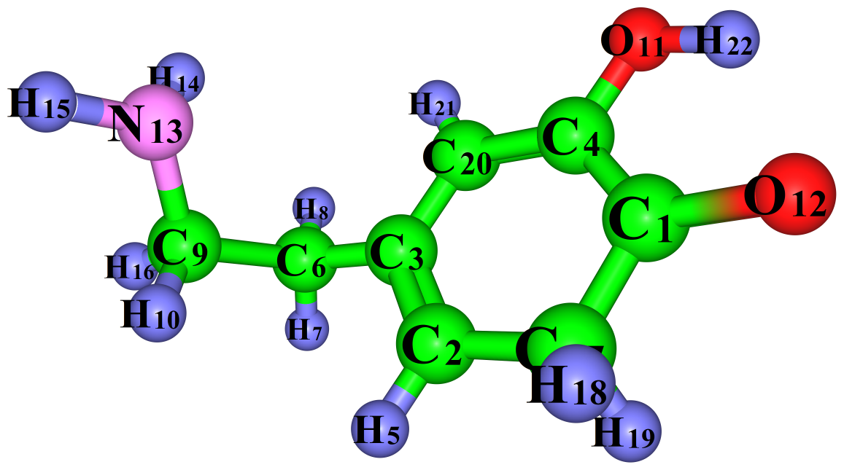
Fig.9: Iso-4

Figure S3 Optimised geometries of Dopamine in ethanol
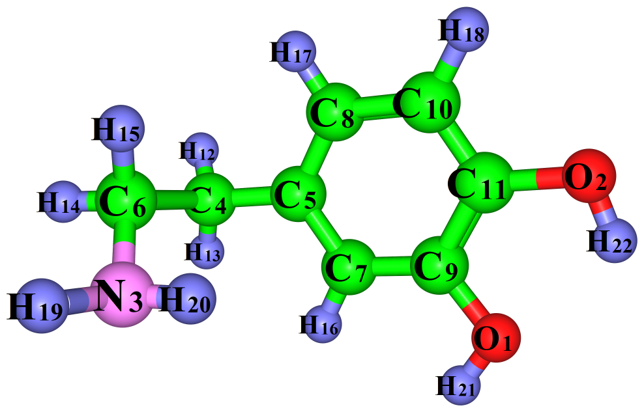
DA⁰
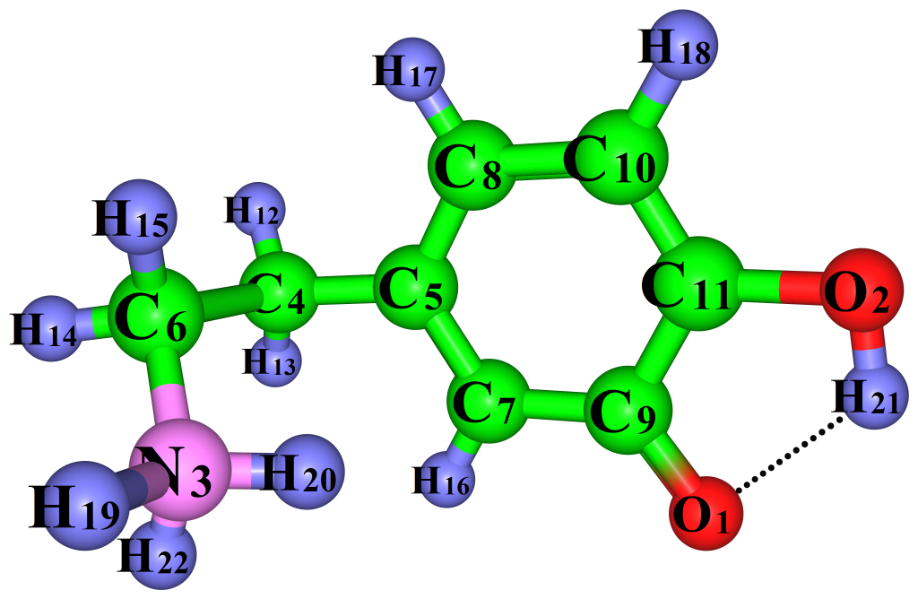
KI-1
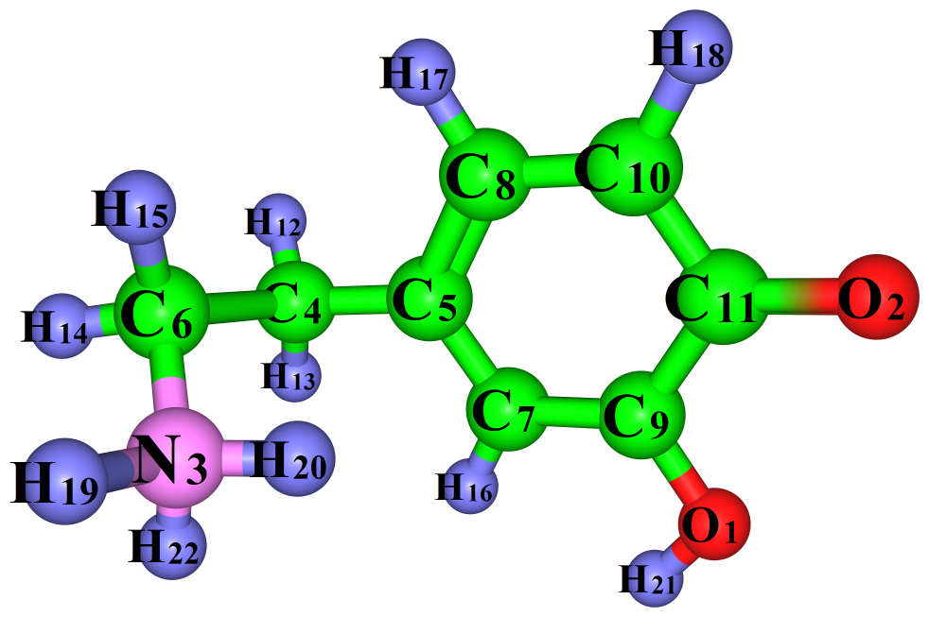
KI-2

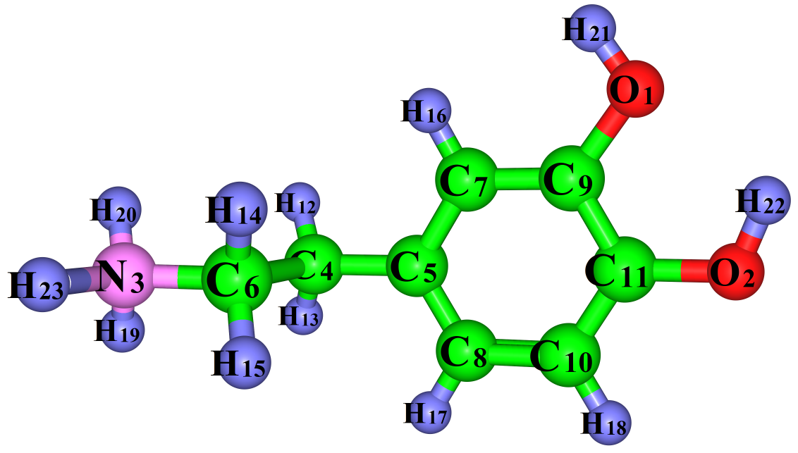
DA⁺
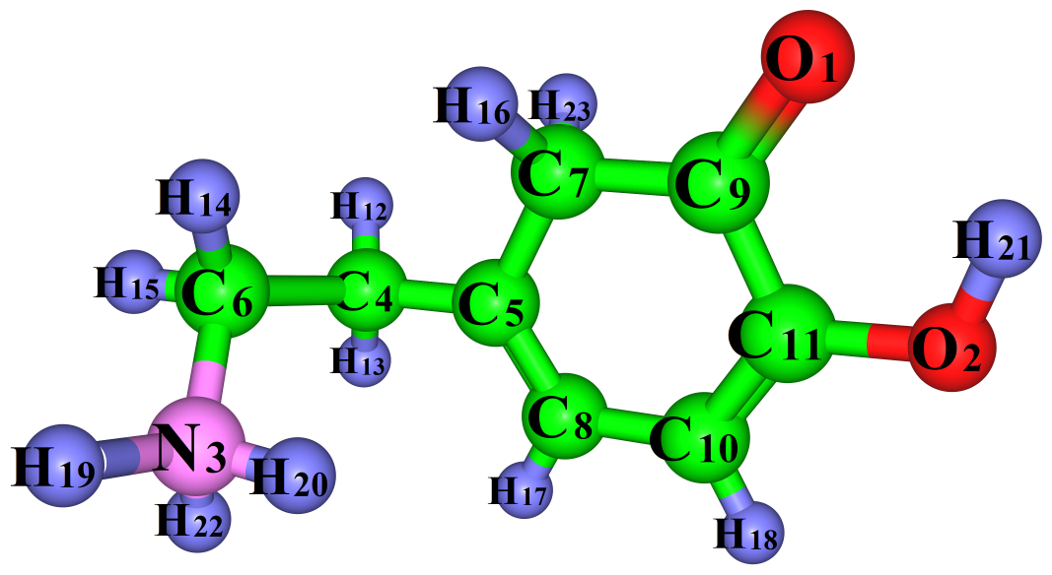
Iso-1

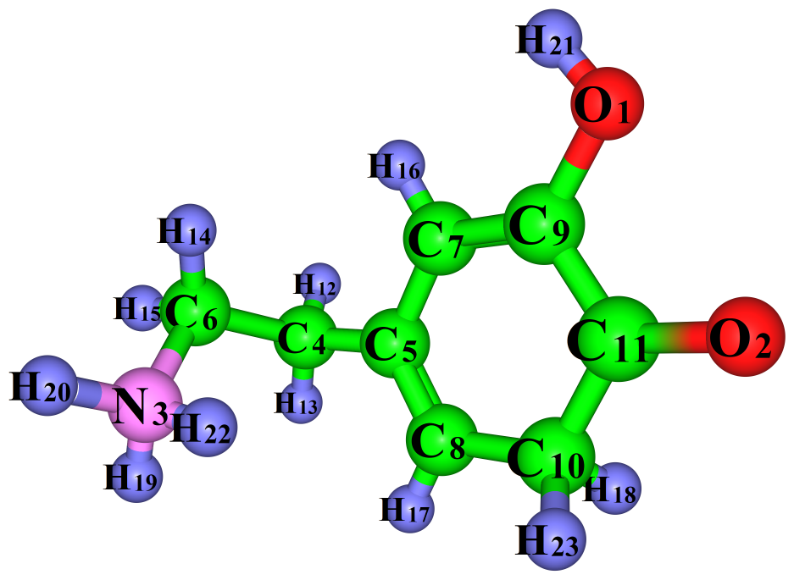
Iso-2

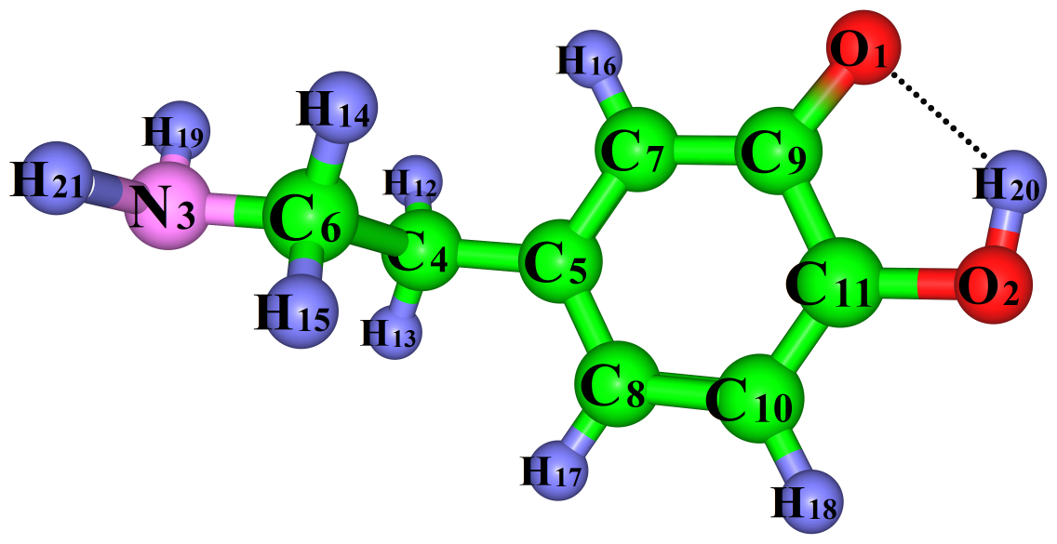
DA⁻

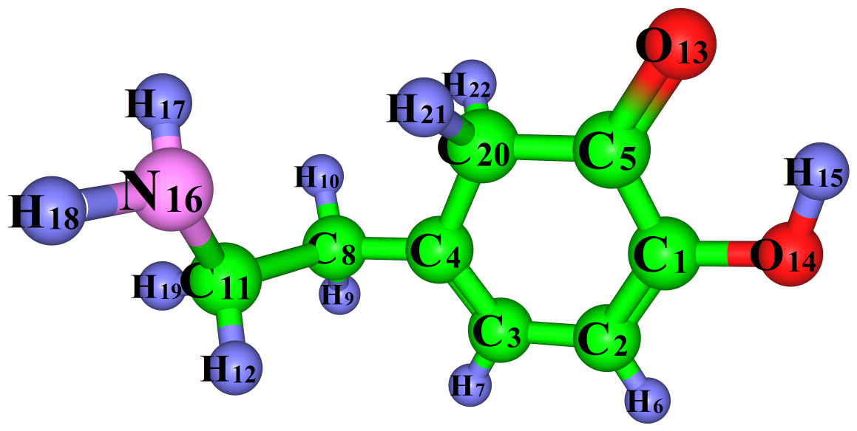
Iso-3
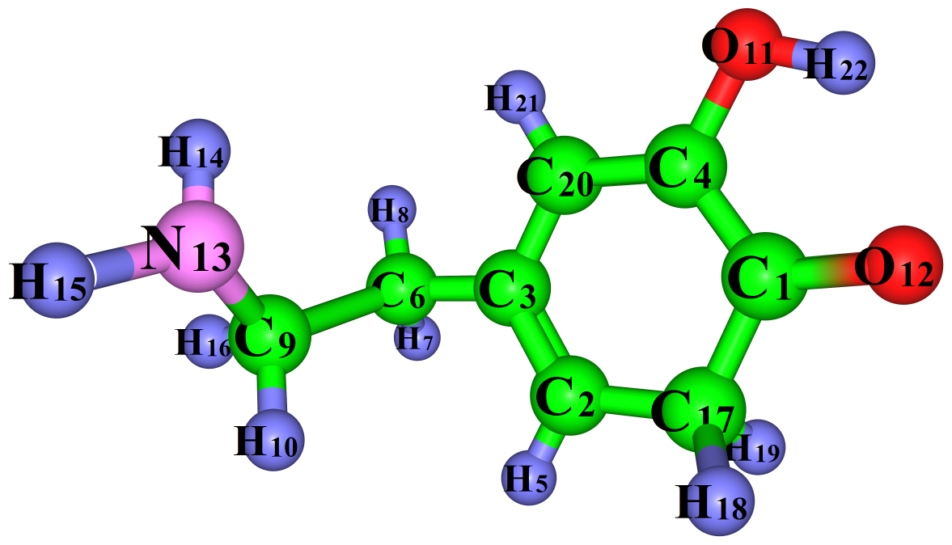

Iso-4

* Colour code: Hydrogen(H) atoms - blue, Oxygen(O) atoms- red, Carbon(C) atoms-green, Nitrogen(N) atoms-pink.

Table S1 Computed and experimental geometrical parameters of neutral Dopamine(DA⁰)
Parameters | Experimental | Calculated
Parameters | Gas | Gas | Water | Ethanol
r(C11-C10) | 1.39 | 1.385 | 1.386 | 1.386
r(C11-C9) | 1.4 | 1.395 | 1.396 | 1.396
r(C11-O2) | 1.37 | 1.363 | 1.368 | 1.368
r(C10-C8) | 1.39 | 1.389 | 1.390 | 1.390
r(C10-H18) | 1.01 | 1.080 | 1.081 | 1.081
r(C8-C5) | 1.38 | 1.393 | 1.394 | 1.394
r(C8-H17) | 0.96 | 1.081 | 1.081 | 1.081
r(C5-C7) | 1.4 | 1.395 | 1.395 | 1.395
r(C5-C4) | 1.52 | 1.506 | 1.395 | 1.507
r(C7-C9) | 1.37 | 1.385 | 1.386 | 1.386
r(C7-H16) | 0.95 | 1.083 | 1.083 | 1.083
r(C9-O1) | 1.38 | 1.376 | 1.372 | 1.372
r(C4-H12) | 0.97 | 1.091 | 1.091 | 1.091
r(C4-H13) | 0.98 | 1.090 | 1.090 | 1.090
r(C4-C6) | 1.52 | 1.532 | 1.531 | 1.531
r(O1-H21) | 0.9 | 0.961 | 0.963 | 0.963
r(O2-H22) | 0.83 | 0.964 | 0.965 | 0.965
r(C6-H14) | - | 1.091 | 1.091 | 1.091
r(C6-H15) | - | 1.098 | 1.097 | 1.097
α(C10-C11-C9) | 120 | 119.037 | 119.296 | 119.283
α (C10-C11-O2) | 123.2 | 120.116 | 120.016 | 120.021
α (C9-C11-O2) | 116.9 | 120.847 | 120.687 | 120.695
α (C11-C10-C8) | 120 | 120.225 | 120.167 | 120.170
α (C11-C10-H18) | 126 | 118.594 | 118.871 | 118.856
α (C8-C10-H18) | 114 | 121.180 | 120.961 | 120.973
α (C10-C8-C5) | 121 | 121.219 | 121.091 | 121.097
α (C10-C8-H17) | 117 | 119.238 | 119.263 | 119.262
α (C5-C8-H17) | 122 | 119.542 | 119.263 | 119.641
α (C8-C5-C7) | 119 | 118.158 | 118.300 | 118.292
α (C8-C5-C4) | 123 | 121.149 | 120.848 | 120.864
α (C7-C5-C4) | 118.4 | 120.644 | 120.813 | 120.804
α (C5-C7-C9) | 121 | 120.812 | 120.846 | 120.846
α (C5-C7-H16) | 118 | 119.667 | 119.995 | 119.976
α (C9-C7-H16) | 120 | 119.520 | 119.159 | 119.178
α (C11-C9-C7) | 119 | 120.548 | 120.300 | 120.311
α (C11-C9-O1) | 119.7 | 115.533 | 115.329 | 115.611
α (C7-C9-O1) | 120.8 | 123.919 | 124.089 | 124.078
α (C5-C4-H12) | 111 | 109.642 | 109.639 | 109.640
α (C5-C4-H13) | 109.8 | 109.947 | 109.885 | 109.890
α (H12-C4-C6) | 108.2 | 108.404 | 108.130 | 108.145
α (H13-C4-C6) | 108.3 | 108.456 | 108.814 | 108.796
α (C9-O1-H21) | 110.4 | 110.077 | 110.538 | 110.520
α (C11-O2-H22) | 108.3 | 108.378 | 108.534 | 108.526
α (C4-C6-N3) | 111.2 | 110.806 | 111.113 | 111.101
α (H14-C6-N3) | 107.8 | 107.913 | 108.016 | 108.011
α (H15-C6-N3) | 113.4 | 113.317 | 112.849 | 112.871
r: Bond lengths in Å, α: bond angles in degree (⁰)

Table S2 Experimental and computed geometrical parameters of cationic dopamine(DA⁰)
Parameters | Experimental | Calculated
Parameters | Gas | Gas | Water | Ethanol
r(C5-C8) | 1.393 | 1.390 | 1.391 | 1.391
r(C10-C8) | 1.385 | 1.388 | 1.391 | 1.390
r(C10-C11) | 1.385 | 1.386 | 1.385 | 1.385
r(C11-C9) | 1.396 | 1.403 | 1.398 | 1.398
r(C9-C7) | 1.381 | 1.384 | 1.384 | 1.385
r(C11-O2) | 1.365 | 1.349 | 1.365 | 1.364
r(C9-O1) | 1.364 | 1.364 | 1.369 | 1.369
r(C5-C4) | 1.511 | 1.508 | 1.507 | 1.507
r(C4-C6) | 1.497 | 1.521 | 1.523 | 1.523
r(C6-N3) | 1.479 | 1.531 | 1.508 | 1.508
r(C8-H17) | 1.09 | 1.082 | 1.081 | 1.081
r(C10-H18) | 0.85 | 1.080 | 1.080 | 1.080
r(C7-H16) | 0.88 | 1.084 | 1.083 | 1.083
r(O2-H22) | 0.9 | 0.966 | 0.966 | 0.966
r(O1-H21) | 0.84 | 0.961 | 0.963 | 0.963
r(C4-H13) | 0.86 | 1.093 | 1.090 | 1.091
r(C4-H12) | 1.03 | 1.092 | 1.091 | 1.090
r(C6-H14) | 0.87 | 1.087 | 1.085 | 1.086
r(C6-H15) | 1.03 | 1.086 | 1.085 | 1.086
r(N3-H20) | 0.93 | 1.021 | 1.020 | 1.020
r(N3-H23) | 0.93 | 1.021 | 1.019 | 1.019
r(N3-H19) | 0.9 | 1.021 | 1.020 | 1.020
α (C5-C8-C10) | 120.9 | 120.664 | 120.761 | 120.758
α (C8-C10-C11) | 119.8 | 120.217 | 120.135 | 120.143
α (C10-C11-C9) | 119.5 | 119.357 | 119.455 | 119.445
α (C11-C9-C7) | 120.4 | 120.280 | 120.244 | 120.243
α (C10-C11-O2) | 123.5 | 119.707 | 120.001 | 119.983
α (C11-C9-O1) | 121.6 | 115.019 | 115.478 | 115.490
α (C8-C5-C4) | 120.5 | 120.290 | 120.895 | 120.829
α (C5-C4-C6) | 111 | 109.542 | 110.423 | 110.346
α (C4-C6-N3) | 111.4 | 110.826 | 110.973 | 111.025
α (C5-C8-H17) | 121 | 120.232 | 119.846 | 119.847
α (C8-C10-H18) | 120 | 121.205 | 120.934 | 120.951
α (C9-C7-H16) | 125 | 119.253 | 119.239 | 119.228
α (C11-O2-H22) | 117 | 109.629 | 108.657 | 108.690
α (C9-O1-H21) | 108 | 111.736 | 110.768 | 110.785
α (C5-C4-H13) | 106 | 110.027 | 109.874 | 109.865
α (C5-C4-H12) | 116 | 110.456 | 110.091 | 110.123
α (C4-C6-H14) | 116 | 112.192 | 111.655 | 111.608
α (C4-C6-H15) | 107 | 111.929 | 111.728 | 111.745
α (C6-N3-H20) | 115 | 110.807 | 111.347 | 111.310
α (C6-N3-H23) | 116 | 111.942 | 111.332 | 111.324
α (C6-N3-H19) | 101 | 110.584 | 111.485 | 111.493
r: Bond lengths in Å, α: bond angles in degree (⁰)

Table S3 Geometrical parameters of anionic dopamine (DA⁻)
Parameters | Calculated
 | Gas | Water | Ethanol
r(C11-C10) | 1.372 | 1.375 | 1.375
r(C11-C9) | 1.441 | 1.431 | 1.431
r(C11-O2) | 1.367 | 1.373 | 1.373
r(C10-C8) | 1.408 | 1.404 | 1.404
r(C10-H18) | 1.084 | 1.083 | 1.083
r(C8-C5) | 1.389 | 1.391 | 1.391
r(C8-H17) | 1.083 | 1.082 | 1.082
r(C5-C7) | 1.401 | 1.401 | 1.401
r(C5-C4) | 1.509 | 1.508 | 1.508
r(C7-C9) | 1.411 | 1.408 | 1.408
r(C7-H16) | 1.085 | 1.084 | 1.084
r(C9-O1) | 1.285 | 1.300 | 1.300
r(C4-H12) | 1.096 | 1.094 | 1.094
r(C4-H13) | 1.092 | 1.091 | 1.091
r(C4-C6) | 1.527 | 1.529 | 1.529
r(O2-H20) | 0.990 | 0.983 | 0.984
r(C6-H14) | 1.095 | 1.096 | 1.096
r(C6-H15) | 1.091 | 1.091 | 1.091
α(C10-C11-C9) | 122.736 | 122.573 | 122.584
α (C10-C11-O2) | 123.867 | 123.019 | 123.067
α (C9-C11-O2) | 113.396 | 114.407 | 114.348
α (C11-C10-C8) | 119.665 | 119.561 | 119.563
α (C11-C10-H18) | 119.655 | 119.816 | 119.805
α (C8-C10-H18) | 120.679 | 120.622 | 120.631
a(C10-C8-C5) | 119.897 | 120.197 | 120.185
α (C10-C8-H17) | 119.979 | 119.764 | 119.774
α (C5-C8-H17) | 120.123 | 120.039 | 120.041
α (C8-C5-C7) | 120.032 | 119.522 | 119.542
α (C8-C5-C4) | 120.301 | 120.490 | 120.481
α (C7-C5-C4) | 119.619 | 119.950 | 119.938
α (C5-C7-C9) | 122.180 | 122.242 | 122.244
α (C5-C7-H16) | 120.013 | 119.524 | 119.551
α (C9-C7-H16) | 117.807 | 118.234 | 118.205
α (C11-C9-C7) | 115.490 | 115.903 | 115.882
α (C11-C9-O1) | 117.088 | 117.412 | 117.397
α (C7-C9-O1) | 127.422 | 126.685 | 126.721
α (C5-C4-H12) | 109.874 | 109.941 | 109.925
α (C5-C4-H13) | 110.560 | 110.221 | 110.261
α (H12-C4-C6) | 108.166 | 108.360 | 108.365
α (H13-C4-C6) | 108.493 | 108.478 | 108.477
α (H19-N3-H21) | 106.484 | 106.137 | 106.163
α (C11-O2-H20) | 99.691 | 101.042 | 100.950
α (C4-C6-N3) | 111.164 | 110.961 | 110.976
α (H14-C6-N3) | 113.037 | 112.910 | 112.929
α (H15-C6-N3) | 108.041 | 108.030 | 108.029
r: Bond lengths in Å,α: bond angles in degree (⁰)

Table S4 Calculated Electronic energies in (Hartree) and Energy gap in (eV) of all molecular conformers in gas and solvents
System | Gas |  | Water |  |  | Ethanol
System | Cal. Electronic energy | Energy gap | Cal. Electronic energy | Energy gap | Cal. Electronic energy |  | Energy gap
Neutral
DA⁰ | -516.913 | 5.341 | -516.923 | 5.547 | -516.922 |  | 5.546
KI-A | -516.86 | 2.772 | -516.91 | 4.280 | -516.907 |  | 4.205
KI-B | -516.833 | 2.562 | -516.898 | 4.072 | -516.894 |  | 3.975
Cation
DA⁺ | -517.276 | 3.536 | -517.378 | 5.549 | -517.375 |  | 5.470
Iso-1 | -517.254 | 3.909 | -517.357 | 3.872 | -517.354 |  | 3.876
Iso-2 | -517.243 | 4.201 | -517.35 | 4.041 | -517.347 |  | 4.051
Anion
DA- | -516.36 | 2.285 | -516.447 | 4.379 | -516.444 |  | 4.318
Iso-3 | -516.91 | 0.804 | -516.997 | 2.728 | -516.994 |  | 2.669
Iso-4 | -516.907 | 0.646 | -516.996 | 2.777 | -516.993 |  | 2.7184

Table S 5 dipole moments of all dopamine conformers.

System | Dipole moments (Debye)
System | Gas | Water | Ethanol
Neutral
DA⁰ | 1.641 | 1.981 | 1.966
KI-1 | 12.124 | 20.685 | 20.214
KI-2 | 13.170 | 25.838 | 25.246
Cation
DA⁺ | 16.856 | 20.919 | 20.733
Iso-1 | 13.209 | 18.174 | 17.965
Iso-2 | 13.537 | 19.621 | 19.358
Anion
DA⁻ | 6.887 | 9.665 | 9.562
Iso-3 | 5.868 | 11.442 | 11.284
Iso-4 | 6.999 | 11.901 | 11.720

Table S6 Natural charge of proton acceptor (q₁) and proton donor (q₂) of dopamine molecule.
System | Bond type | q₁ | q₂ | Δq (e)
Gas
Neutral
DA⁰ | --- | --- | --- | ---
KI-1 | N-H∙∙∙π | 0.450 | -0.473 | 0.924
 | O-H∙∙∙O | 0.494 | -0.678 | 1.172
KI-2 | N-H∙∙∙π | 0.463 | -0.364 | 0.827
Cation
DA⁺ | --- | --- | --- | ---
Iso-1 | N-H∙∙∙π | 0.449 | -0.031 | 0.481
Iso-2 | N-H∙∙∙π | 0.450 | -0.062 | 0.513
Anion
DA⁻ | O-H∙∙∙O | 0.488 | -0.807 | 1.296
Iso-3 | O-H∙∙∙O | 0.483 | -0.753 | 1.236
Iso-4 | O-H∙∙∙O | 0.482 | -0.764 | 1.247
Water
Neutral
DA⁰ | --- | --- | --- | ---
KI-1 | O-H∙∙∙O | 0.491 | -0.856 | 1.347
 | N-H∙∙∙π | 0.450 | -0.363 | 0.813
KI-2 | --- | --- | --- | ---
Cation
DA⁺ | --- | --- | --- | ---
Iso-2 | --- | --- | --- | ---
Iso-3 | --- | --- | --- | ---
Anion
DA⁻ | O-H∙∙∙O | 0.489 | -0.877 | 1.366
Iso-3 | O-H∙∙∙O | 0.485 | -0.846 | 1.331
 | C-H∙∙∙N | 0.209 | -0.861 | 1.070
Iso-4 | O-H∙∙∙O | 0.491 | -0.856 | 1.347
Ethanol
Neutral
DA⁰ | --- | --- | --- | ---
KI-1 | O-H∙∙∙O | 0.491 | -0.850 | 1.341
 | N-H∙∙∙π | 0.451 | -0.368 | 0.820
KI-2 | --- | --- | --- | ---
Cation
DA⁺ | --- | --- | --- | ---
Iso-1 | --- | --- | --- | ---
Iso-2 | --- | --- | --- | ---
Anion
DA⁻ | O-H∙∙∙O | 0.489 | -0.873 | 1.363
Iso-3 | O-H∙∙∙O | 0.485 | -0.842 | 1.327
 | C-H∙∙∙N | 0.211 | -0.859 | 1.070
Iso-4 | O-H∙∙∙O | 0.491 | -0.850 | 1.324

System | Bond type | Gas |  |  |  | Water |  |  |  | Ethanol
 |  | H15 | H20 | H21 | H22 | H15 | H20 | H21 | H22 | H15 | H20 | H21 | H22
Neutral
KI-1 | N-H∙∙∙π | --- | 16.978 (0.0586)  [14.772] | --- | --- | --- | 25.759  (0.0162)  [5.991] | --- | --- |  | 25.475  (0.0175)  [6.275]
 | O-H∙∙∙O | --- | --- | 23.244  (0.0317) [8.506] | --- | --- | --- | 23.521  (0.0322)  [8.229] | --- |  |  | 23.502  (0.0322)  [8.248]
KI-2 | N-H∙∙∙π | --- | --- | --- | 24.885  (0.025)  [6.865] | --- | --- | --- | --- | --- | --- | --- | ---
Cation
Iso-1 | N-H∙∙∙π | --- | 25.150  (0.0180)  [6.600] | --- | --- | --- | --- | --- | --- | --- | --- | --- | ---
Iso-2 | N-H∙∙∙π | --- | --- | --- | 24.600  (0.018)  [7.150] | --- | --- | --- | --- | --- | --- | --- | ---
Anion |  |  |  |  |  |  |  |  |  | --- | --- | --- | ---
DA⁻ | O-H∙∙∙O | --- | 22.688  (0.0378)  [9.062] | --- | --- |  | 23.483  (0.0333)  [8.267] | -- | -- | --- | 23.440  (0.0335)  [8.310] | --- | ---
Iso-3 | O-H∙∙∙O | 24.773  (0.0288) [6.977] | --- | --- | --- | 25.119  (0.0268)  [6.631] | -- | -- | -- | 25.075  (0.0270)  [6.675] | --- | --- | ---
 | C-H∙∙∙N | --- | --- | --- | --- | -- | -- | 27.392  (0.0086)  [4.358] | -- | --- | --- | 27.308  (0.0089)  [4.442] | ---
Iso-4 | O-H∙∙∙O | --- | --- | --- | 24.685  (0.0292)  [7.065] | -- | -- | -- | 25.075  (0.0267)  [6.675] | --- | --- | --- | 25.078  (0.0269)  [6.672]
Table S7 ¹H NMR isotropic shielding (σ) and chemical shift (δ) values in ppm, electron density(ρ) in a.u. of all dopamine conformers in gas and solvents calculated using B3LYP-D3(BJ)/aug-cc-pVTZ basis set
The chemical shift (δ) values are shown in brackets and values for the electron density (σ) are shown in parenthesis

Table S8 Optimised geometry coordinate (cartesian) of the dopamine molecule in gas
DA⁰
O -2.165635000000 1.836385000000 -0.215878000000
O -3.242210000000 -0.502682000000 0.560675000000
N 2.866170000000 1.081858000000 1.002152000000
C 2.238466000000 -0.332928000000 -0.918634000000
C 0.774847000000 -0.385916000000 -0.565175000000
C 3.139070000000 -0.179770000000 0.311868000000
C -0.005046000000 0.771548000000 -0.588350000000
C 0.174951000000 -1.574810000000 -0.155641000000
C -1.338208000000 0.736358000000 -0.214454000000
C -1.162382000000 -1.614626000000 0.220351000000
C -1.928891000000 -0.460289000000 0.194935000000
H 2.522861000000 -1.247605000000 -1.442176000000
H 2.428611000000 0.503882000000 -1.592052000000
H 4.180772000000 -0.165852000000 -0.013618000000
H 3.010281000000 -1.062497000000 0.952473000000
H 0.437705000000 1.710539000000 -0.899434000000
H 0.757413000000 -2.486299000000 -0.133714000000
H -1.628838000000 -2.538559000000 0.531738000000
H 3.502071000000 1.212754000000 1.778145000000
H 1.927276000000 1.078091000000 1.382733000000
H -1.684201000000 2.611104000000 -0.519762000000
H -3.611226000000 0.384412000000 0.472820000000

KI-1
O 2.015072000000 -1.804437000000 -0.410508000000
O 3.138924000000 0.314008000000 0.593806000000
N -2.143333000000 -1.155697000000 1.029106000000
C -2.290447000000 0.469196000000 -0.849516000000
C -0.800054000000 0.543824000000 -0.670104000000
C -2.921988000000 0.016409000000 0.482626000000
C -0.080900000000 -0.683090000000 -0.755885000000
C -0.202302000000 1.661537000000 -0.131957000000
C 1.279532000000 -0.782594000000 -0.345487000000
C 1.146639000000 1.606776000000 0.293446000000
C 1.850120000000 0.436530000000 0.209600000000
H -2.726545000000 1.435772000000 -1.100946000000
H -2.561808000000 -0.231741000000 -1.642473000000
H -3.968264000000 -0.271970000000 0.390856000000
H -2.829334000000 0.811497000000 1.216756000000
H -0.489708000000 -1.512377000000 -1.326760000000
H -0.762756000000 2.580609000000 -0.017921000000
H 1.630196000000 2.489383000000 0.691272000000
H -2.072128000000 -1.146229000000 2.041892000000
H -1.133960000000 -1.081192000000 0.567694000000
H 3.336385000000 -0.623763000000 0.372965000000
H -2.534320000000 -2.048204000000 0.740208000000

KI-2
O -2.141411000000 1.802425000000 -0.000472000000
O -2.941652000000 -0.726852000000 0.614747000000
N 1.673265000000 -0.032939000000 1.514097000000
C 2.354164000000 0.095249000000 -0.887876000000
C 0.874564000000 -0.138722000000 -0.939191000000
C 2.768327000000 0.429415000000 0.579480000000
C 0.000792000000 0.947286000000 -0.683215000000
C 0.378469000000 -1.423556000000 -0.693342000000
C -1.278065000000 0.762014000000 -0.199571000000
C -0.896259000000 -1.634856000000 -0.191444000000
C -1.808820000000 -0.566141000000 0.125354000000
H 2.890227000000 -0.796053000000 -1.213676000000
H 2.683822000000 0.925152000000 -1.515811000000
H 2.855280000000 1.501655000000 0.739380000000
H 3.693861000000 -0.050077000000 0.894325000000
H 0.346738000000 1.961982000000 -0.876868000000
H 1.024877000000 -2.277860000000 -0.877579000000
H -1.266697000000 -2.639711000000 -0.037591000000
H 1.906480000000 0.094129000000 2.495465000000
H 1.409951000000 -1.005726000000 1.315872000000
H -1.756305000000 2.607023000000 -0.361433000000
H 0.804387000000 0.481341000000 1.263865000000

DA⁺
O -2.536352000000 1.785285000000 -0.103321000000
O -3.443443000000 -0.714710000000 -0.391886000000
N 4.306651000000 0.196886000000 -0.368521000000
C 2.042959000000 0.073440000000 0.717004000000
C 0.570684000000 -0.128638000000 0.457967000000
C 2.801465000000 0.037022000000 -0.601601000000
C -0.280889000000 0.969924000000 0.319745000000
C 0.054742000000 -1.411261000000 0.305776000000
C -1.623195000000 0.780838000000 0.038601000000
C -1.289812000000 -1.604149000000 0.018488000000
C -2.137271000000 -0.515167000000 -0.119243000000
H 2.215104000000 1.030125000000 1.216228000000
H 2.418683000000 -0.713823000000 1.376274000000
H 2.508303000000 0.845646000000 -1.266413000000
H 2.674012000000 -0.911302000000 -1.117132000000
H 0.096446000000 1.977922000000 0.448666000000
H 0.695906000000 -2.274657000000 0.428205000000
H -1.701998000000 -2.596566000000 -0.090583000000
H 4.658000000000 -0.549211000000 0.234806000000
H 4.509963000000 1.084805000000 0.094063000000
H -2.148674000000 2.647118000000 0.076058000000
H -3.899368000000 0.135881000000 -0.436141000000
H 4.833338000000 0.169210000000 -1.243143000000

Iso-1
O 2.335433000000 1.705351000000 0.434256000000
O 3.246520000000 -0.793439000000 0.391266000000
N -2.881425000000 -0.580181000000 1.217832000000
C -2.195630000000 0.295091000000 -0.990302000000
C -0.756046000000 0.013491000000 -0.661280000000
C -3.015056000000 0.595184000000 0.267758000000
C 0.153241000000 1.178524000000 -0.407734000000
C -0.260369000000 -1.239953000000 -0.615218000000
C 1.553767000000 0.851537000000 0.064185000000
C 1.110638000000 -1.546033000000 -0.279767000000
C 1.982274000000 -0.564616000000 0.043760000000
H -2.293421000000 1.160625000000 -1.647795000000
H -2.640017000000 -0.551308000000 -1.518177000000
H -2.636165000000 1.462068000000 0.802998000000
H -4.073209000000 0.734686000000 0.064275000000
H -0.268611000000 1.913460000000 0.283072000000
H -0.897301000000 -2.076480000000 -0.882499000000
H 1.439408000000 -2.575397000000 -0.280430000000
H -3.145246000000 -0.348180000000 2.175215000000
H -1.892318000000 -0.881079000000 1.192128000000
H 3.655898000000 0.068680000000 0.588361000000
H -3.450237000000 -1.371684000000 0.913817000000
H 0.278650000000 1.731240000000 -1.348375000000

Iso-2
O 2.408322000000 1.759139000000 0.252970000000
O 3.017985000000 -0.805283000000 0.706279000000
N -2.777070000000 -0.499459000000 1.247336000000
C -2.158219000000 0.379050000000 -0.978381000000
C -0.723706000000 0.001518000000 -0.706512000000
C -2.885716000000 0.702225000000 0.327792000000
C 0.211325000000 1.075180000000 -0.412280000000
C -0.336480000000 -1.288020000000 -0.673800000000
C 1.488493000000 0.835607000000 -0.035336000000
C 1.077153000000 -1.667082000000 -0.389533000000
C 1.970640000000 -0.569179000000 0.158826000000
H -2.223573000000 1.261720000000 -1.614907000000
H -2.675348000000 -0.427825000000 -1.499647000000
H -2.416629000000 1.529443000000 0.854155000000
H -3.941423000000 0.915976000000 0.186914000000
H -0.132098000000 2.098877000000 -0.514897000000
H -1.022201000000 -2.076181000000 -0.963019000000
H 1.547535000000 -1.990140000000 -1.329153000000
H -3.440889000000 -1.230101000000 0.988153000000
H -2.930533000000 -0.263210000000 2.227231000000
H 2.071064000000 2.653376000000 0.119750000000
H -1.823536000000 -0.889544000000 1.125752000000
H 1.155727000000 -2.532817000000 0.269662000000

DA⁻
O -2.332166000000 -1.892362000000 -0.012927000000
O -3.471010000000 0.378674000000 0.391374000000
N 4.308616000000 -0.259759000000 0.312380000000
C 2.081163000000 0.218638000000 -0.662528000000
C 0.593325000000 0.296150000000 -0.421081000000
C 2.863504000000 -0.158305000000 0.594541000000
C -0.161663000000 -0.883619000000 -0.363770000000
C -0.018907000000 1.525062000000 -0.204422000000
C -1.545470000000 -0.877749000000 -0.085905000000
C -1.398427000000 1.582736000000 0.074848000000
C -2.128872000000 0.422295000000 0.132498000000
H 2.295003000000 -0.529577000000 -1.435618000000
H 2.460009000000 1.174021000000 -1.032987000000
H 2.440503000000 -1.082742000000 1.003198000000
H 2.719792000000 0.619040000000 1.347219000000
H 0.315280000000 -1.842533000000 -0.540270000000
H 0.562259000000 2.438237000000 -0.253210000000
H -1.889953000000 2.534733000000 0.240445000000
H 4.464165000000 -0.958406000000 -0.406212000000
H -3.618329000000 -0.599291000000 0.343360000000
H 4.808466000000 -0.576919000000 1.134747000000

Iso-3
C 2.079107000000 0.346997000000 -0.158696000000
C 1.447413000000 1.580475000000 -0.210711000000
C 0.054204000000 1.652417000000 0.045513000000
C -0.714433000000 0.558775000000 0.329508000000
C 1.405216000000 -0.854346000000 0.145733000000
H 2.015122000000 2.472509000000 -0.438510000000
H -0.419901000000 2.629627000000 0.022630000000
C -2.162659000000 0.699698000000 0.673112000000
H -2.378134000000 1.750518000000 0.894669000000
H -2.387750000000 0.140310000000 1.599483000000
C -3.191946000000 0.255589000000 -0.376217000000
H -2.974119000000 0.760915000000 -1.319768000000
O 2.047545000000 -1.952554000000 0.192475000000
O 3.431404000000 0.212294000000 -0.395210000000
H 3.553522000000 -0.751132000000 -0.274663000000
N -3.155046000000 -1.191796000000 -0.616842000000
H -3.183645000000 -1.691995000000 0.264932000000
H -3.956049000000 -1.490696000000 -1.158335000000
H -4.185513000000 0.599953000000 -0.039640000000
C -0.082415000000 -0.806535000000 0.420885000000
H -0.576425000000 -1.515542000000 -0.254297000000
H -0.260308000000 -1.238237000000 1.428518000000

Iso-4
C 2.137378000000 -0.228523000000 0.146311000000
C 0.083390000000 -1.693323000000 -0.093250000000
C -0.668414000000 -0.585451000000 -0.363226000000
C 1.276284000000 0.848816000000 -0.145276000000
H -0.389644000000 -2.670292000000 -0.084460000000
C -2.147972000000 -0.741900000000 -0.612866000000
H -2.362869000000 -1.803179000000 -0.759223000000
H -2.432941000000 -0.236885000000 -1.545085000000
C -3.064489000000 -0.221628000000 0.504512000000
H -2.577663000000 -0.391631000000 1.465864000000
O 1.889140000000 2.084256000000 -0.168726000000
O 3.378273000000 -0.021863000000 0.360915000000
N -3.320455000000 1.220219000000 0.378699000000
H -3.827910000000 1.410232000000 -0.478415000000
H -3.892642000000 1.554637000000 1.144716000000
H -3.996774000000 -0.809493000000 0.500629000000
C 1.555823000000 -1.625493000000 0.197337000000
H 1.791413000000 -2.052803000000 1.188870000000
H 2.134560000000 -2.256595000000 -0.499838000000
C -0.082736000000 0.712220000000 -0.395985000000
H -0.692040000000 1.582820000000 -0.586780000000
H 2.814793000000 1.844208000000 0.039968000000

S9 Optimised geometry coordinate (cartesian) of the dopamine molecule in water
DA⁰
O -2.214736000000 1.815942000000 -0.180502000000
O -3.235590000000 -0.556112000000 0.566893000000
N 2.907536000000 1.018202000000 1.068011000000
C 2.232486000000 -0.246885000000 -0.947557000000
C 0.772153000000 -0.331911000000 -0.582523000000
C 3.147941000000 -0.195702000000 0.279426000000
C -0.032854000000 0.808454000000 -0.584226000000
C 0.203023000000 -1.542208000000 -0.188433000000
C -1.364235000000 0.739571000000 -0.202105000000
C -1.131456000000 -1.617045000000 0.194901000000
C -1.922005000000 -0.478405000000 0.191821000000
H 2.512659000000 -1.116641000000 -1.544262000000
H 2.411538000000 0.639863000000 -1.557347000000
H 4.186524000000 -0.181041000000 -0.054406000000
H 3.007321000000 -1.115798000000 0.860182000000
H 0.380348000000 1.762468000000 -0.887869000000
H 0.806092000000 -2.440260000000 -0.182400000000
H -1.572047000000 -2.557715000000 0.495236000000
H 3.513481000000 1.032020000000 1.879459000000
H 1.956921000000 1.016899000000 1.420880000000
H -1.756534000000 2.614443000000 -0.463917000000
H -3.626768000000 0.324483000000 0.499415000000

KI-1
O 2.154126000000 -1.839280000000 -0.315832000000
O 3.249870000000 0.347530000000 0.578560000000
N -2.621687000000 -1.054661000000 1.029289000000
C -2.197823000000 0.402500000000 -0.936859000000
C -0.726035000000 0.433026000000 -0.600637000000
C -3.051450000000 0.200303000000 0.313505000000
C 0.024346000000 -0.752586000000 -0.668985000000
C -0.137649000000 1.598939000000 -0.125227000000
C 1.379084000000 -0.804191000000 -0.275542000000
C 1.207011000000 1.590563000000 0.277697000000
C 1.934028000000 0.425548000000 0.207383000000
H -2.518277000000 1.342456000000 -1.385738000000
H -2.413864000000 -0.387958000000 -1.657661000000
H -4.109473000000 0.098588000000 0.090574000000
H -2.906318000000 1.014912000000 1.016421000000
H -0.424878000000 -1.653861000000 -1.072121000000
H -0.712452000000 2.513433000000 -0.063012000000
H 1.677244000000 2.495463000000 0.642006000000
H -2.960684000000 -1.084433000000 1.988915000000
H -1.593773000000 -1.098166000000 1.037285000000
H 3.450818000000 -0.596727000000 0.394023000000
H -2.957577000000 -1.891697000000 0.554443000000

KI-2
O -2.239169000000 1.856853000000 -0.184550000000
O -3.268630000000 -0.555055000000 0.618517000000
N 2.666782000000 0.858547000000 1.165776000000
C 2.169352000000 -0.227801000000 -1.003971000000
C 0.712958000000 -0.334342000000 -0.630854000000
C 3.080577000000 -0.239962000000 0.221861000000
C -0.113033000000 0.801320000000 -0.603409000000
C 0.148916000000 -1.543413000000 -0.228779000000
C -1.433021000000 0.734469000000 -0.196056000000
C -1.175380000000 -1.618790000000 0.182073000000
C -2.044395000000 -0.492579000000 0.232402000000
H 2.480929000000 -1.064006000000 -1.631312000000
H 2.352436000000 0.682319000000 -1.578340000000
H 4.125919000000 -0.076890000000 -0.024135000000
H 2.980076000000 -1.168551000000 0.776220000000
H 0.284662000000 1.759443000000 -0.926492000000
H 0.753158000000 -2.443663000000 -0.239118000000
H -1.591675000000 -2.572798000000 0.483455000000
H 3.113415000000 0.773270000000 2.076910000000
H 1.649318000000 0.822664000000 1.290350000000
H -1.725220000000 2.611760000000 -0.490703000000
H 2.896060000000 1.778827000000 0.791391000000

DA⁺
O -2.453379000000 1.840965000000 -0.048038000000
O -3.487106000000 -0.609832000000 -0.396076000000
N 4.287760000000 0.263411000000 -0.348032000000
C 2.049850000000 -0.077726000000 0.707768000000
C 0.572648000000 -0.223322000000 0.442128000000
C 2.811868000000 0.084433000000 -0.601221000000
C -0.236885000000 0.909340000000 0.339312000000
C 0.000535000000 -1.477875000000 0.255634000000
C -1.587788000000 0.785015000000 0.060666000000
C -1.355790000000 -1.606676000000 -0.025513000000
C -2.155419000000 -0.479979000000 -0.125073000000
H 2.232745000000 0.790907000000 1.342060000000
H 2.419682000000 -0.956436000000 1.237311000000
H 2.484269000000 0.962707000000 -1.149453000000
H 2.709288000000 -0.789857000000 -1.237072000000
H 0.185046000000 1.896661000000 0.483125000000
H 0.612874000000 -2.365768000000 0.334521000000
H -1.804344000000 -2.580199000000 -0.164952000000
H 4.686110000000 -0.546279000000 0.128182000000
H 4.468164000000 1.081498000000 0.234544000000
H -1.995379000000 2.674975000000 0.102475000000
H -3.884190000000 0.270560000000 -0.423727000000
H 4.801172000000 0.389025000000 -1.220081000000

Iso-1
O 2.393615000000 1.707975000000 0.373563000000
O 3.284467000000 -0.796533000000 0.412439000000
N -3.050220000000 -0.551088000000 1.173340000000
C -2.161050000000 0.288988000000 -0.994622000000
C -0.728787000000 -0.003715000000 -0.649152000000
C -3.020268000000 0.617373000000 0.223969000000
C 0.166196000000 1.155360000000 -0.338663000000
C -0.240090000000 -1.254772000000 -0.610234000000
C 1.582345000000 0.839016000000 0.062737000000
C 1.129947000000 -1.544800000000 -0.254174000000
C 1.999232000000 -0.563588000000 0.066437000000
H -2.225798000000 1.150059000000 -1.661493000000
H -2.597662000000 -0.558071000000 -1.524034000000
H -2.634685000000 1.461873000000 0.786932000000
H -4.048291000000 0.821060000000 -0.058217000000
H -0.260039000000 1.792773000000 0.441615000000
H -0.875291000000 -2.093160000000 -0.863911000000
H 1.460253000000 -2.574469000000 -0.241921000000
H -3.530387000000 -0.318619000000 2.041958000000
H -2.099635000000 -0.849390000000 1.405111000000
H 3.677074000000 0.075610000000 0.593069000000
H -3.528356000000 -1.352184000000 0.759746000000
H 0.224547000000 1.807428000000 -1.218035000000

Iso-2
O 2.357763000000 1.836431000000 0.240107000000
O 3.210427000000 -0.690584000000 0.515129000000
N -3.017026000000 -0.342055000000 1.220652000000
C -2.120346000000 0.206770000000 -1.034950000000
C -0.696586000000 -0.114096000000 -0.660071000000
C -2.935447000000 0.713459000000 0.149268000000
C 0.201649000000 0.996674000000 -0.392064000000
C -0.258164000000 -1.375552000000 -0.540968000000
C 1.487267000000 0.829967000000 -0.014314000000
C 1.141589000000 -1.685436000000 -0.145545000000
C 2.054776000000 -0.518971000000 0.155258000000
H -2.148033000000 0.988780000000 -1.794713000000
H -2.601824000000 -0.671938000000 -1.463773000000
H -2.482486000000 1.584902000000 0.613039000000
H -3.954793000000 0.952564000000 -0.136206000000
H -0.182837000000 2.003367000000 -0.510839000000
H -0.913657000000 -2.210628000000 -0.749638000000
H 1.628116000000 -2.274480000000 -0.931052000000
H -3.567354000000 -1.144180000000 0.913414000000
H -3.447457000000 0.020137000000 2.070746000000
H 1.925655000000 2.689974000000 0.114537000000
H -2.083268000000 -0.685757000000 1.458151000000
H 1.153175000000 -2.342019000000 0.730195000000

DA⁻
O -2.367435000000 -1.887735000000 0.012418000000
O -3.472101000000 0.434511000000 0.392336000000
N 4.315185000000 -0.228742000000 0.308134000000
C 2.081343000000 0.149808000000 -0.679390000000
C 0.597185000000 0.254340000000 -0.428731000000
C 2.877137000000 -0.131306000000 0.596245000000
C -0.183094000000 -0.907650000000 -0.351714000000
C 0.001084000000 1.495156000000 -0.226247000000
C -1.563082000000 -0.868883000000 -0.073869000000
C -1.372809000000 1.581775000000 0.053602000000
C -2.123912000000 0.432200000000 0.127677000000
H 2.283274000000 -0.652548000000 -1.395437000000
H 2.455075000000 1.074447000000 -1.123703000000
H 2.474684000000 -1.034304000000 1.070742000000
H 2.728239000000 0.690903000000 1.298530000000
H 0.280912000000 -1.874963000000 -0.513589000000
H 0.595041000000 2.398043000000 -0.287112000000
H -1.845006000000 2.544590000000 0.207485000000
H 4.492676000000 -1.031046000000 -0.286496000000
H -3.671018000000 -0.528584000000 0.365601000000
H 4.833008000000 -0.392185000000 1.163578000000

Iso-3
C 2.026913000000 0.386289000000 -0.191385000000
C 1.336545000000 1.595544000000 -0.242667000000
C -0.044996000000 1.605605000000 0.094641000000
C -0.730906000000 0.486097000000 0.461579000000
C 1.437930000000 -0.824857000000 0.182100000000
H 1.845195000000 2.505998000000 -0.528388000000
H -0.573954000000 2.552818000000 0.058234000000
C -2.192658000000 0.535466000000 0.806637000000
H -2.443922000000 1.527524000000 1.191800000000
H -2.408792000000 -0.172868000000 1.616550000000
C -3.168223000000 0.252299000000 -0.343901000000
H -2.965768000000 0.952338000000 -1.156847000000
O 2.139786000000 -1.910660000000 0.214375000000
O 3.375980000000 0.323229000000 -0.511606000000
H 3.576087000000 -0.623218000000 -0.379480000000
N -3.028379000000 -1.109239000000 -0.878345000000
H -3.209019000000 -1.785826000000 -0.144567000000
H -3.727666000000 -1.274045000000 -1.592815000000
H -4.186191000000 0.459407000000 0.014153000000
C -0.026039000000 -0.843110000000 0.555198000000
H -0.541412000000 -1.590218000000 -0.065810000000
H -0.123435000000 -1.247795000000 1.580225000000

Iso-4
C -2.041828000000 0.414243000000 0.206767000000
C 0.213537000000 1.482457000000 -0.226315000000
C 0.727184000000 0.265334000000 -0.562830000000
C -1.431060000000 -0.787723000000 -0.163851000000
H 0.849022000000 2.360583000000 -0.261231000000
C 2.181189000000 0.132907000000 -0.960809000000
H 2.437390000000 0.910693000000 -1.684460000000
H 2.336789000000 -0.823315000000 -1.468237000000
C 3.183156000000 0.241137000000 0.191265000000
H 3.019904000000 1.182138000000 0.719441000000
O -2.251389000000 -1.905778000000 -0.140684000000
O -3.290193000000 0.439249000000 0.540539000000
N 3.027974000000 -0.852303000000 1.159342000000
H 3.170726000000 -1.743375000000 0.696614000000
H 3.740936000000 -0.786303000000 1.876052000000
H 4.193634000000 0.282522000000 -0.236110000000
C -1.212144000000 1.677672000000 0.207807000000
H -1.261088000000 2.123097000000 1.216960000000
H -1.718903000000 2.425349000000 -0.425573000000
C -0.094067000000 -0.898880000000 -0.540955000000
H 0.317251000000 -1.863552000000 -0.806240000000
H -3.104625000000 -1.532363000000 0.152077000000

S10 Optimised geometry coordinate (cartesian) of the dopamine molecule in ethanol
DA⁰
O -2.212835000000 1.816697000000 -0.182012000000
O -3.235594000000 -0.554206000000 0.566952000000
N 2.905074000000 1.020515000000 1.066115000000
C 2.232841000000 -0.249897000000 -0.946658000000
C 0.772361000000 -0.333935000000 -0.582215000000
C 3.147449000000 -0.194913000000 0.280838000000
C -0.031834000000 0.806977000000 -0.584865000000
C 0.202180000000 -1.543402000000 -0.187302000000
C -1.363195000000 0.739345000000 -0.202788000000
C -1.132373000000 -1.616981000000 0.195882000000
C -1.922115000000 -0.477806000000 0.191954000000
H 2.513389000000 -1.121327000000 -1.540771000000
H 2.412329000000 0.635212000000 -1.558674000000
H 4.186231000000 -0.179676000000 -0.052413000000
H 3.007517000000 -1.114008000000 0.863484000000
H 0.382469000000 1.760384000000 -0.888985000000
H 0.804562000000 -2.441927000000 -0.180572000000
H -1.573902000000 -2.556998000000 0.496785000000
H 3.512089000000 1.038902000000 1.876617000000
H 1.954774000000 1.018467000000 1.419717000000
H -1.753409000000 2.614522000000 -0.465089000000
H -3.626018000000 0.326589000000 0.498503000000

KI-1
O 2.139173000000 -1.839444000000 -0.325336000000
O 3.243604000000 0.338369000000 0.579026000000
N -2.588027000000 -1.071189000000 1.021048000000
C -2.204627000000 0.418546000000 -0.927451000000
C -0.730634000000 0.446232000000 -0.602006000000
C -3.043709000000 0.188352000000 0.328980000000
C 0.015036000000 -0.742796000000 -0.676209000000
C -0.137858000000 1.607241000000 -0.121491000000
C 1.369570000000 -0.802444000000 -0.281788000000
C 1.207265000000 1.591376000000 0.281256000000
C 1.929280000000 0.423867000000 0.207300000000
H -2.532358000000 1.365916000000 -1.354839000000
H -2.425100000000 -0.358835000000 -1.661262000000
H -4.103015000000 0.076465000000 0.116899000000
H -2.900075000000 0.994718000000 1.041693000000
H -0.435849000000 -1.639226000000 -1.088586000000
H -0.709053000000 2.523683000000 -0.054607000000
H 1.681456000000 2.492837000000 0.648883000000
H -2.903214000000 -1.115172000000 1.987966000000
H -1.558382000000 -1.104549000000 1.001389000000
H 3.441241000000 -0.605760000000 0.389906000000
H -2.927612000000 -1.905401000000 0.544153000000

KI-2
O -2.233283000000 1.854244000000 -0.189448000000
O -3.258075000000 -0.555374000000 0.622821000000
N 2.628943000000 0.861795000000 1.173029000000
C 2.176858000000 -0.228030000000 -1.002076000000
C 0.718691000000 -0.337195000000 -0.638322000000
C 3.074249000000 -0.229880000000 0.234895000000
C -0.107549000000 0.799092000000 -0.610075000000
C 0.155158000000 -1.545886000000 -0.234073000000
C -1.426707000000 0.732939000000 -0.200570000000
C -1.167936000000 -1.620930000000 0.179657000000
C -2.037582000000 -0.494288000000 0.232004000000
H 2.497480000000 -1.066357000000 -1.621885000000
H 2.362132000000 0.680167000000 -1.579024000000
H 4.120853000000 -0.052269000000 0.004423000000
H 2.978015000000 -1.160402000000 0.786658000000
H 0.289864000000 1.756681000000 -0.935899000000
H 0.759584000000 -2.446117000000 -0.244686000000
H -1.584203000000 -2.574492000000 0.482027000000
H 3.044498000000 0.772782000000 2.098315000000
H 1.606703000000 0.819660000000 1.260051000000
H -1.723879000000 2.606997000000 -0.507892000000
H 2.866125000000 1.784893000000 0.811092000000

DA⁺
O -2.471129000000 1.830525000000 -0.060196000000
O -3.481267000000 -0.632339000000 -0.395191000000
N 4.291171000000 0.249268000000 -0.352632000000
C 2.048661000000 -0.043388000000 0.711343000000
C 0.572819000000 -0.202668000000 0.445854000000
C 2.813487000000 0.071573000000 -0.600995000000
C -0.246746000000 0.921648000000 0.334933000000
C 0.012584000000 -1.463676000000 0.266266000000
C -1.596270000000 0.783211000000 0.055713000000
C -1.341780000000 -1.606662000000 -0.016081000000
C -2.151913000000 -0.488007000000 -0.123429000000
H 2.227601000000 0.848663000000 1.313486000000
H 2.418499000000 -0.900785000000 1.274866000000
H 2.491586000000 0.933975000000 -1.177275000000
H 2.705774000000 -0.821788000000 -1.209043000000
H 0.165745000000 1.913698000000 0.473186000000
H 0.632914000000 -2.345420000000 0.351978000000
H -1.781480000000 -2.584955000000 -0.149882000000
H 4.687108000000 -0.553464000000 0.137561000000
H 4.474901000000 1.077100000000 0.215111000000
H -2.022833000000 2.669051000000 0.093966000000
H -3.887739000000 0.243578000000 -0.426564000000
H 4.803844000000 0.357793000000 -1.227495000000

Iso-1
O 2.392047000000 1.706080000000 0.381598000000
O 3.282483000000 -0.798662000000 0.411057000000
N -3.046241000000 -0.556337000000 1.172719000000
C -2.161879000000 0.293761000000 -0.992718000000
C -0.729516000000 -0.000746000000 -0.649565000000
C -3.019366000000 0.616892000000 0.228423000000
C 0.168212000000 1.157693000000 -0.344174000000
C -0.241906000000 -1.252257000000 -0.611305000000
C 1.582162000000 0.839126000000 0.064251000000
C 1.128431000000 -1.544457000000 -0.257567000000
C 1.998618000000 -0.564465000000 0.064405000000
H -2.227486000000 1.157480000000 -1.656059000000
H -2.599747000000 -0.550930000000 -1.524896000000
H -2.633799000000 1.459297000000 0.794665000000
H -4.048295000000 0.820520000000 -0.050743000000
H -0.258410000000 1.806306000000 0.426386000000
H -0.878131000000 -2.089920000000 -0.865145000000
H 1.457902000000 -2.574360000000 -0.247221000000
H -3.529397000000 -0.330270000000 2.041429000000
H -2.094263000000 -0.850983000000 1.404281000000
H 3.676284000000 0.072593000000 0.593609000000
H -3.519891000000 -1.357472000000 0.753726000000
H 0.234147000000 1.799464000000 -1.230812000000

Iso-2
O 2.361794000000 1.833017000000 0.240507000000
O 3.205317000000 -0.695198000000 0.522348000000
N -3.013481000000 -0.348019000000 1.220573000000
C -2.120925000000 0.213484000000 -1.033051000000
C -0.697129000000 -0.108976000000 -0.659427000000
C -2.936650000000 0.713246000000 0.153708000000
C 0.202925000000 1.000333000000 -0.390427000000
C -0.260726000000 -1.371594000000 -0.544512000000
C 1.488635000000 0.830266000000 -0.014459000000
C 1.139874000000 -1.685452000000 -0.155030000000
C 2.053210000000 -0.521219000000 0.155594000000
H -2.149233000000 0.999116000000 -1.789012000000
H -2.601829000000 -0.663403000000 -1.466429000000
H -2.485554000000 1.583703000000 0.621188000000
H -3.957102000000 0.950594000000 -0.129370000000
H -0.179580000000 2.008003000000 -0.507749000000
H -0.917454000000 -2.204474000000 -0.758082000000
H 1.624615000000 -2.263008000000 -0.950339000000
H -3.564832000000 -1.148683000000 0.911188000000
H -3.439903000000 0.009115000000 2.074842000000
H 1.934701000000 2.688395000000 0.110702000000
H -2.077842000000 -0.692635000000 1.450350000000
H 1.156199000000 -2.353672000000 0.711496000000

DA⁻
O -2.212835000000 1.816697000000 -0.182012000000
O -3.235594000000 -0.554206000000 0.566952000000
N 2.905074000000 1.020515000000 1.066115000000
C 2.232841000000 -0.249897000000 -0.946658000000
C 0.772361000000 -0.333935000000 -0.582215000000
C 3.147449000000 -0.194913000000 0.280838000000
C -0.031834000000 0.806977000000 -0.584865000000
C 0.202180000000 -1.543402000000 -0.187302000000
C -1.363195000000 0.739345000000 -0.202788000000
C -1.132373000000 -1.616981000000 0.195882000000
C -1.922115000000 -0.477806000000 0.191954000000
H 2.513389000000 -1.121327000000 -1.540771000000
H 2.412329000000 0.635212000000 -1.558674000000
H 4.186231000000 -0.179676000000 -0.052413000000
H 3.007517000000 -1.114008000000 0.863484000000
H 0.382469000000 1.760384000000 -0.888985000000
H 0.804562000000 -2.441927000000 -0.180572000000
H -1.573902000000 -2.556998000000 0.496785000000
H 3.512089000000 1.038902000000 1.876617000000
H 1.954774000000 1.018467000000 1.419717000000
H -1.753409000000 2.614522000000 -0.465089000000
H -3.626018000000 0.326589000000 0.498503000000

Iso-3
C 2.042976000000 0.372147000000 -0.183694000000
C 1.371402000000 1.591361000000 -0.239850000000
C -0.014044000000 1.620502000000 0.078891000000
C -0.723226000000 0.509591000000 0.428690000000
C 1.429648000000 -0.832329000000 0.173294000000
H 1.898033000000 2.495871000000 -0.511580000000
H -0.526506000000 2.576915000000 0.045901000000
C -2.183826000000 0.586534000000 0.772123000000
H -2.422510000000 1.598459000000 1.110722000000
H -2.404567000000 -0.080108000000 1.616465000000
C -3.171296000000 0.258117000000 -0.356543000000
H -2.949299000000 0.894580000000 -1.215297000000
O 2.115405000000 -1.927193000000 0.211944000000
O 3.395967000000 0.289244000000 -0.480286000000
H 3.576942000000 -0.661640000000 -0.350473000000
N -3.079873000000 -1.140442000000 -0.796898000000
H -3.277073000000 -1.759163000000 -0.017795000000
H -3.786849000000 -1.331391000000 -1.497055000000
H -4.180663000000 0.522947000000 -0.011506000000
C -0.041429000000 -0.832224000000 0.517693000000
H -0.555511000000 -1.562724000000 -0.123069000000
H -0.165087000000 -1.249261000000 1.535083000000

Iso-4
C -2.041131000000 0.416321000000 0.205907000000
C 0.216342000000 1.479823000000 -0.229226000000
C 0.727819000000 0.260761000000 -0.562413000000
C -1.431962000000 -0.787629000000 -0.161774000000
H 0.853157000000 2.356956000000 -0.267347000000
C 2.180824000000 0.125154000000 -0.962648000000
H 2.436188000000 0.897746000000 -1.692268000000
H 2.334577000000 -0.834593000000 -1.464103000000
C 3.185105000000 0.239809000000 0.186503000000
H 3.027329000000 1.186602000000 0.705942000000
O -2.255032000000 -1.903553000000 -0.138226000000
O -3.289425000000 0.444542000000 0.536924000000
N 3.024691000000 -0.843160000000 1.164906000000
H 3.152675000000 -1.740280000000 0.709719000000
H 3.741856000000 -0.779242000000 1.877528000000
H 4.195371000000 0.272052000000 -0.242762000000
C -1.208238000000 1.677932000000 0.207366000000
H -1.254944000000 2.121425000000 1.217604000000
H -1.714579000000 2.427458000000 -0.424003000000
C -0.094785000000 -0.902011000000 -0.536676000000
H 0.314921000000 -1.868238000000 -0.798811000000
H -3.107570000000 -1.526639000000 0.152332000000

