Effectiveness of a theory-based behavior change intervention on physical activity in patients with chronic obstructive pulmonary disease
Additional file 1. Detailed and additional data of this manuscript.
Table 1
Characteristics of participants (N=89).
Characteristics | Control group(n=44) | Experimental group(n=45) | P-value
Gender
Male | 32(72.72%) | 32(71.11%) | 0.865^{b}
Female | 12(27.27%) | 13(28.89%) | 0.865^{b}
Age(years) | 67.39±6.61 | 66.69±5.71 | 0.595ª
BMI(kg/m²) | 22.55±2.49 | 22.99±3.03 | 0.458ª
Education level
Primary school and below | 28(63.63%) | 31(68.89%) | 0.952^{b}
Middle school | 11(25.00%) | 9(20.00%) | 0.952^{b}
High school | 3(6.82%) | 3(6.67%) | 0.952^{b}
College graduate or beyond | 2(4.55%) | 2(4.44%) | 0.952^{b}
Work status
Full-time employment | 5(11.36%) | 6(13.33%) | 0.778^{b}
Retirement | 39(88.64%) | 39(86.67%) | 0.778^{b}
Marital status
Single | 6(4.55%) | 5(6.67%) | 0.717^{b}
Married/widowed | 38(95.45%) | 40(93.33%) | 0.717^{b}
Living conditions
Live alone | 5(11.36%) | 7(15.56%) | 0.563^{b}
Live with others | 39(88.64%) | 38(84.44%) | 0.563^{b}
Smoking status
Never smoker | 11(25.00%) | 8(17.78%) | 0.650^{b}
Former smoker | 15(34.09%) | 15(33.33%) | 0.650^{b}
Current smoker | 18(40.91%) | 22(48.89%) | 0.650^{b}
Years of diagnosis COPD
<1year | 6(13.64%) | 5(11.11%) | 0.881^{b}
1-5years | 7(15.91%) | 9(20.00%) | 0.881^{b}
5-10years | 22(50.00%) | 24(53.33%) | 0.881^{b}
>10years | 9(20.45%) | 7(15.56%) | 0.881^{b}
GOLD classification
Ⅰ(mild) | 8(18.18%) | 6(13.33%) | 0.384^{b}
Ⅱ(moderate) | 18(40.91%) | 25(55.56%) | 0.384^{b}
Ⅲ(severe) | 18(40.91%) | 14(31.11%) | 0.384^{b}
Comorbidities
Heart disease | 25(56.81%) | 22(48.89%) | 0.503^{b}
Diabetes | 7(15.91%) | 12(26.67%) | 0.503^{b}
Hypertension | 6(13.64%) | 6(13.33%) | 0.503^{b}
Others | 6(13.64%) | 5(11.11%) | 0.503^{b}

Continuous values are presented as (mean±standard) deviation and categorical variables are presented as number (percentage).

Legend: BMI=body mass index;Kg=kilograms;GOLD=Global initiative for chronic obstructive lung disease.

ª Independent t test.

^{b} Chi-squared test.

Table 2
A comparison of the outcome variables between the two groups before and after the intervention.
Variables | Group | baseline | 4weeks | 8weeks | 12weeks | F1(p) | F2(p) | F3(p)
PA | Exp | 1150.02±434.79 | 1300.40±387.17 ª | 1350.67±347.34 ª | 1408.44±361.78 ª | 4.433(0.038) | 5.155(0.003) | 1.886(0.138)
PA | Con | 1162.50±420.87 | 1247.45±485.85 | 1164.20±387.17 | 1146.32±321.55
PA | t | 0.138 | -0.573 | -2.393 | -3.610
PA | p | 0.891 | 0.568 | 0.019 | 0.001
SB | Exp | 7.24±0.14 | 6.47±0.13 ª | 6.22±0.10 ^{ab} | 6.19±0.11 ^{abc} | 10.714(0.002) | 23.030(<0.001) | 14.817(<0.001)
SB | Con | 7.23±0.14 | 7.04±0.14 | 6.75±0.10 | 7.03±0.11
SB | t | -0.052 | 2.980 | 3.872 | 5.356
SB | p | 0.959 | 0.004 | <0.001 | <0.001
mMRC | Exp | 2.44±1.06 | 2.04±1.15 | 1.76±0.91 ª | 1.67±0.91 ^{ac} | 6.893(0.010) | 7.899(<0.001) | 1.874(0.138)
mMRC | Con | 2.61±1.10 | 2.32±0.98 ª | 2.34±1.08 ª | 2.32±1.03
mMRC | t | 1.135 | 1.521 | 3.430 | 3.442
mMRC | p | 0.259 | 0.132 | 0.001 | 0.001
Exercise self-efficacy | Exp | 52.96±5.42 | 55.29±5.43 ª | 56.31±5.45 ª | 63.31±8.10 ^{abc} | 22.282(<0.001) | 10.940(<0.001) | 17.274(<0.001)
Exercise self-efficacy | Con | 53.16±4.76 | 54.57±4.26 ª | 55.25±5.41 ª | 52.07±4.52 ^{bc}
Exercise self-efficacy | t | 0.188 | -0.703 | -0.922 | 0.359
Exercise self-efficacy | p | 0.851 | 0.484 | 0.359 | <0.001
CAT | Exp | 16.62±2.75 | 15.04±2.02 ª | 13.53±1.55 ^{ab} | 13.20±1.91 ^{ab} | 29.976(<0.001) | 20.336(<0.001) | 4.441(<0.001)
CAT | Con | 17.11±2.79 | 16.02±2.14 ª | 16.41±2.18 | 15.80±1.96 ^{ac}
CAT | t | 0.837 | 2.217 | 7.188 | 6.321
CAT | p | 0.405 | 0.029 | <0.001 | <0.001
6MWD | Exp | 317.91±15.10 | 327.27±15.04 ª | 324.47±12.05 ^{ab} | 336.13±11.98 ^{ab} | 13.465(<0.001) | 14.875(<0.001) | 30.545(<0.001)
6MWD | Con | 323.52±14.89 | 328.18±10.68 ª | 318.18±110.68 ^{ab} | 311.48±11.41 ^{abc}
6MWD | t | 1.765 | 0.457 | -6.743 | -9.938
6MWD | p | 0.081 | 0.649 | <0.001 | <0.001

Legend：Exp=Experimental group;Con=Control group;PA=physical activity;SB=sedentary behaviour;mMRC=modified Medical Research Council dyspnoea scale;6MWD=6 minutes walking distance; CAT=COPD Assessment Test;F1=Group effect;F2=Time effect;F3=Interation effect.

ª Compared with baseline P<0.05.

^{b} Compared with 4 weeks after treatment P<0.05.

^{c} Compared with 8 weeks after treatment P<0.05.

Table 3

Comparison of scores of various indexes of lung function between the two groups before and after intervention.
Variables | Experimental group (n=45) |  |  | Control group (n=44) |  |  | Comparison of  two groups
Variables | Baseline | 12weeks | t (P) | Baseline | 12weeks | t (P) | Baseline  t (P) | 12weeks  t (P)
FEV1(L) | 1.61±0.35 | 1.62±0.34 | -1.220  (0.229) | 1.58±0.60 | 1.59±0.34 | -0.052  (0.959) | -0.227  (0.821) | -0.452  (0.652)
FVC(L) | 2.78±0.56 | 2.76±0.58 | 0.897  (0.374) | 2.67±0.92 | 2.76±0.55 | -0.51  (0.613) | -0.677  (0.500) | -0.054  (0.957)
FEV1/FVC | 58.03±6.94 | 59.12±6.75 | -1.545  (0.129) | 58.98±6.71 | 57.88±6.94 | 0.806  (0.425) | 0.654  (0.515) | -0.856  (0.394)
FEV1% | 57.18±15.87 | 60.58±15.31 | -2.551  (0.014) | 57.84±16.62 | 56.91±16.17 | 1.572  (0.123) | 0.193  (0.848) | -1.099  (0.275)
FEV1(L) | 1.61±0.35 | 60.58±15.31 | -2.551  (0.014) | 57.84±16.62 | 56.91±16.17 | -0.052  (0.959) | -0.227  (0.821) | -0.452  (0.652)

Legend: FEV1=forced expiratory volume in 1 s; FVC=forced vital capacity.

Fig 1.

Flowchart of the intervention for the protocol

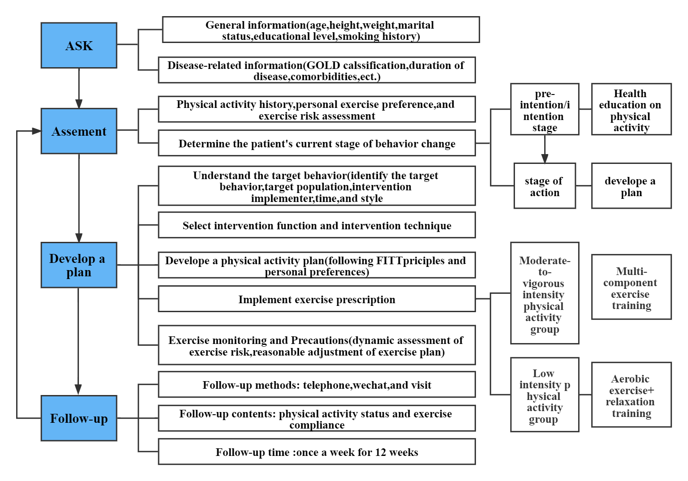

Fig 2.
Study flowchart.

Fig 3.

Changes in outcomes (a) total physical activity, (b) Sedentary time(c), mMRC, (d) 6MWD, (e) Exercise efficacy, and (f) CAT over time in the experimental and control group.

