Supplementary

Table S1. Pubchem, Kyoto Encyclopedia of Genes and Genomes (KEGG), and Human Metabolome Database (HMDB) were used to identify metabolites.
Metabolite | HMDB | PubChem ID | KEGG ID
L-Methionine | HMDB0000696 | 6137 | C00073
L-Proline | HMDB0000162 | 145742 | C00148
L-Lysine | HMDB0000182 | 5962 | C00047
L-Alanine | HMDB0000161 | 5950 | C00041
L-Histidine | HMDB0000177 | 6274 | C00135
L-Aspartic acid | HMDB0000191 | 5960 | C00049
L-Isoleucine | HMDB0000172 | 6306 | C00407
Glycine | HMDB0000123 | 750 | C00037
L-Threonine | HMDB0000167 | 6288 | C00188
L-Leucine | HMDB0000687 | 6106 | C00123
L-Tryptophan | HMDB0000929 | 6305 | C00078
L-Glutamine | HMDB0000641 | 5961 | C00064
L-Asparagine | HMDB0000168 | 6267 | C00152
L-Phenylalanine | HMDB0000159 | 6140 | C00079
L-Serine | HMDB0000187 | 5951 | C00065
L-Glutamic acid | HMDB0000148 | 33032 | C00025
L-Valine | HMDB0000883 | 6287 | C00183
L-Tyrosine | HMDB0000158 | 6057 | C00082
L-Cysteine | HMDB0000574 | 5862 | C00097
L-Arginine | HMDB0000517 | 6322 | C00062
L-Acetylcarnitine | HMDB0000201 | 7045767 | C02571
Propionylcarnitine | HMDB0000824 | 107738 | C03017
Isovalerylcarnitine | HMDB0000688 | 6426851 | C20826
Glutarylcarnitine | HMDB0013130 | 71317118 | -
Hexanoylcarnitine | HMDB0000705 | 6426853 | -
Decanoylcarnitine | HMDB0000651 | 10245190 | -
Dodecanoylcarnitine | HMDB0002250 | 168381 | -
Tetradecanoylcarnitine | HMDB0005066 | 53477791 | -
TG (16:0/16:0/18:0) | HMDB0005357 | 3246953 | C00422
Butanoylcarnitine | HMDB0002013 | 439829 | C02862
Carnitine | HMDB0000062 | 85 | C00318
Octanoylcarnitine | HMDB0000791 | 123701 | C02838
Decanoyllevocarnitine | HMDB0000651 | 11953821 | C03299
Palmitoylcarnitine | HMDB0000222 | 461 | C02990

Table S2. False discovery rate (FDR)-adjusted p-values using the Mann–Whitney U-test for all studied groups comparing the normal and abnormal subgroups. Significant metabolites that had higher concentrations in abnormal or normal subgroups were marked as * or ^, respectively.
​​​​
Names | TG | TC | non-HDL | HDL
C0 | 0.000081* | 0.019429* | 0.002181* | 0.033759*
C2 | 0.589721 | 0.386798 | 0.941537 | 0.296
C3 | 0.000161* | 0.673397 | 0.044562* | 0.000201*
C3DC | 0.262914 | 0.646777 | 0.108884 | 0.377981
C4 | 0.236678 | 0.583084 | 0.888163 | 0.189216
C4OH | 0.035409^ | 0.215486 | 0.760556 | 0.602372
C4DC | 0.478681 | 0.860708 | 0.614015 | 0.053558
C5 | 0.103149 | 0.403788 | 0.031057* | 0.344887
C5:1 | 0.892071 | 0.705174 | 0.248709 | 0.770625
C5OH | 0.132529 | 0.972172 | 0.202845 | 0.051163
C5DC | 0.072575 | 0.466227 | 0.949561 | 0.512388
C6 | 0.376846 | 0.592688 | 0.322574 | 0.02059*
C8 | 0.004793^ | 0.409863 | 0.961406 | 0.064006
C8:1 | 0.000742^ | 0.196729 | 0.814297 | 0.544288
C10 | 0.01045^ | 0.581613 | 0.940585 | 0.10848
C10:1 | 0.000271^ | 0.153829 | 0.42698 | 0.033979*
C12 | 0.214796 | 0.961485 | 0.558745 | 0.645081
C14 | 0.864809 | 0.340191 | 0.685803 | 0.450519
C14:1 | 0.058127 | 0.711212 | 0.597323 | 0.54075
C14:2 | 0.004081^ | 0.171062 | 0.226754 | 0.089475
C14OH | 0.445473 | 0.852785 | 0.882902 | 0.424259
C16 | 0.000304* | 0.002837* | 0.003703* | 0.371632
C16OH | 0.26564 | 0.031739* | 0.019486* | 0.206507
C16:1OH | 0.640467 | 0.990996 | 0.198652 | 0.370504
C16:1 | 0.734315 | 0.47638 | 0.902499 | 0.651836
C18 | 0.00739* | 0.002242* | 0.001674* | 0.458971
C18:1 | 0.397609 | 0.099179 | 0.94334 | 0.841829
C18OH | 0.103483 | 0.96641 | 0.048675^ | 0.802158
C18:1OH | 0.22491 | 0.95278 | 0.88541* | 0.443232
C18:2OH | 0.00422* | 0.002948* | 0.000311* | 0.454691
Alanine | 8.50E-10* | 0.046944* | 0.009534* | 0.013759*
Aspartic Acid | 0.259251 | 0.089656 | 0.919897 | 0.717668
Glutamic Acid | 0.000859* | 0.266617 | 0.600711 | 0.002576*
Leucine | 1.62E-10* | 0.319336 | 0.000118* | 0.034385*
Methionine | 0.863054 | 0.224247 | 0.675677 | 0.404615
Phenylalanine | 0.254706 | 0.670486 | 0.434936 | 0.076391
Tyrosine | 0.019735* | 0.970468 | 0.071748 | 0.212407
Valine | 1.07E-12* | 0.33712 | 0.00001* | 0.01422*
Arginine | 0.475238 | 0.964052 | 0.391372 | 0.268874
Citrulline | 0.112183 | 0.760954 | 0.790319 | 0.008809^
Glycine | 0.003285^ | 0.070501 | 0.000261^ | 0.311849
Ornithine | 0.248338 | 0.04343* | 0.055316 | 0.284138
Proline | 0.002752* | 0.596413 | 0.523067 | 0.021116*
Threonine | 0.018113^ | 0.485817 | 0.310739 | 0.350347
Serine | 0.000015^ | 0.141819 | 0.00155^ | 0.07733
Histidine | 0.124487 | 0.526998 | 0.741848 | 0.826137
Lysine | 0.042896* | 0.732515 | 0.787023 | 0.489627
Tryptophan | 0.000073* | 0.007373* | 0.000003* | 0.471791
Asparagine | 0.020167^ | 0.060012 | 0.254063 | 0.151843
Glutamine | 0.117549 | 0.953791 | 0.698667 | 0.436322
Age | 0.850872 | 0.765746 | 0.923265 | 0.771705
Height | 0.008723* | 0.967887 | 0.946245 | 0.520229
Weight | 0.066764* | 0.929025 | 0.955953 | 0.374468
BMI | 0.74087 | 0.82337 | 0.983512 | 0.63114
WC | 0.059167 | 0.681366 | 0.887625 | 0.247704
HC | 0.216843 | 0.718253 | 0.64385 | 0.923703
Waist/Hip ratio | 0.335343 | 0.022725* | 0.574839 | 0.034552*
Systolic BP | 0.640898 | 0.70438 | 0.084223 | 0.621033
Diastolic BP | 0.163452 | 0.101228 | 0.005719* | 0.137852
ALT | 0.001775* | 0.116547 | 0.386363 | 0.16351

Table S3. Comparison of the top model performance for TG classification.

Data Groups | MLA Name | MLA Parameters | MLA Train Accuracy Mean | MLA Test Accuracy Mean | CV score mean(K10) | ROC_AUC | Recall | Precision | F1 | MLA Test Accuracy STD
TG | LSVC | {'C': 1.2, 'class_weight': None, 'dual': True, 'fit_intercept': False, 'intercept_scaling': 0.1, 'loss': 'squared_hinge', 'max_iter': 1000, 'multi_class': 'ovr', 'penalty': 'l2', 'random_state': None, 'tol': 0.0001, 'verbose': 0} | 0.79 | 0.74 | 0.71 | 0.80 | 0.79 | 0.72 | 0.75 | 0.07
TG | LDA | {'covariance_estimator': None, 'n_components': None, 'priors': None, 'shrinkage': 'auto', 'solver': 'lsqr', 'store_covariance': True, 'tol': 0.0001} | 0.77 | 0.73 | 0.71 | 0.77 | 0.73 | 0.73 | 0.73 | 0.05
TG | SVC | {'C': 1.2, 'break_ties': False, 'cache_size': 200, 'class_weight': None, 'coef0': 0.0, 'decision_function_shape': 'ovr', 'degree': 3, 'gamma': 0.01, 'kernel': 'sigmoid', 'max_iter': -1, 'probability': True, 'random_state': None, 'shrinking': True, 'tol': 0.001, 'verbose': False} | 0.75 | 0.71 | 0.69 | 0.81 | 0.7 | 0.72 | 0.71 | 0.04
TG | LR | {'C': 0.02811768697974228, 'class_weight': None, 'dual': False, 'fit_intercept': True, 'intercept_scaling': 1, 'l1_ratio': None, 'max_iter': 100, 'multi_class': 'auto', 'n_jobs': None, 'penalty': 'l2', 'random_state': None, 'solver': 'lbfgs', 'tol': 0.0001, 'verbose': 0, 'warm_start': False} | 0.77 | 0.7 | 0.72 | 0.80 | 0.68 | 0.71 | 0.7 | 0.04
TG | RF | {'bootstrap': True, 'ccp_alpha': 0.0, 'class_weight': None, 'criterion': 'gini', 'max_depth': 20, 'max_features': 'auto', 'max_leaf_nodes': None, 'max_samples': None, 'min_impurity_decrease': 0.0, 'min_samples_leaf': 1, 'min_samples_split': 6, 'min_weight_fraction_leaf': 0.0, 'n_estimators': 50, 'n_jobs': None, 'oob_score': False, 'random_state': 42, 'verbose': 0, 'warm_start': False} | 1 | 0.66 | 0.66 | 0.76 | 0.64 | 0.68 | 0.66 | 0.03

Table S4. Features extracted by Mann–Whitney U-test, SelectKbest, and REFCV.

Group | MW-U | Selectkbest with Chi-Square | RFECV
TG | C0, C3, C4OH, C8, C8:1, C10, C10:1, C14:2, C16,C18, C18:2OH, Alanine, Glutamic_Acid, Leucine, Phenylalanine, Tyrosine, Valine, Glycine, Proline, Serine, Lysine, Tryptophan, Asparagine, Height, ALT | Alanine, Leucine, Tyrosine, Valine, Glycine, Proline, Serine, Tryptophan, Asparagine, MeanDias | Alanine, Leucine, Valine, Serine, Tryptophan
TC | C0, C16, C16OH, C18, C18:2OH, Alanine, Ornithine, Tryptophan, Waist_Hip | C0, Alanine, Valine, Glycine, Ornithine, Proline, Threonine,  Serine, Tryptophan, ALT | C5DC, C14_2, C16, Methionine, Tryptophan
HDL | C0, C3, C6, Alanine, Glutamic_Acid, Leucine, Valine, Citrulline, Glycine, Proline, Waist_Hip | Alanine, Valine, Glycine, Proline, Serine, Asparagine | C0, C3, Serine, Asparagine, Leucine, Valine
non-HDL cholesterol | C0, C3, C5, C16, C16OH, C18, C18OH, C18:2OH, 'Alanine' 'Leucine' 'Valine' 'Glycine', Serin, Tryptophan, MeanDias, | Alanine, Leucine, Valine, Glycine, Ornithine, Tryptophan | C3, C5, Alanine, Leucine, Serine, Tryptophan

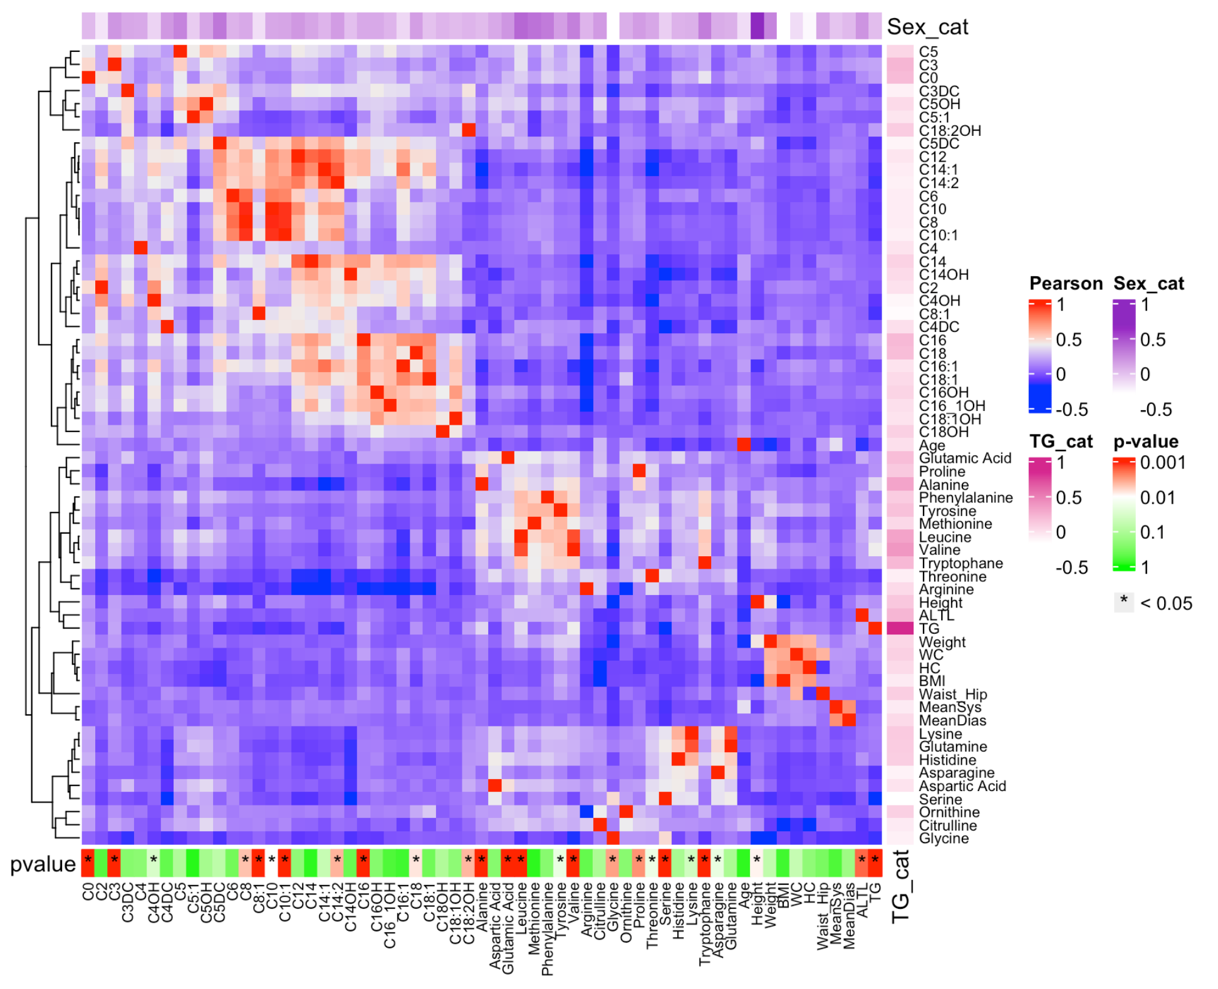
Figure S1. Figure showing Pearson's correlation coefficient (central heatmap) of all study attributes in the TG groups. Hierarchical clustering based on the Pearson method was used to render the rows as a dendrogram (left side of the Figure). The attributes with statistically significant values based on the Mann–Whitney U test (p-value < 0.05) are shown on the button side of the Figure as a star mark (*). Point biserial correlations of attributes based on TG and gender classes are shown as single column heatmaps in the right and upper sides of the Figure, respectively.

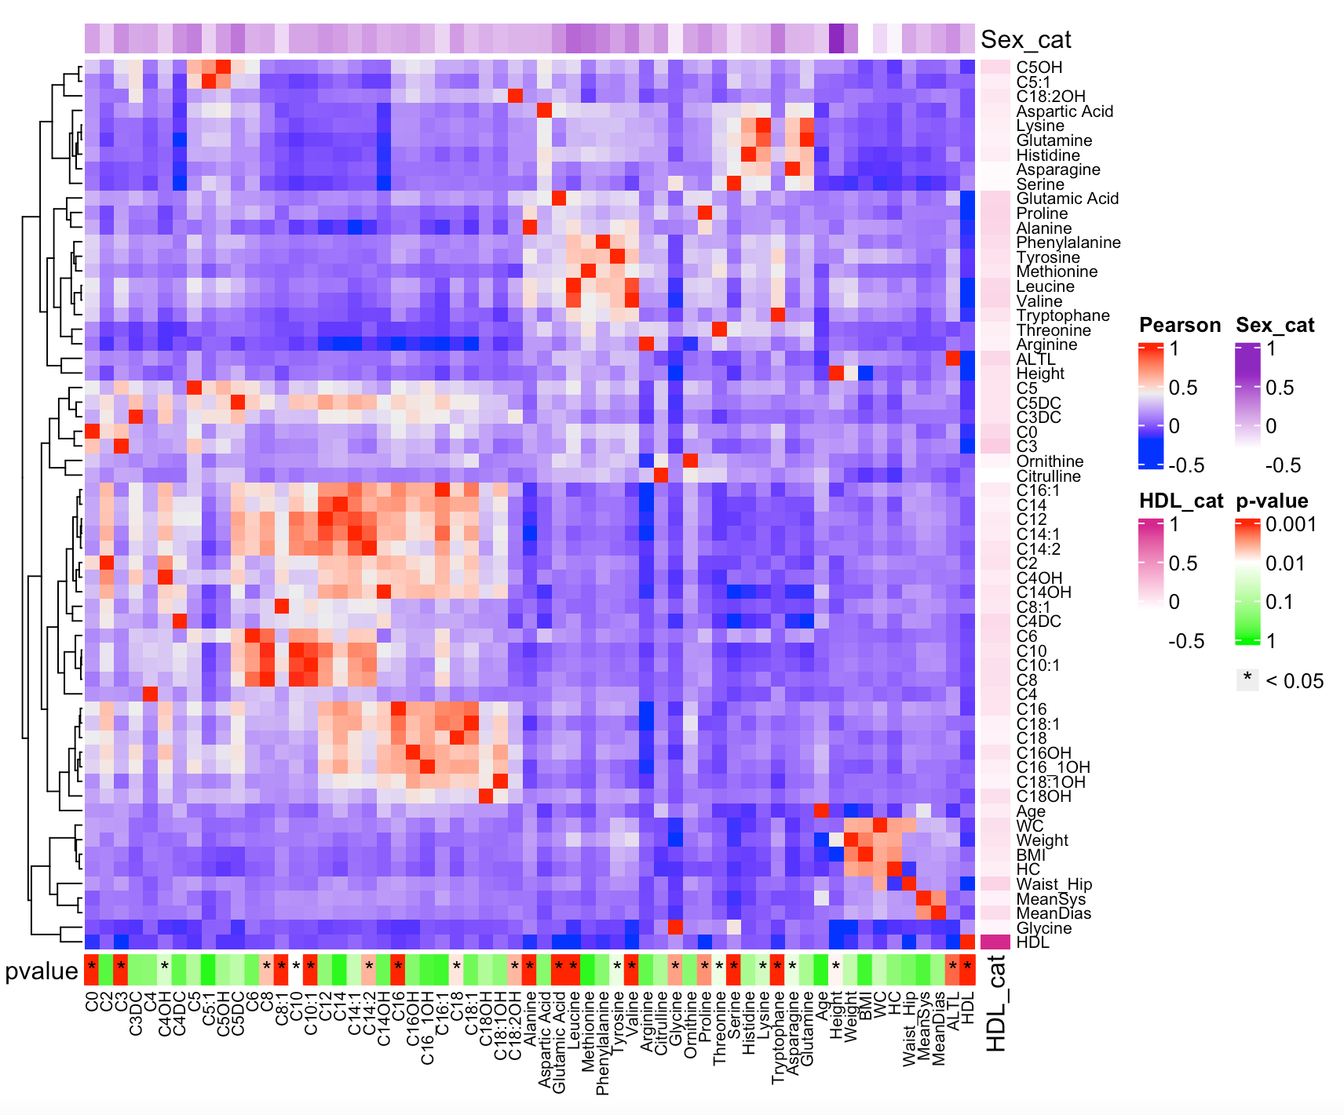
Figure S2. Pearson’s correlation coefficient for all study attributes in the HDL group. For more information, see Figure S1 legend.

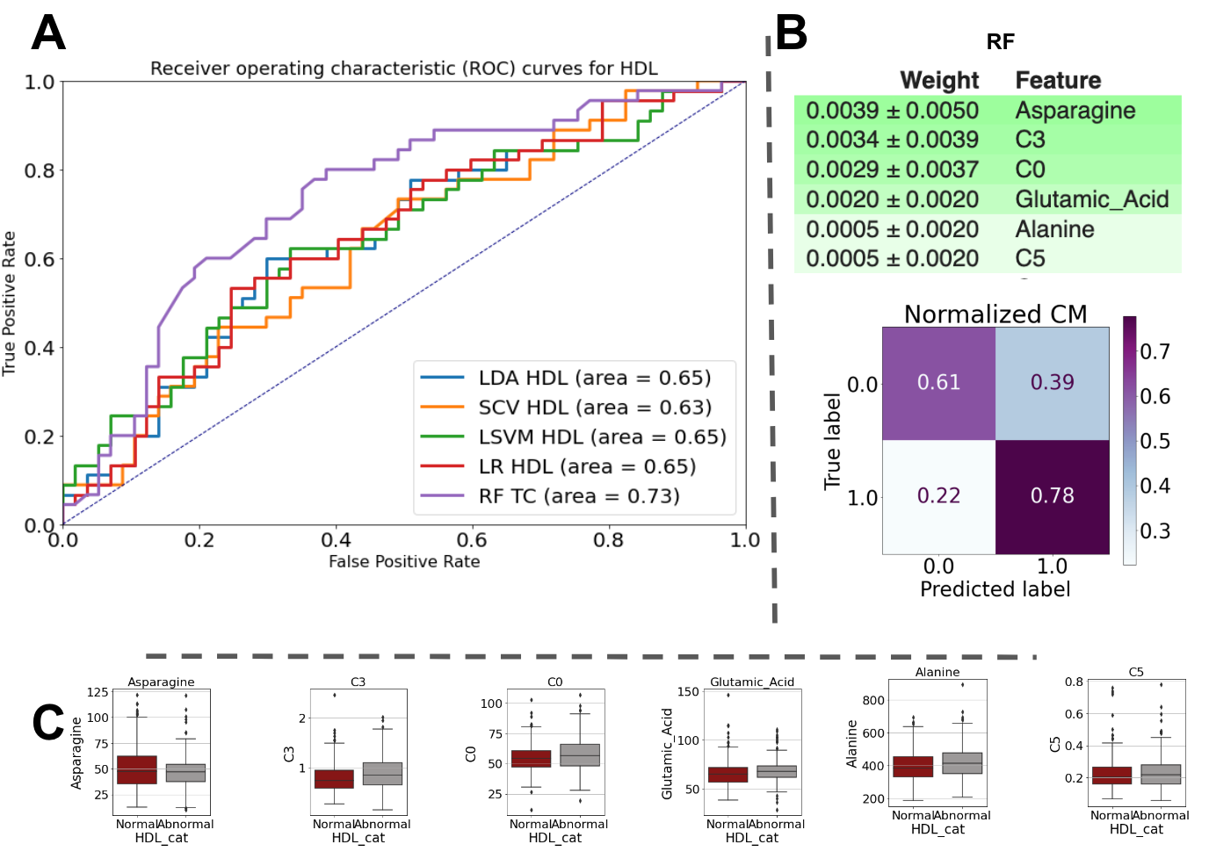
Figure S3. (A) Receiver operating characteristic (ROC) curve for HDL classification. (B) Feature importance and confusion matrix for RF model in HDL classification. (C) Six important features of RF used for HDL classification.

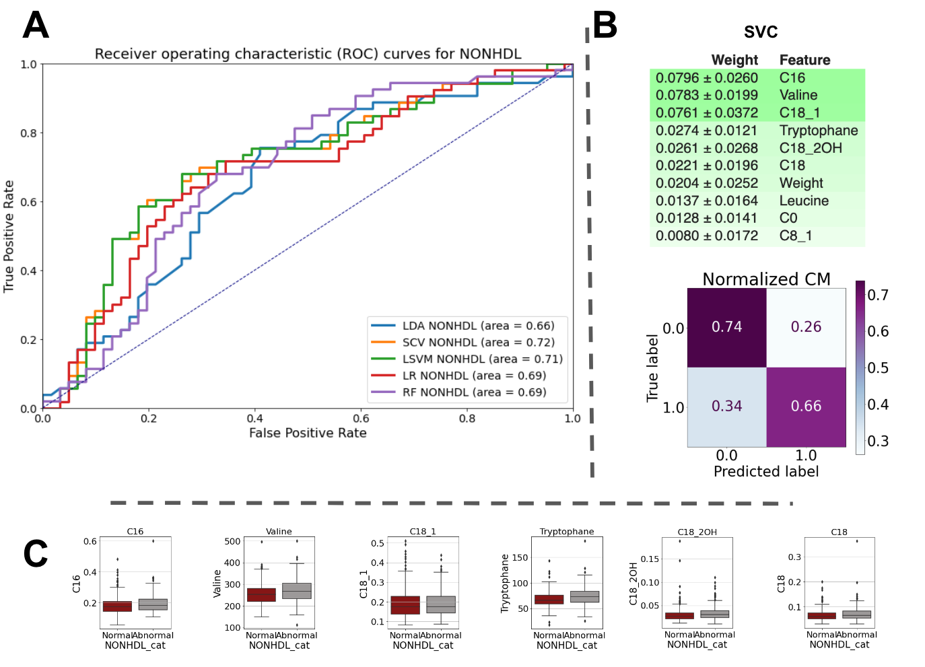
Figure S4. (A) Receiver operating characteristic curves (ROC) for the non-HDL classification. (B) Feature importance and confusion matrix for SVC model in non-HDL classification. (C) Six important features of the SVC used for non-HDL classification.

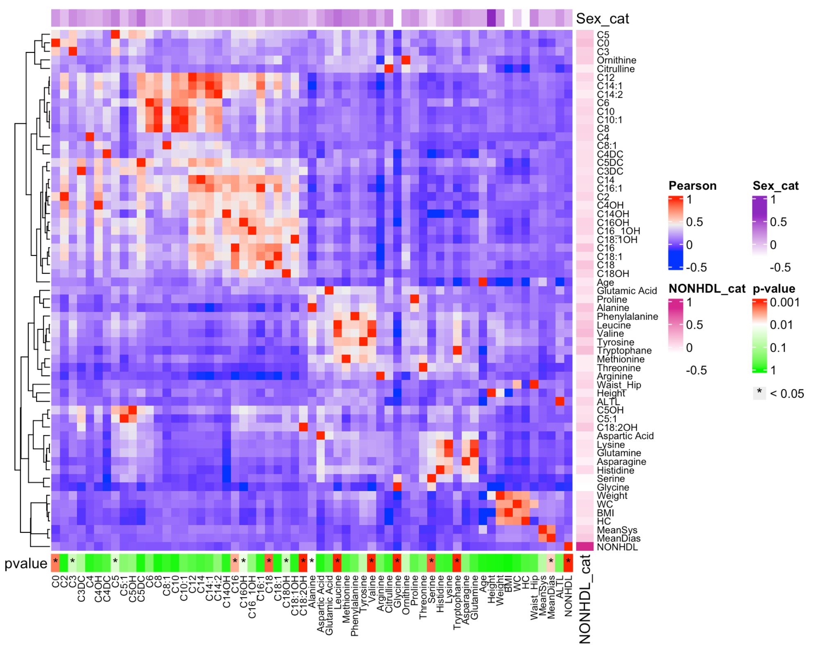
Figure S5. Pearson’s correlation coefficient for all study attributes in the non-HDL group. For more information, see Figure S1 legend.

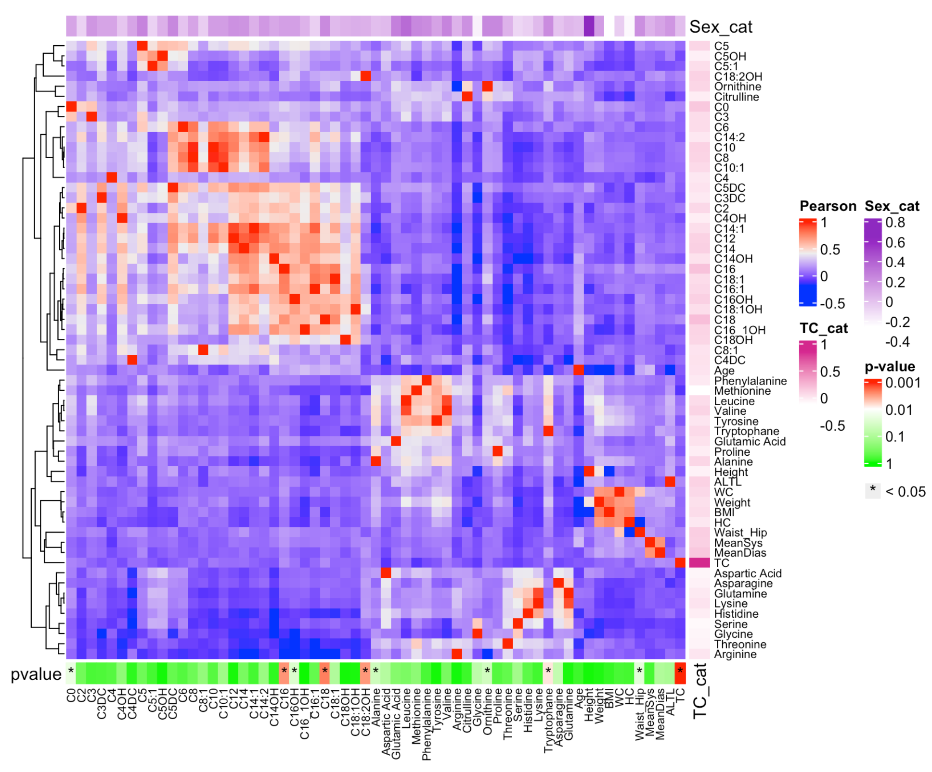
Figure S6. Pearson’s correlation coefficient for all study attributes in the TC group. For more information, see Figure S1 legend.

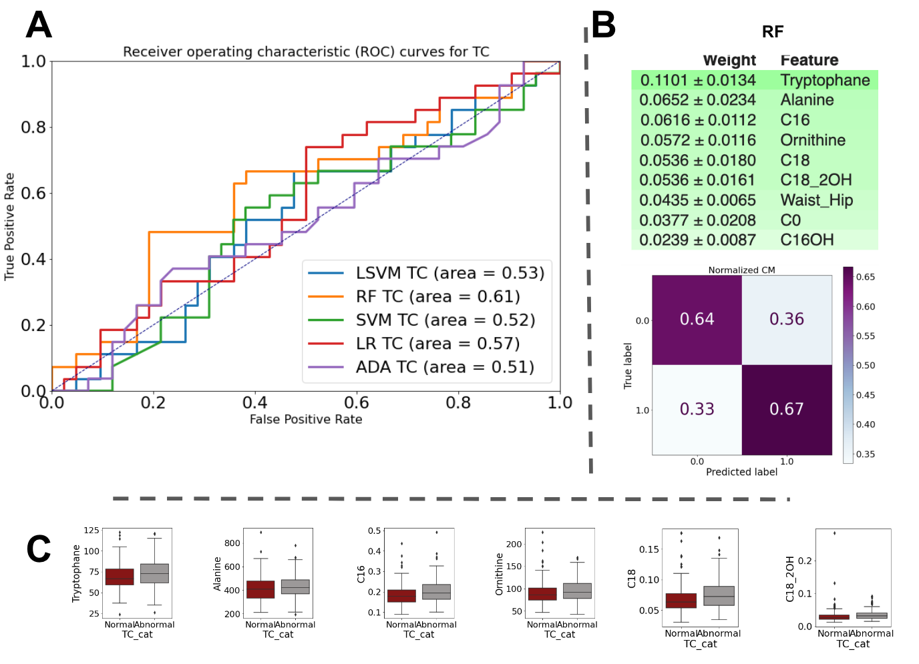
Figure S7. (A) Receiver operator characteristic curves (ROC) for TC classification. (B) Feature importance and confusion matrix for the RF model in TC classification. (C) Six important features of RF used for TC classification.

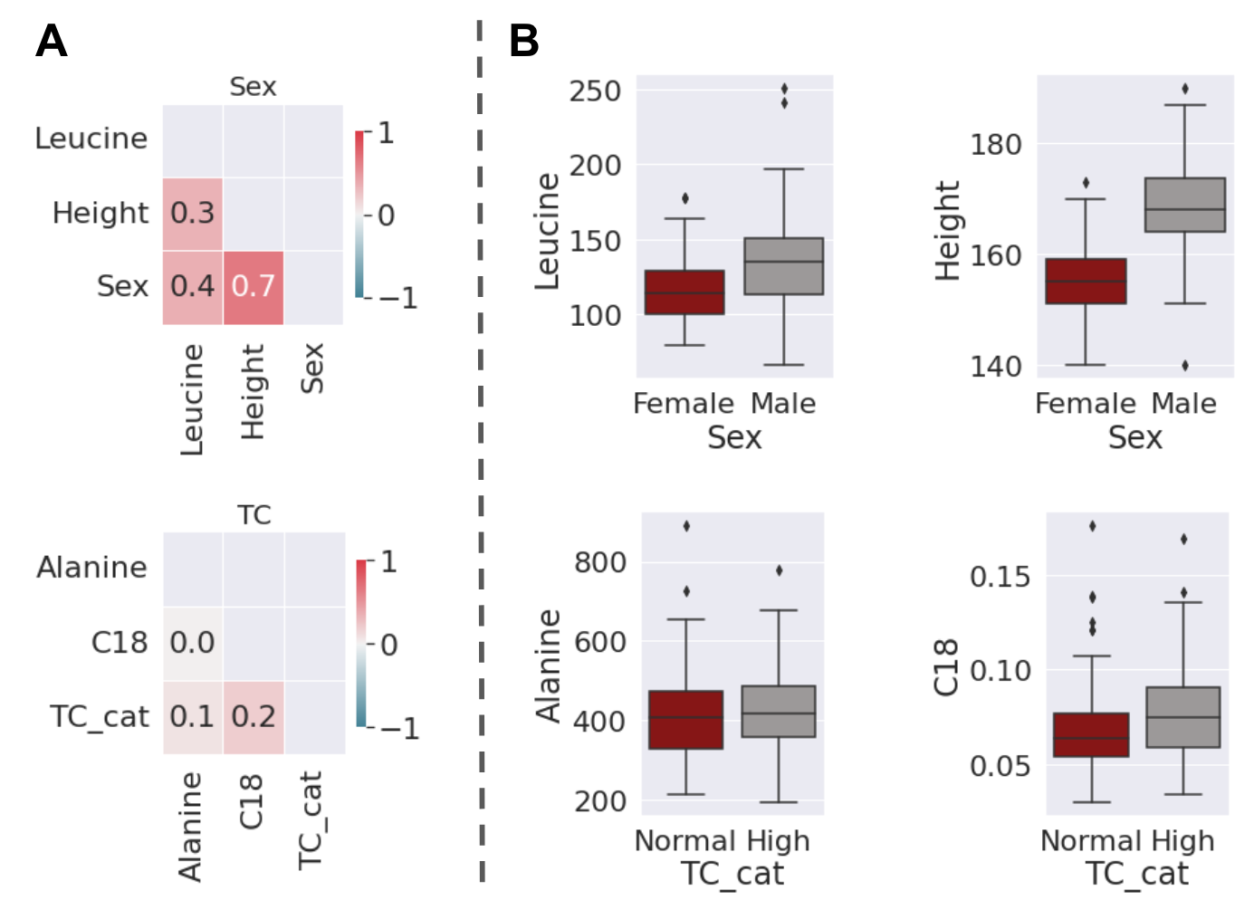
Figure S8. (A) Point Biserial correlation greater than 0.2 based on sex and cholesterol in the TC group. 'Leucine', 'Height' had highest correlation with Sex groups. For cholesterol, Alanine and C18 showed the highest correlation with the TC group. (B) Barplot of highly correlated features.

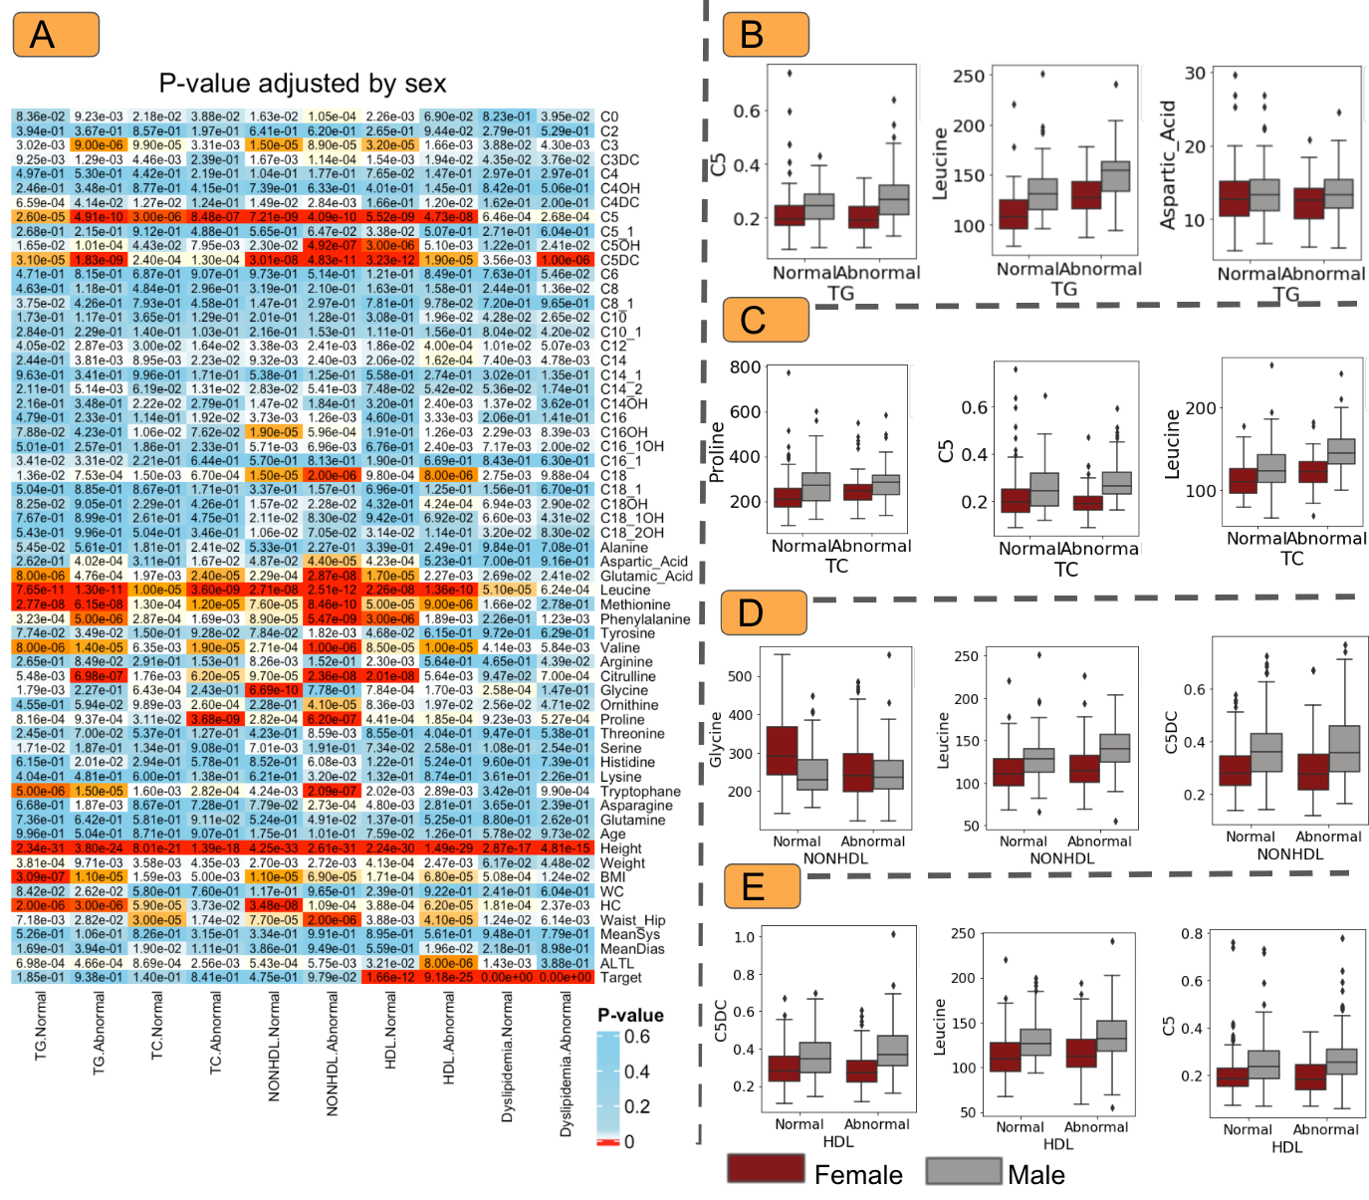
Figure S9. (A) P-values stratified by outcomes(normal/abnormal) comparing males and females in the TG, TC, non-HDL, and HDL groups. The box plot shows the most significant features in the TG (B), TC (C), non-HDL (D), and HDL (E) groups.

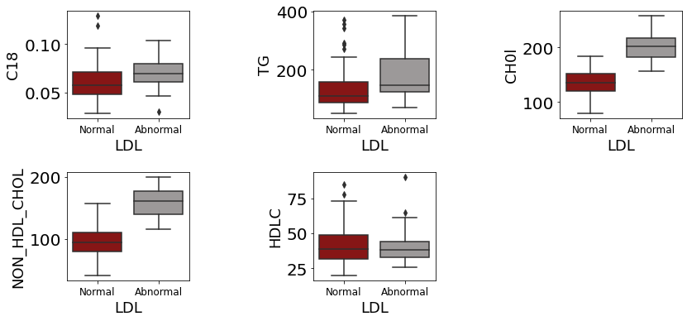
Figure S10. Statistically significant factors with an LDL cutoff level of 100 mg/dL in the drug-receiving groups.

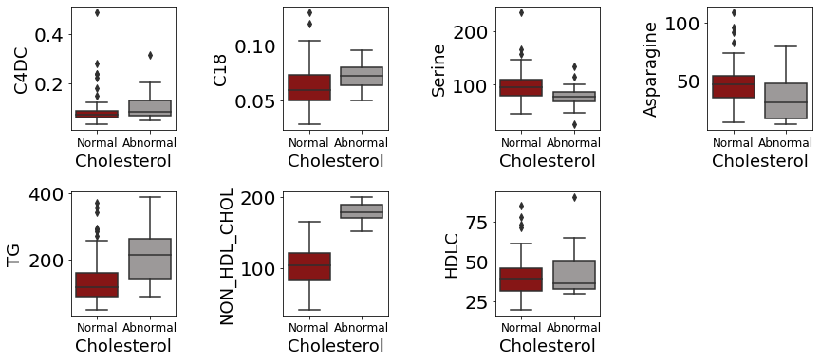
Figure S11. Statistically significant factors with a cholesterol cut-off level of 200 mg/dL in the drug-receiving groups.

