ADDITIONAL FILE 3
S3a: GAM output
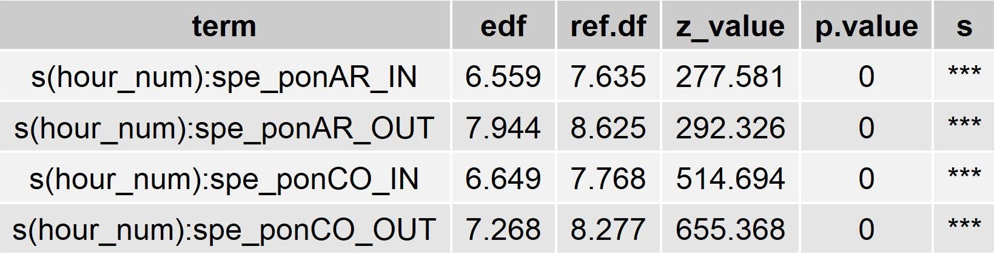
Table reporting the significance of the GAM smooth terms. Term: A. arabiensis (AR) and A. coluzzii (CO) species collected in relation to the position of sampling (IN and OUT); edf: effective degrees of freedom; ref.df: reference degrees of freedom; z-value: test statistic; s: significance.

Hour | A.coluzzii IN | A.coluzzii IN  C.I. lower | A.coluzzii IN  C.I. upper | A.coluzzii OUT | A.coluzzii OUT  C.I. lower | A.coluzzii OUT  C.I. upper | A.arabiensis IN | A.arabiensis  IN  C.I. lower | A.arabiensis  IN  C.I. upper | A.arabiensis OUT | A.arabiensis  OUT  C.I. lower | A.arabiensis  OUT  C.I. upper
16h-17h | 0.19 | 0.09 | 0.40 | 0.35 | 0.18 | 0.68 | 0.01 | 0.003 | 0.080 | 0.03 | 0.01 | 0.20
17h-18h | 0.56 | 0.38 | 0.84 | 0.62 | 0.42 | 0.92 | 0.09 | 0.038 | 0.217 | 0.11 | 0.05 | 0.23
18h-19h | 1.55 | 1.15 | 2.11 | 1.21 | 0.87 | 1.69 | 0.45 | 0.281 | 0.718 | 0.56 | 0.34 | 0.92
19h-20h | 3.94 | 3.03 | 5.13 | 2.70 | 2.03 | 3.60 | 1.53 | 1.099 | 2.121 | 2.85 | 2.07 | 3.94
20h-21h | 8.35 | 6.59 | 10.58 | 6.03 | 4.67 | 7.77 | 3.50 | 2.665 | 4.607 | 6.17 | 4.67 | 8.14
21h-22h | 12.34 | 9.75 | 15.62 | 10.60 | 8.25 | 13.61 | 5.35 | 4.113 | 6.971 | 7.63 | 5.77 | 10.08
22h-23h | 14.12 | 11.23 | 17.75 | 14.64 | 11.53 | 18.59 | 6.08 | 4.723 | 7.826 | 10.04 | 7.72 | 13.04
23h-24h | 17.38 | 13.82 | 21.87 | 19.19 | 15.09 | 24.40 | 6.52 | 5.056 | 8.404 | 13.02 | 9.99 | 16.97
00h-01h | 24.20 | 19.28 | 30.39 | 24.95 | 19.66 | 31.66 | 7.62 | 5.933 | 9.798 | 13.46 | 10.34 | 17.53
01h-02h | 30.45 | 24.34 | 38.10 | 30.02 | 23.76 | 37.93 | 9.31 | 7.285 | 11.894 | 13.33 | 10.30 | 17.25
02h-03h | 33.12 | 26.36 | 41.61 | 35.61 | 28.03 | 45.25 | 10.58 | 8.242 | 13.588 | 13.74 | 10.49 | 18.00
03h-04h | 33.67 | 26.96 | 42.05 | 41.36 | 32.82 | 52.12 | 9.49 | 7.424 | 12.133 | 12.59 | 9.69 | 16.37
04h-05h | 26.82 | 21.29 | 33.79 | 32.36 | 25.38 | 41.25 | 5.34 | 4.082 | 6.994 | 8.56 | 6.42 | 11.40
05h-06h | 13.45 | 10.62 | 17.04 | 11.48 | 8.89 | 14.83 | 1.75 | 1.265 | 2.410 | 2.24 | 1.54 | 3.25
06h-07h | 4.95 | 3.84 | 6.38 | 2.03 | 1.48 | 2.79 | 0.41 | 0.255 | 0.662 | 0.08 | 0.03 | 0.25
07h-08h | 1.77 | 1.18 | 2.63 | 0.27 | 0.14 | 0.53 | 0.09 | 0.033 | 0.244 | 0.00 | 0.00 | 0.01
S3b: GAM predicted coefficients of A. coluzzii and A. arabiensis hourly abundances

GAM Estimated coefficients of A. coluzzii and A. arabiensis hourly abundances indoors (IN) and outdoors (OUT) and relative 95% Confidence Intervals (C.I.)

