Supplementary Materials

Electronic contacts and lubricity characters between monolayer WSe₂ and Zr₂C, Zr₂CY₂ (Y = F or OH)
Qiaohui Wang¹, Hong Li^{1,*}, Lina Si¹, Zhaoliang Dou¹, Hongjuan Yan¹, Ye Yang¹, Gang Zhou², Tao Qing², Shaohua Zhang², and Fengbin Liu^{1,*}
¹ College of Mechanical and Material Engineering, North China University of Technology, Beijing 100144, P. R. China
² Beijing Key Laboratory of Long-life Technology of Precise Rotation and Transmission Mechanisms, Beijing Institute of Control Engineering, Beijing 100094, China
*Corresponding author: lihong@ncut.edu.cn, fbliu@ncut.edu.cn

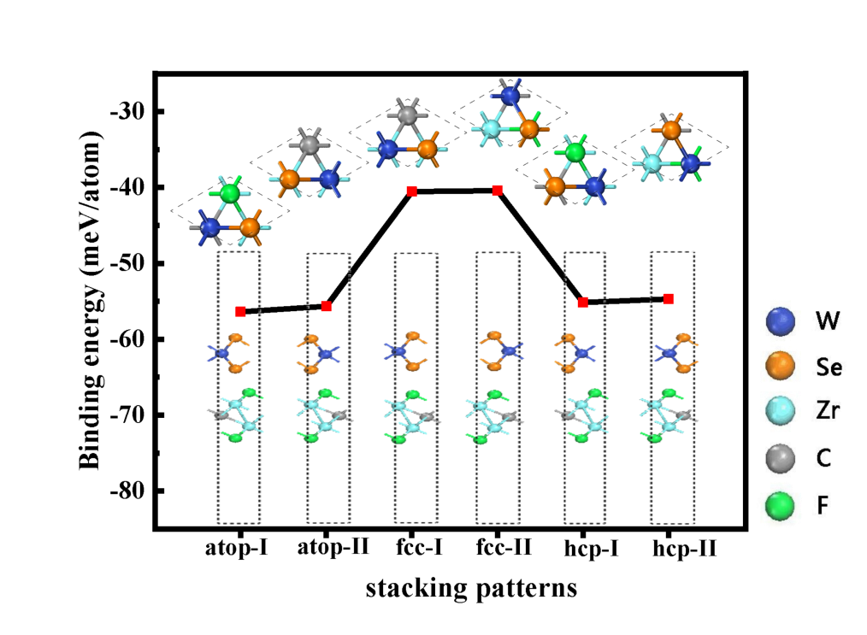
Figure S1. The binding energy of the WSe₂/Zr₂CF₂ vdW heterostructures with high-symmetry stackings. Inserts in the figure are the top view and side view of the respective stacking geometry.
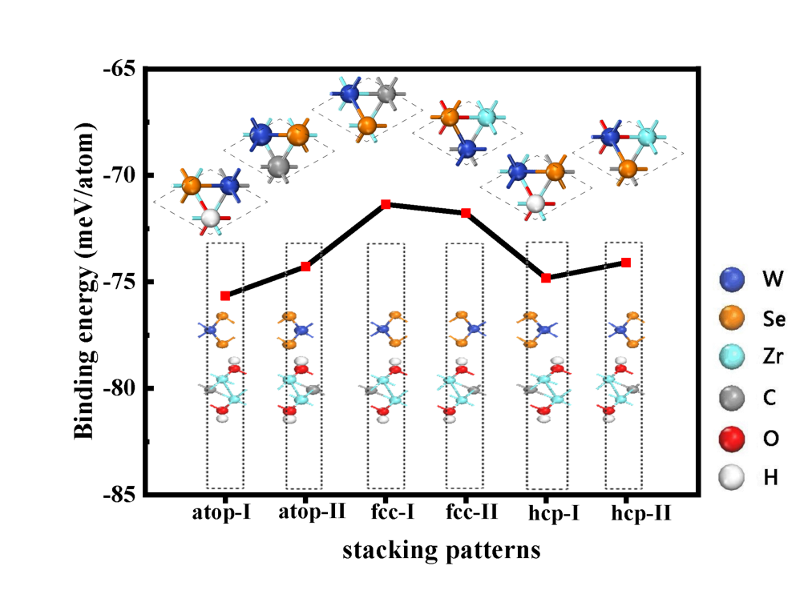
Figure S2. The binding energy of the WSe₂/Zr₂C(OH)₂ vdW heterostructures with high-symmetry stackings. Inserts in the figure are the top view and side view of the respective stacking geometry.

