Supplementary Information for

Noise Learning of Instruments for High-contrast, High-resolution and Fast Hyperspectral Microscopy and Nanoscopy
Hao He^{1,2,3}, Maofeng Cao², Yun Gao¹, Peng Zheng¹, Sen Yan², Jin-Hui Zhong^{4,†}, Lei Wang^{1,†}, Dayong Jin^{3,5}, Bin Ren^{2,6†}
¹School of Aerospace Engineering, Xiamen University, Xiamen, 361005, China.
²State Key Laboratory of Physical Chemistry of Solid Surfaces, Collaborative Innovation Center of Chemistry for Energy Materials (iChEM), The MOE Key Laboratory of Spectrochemical Analysis and Instrumentation, College of Chemistry and Chemical Engineering, Xiamen University, Xiamen 361005, China.
³UTS-SUStech Joint Research Centre for Biomedical Materials & Devices, Department of Biomedical Engineering, College of Engineering, Southern University of Science and Technology, Shenzhen 518055, Guangdong, China.
⁴Department of Materials Science and Engineering, Southern University of Science and Technology, Shenzhen 518055, China.
⁵Institute for Biomedical Materials & Devices (IBMD), University of Technology Sydney, Sydney, NSW 2007, Australia.
⁶ Tan Kah Kee Innovation Laboratory, Xiamen 361104, China
† Correspondence: J.-H.Z. (zhongjh@sustech.edu.cn); L.W. (wanglei33@xmu.edu.cn); B.R. (bren@xmu.edu.cn).

Table of Contents
Supplementary Figures 3
Fig. S1 | Scheme of measuring and analyzing the instrumental noise of Raman microscopes 3
Fig. S2 | Principle of the simulation method to obtain paired spectra of low and high signal to noise ratio (SNR) 4
Fig. S3 | Other results demonstrating the effectiveness of different methods to remove the instrumental noise from Raman spectra of 2D materials 5
Fig. S4 | Performance of NL method at the low laser power limit 6
Fig. S5 | The scheme of Horiba LabRAM HR-Evolution system that integrates confocal Raman with tip-enhanced Raman spectroscopy working in a back-scattering configuration 7
Fig. S6 | Additional results on living-cell fluorescence imaging 8
Fig. S7 | AUnet assisted fast line-scan photoluminescence imaging of 2D materials on gold substrate 9
Supplementary Movies 9
Supplementary Movie 1 – Continuous imaging of a HeLa cell labelled by MitoTracker using a low laser power 9
Supplementary Movie 2 – AUnet enhanced results of the same HeLa cell in Movie 1 9
Supplementary Movie 3 – Continuous imaging of a HeLa cell labelled by MitoTracker using a high laser power 9
Supplementary Movie 4 – Photoluminescence imaging of a WS₂ sample at a broad wavelength of 600-630 nm 9

Supplementary Figures
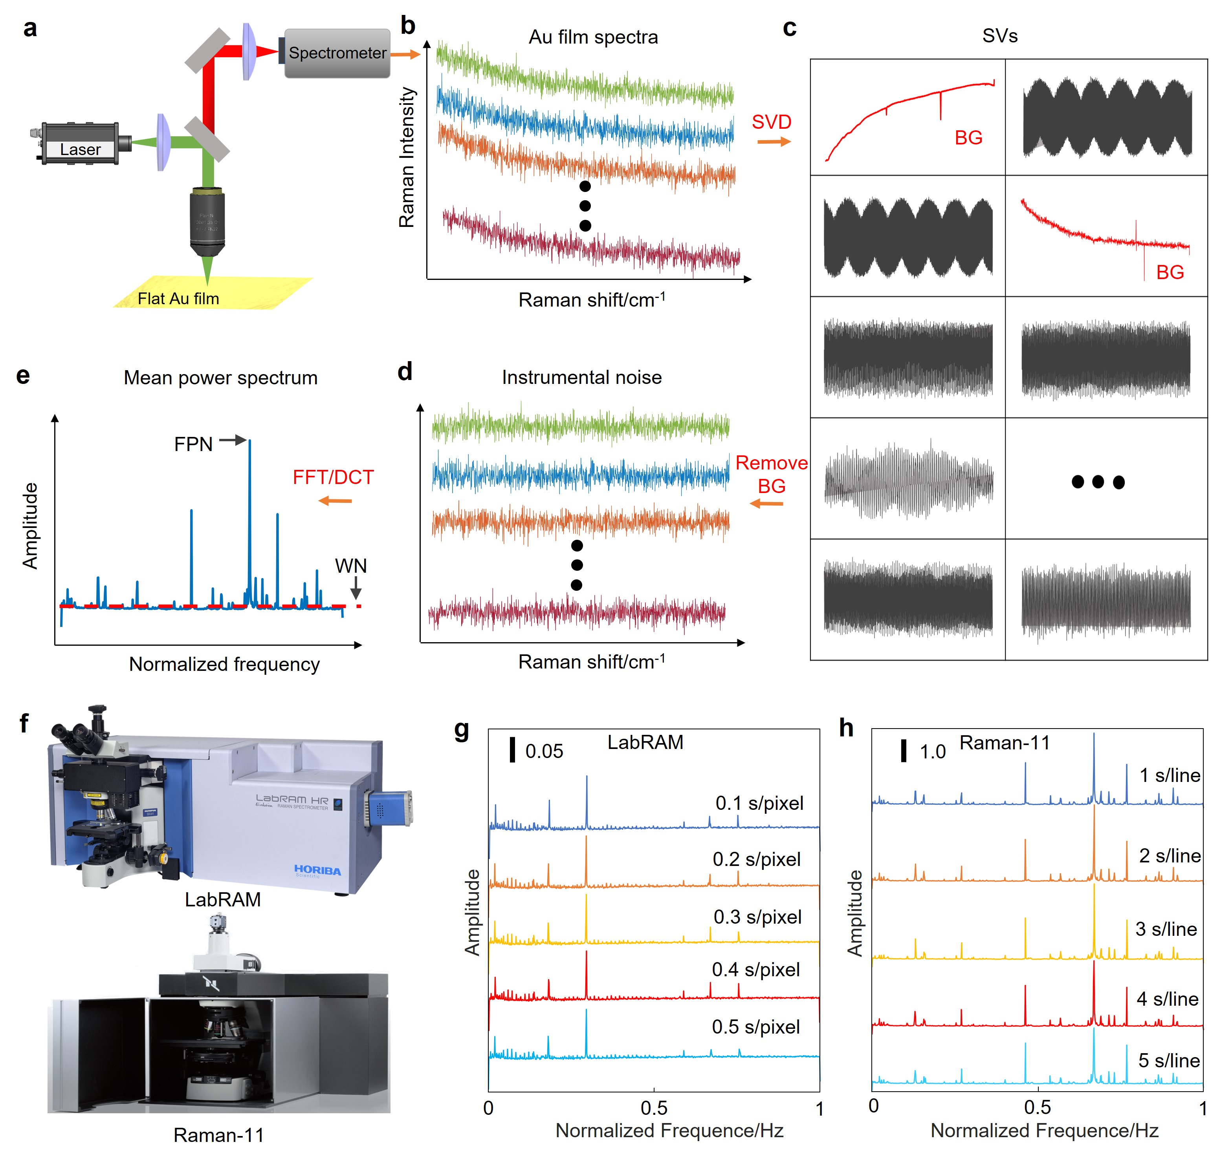

Fig. S1 | Scheme of measuring and analyzing the instrumental noise of Raman microscopes. (a) A scheme of the set-up for measuring instrumental noise from a smooth Au film. (b) The noise spectra from Au film. (c) The singular values (SVs) of two-dimensional (2D) matrix of noise spectra, which is obtained by singular value decomposition (SVD, see Methods in the main text for more details). The SVs related to background (BG, red) are removed, and the remaining SVs (black) are summed to obtain the instrumental noise spectra. (d) The reconstructed instrumental noise spectra. (e) Transform each instrumental noise spectrum either with fast Fourier transform (FFT) or discrete cosine transform (DCT) to obtain the mean power spectrum of each instrument in the frequency domain. The power spectrum shows a clear pattern, which can be further separated into white noise (WN, i.e., the baseline of the power spectrum) and fixed pattern noise (FPN, i.e., the noise source at a specific frequency). (f) The commercial Raman microscopes used in this paper: LabRAM HR-Evolution (Horiba) and Raman-11(Nanophoton). (g) The power spectra of the instrumental noise of LabRAM HR-Evolution at different acquisition time (0.1 s-0.5 s). For each acquisition time, 2,500 instrumental noise spectra were acquired. Other experimental conditions: 633 nm laser (0.1 mW on sample), air dry objective (NA=0.9, 100×); (h) The power spectra of the instrumental noise of the Raman-11 at different acquisition time. For each acquisition time, 10,000 instrumental noise spectra were acquired in a line-scan manner (400 pixels/line). Other experimental conditions: 532 nm laser (50 mW on sample); long-working distance air dry objective (NA=0.45, 50×). The results of two commercial Raman instruments clearly demonstrate that each instrument has a stable, instrumental-specific noise pattern in the frequency domain, which could be statistically modelled using deep learning method.
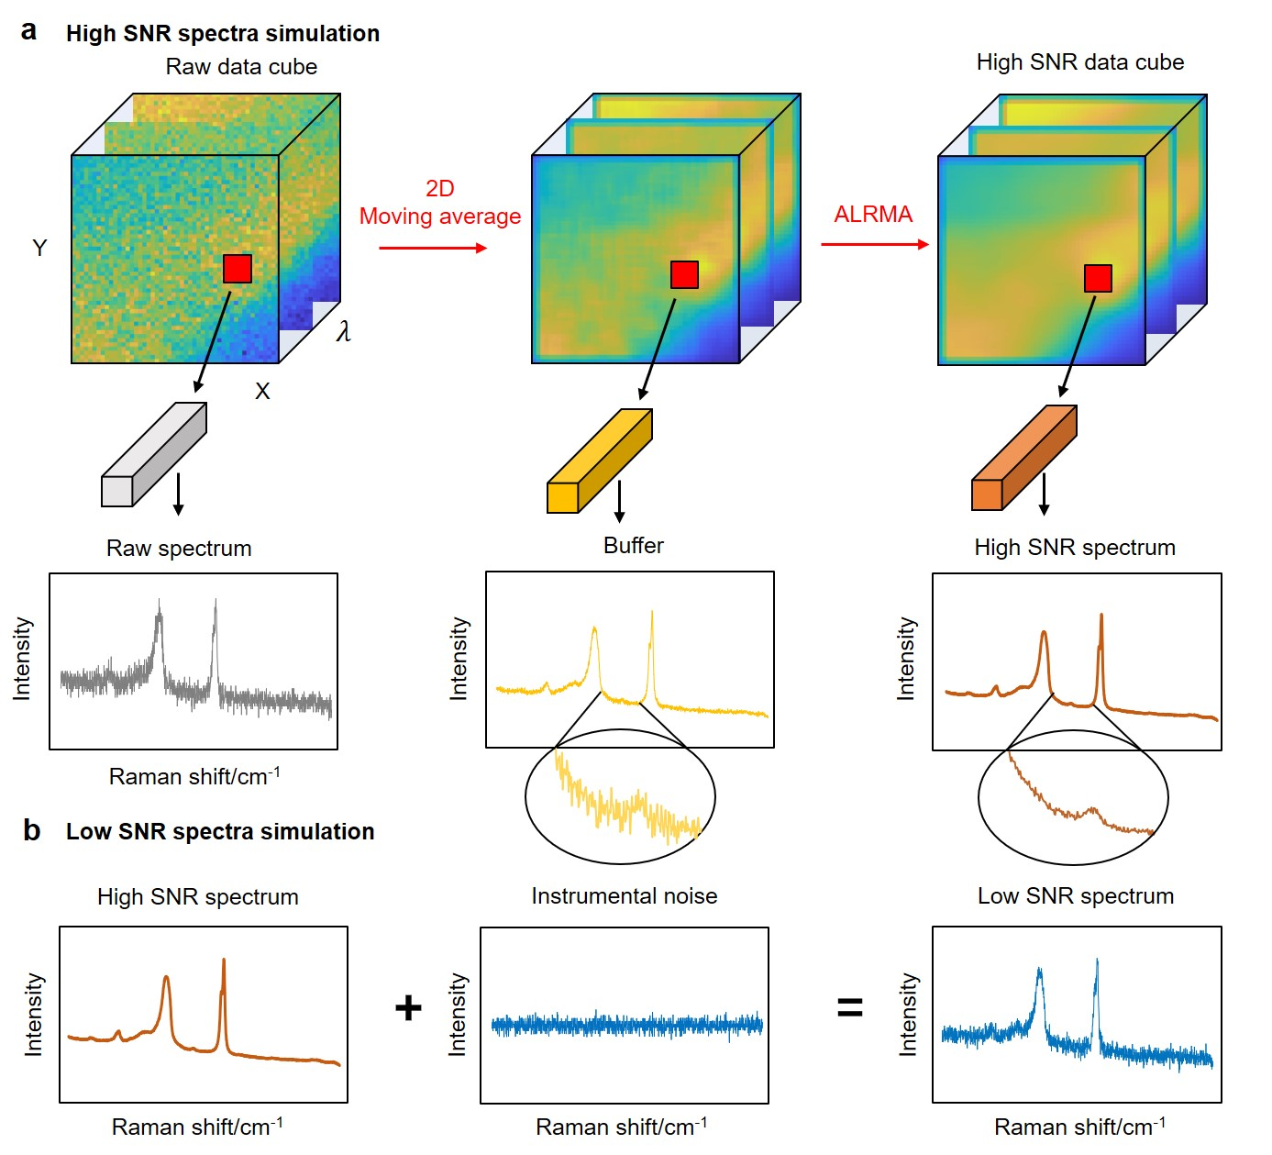

Fig. S2 | Principle of the simulation method to obtain paired spectra of low and high signal to noise ratio (SNR). (a) Two steps to simulate the high-SNR Raman spectra using the raw hyperspectral Raman imaging data acquired from real sample: (1) The raw imaging data are stacked as a three-dimensional (3D) data cube, which are filtered with 2D moving average (with 11×11 window) for each image slice. This step suppresses part of the noise while retains the fidelity at the spectral dimension, which can be observed from the raw (gray, left) and buffer (yellow, middle) Raman spectra; (2) An adaptive low-rank matrix approximation (ALRMA), method is used to further suppress the noise and produce the ground truth (GT) data with high SNR. The inset shows the zoom-in spectra of the buffer spectra (yellow) and ALRMA-processed high-SNR spectra (brown) for comparison. (b) Simulated low SNR spectrum obtained by directly adding the instrumental noise to the high SNR one. The instrumental noise is extracted using the method described in Supplementary Fig. S1.
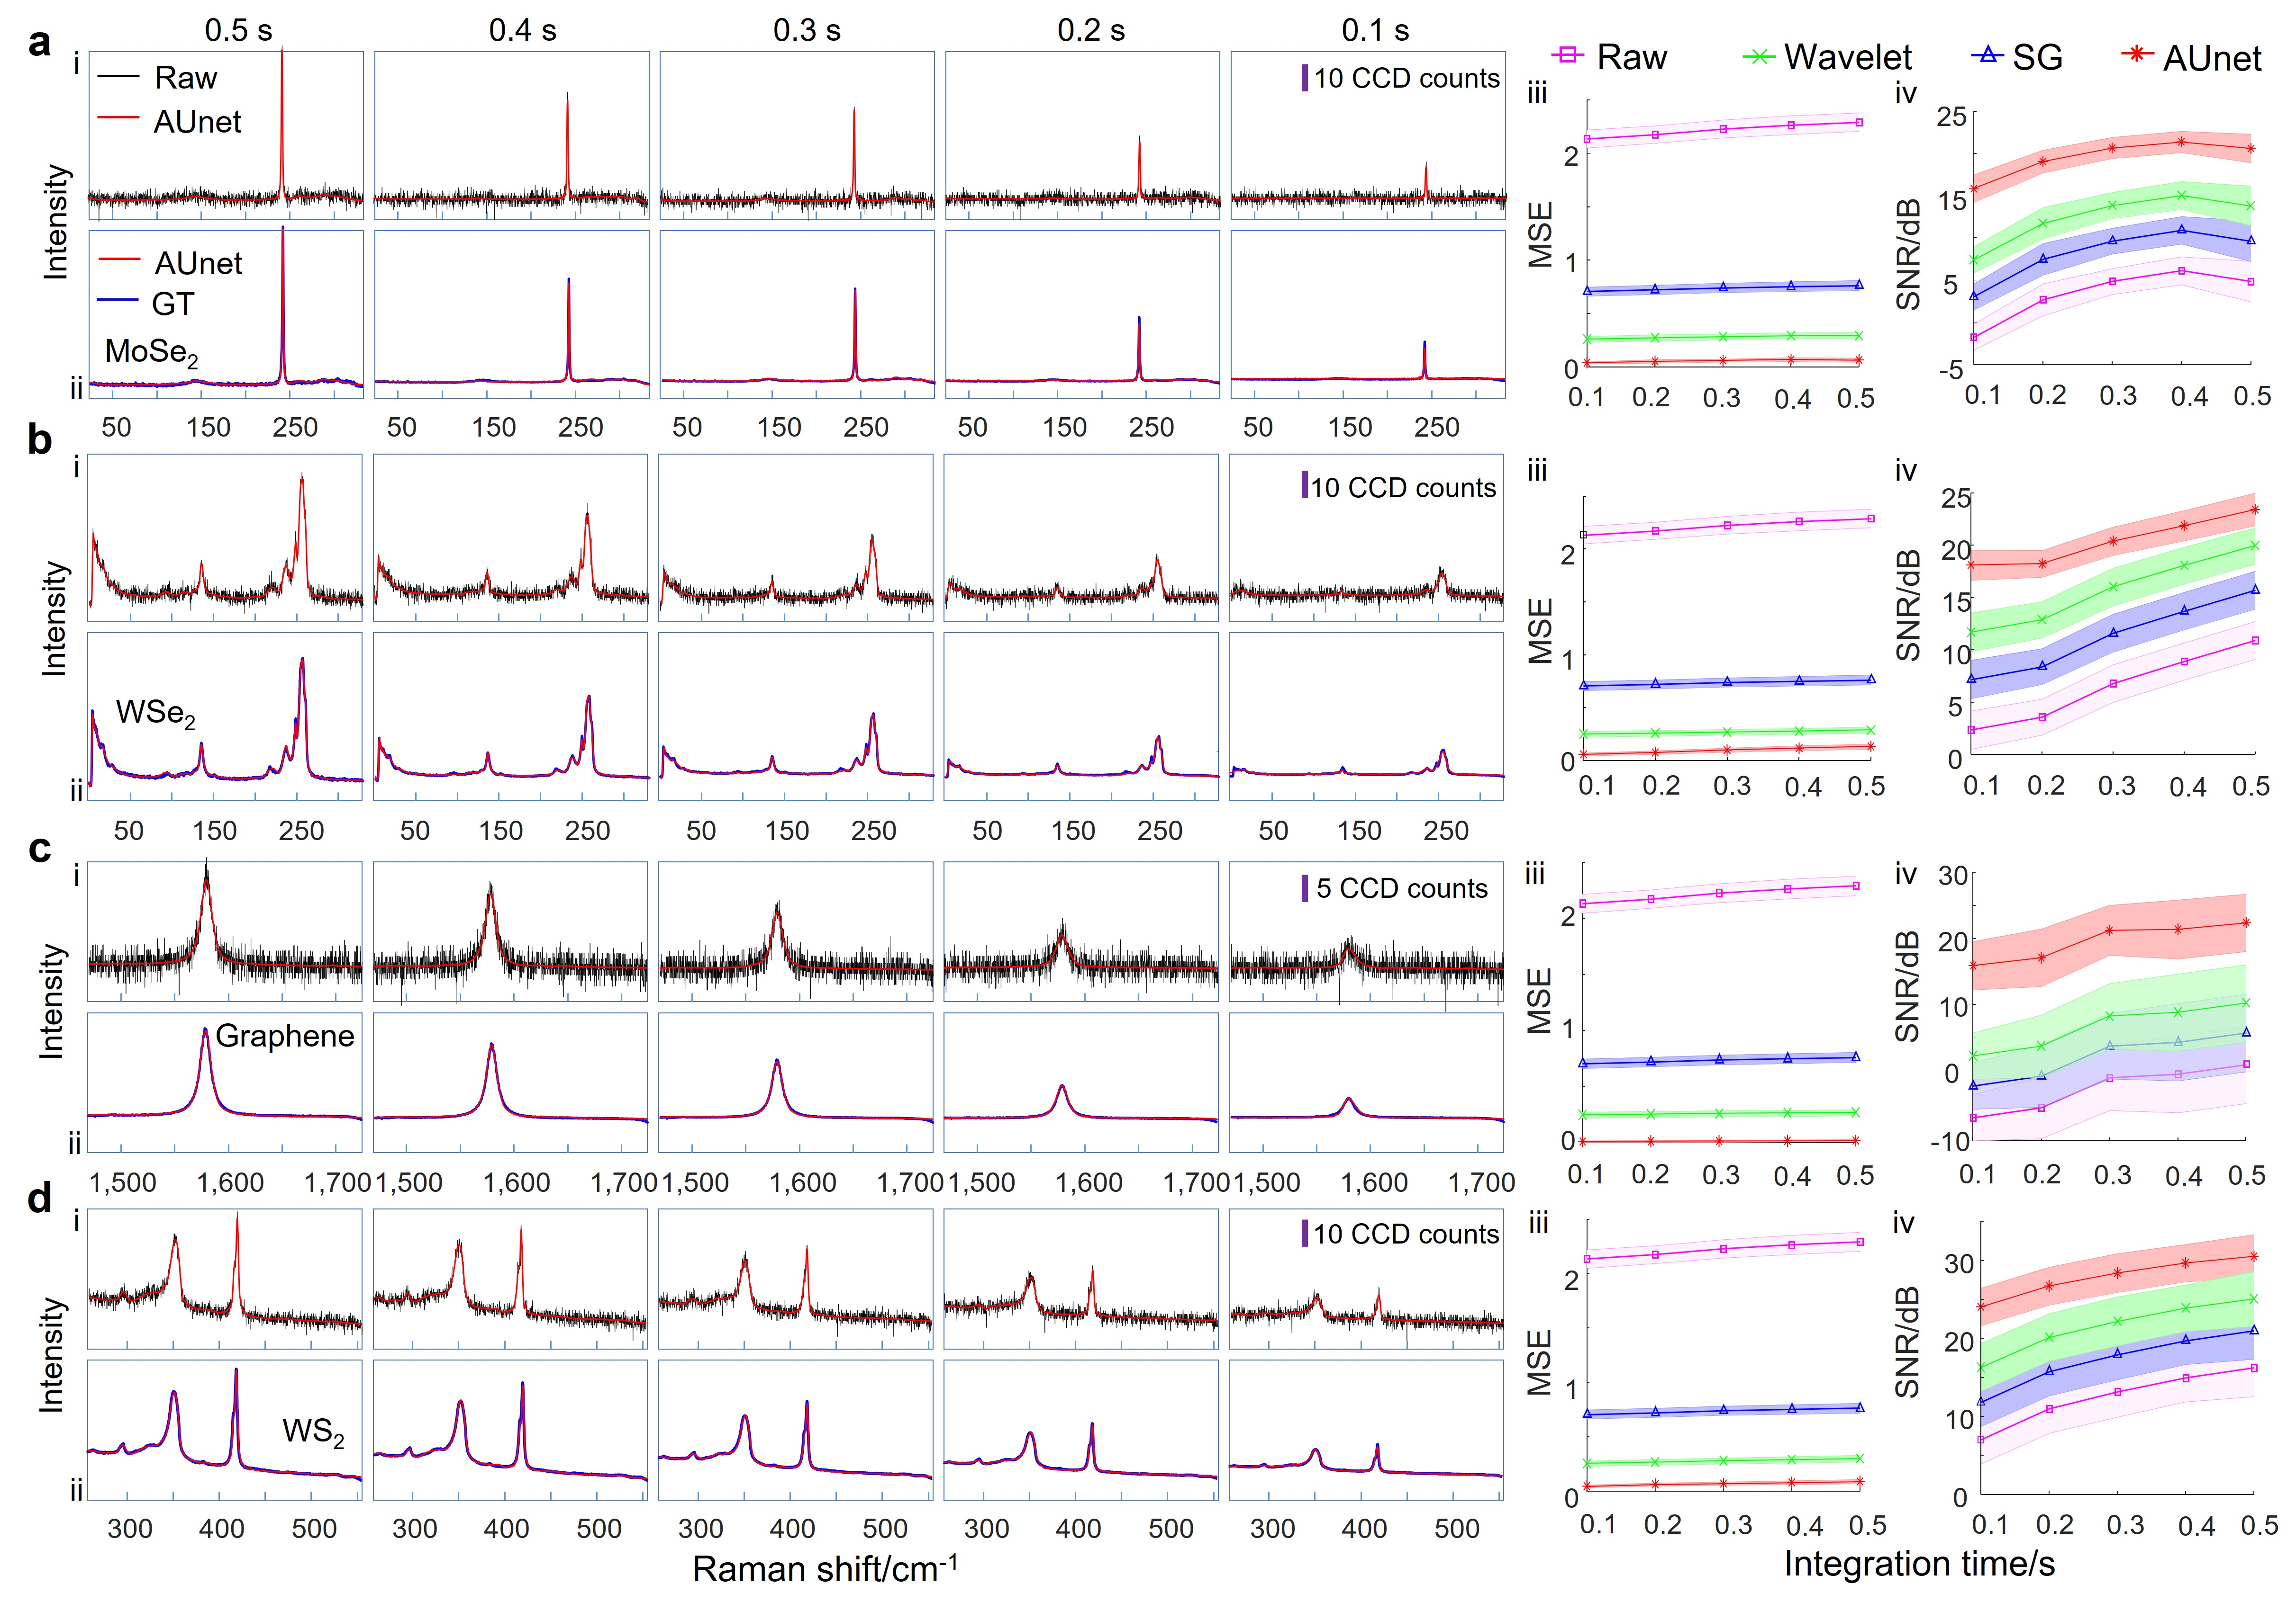

Fig. S3 | Other results demonstrating the effectiveness of different methods to remove the instrumental noise from Raman spectra of 2D materials. Results of (a) MoSe₂, (b) WSe₂, (c) graphene and (d) WS₂ obtained at different acquisition time of 0.1 s to 0.5 s. For each sample, panel i shows the comparison of the raw (black) and AUnet (red) processed Raman spectra; panel ii compares the ground true spectra (GT, blue) with the AUnet processed spectra (red); panels iii and iv present, respectively, the mean square error (MSE) and the SNR of the raw data and the spectra processed with AUnet, Wavelet and SG (see Methods in the main text). For each acquisition time, the MSE and SNR values were the average of 2,500 spectra, and the shaded areas indicate the deviation. The AUnet model used here is the same as Fig. 1e and Fig. 2 in the main text. These results demonstrate the generality of the AUnet model trained using the noise learning (NL) method and its state-of-the-art denoising performance. Measuring conditions: Instrument, LabRAM HR Evolution; laser wavelength, 633 nm; laser power, 6 mW for Graphene, 0.25 mW for WS₂, and 1.25 mW for MoSe₂ and WSe₂; Objective, 100× air dry (NA=0.9), grating: 1800 l/mm.
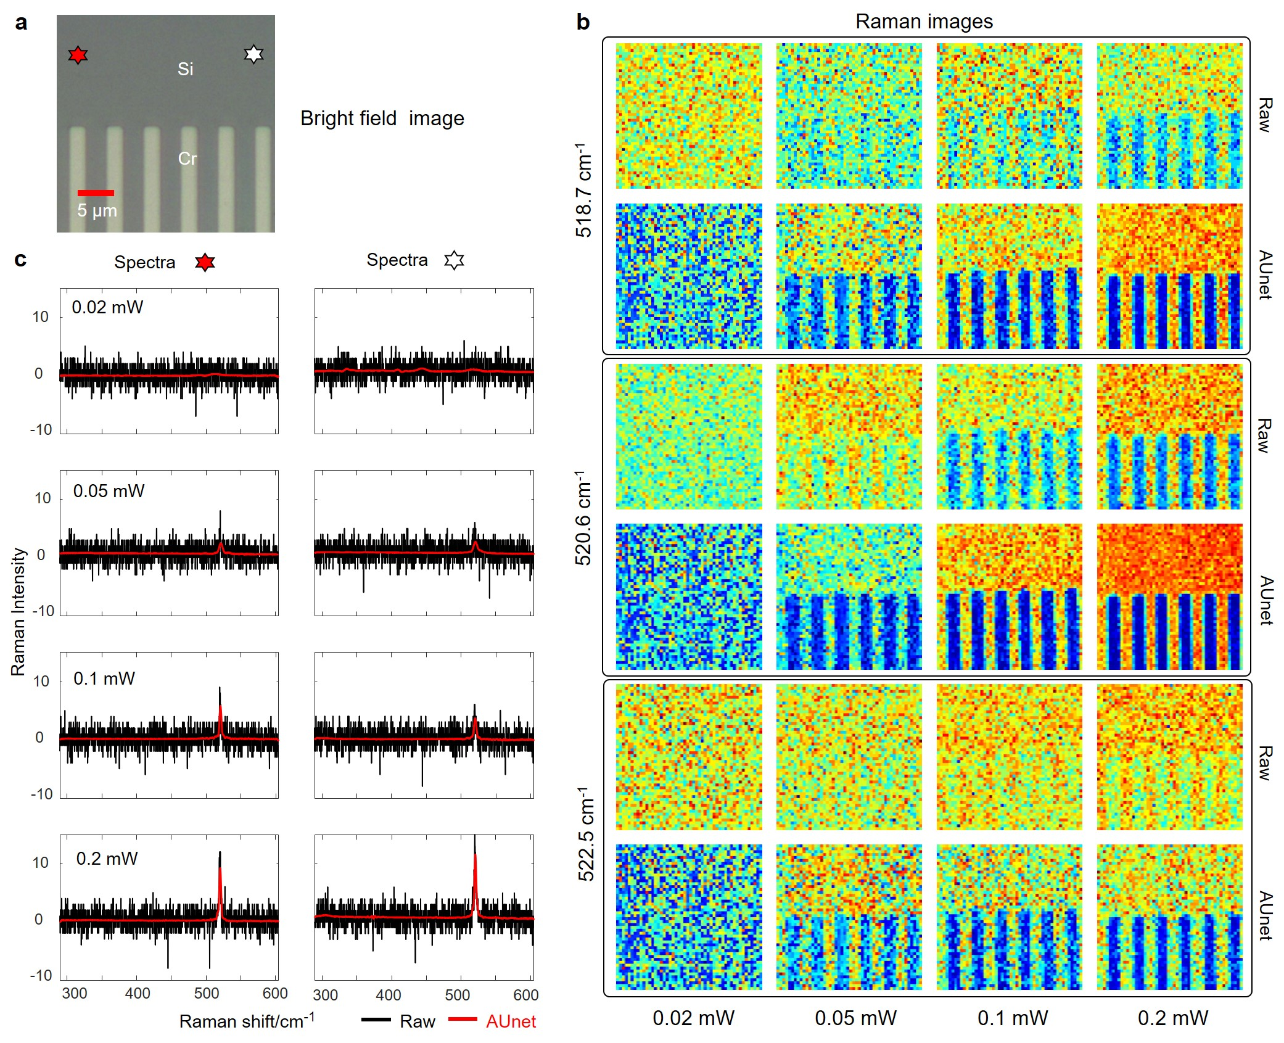

Fig. S4 | Performance of NL method at the low laser power limit. (a) Bright field image of a Cr/Si grating sample. (b) Raman images at three typical wavenumbers (518.7, 520.6, 522.5 cm⁻¹) of the sample acquired with different laser power (0.02, 0.05, 0.1 and 0.2 mW). For each panel, the first row illustrates the raw images, and the second row illustrates the AUnet restored ones. (c) The raw and AUnet restored Raman spectra extracted at the position marked by the red and white stars on the bright field image. Instrument: LabRAM HR-Evolution (Horiba). The AUnet model used here is the same as Fig. 1e and Fig. 2 in the main text without retraining. Objective: air dry, 100×, NA = 0.9. Laser source: 633 nm. Integration time: 100 ms/point. Grating: 1800 l/mm. The Raman signal of Si gradually decreases with decreasing laser power, and it almost disappears at 0.05 mW in the raw data. Such a weak signal can still be differentiated using AUnet. This can be confirmed from the Raman images in (b). The image structures are totally buried in the noise in the raw data at 0.05 mW laser power, especially the 522.5 cm⁻¹ peak, while AUnet clearly uncovers such structures that agree well with the bright field image. This result demonstrates that the NL can push the limits of Raman microscopy.
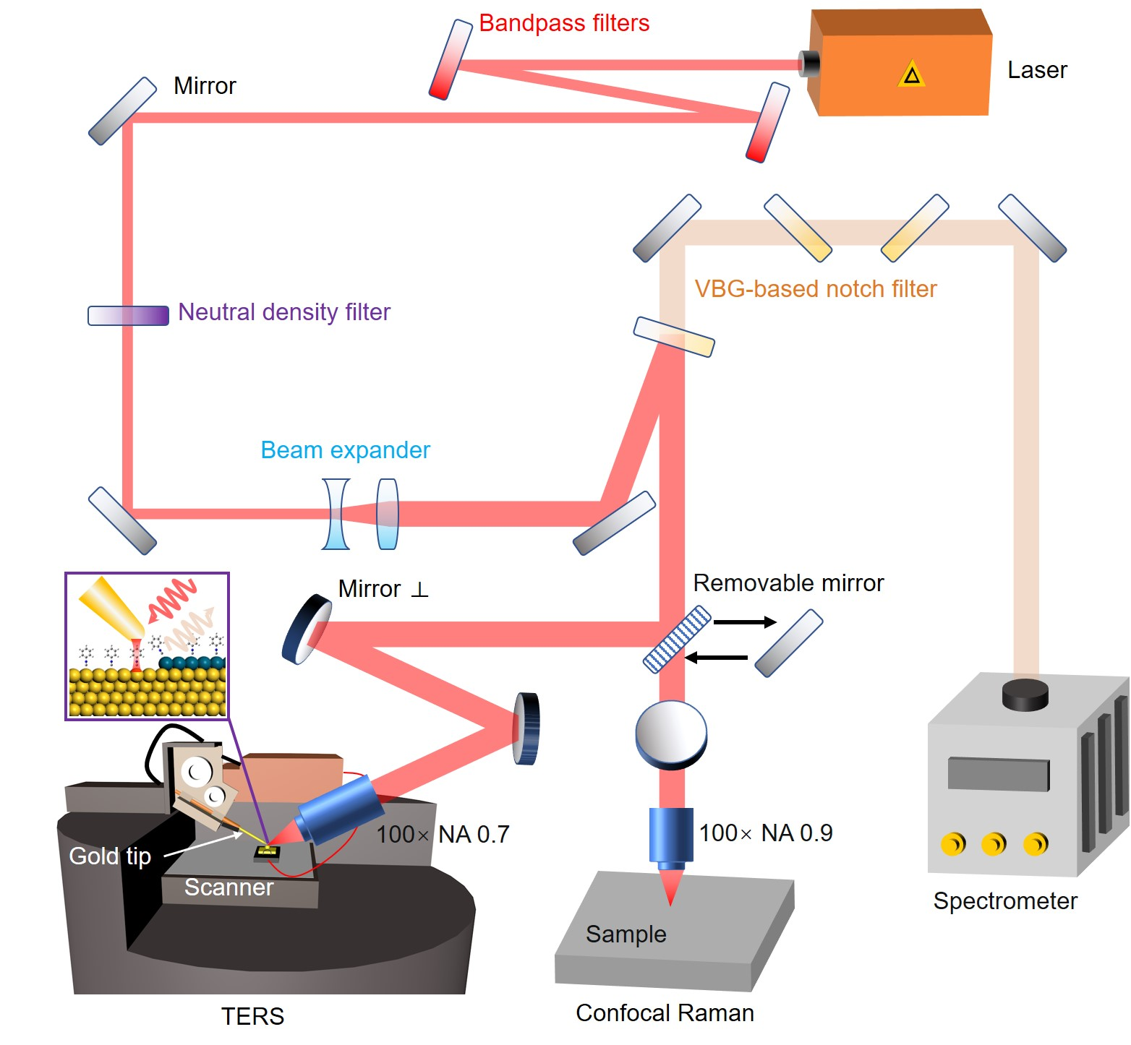

Fig. S5 | The scheme of Horiba LabRAM HR-Evolution system that integrates confocal Raman with tip-enhanced Raman spectroscopy working in a back-scattering configuration. For STM-TERS, the laser is irradiated at the plasmonic tip-sample junction at 25° relative to the horizontal plane (diagram in the purple box is the structure of sample). The switch of the two modalities is achieved via the removable mirror. To get ultra-low frequency Raman signal (< 50 cm⁻¹), several volume Bragg grating (VBG) based notch filters were used to weaken Rayleigh line and additional bandpass filters were used to remove plasma lines from laser source.
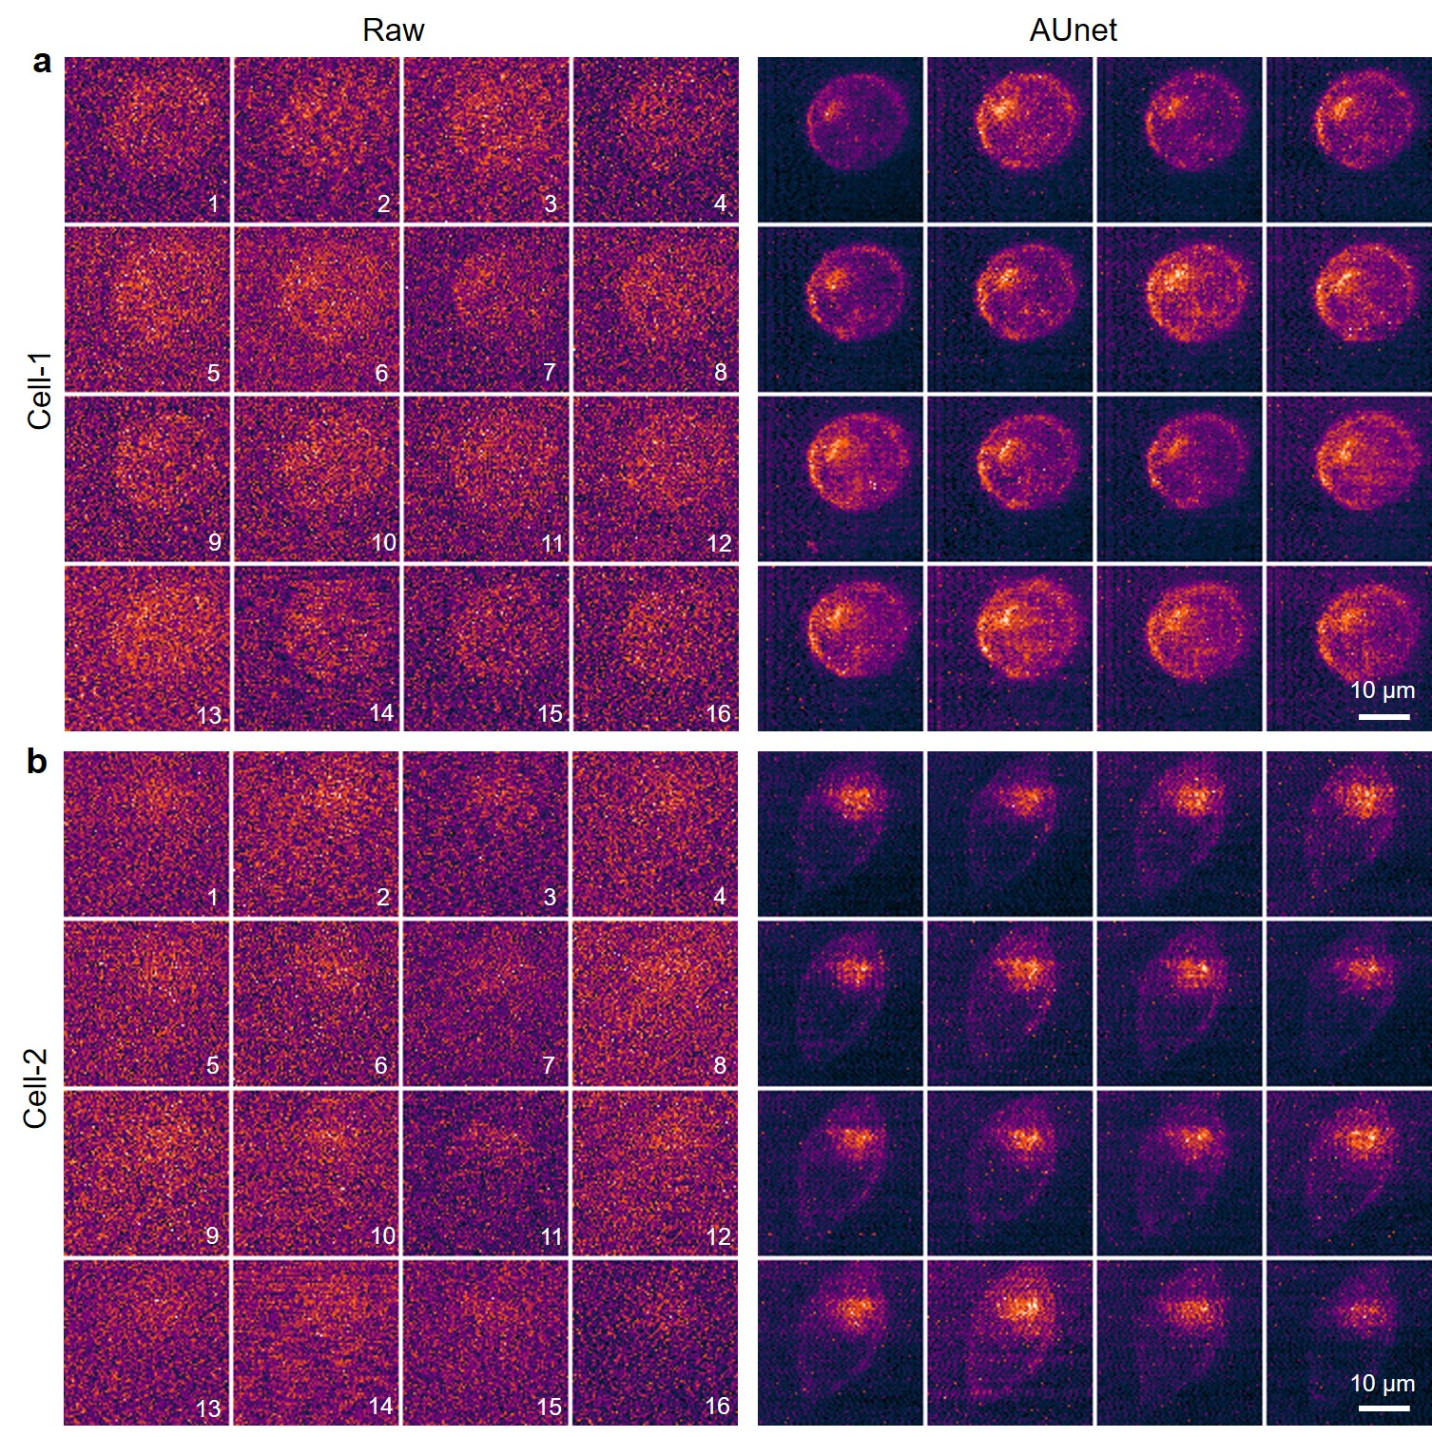

Fig. S6 | Additional results on living-cell fluorescence imaging. Continuous fluorescence imaging of (a) a round-shape HeLa cell and (b) spinel-shape Hela cell using the fluorescence signal at 501 nm from BODIPY FL PI(5)P targeting lysosome. Left: raw images with the number of frames indicated; Right: images after AUnet treatment. Instrument: Raman-11; Objective: air dry 50×, NA = 0.45; Laser wavelength: 488 nm; laser power: 30 µW; integration time: 50 ms/line and 35 s/frame; grating: 600 l/mm.
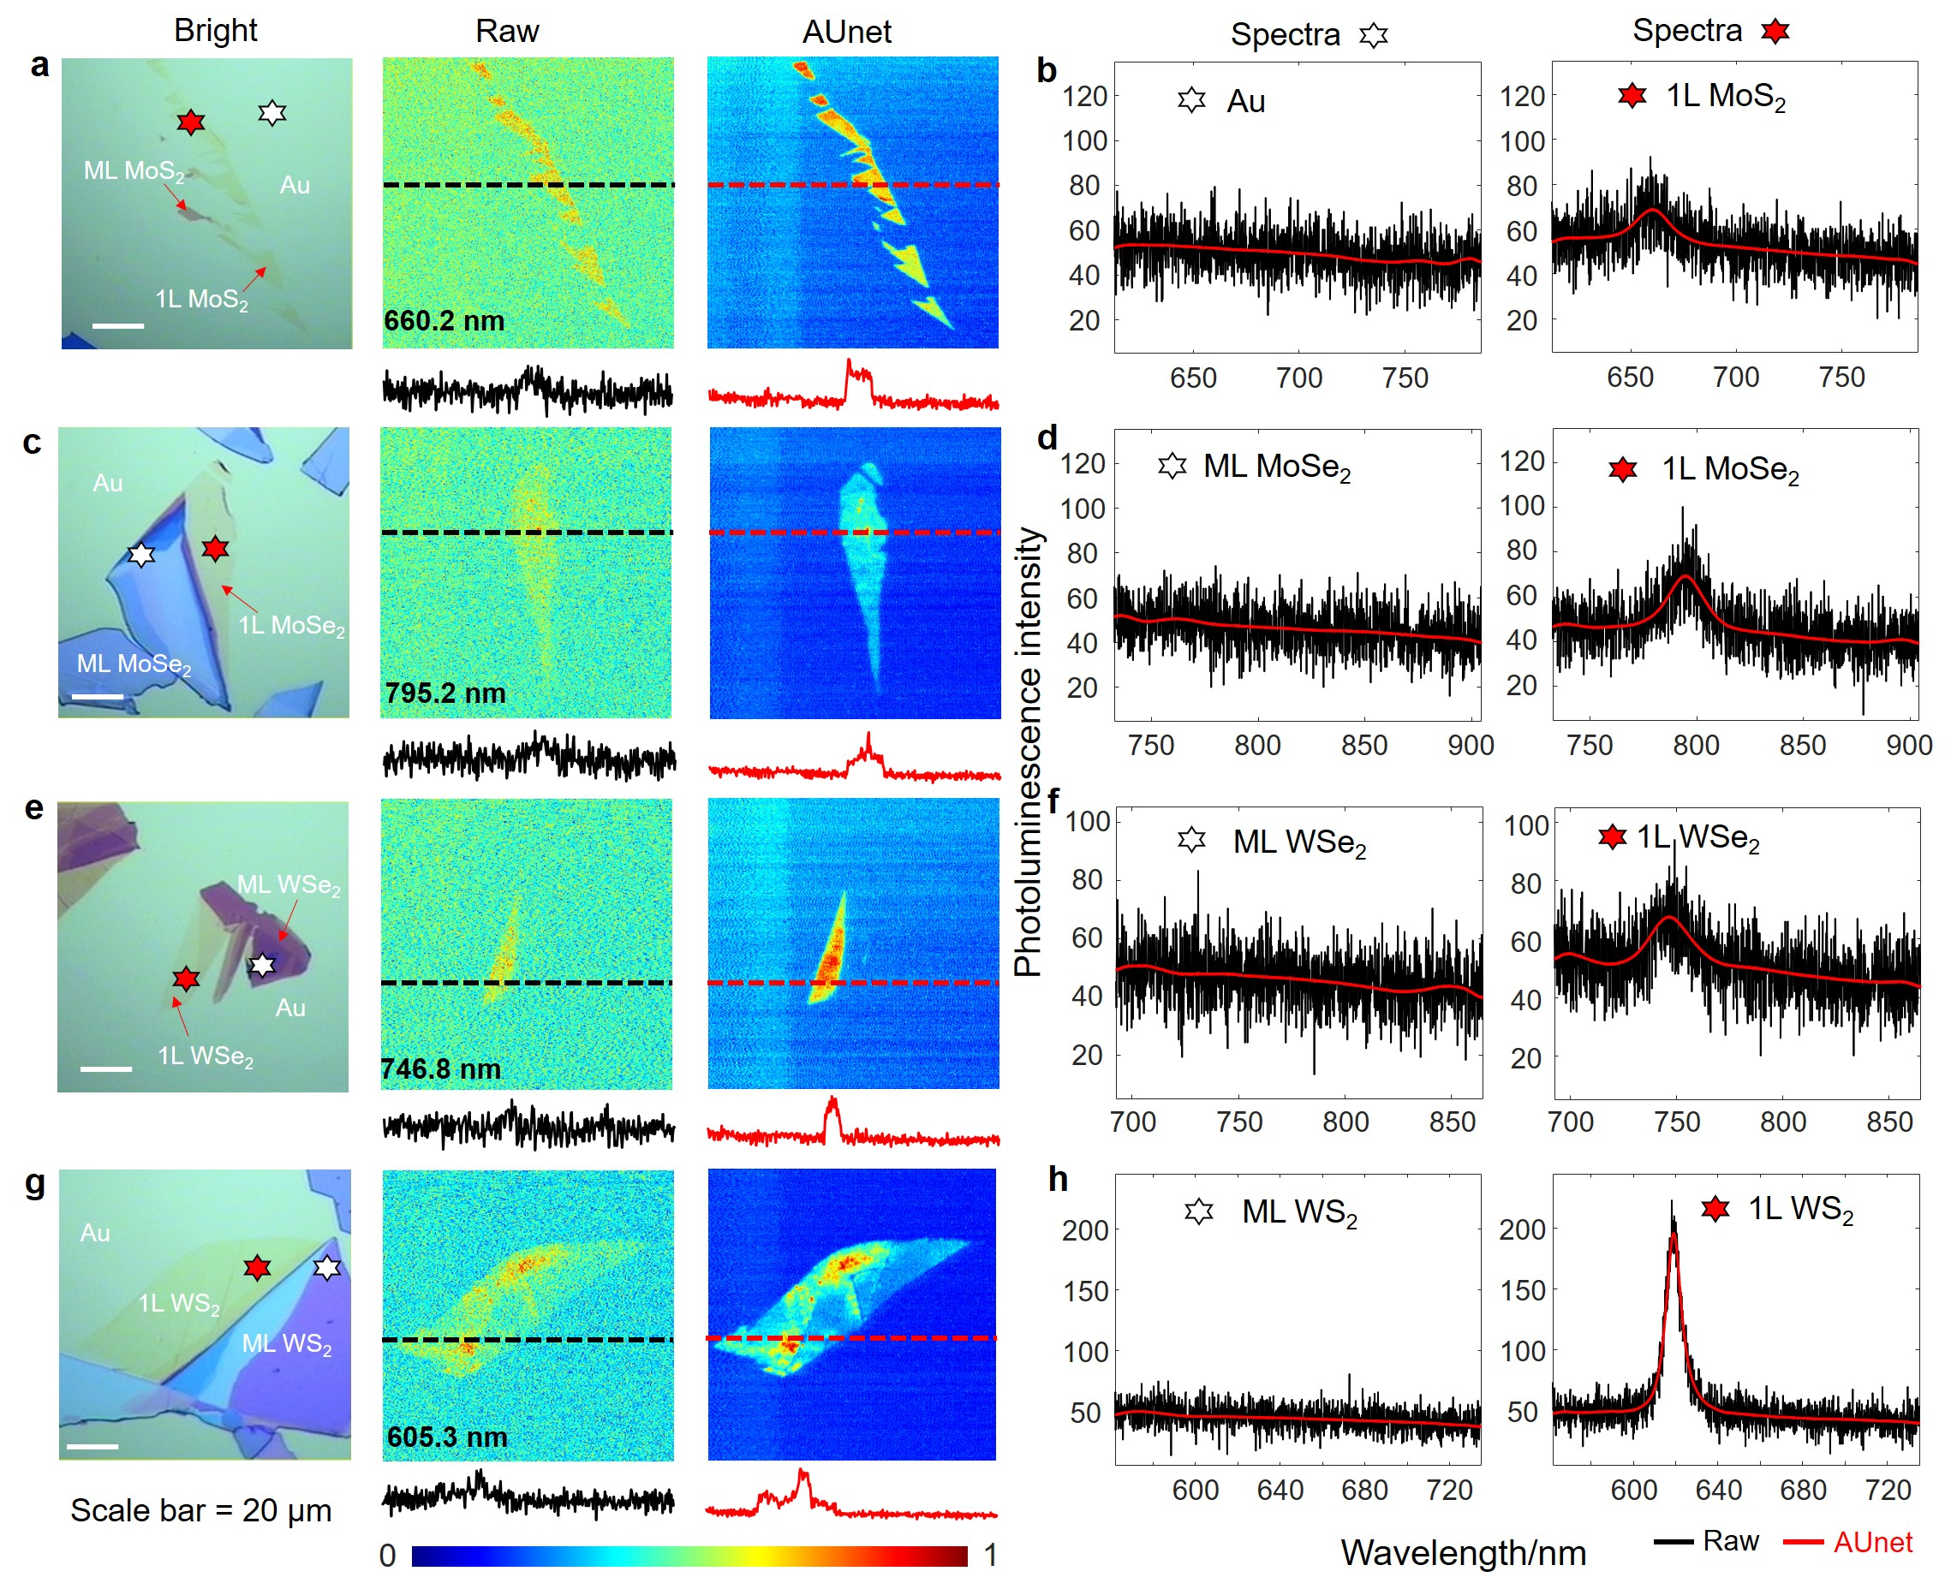

Fig. S7 | AUnet assisted fast line-scan photoluminescence imaging of 2D materials on gold substrate. (a) MoS₂, (c) MoSe₂, (e) WSe₂, (g) WS₂. Left: bright field image. Middle: raw fluorescence image at the indicated wavelength. The black curve at the bottom is the intensity profile along the black dashed line on the image. Right: fluorescence image after pixel-wise denoising by the pretrained AUnet, the red curve at the bottom is the intensity profile along the red dashed line. (b, d, f, h) Corresponding spectra of the four samples. Left: fluorescence spectra at the position marked by the white and red stars on the bright field image. Black curves indicate the noisy raw spectra and red curves are the high SNR spectra processed by AUnet. The AUnet model used here is the same as Fig. 4 in the main text without retraining. Measurement conditions: Instrument: Raman-11, Nanophoton; Laser wavelength, 532 nm; Laser power, 0.08 mW; Objective: 50× air dry (NA=0.45); Integration time: 100 ms/line; Grating: 600 l/mm.

Supplementary Movies

Supplementary Movie 1 – Continuous imaging of a HeLa cell labelled by MitoTracker using a low laser power.

Supplementary Movie 2 – AUnet enhanced results of the same HeLa cell in Movie 1.

Supplementary Movie 3 – Continuous imaging of a HeLa cell labelled by MitoTracker using a high laser power.

Supplementary Movie 4 – Photoluminescence imaging of a WS₂ sample at a broad wavelength of 600-630 nm.

He, H. et al. Collaborative Low-Rank Matrix Approximation-Assisted Fast Hyperspectral Raman Imaging and Tip-Enhanced Raman Spectroscopic Imaging. Anal Chem 93, 14609-14617 (2021).
He, H. et al. Automated weak signal extraction of hyperspectral Raman imaging data by adaptive low‐rank matrix approximation. Journal of Raman Spectroscopy 51, 2552-2561 (2020).

