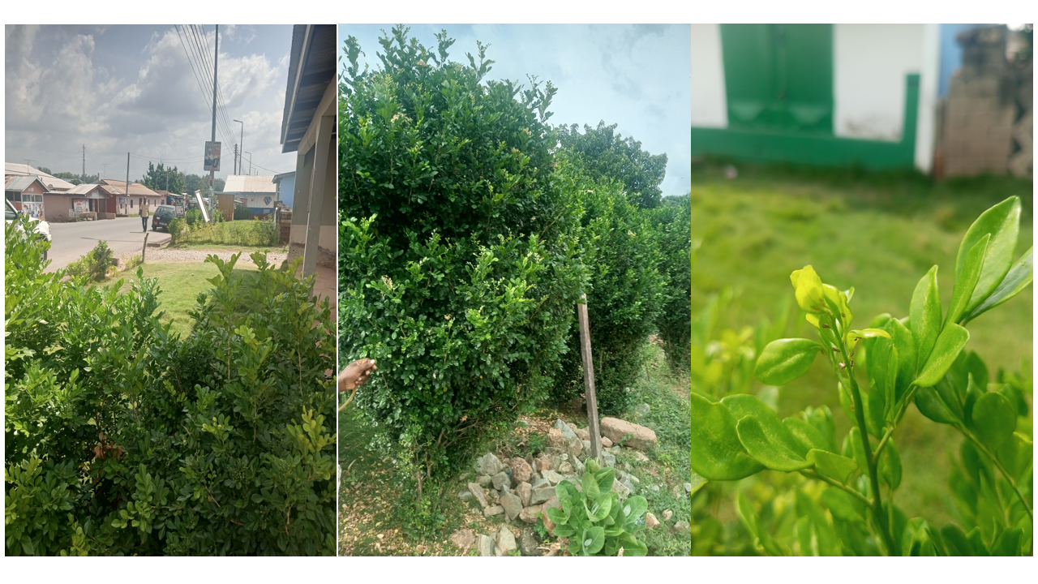Fig. S1. Murraya paniculata Linnaeus being used as a hedge in the Volta Region, Ghana.

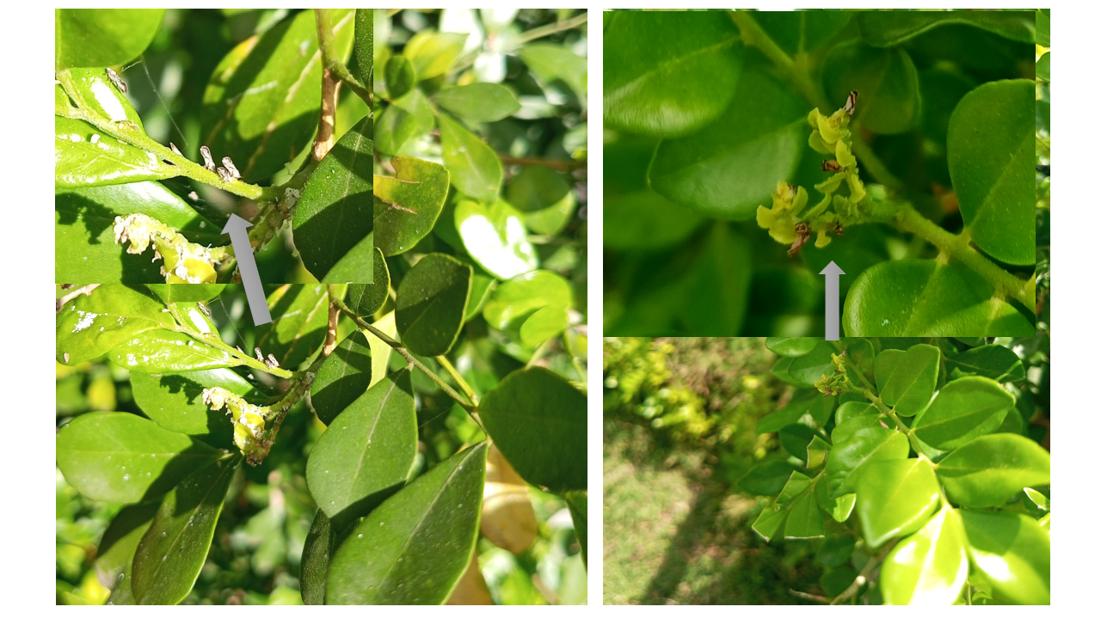 Fig. S2. Adult of the suspected Asian citrus psyllid (Diaphorina citri Kuwayama) observed in Orange Jasmine (Murraya paniculata Linnaeus) in one of the locations in Ho, Volta Region, Ghana.

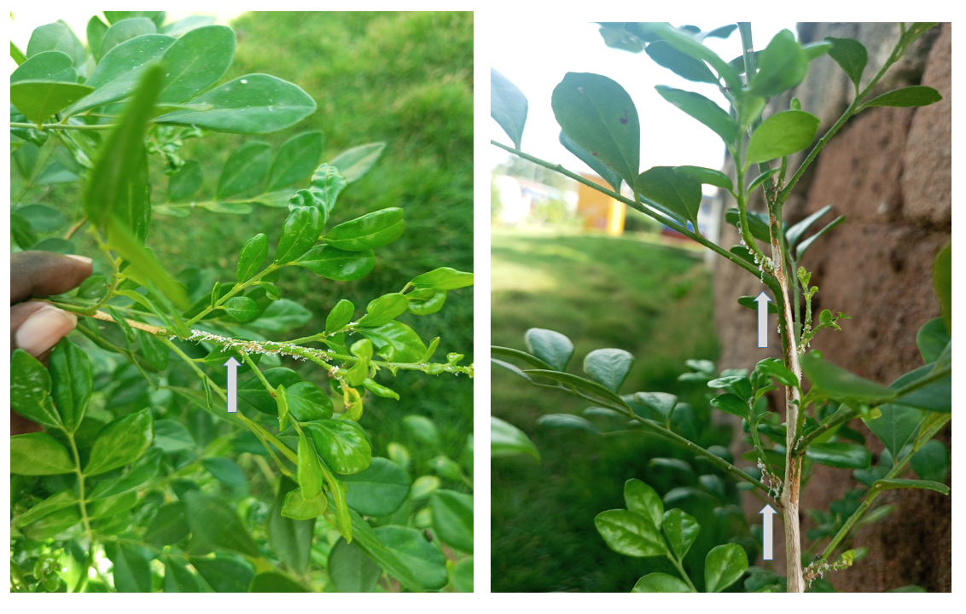Fig. S3. Nymphs of the suspected Asian citrus psyllid (Diaphorina citri Kuwayama) observed in Orange Jasmine (Murraya paniculata Linnaeus) in one of the locations in Ho, Volta Region, Ghana.

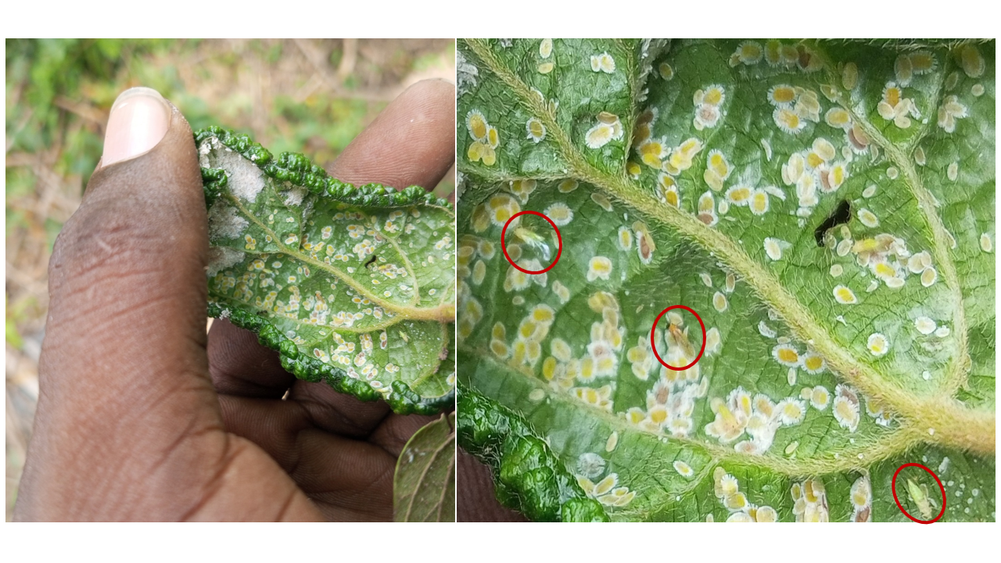Fig. S4. Adults (circled) and nymphs of the suspected African citrus triozid (Trioza erytreae Del Guercio) observed in Triclisia patens (Oliv.) in one of the locations in Ho, Volta Region, Ghana.

