Supplementary Information

Graph theoretical description of phase transitions in nanoscale assemblies of surfactants

Ruochen Yang,^{a,§} Kalil Bernardino,^{b,§} Xiongye Xiao,ª Weverson R. Gomes,^{b} Davi A. Mattoso,^{b} Nicholas A. Kotov,^{c,*} Paul Bogdan^{a,*} and André F. de Moura^{b,*}
ª Ming Hsieh Department of Electrical and Computer Engineering, University of Southern California, Los Angeles, CA, 90089, USA.
^{b} Department of Chemistry, Federal University of São Carlos, São Carlos, SP, 13565-905, Brazil.
^{c} Department of Chemical Engineering, Department of Materials Science and Engineering, Biointerfaces Institute, University of Michigan, Ann Arbor, MI, 48109-2102, USA.
§ These authors contributed equally.
* Corresponding authors: kotov@umich.edu, pbogdan@usc.edu and moura@ufscar.br

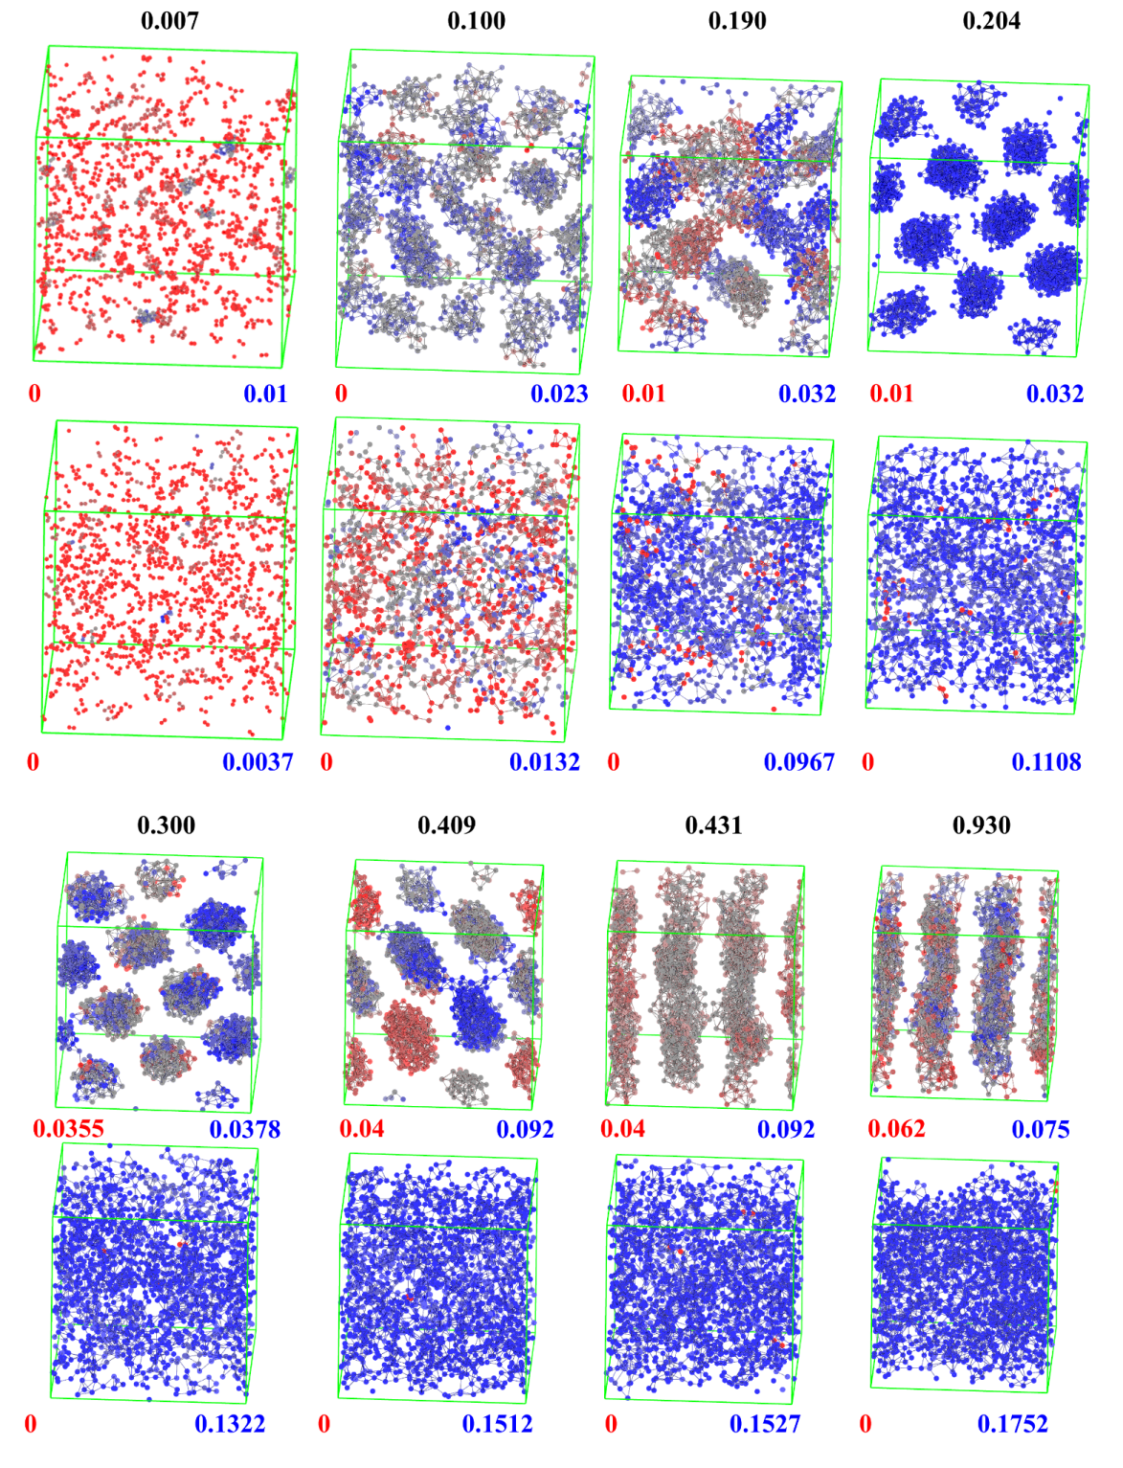
Supplementary Figure 1. Graphical representations of the structures from which the graphs of Supplementary Fig. 2 were computed showing only surfactant tail sites colored using closeness centrality values (range of values used to color given in the bottom of each structure). Surfactant molar fraction is given by black numbers above structures. For each molar fraction, the structure in the top corresponds to the real solution with the one below corresponds to the ideal solution. Connections were drawn between tail sites within 0.7 nm from each other, the same cut radius used to define the connections in the construction of the graphs. Green lines indicate the boundaries of the simulation box, which is shown in the same scale for every composition except x = 0.007, so the shrinking in box size with composition reflect the actual reduction of the simulation box for mole fractions larger than 0.1.

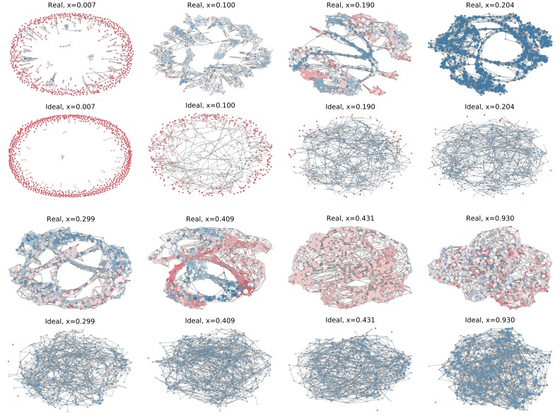
Supplementary Figure 2. Graph visualization for the same structures from MD simulation shown in Supplementary Fig. 1. Nodes were colored based on closeness centrality value using the same color scale as Supplementary Fig. 1.

Supplementary Figure 3. Variance of the closeness centrality and node-based fractal dimension (NFD) during the molecular dynamic simulation. A significant drop of the variation of both closeness centrality and fractal dimension (NFD) at molar fraction x = 0.204 (transition from micelle to hexagonal) can further support our observation of the phase transition.

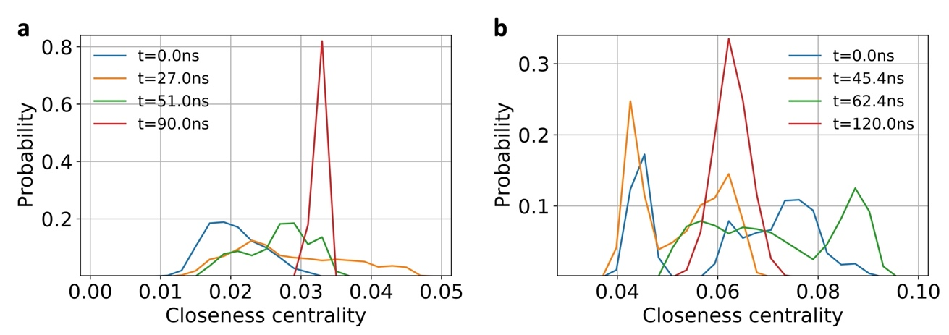

Supplementary Figure 4. Closeness centrality distribution of (a) the selected snapshots of Fig. 3a around phase transitions from micelle to hexagonal and (b) around the transition from hexagonal to lamellar in Fig. 4a.
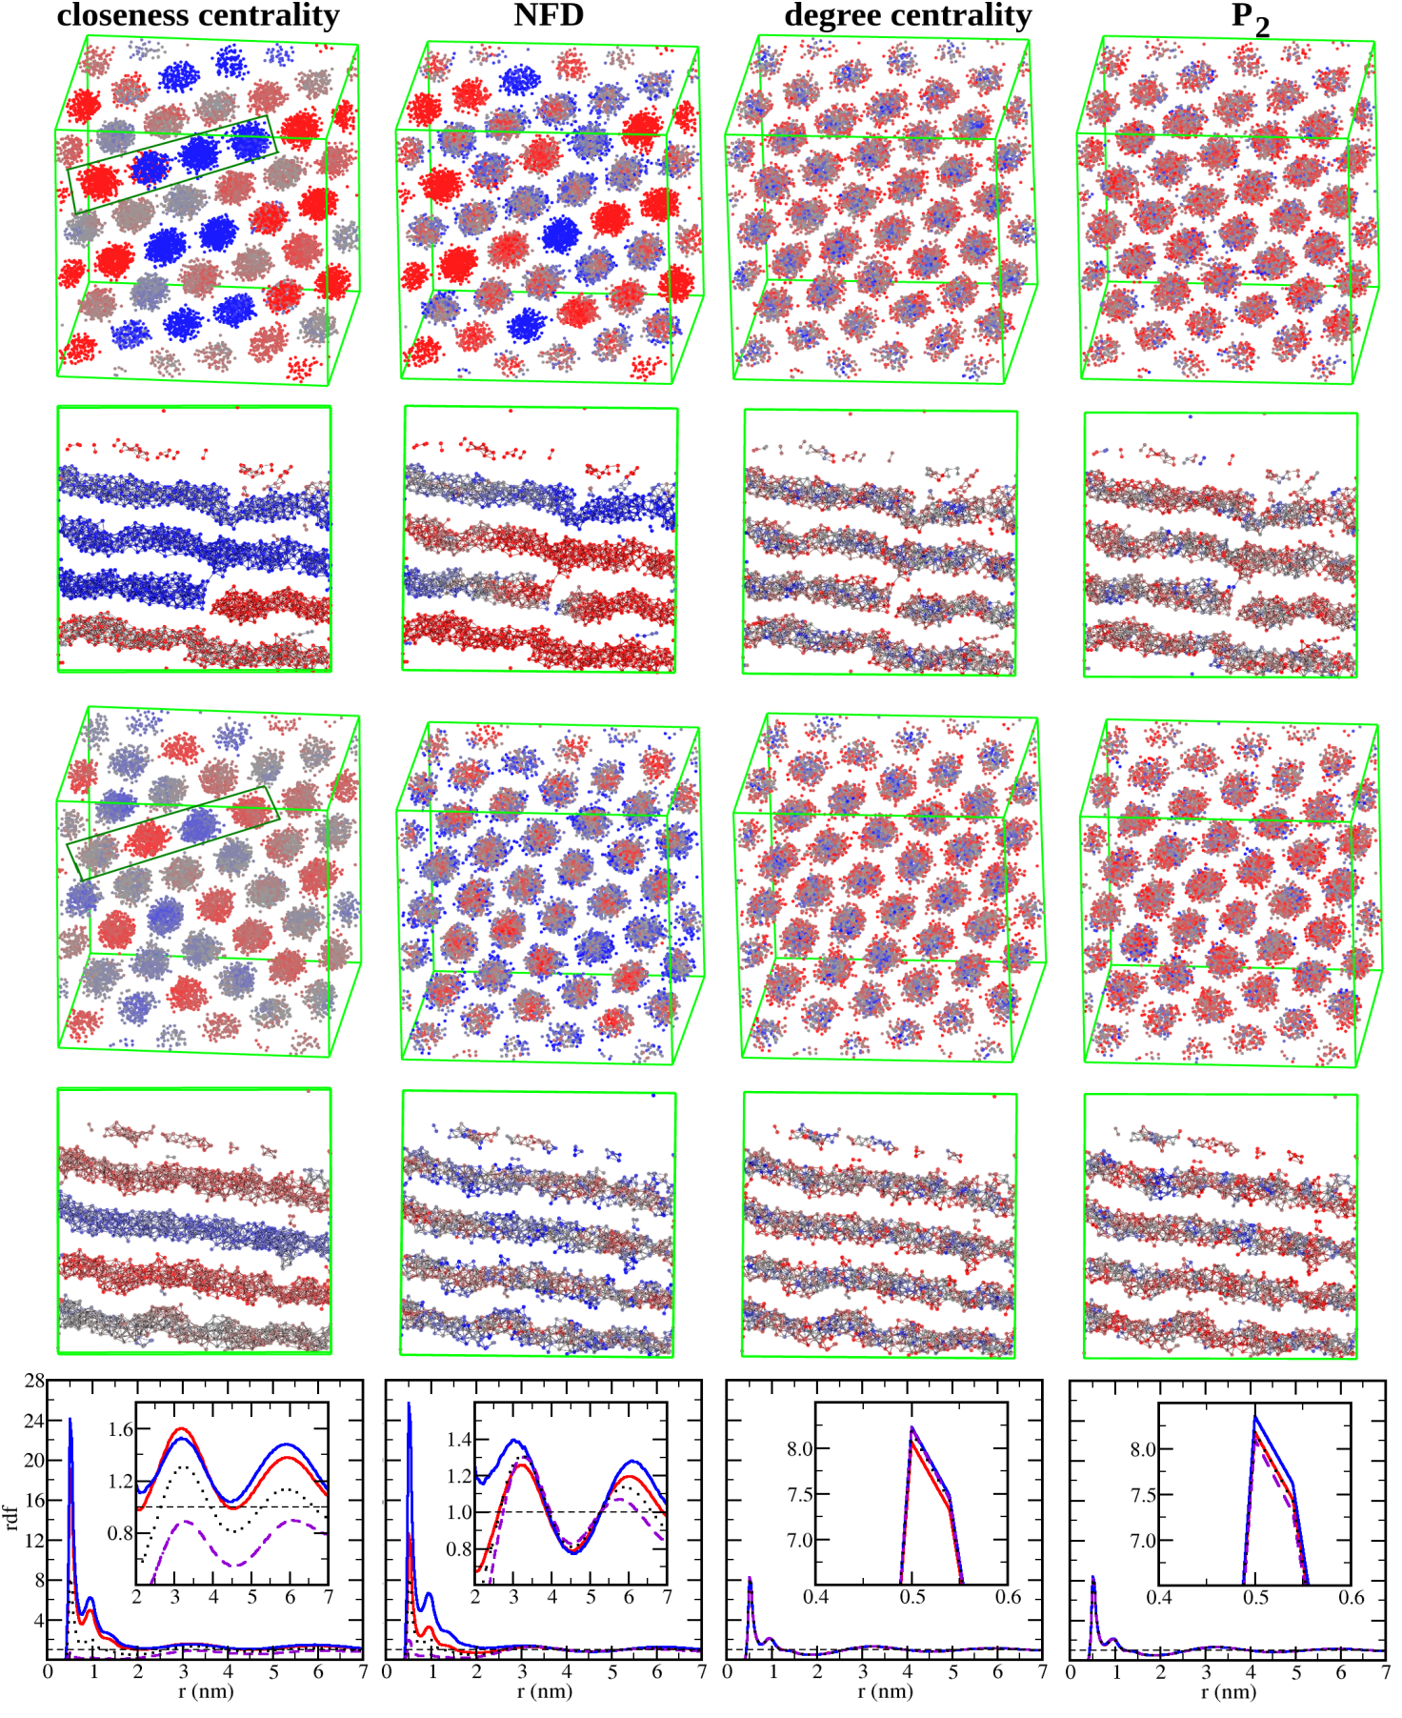
Supplementary Figure 5. Two selected structures for the larger model system with the OTAB molar fraction of 0.2177 showing only the surfactant tail sites colored using (from left to right) values of closeness centrality, NFD, degree centrality and P₂, with red and blue colors representing low and high values of the respective metric. Below the lateral view of the whole system, another representation of the same structure is given focusing on the lateral view of four tube segments marked with the dark green lines on the left, in which lines were included to highlighted the surfactant tails that are connected in the construction of the graph. At the bottom is shown the radial distribution function between the terminal tail site of surfactant molecules with red curves including only the 25% molecules with lowest values for the metric, blue curves including only the 25% with highest values, purple dashed curves gives the distribution of the 25% higher in relation to the 25% lower and the dotted black curves include every surfactant molecule. Insets zoom over the long-range structure for closeness centrality and fractal dimension and over the first peak for other metrics.
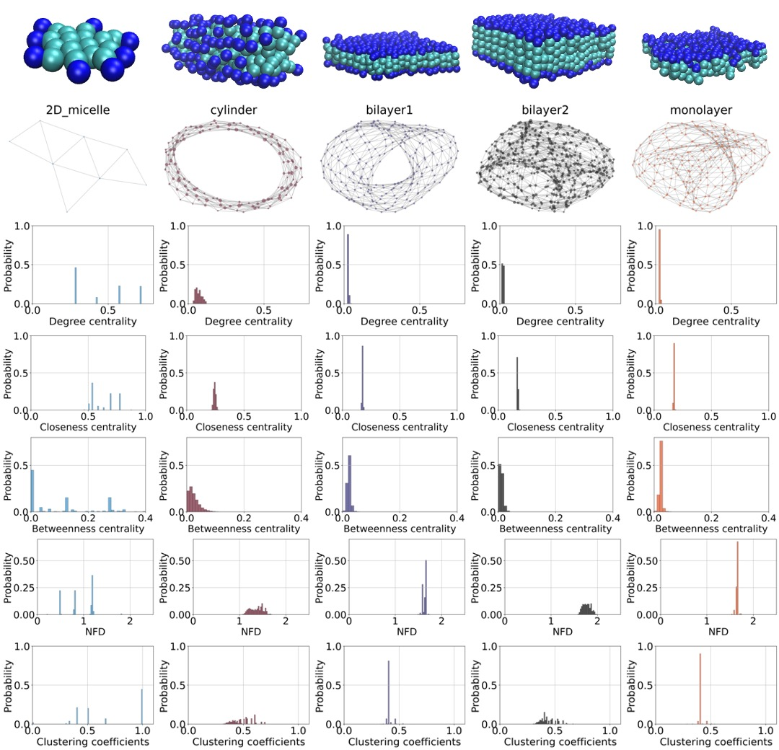
Supplementary Figure 6. GT descriptors, i.e., closeness centrality, degree centrality, betweenness centrality and clustering coefficients, calculated for five idealized systems (bidimensional micelle, bilayer 1, bilayer 2, infinity cylinder micelle and monolayer) using the terminal tail sites as nodes.
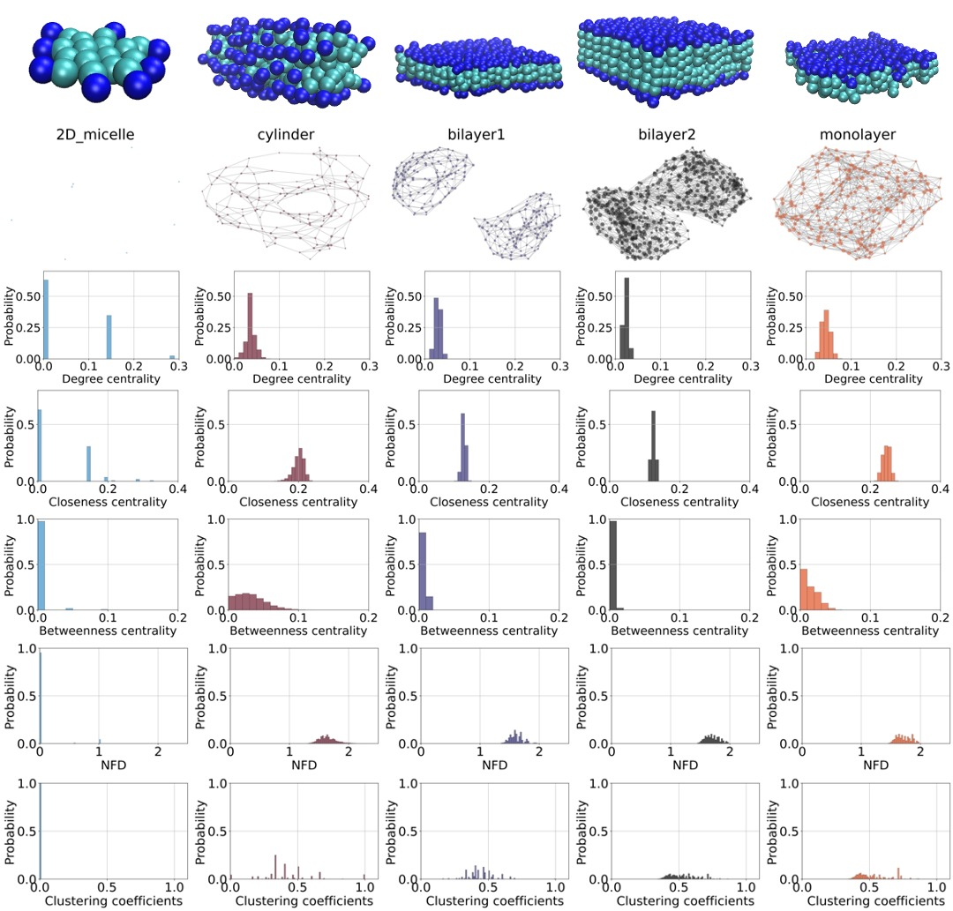

Supplementary Figure 7. Graph properties (closeness centrality, degree centrality, betweenness centrality and clustering coefficients) calculated for the same five idealized systems in Supplementary Fig. 6 using the head sites as nodes to build network.

Supplementary Comment: We also considered the GT metrics for five idealized systems: bi-dimensional micelles, infinite cylinders, monolayers and two distinct bilayers, one with the surfactant tails interdigitated (bilayer 1) and the bilayer formed by two dense monolayers (bilayer 2). Although these structures have not been experimentally observed for OTAB, these simulations allow one to test the ability of GT to distinguish between these different organizational patterns (Supplementary Fig. 6). Descriptors, such as degree centrality, clustering coefficient and nodal fractal dimension, can distinguish between these structures, showing different average values and/or sharpness of the distribution. The cases of surfactant molecules organized in the nearly identical structures, such as bilayer 1 and monolayer, yield similar results for every metric concerning the tail-tail contacts. If the same metrics are considered for the head-head contact, then a clear distinction between those two structures also emerges (Supplementary Fig. 7).

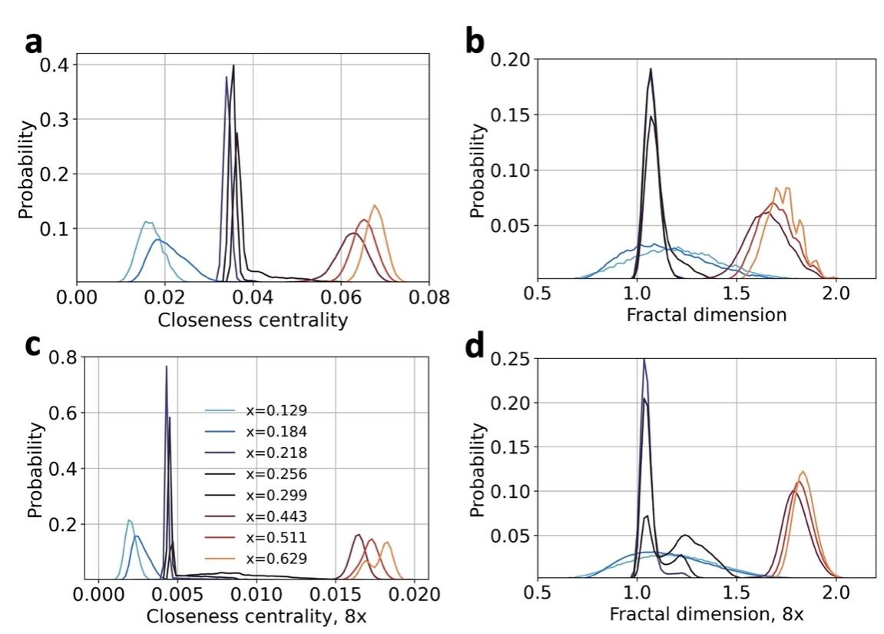

Supplementary Figure 8. Distribution of values of closeness centrality (left) and fractal dimension (right) for selected compositions of the original model systems (top) and eight times larger model systems (bottom).

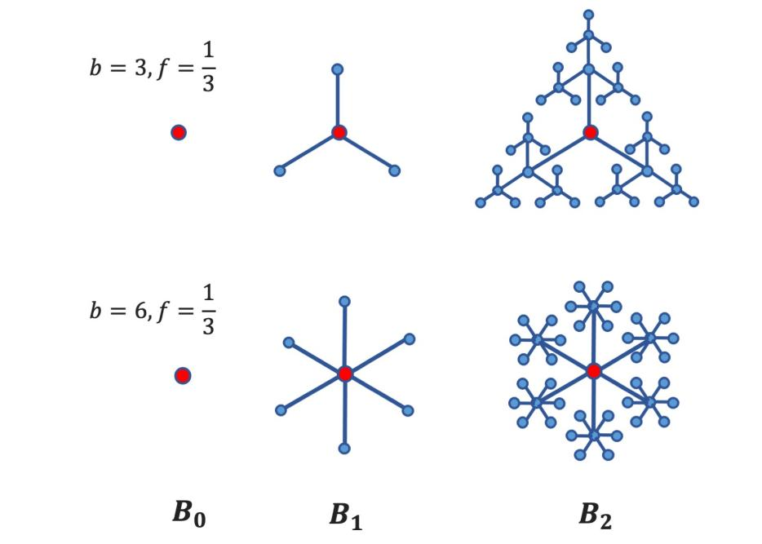
Supplementary Figure 9. The box-growing method on the Sierpinski fractal graphs under different copy factors $b$ and a scaling factor $f$.

Supplementary Table 1 - Number of water particles, N_{W}*, surfactant molar fraction, x_{mol}, and mass fraction, x_{mass}, in every simulation along the phase diagram scan
N | N_{W} | x_{mol} | x_{mass} | n | N_{W} | x_{mol} | x_{mass} | n | N_{W} | x_{mol} | x_{mass}
1 | 112890 | 0.0070 | 0.0903 | 58 | 10917 | 0.0683 | 0.5064 | 115 | 963 | 0.4538 | 0.9208
2 | 108369 | 0.0073 | 0.0937 | 59 | 10476 | 0.0709 | 0.5167 | 116 | 921 | 0.4648 | 0.9240
3 | 104031 | 0.0076 | 0.0972 | 60 | 10053 | 0.0737 | 0.5270 | 117 | 879 | 0.4765 | 0.9272
4 | 99864 | 0.0079 | 0.1008 | 61 | 9645 | 0.0766 | 0.5373 | 118 | 840 | 0.4878 | 0.9302
5 | 95865 | 0.0083 | 0.1046 | 62 | 9255 | 0.0796 | 0.5475 | 119 | 801 | 0.4997 | 0.9333
6 | 92025 | 0.0086 | 0.1085 | 63 | 8880 | 0.0826 | 0.5578 | 120 | 765 | 0.5112 | 0.9361
7 | 88338 | 0.0090 | 0.1125 | 64 | 8520 | 0.0858 | 0.5680 | 121 | 729 | 0.5232 | 0.9389
8 | 84801 | 0.0093 | 0.1167 | 65 | 8175 | 0.0891 | 0.5781 | 122 | 696 | 0.5348 | 0.9415
9 | 81405 | 0.0097 | 0.1209 | 66 | 7842 | 0.0926 | 0.5882 | 123 | 663 | 0.5468 | 0.9441
10 | 78144 | 0.0101 | 0.1254 | 67 | 7524 | 0.0961 | 0.5982 | 124 | 633 | 0.5583 | 0.9465
11 | 75015 | 0.0106 | 0.1299 | 68 | 7218 | 0.0998 | 0.6081 | 125 | 603 | 0.5702 | 0.9489
12 | 72009 | 0.0110 | 0.1346 | 69 | 6924 | 0.1036 | 0.6180 | 126 | 573 | 0.5827 | 0.9513
13 | 69123 | 0.0114 | 0.1394 | 70 | 6642 | 0.1075 | 0.6277 | 127 | 546 | 0.5944 | 0.9535
14 | 66354 | 0.0119 | 0.1444 | 71 | 6372 | 0.1115 | 0.6374 | 128 | 519 | 0.6065 | 0.9557
15 | 63696 | 0.0124 | 0.1495 | 72 | 6114 | 0.1157 | 0.6469 | 129 | 495 | 0.6178 | 0.9577
16 | 61143 | 0.0129 | 0.1548 | 73 | 5865 | 0.1200 | 0.6563 | 130 | 471 | 0.6294 | 0.9596
17 | 58692 | 0.0134 | 0.1602 | 74 | 5625 | 0.1245 | 0.6657 | 131 | 447 | 0.6415 | 0.9616
18 | 56340 | 0.0140 | 0.1658 | 75 | 5394 | 0.1292 | 0.6749 | 132 | 426 | 0.6525 | 0.9634
19 | 54081 | 0.0146 | 0.1716 | 76 | 5175 | 0.1339 | 0.6840 | 133 | 405 | 0.6639 | 0.9651
20 | 51912 | 0.0152 | 0.1775 | 77 | 4962 | 0.1388 | 0.6930 | 134 | 384 | 0.6757 | 0.9669
21 | 49830 | 0.0158 | 0.1835 | 78 | 4758 | 0.1439 | 0.7018 | 135 | 363 | 0.6879 | 0.9686
22 | 47832 | 0.0165 | 0.1897 | 79 | 4563 | 0.1492 | 0.7105 | 136 | 345 | 0.6987 | 0.9701
23 | 45915 | 0.0171 | 0.1961 | 80 | 4377 | 0.1545 | 0.7190 | 137 | 327 | 0.7098 | 0.9716
24 | 44073 | 0.0178 | 0.2026 | 81 | 4197 | 0.1601 | 0.7274 | 138 | 309 | 0.7214 | 0.9732
25 | 42306 | 0.0186 | 0.2093 | 82 | 4026 | 0.1658 | 0.7356 | 139 | 291 | 0.7333 | 0.9747
26 | 40608 | 0.0193 | 0.2162 | 83 | 3861 | 0.1716 | 0.7436 | 140 | 276 | 0.7435 | 0.9759
27 | 38979 | 0.0201 | 0.2232 | 84 | 3702 | 0.1777 | 0.7516 | 141 | 261 | 0.7540 | 0.9772
28 | 37416 | 0.0209 | 0.2304 | 85 | 3549 | 0.1840 | 0.7594 | 142 | 246 | 0.7648 | 0.9785
29 | 35916 | 0.0218 | 0.2377 | 86 | 3402 | 0.1904 | 0.7670 | 143 | 231 | 0.7759 | 0.9798
30 | 34476 | 0.0227 | 0.2452 | 87 | 3261 | 0.1970 | 0.7745 | 144 | 216 | 0.7874 | 0.9811
31 | 33093 | 0.0236 | 0.2529 | 88 | 3126 | 0.2038 | 0.7818 | 145 | 204 | 0.7968 | 0.9821
32 | 31764 | 0.0246 | 0.2607 | 89 | 2997 | 0.2107 | 0.7889 | 146 | 192 | 0.8065 | 0.9831
33 | 30489 | 0.0256 | 0.2687 | 90 | 2874 | 0.2177 | 0.7958 | 147 | 180 | 0.8163 | 0.9842
34 | 29265 | 0.0266 | 0.2768 | 91 | 2754 | 0.2251 | 0.8026 | 148 | 168 | 0.8264 | 0.9852
35 | 28089 | 0.0277 | 0.2851 | 92 | 2640 | 0.2326 | 0.8092 | 149 | 156 | 0.8368 | 0.9863
36 | 26961 | 0.0288 | 0.2935 | 93 | 2529 | 0.2403 | 0.8158 | 150 | 144 | 0.8475 | 0.9873
37 | 25878 | 0.0300 | 0.3021 | 94 | 2424 | 0.2481 | 0.8221 | 151 | 135 | 0.8556 | 0.9881
38 | 24837 | 0.0312 | 0.3108 | 95 | 2322 | 0.2562 | 0.8283 | 152 | 126 | 0.8639 | 0.9889
39 | 23838 | 0.0325 | 0.3197 | 96 | 2226 | 0.2644 | 0.8342 | 153 | 117 | 0.8724 | 0.9897
40 | 22881 | 0.0338 | 0.3286 | 97 | 2133 | 0.2728 | 0.8400 | 154 | 108 | 0.8811 | 0.9904
41 | 21960 | 0.0351 | 0.3378 | 98 | 2043 | 0.2814 | 0.8457 | 155 | 99 | 0.8899 | 0.9912
42 | 21078 | 0.0366 | 0.3470 | 99 | 1956 | 0.2903 | 0.8513 | 156 | 90 | 0.8989 | 0.9920
43 | 20229 | 0.0380 | 0.3564 | 100 | 1872 | 0.2994 | 0.8568 | 157 | 81 | 0.9081 | 0.9928
44 | 19416 | 0.0396 | 0.3658 | 101 | 1794 | 0.3084 | 0.8619 | 158 | 72 | 0.9174 | 0.9936
45 | 18636 | 0.0412 | 0.3754 | 102 | 1719 | 0.3176 | 0.8669 | 159 | 66 | 0.9238 | 0.9941
46 | 17886 | 0.0428 | 0.3851 | 103 | 1647 | 0.3269 | 0.8718 | 160 | 60 | 0.9302 | 0.9947
47 | 17166 | 0.0445 | 0.3948 | 104 | 1578 | 0.3364 | 0.8765 | 161 | 54 | 0.9368 | 0.9952
48 | 16476 | 0.0463 | 0.4047 | 105 | 1509 | 0.3465 | 0.8813 | 162 | 48 | 0.9434 | 0.9957
49 | 15813 | 0.0482 | 0.4146 | 106 | 1443 | 0.3567 | 0.8859 | 163 | 42 | 0.9501 | 0.9963
50 | 15177 | 0.0501 | 0.4246 | 107 | 1380 | 0.3670 | 0.8903 | 164 | 36 | 0.9569 | 0.9968
51 | 14565 | 0.0521 | 0.4347 | 108 | 1320 | 0.3774 | 0.8946 | 165 | 30 | 0.9639 | 0.9973
52 | 13977 | 0.0541 | 0.4449 | 109 | 1263 | 0.3878 | 0.8987 | 166 | 24 | 0.9709 | 0.9979
53 | 13413 | 0.0563 | 0.4550 | 110 | 1209 | 0.3982 | 0.9026 | 167 | 18 | 0.9780 | 0.9984
54 | 12873 | 0.0585 | 0.4653 | 111 | 1155 | 0.4092 | 0.9065 | 168 | 12 | 0.9852 | 0.9989
55 | 12354 | 0.0608 | 0.4755 | 112 | 1104 | 0.4202 | 0.9103 | 169 | 6 | 0.9926 | 0.9995
56 | 11856 | 0.0632 | 0.4858 | 113 | 1056 | 0.4310 | 0.9138 | 170 | 0 | 1.0000 | 1.0000
57 | 11376 | 0.0657 | 0.4961 | 114 | 1008 | 0.4425 | 0.9174
* NW gives the total amount of water particles, being the amount of each type equal to N_{W}/3. The molar fraction reported is the equivalent in a real system, where the number of real water molecules corresponds to 3 times N_{W}.

