Appendix 1
Model Diagnostics by Species

Dover Sole

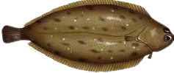

Species | Spatial Field? | Environment Splines? | Log Likelihood | Matern range | Model weight
Dover sole | FALSE | FALSE | -37840 | 102.7 | <0.01
Dover sole | FALSE | TRUE | -37502 | 106.6 | 0.21
Dover sole | TRUE | FALSE | -36735 | 135.4 | <0.01
Dover sole | TRUE | TRUE | -36535 | 122.7 | 0.79

Table A.1 Model fit statistics for the four Dover sole models, including the options chosen for each model (i.e., whether to include spatial fields and whether or not the relationships between CPUE and bottom temperature and oxygen were modelled as splines), the model weight in the ensemble after cross-validation (see Methods), the out-of-sample log likelihood from cross-validation, the Matern practical range parameter (defined as the distance at which the spatial correlation in the data drops to ⍴=0.13 (Lindgren and Rue 2015)), and finally the model weight used in subsequent analyses.

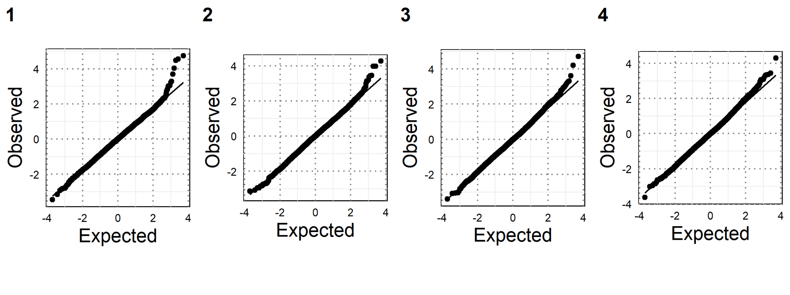
Figure A.1 Randomized quantile residual plots (Dunn and Smyth 1996) for the four Dover sole models described in Table A.1.
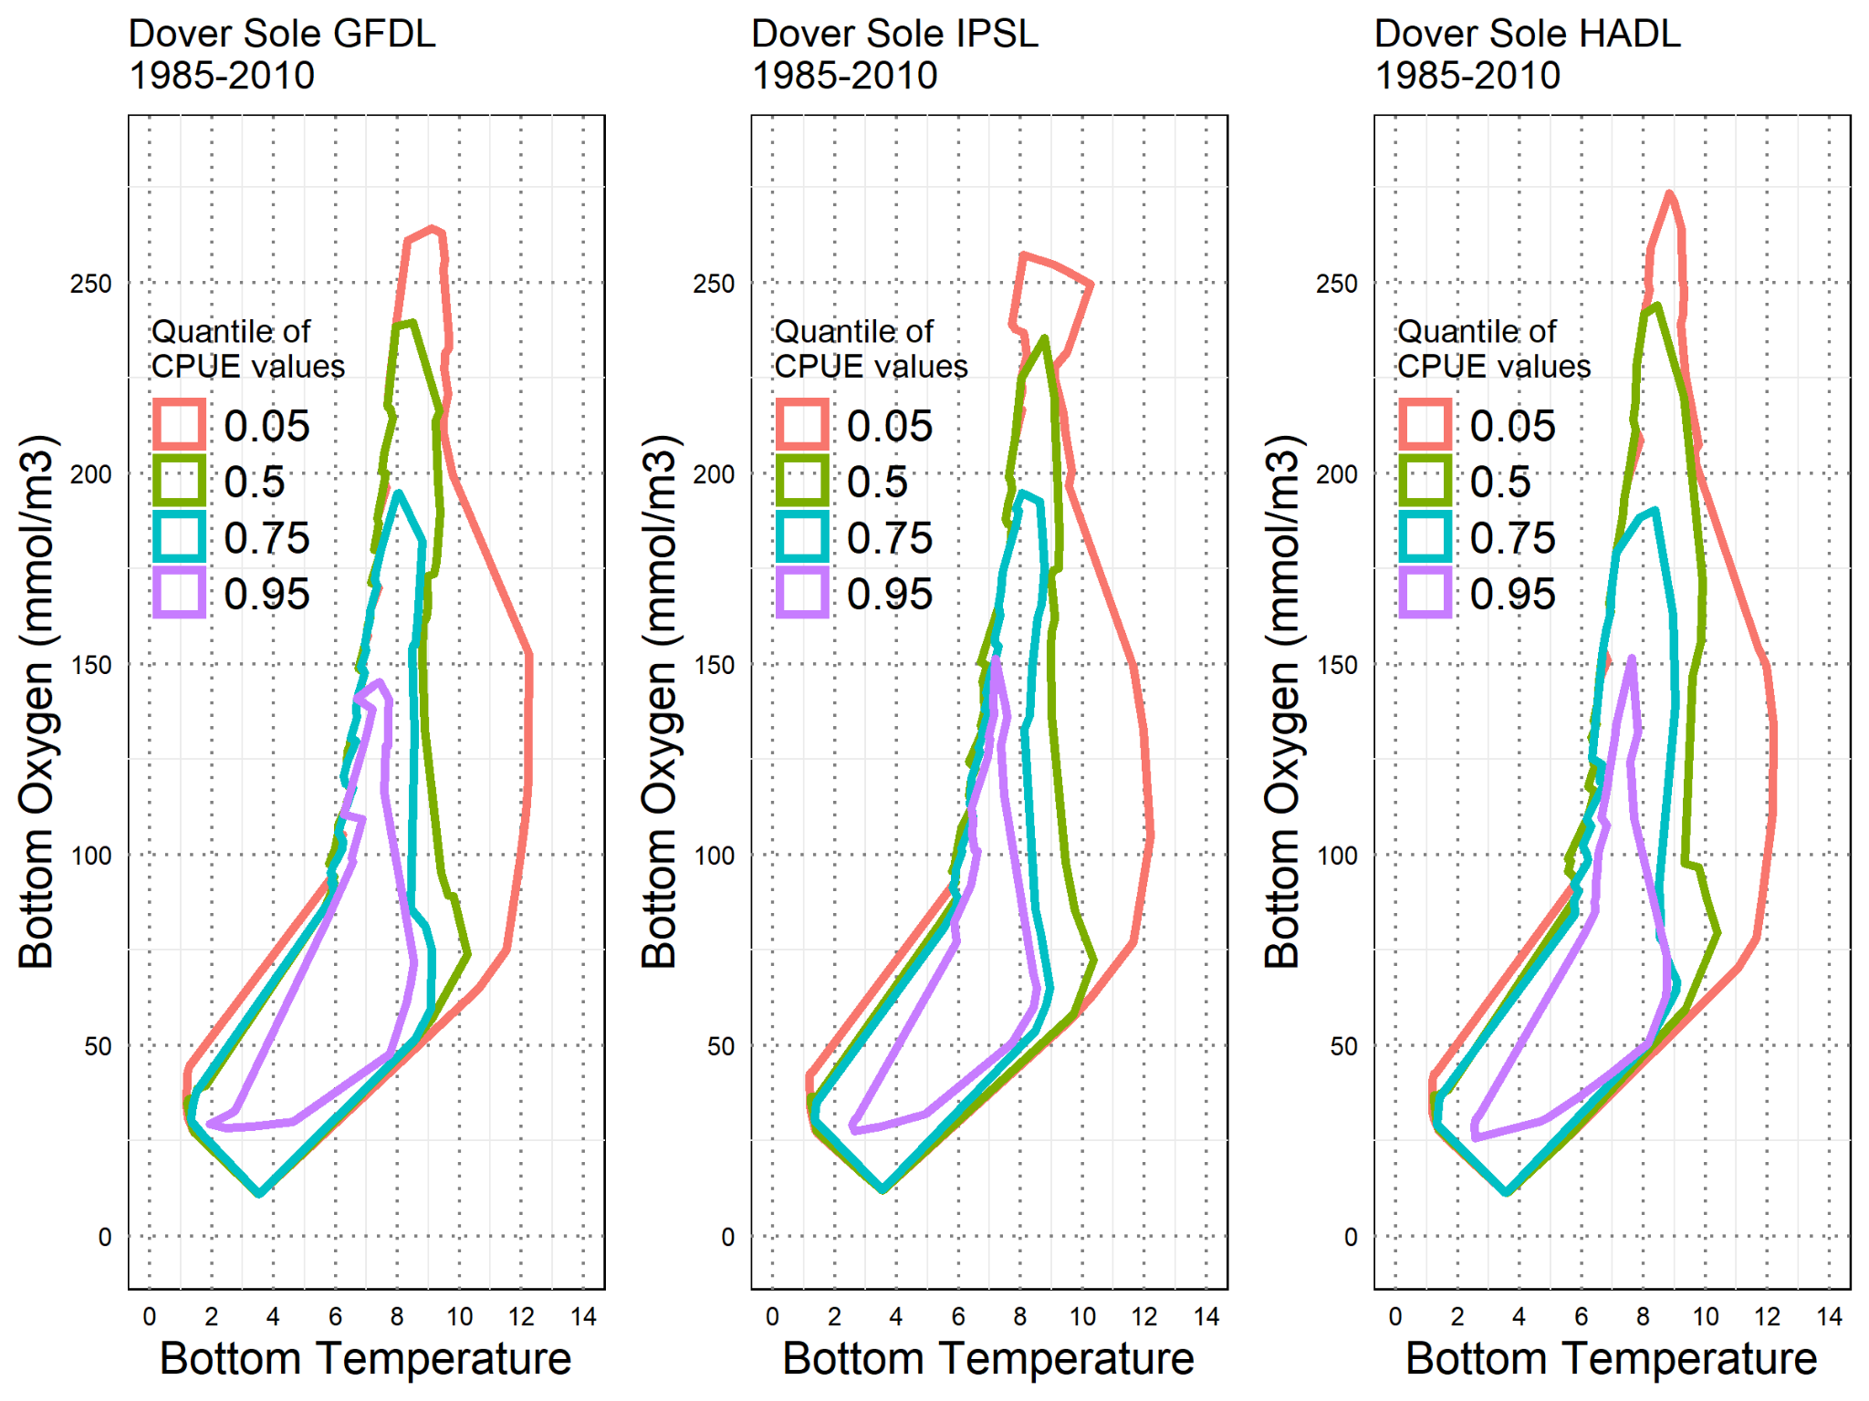
Figure A.2 Empirical environmental niche of Dover sole estimated using the ensemble predictions for 1985 to 2010 under the three separate Earth System Models (GFDL, IPSL, and HADL, respectively, from left to right). Each polygon is a concave hull outlining a range of bottom temperature (x-axis) and bottom oxygen (y-axis) values encompassing all values greater than or equal to the 5th, 50th, 75th, or 95th percentile of predicted CPUE values.

Sablefish
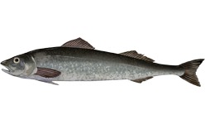
Species | Spatial Field? | Environment Splines? | Log Likelihood | Matern range | Model weight
Sablefish | FALSE | FALSE | -31534 | 65.79 | 0.10
Sablefish | FALSE | TRUE | -31506 | 68.56 | 0.12
Sablefish | TRUE | FALSE | -31640 | 50.21 | <0.01
Sablefish | TRUE | TRUE | -31597 | 51.14 | 0.78

Table A.2 Model fit statistics for the four sablefish models, including the options chosen for each model (i.e., whether to include spatial fields and whether or not the relationships between CPUE and bottom temperature and oxygen were modelled as splines), the model weight in the ensemble after cross-validation (see Methods), the out-of-sample log likelihood from cross-validation, the Matern practical range parameter (defined as the distance at which the spatial correlation in the data drops to ⍴=0.13 (Lindgren and Rue 2015)), and finally the model weight used in subsequent analyses.

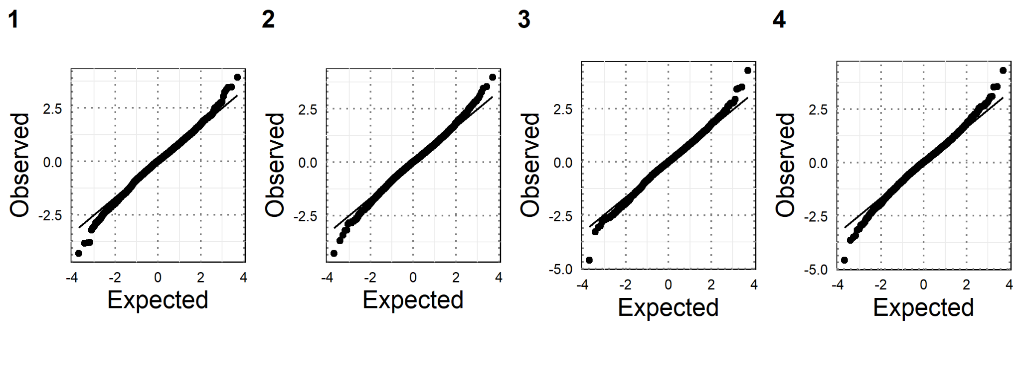
Figure A.3 Randomized quantile residual plots (Dunn and Smyth 1996) for the four sablefish models described in Table A.2.
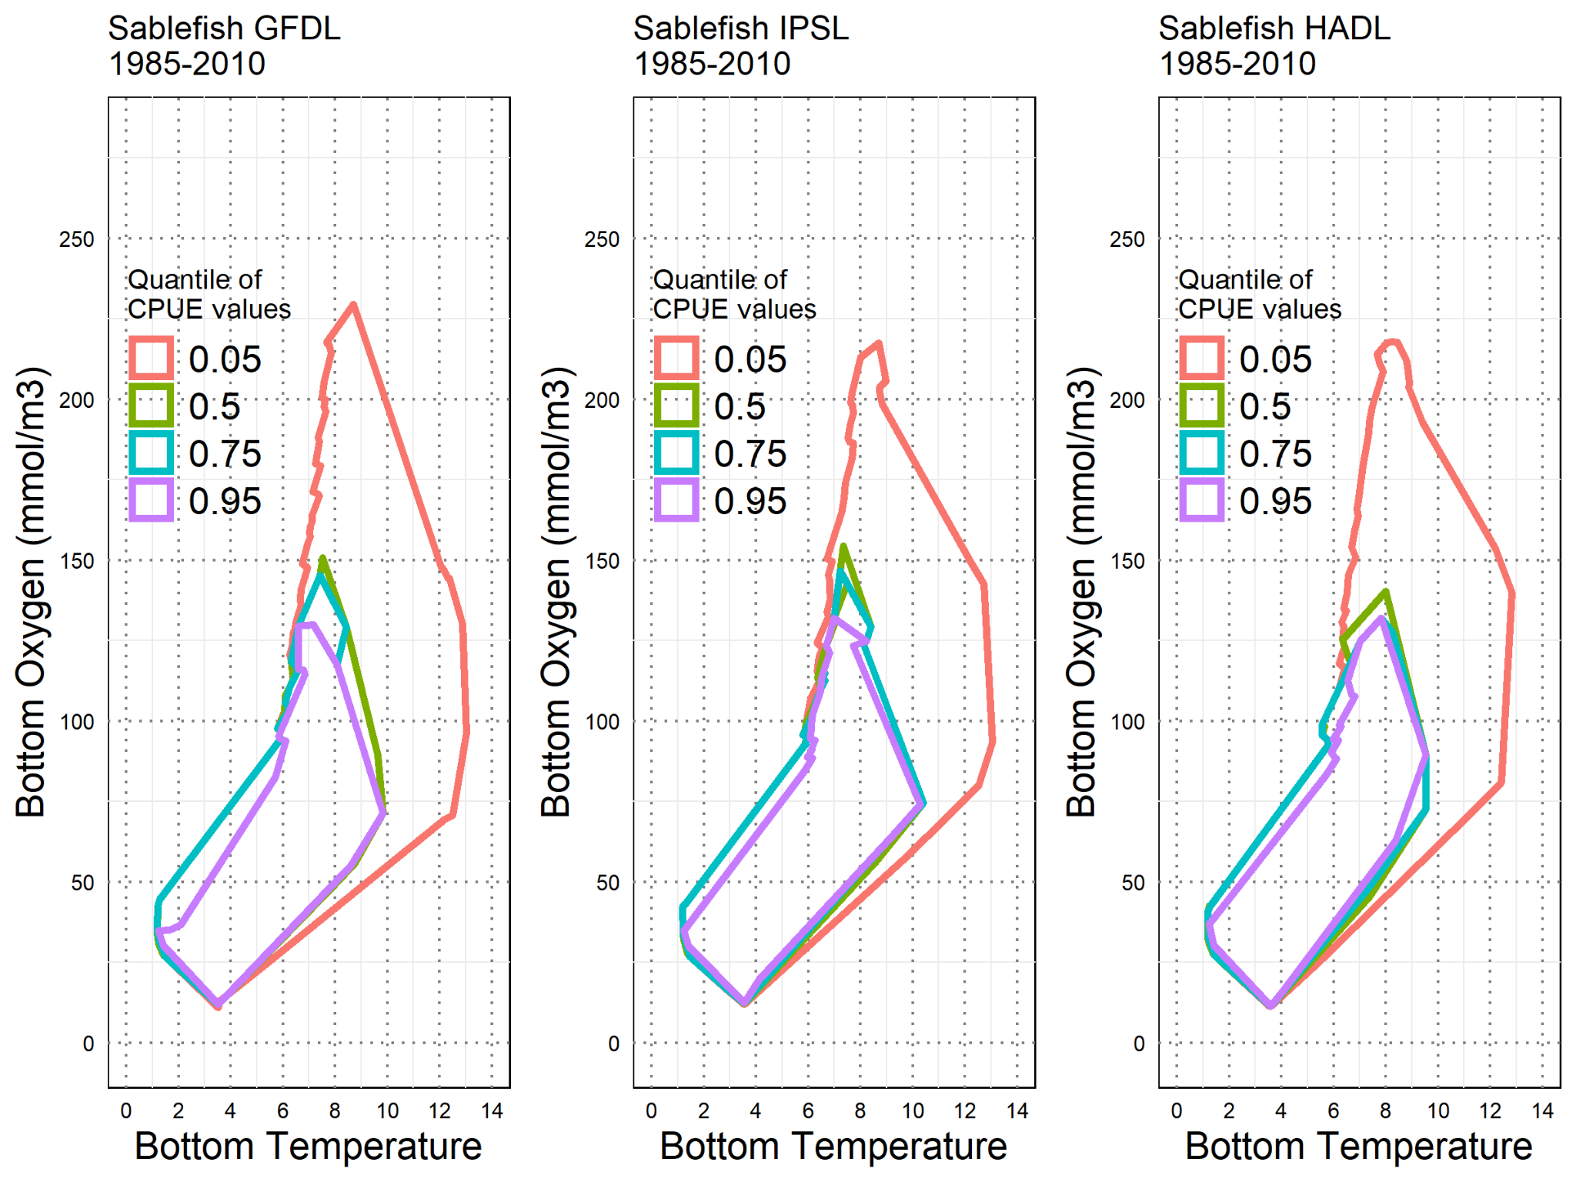
Figure A.4 Empirical environmental niche of sablefish estimated using the ensemble predictions for 1985 to 2010 under the three separate Earth System Models (GFDL, IPSL, and HADL, respectively, from left to right). Each polygon is a concave hull outlining a range of bottom temperature (x-axis) and bottom oxygen (y-axis) values encompassing all values greater than or equal to the 5th, 50th, 75th, or 95th percentile of predicted CPUE values.

Shortspine Thornyhead
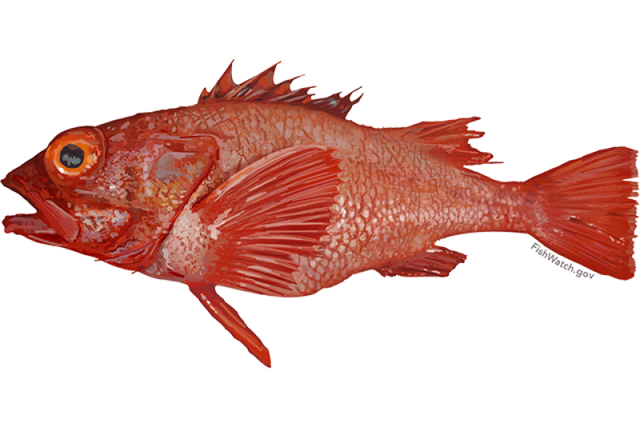
Species | Spatial Field? | Environment Splines? | Log Likelihood | Matern range | Model weight
Shortspine thornyhead | FALSE | FALSE | -21424 | 39.57 | 0.02
Shortspine thornyhead | FALSE | TRUE | -21234 | 41.77 | 0.34
Shortspine thornyhead | TRUE | FALSE | -20905 | 49.26 | <0.01
Shortspine thornyhead | TRUE | TRUE | -20791 | 49.24 | 0.64

Table A.3 Model fit statistics for the four shortspine thornyhead models, including the options chosen for each model (i.e., whether to include spatial fields and whether or not the relationships between CPUE and bottom temperature and oxygen were modelled as splines), the model weight in the ensemble after cross-validation (see Methods), the out-of-sample log likelihood from cross-validation, the Matern practical range parameter (defined as the distance at which the spatial correlation in the data drops to ⍴=0.13 (Lindgren and Rue 2015)), and finally the model weight used in subsequent analyses.

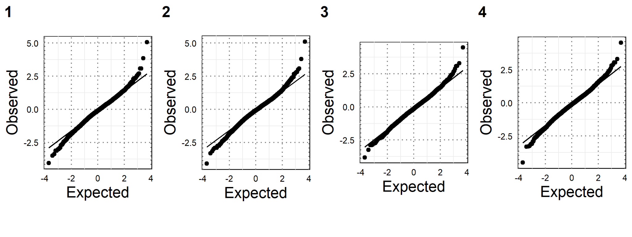
Figure A.5 Randomized quantile residual plots (Dunn and Smyth 1996) for the four shortspine thornyhead models described in Table A.3.

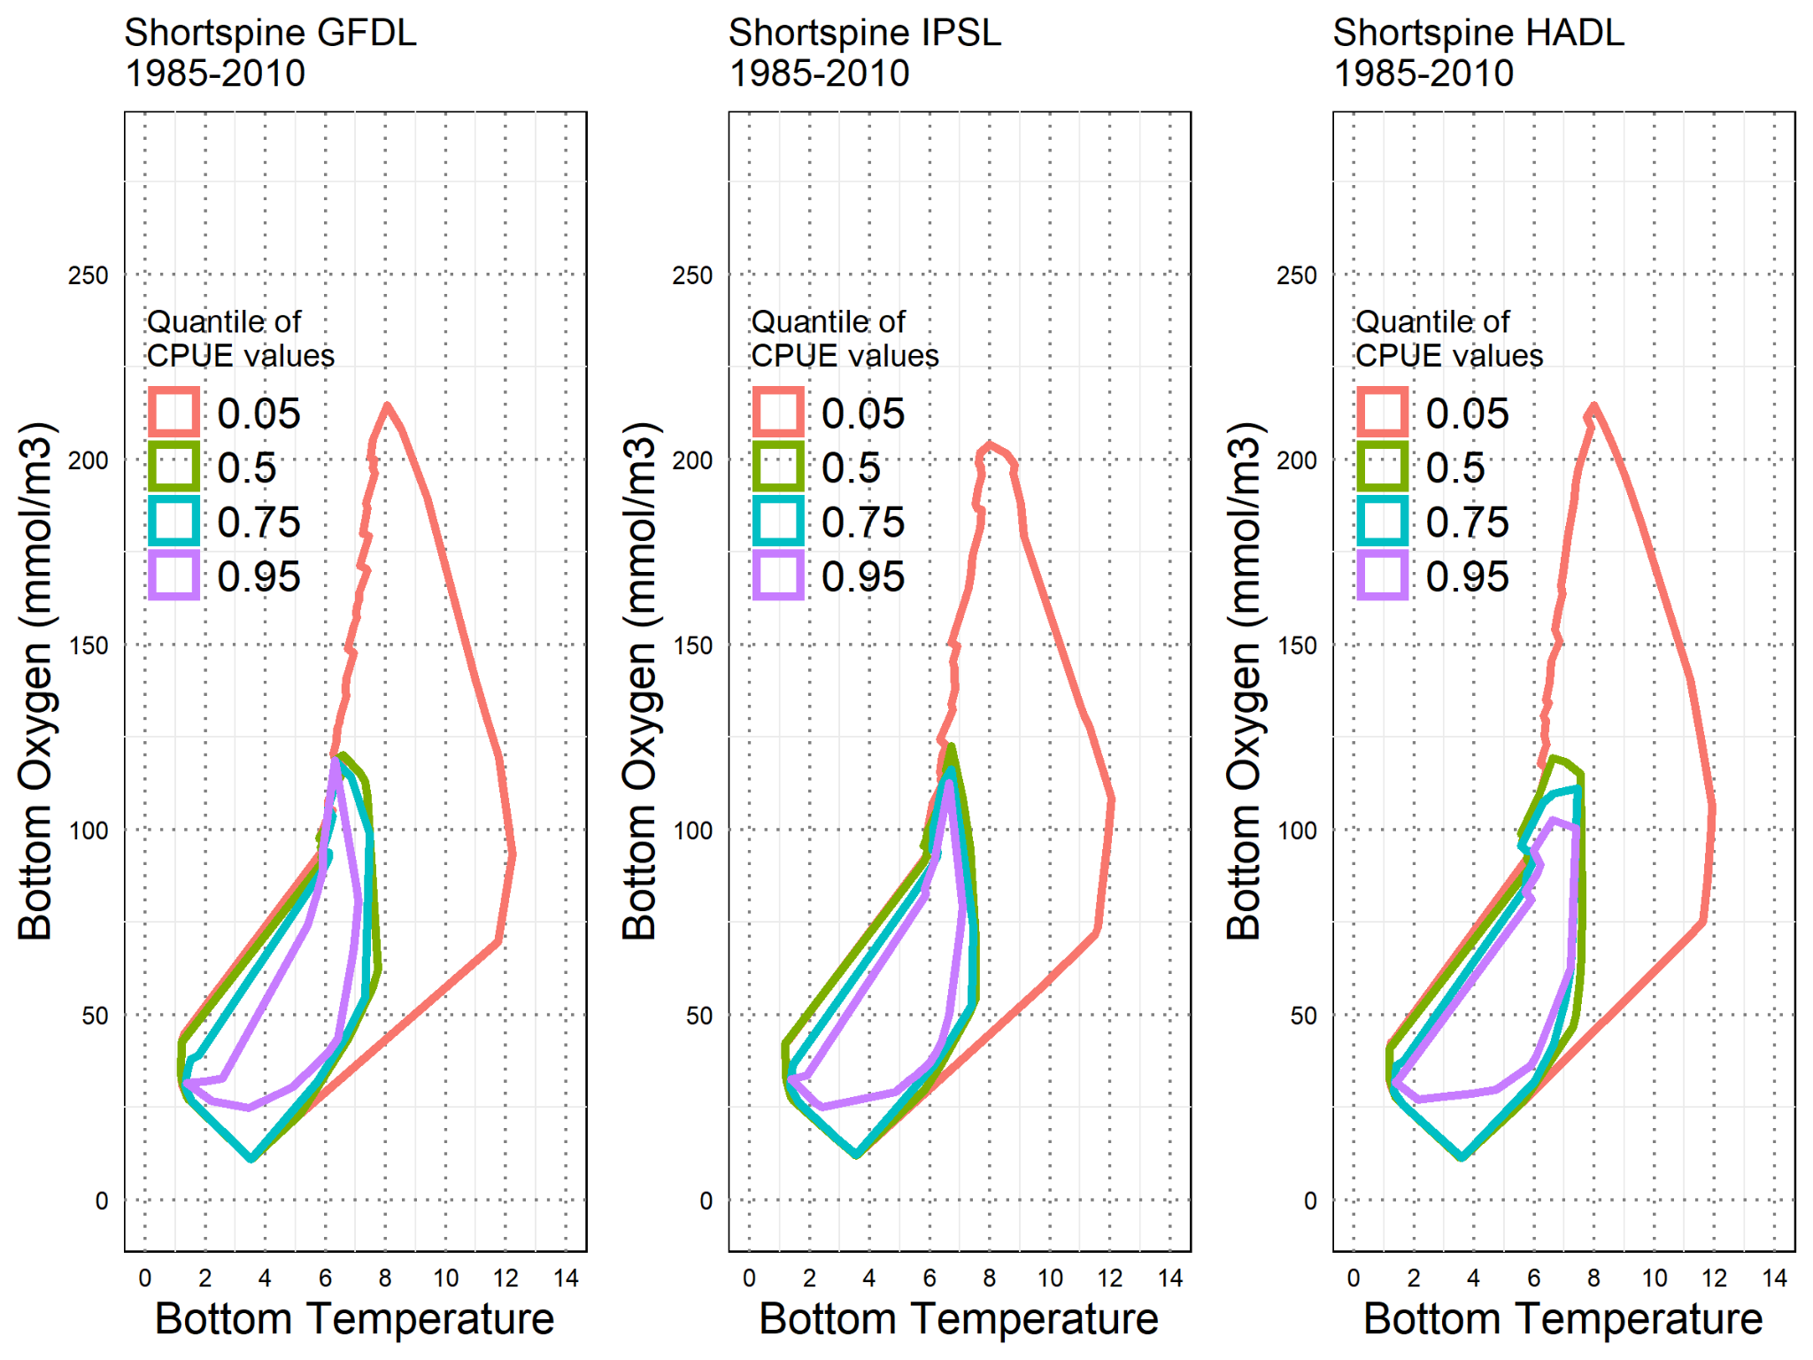
Figure A.6 Empirical environmental niche of shortspine thornyhead estimated using the ensemble predictions for 1985 to 2010 under the three separate Earth System Models (GFDL, IPSL, and HADL, respectively, from left to right). Each polygon is a concave hull outlining a range of bottom temperature (x-axis) and bottom oxygen (y-axis) values encompassing all values greater than or equal to the 5th, 50th, 75th, or 95th percentile of predicted CPUE values.

Longspine Thornyhead
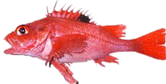
Species | Spatial Field? | Environment Splines? | Log Likelihood | Matern range | Model weight
Longspine thornyhead | FALSE | FALSE | -21390 | 161.74 | <0.01
Longspine thornyhead | FALSE | TRUE | -16334 | 161.44 | 0.09
Longspine thornyhead | TRUE | FALSE | -19332 | 112.92 | 0.80
Longspine thornyhead | TRUE | TRUE | -16095 | 105.76 | 0.11

Table A.4 Model fit statistics for the four longspine thornyhead models, including the options chosen for each model (i.e., whether to include spatial fields and whether or not the relationships between CPUE and bottom temperature and oxygen were modelled as splines), the model weight in the ensemble after cross-validation (see Methods), the out-of-sample log likelihood from cross-validation, the Matern practical range parameter (defined as the distance at which the spatial correlation in the data drops to ⍴=0.13 (Lindgren and Rue 2015)), and finally the model weight used in subsequent analyses.

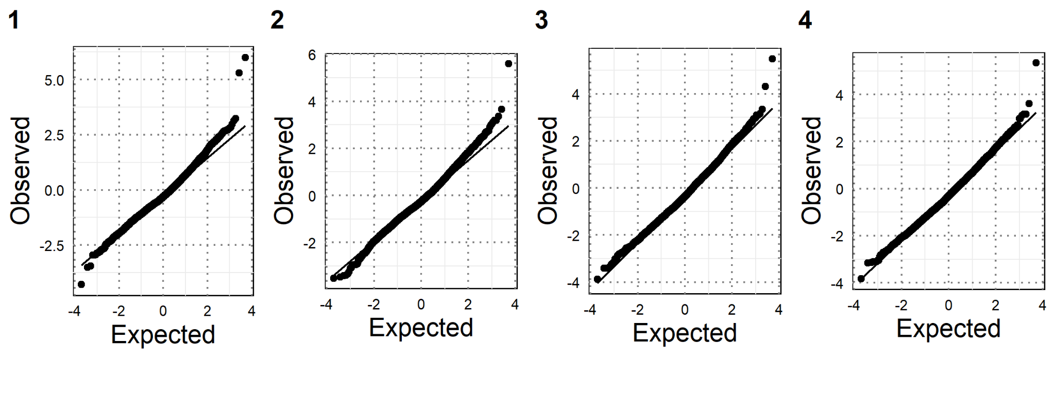
Figure A.7 Randomized quantile residual plots (Dunn and Smyth 1996) for the four longspine thornyhead models described in Table A.4.

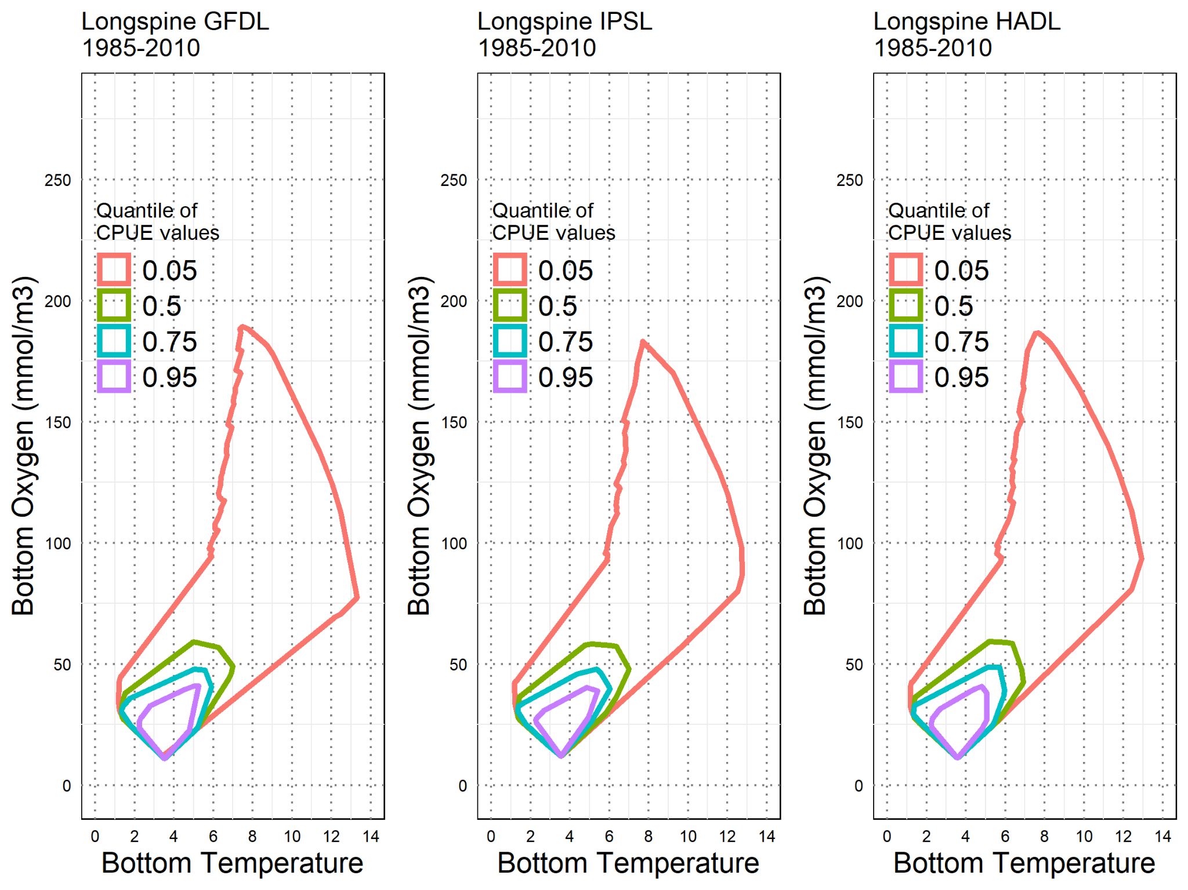
Figure A.8 Empirical environmental niche of longspine thornyhead estimated using the ensemble predictions for 1985 to 2010 under the three separate Earth System Models (GFDL, IPSL, and HADL, respectively, from left to right). Each polygon is a concave hull outlining a range of bottom temperature (x-axis) and bottom oxygen (y-axis) values encompassing all values greater than or equal to the 5th, 50th, 75th, or 95th percentile of predicted CPUE values.

Appendix 2
Supplementary Figures

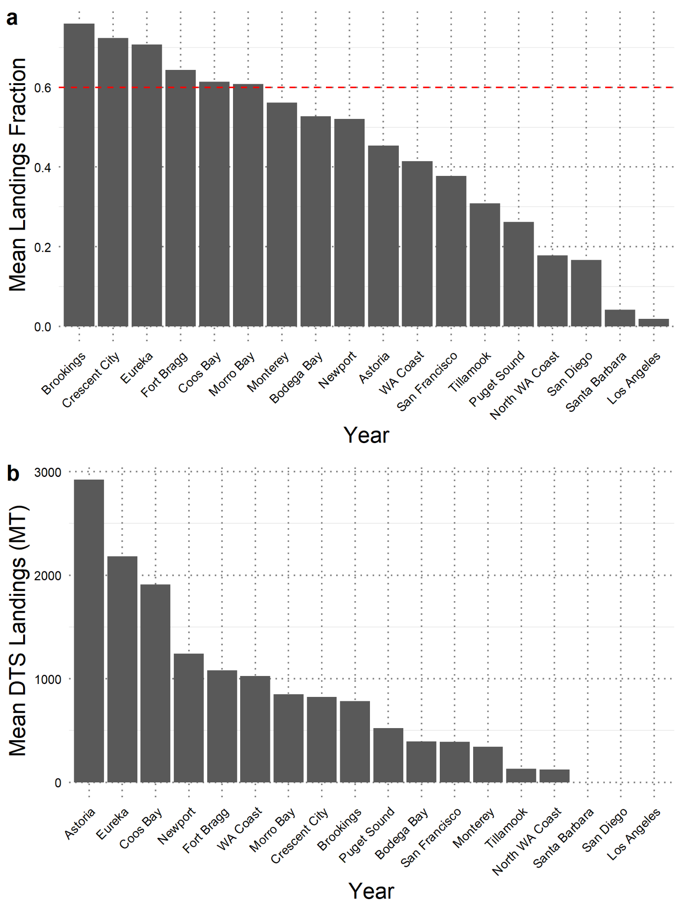
Figure A.9 a) Fraction of all groundfish landings comprised of any combination of DTS species, by IO-PAC port group, and averaged across the years 1987-2019. b) Mean annual landings of DTS species by port group. For the main fishing footprint analysis, we selected all port groups whose mean landings fraction was greater than 0.6, indicated with the red dashed line in (a), and the Astoria port group, which had by far the greatest annual landings of DTS.
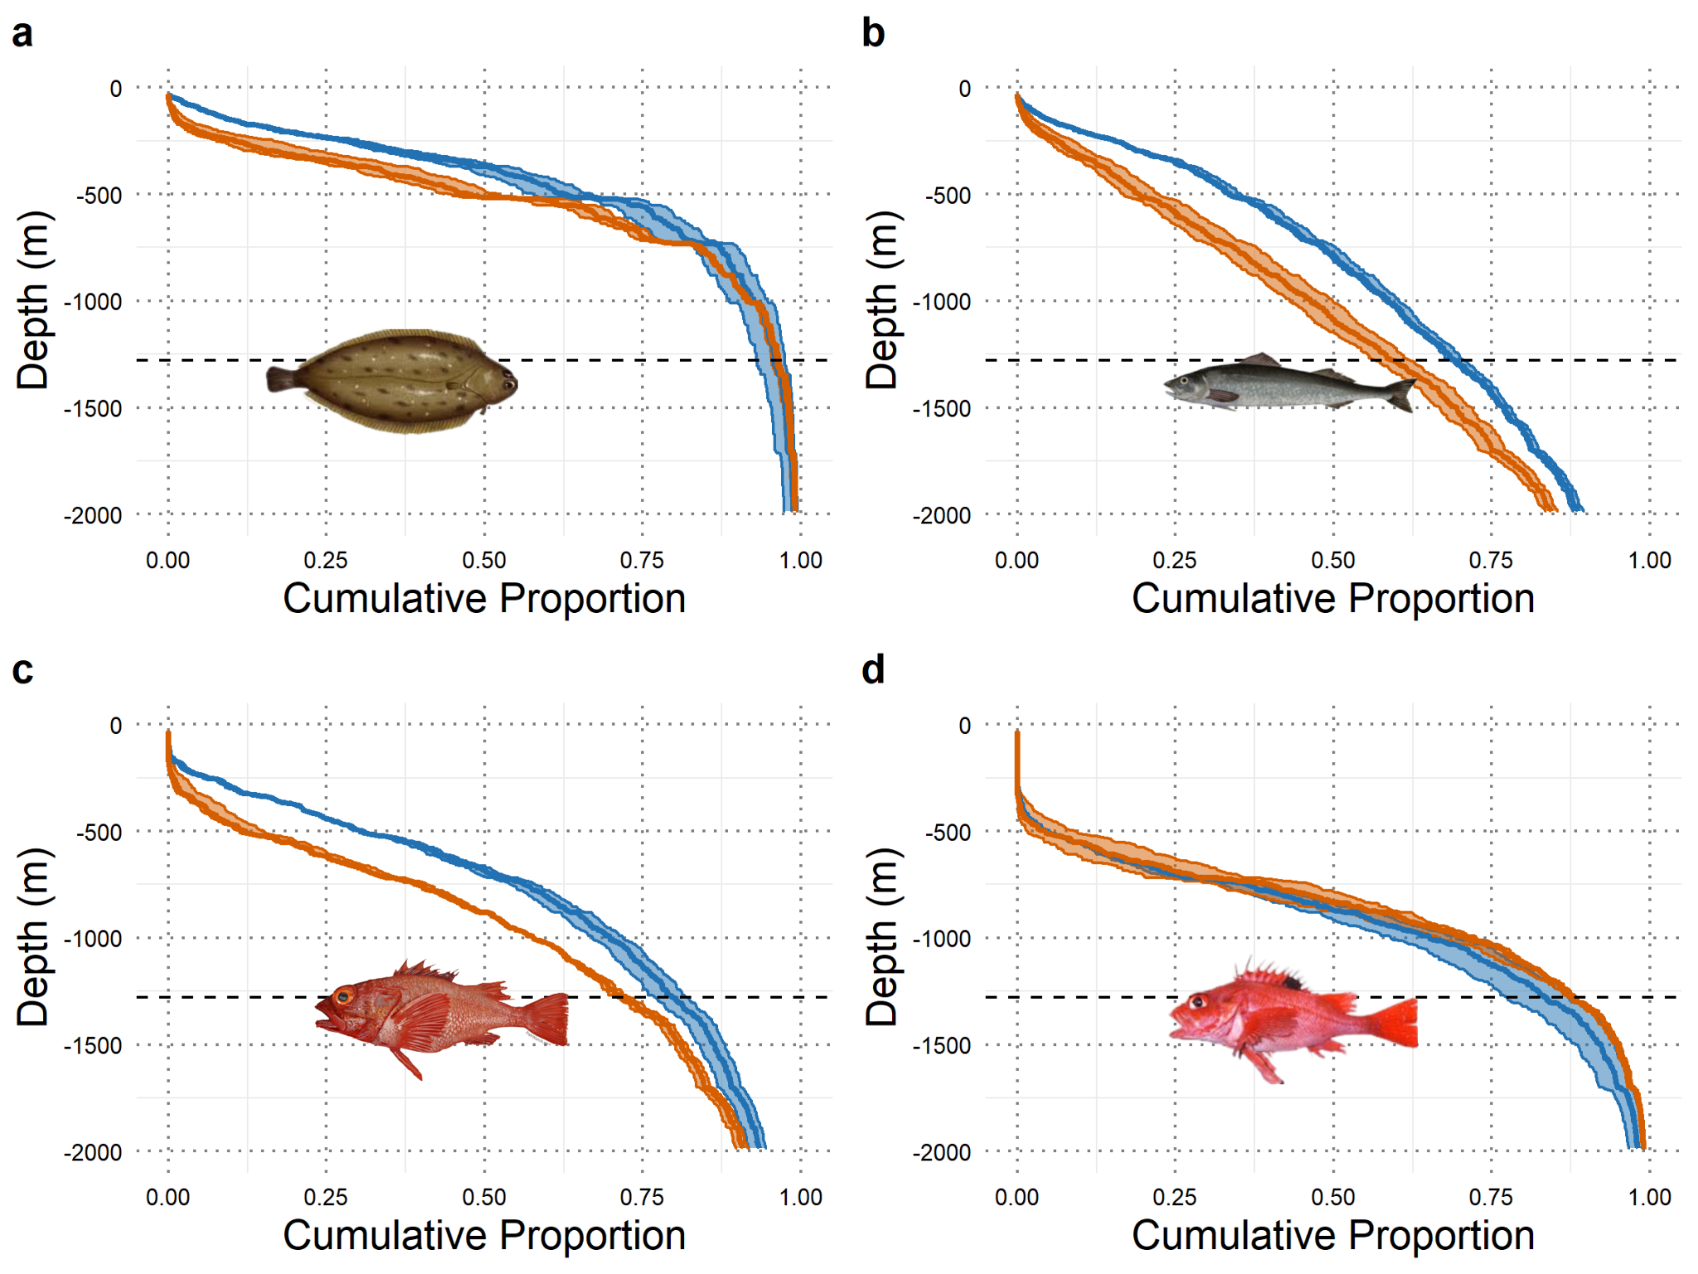
Figure A.10. Cumulative depth distribution change for a) Dover sole, b) sablefish, c) shortspine thornyhead, and d) longspine thornyhead between 1985-2010 (blue line) and 2075-2100 (red line). Values shown as the proportion of total projected biomass (mean, 5th, and 95th percentiles across all CCROMS models and simulations) that is expected to occur shallower than any given depth. Therefore, a red line below a blue line indicates a projected shift to greater depths, and vice versa. Dotted line at 700 fathoms indicates the regulatory depth limit of bottom trawling (see Methods).
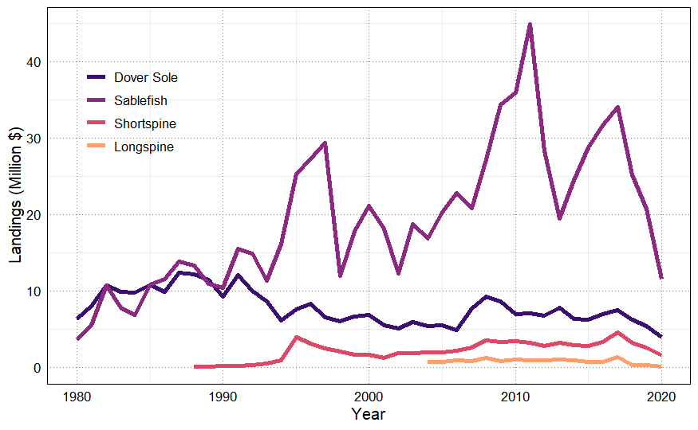
Figure A.11. Landed value of DTS species by year. Data include all ports in Washington, Oregon, and California, 1980-2020, collected from https://www.fisheries.noaa.gov/foss.

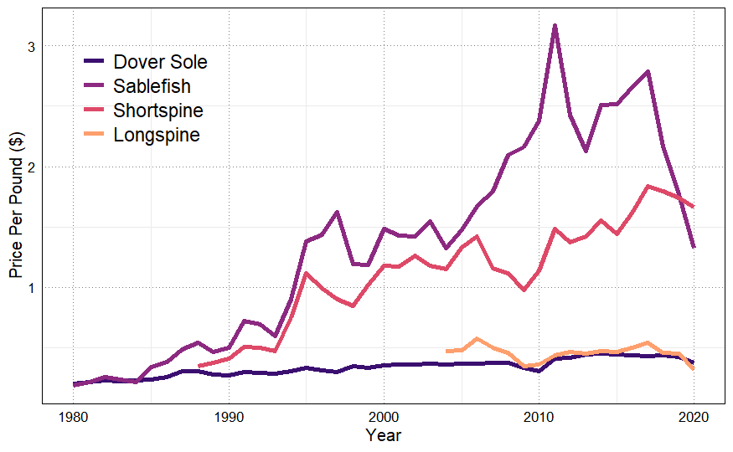
Figure A.12. Price per pound of DTS species by year. Data include all ports in Washington, Oregon, and California, 1980-2020, collected from https://www.fisheries.noaa.gov/foss.
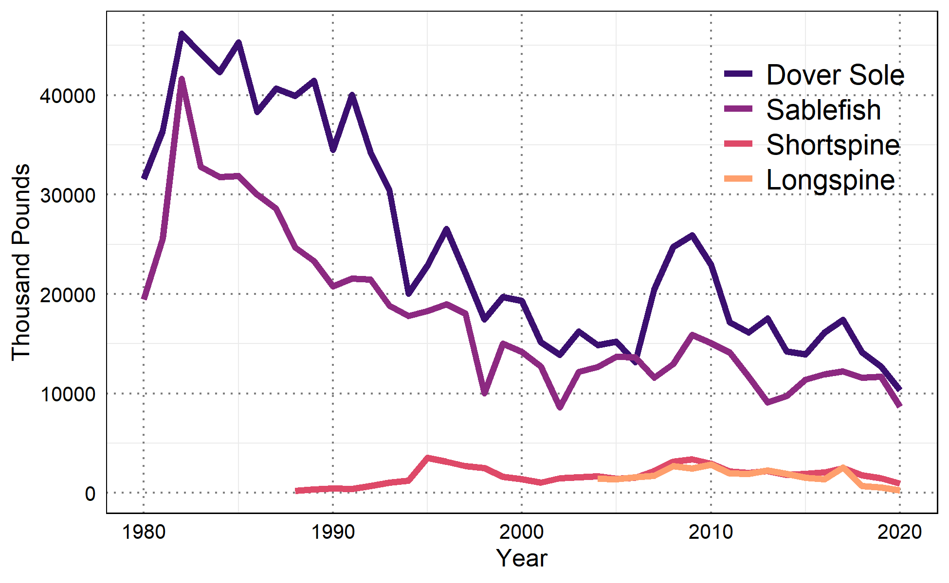
Figure A.13. Landings of DTS species in thousands of pounds by year. Data include all ports in Washington, Oregon, and California, 1980-2020, collected from https://www.fisheries.noaa.gov/foss.

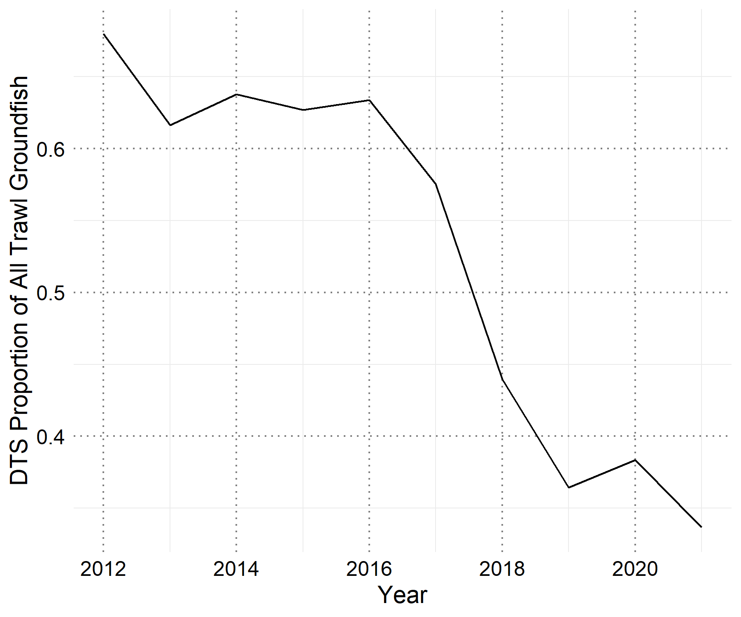
Figure A.14. Landings of DTS species as a proportion of all trawl-caught groundfish species on the U.S. West Coast. Data collected from the Pacific Fisheries Information Network (PacFIN), retrieved 13 December 2022.
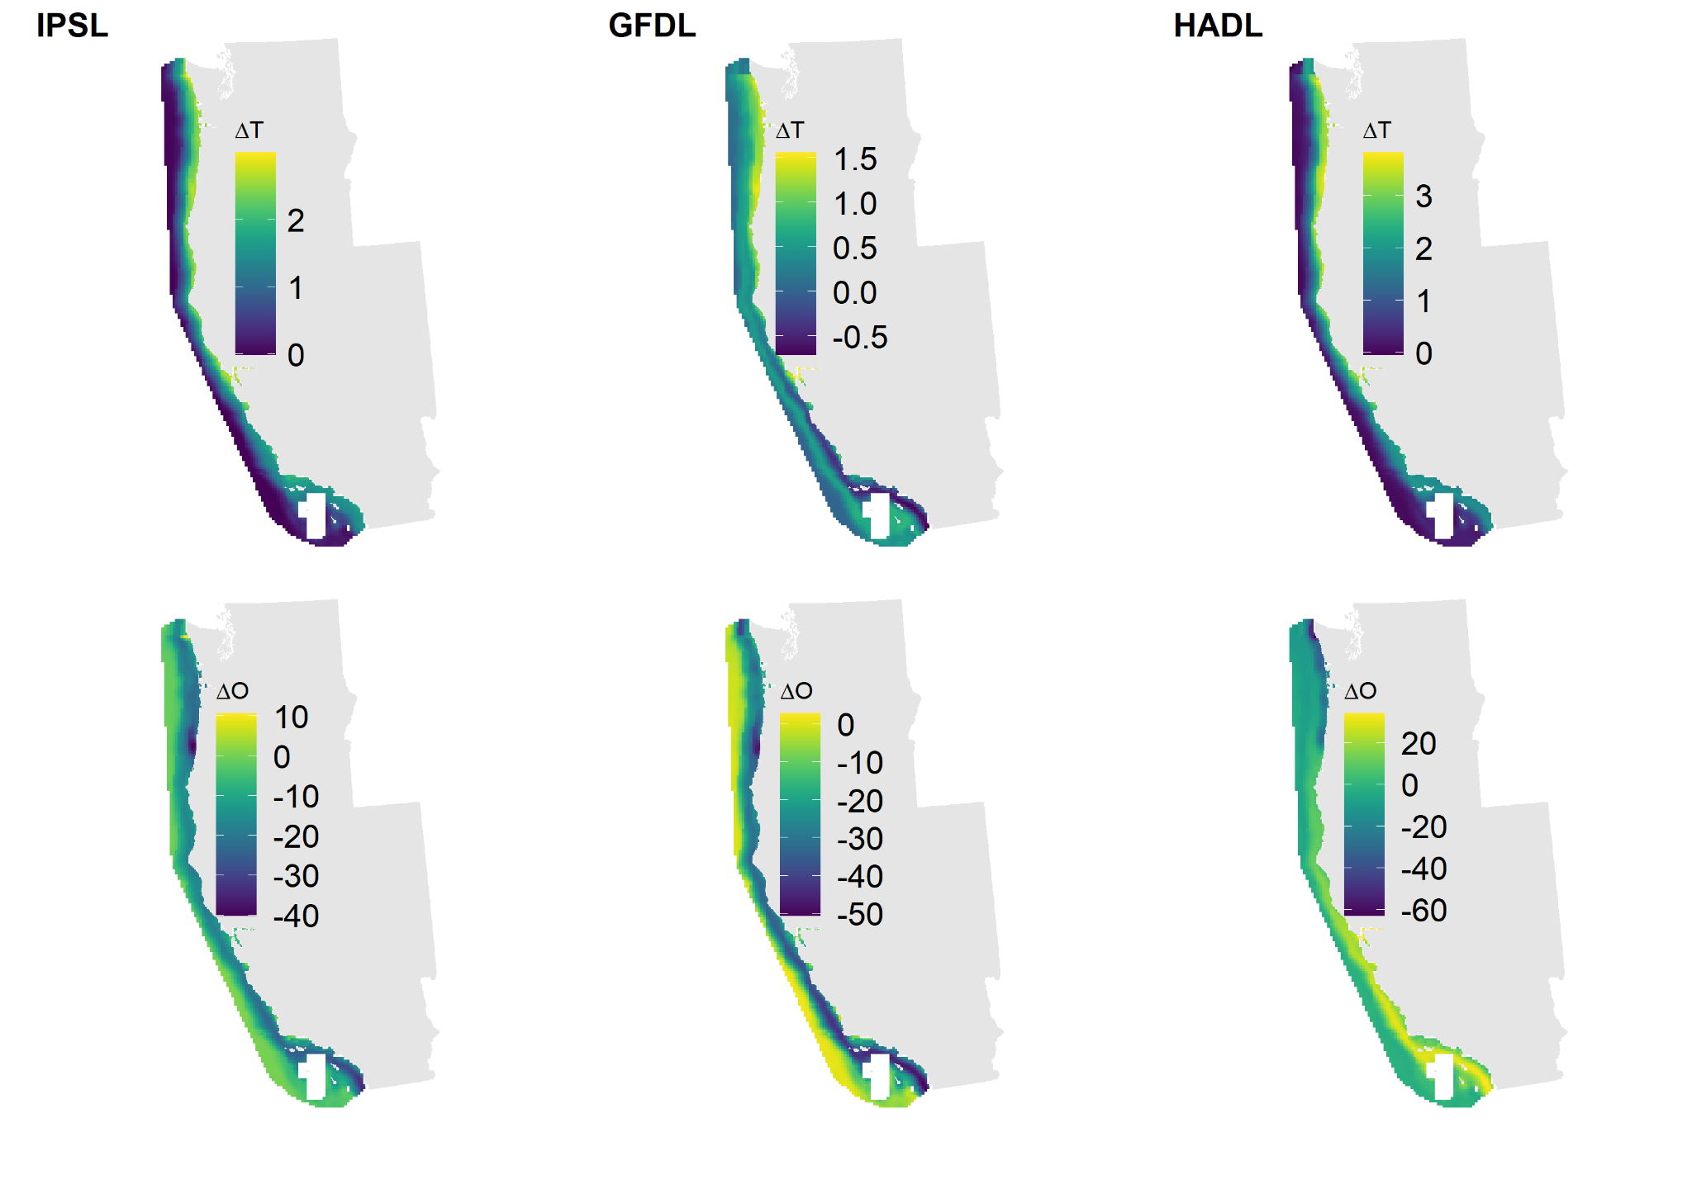
Figure A.14 Projected change in bottom temperature (degrees C) and bottom oxygen (mmol/m3), comparing the 2075-2100 mean to a 1985-2010 baseline period under three alternative Earth System models: Institut Pierre Simon Laplace CM5A-MR (IPSL), Hadley Center HadGEM2-ES (HADL), and Geophysical Fluid Dynamics Laboratory ESM2M (GFDL) ESMs. All of these models assume the RCP8.5 emissions scenario.
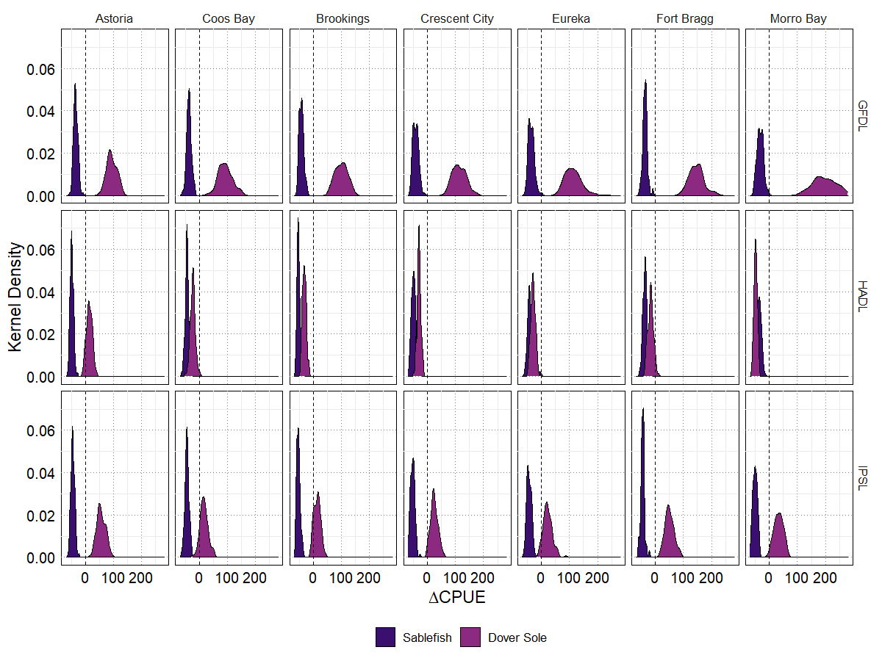
Figure A.15. Projected percent change in CPUE from a 1985-2010 mean to a 2075-2100 mean for sablefish and Dover sole within major U.S. west coast DTS fishing grounds under alternative CCROMS ESM projections (rows).

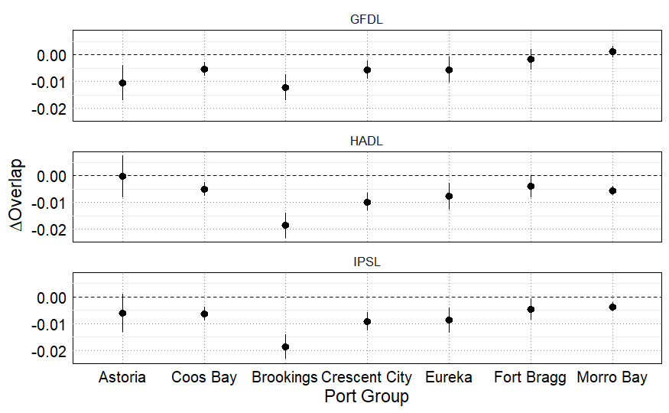
Figure A.16 Change in overlap from a 1985-2010 mean to a 2075-2100 mean for sablefish and Dover sole across major U.S. west coast DTS fishing grounds, measured by the Bhattacharyya’s coefficient under alternative CCROMS ESM projections (rows).

