Cascading use of renewable growing media versus peat or mineral wool: added value of biochar for end-of-life, recycling of nutrients and C storage potential
Supplementary Information (SI)
Table S1. Overview of the set-up of the tomato (T) and strawberry (S) trials.
Code | Duration | Start | End | First harvest | Mineral wool | Peat | Renewable | Renewable + biochar
T1 | short (130 days) | 27/06/2019 | 4/11/2019 | 27/08/2019 | x | x | peatfree | 10 vol% biochar 1
T2 | long (315 days) | 12/12/2019 | 22/10/2020 | 17/03/2020 | x | x | peatfree
T3 | long (317 days) | 8/12/2020 | 21/10/2021 | 16/03/2021 | x |  | peatfree
S1 | long (279 days) | 20/08/2019 | 25/05/2020 | 1/10/2019 and 9/4/2020 |  |  | Peatreduced | 10 vol% biochar 1
S2 | long (278 days) | 19/08/2020 | 24/05/2021 | 1/10/2020 and 9/4/2021 |  | x | Peatreduced | 3 vol% biochar 2
S3 | short (153 days) | 14/07/2021 | 14/12/2021 | 24/08/2021 |  | x | Peatreduced | 10 vol% biochar 3
Details
T1 | 11/12 slabs/treatment, peatfree slabs: 1,20m, 3 plants/slab, peat slab: 0,90m, 2 plants/slab, mineral wool slab: 1,33 m, 3 plants/slab
T2 | Peat and peatfree slabs: 1,00m (26L), 2 plants per slab, mineral wool slab: 2,00 m (30L), 4 plants per slab, 40 plants per object
T3 | Peat and peatfree slabs: 1,00m (26L), 2 plants per slab, mineral wool slab: 2,00 m (30L), 4 plants per slab, 40 plants per object
S1 | White 9L Meerle trays, 24/09/2019: fertigation regime switched (reproductive phase)
S2 | White 9L Meerle trays, 24/08/2020: fertigation regime switched (reproductive phase)
S3 | White 8L Beekenkamp trays, 10/08/2021 fertigation regime switched (reproductive phase)

Table S2. Composition of the fertigation solution during the vegetative and harvest stage of strawberry (S) cultivation, and during tomato (T) cultivation
 | K | Mg | Ca | NH₄ | NO₃ | P | Cl | SO₄ | Fe | Mn | Cu | Zn | B | Mo | EC
 | mmol/l |  |  |  |  |  |  |  | µmol/l |  |  |  |  |  | mS/cm
Strawberry, vegetative | 5.3 | 1.2 | 3.1 | 1.0 | 11.1 | 1.0 | 0.0 | 1.5 | 37.5 | 25.0 | 0.8 | 7.0 | 15.0 | 0.5 | 1.5
Strawberry, harvest | 6.8 | 1.1 | 3.0 | 0.0 | 10.5 | 0.9 | 0.0 | 1.8 | 37.5 | 25.0 | 0.8 | 7.0 | 15.0 | 0.5 | 1.5
Tomato | 11.1 | 2.1 | 5.5 | 0.5 | 18.2 | 2.0 | 1.0 | 2.8 | 40.0 | 21.0 | 0.8 | 5.0 | 30.0 | 0.5 | 3.0

Table S3. Characteristics of the biochars used in the tomato (T) and strawberry (S) trials (EC: electrical conductivity, OC: organic C, DM: dry matter).

Trial |  | S1, T1 | S2 | S3
Biochar type |  | Mixed park wood biochar | Mixed park wood biochar | Fine beech wood biochar
pH-H2O | - | 9.0 | 9.5 | 9.3
EC | µS/cm | 180 | 416 | 242
OC | %/DM | 74 | 77 | 83
total N | %/DM | 0.17 | 0.48 | 0.35
C/N | - | 448 | 160 | 241
P | mg/kg DM | 0.4 | 2.5 | 0.5
K | mg/kg DM | 3.2 | 5.2 | 7.3
Mg | mg/kg DM | 1.6 | 1.7 | 1.8
Ca | mg/kg DM | 8.1 | 10.0 | 12.7
Reactor |  | Indirectly heated screw feeding reactor | Indirectly heated screw feeding reactor | Pilot-scale grate-type gasifier
Configuration |  | Cylindrical horizontal vessel rotating around its axis | Cylindrical horizontal vessel rotating around its axis | Gasification on a Grate
Quality control |  | inert gas flow in countercurrent mode to prevent tar condensation | inert gas flow in countercurrent mode to prevent tar condensation | poly-aromatic hydrocarbons released are taken up in the gas stream and burned by the use of the secondary air
Input capacity | kg/h | 3-5 | 3-5 | 20-40
Temperature | °C | 670 | 600 | 550

Table S4. Composition (vol%) of the peat, peat-reduced, peat-free and biochar-amended blends used in the tomato (T) and strawberry (S) trials.
Trial | S1, S2 | S1, S2, S3 | S1, S3 | S2 | T1, T2 | T1, T2, T3 | T1
Blend | Peat | peat-reduced | peat-reduced + biochar | peat-reduced + biochar | Peat | Peatfree | Peatfree + biochar
Peat | 75 | 45 | 41 | 44 | 80 | 0 | 0
Coir | 15 | 9 | 8 | 9 | 20 | 40 | 36
Perlite | 10 | 6 | 5 | 6 | 0 | 0 | 0
Wood fiber | 0 | 25 | 22.5 | 24 | 0 | 30 | 27
Green compost | 0 | 15 | 13.5 | 14 | 0 | 10 | 9
Biochar | 0 | 0 | 10 | 3 | 0 | 0 | 10
Bark compost | 0 | 0 | 0 | 0 | 0 | 20 | 18

Table S5. Microbial biomass in the spent growing media of strawberry trial S2 (2 samples analysed per blend) versus the virgin material used in the growing media blends, based on phospholipid fatty acids (PLFA) quantification* (OC: organic carbon).
 | Blend/material | Replicate | Total non-specific bacteria | Total gram+ bacteria | Total gram- bacteria | Total fungi | Total biomass
 |  |  | nmol/g OC | nmol/g OC | nmol/g OC | nmol/g OC | nmol/g OC
Spent growing media | peat-reduced | 1 | 289 | 314 | 155 | 162 | 1113
 |  | 2 | 594 | 612 | 318 | 382 | 2270
 | peat-based | 1 | 243 | 173 | 144 | 161 | 833
 |  | 2 | 228 | 169 | 125 | 166 | 801
 | peat-reduced + biochar | 1 | 394 | 336 | 203 | 271 | 1437
 |  | 2 | 275 | 331 | 181 | 138 | 1147
Virgin material | Green compost |  | 495 | 696 | 202 | 98 | 1711
 | Bark compost |  | 204 | 116 | 63 | 141 | 616
 | Wood fiber |  | 35 | 18 | 14 | 39 | 140
 | Coir |  | 138 | 90 | 51 | 69 | 420
 | Peat |  | 38 | 29 | 6 | 14 | 116

*PLFAs were isolated from 0.75g freeze-dried material using phosphate buffer, chloroform and methanol at a 0.9 : 1 : 2 ratio. Phospholipids separated by solid phase extraction were saponified and then methylated using 0.2 M methanolic KOH to form fatty acid methyl esters (FAME), which were analyzed using a capillary gas chromatograph-flam ionization detector (Perkin Elmer Clarus 600, Perkin Elmer, Waltham, MA, USA) with a Supelco SP-2560 column. PLFAs were identified by retention time using an external FAME (RESTEK Corporation, Bellefonte, PA, USA) and bacterial acid methyl ester (BAME) mix (Sigma Aldrich, St Louis, MO, USA) and quantified with a C19 : 0 internal standard. Total microbial biomass was calculated as the sum of 18 PLFAs (i-C15 : 0, a-C15 : 0, i-C16 : 0, i-C17 : 0, C16 : 1c9, C17 : 0cy, C19 : 0cy, C14 : 0, C15 : 0, C16 : 0, C17 : 0, C18 : 0, 10Me-C16 : 0, 10Me-C18 : 0, C18 : 2c9,12, C16 : 1c11, C18 : 1c9). To cope with the range of C contents and bulk density of the different materials, total microbial biomass was expressed per g C.

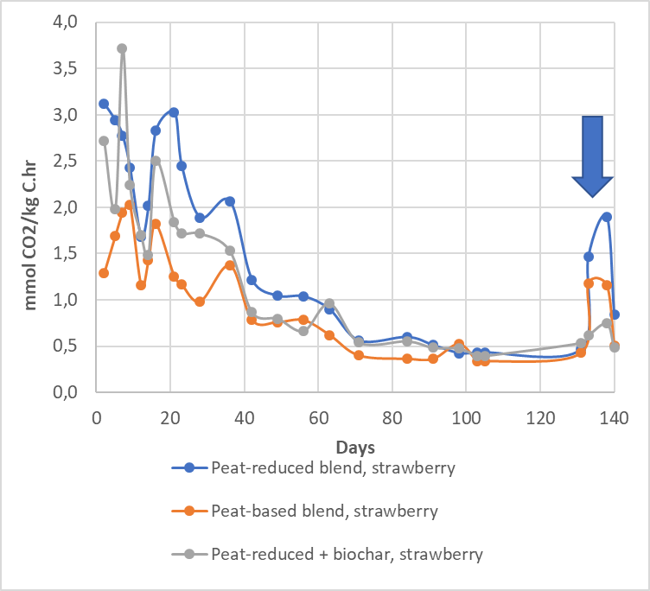
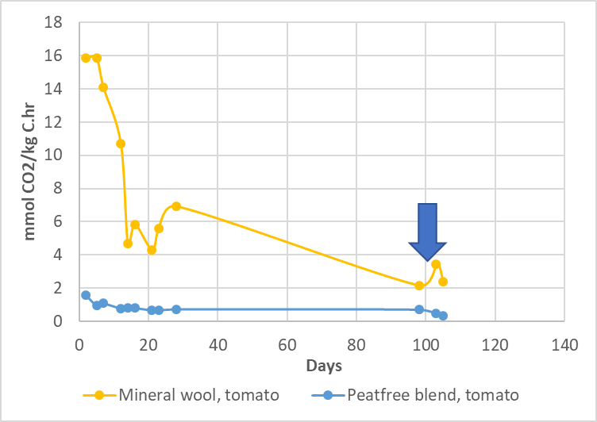
Fig. S1. C mineralization during a 140 day period for spent growing media of tomato trial T3 and strawberry trial S3. An extra dose of mineral fertilizer was added at day 138 for the spent growing media for strawberry, and at day 103 for the spent growing media for tomato. Samples were kept at 20°C and at a constant moisture content during the whole period.

