Supplementary Material

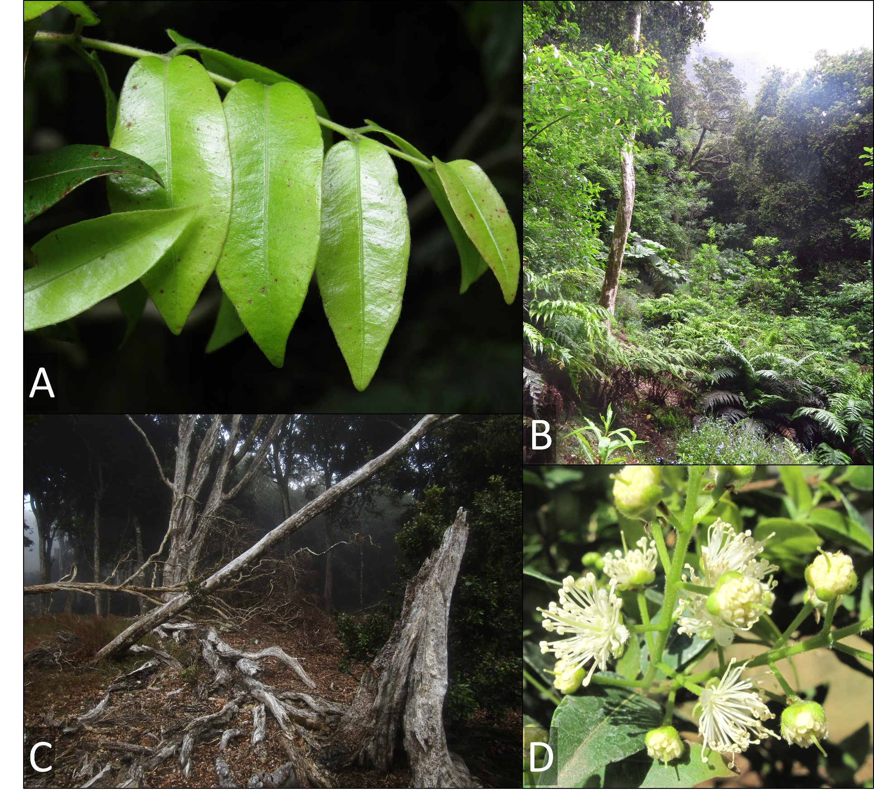
Fig. S1 Characteristics of the tree species N. fernandeziana: (a) new leaves, (b) forests and high plant diversity, (c) closed forest of the species with fallen trees, (d) cluster of flowers

Table S1. Detailed tree-ring information of each N. fernandeziana cross-section analyzed.
N° Samples | Minimum ages (years) | Mean growth (mm) | Standard deviation (mm) | Minimum growth (mm) | Maximum growth (mm)
IRC001 | 142 | 1.16 | 0.73 | 0.17 | 3.20
IRC002 | 166 | 0.65 | 0.38 | 0.09 | 1.95
IRC003 | 161 | 0.92 | 0.65 | 0.13 | 2.60
IRC004 | 175 | 0.64 | 0.47 | 0.10 | 2.26
IRC005 | 189 | 0.74 | 0.51 | 0.04 | 2.26
IRC007 | 219 | 0.73 | 0.43 | 0.09 | 2.74
IRC008 | 243 | 0.84 | 0.55 | 0.08 | 2.97
IRC009 | 86 | 1.25 | 0.90 | 0.16 | 4.00
IRC010 | 201 | 1.28 | 0.80 | 0.12 | 3.72
IRC011 | 456 | 0.56 | 0.49 | 0.05 | 3.26
IRC012 | 129 | 1.21 | 0.48 | 0.18 | 2.33
IRC013 | 222 | 1.00 | 0.57 | 0.12 | 3.28
IRC014 | 218 | 1.12 | 0.65 | 0.25 | 3.75
IRC015 | 122 | 0.58 | 0.46 | 0.12 | 2.32
IRC017 | 179 | 0.97 | 0.82 | 0.14 | 4.77
IRC022 | 195 | 1.22 | 0.64 | 0.24 | 2.90
IRC023 | 177 | 1.22 | 0.88 | 0.17 | 3.40
IRC025 | 96 | 0.51 | 0.43 | 0.12 | 2.80
IRC027 | 124 | 0.55 | 0.40 | 0.10 | 2.31
IRC028 | 120 | .0.63 | 0.37 | 0.10 | 1.74
IRC030 | 149 | 0.54 | 0.26 | 0.10 | 1.31
IRC031 | 228 | 0.95 | 0.53 | 0.13 | 2.40
IRC032 | 201 | 1.16 | 0.92 | 0.19 | 5.18
IRC033 | 196 | 0.41 | 0.33 | 0.07 | 2.17

