Supplementary tables
Supplementary table 1: Feeding and housing schedule for experimental fish.
Age (weeks) | Housing | Food schedule (per tank) | Couple composition
0 – 1 | 1L tank | 2 mL brine shrimp | Bulk hatchlings
1 – 2 | 3,5L tank | 2 mL brine shrimp | 5 hatchlings
2 – 3 | 3,5L tank | 2 mL brine shrimp  0.1 mL Chironomidae larvae | 5 hatchlings
3 – 4 | 3,5L tank | 2 mL brine shrimp  0.25 mL Chironomidae larvae | 4 hatchlings
4 – 5 | 3,5L tank | 2 mL brine shrimp  0.5 mL Chironomidae larvae | 3 females &1 male
5 - 12 | 3,5L tank | 1 mL Chironomidae larvae | 3 females & 1 male
12 - … | 3,5L tank | 1 mL Chironomidae larvae | 3 females

Supplementary table 2: List of the primary and secondary antibodies used for immunohistochemistry.
Primary antibodies
Antibody | Manufacturer | Catalogue number | Host species | Dilution
BrdU | Abcam | AB6326 | Rat | 1:400
TH | Millipore | AB152 | Rabbit | 1:400
Chat | Millipore | AB144P | Goat | 1:200
Secondary antibodies
Goat IgG Alexa 488 | ThermoFisher | A11055 | Donkey | 1:200
Rabbit IgG Alexa 488 | ThermoFisher | A21206 | Donkey | 1:200
Rat IgG Alexa 594 | ThermoFisher | A48271 | Donkey | 1:200

Supplementary table 3: List containing detailed information concerning the training and testing datasets for each counting model. Chat, choline acetyltransferase; n°, number; px, pixels; TH, tyrosine hydroxylase
Label | Training frame n° | Testing frame n° | Frame size (px) | Frame size (µm)
Biocytin | 18 | 36 | 512x512 | 235.89x235.89
TH | 64 | 35 | 768x768 | 353.84x353.84
Chat | 64 | 24 | 512x512 | 235.89x235.89

Supplementary table 4: Overview of the fish used to assess to overall cell size of their retinal single cell suspension. Per age, the number (n°) and length of the fish are reported as well as the percentage of living cells, the total, viable and dead cell numbers, and the average cell size per single cell suspension.
Age (weeks) | Fish n° | Length fish (cm) | Survival (%) | Total cells/mL | Viable cells/mL | Dead cells/mL | <cell size> (µm)
6 | 1 | 2,780 | 76,0 | 5,50E+06 | 4,18E+06 | 1,32E+06 | 6,4
 | 2 | 2,790 | 80,3 | 5,01E+06 | 4,02E+06 | 9,87E+05 | 7,3
 | 3 | 2,480 | 81,3 | 3,99E+06 | 3,24E+06 | 7,46E+05 | 8,0
 | 4 | 2,590 | 82,9 | 3,94E+06 | 3,27E+06 | 6,74E+05 | 7,0
 | 5 | 2,510 | 94,1 | 3,88E+06 | 3,65E+06 | 2,29E+05 | 7,5
 | 6 | 2,860 | 87,6 | 1,04E+06 | 9,11E+05 | 1,29E+05 | 7,5
 | 7 | 2,755 | 91,1 | 9,72E+06 | 8,85E+06 | 8,65E+05 | 7,5
 | 8 | 2,895 | 91,7 | 5,31E+06 | 4,87E+06 | 4,41E+05 | 6,9
 | 9 | 2,620 | 92,4 | 6,26E+06 | 5,78E+06 | 4,76E+05 | 6,7
 | 10 | 2,830 | 91,7 | 8,85E+06 | 8,12E+06 | 7,35E+05 | 7,6
12 | 1 | 3,625 | 77,3 | 6,34E+06 | 4,90E+06 | 1,44E+06 | 7,8
 | 2 | 3,590 | 77,2 | 5,16E+06 | 3,98E+06 | 1,18E+06 | 6,7
 | 3 | 3,160 | 75,1 | 5,33E+06 | 4,00E+06 | 1,33E+06 | 8,1
 | 4 | 3,510 | 81,0 | 5,71E+06 | 4,63E+06 | 1,08E+06 | 8,1
 | 5 | 3,275 | 78,5 | 5,10E+06 | 4,00E+06 | 1,10E+06 | 8,2
 | 6 | 3,220 | 86,2 | 6,64E+06 | 5,72E+06 | 9,16E+05 | 7,2
 | 7 | 3,230 | 89,3 | 1,16E+07 | 1,04E+07 | 1,24E+06 | 7,2
 | 8 | 3,440 | 92,4 | 7,19E+06 | 6,64E+06 | 5,46E+05 | 8,1
 | 9 | 3,355 | 87,6 | 8,04E+06 | 7,04E+06 | 9,97E+05 | 7,1
18 | 1 | 4,180 | 80,0 | 7,93E+06 | 6,34E+06 | 1,59E+06 | 8,5
 | 2 | 3,855 | 77,5 | 7,75E+06 | 6,01E+06 | 1,74E+06 | 7,9
 | 3 | 3,890 | 87,1 | 7,76E+06 | 6,76E+06 | 1,00E+06 | 9,1
 | 4 | 3,845 | 82,9 | 6,46E+06 | 5,36E+06 | 1,10E+06 | 7,9
 | 5 | 3,935 | 87,5 | 8,65E+06 | 7,57E+06 | 1,08E+06 | 8,6
 | 6 | 4,220 | 82,4 | 7,81E+06 | 6,44E+06 | 1,37E+06 | 8,9
 | 7 | 3,880 | 85,2 | 9,18E+06 | 7,82E+06 | 1,36E+06 | 7,9
 | 8 | 4,430 | 83,9 | 9,39E+06 | 7,88E+06 | 1,51E+06 | 8,1
 | 9 | 3,760 | 83,9 | 9,40E+06 | 7,89E+06 | 1,51E+06 | 8,1
 | 10 | 3,780 | 88,2 | 9,46E+06 | 8,34E+06 | 1,12E+06 | 7,7
24 | 1 | 4,400 | 79,4 | 6,82E+06 | 5,42E+06 | 1,40E+06 | 8,5
 | 2 | 4,045 | 83,7 | 4,63E+06 | 3,88E+06 | 7,55E+05 | 9,1
 | 3 | 4,595 | 83,7 | 8,55E+06 | 7,16E+06 | 1,39E+06 | 9,2
 | 4 | 3,900 | 84,5 | 9,45E+06 | 7,99E+06 | 1,46E+06 | 8,7
 | 5 | 4,285 | 84,7 | 7,10E+06 | 6,01E+06 | 1,09E+06 | 9,6
 | 6 | 4,215 | 82,5 | 1,02E+07 | 8,42E+06 | 1,79E+06 | 7,8
 | 7 | 4,230 | 80,8 | 6,29E+06 | 5,08E+06 | 1,21E+06 | 9,0
 | 8 | 4,480 | 84,6 | 1,18E+07 | 9,98E+06 | 1,82E+06 | 8,0
 | 9 | 3,450 | 87,2 | 1,08E+07 | 9,42E+06 | 1,38E+06 | 8,6
 | 10 | 4,000 | 87,0 | 1,08E+07 | 9,40E+06 | 1,40E+06 | 9,2

Supplementary figures
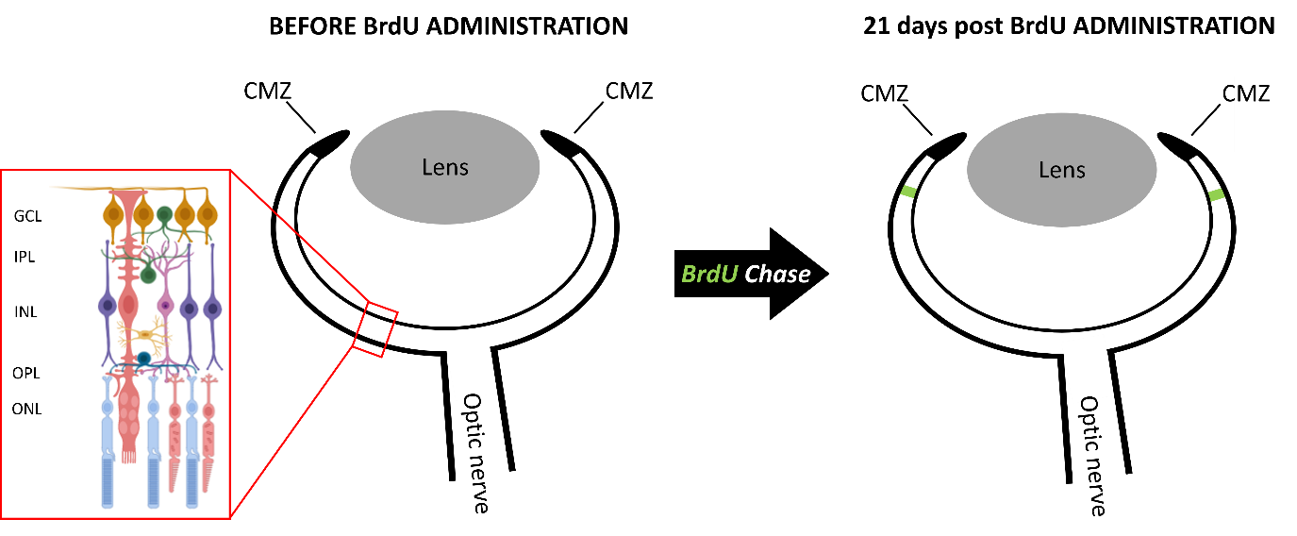
Supplementary figure S1: Schematic illustration of the BrdU pulse chase experiment that enables to evaluate cell addition facilitated by the CMZ. BrdU is injected intraperitoneally twice with a 4 h interval. 21 days later, the fish are sacrificed and BrdU is visualized using immunohistochemistry As the BrdU incorporated by the cells in the stem niche dilutes with every cellular division, a gradient of BrdU labelling can be observed. This results in an area with high BrdU labelling, containing the neurons born at time of BrdU administration, which is found distally from the CMZ at 21 dpIP and here depicted by the green area. The number of BrdU positive cells within this highly positive zone was determined in the three retinal cell layers, being the GCL, INL and ONL. BrdU, 5-Bromo-2’-deoxyuridine; CMZ, ciliary marginal zone; dpIP, days post intraperitoneal injection; INL, inner nuclear layer; IPL, inner plexiform layer; ONL, outer nuclear layer; OPL, outer plexiform layer; GCL, ganglion cell layer.
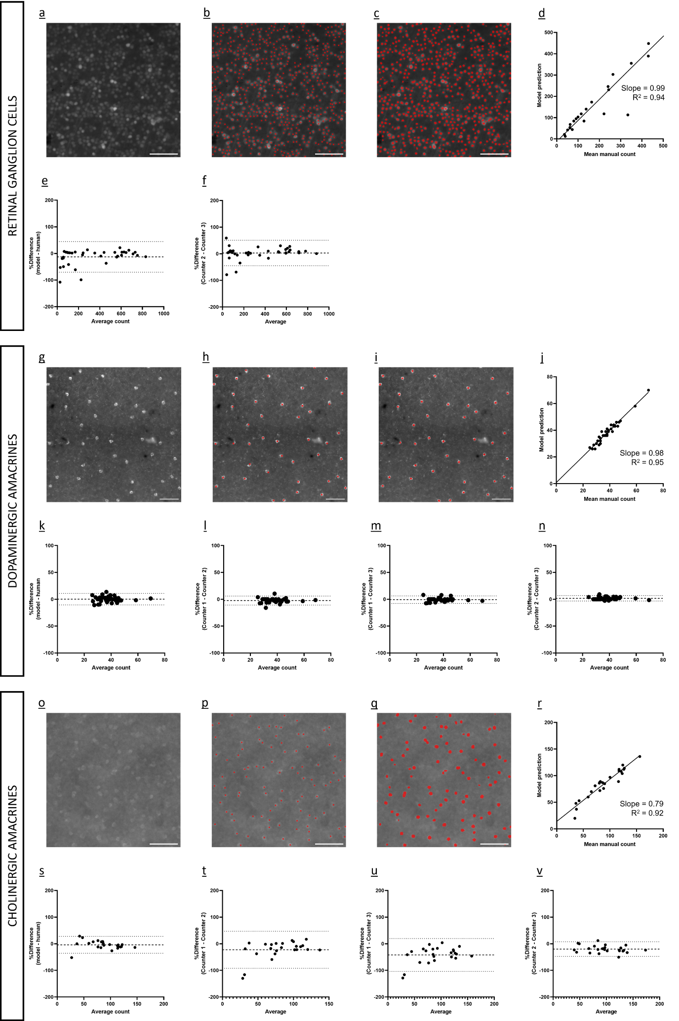
Supplementary figure S2: Analysis of the counting performance of the trained models for RGCs, dopaminergic and cholinergic amacrines. a, g, o To train the deep learning models, frames were sampled from whole-mounts stained for the different cell types, namely retinal ganglion cells (a), dopaminergic (g) and cholinergic (o) amacrine cells. b, h, p Manual annotation of the labelled sells was carried out by expert human counters. c, I, q After model training, the frames were also ran through the deep learning model to evaluate performance. d, j, r To evaluate the performance of the models, linear regression analysis was performed between the average of the manual counts versus the automated ones. This showed a very high linear relationship between the counting methods. The best-fit linear regression correlation coefficients (R2 and slope) are indicated on the graph. e, k, s The bias between counting methods was evaluated via Bland–Altman analysis of the automated counts compared to the human average. The plots depict the mean bias and ±95% limits of agreement. f, l-n, t-v The Bland–Altman bias analyses was performed on the expert counters also. The bias between manual counts performed by different users is comparable to the ones between the average manual count and the model. Thus the performance of the model is deemed satisfactory. Scale bar = 50 μm
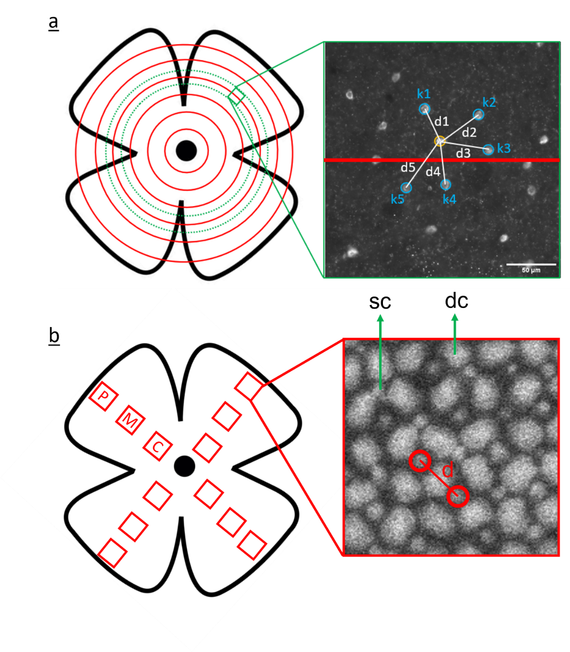
Supplementary figure S3: Schematic illustration of the tissue stretching analyses within the INL and ONL of the killifish retina. a A Python script was used to determine the NND (K = 5) of immunopositive TH cells in retinal WMs stained for TH. Centroid coordinates from every cell were retrieved from RGCode, the ONH was manually annotated on every retina and the distance of the five nearest neighbours was calculated for every cell at all distances from the ONH that was rounded to a tenth of a millimetre. Finally, the average NND was determined. b The ONL of retinal WMs stained for DAPI was imaged using a confocal microscope at specific locations (C, M and P) in the retinal quadrants. Stereotypical pattern was detected and used to distinguish single cones (sc) from double cones (dc). Per frame, the distance between four independent single cones pairs was measured manually and averaged. Distance were always measured by crossing a dc. C, central; dc, double cone; K, number of neighbours; M, mid; P, peripheral; sc, single cone; TH, tyrosine hydroxylase; WMs, whole-mounts

