Figure S1. Blots in Fig. 1C were shown.

Figure S2. Blots in Fig.2A,2C&2D were shown.

Figure S3. Blots in Fig. 3A,3B,3C&3D were shown.

Figure S4. Blots in Fig. 4A,4B&4C were shown.

Figure S1. Blots in Fig. 1C were shown.

β-actin AXL

GAPDH PD-L1

Figure S2. Blots in Fig.2A,2C&2D were shown.

Fig. 2A
HCC827-Gef
PD-L1
+siNC +siPD-L1
β-actin
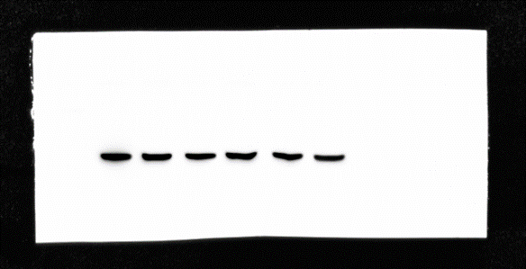
+siNC +siPD-L1

PC9-Gef
PD-L1
+siNC +siPD-L1
β-actin
+siNC +siPD-L1

HCC827
PD-L1
3
2
1
+NC +PD-L1
β-actin
+NC +PD-L1

PC-9
PD-L1
+NC +PD-L1
β-actin
+NC +PD-L1

Fig.2C
HCC827-Gef
AKT
+siNC +siPD-L1
p-AKT
+siNC +siPD-L1
ERK
+siNC +siPD-L1

p-ERK
+siNC +siPD-L1
STAT3
+siNC +siPD-L1
p-STAT3
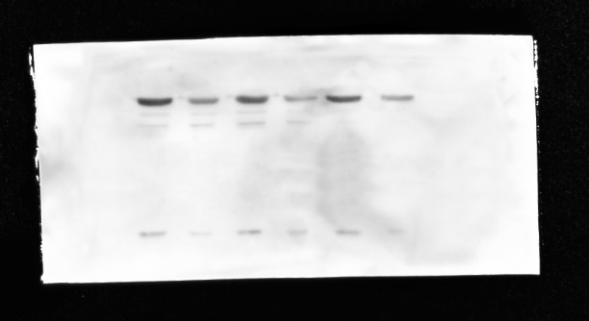
+siNC +siPD-L1

GAPDH
+siNC +siPD-L1

PC9-Gef
AKT
+siNC +siPD-L1
p-AKT
+siNC +siPD-L1
ERK
+siNC +siPD-L1

p-ERK
+siNC +siPD-L1
STAT3
+siNC +siPD-L1
p-STAT3
+siNC +siPD-L1

GAPDH
+siNC +siPD-L1

HCC827
AKT
+NC +PD-L1
p-AKT
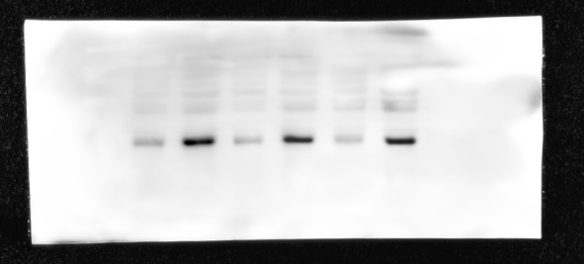
+NC +PD-L1
ERK
+NC +PD-L1
p-ERK
+NC +PD-L1
STAT3
+NC +PD-L1
p-STAT3
+NC +PD-L1
GAPDH
+NC +PD-L1

PC9
AKT
+NC +PD-L1
p-AKT
+NC +PD-L1
ERK
+NC +PD-L1
p-ERK
+NC +PD-L1
STAT3
+NC +PD-L1
p-STAT3
+NC +PD-L1
GAPDH
+NC +PD-L1

Fig.2D
HCC87-Gef
E-Cadherin
+siNC +siPD-L1
N- Cadherin
+siNC +siPD-L1
Fibronetin
+siNC +siPD-L1

Vimentin
+siNC +siPD-L1
GADPH
+siNC +siPD-L1

\

PC9-Gef
E-Cadherin
+siNC +siPD-L1

N- Cadherin
+siNC +siPD-L1
Fibronetin
+siNC +siPD-L1

Vimentin
+siNC +siPD-L1
GADPH
+siNC +siPD-L1

HCC827
E-Cadherin
+NC +PD-L1
N- Cadherin
+NC +PD-L1
Fibronetin
+NC +PD-L1
Vimentin
+NC +PD-L1

GADPH
+NC +PD-L1

PC9
E-Cadherin
+NC +PD-L1
N- Cadherin
+NC +PD-L1
Fibronectin
+NC +PD-L1

Vimentin
+NC +PD-L1
GADPH
+NC +PD-L1

Figure S3. Blots in Fig. 3A,3B,3C&3D were shown.
Fig. 3A
PC9-Gef
AXL
+siNC +siAXL
GADPH
+siNC +siAXL

HCC827-Gef
AXL
+siNC +siAXL
GADPH
+siNC +siAXL

Fig. 3B
PC9-Gef
PD-L1
+siNC +siAXL
β-actin
+siNC +siAXL

HCC827-Gef
PD-L1
+siNC +siAXL
β-actin
+siNC +siAXL

Fig. 3C
PC9
AXL
+NC +AXL
GADPH
+NC +AXL
HCC827
AXL
+NC +AXL
GADPH
+NC +AXL

Fig. 3D
PC9
PD-L1
+NC +AXL
β-actin
+NC +AXL
HCC827
PD-L1
+NC +AXL
β-actin
+NC +AXL

Figure S4. Blots in Fig. 4A,4B&4C were shown.
Fig. 4A
PC9
AKT
+NC +AXL
p-AKT
+NC +AXL
ERK
+NC +AXL
p-ERK
+NC +AXL

STAT3
+NC +AXL
p-STAT3
+NC +AXL

GADPH
+NC +AXL

HCC827
AKT
+NC +AXL
p-AKT
+NC +AXL
ERK
+NC +AXL
p-ERK
+NC +AXL
STAT3
+NC +AXL
p-STAT3
+NC +AXL

GADPH
+NC +AXL

Fig. 4B
PC9-Gef
AKT
+siNC +siAXL
p-AKT
+siNC +siAXL
ERK
+siNC +siAXL

p-ERK
+siNC +siAXL
STAT3
+siNC +siAXL

p-STAT3
+siNC +siAXL

GADPH
+siNC +siAXL
HCC827-Gef
AKT
+siNC +siAXL
p-AKT
+siNC +siAXL
ERK
+siNC +siAXL
p-ERK
+siNC +siAXL

STAT3

+siNC +siAXL
p-STAT3
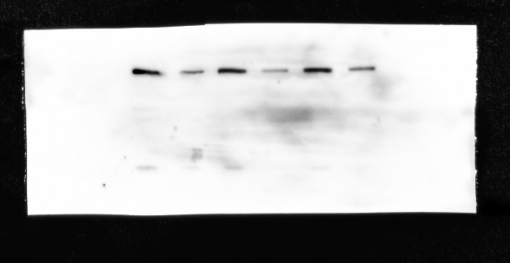
+siNC +siAXL

GADPH
+siNC +siAXL

Fig. 4C
PD-L1

β-actin

