Supplementary material

Table S1. Sediment trap sample time-series. The orange line (MDI-V-11) shows a missing sampling interval due to the presence of crabs in the sediment trap funnel resulting in a technical failure.

Sample | Date (start) | Date (end) | days
MDI-I-1 | 11-Sep-10 | 1-Oct-10 | 20
MDI-I-2 | 1-Oct-10 | 1-Nov-10 | 31
MDI-I-3 | 1-Nov-10 | 1-Dec-10 | 30
MDI-I-4 | 1-Dec-10 | 1-Jan-11 | 31
MDI-I-5 | 1-Jan-11 | 1-Feb-11 | 31
MDI-I-6 | 1-Feb-11 | 1-Mar-11 | 28
MDI-I-7 | 1-Mar-11 | 1-Apr-11 | 31
MDI-I-8 | 1-Apr-11 | 1-May-11 | 30
MDI-I-9 | 1-May-11 | 1-Jun-11 | 31
MDI-I-10 | 1-Jun-11 | 1-Jul-11 | 30
MDI-I-11 | 1-Jul-11 | 1-Aug-11 | 31
MDI-I-12 | 1-Aug-11 | 1-Sep-11 | 31
MDI-II-1 | 6-Sep-11 | 1-Oct-11 | 25
MDI-II-2 | 1-Oct-11 | 1-Nov-11 | 31
MDI-II-3 | 1-Nov-11 | 1-Dec-11 | 30
MDI-II-4 | 1-Dec-11 | 1-Jan-12 | 31
MDI-II-5 | 1-Jan-12 | 1-Feb-12 | 31
MDI-II-6 | 1-Feb-12 | 1-Mar-12 | 29
MDI-II-7 | 1-Mar-12 | 1-Apr-12 | 31
MDI-II-8 | 1-Apr-12 | 1-May-12 | 30
MDI-II-9 | 1-May-12 | 1-Jun-12 | 31
MDI-II-10 | 1-Jun-12 | 1-Jul-12 | 30
MDI-II-11 | 1-Jul-12 | 31-Jul-12 | 30
MDI-II-12 | 31-Jul-12 | 31-Aug-12 | 31
MDI-III-1 | 6-Sep-12 | 27-Sep-12 | 21
MDI-III-2 | 27-Sep-12 | 8-Nov-12 | 42
MDI-III-3 | 8-Nov-12 | 20-Dec-12 | 42
MDI-III-4 | 20-Dec-12 | 31-Jan-13 | 42
MDI-III-5 | 31-Jan-13 | 14-Mar-13 | 42
MDI-III-6 | 14-Mar-13 | 25-Apr-13 | 42
MDI-III-7 | 25-Apr-13 | 16-May-13 | 21
MDI-III-8 | 16-May-13 | 26-May-13 | 10.5
MDI-IV-1 | 29-May-13 | 7-Jun-13 | 9
MDI-IV-2 | 7-Jun-13 | 16-Jun-13 | 9
MDI-IV-3 | 16-Jun-13 | 24-Jun-13 | 8
MDI-IV-4 | 24-Jun-13 | 2-Jul-13 | 8
MDI-IV-5 | 2-Jul-13 | 10-Jul-13 | 8
MDI-IV-6 | 10-Jul-13 | 18-Jul-13 | 8
MDI-IV-7 | 18-Jul-13 | 26-Jul-13 | 8
MDI-IV-8 | 26-Jul-13 | 3-Aug-13 | 8
MDI-IV-9 | 3-Aug-13 | 11-Aug-13 | 8
MDI-IV-10 | 11-Aug-13 | 19-Aug-13 | 8
MDI-IV-11 | 19-Aug-13 | 27-Aug-13 | 8
MDI-IV-12 | 27-Aug-13 | 4-Sep-13 | 8
MDI-V-1 | 10-Sep-13 | 1-Oct-13 | 21
MDI-V-2 | 1-Oct-13 | 1-Dec-13 | 61
MDI-V-3 | 1-Dec-13 | 1-Feb-14 | 62
MDI-V-4 | 1-Feb-14 | 1-Apr-14 | 59
MDI-V-5 | 1-Apr-14 | 16-Apr-14 | 15
MDI-V-6 | 16-Apr-14 | 1-May-14 | 15
MDI-V-7 | 1-May-14 | 16-May-14 | 15
MDI-V-8 | 16-May-14 | 1-Jun-14 | 16
MDI-V-9 | 1-Jun-14 | 1-Jul-14 | 30
MDI-V-10 | 1-Jul-14 | 3-Aug-14 | 33
MDI-V-11 | 3-Aug-14 | 12-Sep-14
MDI-VI-1 | 12-Sep-14 | 1-Oct-14 | 19
MDI-VI-2 | 1-Oct-14 | 1-Dec-14 | 61
MDI-VI-3 | 1-Dec-14 | 1-Feb-15 | 62
MDI-VI-4 | 1-Feb-15 | 1-Apr-15 | 59
MDI-VI-5 | 1-Apr-15 | 16-Apr-15 | 15
MDI-VI-6 | 16-Apr-15 | 1-May-15 | 15
MDI-VI-7 | 1-May-15 | 16-May-15 | 15
MDI-VI-8 | 16-May-15 | 1-Jun-15 | 16
MDI-VII-1 | 24-Jun-15 | 16-Jul-15 | 22
MDI-VII-2 | 16-Jul-15 | 1-Aug-15 | 16
MDI-VII-3 | 1-Aug-15 | 16-Aug-15 | 15
MDI-VII-4 | 16-Aug-15 | 1-Sep-15 | 16
MDI-VII-5 | 1-Sep-15 | 16-Sep-15 | 15
MDI-VII-6 | 16-Sep-15 | 1-Oct-15 | 15
MDI-VII-7 | 1-Oct-15 | 1-Jan-16 | 92
MDI-VII-8 | 1-Jan-16 | 1-Apr-16 | 91
MDI-VII-9 | 1-Apr-16 | 1-May-16 | 30
MDI-VII-10 | 1-May-16 | 16-May-16 | 15
MDI-VII-11 | 16-May-16 | 19-May-16 | 3
MDI-VIII-1 | 26-May-16 | 16-Jun-16 | 21
MDI-VIII-2 | 16-Jun-16 | 1-Jul-16 | 15
MDI-VIII-3 | 1-Jul-16 | 16-Jul-16 | 15
MDI-VIII-4 | 16-Jul-16 | 1-Aug-16 | 16
MDI-VIII-5 | 1-Aug-16 | 16-Aug-16 | 15
MDI-VIII-6 | 16-Aug-16 | 1-Sep-16 | 16
MDI-VIII-7 | 1-Sep-16 | 16-Sep-16 | 15
MDI-VIII-8 | 16-Sep-16 | 16-Oct-16 | 30
MDI-VIII-9 | 16-Oct-16 | 1-Jan-17 | 77
MDI-VIII-10 | 1-Jan-17 | 1-Apr-17 | 90
MDI-VIII-11 | 1-Apr-17 | 1-May-17 | 30
MDI-VIII-12 | 1-May-17 | 14-Jun-17 | 44
MDI-IX-1 | 22-Jun-17 | 16-Jul-17 | 24
MDI-IX-2 | 16-Jul-17 | 1-Aug-17 | 16
MDI-IX-3 | 1-Aug-17 | 16-Aug-17 | 15
MDI-IX-4 | 16-Aug-17 | 1-Sep-17 | 16
MDI-IX-5 | 1-Sep-17 | 16-Sep-17 | 15
MDI-IX-6 | 16-Sep-17 | 1-Oct-17 | 15
MDI-IX-7 | 1-Oct-17 | 1-Nov-17 | 31
MDI-IX-8 | 1-Nov-17 | 1-Jan-18 | 61
MDI-IX-9 | 1-Jan-18 | 1-Apr-18 | 90
MDI-IX-10 | 1-Apr-18 | 1-May-18 | 30
MDI-IX-11 | 1-May-18 | 1-Jun-18 | 31
MDI-IX-12 | 1-Jun-18 | 3-Jul-18 | 32

Table S2. Sediment trap samples with the mesozooplankton dataset. The individual abundances were calculated as fluxes, ind m⁻² d⁻¹.

Sample | Copepods fluxes | Amphipods fluxes | Euphasiids fluxes |  | Polychaetess fluxes |  | Thecosomaths fluxes |  | Copelats fluxes
MDI-I-1 | 423 | 1 |  | 0 |  | 0 |  | 0 |  | 0
MDI-I-2 | 180 | 1 |  | 0 |  | 28 |  | 0 |  | 1
MDI-I-3 | 224 | 0 |  | 1 |  | 4 |  | 0 |  | 24
MDI-I-4 | 212 | 1 |  | 0 |  | 5 |  | 0 |  | 138
MDI-I-5 | 164 | 1 |  | 5 |  | 3 |  | 0 |  | 128
MDI-I-6 | 82 | 1 |  | 2 |  | 0 |  | 0 |  | 46
MDI-I-7 | 165 | 0 |  | 3 |  | 2 |  | 0 |  | 0
MDI-I-8 | 88 | 0 |  | 0 |  | 0 |  | 0 |  | 0
MDI-I-9 | 61 | 1 |  | 0 |  | 1 |  | 0 |  | 0
MDI-I-10 | 201 | 25 |  | 0 |  | 2 |  | 0 |  | 0
MDI-I-11 | 145 | 22 |  | 0 |  | 0 |  | 0 |  | 0
MDI-I-12 | 505 | 1 |  | 0 |  | 1 |  | 0 |  | 0
MDI-II-1 | 271 | 2 |  | 12 |  | 2 |  | 0 |  | 0
MDI-II-2 | 85 | 1 |  | 0 |  | 1 |  | 0 |  | 0
MDI-II-3 | 142 | 0 |  | 0 |  | 1 |  | 2 |  | 1
MDI-II-4 | 102 | 1 |  | 0 |  | 2 |  | 1 |  | 0
MDI-II-5 | 278 | 1 |  | 0 |  | 1 |  | 6 |  | 0
MDI-II-6 | 191 | 1 |  | 0 |  | 0 |  | 3 |  | 0
MDI-II-7 | 232 | 0 |  | 0 |  | 0 |  | 3 |  | 0
MDI-II-8 | 339 | 0 |  | 1 |  | 0 |  | 0 |  | 0
MDI-II-9 | 26 | 46 |  | 3 |  | 0 |  | 1 |  | 0
MDI-II-10 | 86 | 51 |  | 4 |  | 2 |  | 0 |  | 0
MDI-II-11 | 128 | 24 |  | 1 |  | 0 |  | 0 |  | 0
MDI-II-12 | 105 | 2 |  | 0 |  | 4 |  | 0 |  | 0
MDI-III-1 | 290 | 0 |  | 0 |  | 5 |  | 0 |  | 0
MDI-III-2 | 83 | 0 |  | 0 |  | 2 |  | 5 |  | 0
MDI-III-3 | 226 | 0 |  | 0 |  | 0 |  | 28 |  | 0
MDI-III-4 | 120 | 0 |  | 0 |  | 0 |  | 30 |  | 0
MDI-III-5 | 194 | 0 |  | 1 |  | 0 |  | 4 |  | 0
MDI-III-6 | 112 | 0 |  | 0 |  | 0 |  | 1 |  | 0
MDI-III-7 | 10 | 7 |  | 0 |  | 0 |  | 3 |  | 0
MDI-III-8 | 34 | 13 |  | 2 |  | 72 |  | 0 |  | 0
MDI-IV-1 | 22 | 220 |  | 7 |  | 33 |  | 0 |  | 0
MDI-IV-2 | 53 | 78 |  | 2 |  | 9 |  | 0 |  | 0
MDI-IV-3 | 63 | 8 |  | 5 |  | 3 |  | 0 |  | 0
MDI-IV-4 | 113 | 5 |  | 5 |  | 0 |  | 0 |  | 0
MDI-IV-5 | 45 | 18 |  | 3 |  | 0 |  | 0 |  | 0
MDI-IV-6 | 248 | 0 |  | 8 |  | 0 |  | 0 |  | 0
MDI-IV-7 | 88 | 3 |  | 5 |  | 0 |  | 0 |  | 0
MDI-IV-8 | 48 | 0 |  | 5 |  | 3 |  | 0 |  | 0
MDI-IV-9 | 85 | 0 |  | 3 |  | 0 |  | 0 |  | 5
MDI-IV-10 | 118 | 0 |  | 5 |  | 0 |  | 0 |  | 0
MDI-IV-11 | 18 | 0 |  | 0 |  | 0 |  | 10 |  | 0
MDI-IV-12 | 163 | 13 |  | 0 |  | 28 |  | 23 |  | 0
MDI-V-1 | 78 | 3 |  | 0 |  | 6 |  | 0 |  | 0
MDI-V-2 | 61 | 1 |  | 0 |  | 1 |  | 1 |  | 0
MDI-V-3 | 118 | 0 |  | 3 |  | 0 |  | 4 |  | 0
MDI-V-4 | 17 | 0 |  | 1 |  | 0 |  | 0 |  | 0
MDI-V-5 | 1 | 0 |  | 0 |  | 0 |  | 0 |  | 0
MDI-V-6 | 3 | 0 |  | 0 |  | 0 |  | 0 |  | 0
MDI-V-7 | 7 | 1 |  | 0 |  | 0 |  | 0 |  | 0
MDI-V-8 | 0 | 50 |  | 0 |  | 0 |  | 0 |  | 0
MDI-V-9 | 9 | 35 |  | 0 |  | 0 |  | 0 |  | 0
MDI-V-10 | 2 | 1 |  | 0 |  | 0 |  | 0 |  | 0
MDI-V-11
MDI-VI-1 | 54 | 0 |  | 2 |  | 3 |  | 1 |  | 0
MDI-VI-2 | 50 | 0 |  | 1 |  | 0 |  | 1 |  | 0
MDI-VI-3 | 5 | 1 |  | 0 |  | 0 |  | 0 |  | 0
MDI-VI-4 | 0 | 0 |  | 0 |  | 0 |  | 0 |  | 0
MDI-VI-5 | 0 | 0 |  | 0 |  | 0 |  | 0 |  | 0
MDI-VI-6 | 1 | 1 |  | 0 |  | 0 |  | 0 |  | 0
MDI-VI-7 | 7 | 0 |  | 0 |  | 0 |  | 0 |  | 0
MDI-VI-8 | 3 | 3 |  | 0 |  | 0 |  | 0 |  | 0
MDI-VII-1 | 32 | 0 |  | 7 |  | 0 |  | 0 |  | 0
MDI-VII-2 | 21 | 0 |  | 1 |  | 0 |  | 0 |  | 0
MDI-VII-3 | 29 | 0 |  | 4 |  | 0 |  | 0 |  | 0
MDI-VII-4 | 13 | 0 |  | 1 |  | 6 |  | 0 |  | 0
MDI-VII-5 | 19 | 0 |  | 1 |  | 17 |  | 0 |  | 0
MDI-VII-6 | 16 | 0 |  | 3 |  | 13 |  | 0 |  | 0
MDI-VII-7 | 5 | 0 |  | 0 |  | 1 |  | 0 |  | 0
MDI-VII-8 | 35 | 0 |  | 0 |  | 0 |  | 0 |  | 0
MDI-VII-9 | 69 | 0 |  | 0 |  | 0 |  | 1 |  | 0
MDI-VII-10 | 39 | 0 |  | 0 |  | 0 |  | 0 |  | 0
MDI-VII-11 | 20 | 0 |  | 0 |  | 0 |  | 0 |  | 0
MDI-VIII-1 | 6 | 1 |  | 0 |  | 0 |  | 0 |  | 0
MDI-VIII-2 | 12 | 24 |  | 0 |  | 0 |  | 0 |  | 0
MDI-VIII-3 | 17 | 11 |  | 0 |  | 0 |  | 0 |  | 0
MDI-VIII-4 | 19 | 1 |  | 1 |  | 1 |  | 0 |  | 0
MDI-VIII-5 | 5 | 0 |  | 0 |  | 0 |  | 4 |  | 0
MDI-VIII-6 | 58 | 0 |  | 1 |  | 1 |  | 124 |  | 1
MDI-VIII-7 | 11 | 0 |  | 0 |  | 4 |  | 101 |  | 0
MDI-VIII-8 | 19 | 0 |  | 0 |  | 5 |  | 24 |  | 2
MDI-VIII-9 | 28 | 0 |  | 0 |  | 0 |  | 2 |  | 0
MDI-VIII-10 | 193 | 0 |  | 0 |  | 0 |  | 0 |  | 0
MDI-VIII-11 | 3 | 0 |  | 0 |  | 1 |  | 0 |  | 0
MDI-VIII-12 | 31 | 2 |  | 2 |  | 1 |  | 0 |  | 0
MDI-IX-1 | 50 | 8 |  | 3 |  | 0 |  | 0 |  | 0
MDI-IX-2 | 15 | 1 |  | 0 |  | 3 |  | 0 |  | 0
MDI-IX-3 | 47 | 4 |  | 4 |  | 3 |  | 0 |  | 0
MDI-IX-4 | 28 | 1 |  | 1 |  | 26 |  | 0 |  | 0
MDI-IX-5 | 15 | 0 |  | 0 |  | 11 |  | 0 |  | 1
MDI-IX-6 | 47 | 0 |  | 1 |  | 13 |  | 0 |  | 0
MDI-IX-7 | 25 | 0 |  | 0 |  | 8 |  | 1 |  | 1
MDI-IX-8 | 42 | 0 |  | 1 |  | 2 |  | 2 |  | 0
MDI-IX-9 | 67 | 0 |  | 1 |  | 1 |  | 1 |  | 1
MDI-IX-10 | 23 | 0 |  | 0 |  | 0 |  | 1 |  | 0
MDI-IX-11 | 8 | 3 |  | 1 |  | 2 |  | 0 |  | 1
MDI-IX-12 | 44 | 9 |  | 1 |  | 1 |  | 1 |  | 0

Table S3: Richness of taxa calculated via annual Margalef Index $d=\frac{\left(C-1\right)}{\ln{N}}$, where C=number of classes and N= total number of individuals. The years 2010 and 2018 (in orange) are not complete: the data below show the months Sept – Dec 2010, and Jan – Jul 2018.

Year | d averaged per year | SD
2010 | 0.44 | 0.19
2011 | 0.46 | 0.21
2012 | 0.38 | 0.20
2013 | 0.47 | 0.17
2014 | 0.42 | 0.39
2015 | 0.50 | 0.39
2016 | 0.45 | 0.31
2017 | 0.73 | 0.22
2018 | 0.93 | 0.48

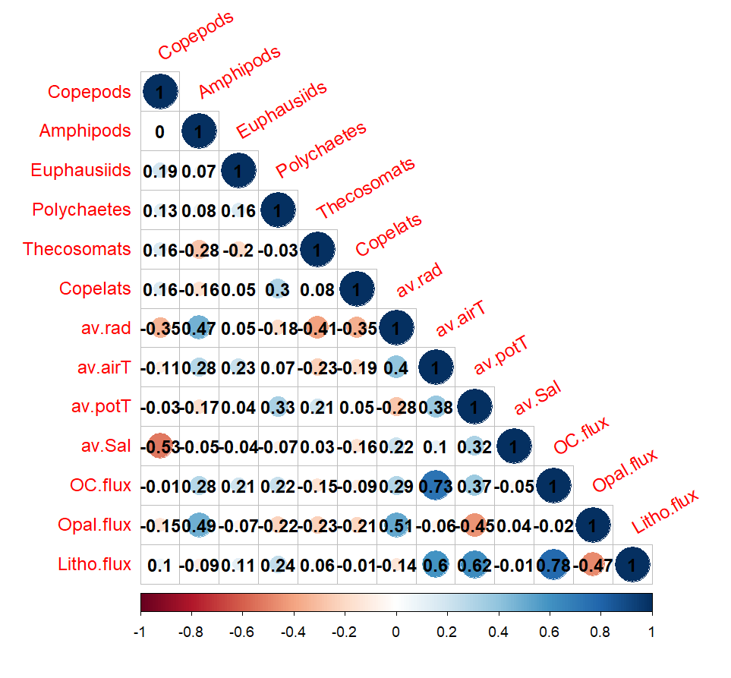ss
Figure S1: Spearman’s rank correlation plot, including the physical, chemical and biological data. The physical data were averaged by the sediment trap deployment period. Legend: Taxa are expressed as fluxes (n ind m⁻² d⁻¹), av.rad is the solar radiation expressed as W m⁻², av.airT is the air temperature measured in °C, av.potT is the potential temperature of the water at ~87m depth (°C), av.Sal is the practical salinity, OC.flux is the organic Carbon flux (mg m⁻² d⁻¹), Opal.flux (mg m⁻² d⁻¹), Litho.flux is the lithogenic material (mg m⁻² d⁻¹).

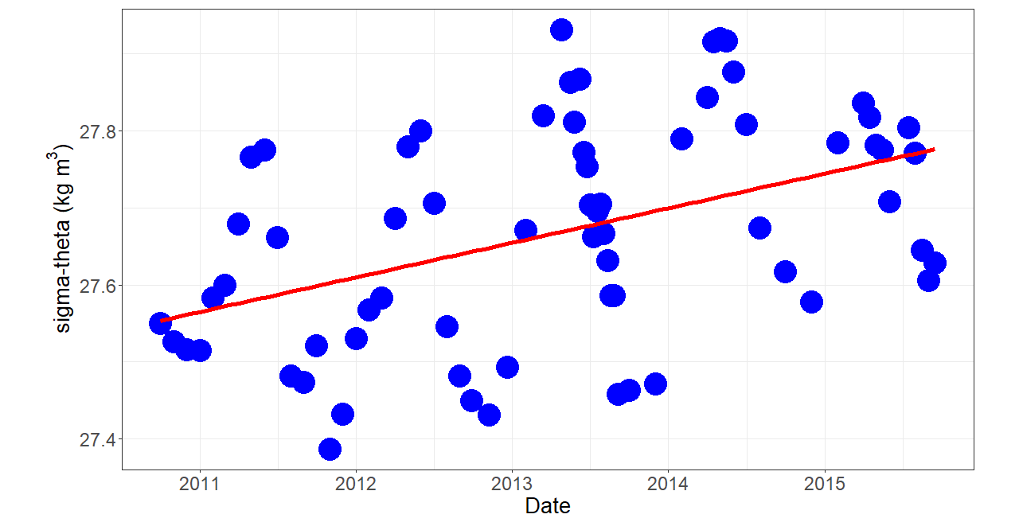
Figure S2: Density of the water mass at ~87 m depth overtime (kg m³). The sigma-theta was calculated with the R Studio library “oce” from S and potential T, at pressure = 0.

