Synthesis, characterization and antibacterial assays of new N,N¹-disubstituted 2,2’-dithiodianiline derivatives

Karolis Skrickus¹, Jūratė Šiugždaitė², Raimundas Lelešius², Kazimieras Anusevičius¹, Birutė Grybaitė¹, Rita Vaickelionienė¹, Vytautas Mickevičius¹

¹Kaunas University of Technology, Radvilėnų Rd. 19, LT-50254, Kaunas, Lithuania
²Department of Patobiology, Lithuanian University of Health Sciences, Tilžės St. 18, 47181 Kaunas, Lithuania

Supporting information

¹H and ¹³C NMR spectra of compounds 2, 3, 5, 7-23 and mass spectra of synthesized compounds 2b and 5

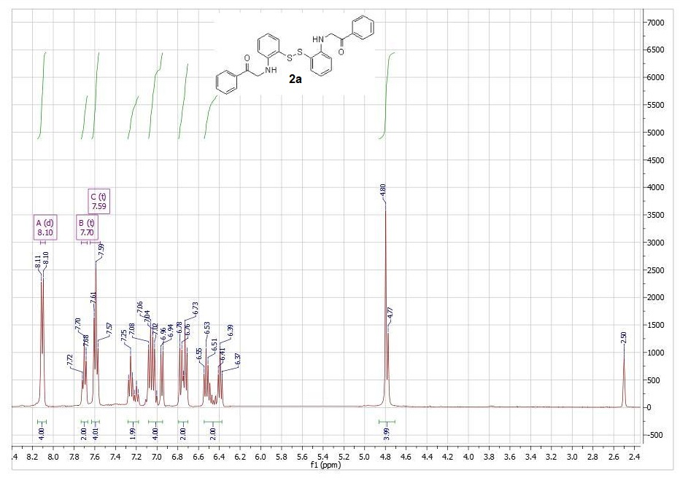
Figure S1: ¹H NMR spectrum of compound 2a
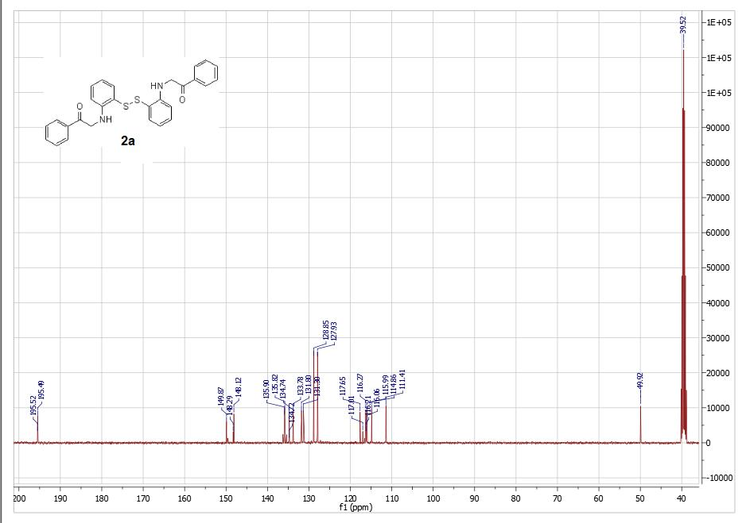
Figure S2: ¹³C NMR spectrum of compound 2a
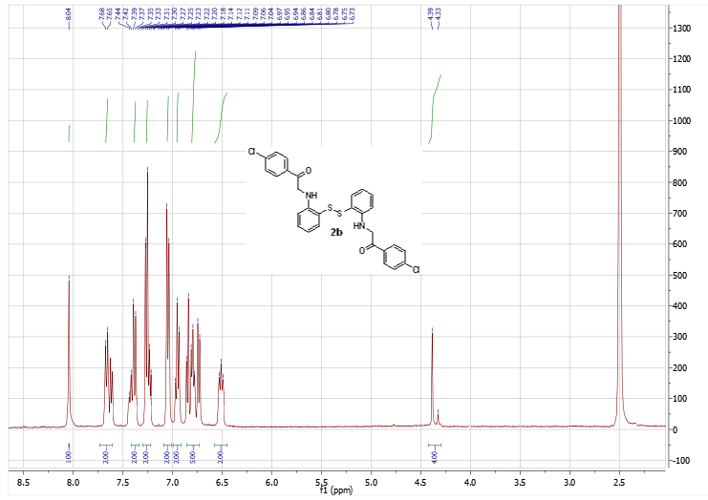
Figure S3: ¹H NMR spectrum of compound 2b
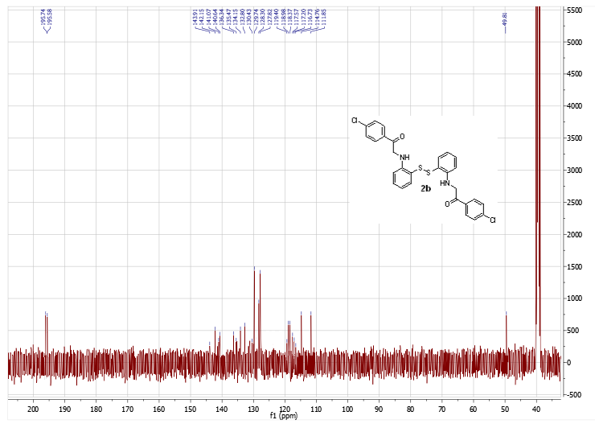
Figure S4: ¹³C NMR spectrum of compound 2b

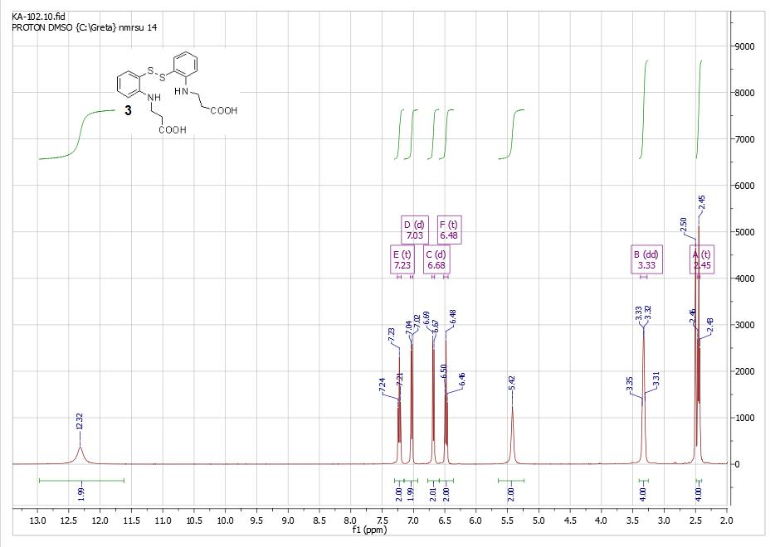
Figure S5: ¹H NMR spectrum of compound 3

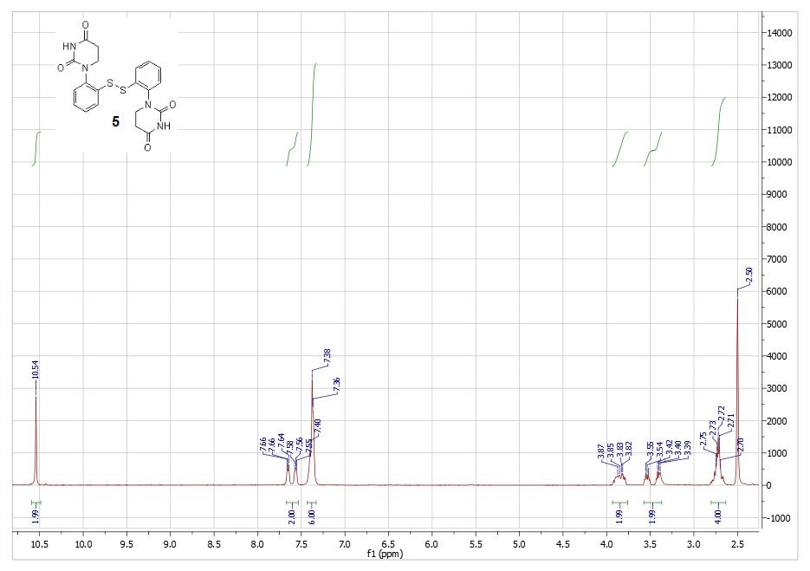
Figure S6: ¹H NMR spectrum of compound 5

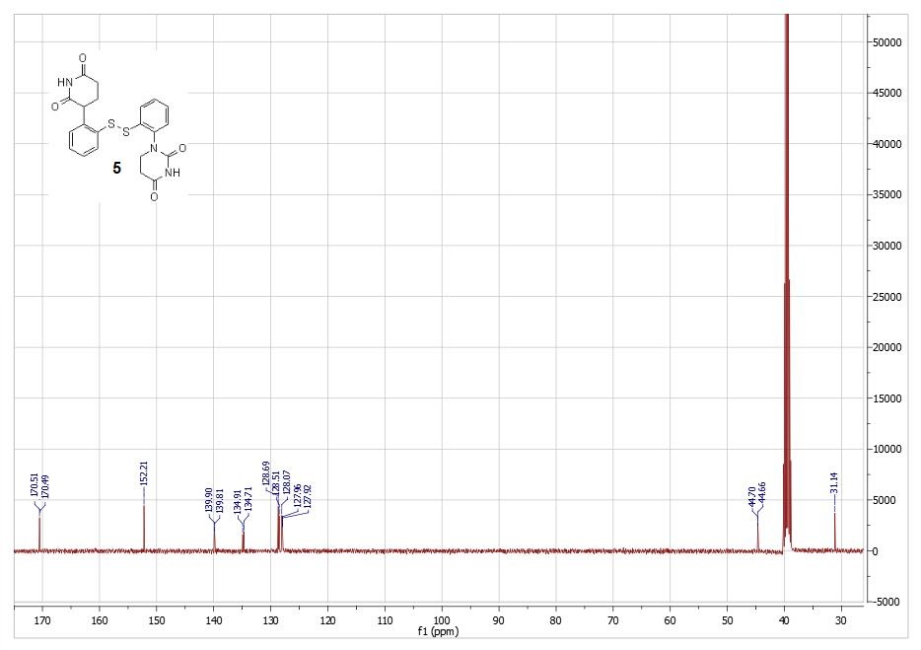
Figure S7: ¹³C NMR spectrum of compound 5
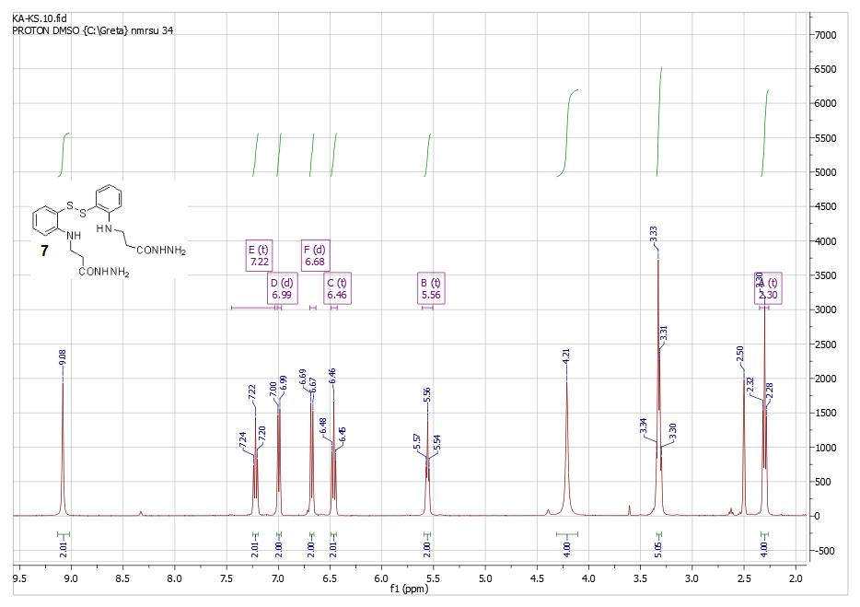
Figure S8: ¹H NMR spectrum of compound 7

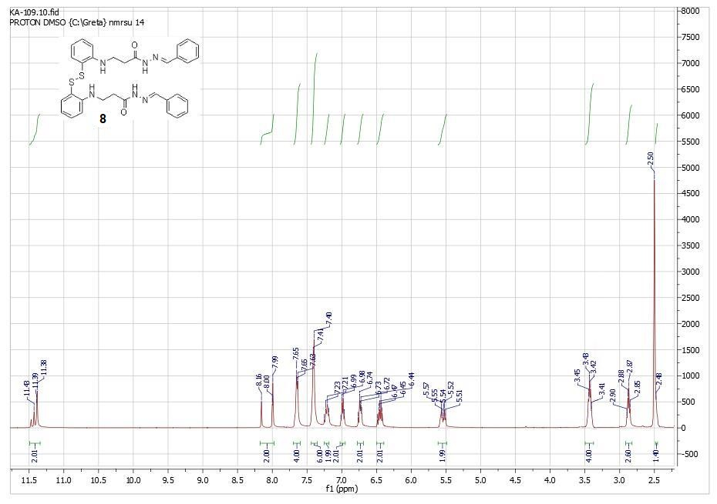
Figure S9: ¹H NMR spectrum of compound 8
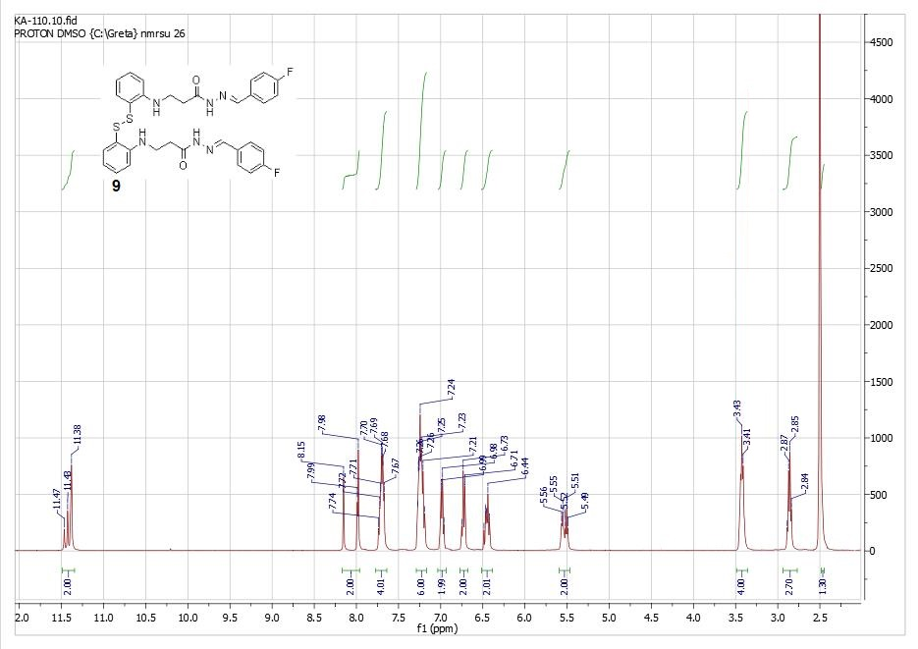
Figure S10: ¹H NMR spectrum of compound 9

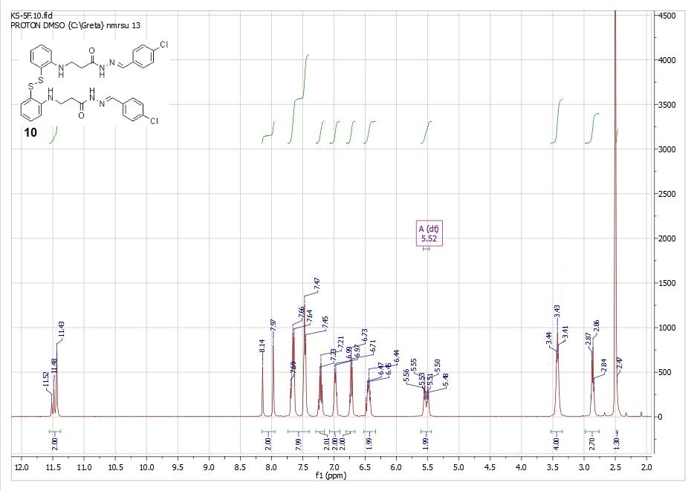
Figure S11: ¹H NMR spectrum of compound 10
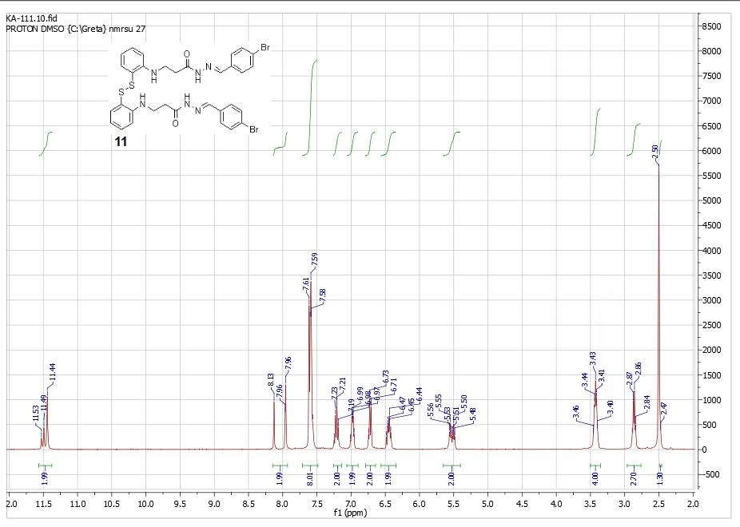
Figure S12: ¹H NMR spectrum of compound 11

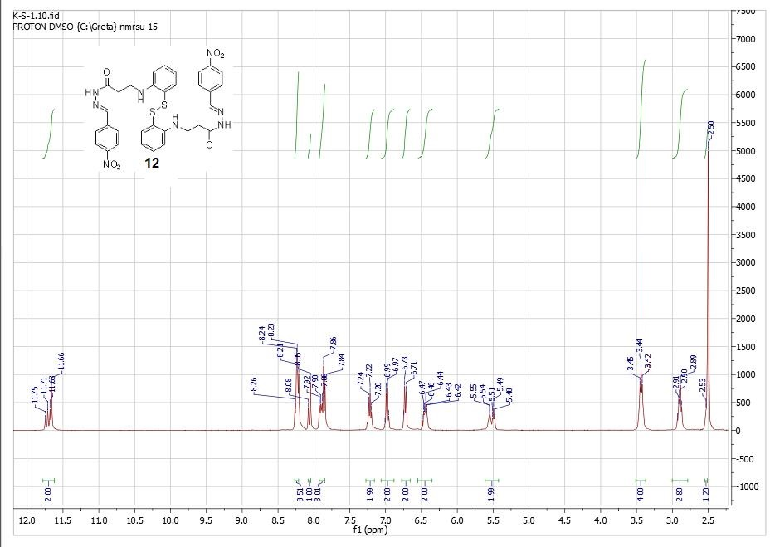
Figure S13: ¹H NMR spectrum of compound 12
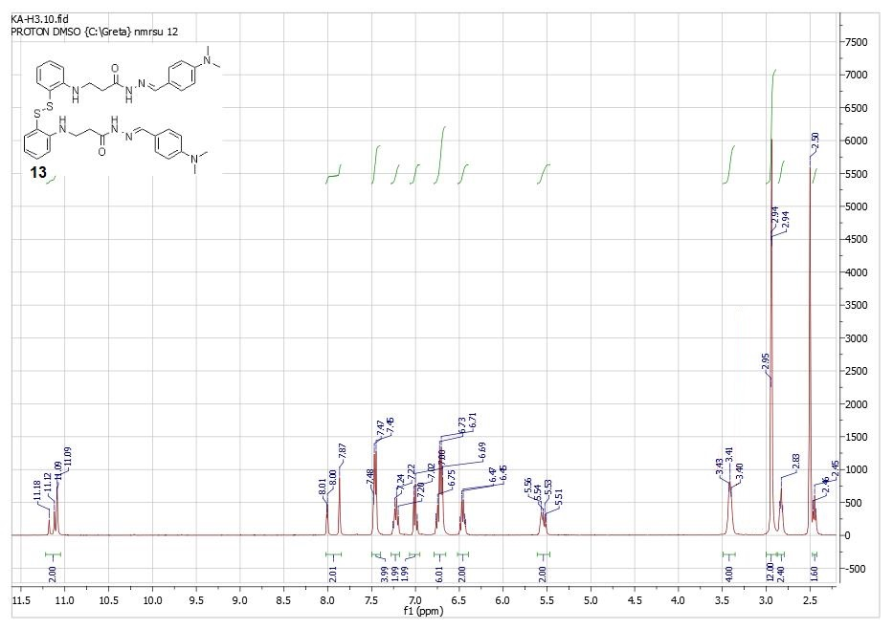
Figure S14: ¹H NMR spectrum of compound 13

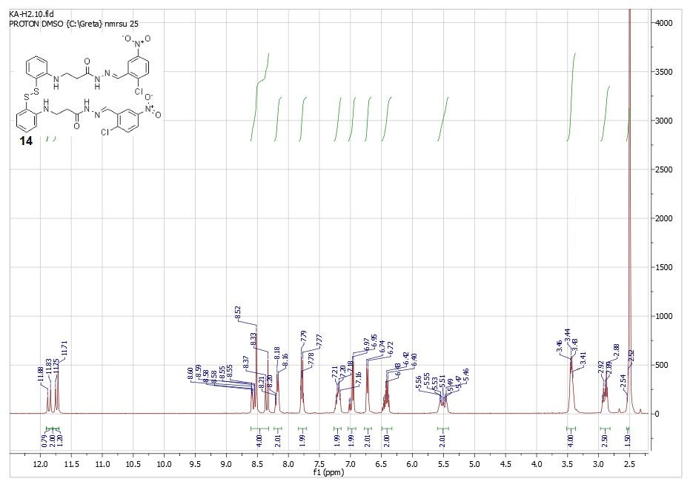
Figure S15: ¹H NMR spectrum of compound 14
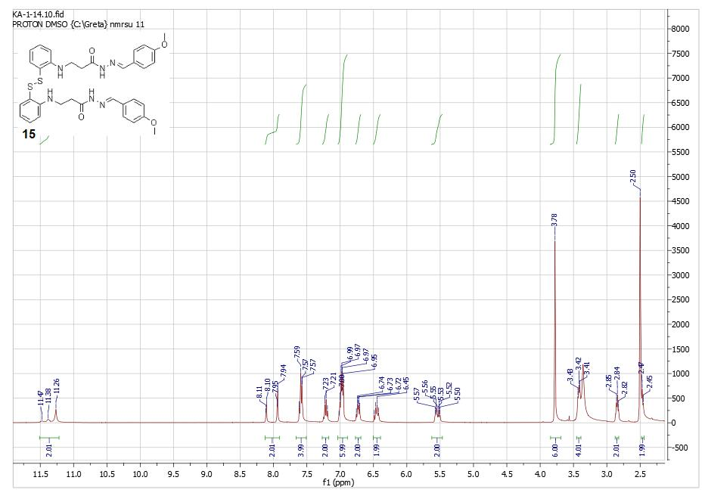
Figure S16: ¹H NMR spectrum of compound 15

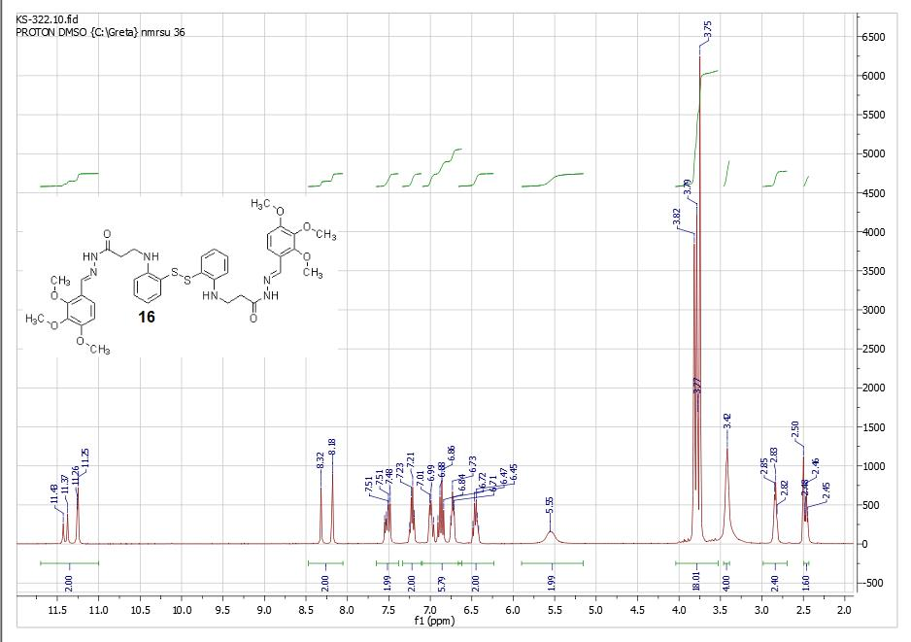
Figure S17: ¹H NMR spectrum of compound 16
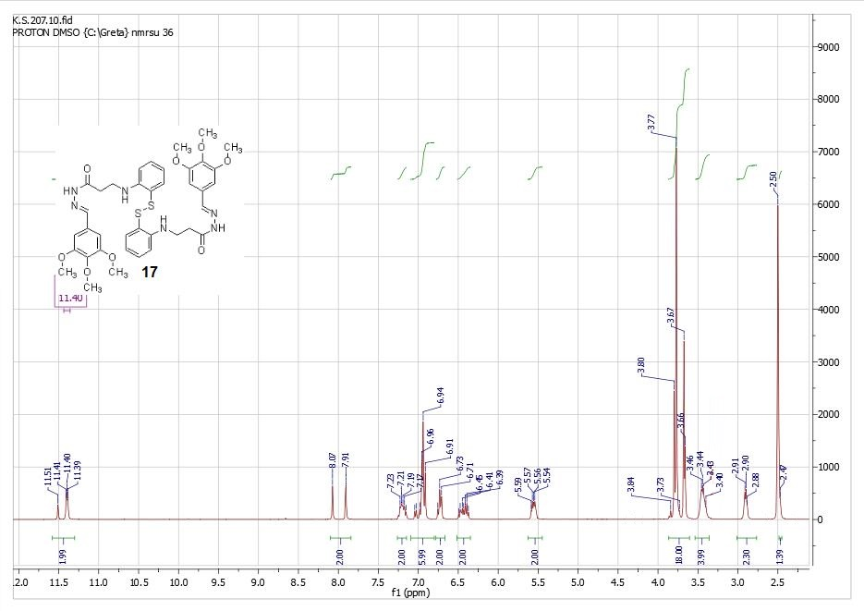
Figure S18: ¹H NMR spectrum of compound 17

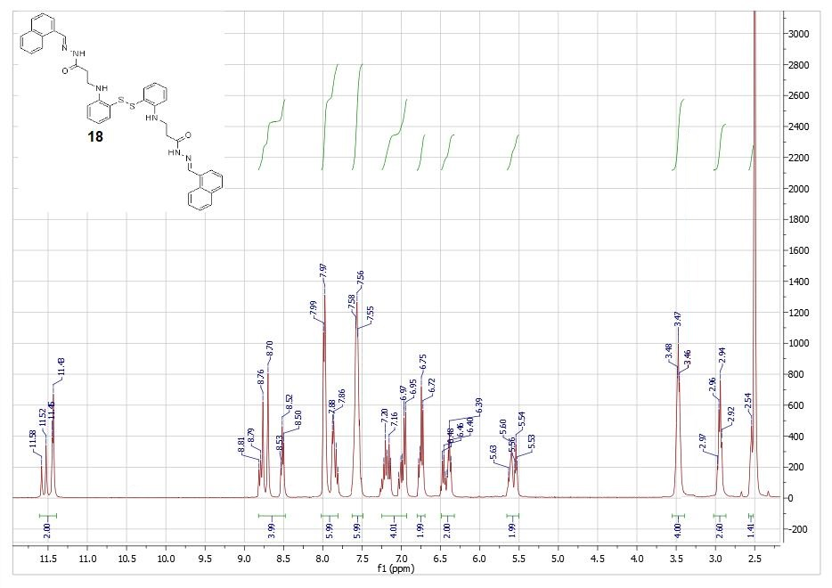
Figure S19: ¹H NMR spectrum of compound 18
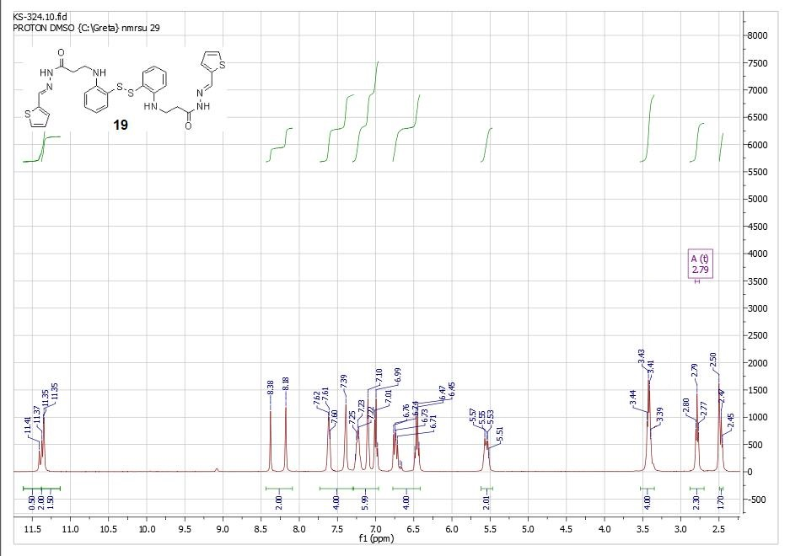
Figure S20: ¹H NMR spectrum of compound 19

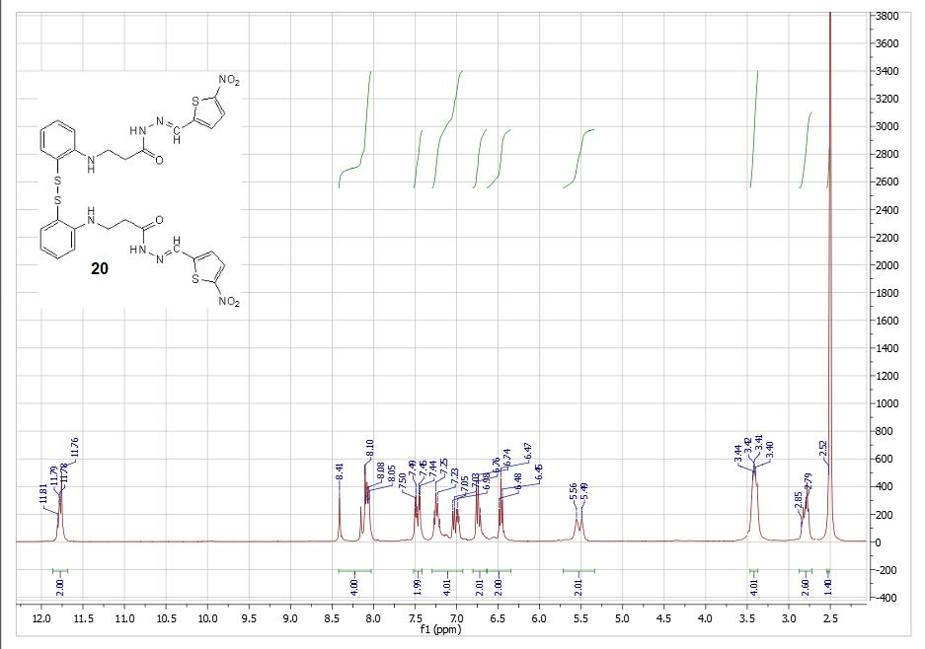
Figure S21: ¹H NMR spectrum of compound 20
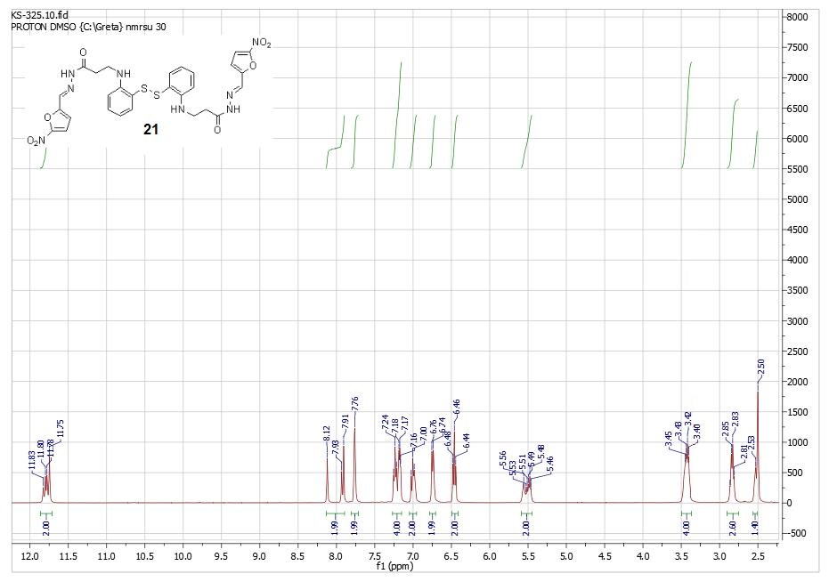
Figure S22: ¹H NMR spectrum of compound 21

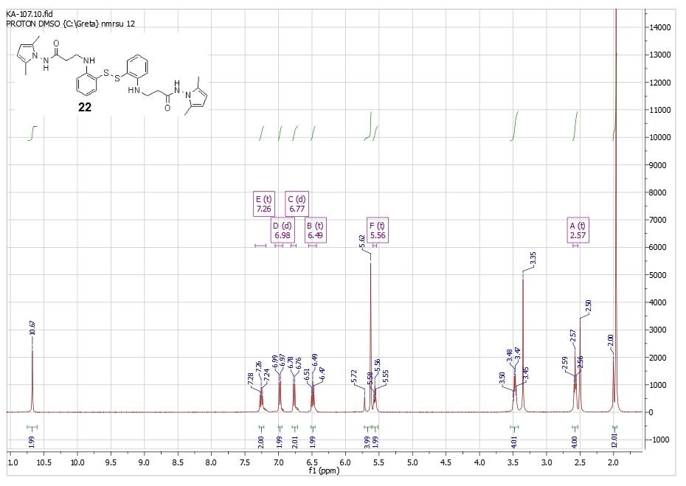
Figure S23: ¹H NMR spectrum of compound 22
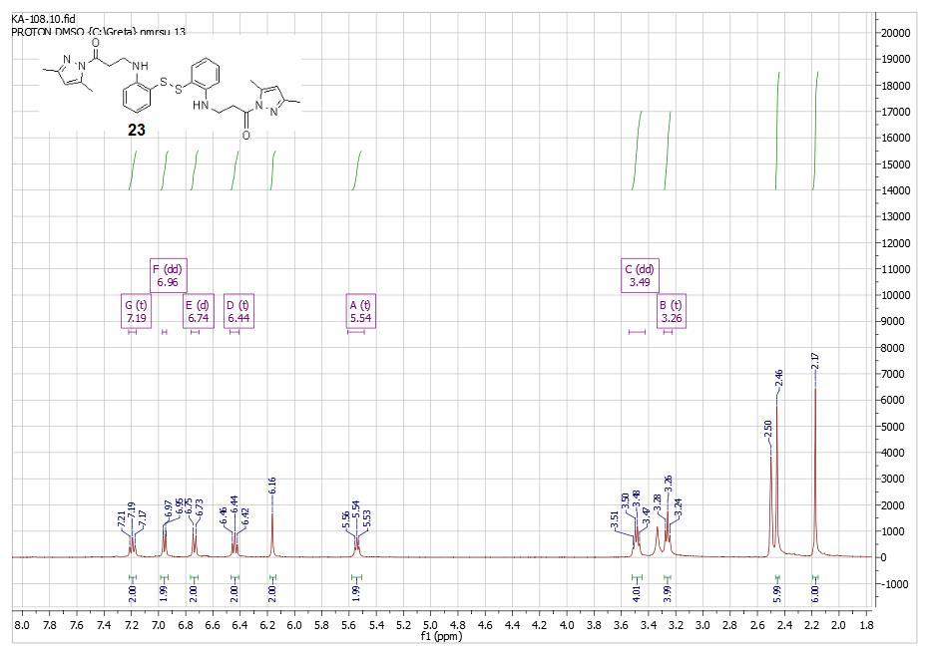
Figure S24: ¹H NMR spectrum of compound 23

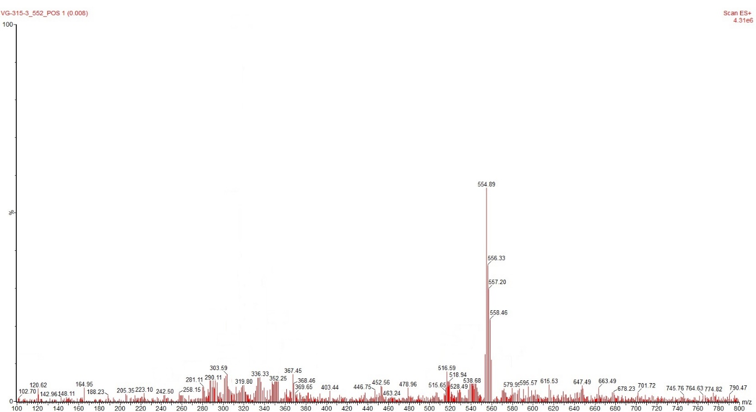
Figure S25: Mass spectrum of compound 2b.
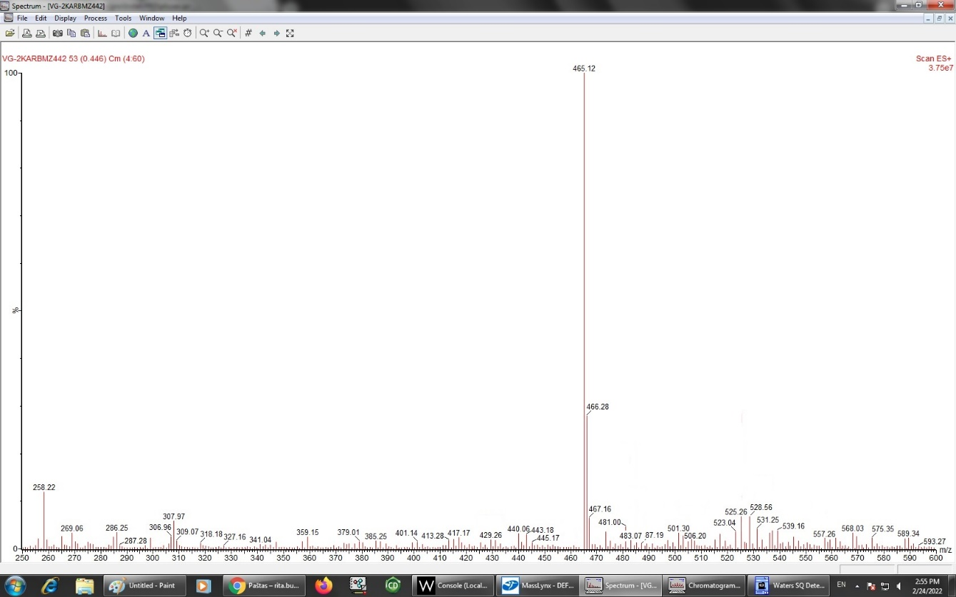
Figure S26: Mass spectrum of compound 5.

